**Week-4**

**Task-1**

**Aim:** To create a java program with class named “Book” the class should contain various attributes “title of the book”,” author”, “year of publication”. It should contain a constructor with parameters which initializes “title of the book”,” author”, “year of publication”. create a method which displays the details of the book i.e “title of the book”,” author”, “year of publication”. Display the details of two books by creating two objects.

Input Code:

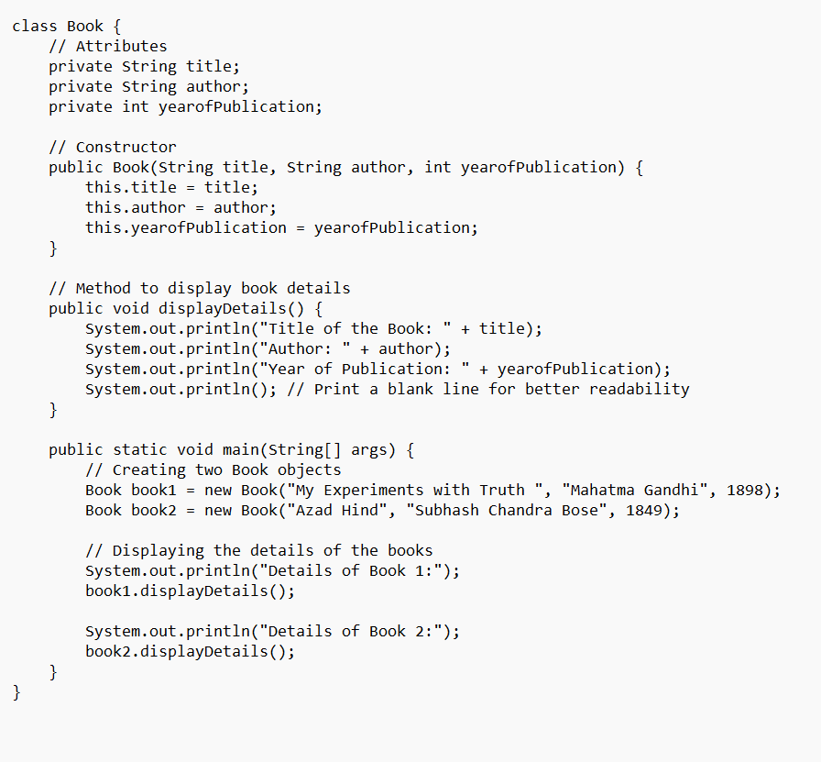

Output:

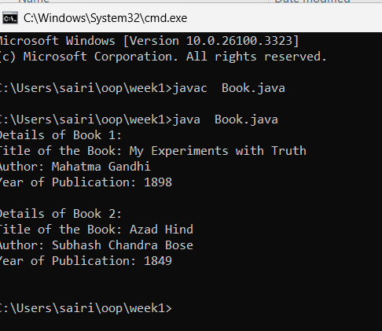

**Task-2**

**Aim:** To create a java program with class named myclass with a static variable count of “int” type initialize to zero and a constant variable “pi” of type double initialize to 3.1415 as attributes of that class now define a constructor for my class that increments the count variable each time an object of myclass is created finally print the finial values of “count” and “pi” variables.

Input Code:

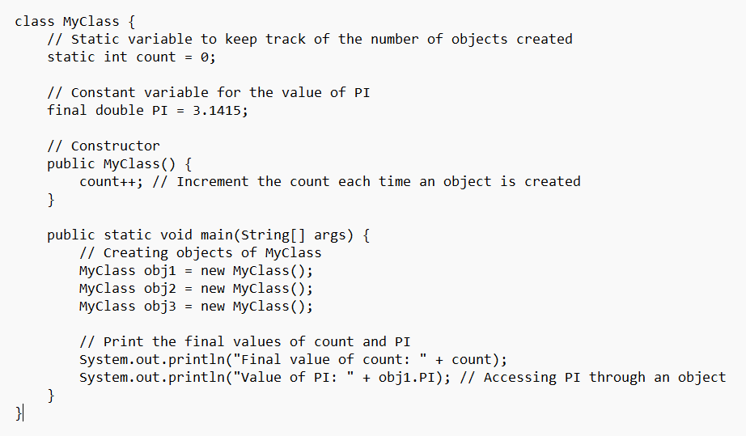

Output:

