\  Security Level:  Confidential |  |  |  |  |  |  |  | Document No.:
Engineer Test Report

Customer Name | DIGI
Product Name
Model Name | IOG87BDG_0T001
Document Revision | V0.1
Release Date

大分類 | 中分類 | 小分類 |  | Editor |  | Checker |  |  | Approver
文件 |  |  |  | Harry | 2015/9/24

Commitment Page

Acquirer
Stakeholder | Name | Signature | Date

Supplier
Stakeholder | Name | Signature | Date

Revision History

Rev | Date | Change Description
V0.1 | 2015/9/24 | Init
V0.2 | 2015/9/25 | Add dhcp relay

DNSMasq Function List
- DHCP server
  - Verification: OK
- DNS cache
  - Verification: OK
- DHCP Relay
  - Verification: OK

- DHCP server
“DHCP server” Dnsmasq can work as a DHCP server with the correct configurations.

- Verification
Login DUT via COM port:
- Type the following command to initial the lan setting :
cd /home/digi
vi eth.init
copy the content in eth.init in attachment and right-click the mouse at console
:wq
sh eth.init

Now you should get the following br interface

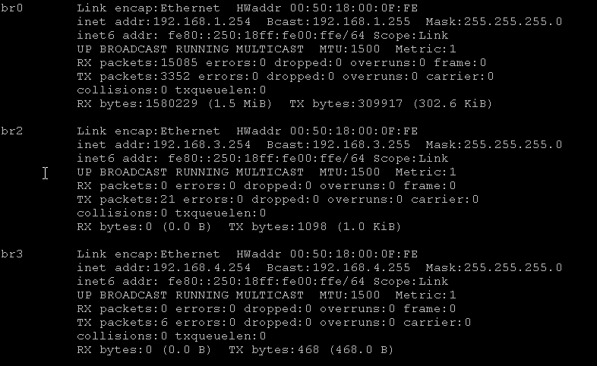

- Type the following command to get the configuration files
cd /var/lib
mkdir misc
cd /var/run
mkdir dnsmasq
cd dnsmasq
vi dnsmasq.conf
copy the content in dnsmasq.conf in attachment and right-click the mouse at console
:wq
vi options.conf
copy the content in options.conf in attachment and right-click the mouse at console
:wq
vi hosts.conf
copy the content in hosts.conf in attachment and right-click the mouse at console
:wq
vi resolv.conf
copy the content in resolv.conf in attachment and right-click the mouse at console
:wq

- Type the following to initial DNSMasq
dnsmasq –-conf-file= /var/run/dnsmasq/dnsmasq.conf –-user=root

Now the DNSMasq can work as DHCP server at port 1~3

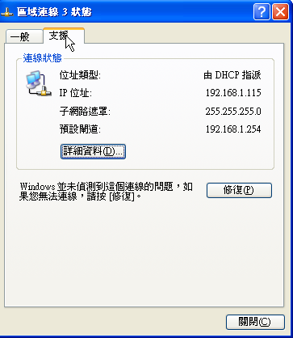

- DNS Cache

“DNS Cache” Dnsmasq can work as a dns cache with the correct configurations.

- Verification
Login DUT via COM port:

        - After the setting at DHCP Server, dnsmasq is already running so dns cache can be used after following setting
cd /etc
vi resolv.conf
nameserver 127.0.0.1
:wq
ifconfig eth2.2 static-IP
route add default gw gateway-ip
check the route and static ip can work

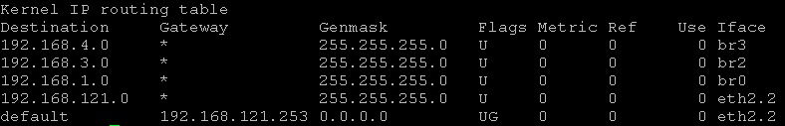

        - Type the following command to send dns query
dns-query www.google.com.tw

        - Disconnect the ether wan and send dns-query again
dns-query www.google.com.tw

Note that cache data only remain in a period time.

- DHCP Relay

“DHCP Relay” DNSMasq provides DHCP relay feature at version 2.75. DHCP relay can forward DHCP requset to remote DHCP server.

  - Verification
Login DUT via COM port:
- Type the following command to add the dhcp relay option to dnsmasq.conf
vi dnsmasq.conf
dhcp-relay=192.168.1.254,DHCP-SERVER-IP
:wq
dnsmasq –-conf-file= /var/run/dnsmasq/dnsmasq.conf --user=root

Login DHCP server via COM port:make IOG761AM_0T001 as DHCP server
- Type the following command to start etherdump to examine the DHCP request packets.
etherdump –i br0 –p udp

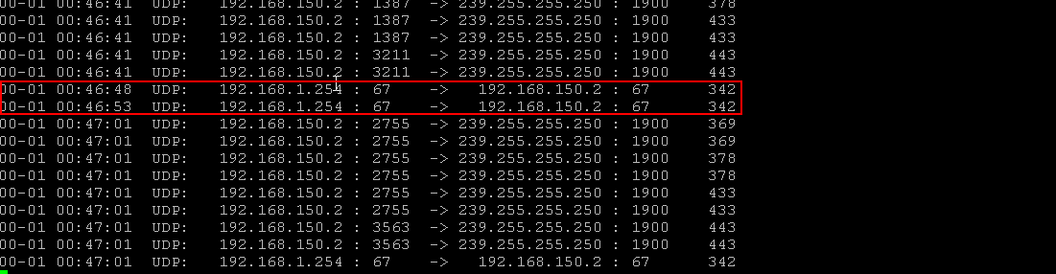

Since the IOG761AM_0T001 do not has the correct configuration for DHCP relay, it won’t reply the relay request. However, the test here is to make sure the DHCP relay feature can work fine.

