|  |  |  |  |  |  |  |  |  |  |  |
| --- | --- | --- | --- | --- | --- | --- | --- | --- | --- | --- |
| \  Security Level:  **Confidential** | | |  | | | | | Document No.: | | |
| **Engineer Test Report**   |  |  | | --- | --- | | **Customer Name** | DIGI | | **Product Name** |  | | **Model Name** | IOG87BDG_0T001 | | **Document Revision** | V0.1 | | **Release Date** |  | | | | | | | | | | | |
|  |  |  | | **Editor** | | **Checker** | | | **Approver** | |
| 文件 |  |  | | Yaya | 2015/10/26 |  |  | |  |  |

# Commitment Page

|  |  |  |  |
| --- | --- | --- | --- |
| **Acquirer** | | | |
| **Stakeholder** | **Name** | **Signature** | **Date** |
|  |  |  |  |
|  |  |  |  |
|  |  |  |  |
|  |  |  |  |
|  |  |  |  |

|  |  |  |  |
| --- | --- | --- | --- |
| **Supplier** | | | |
| **Stakeholder** | **Name** | **Signature** | **Date** |
|  |  |  |  |
|  |  |  |  |
|  |  |  |  |
|  |  |  |  |
|  |  |  |  |

# Revision History

|  |  |  |
| --- | --- | --- |
| **Rev** | **Date** | **Change Description** |
| V0.1 | 2015/10/26 | Init |
| V0.2 | 2015/10/30 | Modify for UCI |
| V0.3 | 2015/11/02 | Modify the test command |
|  |  |  |
|  |  |  |
|  |  |  |

NTPClient Function List

1. Sync time
   1. Verification: OK
2. Sync time

Using NTPClient command to sync the device time with server

* 1. Pre-condiction

You should set the network and ensure the network is ready.

1. Login DUT via COM port:
2. Type the following command to initial the network setting :   
   $cd /home/digi  
   $vi eth.init  
   copy the content in eth.init in attachment and right-click the mouse at console  
   $:wq  
   $sh eth.init

$ifconfig eth2.2 static-IP  
$route add default gw gateway-ip

check the route and static ip can work

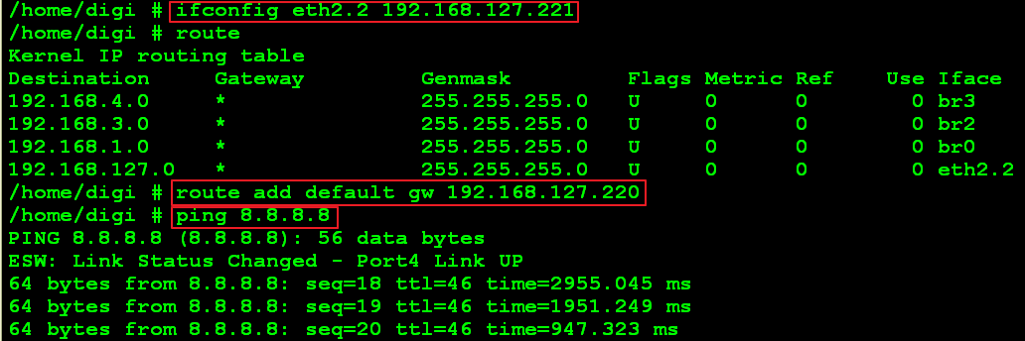

* 1. Run NTPClient

1. Type command to check the time before this test:  
   $date

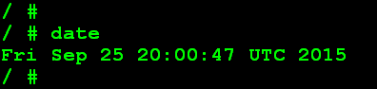

1. Type the following commands,

Move to the uci folder

$./ntpclient_start

You can see the following screenshot:

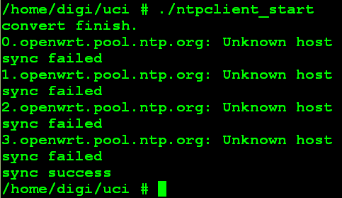

If console shows “sync success”, the device time will change to current time.

1. Type command to check the time now:

$date

Check the current time from worldtimeserver.com

http://www.worldtimeserver.com/current_time_in_UTC.aspx

