Design and Analysis of Algorithms (23CSE211)

LAB ASSIGNMENT - 4

Name: Punamalli Sai Sanath Kumar
Roll No: CH.SC.U4CSE24237
Section: CSE-‘C’

Prims Algorithm:

CODE:
#include <stdio.h>
#include <limits.h>
#define V 5

int findMinKey(int key[], int mst[])
{
int min = INT_MAX;
int minIndex = -1;
int i;

for (i = 0; i < V; i++)
{
if (mst[i] == 0 && key[i] < min)
{
min = key[i];
minIndex = i;
}
}
return minIndex;
}

void primsAlgorithm(int graph[V][V])
{
int parent[V];
int key[V];
int mst[V];
int i, j, u;

for (i = 0; i < V; i++)
{
key[i] = INT_MAX;
mst[i] = 0;
}

key[0] = 0;
parent[0] = -1;

for (i = 0; i < V - 1; i++)
{
u = findMinKey(key, mst);
mst[u] = 1;

for (j = 0; j < V; j++)
{
if (graph[u][j] != 0 && mst[j] == 0 && graph[u][j] < key[j])
{
key[j] = graph[u][j];
parent[j] = u;
}
}
}

printf("Edge \tWeight\n");
for (i = 1; i < V; i++)
{
printf("%d - %d \t%d\n", parent[i], i, graph[i][parent[i]]);
}
}

int main()
{
int graph[V][V] =
{
{0, 2, 0, 6, 0},
{2, 0, 3, 8, 5},
{0, 3, 0, 0, 7},
{6, 8, 0, 0, 9},
{0, 5, 7, 9, 0}
};

primsAlgorithm(graph);

return 0;
}

OUTPUT:
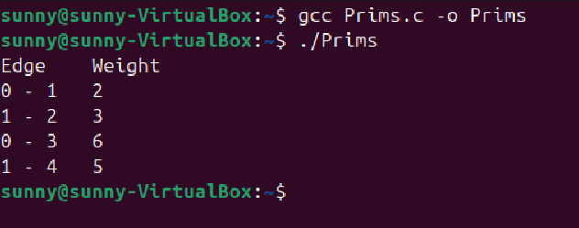

- KRUSKAL’S ALGORITHM:

CODE:
#include <stdio.h>
#include <stdlib.h>

#define V 5
#define E 7

struct Edge
{
int u;
int v;
int weight;
};

int findParent(int parent[], int vertex)
{
if (parent[vertex] == -1)
return vertex;

return findParent(parent, parent[vertex]);
}

void unionSet(int parent[], int x, int y)
{
int xRoot = findParent(parent, x);
int yRoot = findParent(parent, y);

parent[xRoot] = yRoot;
}

int compareEdges(const void *a, const void *b)
{
struct Edge *e1 = (struct Edge *)a;
struct Edge *e2 = (struct Edge *)b;

return e1->weight - e2->weight;
}

void kruskalAlgorithm(struct Edge edges[])
{
int parent[V];
int i;
int totalWeight = 0;

for (i = 0; i < V; i++)
{
parent[i] = -1;
}

qsort(edges, E, sizeof(struct Edge), compareEdges);

printf("Edge \tWeight\n");

for (i = 0; i < E; i++)
{
int u = edges[i].u;
int v = edges[i].v;
int w = edges[i].weight;

int x = findParent(parent, u);
int y = findParent(parent, v);

if (x != y)
{
printf("%d - %d \t%d\n", u, v, w);
totalWeight = totalWeight + w;
unionSet(parent, x, y);
}
}

printf("Total weight of MST: %d\n", totalWeight);
}

int main()
{
struct Edge edges[E] =
{
{0, 1, 2},
{0, 3, 6},
{1, 2, 3},
{1, 4, 5},
{2, 4, 7},
{2, 3, 8},
{3, 4, 9}
};

kruskalAlgorithm(edges);

return 0;
}

OUTPUT:
