Design and Analysis of Algorithms (23CSE211)

LAB ASSIGNMENT - 2

Name: Punamalli Sai Sanath Kumar
Roll No: CH.SC.U4CSE24237
Section: CSE-‘C’

Bubble Sort:-

Code:
#include <stdio.h>
int main() {
int n;
printf("Enter number of elements: ");
scanf("%d", &n);
int a[n];
printf("Enter the elements:\n");
for (int i = 0; i < n; i++) {
scanf("%d", &a[i]);
}
for (int i = 0; i < n - 1; i++) {
for (int j = 0; j < n - i - 1; j++) {
if (a[j] > a[j + 1]) {
int temp = a[j];
a[j] = a[j + 1];
a[j + 1] = temp;
}
}
}
printf("Sorted array: ");
for (int i = 0; i < n; i++) {
printf("%d ", a[i]);
}
return 0;
}
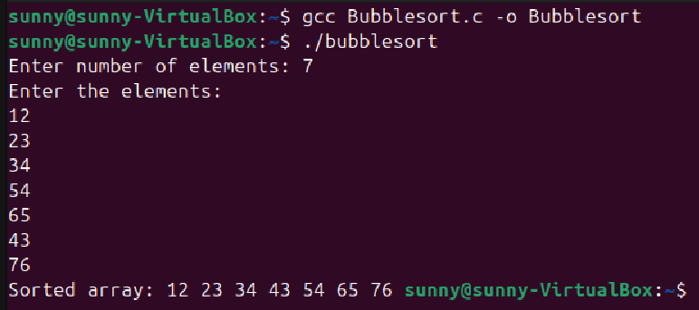

Insertion Sort:-
Code:
#include <stdio.h>
int main() {
int n;
printf("Enter number of elements: ");
scanf("%d", &n);
int a[n];
printf("Enter the elements:\n");
for (int i = 0; i < n; i++) {
scanf("%d", &a[i]);
}
for (int i = 1; i < n; i++) {
int value = a[i];
int j = i - 1;
while (j >= 0 && a[j] > value) {
a[j + 1] = a[j];
j--;
}
a[j + 1] = value;
}
printf("Sorted array: ");
for (int i = 0; i < n; i++) {
printf("%d ", a[i]);
}
return 0;
}

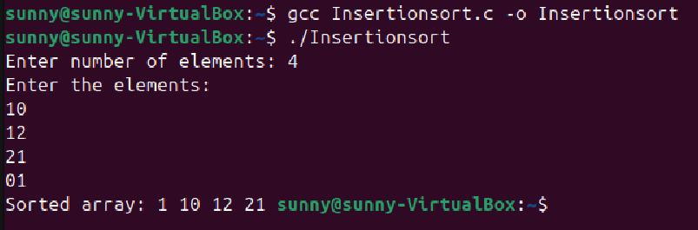

Selection Sort:-

Code:
#include <stdio.h>
int main() {
int n;
printf("Enter number of elements: ");
scanf("%d", &n);
int a[n];
printf("Enter the elements:\n");
for (int i = 0; i < n; i++) {
scanf("%d", &a[i]);
}
for (int i = 0; i < n - 1; i++) {
int minPos = i;
for (int j = i + 1; j < n; j++) {
if (a[j] < a[minPos]) {
minPos = j;
}
}
int temp = a[i];
a[i] = a[minPos];
a[minPos] = temp;
}
printf("Sorted array: ");
for (int i = 0; i < n; i++) {
printf("%d ", a[i]);
}
return 0;
}

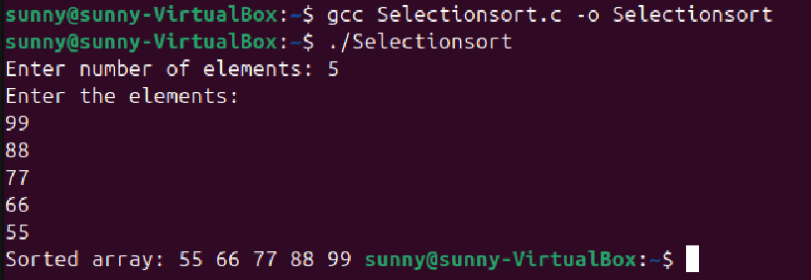

Bucket Sort:-

Code:
#include <stdio.h>
int main() {
int n;
printf("Enter number of elements: ");
scanf("%d", &n);
int a[n];
printf("Enter the values (0 to 100):\n");
for (int i = 0; i < n; i++) {
scanf("%d", &a[i]);
}
int bucket[101] = {0};
for (int i = 0; i < n; i++) {
bucket[a[i]]++;
}
printf("Sorted array: ");
for (int value = 0; value <= 100; value++) {
while (bucket[value] > 0) {
printf("%d ", value);
bucket[value]--;
}
}
return 0;
}

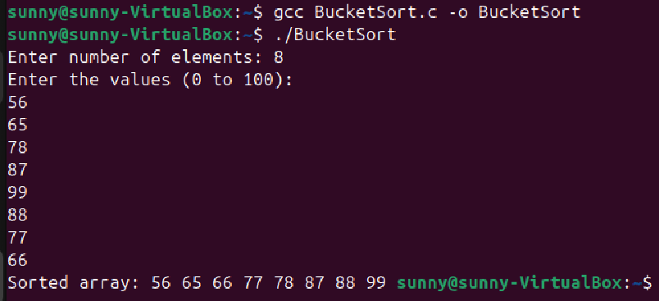

Heap Sort:-

Code:
#include <stdio.h>
int main() {
int n;
printf("ENTER NO. OF ELEMENTS: ");
scanf("%d", &n);
int arr[n];
printf("ENTER THE VALUES: ");
for (int i = 0; i < n; i++) {
scanf("%d", &arr[i]);
}
for (int i = 1; i < n; i++) {
int child = i;
while (child > 0) {
int parent = (child - 1) / 2;
if (arr[child] > arr[parent]) {
int temp = arr[child];
arr[child] = arr[parent];
arr[parent] = temp;
child = parent;
} else {
break;
}
}
}
for (int i = n - 1; i > 0; i--) {
int temp = arr[0];
arr[0] = arr[i];
arr[i] = temp;
int parent = 0;
while (1) {
int left = 2 * parent + 1;
int right = 2 * parent + 2;
int biggest = parent;
if (left < i && arr[left] > arr[biggest])
biggest = left;
if (right < i && arr[right] > arr[biggest])
biggest = right;
if (biggest != parent) {
int t = arr[parent];
arr[parent] = arr[biggest];
arr[biggest] = t;
parent = biggest;
}
else {
break;
}
}
}
printf("Sorted array: ");
for (int i = 0; i < n; i++) {
printf("%d ", arr[i]);
}
return 0;
}

