Design and Analysis of Algorithms (23CSE211)

LAB ASSIGNMENT - 3

Name: Punamalli Sai Sanath Kumar
Roll No: CH.SC.U4CSE24237
Section: CSE-‘C’

BFS:-

Code:
#include <stdio.h>
#define MAX 20
int graph[MAX][MAX];
int visited[MAX];
int queue[MAX];
int front = 0;
int rear = -1;
int n;
void enqueue(int value)
{
rear = rear + 1;
queue[rear] = value;
}
int dequeue()
{
int value;
value = queue[front];
front = front + 1;
return value;
}
void bfs(int start)
{
int current, i;
visited[start] = 1;
enqueue(start);
printf("\nBFS Traversal: ");
while (front <= rear)
{
current = dequeue();
printf("%d ", current + 1);
for (i = 0; i < n; i++)
{
if (graph[current][i] == 1 && visited[i] == 0)
{
visited[i] = 1;
enqueue(i);
}
}
}
printf("\n");
}
void displayMatrix()
{
int i, j;
printf("\nAdjacency Matrix:\n");
for (i = 0; i < n; i++)
{
for (j = 0; j < n; j++)
{
printf("%d ", graph[i][j]);
}
printf("\n");
}
}
int main()
{
int i, j, edge, start;
printf("Enter number of vertices: ");
scanf("%d", &n);
for (i = 0; i < n; i++)
{
visited[i] = 0;
for (j = 0; j < n; j++)
{
graph[i][j] = 0;
}
}
printf("\nEnter edges (1 = Yes, 0 = No):\n");
for (i = 0; i < n; i++)
{
for (j = i + 1; j < n; j++)
{
printf("Is there an edge between %d and %d? ", i + 1, j + 1);
scanf("%d", &edge);
if (edge == 1)
{
graph[i][j] = 1;
graph[j][i] = 1;
}
}
}
displayMatrix();
printf("\nEnter starting vertex: ");
scanf("%d", &start);
bfs(start - 1);
return 0;
}
OUTPUT:

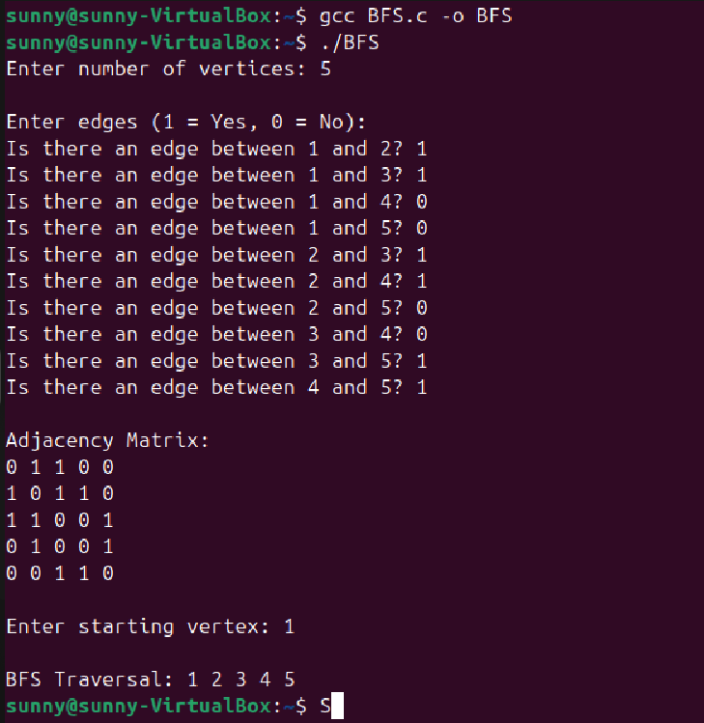

2.DFS:-

Code:
#include <stdio.h>
#define MAX 20
int graph[MAX][MAX];
int visited[MAX];
int n;
void dfs(int node)
{
int i;
visited[node] = 1;
printf("%d ", node + 1);
for (i = 0; i < n; i++)
{
if (graph[node][i] == 1 && visited[i] == 0)
{
dfs(i);
}
}
}
void displayMatrix()
{
int i, j;
printf("\nAdjacency Matrix:\n");
for (i = 0; i < n; i++)
{
for (j = 0; j < n; j++)
{
printf("%d ", graph[i][j]);
}
printf("\n");
}
}
int main()
{
int i, j, edge, start;
printf("Enter number of vertices: ");
scanf("%d", &n);
for (i = 0; i < n; i++)
{
visited[i] = 0;
for (j = 0; j < n; j++)
{
graph[i][j] = 0;
}
}
printf("\nEnter edges (1 = Yes, 0 = No):\n");
for (i = 0; i < n; i++)
{
for (j = i + 1; j < n; j++)
{
printf("Is there an edge between %d and %d? ", i + 1, j + 1);
scanf("%d", &edge);

if (edge == 1)
{
graph[i][j] = 1;
graph[j][i] = 1;
}
}
}
displayMatrix();
printf("\nEnter starting vertex for DFS: ");
scanf("%d", &start);
printf("\nDFS Traversal: ");
dfs(start - 1);
printf("\n");
return 0;
}
OUTPUT:

