Design and Analysis of Algorithms (23CSE211)

LAB ASSIGNMENT - 5

Name: Punamalli Sai Sanath Kumar
Roll No: CH.SC.U4CSE24237
Section: CSE-‘C’
- QUICK SORT:-
CODE:
#include <stdio.h>
#include <stdlib.h>
void swap(int *x, int *y)
{
int temp;
temp = *x;
*x = *y;
*y = temp;
}
int partition(int arr[], int low, int high)
{
int pivot;
int i, j;
pivot = arr[high];
i = low - 1;
for (j = low; j < high; j++)
{
if (arr[j] <= pivot)
{
i = i + 1;
swap(&arr[i], &arr[j]);
}
}
swap(&arr[i + 1], &arr[high]);
return i + 1;
}
void quickSort(int arr[], int low, int high)
{
int pos;
if (low < high)
{
pos = partition(arr, low, high);

quickSort(arr, low, pos - 1);
quickSort(arr, pos + 1, high);
}
}
int main()
{
int n, i;
int *arr;
printf("Enter number of elements: ");
scanf("%d", &n);
arr = (int *)malloc(n * sizeof(int));
printf("Enter elements:\n");
for (i = 0; i < n; i++)
{
scanf("%d", &arr[i]);
}
quickSort(arr, 0, n - 1);
printf("Sorted array:\n");
for (i = 0; i < n; i++)
{
printf("%d ", arr[i]);
}
free(arr);
return 0;
}
OUTPUT:

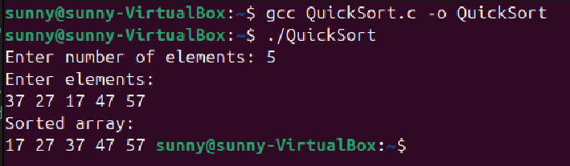

2.MERGE SORT
CODE:
#include <stdio.h>
#include <stdlib.h>
void merge(int arr[], int left, int mid, int right)
{
int i, j, k;
int size;
int *temp;
size = right - left + 1;
temp = (int *)malloc(size * sizeof(int));
i = left;
j = mid + 1;
k = 0;
while (i <= mid && j <= right)
{
if (arr[i] <= arr[j])
{
temp[k] = arr[i];
i++;
}
else
{
temp[k] = arr[j];
j++;
}
k++;
}
while (i <= mid)
{
temp[k] = arr[i];
i++;
k++;
}
while (j <= right)
{
temp[k] = arr[j];
j++;
k++;
}
for (i = left, k = 0; i <= right; i++, k++)
{
arr[i] = temp[k];
}
free(temp);
}
void mergeSort(int arr[], int left, int right)
{
int mid;
if (left < right)
{
mid = (left + right) / 2;

mergeSort(arr, left, mid);
mergeSort(arr, mid + 1, right);

merge(arr, left, mid, right);
}
}
int main()
{
int n, i;
int arr[50];
printf("Enter number of elements: ");
scanf("%d", &n);
printf("Enter elements:\n");
for (i = 0; i < n; i++)
{
scanf("%d", &arr[i]);
}
mergeSort(arr, 0, n - 1);
printf("Sorted array:\n");
for (i = 0; i < n; i++)
{
printf("%d ", arr[i]);
}
return 0;
}
OUTPUT:
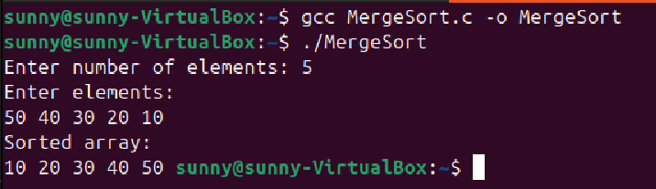
3)BST
CODE:
#include <stdio.h>
#include <stdlib.h>
struct Node
{
int data;
struct Node *left;
struct Node *right;
};
struct Node* createNode(int value)
{
struct Node *temp;
temp = (struct Node *)malloc(sizeof(struct Node));
temp->data = value;
temp->left = NULL;
temp->right = NULL;
return temp;
}
struct Node* insertNode(struct Node *root, int value)
{
if (root == NULL)
{
return createNode(value);
}
if (value < root->data)
{
root->left = insertNode(root->left, value);
}
else if (value > root->data)
{
root->right = insertNode(root->right, value);
}
return root;
}
void inorderTraversal(struct Node *root)
{
if (root != NULL)
{
inorderTraversal(root->left);
printf("%d ", root->data);
inorderTraversal(root->right);
}
}
int main()
{
struct Node *root = NULL;
int n, i, value;
printf("Enter number of nodes: ");
scanf("%d", &n);
printf("Enter the values:\n");
for (i = 0; i < n; i++)
{
scanf("%d", &value);
root = insertNode(root, value);
}
printf("Inorder Traversal of BST:\n");
inorderTraversal(root);
return 0;
}
OUTPUT:

