Design and Analysis of Algorithms (23CSE211)

LAB ASSIGNMENT - 1

Name: Punamalli Sai Sanath Kumar
Roll No: CH.SC.U4CSE24237
Section: CSE-‘C’
1)Write a program to find the sum of first n natural numbers using user-defined function.
Code:
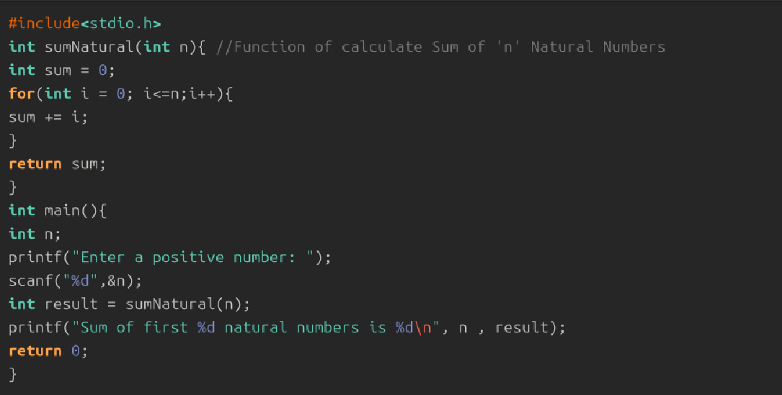
Output:
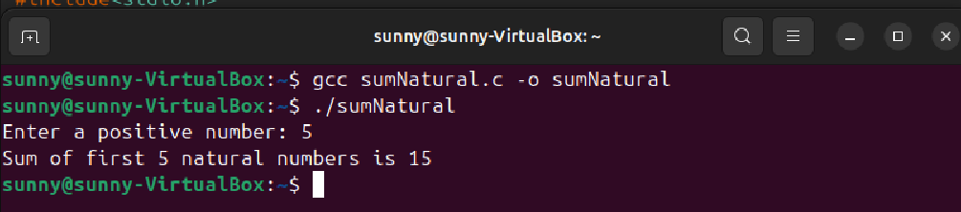

Interpretation:
- In this program, I take an integer n as input from the user.
- Instead of using a loop, I calculate the sum directly using the mathematical formula:
Sum=n*(n+1)/2
- This formula gives the total of the first n natural numbers instantly.
- The program substitutes the input value of n into the formula and evaluates the expression.
- The calculated result is then printed as the sum.
- The output is accurate because the formula is a proven arithmetic progression formula.
- The space complexity of this program is O(1) because it uses only a few fixed variables. The amount of memory needed does not increase with the input size, so the space remains constant.
2) Write a program to find the sum of squares of first n natural numbers using user-defined function.
Code:
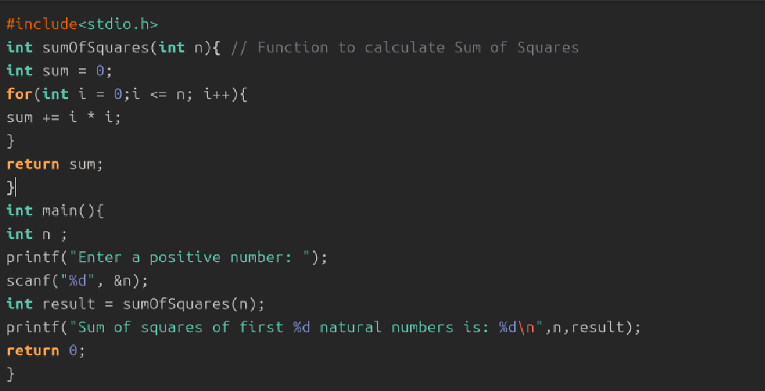
Output:
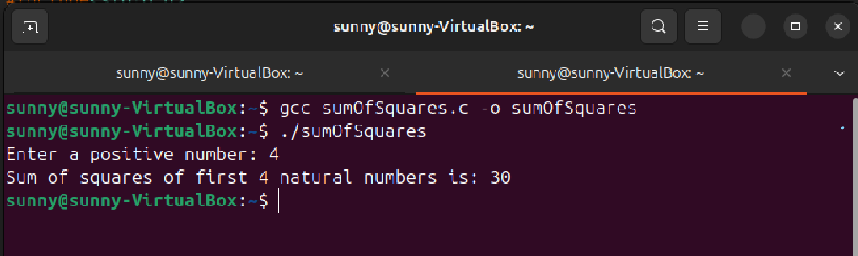
Interpretation:
- The program first takes n from the user.
- Instead of squaring each number manually, I use the formula for the sum of squares: sum= n*(n+1)*(2n+1)/6
- The program plugs the input value into this expression.
- This formula gives the total of the squares directly.
- After calculating the value, the program prints the final result.
- This method is efficient and correct because it avoids loops and uses a standard mathematical formula.
- The space complexity of this program is O(1) because it does not use recursion, arrays, or dynamic memory. It only uses a fixed set of variables, so the memory usage does not increase with n.
3) Write a program to find the sum of cubes of first n natural numbers using user-defined function.
Code:
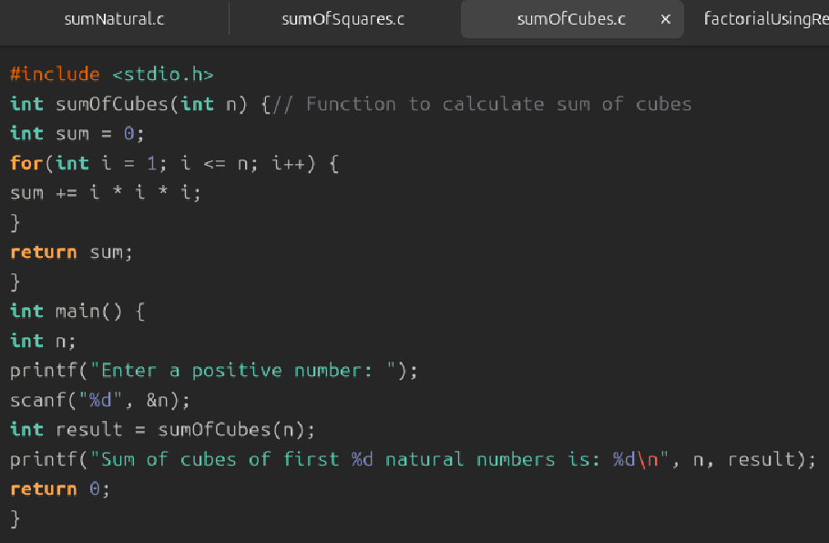
Output:
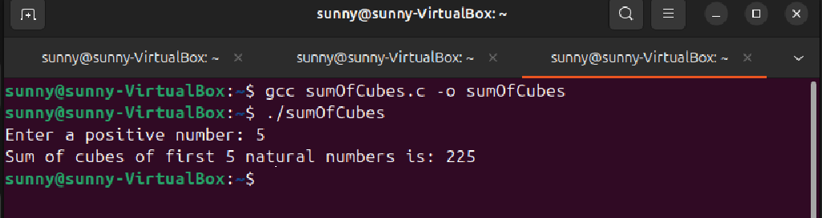
Interpretation:
- The program takes n as user input.
- To compute the sum of cubes, I use the formula:
Sum = (n*(n+1)/2)^2
- The formula states that the sum of cubes is equal to the square of the sum of the first n numbers.
- The program first calculates n(n+1)/2 and then squares the value.
- The final computed result is displayed to the user.
- This formula gives the exact value of 1^3+2^3+…..n^3 without any loops, making the program efficient and correct.
- The space complexity of this program is O(1), meaning constant space. Since it uses no recursion, no arrays, and no dynamic memory allocation, the memory used stays the same regardless of the value of n.
4) Write a program to find factorial of a natural number using recursive function.
Code:
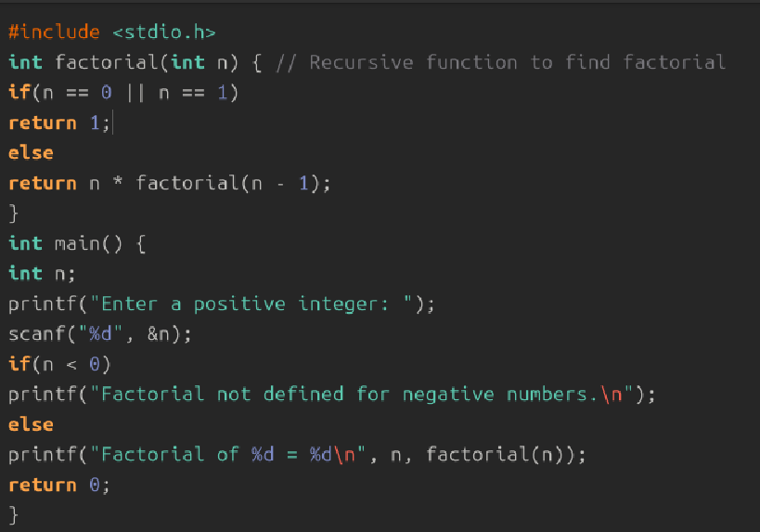
Output:
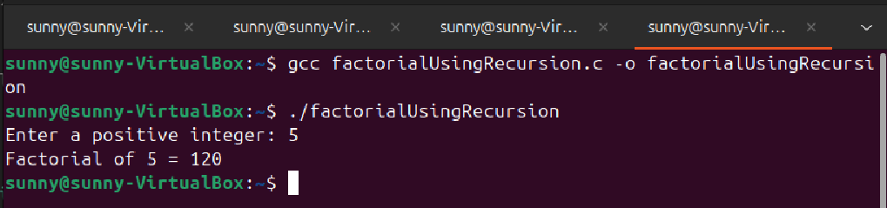
Interpretation:
- In this program, the user is first asked to enter a natural number n.
- The program then calls the recursive function factorial(n) to compute the factorial value.
- Inside the function, a base condition checks whether n is 0 or 1. If true, it returns 1 because $0!=1$and $1!=1$.
- If n is greater than 1, the function calls itself with the value (n - 1) and multiplies the result with n.
- This recursive process continues until it reaches the base case, gradually computing the factorial value.
- Once all recursive calls are completed, the final computed factorial is returned to main() and printed.
- The output correctly represents the factorial of the given number because the recursive formula $n!=n×(n-1)!$is implemented accurately.
- The space complexity of this program is O(n) because the recursive function creates a new stack frame for each call. Even though no arrays or dynamic memory are used, the recursion depth depends on n, so the memory usage grows linearly.

5) write a program to transpose a 3x3 matrix.
Code:
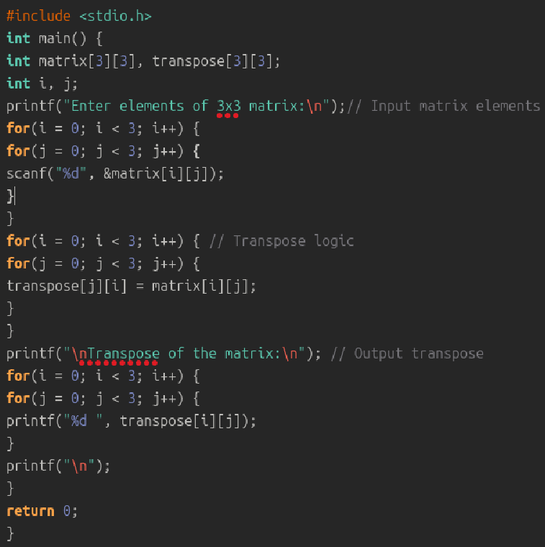

Output:
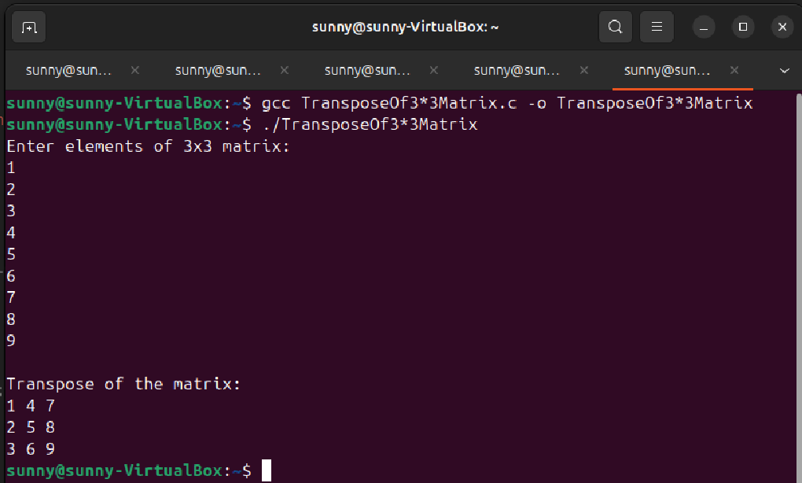

Interpretation:
- In this program, I first take input of a 3×3 matrix from the user.
- A nested loop is used to read all 9 elements into the matrix.
- To find the transpose, the program interchanges rows and columns.
- This is done using the logic: transpose[j][i] = matrix[i][j].
- Another nested loop is used to print the transposed matrix.
- The output shows the matrix with its rows and columns swapped, so the transpose logic is correct.
- The space complexity of this program is O(1) because the memory usage does not increase with the input size. It uses only a fixed amount of space, so the total space stays constant.

6) write a program to print the Fibonacci series upto a given number using user defined function(for first n natural numbers)
Code:
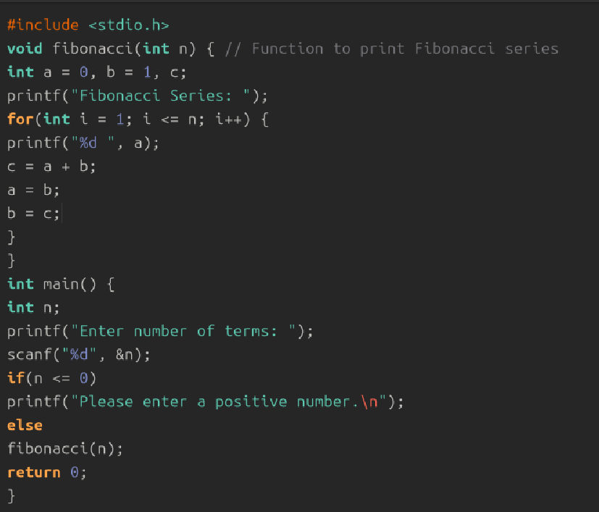
Output:
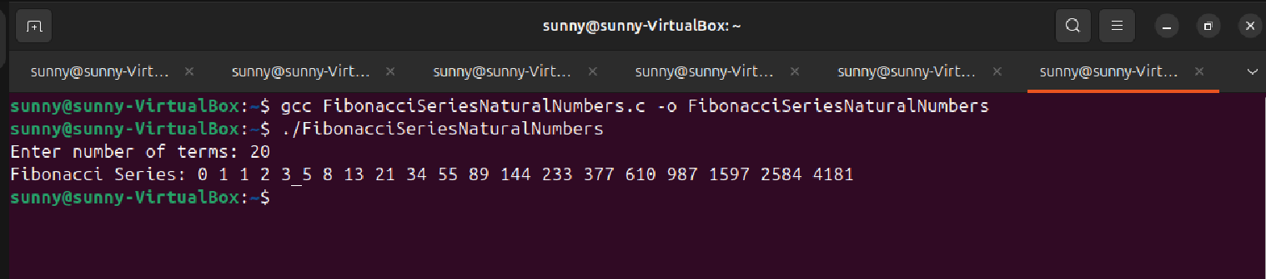

Interpretation:
- The program asks the user to enter a number n.
- It starts with two numbers: 0 and 1 (first two Fibonacci terms).
- Using a loop, it prints each Fibonacci number.
- Each new number is found by adding the previous two numbers.
- The values keep updating to generate the next term.
- The loop stops when the Fibonacci number becomes greater than or equal to n.
- Thus, the program prints the Fibonacci series up to the given limit.
- The space complexity of this program is O(1) because it uses no arrays, no recursion, and no dynamic memory allocation. It only uses a few fixed variables, so the memory needed does not change based on how many Fibonacci terms are printed.

