**Waterfall model:**

To validate Waterfall model, kindly run (load the files and ctrl+r) Waterfall Method.qvw in ClickView.

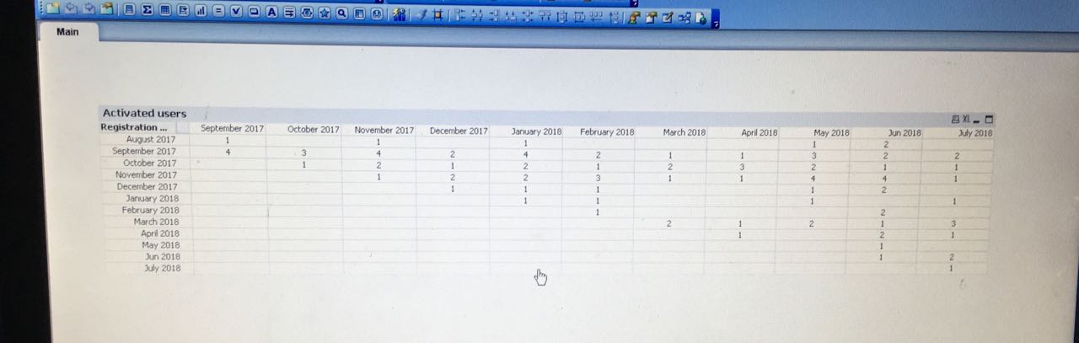

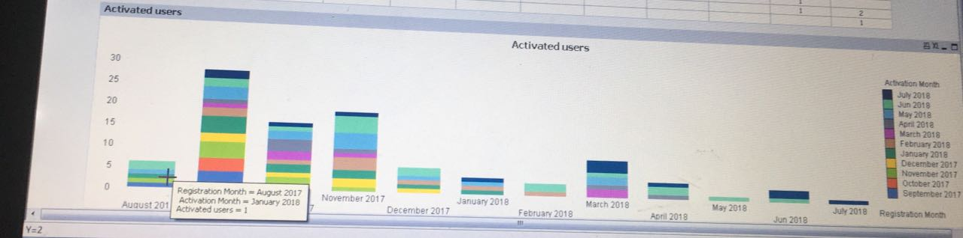

**Market Share Analysis:**

To validate Market Share Analysis, kindly run the code in Final_code.txt and Join_table_code.txt in any IDE (I used IntelliJ). I used Spark to generate the Venn Diagram as there are few limitations with the trial version of Visualization Tool.