**Ease Type**

Ease Type is an online lightweight text-editor with spell checking and auto corrector functionality.

**Features Provided:**

This software works as a text editor. User can even format the text like bold, increasing font size and many more . The main feature is the software can do auto correction and auto complete in a effective and easy way. The software also has user friendly User Interface any level of user can understand how to use.

**Project Files:**

* **Index.html**

The homepage of the website starts with index.html. A screenshot of index.html can be seen below. It uses styles.css as an external CSS file as well as app.js for animations and theme switching between dark and light themes. This page redirects you to a page that contains the EaseType text editor.

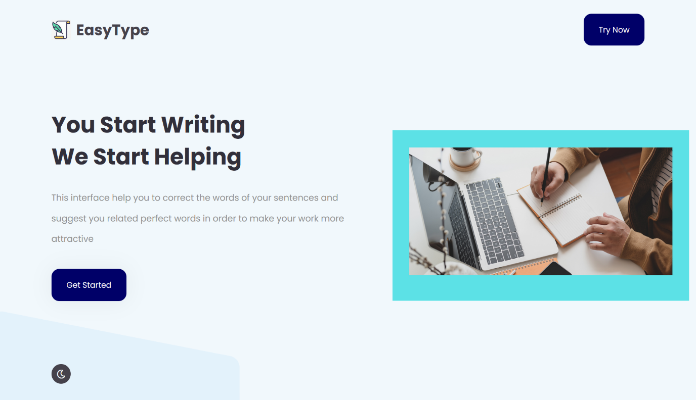

* **Easetype.html**

Easetype.html contains the text editor. A version of quill editor is used here. The format of a user's text can be customized using a quill editor. Algolia uses the space above the text editor for its autocomplete feature.The space below the editor is used by typo-js suggestions where the user gets suggestions of the words incorrect word he selects.

* **Script files** : app.js
* **CSS files**: styles.css, cssfile.css

**Directions To Use:** To use need latest version of any Chromium or Firefox browser and at least a decent internet. As this pure JavaScript, this is completely dependent upon client-side internet and their facilities.

Open easetype.html through file explorer.

Default UI of Ease Type webpage:

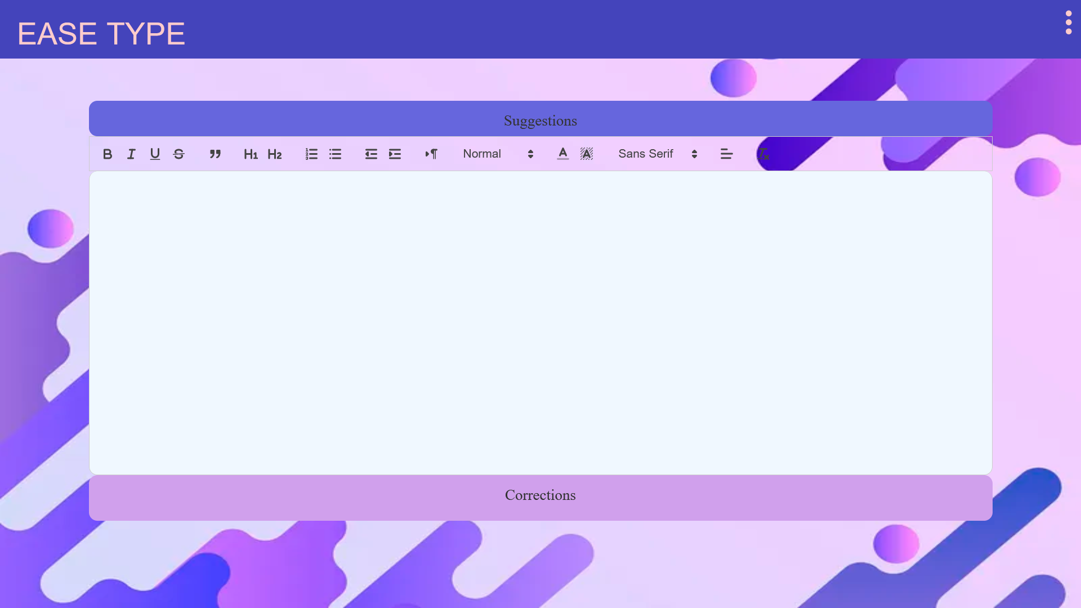

Suggestion box gives you suggestions while typing, you can click on the suggestions or use arrows ↑ and ↓ to navigate through the menu bar.

refer suggestions.gif in zip

Correction box gives you corrections for the wrong words when they are selected by dragging on or by double clicking on the wrong word. You can choose the appropriate word from the correction box below

refer corrections.gif in zip

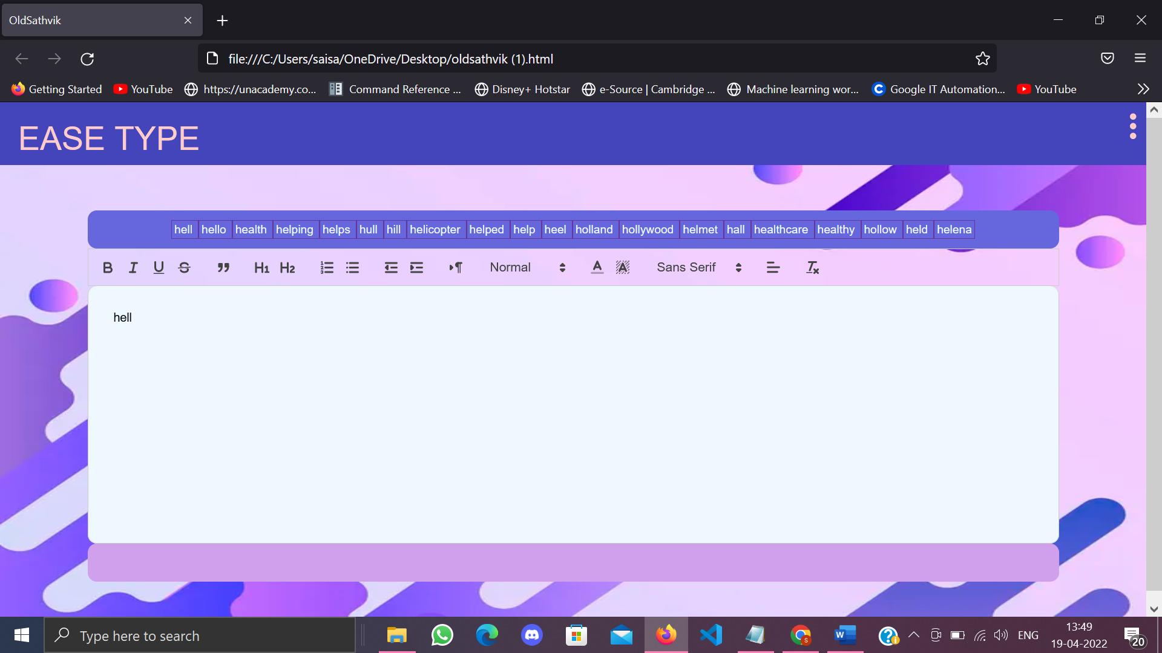

This is the tool bar when a word or a whole string is selected, you can modify it with Bold or Italic or Underline and can be aligned in your preference and size and color with your preferred and suggested font style.

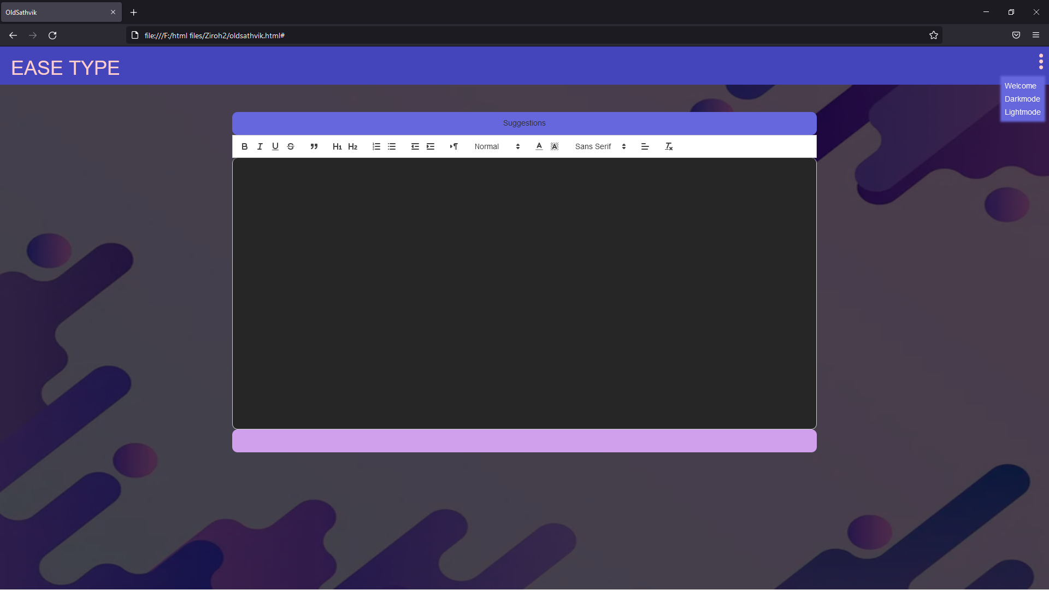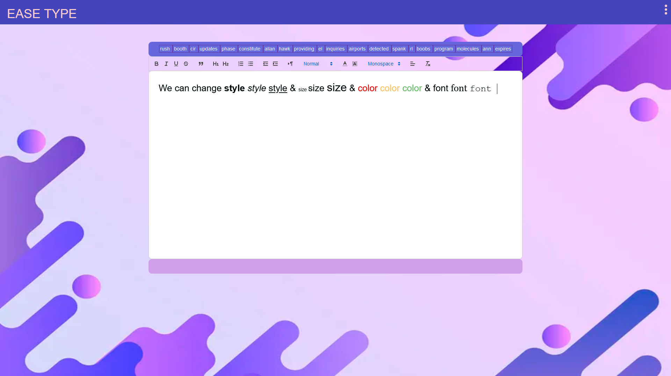

This is a dropdown bar which gives you direction link to welcome page and Dark mode is to darken the UI to make it night time friendly for user. Light mode is to Lighten the UI for most lit environments and for outdoor purposes.

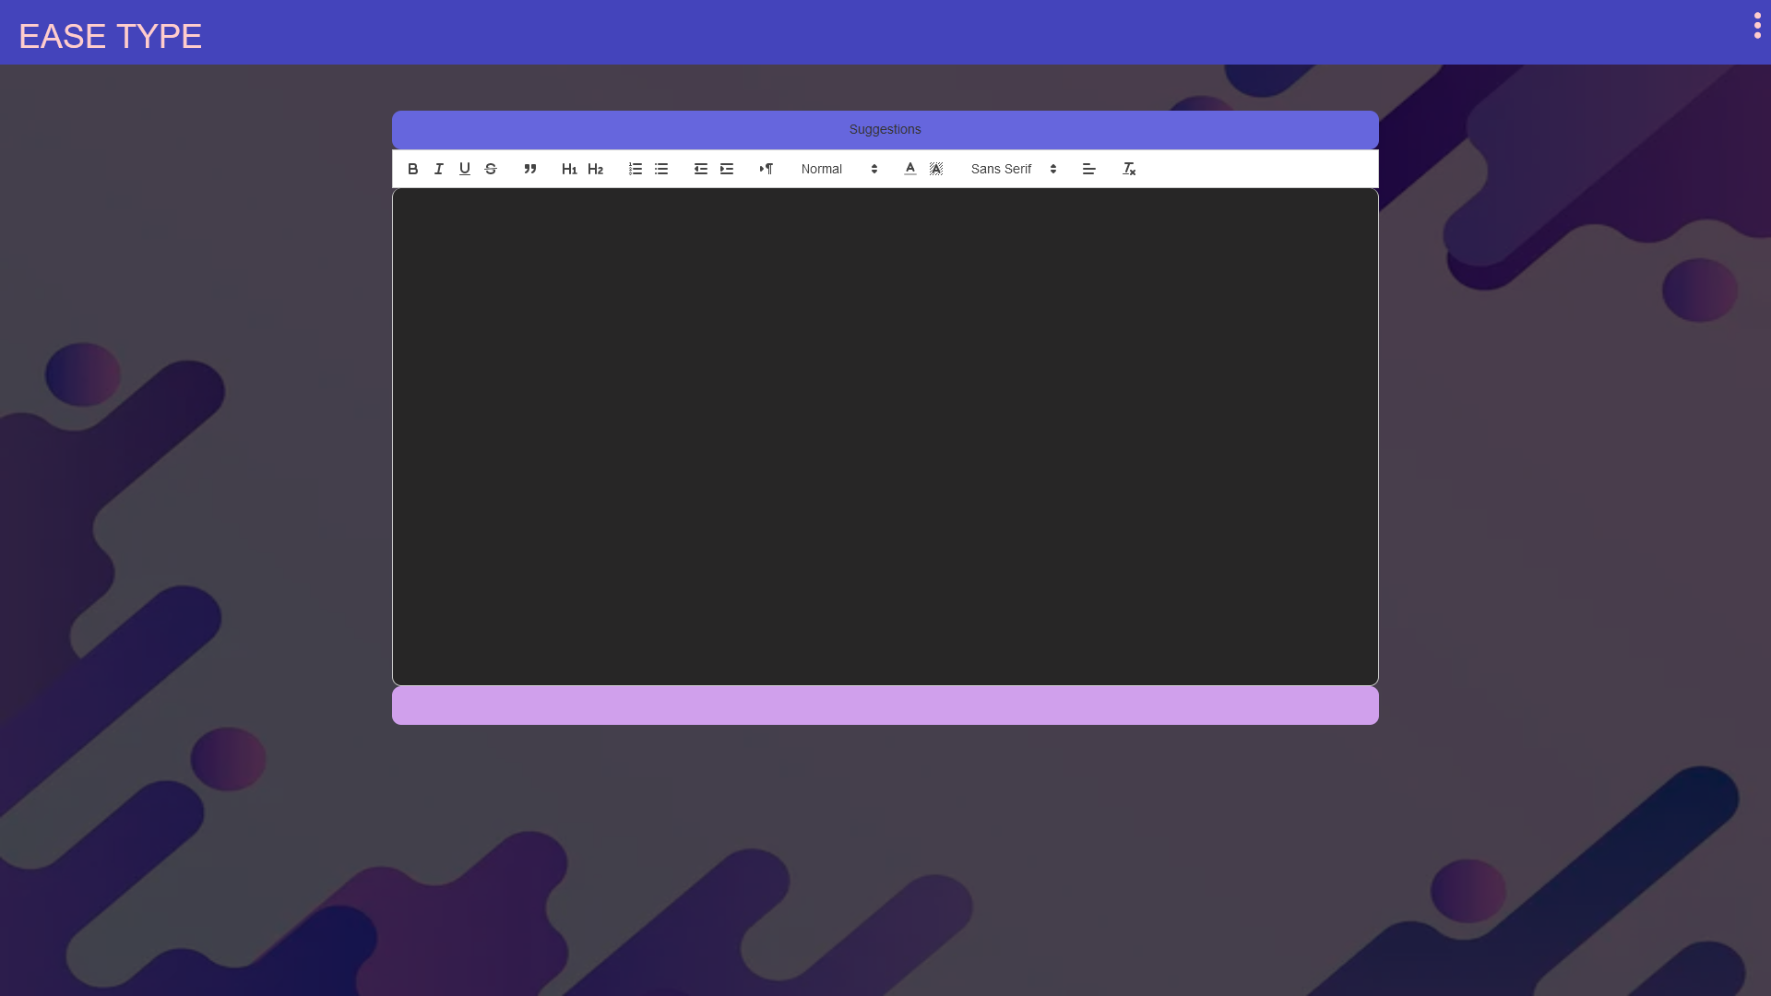

This is the UI at dark mode. Light mode is default UI.

**Demo:**

Go through the video in order to understand more clearly **suggestions.mp4** and **corrections.mp4**

Homepage: index.html

Text editor: easetype.html

**Files required:**

Every file provided in the following zip.

**Tools used:**

Visual studio code

**Team-2**

-Heartful thanks for the Ziroh Labs for proving this wonderful opportunity