PERSONALIZED COURSE SPECIFICATION BASED ON LEARNER SPECIFICATIONS

This project proposes a method to filter the courses that are already present. The main objective of this project is to reduce the time taken for searching a course. A user has to know what they want so that they can select the options in the filter. There are many options that a user can choose from. We can select from price ranges or course ratings or certification providers and so on. In the process of filtration, the web page is dynamically updated every time the user enters new input or edits an existing input. The system’s main process is filtrating the courses list based on user input, it does not recommend any courses on its own. It is the user’s ultimate decision on choosing a course from the list of courses. Our main objective is to reduce the time taken to search for a course and to make sure that you can have quality information.

How to Deploy

* Install and run the XAMPP server from the tools provided on your local computer.
* Place the project folder (Course_Suggestion) in C:\xampp\htdocs.
* Project starts from index.php.

How to use it

* Project starts from index.php.
* Open a web browser and execute by typing the project name including the server name and port number.



* Click the required courses by selecting the requirements from the filtration sections given.

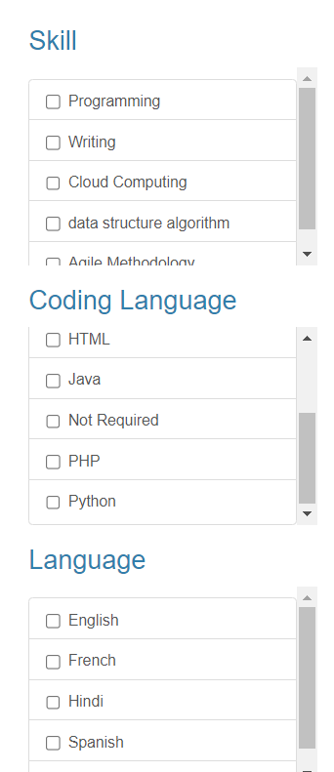

* The user can choose from the following sections:
  + Skill
  + Coding Language
  + Language
  + Level
  + Price Range
  + Duration Range
  + Certification
  + Provider
  + Rating

## The interface gets automatically changes once the options are selected they can be single or multiple.

## 

* Once the user clicks on the particular course, they will be redirected to the respective course website.



* Based on the inputs of the user the webpage gets dynamically updated and the desired results are produced. The time taken to produce the results based on inputs if the user is less than 2 seconds, which makes it a major relief for the people who are confused about selection of courses.
* If the input given by the user forms a pattern then the desired output is produced. The user can select multiple options and can give any information until it makes a pattern. The pattern formed by the input data makes the result.
* If the input data that is given by the user does not form any pattern then the result is produced as “No Data Found”. Make sure that the input given by the user is forming a pattern so that the output is formed.

