Business Case Project

**1. Import the dataset and do usual exploratory analysis steps like checking the structure & characteristics of the dataset.**

**A**. Data type of all columns in the “customers” table.

DESCRIBE

From business_data.customers;

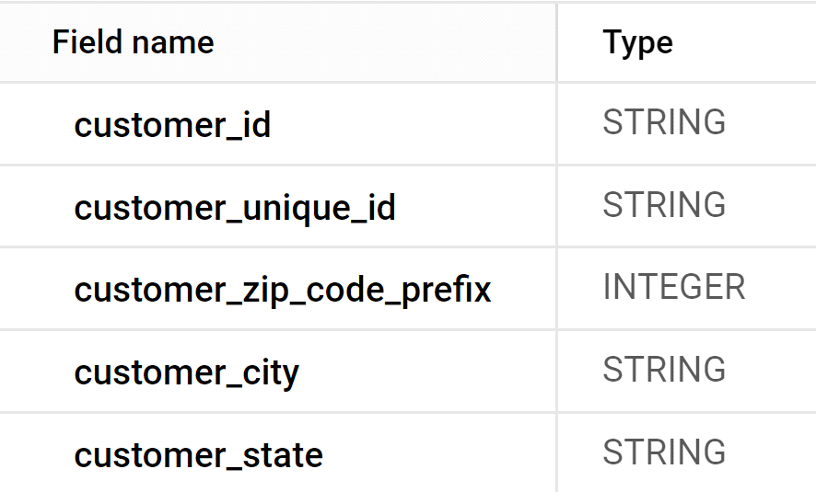

**B**. Get the time range between which the orders were placed.

Select

min (order_purchase_timestamp) as first_order,

max(order_purchase_timestamp) as last_order

From business_data.orders;

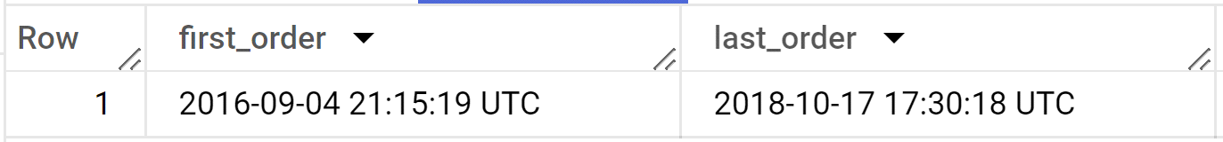

**C**. Count the Cities & States of customers who ordered during the given period.

with demo as (

select * from business_data.orders as o

join business_data.customers as c

on o.customer_id = c.customer_id)

select

count(distinct customer_city) as num_unique_cities,

count(distinct customer_state) as num_unique_states

from demo

where order_purchase_timestamp between "2016-09-04" and "2018-10-17”;

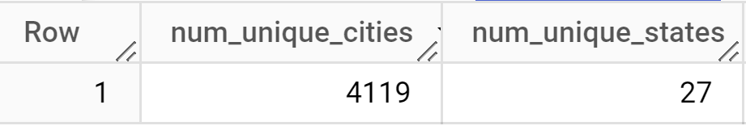

II.In-depth Exploration:

**A.** Is there a growing trend in the no. of orders placed over the past years?

Select

Extract (year from or der_purchase_timestamp) as order_year,

Count(*) as order_count

From business_data.orders

Group by (year from order_purchase_timestamp)

Order by order_year;

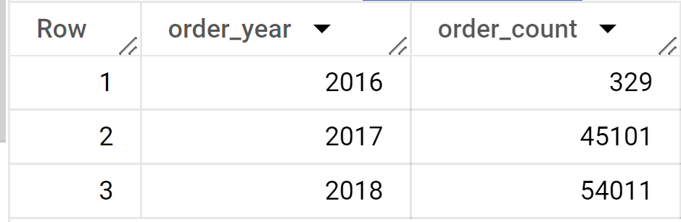

**B**. Can we see some kind of monthly seasonality in terms of the no. of orders being placed?

Select

extract(year from order_purchase_timestamp) as year,

extract(month from order_purchase_timestamp) as month,

count(*) as order_count

from business_data.orders

Group by

extract(year from order_purchase_timestamp),

extract(month from order_purchase_timestamp)

order by year,month;

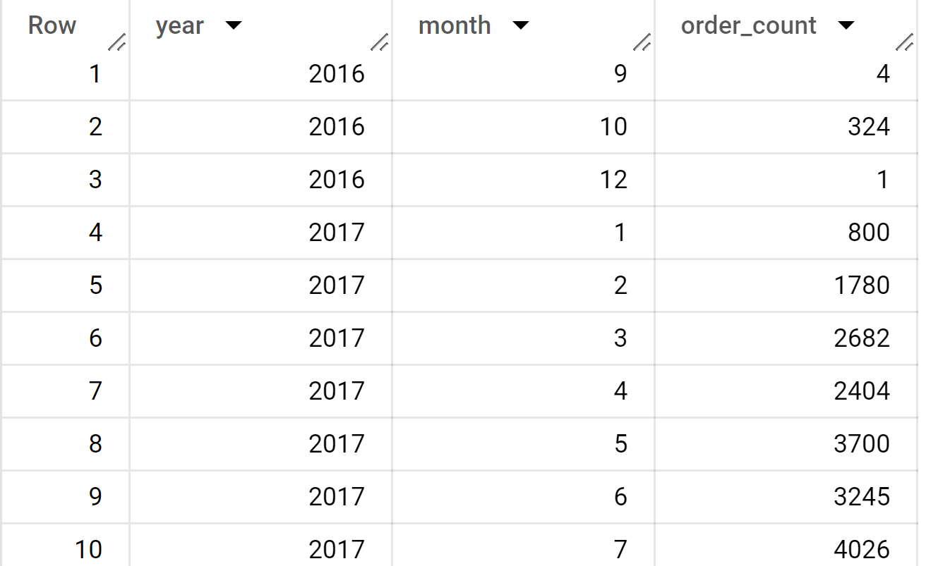

**C**. During what time of the day, do the Brazilian customers mostly place their orders?

(Dawn, Morning, Afternoon or Night)

● 0-6 hrs : Dawn

● 7-12 hrs : Mornings

● 13-18 hrs : Afternoon

● 19-23 hrs : Night.

Select c.customer_city,

case

when extract(hour from order_purchase_timestamp) between 0 and 6 then "dawn"

when extract(hour from order_purchase_timestamp) between 7 and 12 then "morning"

when extract(hour from order_purchase_timestamp) between 13 and 18 then "afternoon"

else "night"

end as order_time_category,

count(*) as order_count

from business_data.orders as o

 join business_data.customers as c

 on o.customer_id = c.customer_id

where c.customer_city = "brasilia"

group by order_time_category,c.customer_city

order by order_count desc;

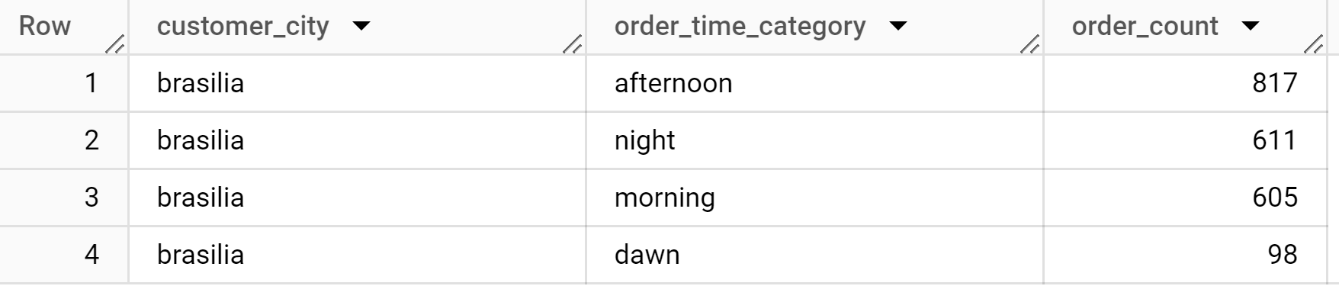

III. Evolution of E-commerce orders in the Brazil region:

**A**.Get the month on month no. of orders placed in each state?

With demo as (

Select *

from business_data.customers as c

Right join business_data.orders as o

On c.customer_id=o.customer_id)

Select extract ( month from order_purchase_timestamp) as month,

customer_state,

count (*)as num_orders

From demo

Group by month,customer_state

Order by month,customer_state;

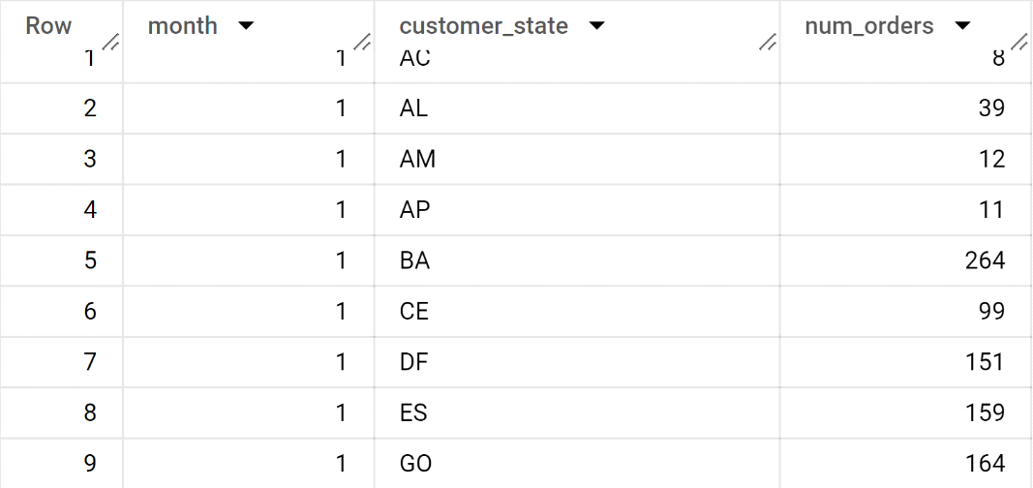

**B**. How are the customers distributed across all the states?

Select Customer_state,count (*)as customer_count

From business_data.customers

Group by customer_state

Order by customer_count desc;

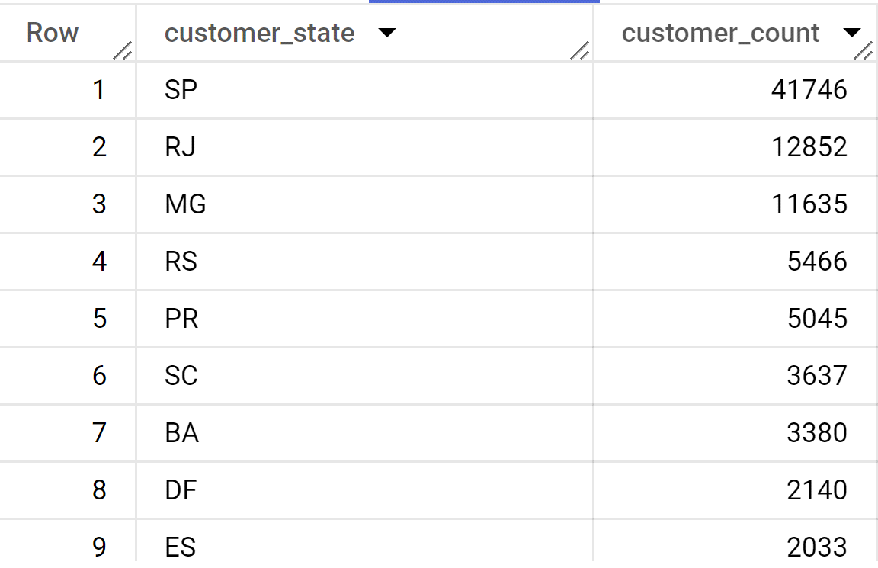

IV.Impact on Economy: Analyze the money movement by e-commerce by looking at order prices, freight and others.

**A**. Calculate the Total & Average value of order price for each state.

Select s.seller_state, sum(price) AS total_order_price,

avg (price)as avg_order_price from business_data.sellers as s

Join business_data.order_items as o

On s.seller_id = o.seller_id

Group by s.seller_state;

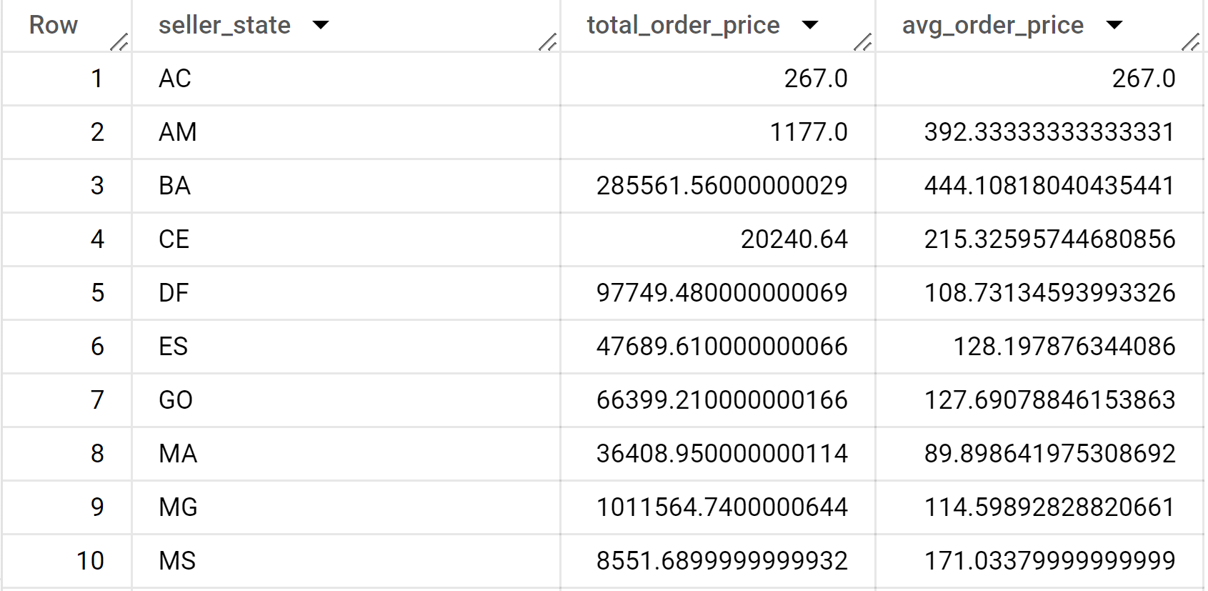

**B**.Calculate the Total & Average value of order freight for each state.

Select s.seller_state,sum(freight_value) as total_order_freight,

avg(freight_value) as avg_order_freight from business_data.order_items as o

join business_data.sellers as s

on o.seller_id = s.seller_id

group by s.seller_state;

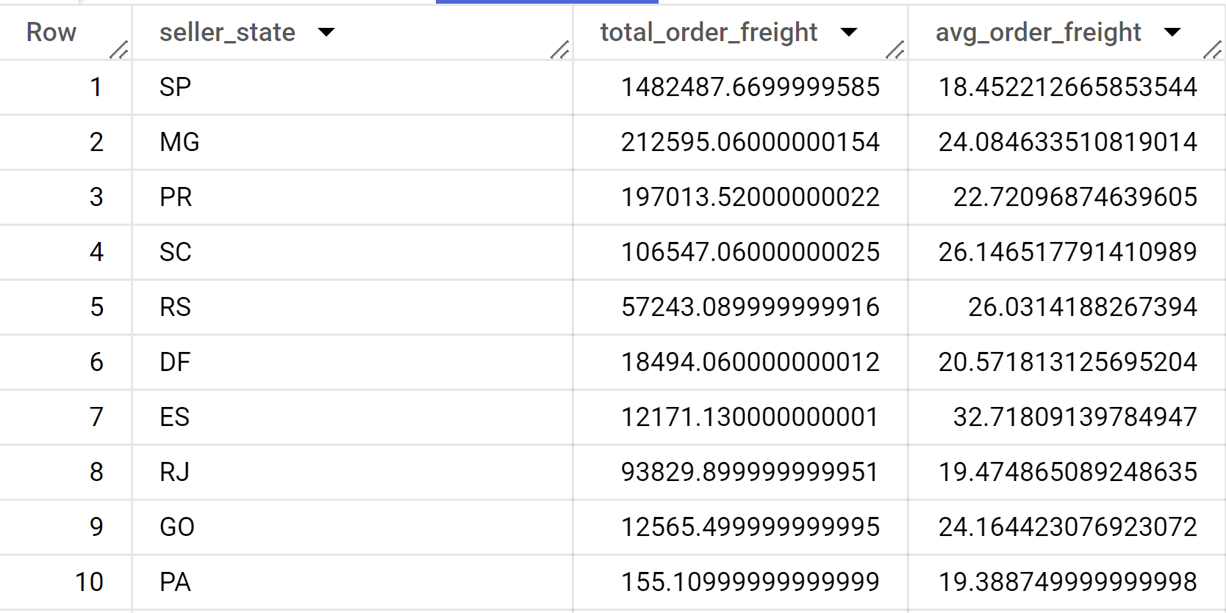

V. Analysis based on sales, freight and delivery time.

**A**.Find the no. of days taken to deliver each order from the order’s purchase date as delivery time. Also, calculate the difference (in days(between the estimated & actual delivery date of an order. Do this in a single query.

Select order_id,

DATE_DIFF(order_delivered_customer_date,order_purchase_timestamp,DAY)as delivery_time,

DATE_DIFF(order_estimated_delivery_date,order_delivered_customer_date,DAY)as diff_estimated_delivery

from business_data.orders;

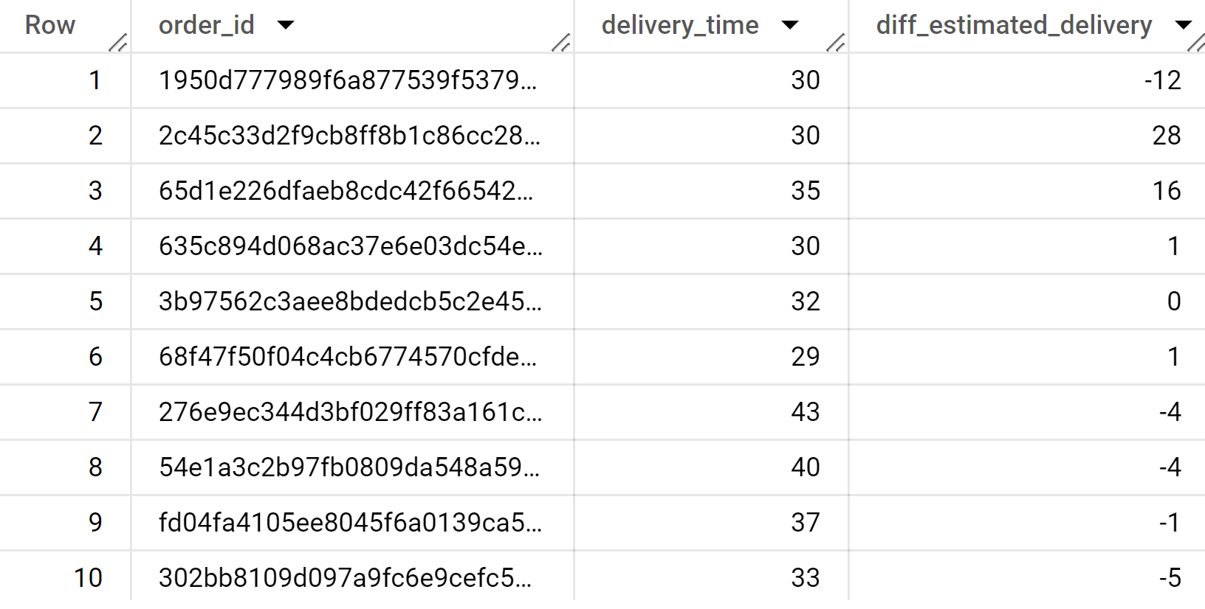

**B**.Find out the top 5 states with the highest & lowest average freight value.

**TOP 5 state highest average freight value**

Select s.seller_state,avg (freight_value) as avg_freight_value

from business_data.order_items as o

full join business_data.sellers as s

 on o.seller_id = s.seller_id

 group by s.seller_state

 order by avg_freight_value desc

 limit 5;

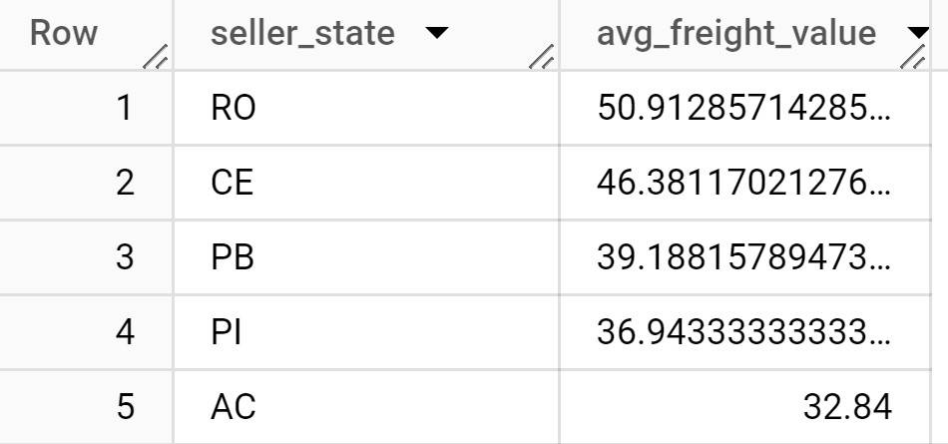

**TOP 5 state lowest average freigh value**

select s.seller_state,avg(freight_value) as avg_freight_value

from business_data.order_items as o

full join business_data.sellers as s

on o.seller_id = s.seller_id

group by s.seller_state

order by avg_freight_value asc

limit 5;

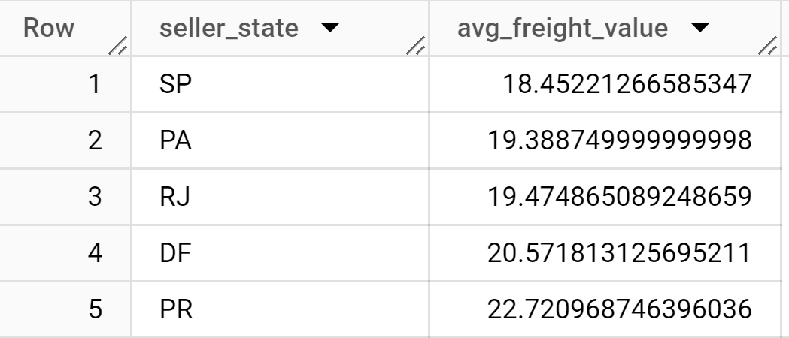

**C**.Find out the top 5 states with the highest & lowest average delivery time.

Top 5 state highest average delivery time

with demo as (

select * from business_data.orders as o

join business_data.customers as c

on o.customer_id = c.customer_id)

select customer_state,round(avg(DATE_DIFF(order_delivered_customer_date,order_purchase_timestamp,HOUR)),2) as avg_delivery_time

from demo

group by customer_state

order by avg_delivery_time asc

limit 5;

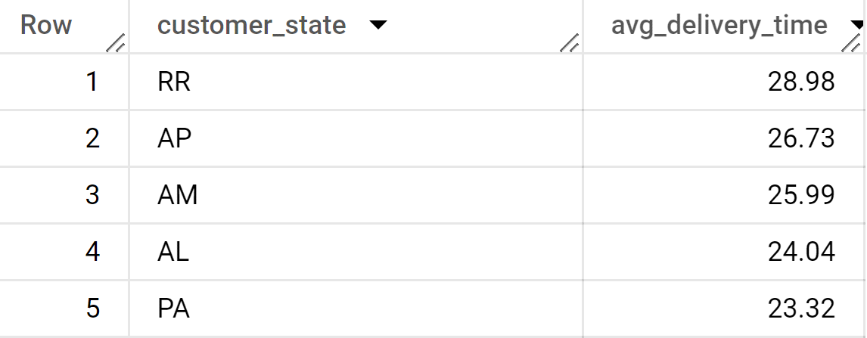

Top 5 state lowest average delivery time

with demo as (

select * from business_data.orders as o

join business_data.customers as c

on o.customer_id = c.customer_id

)

select customer_state,round(avg(DATE_DIFF(order_delivered_customer_date,order_purchase_timestamp,DAY)),2) as avg_delivery_time

from demo

group by customer_state

order by avg_delivery_time desc limit 5;

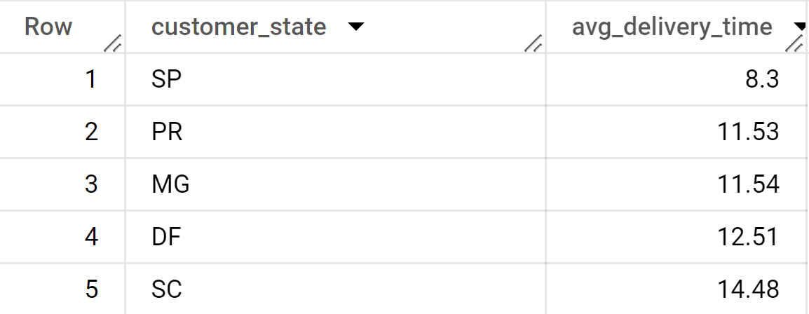

**D**. Find out the top 5 states where the order delivery is really fast as compared to the estimated date of delivery. You can use the difference between the averages of actual & estimated delivery date to figure out how fast the delivery was for each state.

with demo as

(select * from business_data.orders as o

join business_data.customers as c

on o.customer_id = c.customer_id)

select customer_state,

date_diff(order_delivered_customer_date,order_purchase_timestamp,day)-

date_diff(order_estimated_delivery_date,order_purchase_timestamp, day)

as delivery_speed

from demo

where order_status="delivered"

group by customer_state,delivery_speed

order by delivery_speed desc

limit 5;

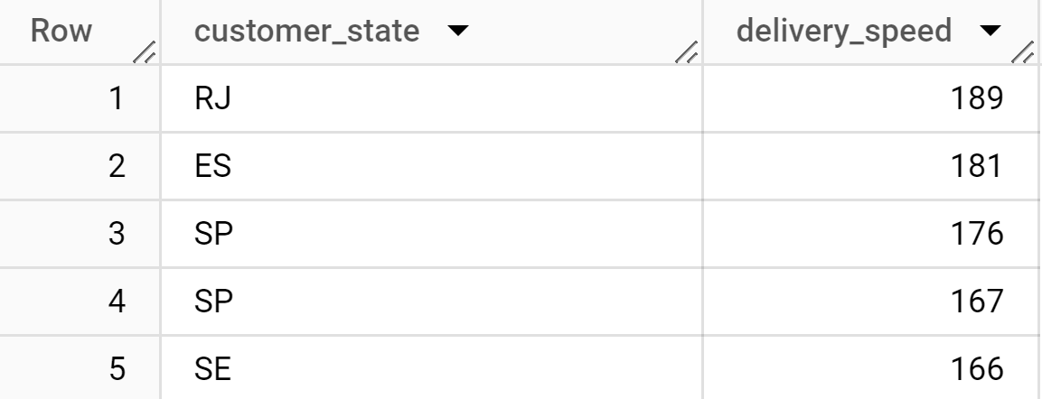

VI. Analysis based on the payments:

**A**.Find the month on month no. of orders placed using different payment types?

select

extract(year from o.order_purchase_timestamp) as year,

extract(month from o.order_purchase_timestamp) as month,

p.payment_type,

count(*) as num_orders

from business_data.orders as o

join business_data.payments as p

on o.order_id = p.order_id

group by year,month,p.payment_type

order by year,month,p.payment_type

limit 10;

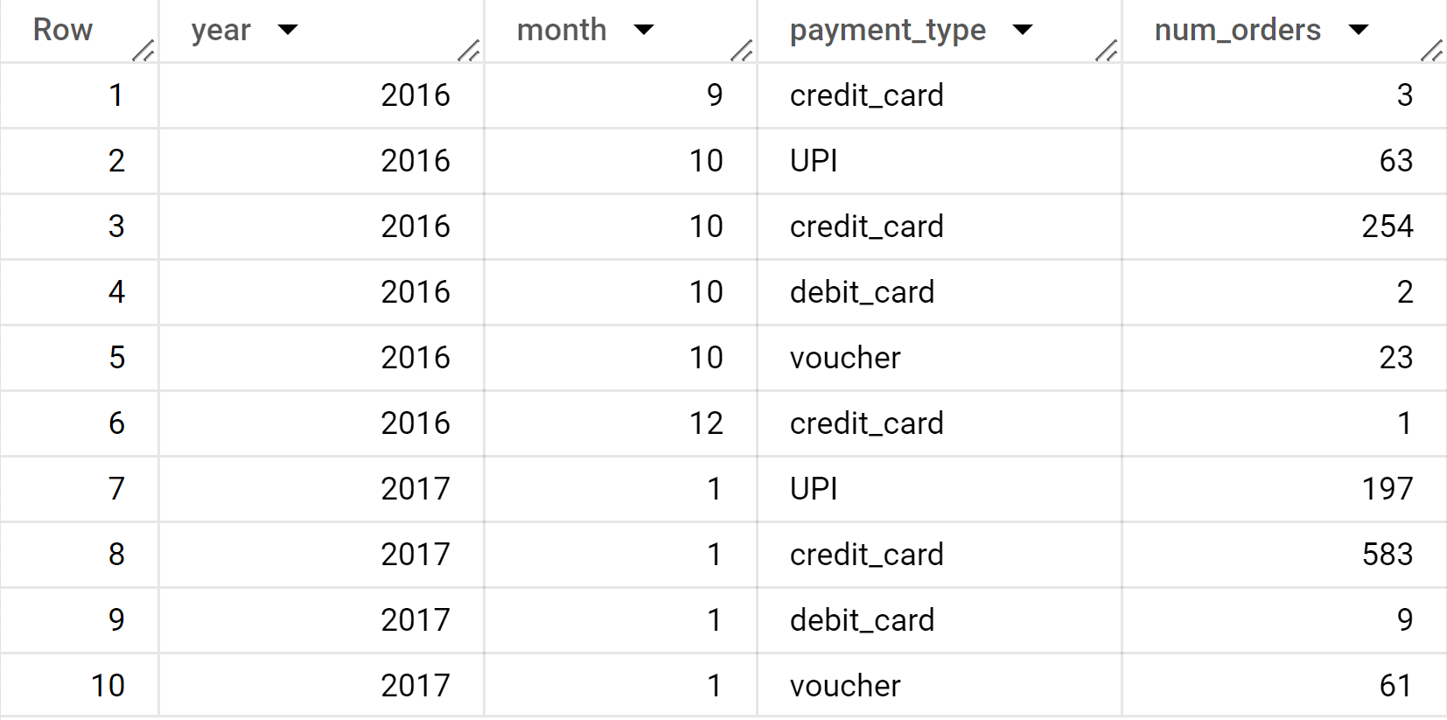

**B**.Find the no. of orders placed on the basis of the payment installments that have been paid.

Select count(distinct order_id) as num_orders

from business_data.payments

where payment_installments =1;

