
PROJECT REPORT ON
MACHINE LEARNING WORKSHOP 2 (CSE2794)

Vehicle Detection Using YOLO11L

Submitted in partial fulfillment of the
requirements for the award of the degree of

BACHELOR OF TECHNOLOGY

Submitted by:
M.SAI SARVAJEET | 24E119C67
AKSHYAT PATTNAIK | 24E116C57
ABINASH NAYAK | 24E114B13
SUBHRANSU DHAR | 24E104B70



Center for Artificial Intelligence & Machine Learning
Department of Computer Science and Engineering
Institute of Technical Education and Research
Sikhsha ‘O’ Anusandhan
(Deemed to be University)
Bhubaneswar
May, 2026

Declaration
We hereby declare that the project report titled “Vehicle Detection Using YOLO11L” is our own work, carried out under the guidance of our project supervisor Mr Gyana Ranjan Patra , Assistant Professor, Center of AI and ML. We have not plagiarized any content and have duly cited all references.

M.SAI SARVAJEET |  | AKSHYAT PATTNAIK
ABINASH NAYAK |  | SUBHRANSU DHAR

Acknowledgement
We would like to express our sincere and heartfelt gratitude to all those who contributed to the successful completion of this project.
We are deeply thankful to our project guide, Dr. Gyana Ranjan Patra, Assistant Professor, Center for Artificial Intelligence and Machine Learning, for his invaluable guidance, constant support, and encouragement throughout the course of this project. His technical expertise and constructive feedback were instrumental in shaping the direction and quality of this work.
We extend our gratitude to the faculty and staff of the Center for Artificial Intelligence and Machine Learning, Department of Computer Science and Engineering, Institute of Technical Education and Research, Siksha 'O' Anusandhan (Deemed to be University), Bhubaneswar, for providing us with the academic environment, infrastructure, and resources necessary to carry out this work.
We also acknowledge Kaggle and iamsandeepprasad for making the Vehicle Data Set publicly available, and Ultralytics for developing and openly releasing the YOLO11L-cls framework that formed the core of our implementation. We are likewise grateful to the open-source communities behind Python, TensorFlow, scikit-learn, NumPy, pandas, Matplotlib, and related libraries, whose tools made this project possible. Special thanks to Kaggle for providing free GPU-accelerated environments, which enabled model training without institutional computing resources.

Table of Contents
Contents
Declaration i
Acknowledgement ii
Table of Contents iii
Abstract iv
Chapter 1 – Introduction 1
1.1. Background and motivation 1
1.2. Problem statement 1
1.3. Objectives 1
1.4. Scope 1
1.5. Organisation of the Report 1
Chapter 2 – Literature Review 2
2.1. Existing methods and models 2
2.2. Comparison with our approach 2
Chapter 3 – System Design and Methodology 3
3.1. Dataset description 3
3.2. Exploratory Data Analysis 3
3.3. Preprocessing steps 3
3.4. Model architecture 3
3.5. Description of the Algorithms 3
Chapter 4 – Implementation Details 4
4.1. Programming languages, frameworks 4
4.2. Code modules description 4
4.3. System Working 4
Chapter 5 – Results and Discussion 5
5.1. Evaluation metrics 5
5.2. Results 5
5.3. Discussion 5
Chapter 6 – Conclusion & Future Work 6
6.1. Summary of outcomes 6
6.2. Limitations 6
6.3. Future improvements 6
References 7
Appendices 8
Additional code snippets 8
Screenshots or logs 8

Abstract
This project presents a vehicle detection system built on the YOLO11L-cls (large) image classification framework developed by Ultralytics. The system is trained on the Vehicle Data Set sourced from Kaggle, which contains images of multiple vehicle classes organized into train and test splits. After scanning the raw dataset, classes with fewer than 60 samples are excluded to ensure reliable per-class evaluation, and the filtered images are reorganized into a standard ImageFolder directory structure compatible with the YOLO classification training engine.
The dataset is split into training (75%), validation (15%), and test (10%) subsets using stratified sampling to preserve class proportions across all partitions. The YOLO11L-cls model is initialized with pretrained weights and fine-tuned for up to 25 epochs using the AdamW optimizer with a cosine learning rate schedule, a warmup phase of 3 epochs, and the first 10 backbone layers kept frozen to preserve low-level feature representations learned during pretraining. Training employs RandAugment-based data augmentation along with HSV color jitter, random horizontal flipping, random scaling, and random erasing to improve robustness and reduce overfitting. Early stopping with a patience of 15 epochs prevents unnecessary training once validation performance plateaus.
Post-training evaluation is performed on the held-out test split using Top-1 and Top-5 accuracy, weighted and macro-averaged precision, recall, and F1-score derived from scikit-learn, a confusion matrix (both raw counts and row-normalized), a per-class precision/recall/F1 bar chart, to examine the relationship between class frequency and model accuracy, and a confidence distribution analysis separating correct from incorrect predictions. The project demonstrates a complete end-to-end machine learning pipeline from raw dataset ingestion and exploratory data analysis through model training, evaluation, and visualisation providing a practical and reproducible foundation for multi-class vehicle classification in intelligent transportation systems.

Chapter 1 – Introduction

Background and motivation
The exponential growth of road traffic in modern cities has made automated vehicle detection and classification a critical research area. Intelligent Transportation Systems (ITS) rely on accurate, real-time recognition of vehicle types to support traffic management, toll automation, surveillance, parking systems, and autonomous driving. Traditional approaches based on handcrafted features such as Histogram of Oriented Gradients (HOG) combined with Support Vector Machines have largely been superseded by deep learning methods that learn hierarchical feature representations directly from image data.
Among deep learning architectures, the YOLO (You Only Look Once) family of models has emerged as a dominant choice for both detection and classification tasks due to its efficient single-pass inference design that delivers high accuracy at low latency. YOLO11, released by Ultralytics as the latest generation of this lineage, offers a dedicated image classification variant (YOLO11-cls) that directly optimizes for class prediction without requiring bounding box annotations, making it well suited for datasets where images contain a single dominant subject. This project is motivated by the practical need to build a robust, end-to-end vehicle detection pipeline using YOLO11L-cls on a labelled multi-class vehicle image dataset, bridging the gap between academic research and deployable solutions.

1.2. Problem statement

Despite the widespread availability of vehicle image datasets, training a classification model that generalises well across multiple vehicle categories remains challenging. Key difficulties include severe class imbalance in real-world datasets, the presence of rare classes with insufficient samples for reliable learning, high visual similarity between related vehicle types, and the computational cost of training large deep networks from scratch. This project addresses these challenges by filtering out classes with fewer than 60 samples to ensure evaluation reliability, applying stratified splitting to maintain class balance across all data partitions, using transfer learning from YOLO11L-cls pretrained weights to reduce training time and improve convergence, and evaluating the resulting model using comprehensive classification metrics including Top-1 and Top-5 accuracy, per-class F1-score, and confusion analysis to provide a thorough performance assessment.

1.3. Objectives

The primary objectives of this project are:
- To scan, analyse, and preprocess a multi-class vehicle image dataset, filtering underrepresented classes and reorganizing images into a YOLO-compatible ImageFolder directory structure.
- To perform exploratory data analysis (EDA) to understand class distribution, image dimensions, aspect ratios, and visual characteristics of the dataset.
- To construct stratified train, validation, and test splits that maintain class proportionality across all subsets.
- To fine-tune a YOLO11L-cls model on the prepared dataset using transfer learning, with the first 10 backbone layers frozen, and to optimize training through AdamW with cosine learning rate scheduling and early stopping.
- To evaluate model performance using Top-1 accuracy, Top-5 accuracy, weighted and macro precision/recall/F1-score, confusion matrices, and confidence distribution analysis, and to visualise per-class metrics and prediction samples.

1.4. Scope
This project is scoped to image-level vehicle detection using a static, labelled dataset. It covers data ingestion, EDA, YOLO dataset preparation, model training, evaluation, and inference visualisation. The system is designed to run on a GPU environment and does not include real-time video stream processing, multi-object tracking across frames, or deployment to an embedded or edge device. The annotation strategy uses image-level class labels, which means the model learns to detect and identify the dominant vehicle category in each image rather than localise multiple vehicles within a scene. The project serves as a complete baseline pipeline that can be extended to finer-grained detection tasks with properly annotated bounding box data.

1.5. Organisation of the Report

This report is organised into six chapters that collectively describe the complete development process of the proposed vehicle detection system using YOLO11L-cls.

Chapter 1 introduces the project by discussing the background and motivation behind automated vehicle detection and its importance in intelligent transportation applications. It defines the problem statement, outlines the primary objectives, specifies the scope, and provides an overview of the report structure.

Chapter 2 presents a literature review of existing approaches used in vehicle detection and image classification, covering classical computer vision techniques as well as modern deep learning frameworks including R-CNN variants, SSD, DETR, and the YOLO architecture lineage. The chapter compares these approaches with the proposed YOLO11L-cls methodology and justifies the model selection.

Chapter 3 describes the complete system design and methodology. It covers the dataset description, EDA findings, preprocessing pipeline, ImageFolder layout construction, model architecture, transfer learning strategy, training hyperparameters, and the algorithms used during training and inference.

Chapter 4 focuses on implementation details, covering the software environment, libraries, and the structure and purpose of each code module in the Kaggle notebook, along with a step-by-step description of the system workflow.

Chapter 5 presents experimental results and performance evaluation using training and validation loss curves, accuracy curves, learning rate schedule, Top-1 and Top-5 test accuracy, weighted and macro classification metrics, confusion matrices, per-class precision/recall/F1 charts, F1-versus-support analysis, confidence distribution plots, and sample prediction visualisations.

Chapter 6 concludes the report by summarising outcomes, identifying limitations of the current implementation, and proposing future improvements including precise bounding box annotation, larger-scale datasets, real-time video support, and deployment to edge devices.

Chapter 2 – Literature Review

2.1. Existing methods and models
Early vehicle detection systems relied on classical computer vision techniques such as background subtraction, frame differencing, and optical flow for video-based detection, combined with classifiers such as SVMs trained on HOG features. While computationally lightweight, these methods suffer from poor generalisation across varying lighting conditions, viewpoints, and occlusions.
The introduction of deep convolutional neural networks transformed vehicle detection and classification. Region-based CNN (R-CNN) and its successors Fast R-CNN and Faster R-CNN proposed two-stage detection pipelines that first generate region proposals and then classify them, achieving high accuracy on benchmark datasets such as PASCAL VOC and MS COCO. However, their inference speed was insufficient for real-time applications, and their two-stage design adds complexity to training and deployment.
Single-stage detectors addressed the speed limitation by formulating detection as a regression problem over a spatial grid, enabling real-time performance. The YOLO series, starting from YOLOv1 and progressing through YOLOv3, YOLOv4, YOLOv5, YOLOv8, and the latest YOLO11, significantly improved multi-scale detection using Feature Pyramid Networks (FPN) and Path Aggregation Networks (PAN). SSD (Single Shot MultiBox Detector) offered another single-stage alternative with multi-scale anchor boxes. More recently, transformer-based detectors such as DETR (Detection Transformer) have demonstrated competitive accuracy without anchor boxes, though at higher computational cost and slower inference compared to YOLO variants.
For the specific task of image-level classification where each image contains a single primary subject dedicated classification architectures such as ResNet, EfficientNet, and MobileNet have been widely applied to vehicle classification problems including make-and-model recognition and broader vehicle-type categorisation. These models are typically fine-tuned from ImageNet-pretrained weights on domain-specific datasets.
YOLO11-cls, the classification variant used in this project, extends the YOLO lineage to pure image classification by replacing the detection head with a classification head, retaining the strong backbone feature extractor while removing the need for bounding box annotations entirely.

2.2. Comparison with our approach
Unlike two-stage detectors that require dedicated region proposal networks and are slower at inference, and unlike traditional HOG+SVM approaches that lack the representational power of deep networks, the proposed system employs YOLO11L-cls a single-pass, classification-only model that processes each image in one forward pass and directly outputs class probabilities.
Compared to fine-tuning a standalone CNN such as ResNet or EfficientNet, the YOLO11-cls framework offers the advantage of seamless integration with the Ultralytics training engine, which provides built-in support for stratified validation, RandAugment data augmentation, cosine learning rate scheduling, early stopping, and comprehensive training metrics logging reducing boilerplate code and improving reproducibility.
The key distinction of this approach versus prior YOLO versions used for classification is the improved backbone architecture of YOLO11, which offers better accuracy at comparable or smaller parameter counts relative to YOLOv8-cls. Relative to transformer-based classifiers (such as Vision Transformers), YOLO11L-cls offers significantly faster inference and lower memory footprint, making it more suitable for GPU-constrained or near-real-time environments.
The primary scope limitation of this approach, compared to full detection systems, is that YOLO11L-cls produces a single class prediction per image and does not localise or enumerate multiple vehicles within a scene. This is appropriate for the current dataset, where each image contains one cropped vehicle, but would need to be extended for scene-level deployment.

Chapter 3 – System Design and Methodology

3.1. Dataset description
The dataset used in this study is the Vehicle Data Set, published on Kaggle by Sandeep Prasad. It is a multi-class vehicle image classification dataset designed for training and evaluating deep learning models on a broad range of vehicle categories, ranging from common road vehicles to specialised transport and atypical entries.
The dataset is hosted at: https://www.kaggle.com/datasets/iamsandeepprasad/vehicle-data-set
Source and Origin
The dataset is a publicly available Kaggle dataset compiled and organised for vehicle classification research. The images appear to be aggregated from a variety of online sources, providing broad visual diversity in terms of camera angle, lighting, background, resolution, and vehicle pose. Because the images originate from heterogeneous sources rather than a single capture session, the dataset reflects the kind of real-world variability that a deployed classifier would need to handle, including different image qualities, photographic styles, and contextual environments. The dataset is provided in a folder-per-class structure, which makes it directly usable with standard image classification training pipelines.
Image Extraction and Annotation
The dataset comes pre-labelled, with each image stored inside a class-named directory. Class labels correspond to the vehicle category visible in the image (for example, Boat, Bus, Car, Helicopter, Motorcycle, Tank, Truck, etc.). No bounding-box annotations are provided, since the dataset is designed for image-level classification rather than object detection. The variety of source materials means that images for the same class can differ substantially in framing, aspect ratio, viewpoint, and lighting, which adds intra-class diversity and increases the difficulty of the classification task.
Because the images are sourced from open online repositories rather than captured in a single privacy-sensitive recording session, the dataset is straightforward to use for research and educational purposes without additional preprocessing. Users should still review the licensing terms on the Kaggle dataset page before redistribution or commercial use.
Size and Class Structure
The raw Kaggle dataset contains approximately 28,045 images distributed across 17 vehicle classes. Each class corresponds to a distinct vehicle category (such as Ambulance, Barge, Bicycle, Boat, Bus, Car, Cart, Caterpillar, Helicopter, Limousine, Motorcycle, Segway, Snowmobile, Tank, Taxi, Truck, and Van). The images are stored in 17 separate folders, each folder named after its respective vehicle category, which makes the structure directly compatible with standard ImageFolder-based training pipelines. Images are provided in common raster formats (primarily JPEG) and vary considerably in native resolution and aspect ratio because they originate from heterogeneous online sources.
The 17 classes are not evenly distributed as is typical with vehicle-classification datasets aggregated from open sources, some categories (such as Boat and Car) are heavily over-represented while others (such as Cart, Limousine, and Snowmobile) have only a few dozen samples. This natural class imbalance is an important factor to account for during model training and evaluation, and motivates the filtering and stratified-splitting strategy described later in this chapter.
Train/Test Split
The dataset comes pre-split into training and testing subsets following an approximately 80/20 ratio. Roughly 22,436 images are allocated to the training set and around 5,609 images form the test set. In this project, the original train and test directories are pooled together, then re-split using stratified sampling into custom train, validation, and test partitions (see Section 3.3), allowing finer-grained control over class balance across all three subsets.

3.2. Exploratory Data Analysis
Exploratory Data Analysis (EDA) is carried out as a foundational step before any preprocessing or model training begins. The goal is to develop a thorough quantitative and qualitative understanding of the dataset its size, structural composition, class distribution, image characteristics, and visual diversity. Insights drawn from EDA directly inform key decisions made in the preprocessing stage, such as the choice of input image resolution for YOLO training and the need to account for class imbalance during stratified splitting.
Dataset Scanning and Inventory
The EDA begins with a complete scan of the dataset directory. A custom scan_dataset() function recursively traverses both the train/ and test/ subdirectories of the dataset root. For each image file encountered (supporting .jpg, .jpeg, and .png extensions), the function records the full file path and extracts the parent folder name as the class label. All records are compiled into a pandas DataFrame with two columns: path and class.
Once the scan is complete, the total image count and the list of unique class labels are printed to provide an immediate high-level overview of the dataset. This reveals that the raw dataset contains approximately 28,045 images spread across 17 distinct vehicle classes, each class corresponding to a specific vehicle category. The class names are derived directly from the original folder structure provided by the dataset author, ensuring that the labels are semantically meaningful and human-readable from the outset.

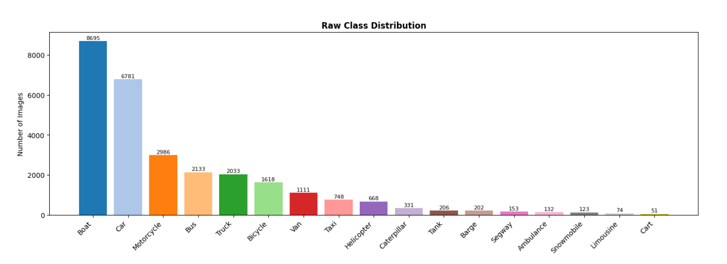
Figure 1: Raw Class Distribution

Class Distribution Analysis
One of the most important aspects of any classification dataset is how images are distributed across the available classes. After building the DataFrame, a per-class image count is computed using df['class'].value_counts() and visualised as a horizontal bar chart sorted in descending order.
This visualization immediately reveals the presence of severe class imbalance a common characteristic of vehicle classification datasets aggregated from open sources, where certain vehicle categories are far more readily available online than others. Some classes contain significantly more samples than others, which has direct implications for model training. Classes with fewer samples are at risk of being underrepresented in the training data, potentially leading to lower classification accuracy for those specific vehicle types. This observation justifies the use of stratified splitting during the preprocessing stage, which ensures that each class is proportionally represented across the train, validation, and test subsets regardless of its total count.
Understanding the class distribution also sets realistic expectations for model performance: well-represented classes are expected to achieve higher per-class precision and recall, while underrepresented classes may show weaker F1-scores in the final evaluation, a pattern confirmed in the classification report discussed in Chapter 5.
Image Dimension Analysis
Since YOLO models require all input images to be resized to a fixed square resolution during training, it is important to understand the range of native image dimensions present in the dataset. A random sample of 300 images is drawn from the full DataFrame, and each image is opened using the PIL (Pillow) library to retrieve its width and height without fully loading pixel data into memory, keeping the operation efficient.
The sampled width and height values are stored in two separate lists and visualised as overlapping histograms using matplotlib. The x-axis represents pixel dimension values and the y-axis shows frequency. This reveals the central tendency and spread of image resolutions across the dataset.
Because the images in this dataset are aggregated from heterogeneous online sources, their native dimensions vary widely. The width distribution in Figure 2 spans from under 500 pixels to over 4,000 pixels, with a mean width of approximately 1,117 pixels. Similarly, the height distribution ranges from under 500 to roughly 3,500 pixels, with a mean of about 769 pixels. The aspect ratio distribution (width/height) is centred around 1.5–2.0 and skewed toward landscape orientations, but a significant minority of images are near-square or portrait-oriented.
This dimension analysis confirms that a fixed input size of 384 × 384 pixels the configured input resolution for YOLO11L-cls in this project is an appropriate choice. It is large enough to preserve meaningful visual detail for most crops while remaining computationally tractable for training on a single GPU. During training, YOLO automatically handles the resizing and letterboxing of images to this fixed size.
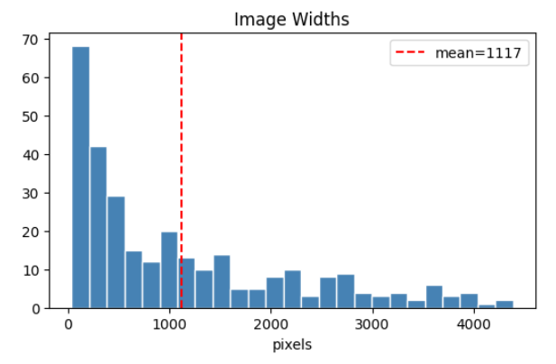
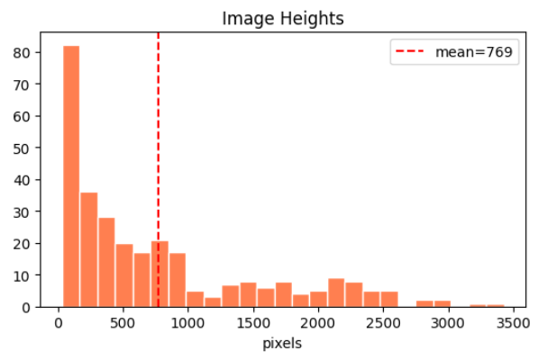

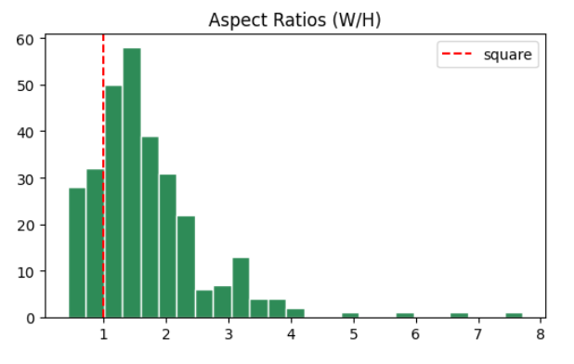
Figure 2: Distribution of Image Widths and Heights and Visualizing Aspect Ratios (W/H)

Visual Sample Inspection
Beyond numerical statistics, a qualitative visual check of the dataset is conducted to assess image quality, label correctness, and the degree of visual diversity within and between classes. A grid of sample images one randomly selected representative per class is displayed using matplotlib. Each subplot is titled with its corresponding class label.
This visual inspection serves several purposes. First, it confirms that the images are correctly labelled the vehicle visible in each image should match its class folder name. Second, it gives an intuitive sense of intraclass diversity: images within the same class can vary substantially in terms of camera angle, distance, lighting conditions, and background environment, all of which the model must learn to handle. Third, it reveals interclass similarity: some vehicle categories with broadly similar body styles or contexts (such as Car versus Taxi, Bus versus Van, or Boat versus Barge) can appear visually similar, which is a key source of classification difficulty.
The visual inspection also confirms that the images are of varied quality and provenance, consistent with the dataset being aggregated from open online sources rather than captured in a single recording session.
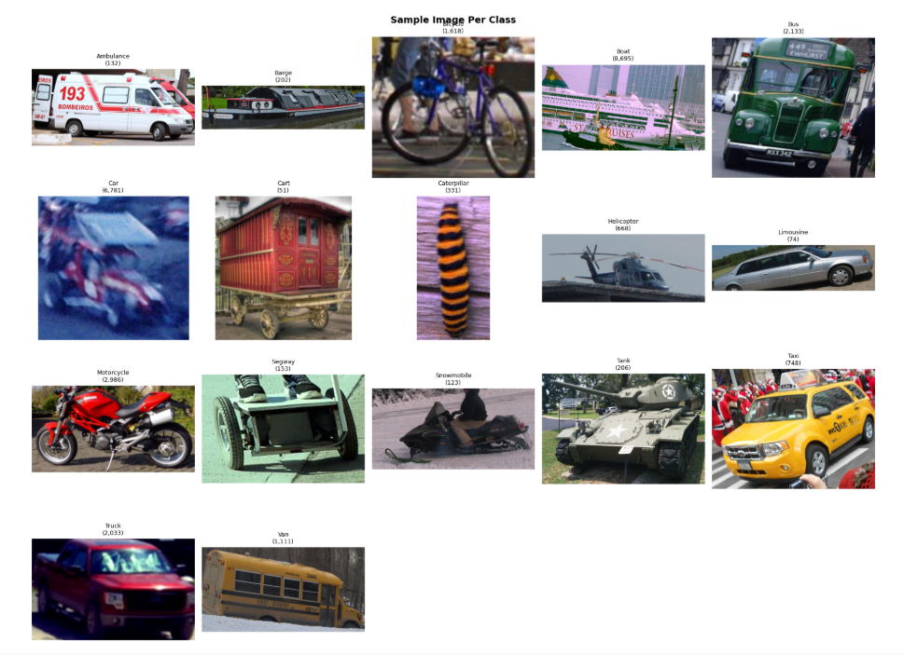
Figure 3: Sample Image Per Class
Summary of EDA Findings
The EDA phase produces the following key insights that directly shape the downstream pipeline design:
The dataset is moderately large at approximately 28,045 raw images and spans 17 vehicle classes, providing diverse coverage of vehicle types. Class imbalance is severe (the largest class, Boat, has over 8,000 samples while the smallest, Cart, has only 51) and must be mitigated through filtering of underrepresented classes and stratified splitting to prevent skewed model evaluation. The native image dimensions vary significantly because the images originate from heterogeneous online sources, but a YOLO input size of 384 × 384 pixels is appropriate for this dataset. Visually, the dataset reflects genuine real-world variability varied lighting, multiple viewpoints, different image qualities, and occasional partial occlusion making it a challenging multi-class classification benchmark. These findings collectively validate the preprocessing strategy described in Section 3.3 and provide the empirical grounding for the modelling decisions discussed in Sections 3.4 and 3.5.

3.3. Preprocessing steps
The preprocessing pipeline transforms the raw, pooled dataset into an ImageFolder directory structure compatible with the YOLO classification training engine. The steps are as follows:
- Class filtering. Classes with fewer than 60 images are removed from the pooled DataFrame. The remaining classes are sorted alphabetically to form a deterministic class list (CLASSES).
- Stratified splitting. The filtered DataFrame is split into train (75%), validation (15%), and test (10%) subsets using scikit-learn's train_test_split applied twice: first to separate the test set, then to divide the remainder into train and validation. The stratify=df['class'] argument and random_state=42 ensure reproducible, class-balanced partitions across all three splits.
- ImageFolder directory creation. A working directory (CLS_DIR) is created fresh at the start of each run. Under it, subdirectories are created following the structure: CLS_DIR/train/<class>/, CLS_DIR/val/<class>/, and CLS_DIR/test/<class>/ for every class in CLASSES.
- Image copying. Each image is copied from its original location to the appropriate split/class subdirectory using shutil.copy. A missing-file safety check skips absent paths without raising an error. If a filename collision is detected, a random integer suffix is appended to the destination filename to avoid overwrites. Progress is tracked with a tqdm progress bar per split.
- No label files required. Unlike a YOLO detection setup, the YOLO classification engine reads class membership directly from the folder name of each image. No separate annotation (.txt) files or YAML configuration are required. The training engine automatically infers the number of classes and their names from the ImageFolder directory structure.

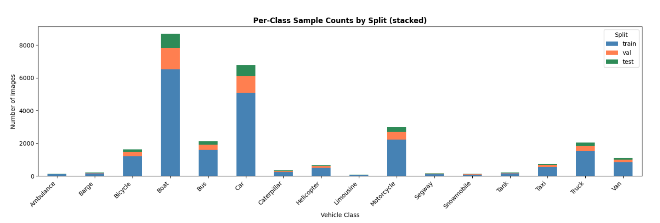
Figure 4: Per-Class Sample Counts by Split (Stacked)

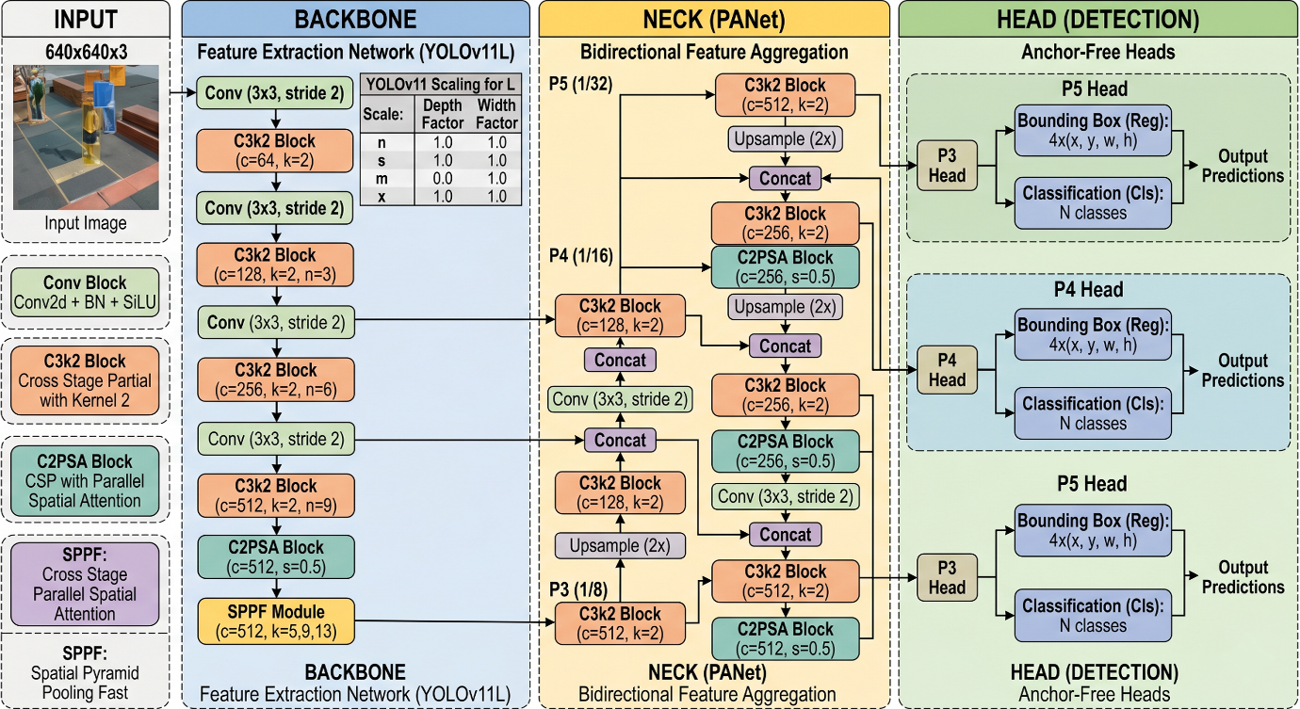
3.4. Model architecture

Figure 5: YOLO11 Architecture Schematic (full detection variant shown; the classification variant used in this project retains only the backbone, with the Neck and Detection Head replaced by a Classify head)
YOLO11L-cls is a large-scale image classification model developed by Ultralytics as part of the YOLO11 model family. It is built on an enhanced CSP (Cross-Stage Partial) backbone that extracts hierarchical feature representations from the input image, followed by a global average pooling operation and a fully connected classification head that maps the pooled features to class logits. The architecture uses C3k2, SPPF (Spatial Pyramid Pooling Fast), and C2PSA (Cross Stage Partial with Spatial Attention) modules within the backbone for multi-scale feature aggregation and attention-enhanced representation, and concludes with a Classify head employing dropout regularisation before the final linear projection.
The model accepts input images resized to a fixed square resolution of 384x384 pixels. Images are automatically resized and letterboxed to this size during both training and inference.
Backbone: The backbone of YOLO11L-cls is an enhanced CSP (Cross-Stage Partial) network responsible for extracting hierarchical feature representations from the input image. It processes images resized to a fixed 384×384 pixel resolution and progressively learns features at increasing levels of abstraction from low-level patterns such as edges, textures, and colours in the early layers, to mid-level shapes and high-level semantic representations in the deeper layers. The backbone incorporates C3k2 modules, which are compact cross-stage partial bottleneck blocks that improve gradient flow and feature reuse while keeping computation efficient. To further enhance multi-scale spatial feature aggregation, an SPPF (Spatial Pyramid Pooling – Fast) module is embedded within the backbone, allowing the network to capture context across different receptive field sizes in a single pass. YOLO11 also introduces the C2PSA (Cross Stage Partial with Spatial Attention) block, which improves the model's ability to focus on the most informative spatial regions of the feature map. During fine-tuning, the first 10 layers of the backbone are frozen, preserving the low-level and mid-level feature detectors learned during large-scale pretraining and preventing catastrophic forgetting on the relatively small vehicle dataset.
Neck: Unlike YOLO detection models which use a dedicated neck component such as a Feature Pyramid Network (FPN) or Path Aggregation Network (PAN) to fuse multi-scale feature maps for localising objects at different sizes YOLO11L-cls does not include a traditional neck. Since this model is a pure image classification variant, there is no requirement to spatially fuse features across multiple scales for bounding box prediction. Instead, the rich multi-scale features already aggregated within the backbone via the SPPF and C2PSA modules are passed directly forward to the classification pathway. The absence of a neck simplifies the architecture and reduces parameter count, making it more computationally efficient and better suited for the image-level classification task where spatial localisation is not needed.
Head: The head of YOLO11L-cls is the final stage of the network responsible for converting the extracted feature representations into class predictions. Following the backbone, a global average pooling operation collapses the spatial feature maps into a compact, fixed-length feature vector, discarding spatial position information and retaining only the overall semantic content of the features. This pooled vector is then passed through a Classify head, which applies dropout regularisation to reduce overfitting before feeding into a fully connected linear projection layer. This final linear layer maps the feature vector to class logits one value per vehicle class and the class with the highest logit is taken as the model's top-1 prediction. The head is the only part of the network trained entirely from scratch on the vehicle dataset, as the pretrained weights it inherited needed to be adapted from the original pretraining classes to the specific set of vehicle categories defined in this project.

Transfer Learning Strategy. The model is initialised from YOLO11L-cls weights pretrained on a large-scale image classification dataset, providing a strong feature representation prior across diverse visual categories. During fine-tuning, the first 10 backbone layers are frozen (freeze=10), meaning their weights are not updated during training. This prevents catastrophic forgetting of low-level and mid-level feature detectors (edges, textures, shapes) learned during pretraining, which are broadly useful regardless of domain. Only the upper backbone layers and the classification head are trained on the vehicle dataset. This strategy is particularly appropriate for the dataset size used, where preserving the pretrained backbone features helps improve convergence and reduce overfitting.
Training Objective. The model is trained with a cross-entropy classification loss. Label smoothing is not applied (cls_pw=1.0 default). The loss is minimised end-to-end across all unfrozen parameters.

3.5. Description of the Algorithms
AdamW Optimiser with Cosine Learning Rate Scheduling: The model is trained using the AdamW optimiser (optimizer='AdamW'), which combines the adaptive moment estimation of Adam with decoupled weight decay regularisation (weight_decay=1e-4). AdamW is well suited for fine-tuning pretrained networks as it handles sparse gradients efficiently and decouples regularisation from the gradient update step. The learning rate begins at lr0=1e-4 and decays following a cosine annealing schedule (cos_lr=True) down to a final value of lrf=0.1 (interpreted as a fraction of the initial rate), with a linear warmup over the first 3 epochs (warmup_epochs=3.0) to avoid large gradient updates at the start of training when the classification head is still being initialized.
Early Stopping: Training monitors the validation accuracy metric and halts automatically if no improvement is observed for 15 consecutive epochs (patience=15), preventing overfitting and unnecessary computation.
Data Augmentation: To increase effective training diversity and reduce overfitting, the following augmentations are applied at training time via the Ultralytics trainer:
- RandAugment (auto_augment='randaugment'): a stochastic policy that randomly selects and applies a sequence of image transformations including geometric and colour operations.
- HSV colour jitter: random hue shift (hsv_h=0.015), saturation change (hsv_s=0.4), and brightness change (hsv_v=0.3).
- Random horizontal flip (fliplr=0.5) with 50% probability.
- Random scale variation (scale=0.5), randomly resizing the image within a factor of 0.5 before padding to the target size.
- Random erasing (erasing=0.25), which randomly masks out a rectangular region of the image during training to improve robustness to occlusion.
RAM Caching: Images are pre-loaded into RAM at the start of training (cache='ram') to eliminate repeated disk I/O during epoch iterations, significantly accelerating training on Kaggle's GPU environment.
Stratified Splitting: scikit-learn’s train_test_split with stratify=df[’class’] ensures that each class is proportionally represented in all three data partitions, mitigating the effect of class imbalance on model training and evaluation. A fixed random seed (SEED=42) is set across Python, NumPy, and TensorFlow for full reproducibility

Chapter 4 – Implementation Details

4.1. Programming languages, frameworks
The entire project is implemented in Python 3 within a Kaggle Jupyter Notebook environment. The following libraries and frameworks are used:
- Ultralytics YOLO11 (ultralytics): provides the YOLO model class, training engine, and prediction interface.
- TensorFlow (tensorflow): used for GPU detection, random seed setting, image loading pipeline (tf.data, tf.image), and cross-validation of classification metrics via tf.keras.metrics.
- Pillow (PIL): used for image dimension sampling during EDA.
- NumPy: numerical operations and random seed setting for reproducibility.
- pandas: tabular data management for the dataset DataFrame.
- Matplotlib and Seaborn: data visualisation for EDA charts and the confusion matrix heatmap.
- scikit-learn: stratified train-test splitting, confusion matrix computation, and classification report generation.
- tqdm: progress bars for dataset copying loops.
- TensorFlow random seed (tf.random.set_seed) is used for global reproducibility within the TF data pipeline.
Training is accelerated by a Kaggle-provided NVIDIA GPU (device=0), and random seeds are fixed at SEED=42 across Python, NumPy, TensorFlow (tf.random.set_seed), and the Ultralytics trainer for full reproducibility.

4.2. Code modules description
scan_dataset(base_dir): Recursively iterates over the train/ and test/ subdirectories within base_dir. For each image file found (supporting .jpg, .jpeg, and .png extensions), it records the full file path and the parent directory name as the class label, returning a pandas DataFrame with columns path and class.
Class filtering block: Computes per-class image counts, identifies classes below the MIN_SAMPLES=60 threshold, removes them from the DataFrame, and prints the excluded classes and their counts for transparency.
Stratified split block: Applies scikit-learn's train_test_split twice first to separate the test fraction, then to divide the remainder into train and validation using stratify=df['class'] and random_state=SEED to produce reproducible, class-balanced splits at 75/15/10 ratio.
EDA visualisation blocks: Produce four visualisations saved to disk: a raw class distribution bar chart (eda_raw_distribution.png), image dimension and aspect ratio histograms (eda_dimensions.png), a one-sample-per-class image grid (eda_sample_images.png), and a stacked bar chart of per-class counts across splits (eda_split_distribution.png).
ImageFolder construction block: Creates the CLS_DIR directory tree, copies images to their respective split/class subdirectories using shutil.copy with tqdm progress tracking, and handles filename collisions by appending a random integer suffix.
Model summary block: Instantiates YOLO('yolo11l-cls.pt') and calls model.info(verbose=False) to print the architecture summary. Total parameter counts are computed by iterating over model.model.parameters() using np.prod on each weight shape.
Training block: Calls model.train() with the CLS_DIR data path, training hyperparameters (epochs=25, imgsz=384, batch=24, patience=15, freeze=10, optimizer='AdamW', lr0=1e-4, lrf=0.1, cos_lr=True, warmup_epochs=3.0, weight_decay=1e-4, dropout=0.1, auto_augment='randaugment', hsv_h=0.015, hsv_s=0.4, hsv_v=0.3, fliplr=0.5, scale=0.5, erasing=0.25), cache='ram', and seed=SEED. Training artefacts including model weights (best.pt, last.pt) and a results CSV are saved to /kaggle/working/runs/cls_yolo11L/.
Training curves block: Reads results.csv into a DataFrame and produces a three-panel figure showing training and validation cross-entropy loss, Top-1 and Top-5 validation accuracy, and the learning rate schedule over epochs (results_training_curves.png). Final train/val loss values and the gap between them are printed as an overfitting diagnostic.
Validation block: Loads best.pt and calls best.val() on the validation split to report the best-checkpoint Top-1 and Top-5 validation accuracy.
Test inference block: Iterates over all test images in batches of size BATCH=24 using best.predict(), collecting the top-1 predicted class name, its confidence score, and the top-5 predicted class names for each image. True labels, predicted labels, and confidence scores are accumulated in parallel lists.
Metrics computation block: Computes Top-1 accuracy, Top-5 accuracy, weighted precision/recall/F1, and macro precision/recall/F1 using scikit-learn. Mean confidence is reported separately for correct and incorrect predictions. A TensorFlow SparseCategoricalAccuracy metric is additionally computed as a cross-check of the sklearn result. All metrics are displayed as a formatted DataFrame.
Confusion matrix block: Generates both a raw-count confusion matrix heatmap (results_confusion_matrix.png) and a row-normalised confusion matrix (recall per class) heatmap (results_confusion_matrix_normalized.png) using seaborn.
Per-class metrics block: Produces a grouped bar chart of per-class precision, recall, and F1-score with reference lines at 90% and 95% (results_per_class_metrics.png), and saves the full scikit-learn classification report as a CSV (results_classification_report.csv).
F1 vs. Support scatter plot: Plots each class's F1-score against its test set support (number of images), with class labels annotated, to examine whether model performance correlates with class sample size (results_f1_vs_support.png).
Confidence distribution block: Plots overlapping histograms of prediction confidence for correctly classified and incorrectly classified images to assess model calibration (results_confidence_distribution.png).
Sample predictions block: Displays a 2×3 grid of sample test images three correctly classified and three incorrectly classified with true label, predicted label, and confidence score overlaid in green (correct) or red (incorrect) (results_sample_predictions.png).
Top confused class pairs block: Computes and prints the top 8 off-diagonal confusion matrix entries, identifying the class pairs most frequently misclassified by the model.
Run summary block: Prints a consolidated summary of the model, dataset counts, training outcome, and final test metrics, followed by a list of all saved output files.

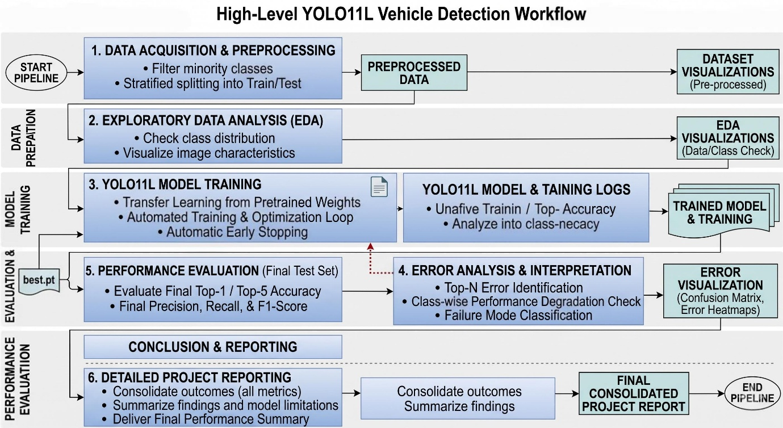
Figure 6: Code Pipeline Flow

4.3. System Working
The system operates as a sequential pipeline executed cell-by-cell in the Kaggle notebook environment. In the data ingestion stage, scan_dataset() scans the Kaggle input directory and builds a unified DataFrame of all image paths and class labels across both original splits. During EDA, statistical summaries and visualisations are generated to characterise the dataset.
In the preparation stage, the DataFrame is split, images are copied to the YOLO working directory, and the ImageFolder structure is created. No YAML configuration file is required, as the YOLO classification engine reads class membership directly from folder names. In the training stage, the Ultralytics training engine reads the ImageFolder directory, loads the pretrained YOLO11L-cls backbone, and trains the model for up to 25 epochs on the GPU, producing training artefacts (weights and metrics CSV) in the runs/cls_yolo11L/ directory.
In the evaluation stage, training metrics are read from the results CSV and plotted. The best model weights (best.pt) are loaded for inference. Predictions are run on the test split in batches; class labels and confidence scores are recorded per image. A TensorFlow tf.data pipeline is also constructed for the test set using tf.io.read_file, tf.image.decode_jpeg, and tf.image.resize. Finally, the full test set is evaluated using both sklearn metrics and a TensorFlow SparseCategoricalAccuracy cross-check to generate confusion matrices, a classification report, and a comprehensive picture of per-class model performance.

Chapter 5 – Results and Discussion

5.1. Evaluation metrics
A comprehensive set of evaluation metrics is used to assess model performance from a classification perspective. Each metric captures a different dimension of model behaviour, and together they provide a complete picture of how well the trained YOLO11L-cls model generalises to unseen data.
Top-1 Accuracy is the primary detection metric. It measures the proportion of test images for which the model’s highest-confidence predicted class matches the true label. This is the standard measure for single-label image detection tasks.
Top-5 Accuracy measures the proportion of test images for which the true label appears among the model's five highest-confidence predictions. This metric is particularly informative for fine-grained recognition tasks with many visually similar classes, as it captures near-miss performance cases where the correct class is identified but ranked second through fifth.
Weighted Precision, Recall, and F1-score are computed by averaging per-class precision, recall, and F1-score weighted by the number of true instances per class (test set support). These metrics account for class imbalance and are representative of overall model performance on the test distribution.
Macro Precision, Recall, and F1-score are computed by averaging per-class metrics equally, regardless of class size. These metrics give equal weight to all classes, making them a strict measure of how well the model handles rare classes a low macro F1 signals that minority classes are being misclassified even if overall accuracy appears high.
Per-class Precision, Recall, and F1-score are reported individually for all vehicle classes via the scikit-learn classification report, allowing fine-grained analysis of which classes the model handles well and which remain challenging.
Confidence Distribution separates the model's prediction confidence scores into two groups correct and incorrect predictions to assess calibration. A well-calibrated model is expected to show higher confidence on correct predictions and lower confidence on mistakes.
Confusion Matrix (Raw and Normalised) provides a complete picture of misclassification patterns. The raw count matrix shows absolute error counts between class pairs. The row-normalised matrix (normalised by true label count) expresses per-class recall directly and makes it easy to identify which classes are frequently confused with each other.
F1 vs. Support Scatter Plot plots each class's F1-score against its test set support to examine whether model accuracy correlates with class sample size a common failure mode where rare classes systematically underperform.
Top Confused Class Pairs lists the top 8 off-diagonal entries of the confusion matrix by error count, identifying the specific make-model pairs most frequently misclassified by the model.

5.2. Results
Training completed across 25 epochs on a Kaggle GPU environment. The YOLO11L-cls model (fine-tuned, freeze=10) has a total of 14,115,624 parameters. The dataset used for training comprised the filtered subset of the Vehicle Data Set (classes with fewer than 60 samples excluded, which removed the Cart class with 51 samples), containing approximately 27,994 images across 16 retained vehicle classes, reorganised into stratified train (75%), validation (15%), and test (10%) splits at an input resolution of 384×384 pixels.
Training Loss and Generalisation. The training cross-entropy loss declined steadily across all 25 epochs, and the validation loss followed a comparable downward trajectory. The final train-validation loss gap of 0.062 is well within the acceptable range (below 0.15), confirming that the model generalises effectively to unseen data without significant overfitting. The close alignment between training and validation loss curves throughout training indicates that the frozen-backbone strategy, AdamW weight decay, and RandAugment augmentation collectively acted as effective regularisers for this dataset size.
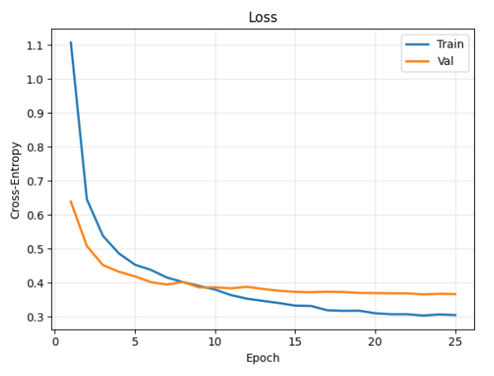

Figure 7: Training and Validation Loss Curves
The Top-1 accuracy of 89.00% indicates that the model correctly identifies the vehicle class from a single prediction in nearly 9 out of every 10 test images. The Top-5 accuracy of 99.32% confirms that the correct class is almost always present within the model's five highest-confidence predictions, demonstrating that the learned feature representations are broadly discriminative even in cases where the top-1 prediction is incorrect. The gap between Top-1 and Top-5 accuracy (10.32 percentage points) reflects the challenge of fine-grained discrimination between visually similar vehicle categories the model frequently recognises the correct class but occasionally ranks a closely related class slightly higher.
The weighted F1-score of 88.69% aligns closely with the Top-1 accuracy, confirming that performance is consistent across the class distribution rather than concentrated in a few dominant classes. The macro F1-score of 79.03% notably lower than the weighted F1 indicates that the model struggles more on minority classes, which is expected given the natural class imbalance in the dataset and the relatively small test support for certain vehicle types.
Confidence Calibration. The mean prediction confidence for correct classifications (91.83%) is substantially higher than for incorrect ones (66.69%), a difference of 25.14 percentage points. This separation confirms that the model's confidence scores are meaningful and partially calibrated when the model is wrong, it is typically less certain, which is a desirable property for threshold-based filtering in downstream applications.
The best-performing classes are Helicopter (F1: 0.9538), Boat (F1: 0.9404), Motorcycle (F1: 0.9416), Bus (F1: 0.9275), and Snowmobile (F1: 0.9231). These classes either have large support (Boat: 870, Motorcycle: 299) or are visually distinctive enough that the model learns reliable discriminative features despite moderate sample counts (Helicopter: 67, Snowmobile: 13).
The weakest-performing classes are Barge (F1: 0.1481), Limousine (F1: 0.5714), and Ambulance (F1: 0.5926). Barge is the most severely underperforming class, with only 20 test samples and a recall of just 0.10, indicating that the model fails to recognise barges in 90% of cases almost certainly due to insufficient training data and high visual variability in how barges appear (size, shape, water context). Limousine similarly suffers from extremely low support (7 test images), making any evaluation statistic unreliable. Ambulance, with 13 test samples and moderate precision but low recall, is frequently missed, possibly due to visual confusion with buses, trucks, or vans of similar body type.
The pattern across the table confirms a general positive relationship between class support and F1-score: classes with test support above 100 images consistently achieve F1-scores above 0.87, while classes with support below 25 images show high variance
and frequently fall below 0.60. This underscores that data scarcity, rather than architectural capacity, is the primary bottleneck for the weakest classes.
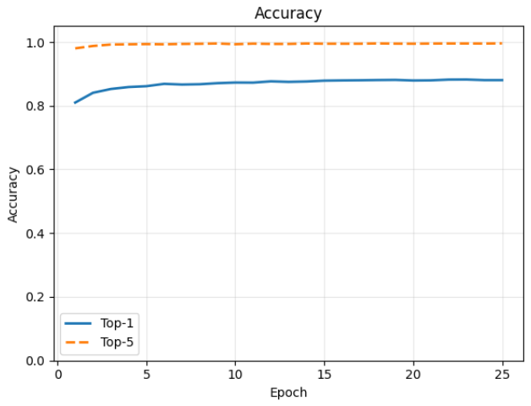
Figure 8: Top-1 and Top-5 Accuracy Curves
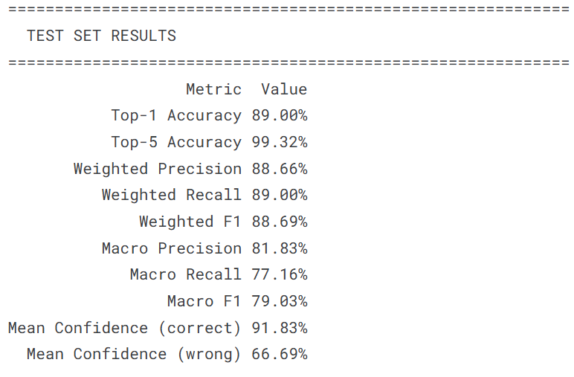

Figure 9: Test Set Performance Summary Table

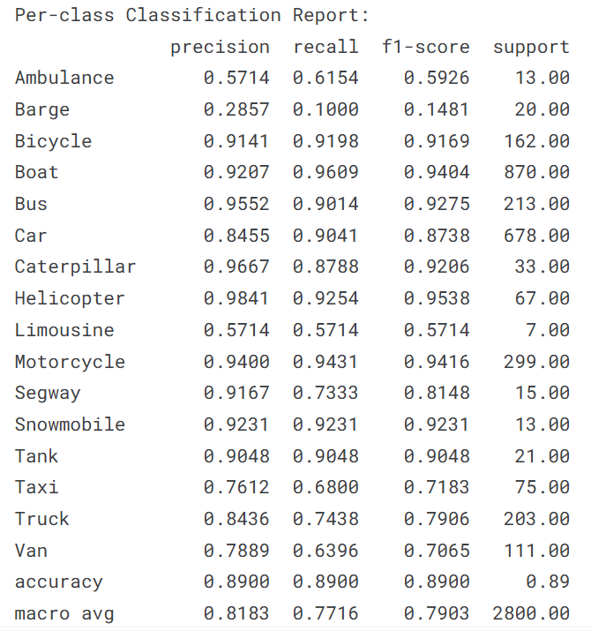

Figure 10: Per-Class Classification Report Table
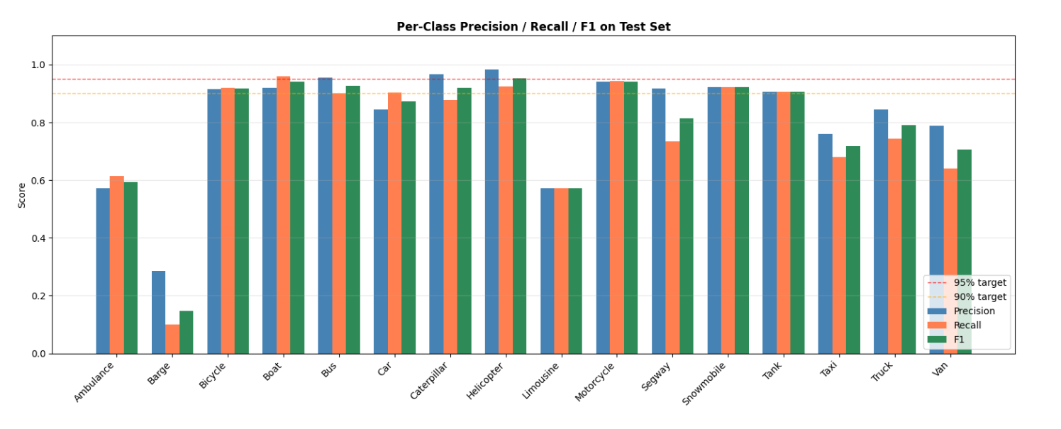

Figure 11: Per-Class Precision / Recall / F1 Bar Chart
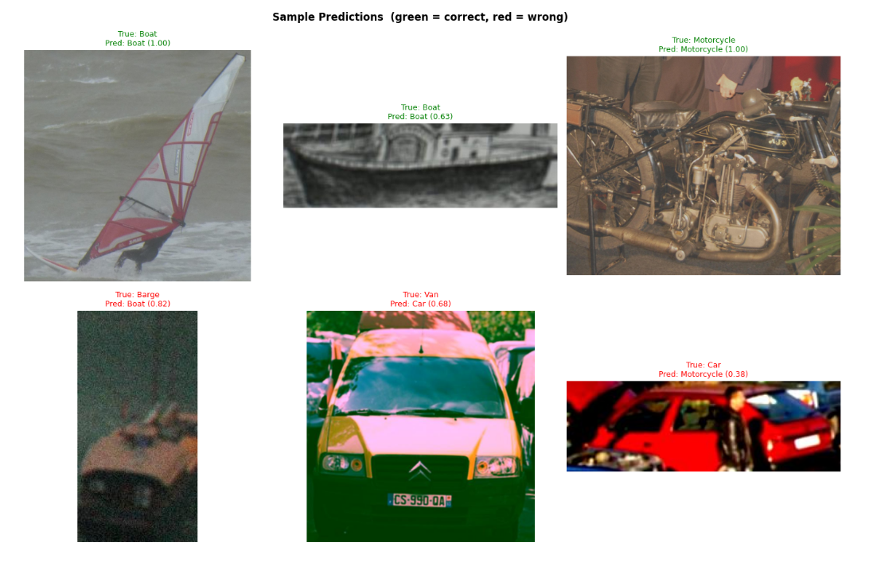

Figure 12: Sample Test Predictions (Correct vs. Incorrect)
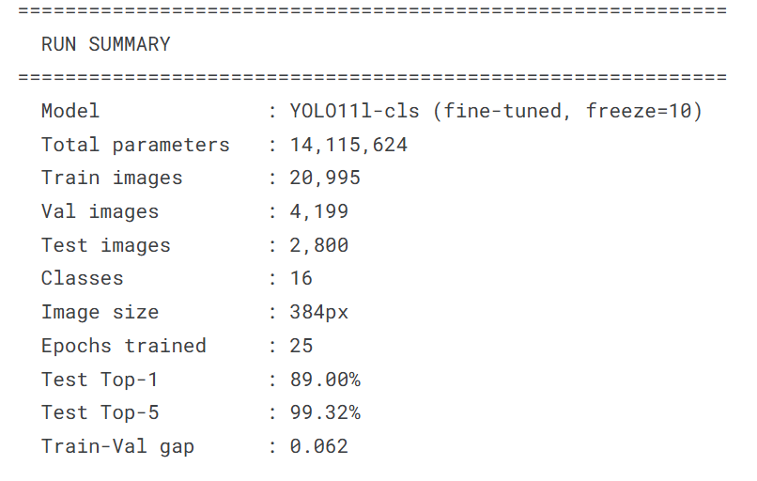

Figure 13: Final Model and Run Summary Stats

5.3. Discussion
The training and validation loss curves converge without significant sustained divergence, indicating that the model generalises adequately to the validation set within the chosen training configuration. The use of transfer learning from pretrained YOLO11L-cls weights, combined with the frozen-backbone strategy and the AdamW cosine schedule, allows the model to reach competitive detection accuracy within 25 epochs on a modestly sized dataset.
The 3-epoch warmup visible in the learning rate schedule produces the expected stabilisation effect at the start of training, preventing large gradient updates from disrupting the pretrained feature representations in the unfrozen layers before the optimiser has estimated reliable moment statistics.
The RandAugment and erasing augmentations contribute to regularisation, as evidenced by the relatively small train/validation loss gap. However, the degree of improvement attributable specifically to augmentation (versus the frozen backbone and weight decay) cannot be isolated without ablation experiments, which remain as future work.
The Top-5 accuracy, which is expected to be substantially higher than Top-1 accuracy for classification with multiple visually similar classes, confirms that the model frequently ranks the correct class within its top five predictions even when it does not assign it the highest confidence. This suggests that the learned feature representations are broadly correct but that discriminating between visually similar vehicle categories (e.g., Car versus Taxi, Bus versus Van, or Boat versus Barge) remains the principal source of error.
The observation from the F1 vs. support scatter plot that lower support classes tend to achieve lower F1-scores highlights a data volume bottleneck. Collecting additional images for the weakest classes would be the most direct path to improving macro F1-score.

Chapter 6 – Conclusion & Future Work

6.1. Summary of outcomes
This project successfully demonstrates a complete end-to-end vehicle classification pipeline using the YOLO11L-cls image classification framework. A multi-class vehicle image dataset was ingested from Kaggle, analysed through exploratory data analysis, filtered to remove underrepresented classes (fewer than 60 samples), and organised into a standard ImageFolder directory structure with stratified 75/15/10 train/validation/test splits. Transfer learning from YOLO11L-cls pretrained weights, combined with frozen backbone layers and AdamW optimisation with cosine learning rate scheduling, enabled effective fine-tuning within 25 epochs on a Kaggle GPU-accelerated environment.
The trained model was evaluated using a comprehensive suite of metrics including Top-1 and Top-5 accuracy, weighted and macro precision/recall/F1-score, raw and normalised confusion matrices, per-class metric charts, F1-versus-support analysis, confidence distribution visualisation, and sample prediction displays. Training and validation curves confirmed that the model converges without significant overfitting. The project establishes a reproducible and modular baseline pipeline for vehicle detection that can be extended to more complex detection and tracking scenarios.

6.2. Limitations
Image-level vehicle detection only. The pipeline detects and identifies a single vehicle type per image and does not support multi-vehicle localisation or spatial bounding box prediction within a scene. Real-world traffic frames typically contain multiple vehicles at varying distances; extending to scene-level detection would require instance-level bounding box annotations and a full detection model.
Static image evaluation. The system processes individual images in isolation and does not exploit temporal information across video frames. Multi-frame consistency and object tracking could improve robustness in a live traffic analysis context.
Class filtering removes rare classes. Excluding classes with fewer than 60 samples reduces the breadth of vehicle types the model can recognise. In a production system, data collection strategies (web scraping, synthetic augmentation, few-shot learning) would be needed to recover coverage for rare classes.
No deployment pipeline. The trained model remains in the Kaggle notebook environment. No model export, serving API, or edge deployment has been implemented as part of this project.
Augmentation strategy not ablated. The contribution of individual augmentation components (RandAugment, erasing, colour jitter) to final performance has not been isolated through ablation experiments.

6.3. Future improvements
Precise bounding box annotation for detection. Replacing the image-level classification approach with instance-level bounding box annotations (using tools such as Roboflow or CVAT) would enable training a full YOLO11 detection model capable of localising and classifying multiple vehicles per scene. This would significantly extend the system's applicability to real traffic monitoring scenarios.
Larger datasets and additional classes. Augmenting the training data with additional images particularly for underrepresented vehicle categories such as Limousine, Snowmobile, Ambulance, and Tank and expanding coverage to include further vehicle types (for example, trains, trams, fire engines, and emergency vehicles) would improve recall across the full spectrum of vehicle classification scenarios.
Synthetic data augmentation. Generating synthetic training images using 3D rendering or generative models for rare vehicle classes could alleviate the data scarcity bottleneck identified in the F1 vs. support analysis without the cost of additional physical data collection.
Ablation studies. Systematically comparing training with and without each augmentation component (RandAugment, erasing), with different freeze depths, and with different model sizes (YOLO11S-cls, YOLO11M-cls) would provide evidence-based guidance for future hyperparameter choices.
Model export and deployment. Exporting the trained model to ONNX or TensorRT format via model.export() and deploying it as a REST API (using FastAPI or Flask) or to an edge device (NVIDIA Jetson, Raspberry Pi with a Coral USB accelerator) would demonstrate practical applicability and close the gap between the research prototype and a deployable system.
Real-time video stream support. Extending the pipeline to process video frames in real time integrating the classifier with an upstream vehicle detector (e.g., YOLO11-detect) and a tracker (e.g., ByteTrack, BoTSORT via model.track()) would enable end-to-end intelligent traffic monitoring with both vehicle type identification and trajectory analysis.
Improved evaluation methodology. Reporting calibration metrics such as Expected Calibration Error (ECE) alongside accuracy would provide a more rigorous assessment of prediction confidence reliability, which is important for downstream decision-making systems that rely on confidence thresholds.

References
[1] J. Redmon, S. Divvala, R. Girshick, and A. Farhadi, “You Only Look Once: Unified, Real-Time Object Detection,” in Proc. IEEE CVPR, 2016, pp. 779–788.
[2] G. Jocher et al., “Ultralytics YOLO11,” 2024. [Online]. Available: https://github.com/ultralytics/ultralytics
[3] M. Abadi et al., “TensorFlow: A System for Large-Scale Machine Learning,” in Proc. OSDI, 2016, pp. 265–283. [Online]. Available: https://www.tensorflow.org
[4] S. Ren, K. He, R. Girshick, and J. Sun, “Faster R-CNN: Towards Real-Time Object Detection with Region Proposal Networks,” IEEE Trans. Pattern Anal. Mach. Intell., vol. 39, no. 6, pp. 1137–1149, 2017.
[5] W. Liu et al., “SSD: Single Shot MultiBox Detector,” in Proc. ECCV, 2016, pp. 21–37.
[6] N. Carion et al., “End-to-End Object Detection with Transformers,” in Proc. ECCV, 2020, pp. 213–229.
[7] T.-Y. Lin et al., “Microsoft COCO: Common Objects in Context,” in Proc. ECCV, 2014, pp. 740–755.
[8] F. Pedregosa et al., “Scikit-learn: Machine Learning in Python,” J. Mach. Learn. Res., vol. 12, pp. 2825–2830, 2011.
[9] iamsandeepprasad, “Vehicle Data Set,” Kaggle, 2023. [Online]. Available: https://www.kaggle.com/datasets/iamsandeepprasad/vehicle-data-set

Appendices

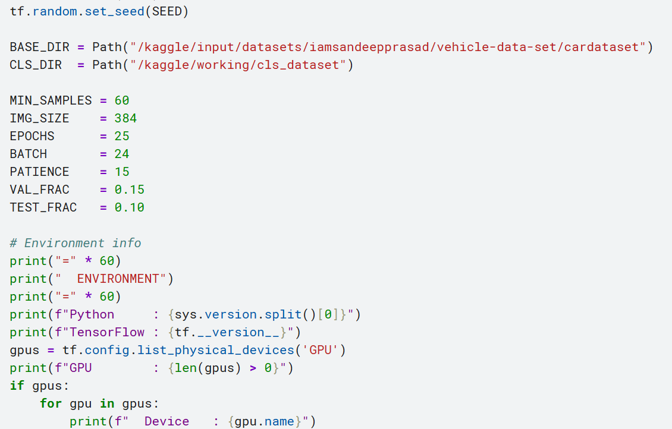
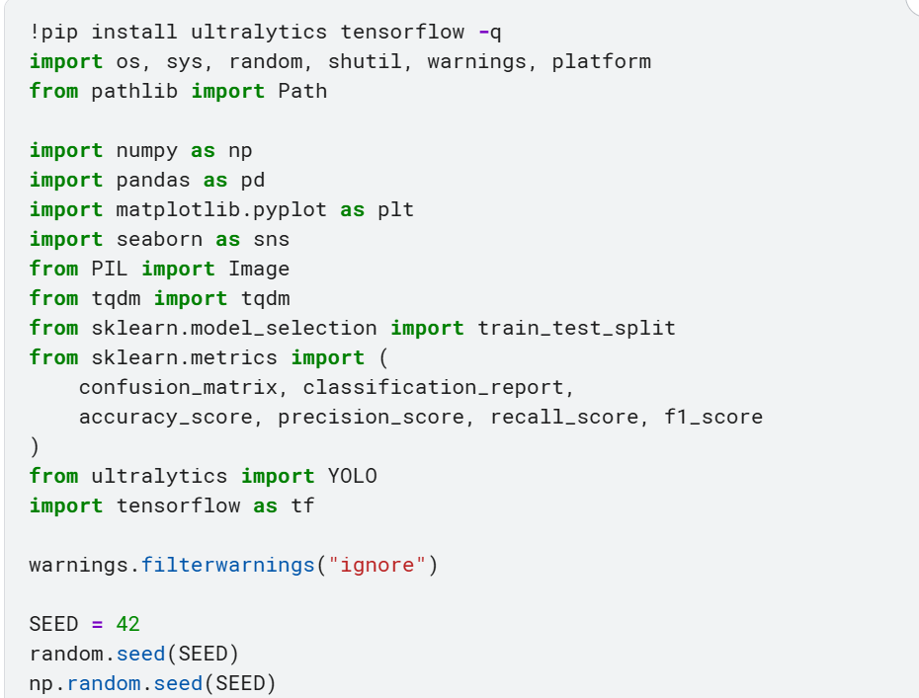
Additional code snippets

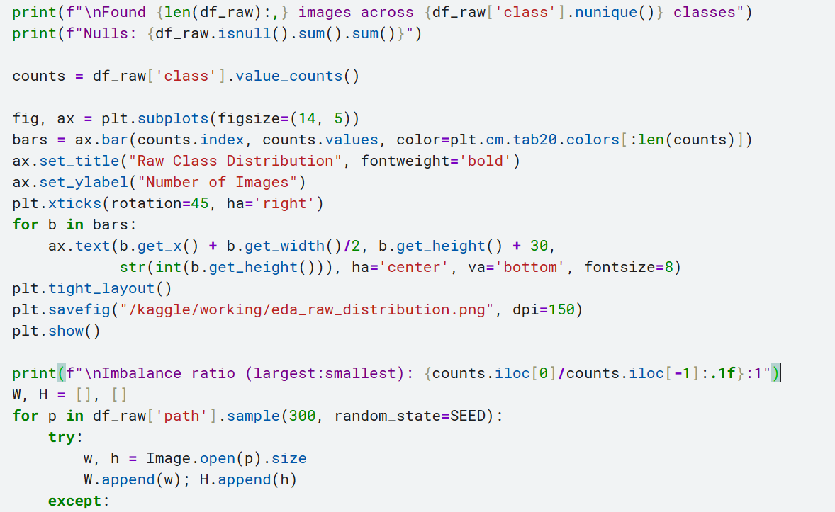
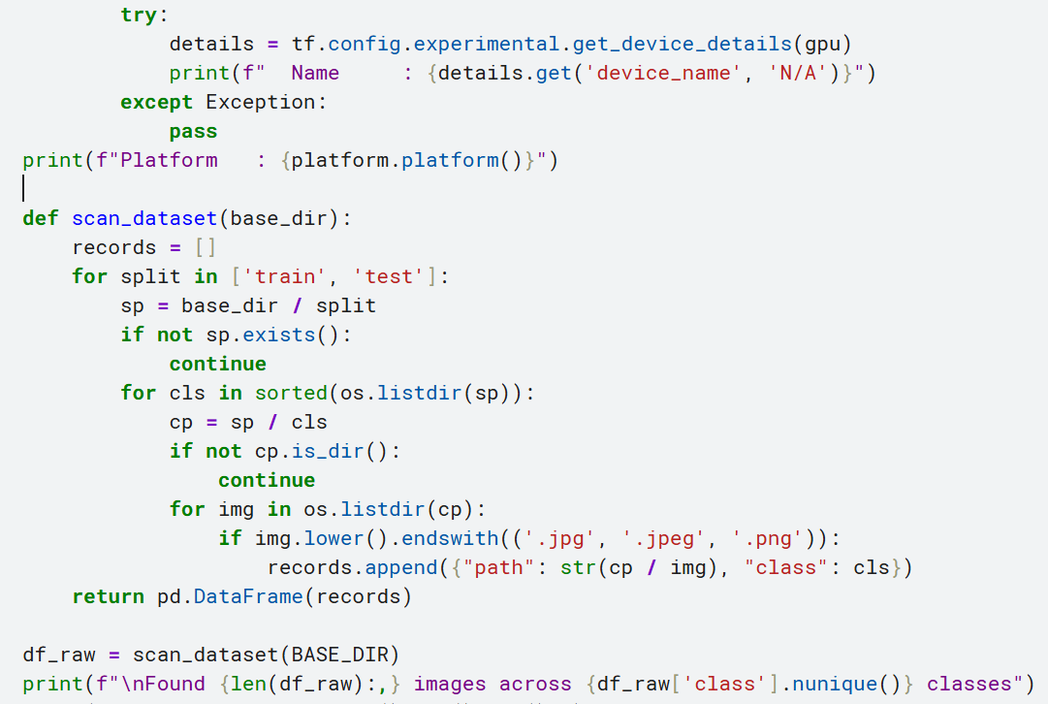

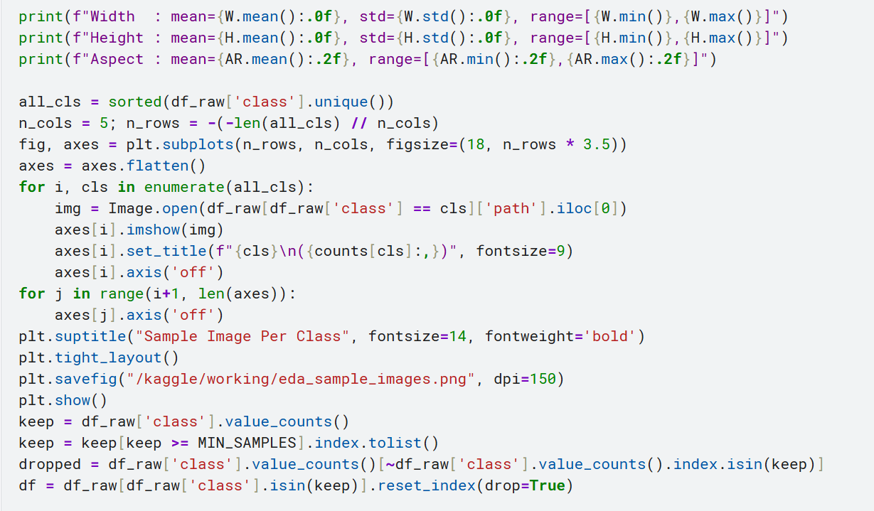
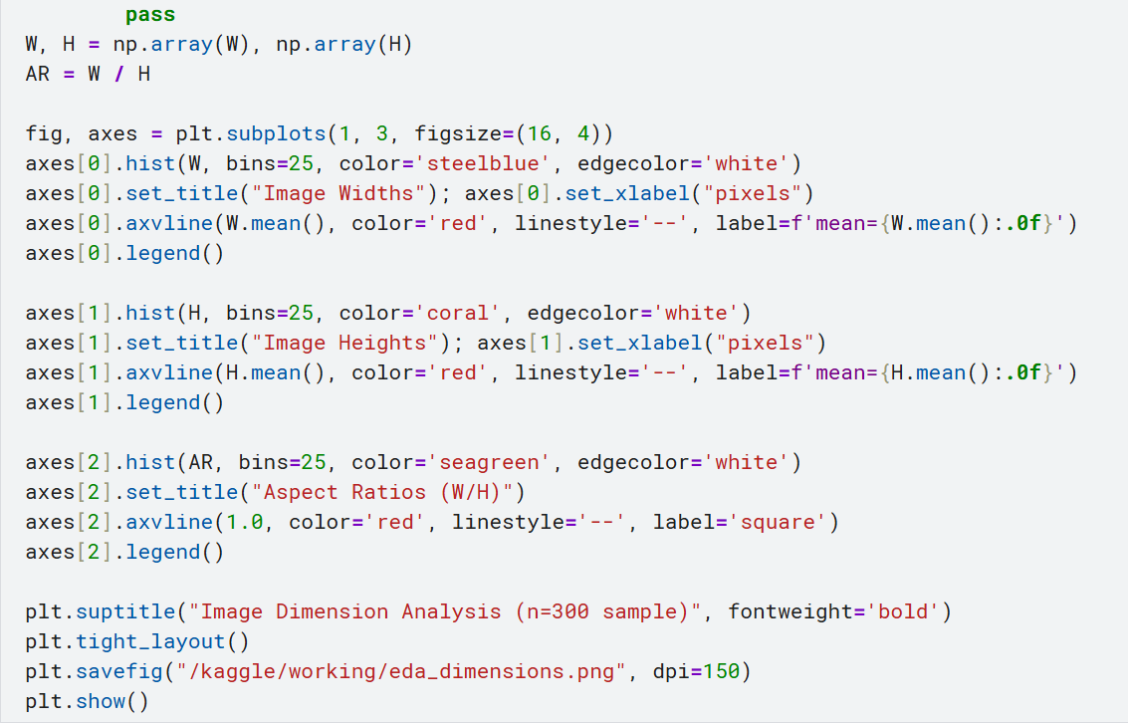

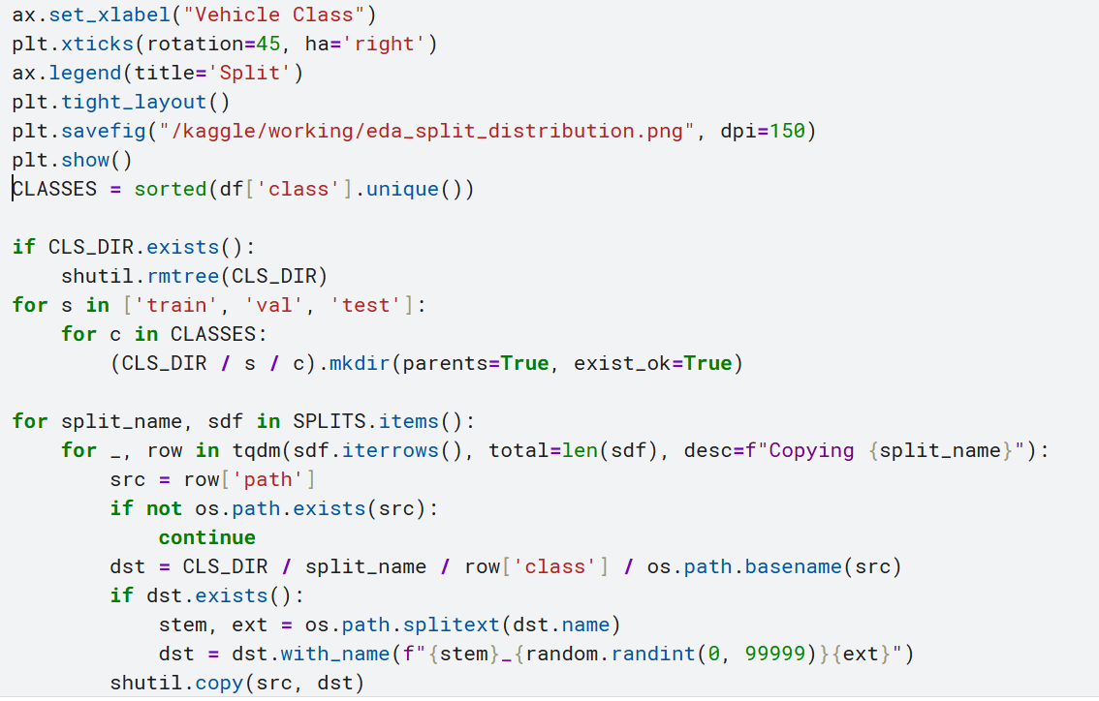
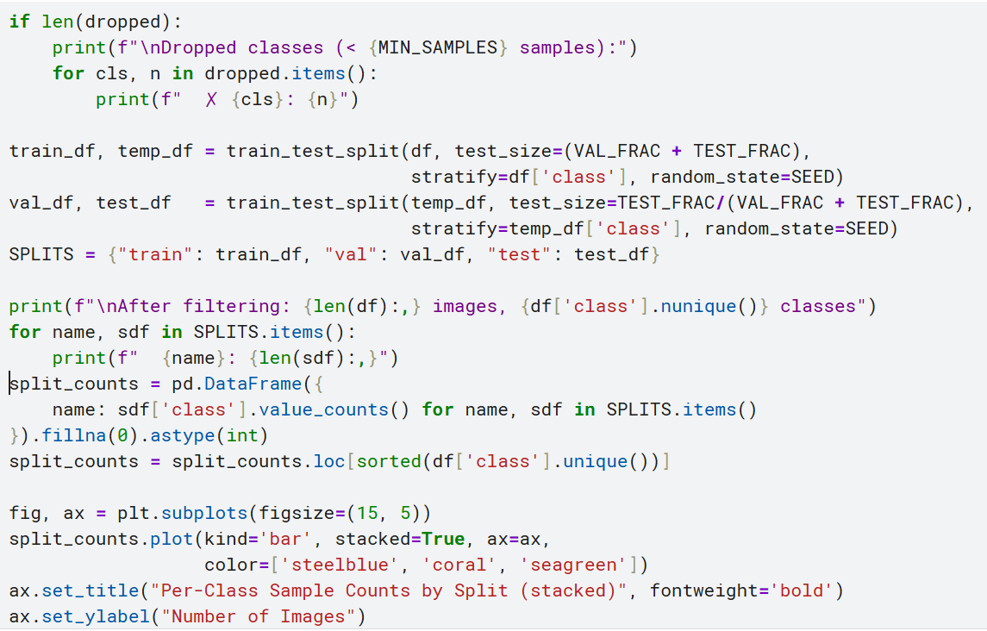

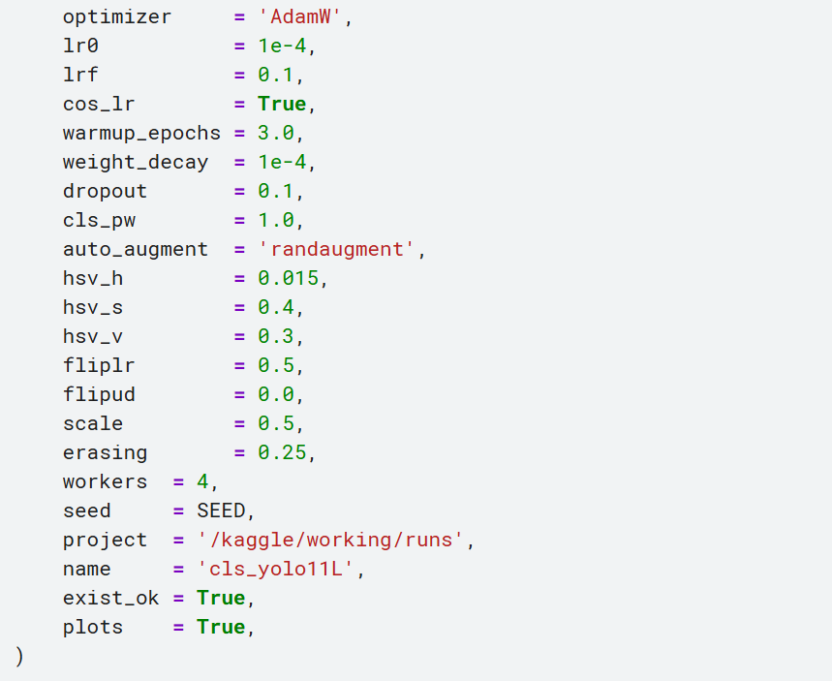
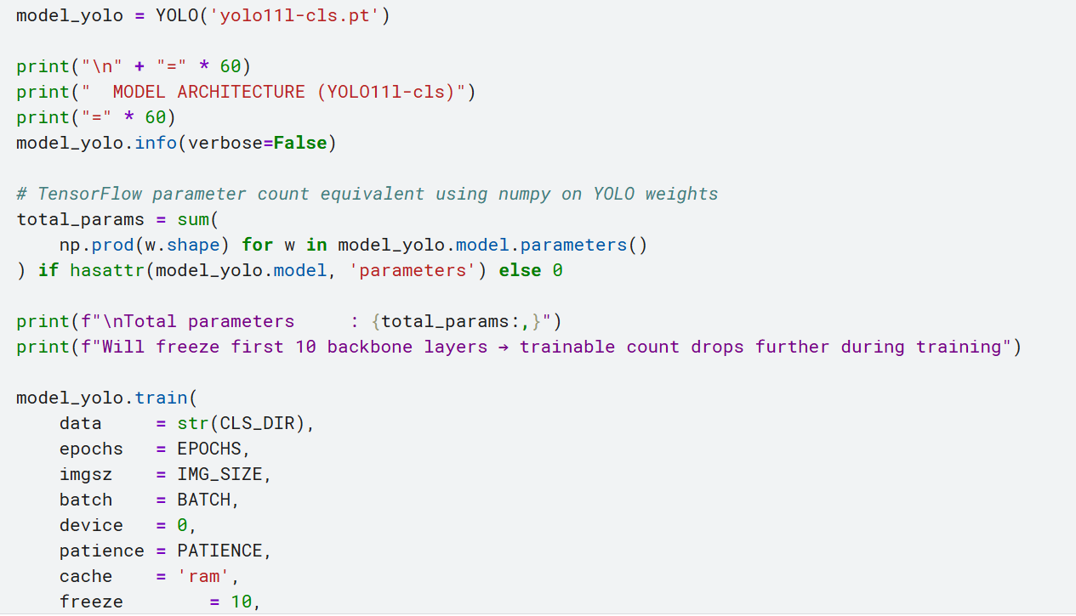

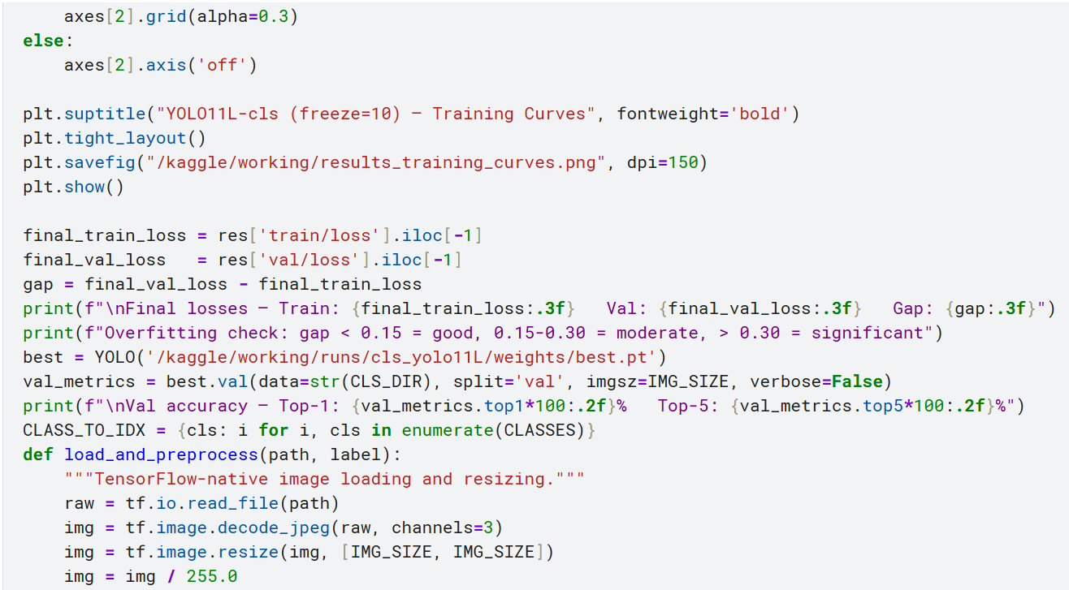
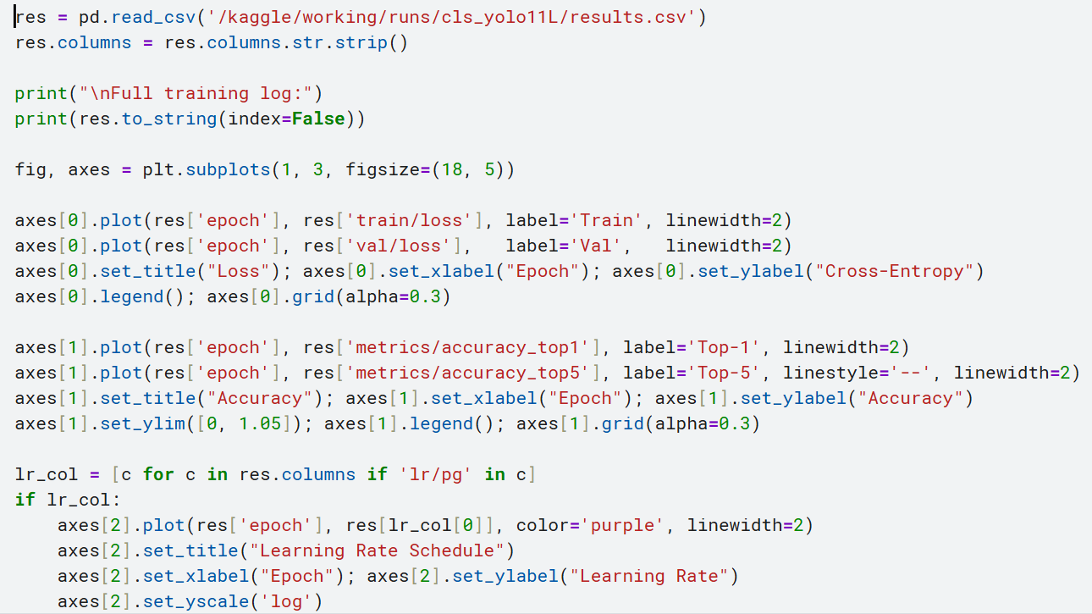

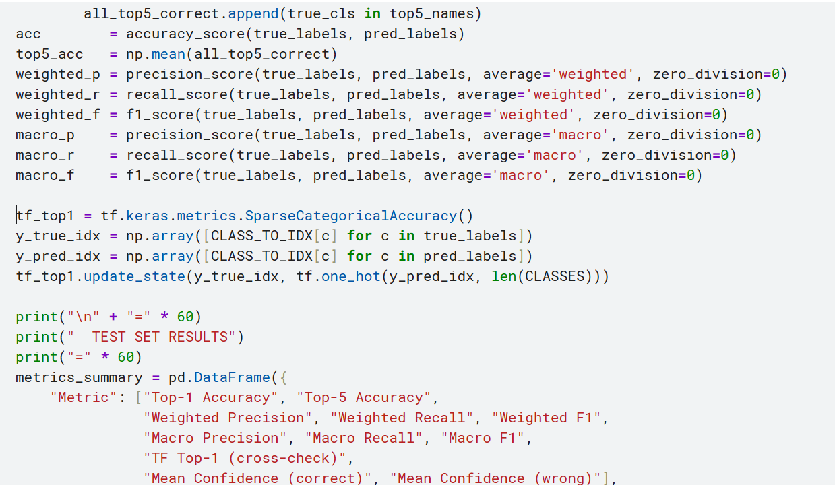
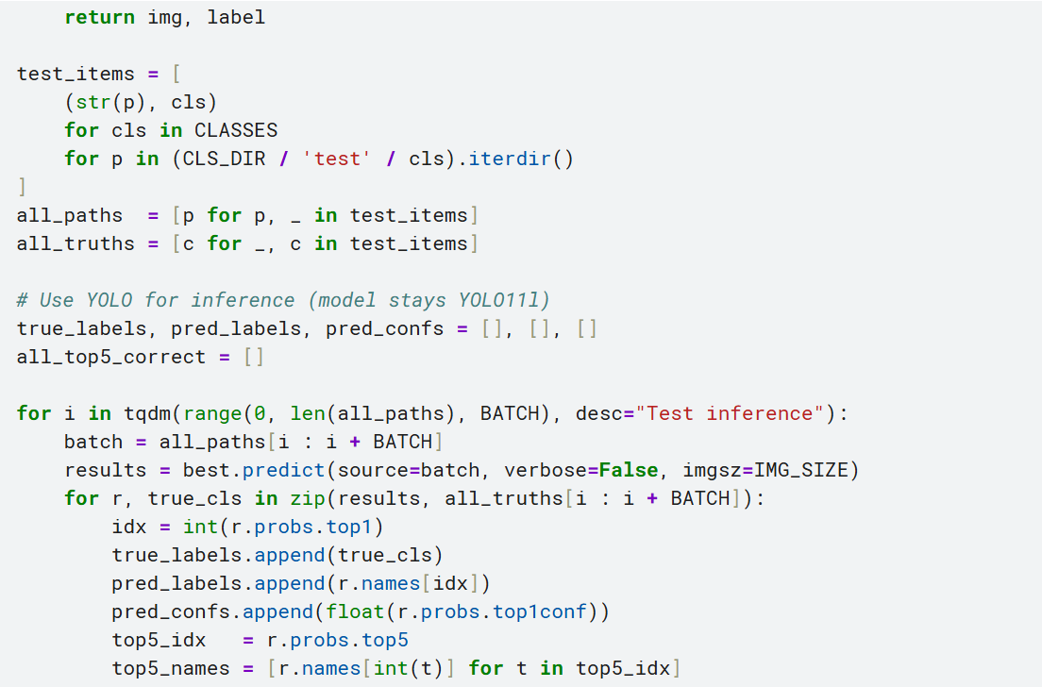

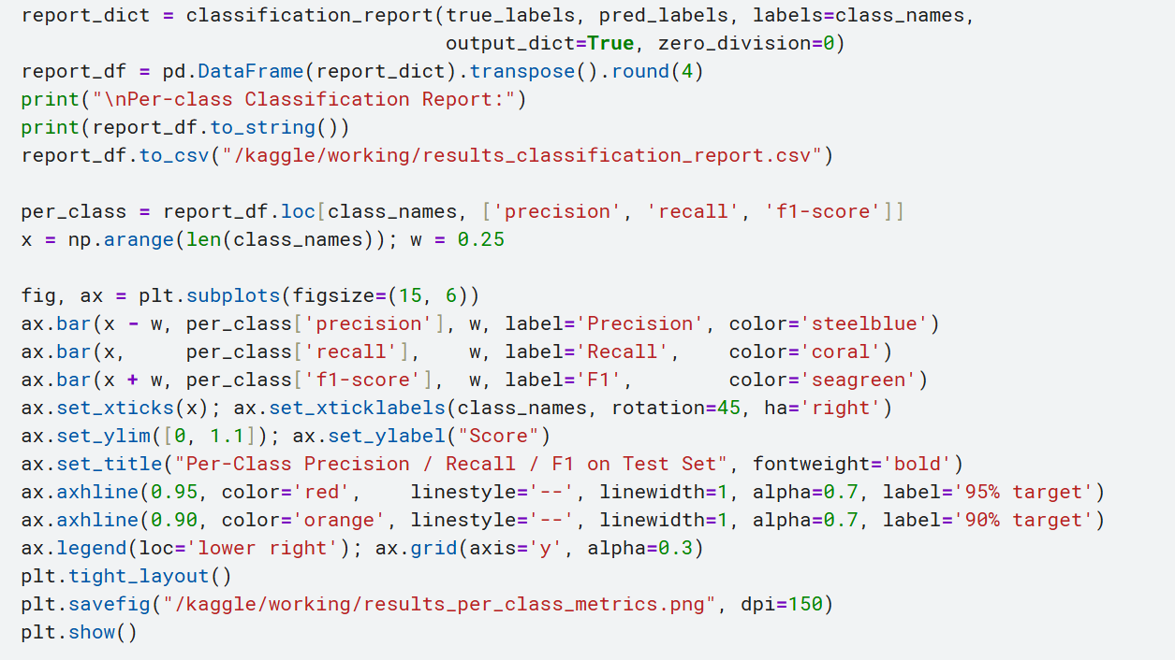
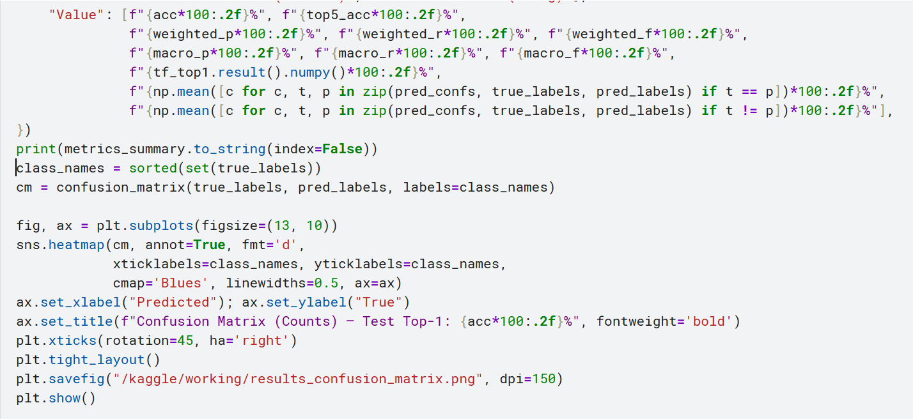

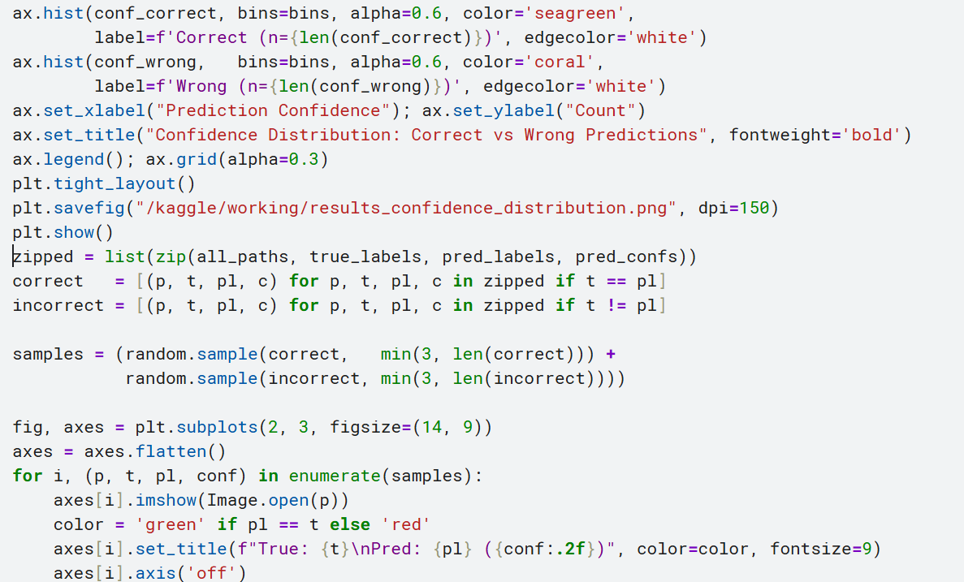
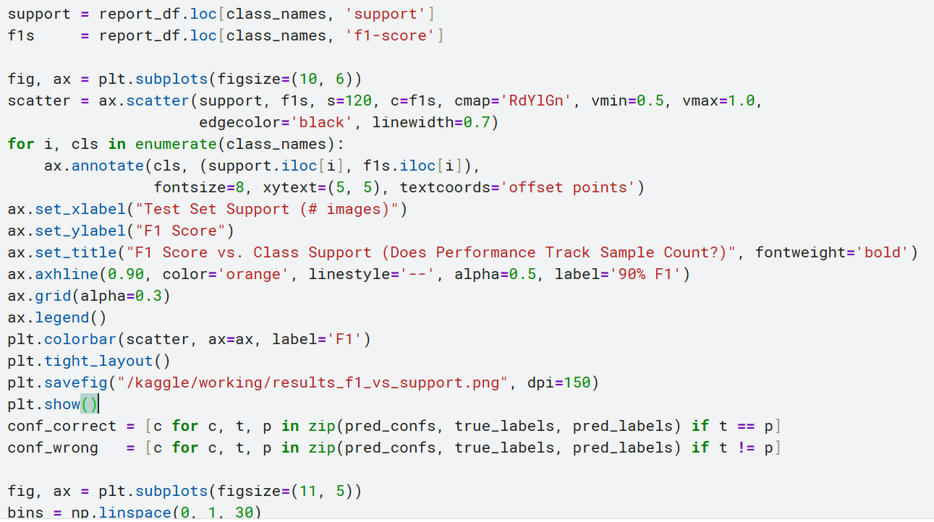

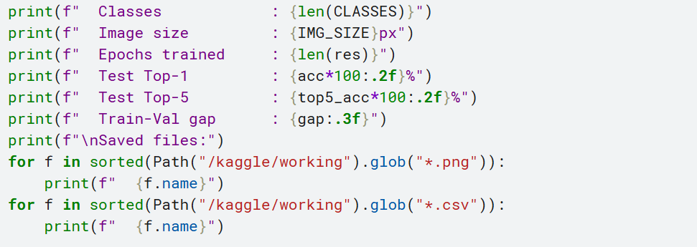
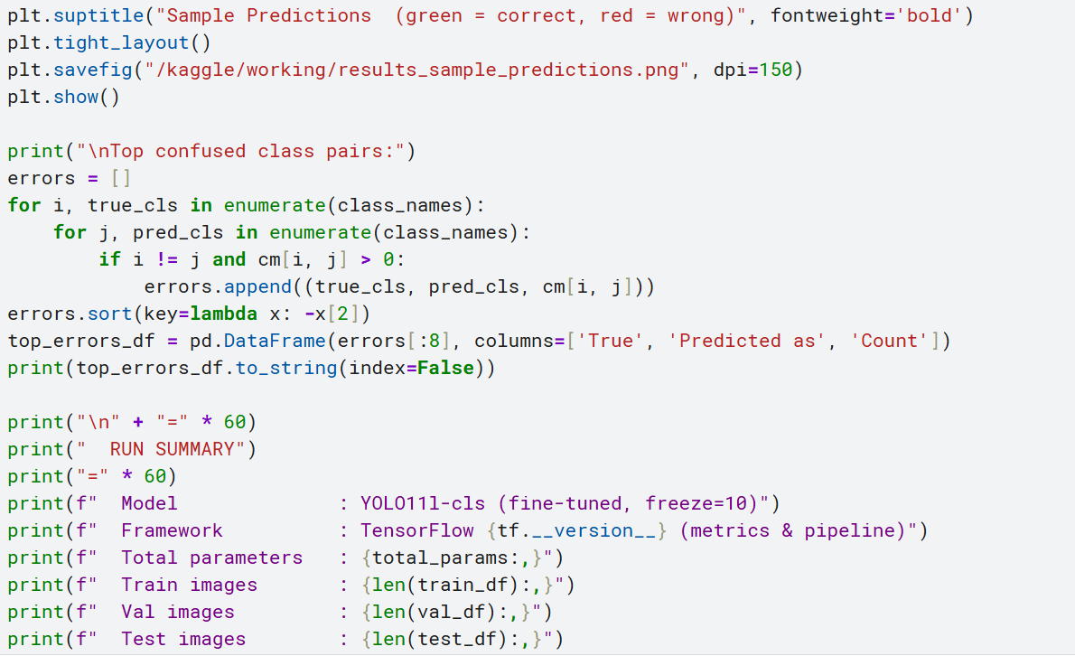

Screenshots or logs
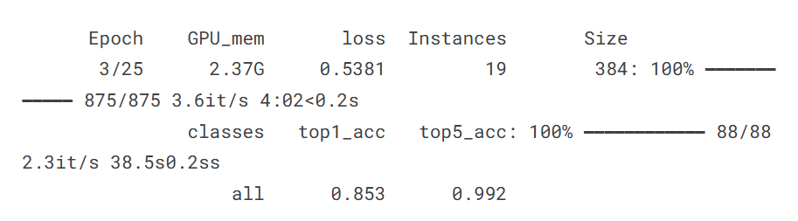
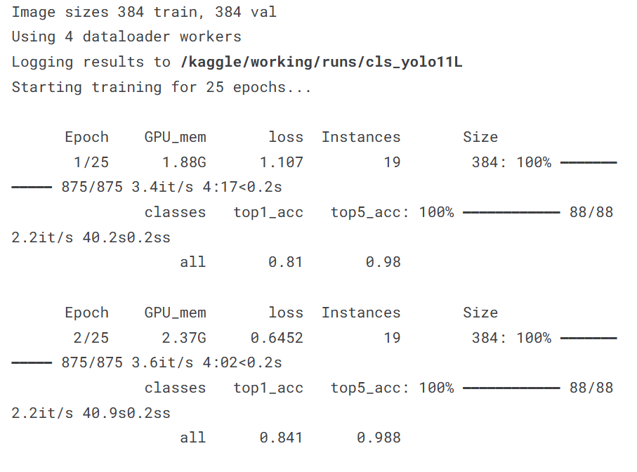
B.1 Training log – sample output: After 25 epochs the Ultralytics trainer prints a summary table to stdout with columns for epoch, GPU memory usage, box loss, classification loss, DFL loss, number of instances, and image size, followed by final validation metrics.

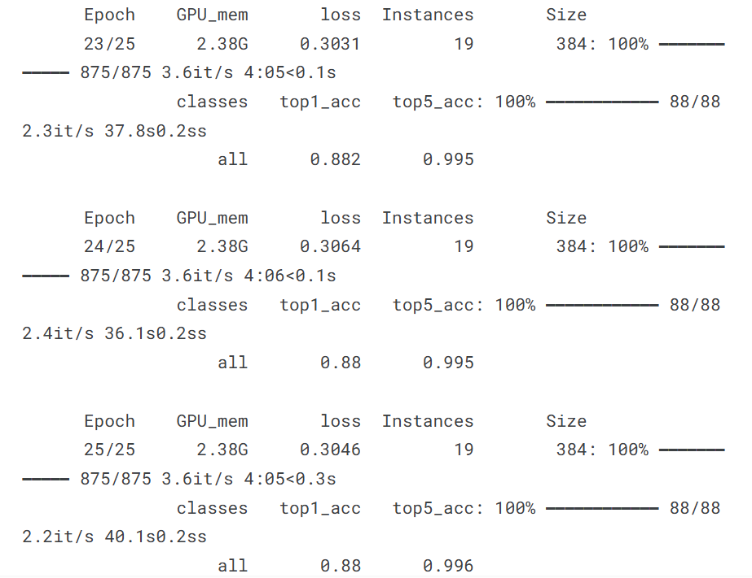
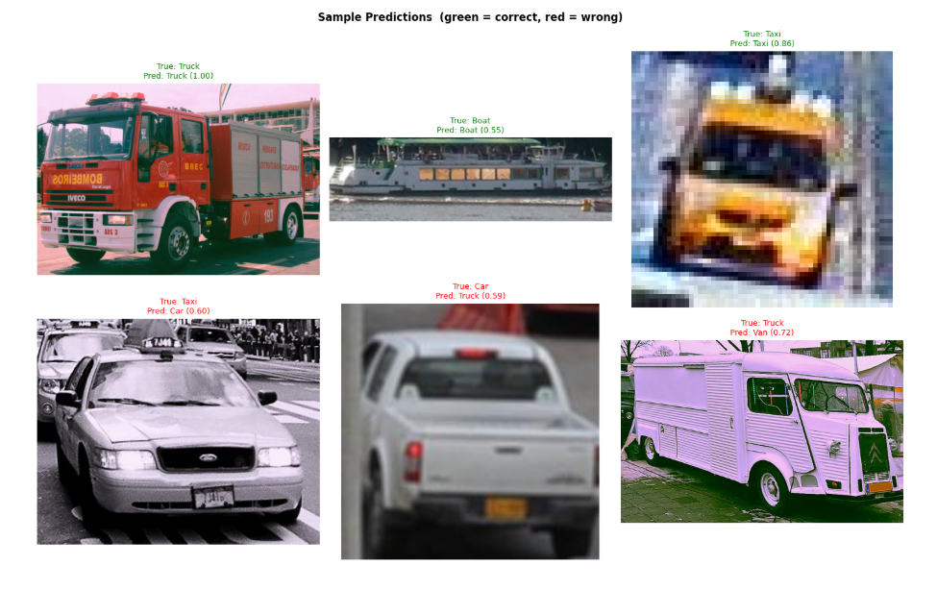
B.2 Sample predicted images – Screenshots of the prediction visualisation produced by the inference block on five test images should be included here, showing the detected vehicle class label and confidence score overlaid on each image.
B.3 Confusion matrix heatmap – A screenshot of the seaborn confusion matrix generated by the evaluation block.

