# **EEE F311 Communication Systems Lab**

# **Experiment 2:**

### ANANTHA SAI SATWIK VYSYARAJU

### 2019A3PS1323H

Q1: Here we are considering two matrices a = $\left[\begin{matrix}1 & 2 \\ 3 & 4\end{matrix}\right]$ and b = $\left[\begin{matrix}2 & 2 \\ 2 & 2\end{matrix}\right]$

We can see the output of my function kronecker(a,b) and in-built function kron(a,b) comes out to be the same.

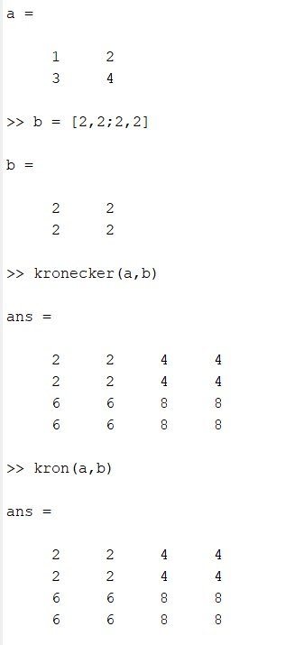

Q2: Here we are using an identity matrix so that we can confirm by manual calculation also since Ai for all “i” belongs to [1,10] is A itself. so the coefficient comes out to be $\left(\sum_{i=1}^{i=10}{\frac{1}{i!}}\right)×A$ which can be approximated for exponential matrix (“matrixExponential.m” function)

The value of this $\left(\sum_{i=1}^{i=10}{\frac{1}{i!}}\right)$ Comes out to be 1.7183. We also use a “matmul.m” function for multiplying two matrices,

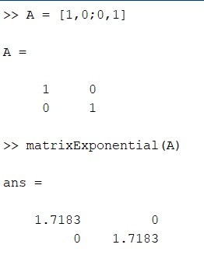

Q3: (0.01)n <0.00001 and for this the n value comes out to be 3 by manual verification and it is the same from the function.

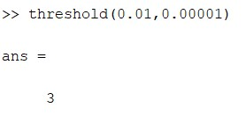

Q4: The random vector whose mean is 0 and variance is 1 and size n can be constructed from the function randn(n). From the constructed vector or matrix, we can easily calculate the average of the values of matrix.

