DSA Lab Sheet 6

1.
a) Given a sorted array of integers, write a program to find an element in it and return its index. The algorithm should complete the task in O(log2n) time, where n is the number of elements in the array. Implement your algorithm through both iterative and recursive approach. Take care of the following edge cases:
- If the element does not exist, return the index of the next smallest number just greater than the element.
- If the element is greater than all the integers in the array, return the length of the array
- If multiple copies of the element occur, return the first occurrence

#include<stdio.h>
#include<iostream>

using namespace std;

int binarySearchIterative(int* arr, int len, int ele){
int low = 0, high = len;
int mid;
while(low<high){
mid = (low+high)/2;
if(arr[mid] >= ele){
/* since we have to find the first occurence, we keep moving left with the hope that the element occurs again */
high = mid;
}
else {
low = mid + 1;
}
}
if(low<len && arr[low]<ele)
return low+1;
return low;
}

int binarySearchRecursive(int* arr, int len, int ele, int low, int high){
//base case
if(low>=high){
if(low<len && arr[low]<ele){
return low+1;
}
else {
return low;
}
}
int mid = (low+high)/2;
if(arr[mid] >= ele){
return binarySearchRecursive(arr, len, ele, low, mid);
}
return binarySearchRecursive(arr, len, ele, mid+1, high);
}

int main(){
int n;
cin>>n;
int arr[n];
for(int i=0; i<n; i++){
cin>>arr[i];
}
int element;
cin>>element;
cout<<"Index using iterative solution: "<<binarySearchIterative(arr, n, element)<<endl;
cout<<"Index using recursive solution: "<<binarySearchRecursive(arr, n, element, 0, n)<<endl;
}

b) Now perform the same task as in a) but in O(log3n) complexity. This can be done using ternary search, a concept similar to binary search.

A rough idea: We divide the array into 3 parts instead of 2. Let us call the pivot points as mid1 and mid2. We then check if the element lies in range [low, mid1] or (mid1, mid2] or (mid2, high], and divide the array accordingly. This keeps happening recursively.

For this problem, you may handle the edge cases differently for the sake of simplicity:
- If the element does not exist, return -1
- If the element occurs multiple times, return any index.

-------------------------------------------------------------------------------------------------------

2.
a) Given a positive integer n (n<=30) and a non-negative integer r, write a program to compute nCr (n choose r) using both binary recursion and iterative approach.

#include<iostream>
#include<cstring>
using namespace std;

long long nCrRecursive(int n, int r)
{
if(r>n)
return 0;
if(r==0 || r==n)
return 1;

return nCrRecursive(n-1, r-1)
+ nCrRecursive(n-1, r);
}

long long nCrIterative(int N, int R){
long long mat[N+1][R+1];
memset(mat, 0, sizeof(mat));
mat[0][0] = 1;
for(int n = 1; n<=N; n++){
for(int r = 0; r<=n; r++){
if(r==0 || r==n){
mat[n][r] = 1;
}
else{
mat[n][r] = mat[n-1][r-1] + mat[n-1][r];
}
if(n==N && r==R) return mat[N][R];
}
}
return mat[N][R];
}

int main(){
int n,r;
cin>>n>>r;
if(r>n){
cout<<"Invalid input\n";
return 0;
}
cout<<n<<" C "<<r<<":\n";
cout<<"Recursive: "<<nCrRecursive(n,r)<<endl;
cout<<"Iterative: "<<nCrIterative(n,r)<<endl;
return 0;
}

b) Similar to a), find the recurrence relation for nPr and implement functions to find nPr using both recursive and iterative approach.

-------------------------------------------------------------------------------------------------------

3.
a) Given 2 positive integers a and n, define a custom function pow(int a, int n) that computes an. Also return the total number of multiplication operations performed.

#include<stdio.h>
#include<iostream>
using namespace std;

struct Power{
long long value, countOfOperations;
};
Power pow(int a, int n){
long long answer = 1;
long long count = 0;
while(n--){
answer*=a;
count++;
}
Power ans;
ans.value =answer;
ans.countOfOperations=count;
return ans;
}
int main(){
int a,n;
cin>>a>>n;
Power p = pow(a, n);
cout<<"pow(a,n): "<<p.value<<endl;
cout<<"No. of multiplications: "<<p.countOfOperations<<endl;
}

b) While the above approach is pretty straightforward and simple to implement, it is not practical for many real-life applications, like the RSA Encryption where an integer is raised to the power of a number with very large magnitude, often greater than 109. A more efficient algorithm exists to compute an, described briefly as follows:

A rough idea: As an example, let us take a128. Starting with a, we first square it to get a2. Then we square it again to get a4, and keep squaring the result in a similar fashion till we get a128. The number of “square” or multiplication operations we do here will be 7, or log2128. Hence, we achieve our task in O(log2n) complexity.

Things however get tricky when “n”, the exponent, is not a power of 2. Taking cue from the above example, come up with an algorithm to find pow(a, n) efficiently for any positive “n” and implement it. Print the number of multiplication operations performed.

(Hint: Think in terms of the binary representation of n. At every point of moving through the binary representation, one would make either of the two choices: either simply square the current result, or square and multiply by a)
------------------------------------------------------------------------------------------------------

4.
a) Convolution is a basic matrix operation that forms the very basis of Convolutional Neural Networks. It involves a matrix, called filter or kernel, sliding over a larger matrix and storing into another matrix (called feature map). Each element of the filter map is obtained by the element-wise multiplication of the filter with the corresponding region in the basic matrix. Refer to the following gif for better understanding:
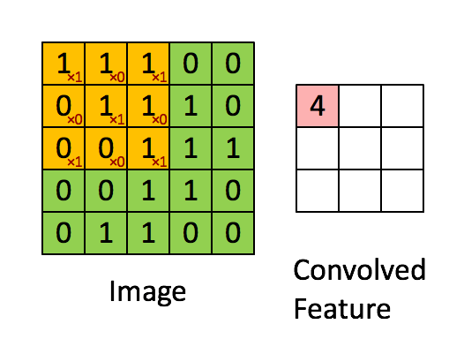

source: https://medium.com/@icecreamlabs/3x3-convolution-filters-a-popular-choice-75ab1c8b4da8

Here, the yellow matrix (3x3 matrix of 1’s and 0’s) is the filter while the green matrix (5x5 matrix of 0’s and 1’s) is the image. The pink matrix is the answer we seek. Write a program to input the image matrix, the filter and print the feature map obtained, along with the number of multiplication operations performed.

Sample Input:
Enter dimensions of the matrix:
5
Input the matrix:
1 1 1 0 0
0 1 1 1 0
0 0 1 1 1
0 0 1 1 0
0 1 1 0 0
Enter dimensions of the filter:
3
Input the matrix:
1 0 1
0 1 0
1 0 1
Sample Output:
Output matrix:
4 3 4
2 4 3
2 3 4
Number of multiplication operations: 81

#include<iostream>

using namespace std;

int main(){
int N, f, i, j, count = 0;

cout<<"Enter dimensions of the matrix:\n";
cin>>N;
int mat[N][N];
cout<<"Input the matrix:\n";
for(i=0;i<N;i++){
for(j=0;j<N;j++){
cin>>mat[i][j];
}
}

cout<<"Enter dimensions of the filter:\n";
cin>>f;
int filter[f][f];
cout<<"Input the matrix:\n";
for(i=0;i<f;i++){
for(j=0;j<f;j++){
cin>>filter[i][j];
}
}

int featureMap[N-f+1][N-f+1];

for(int convRow=0; convRow<N-f+1; convRow++){
for(int convColumn=0; convColumn<N-f+1; convColumn++){
int val = 0;
for(i=0;i<f;i++){
for(j=0;j<f;j++){
val = val + mat[convRow+i][convColumn+j]*filter[i][j];
count++;
}
}
featureMap[convRow][convColumn] = val;
}
}

cout<<"Output matrix:\n";
for(i=0;i<N-f+1;i++){
for(j=0;j<N-f+1;j++){
cout<<featureMap[i][j]<<" ";
}
cout<<endl;
}
cout<<"Number of multiplication operations: "<<count<<endl;
}

b) To the problem a), we now introduce the concept of stride. We refer to the number of rows and columns traversed per slide as the stride. For part a), the stride was by default 1. The following image shows stride of 1 and 2 respectively.
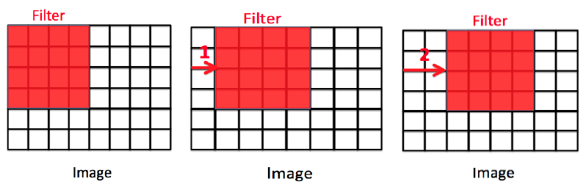
Modify the program in a) to support strides greater than 1. Stride may be taken as an input from the user.

-------------------------------------------------------------------------------------------------------
<end>

