

**OVER-SPEED DETECTION**

**SUBMITTED TO :**

Dr. Ravi Kumar Jatoth

Professor - Electronics & communication Engineering

Dr. Vasundhara

Assistant Professor - Electronics & communication Engineering

**SUBMITTED BY:**

T Veera Kumar – 21ECB0B62

V Sai Sharanya – 21ECB0B63

V Rahul – 21ECB0B65

**Table of contents**

**CONTENT PAGE NO**

* **Introduction 3**
* **Components used 4-5**
* **Explanation of different blocks**
* Power supply circuit 6
* IC 555 7-11
* IC CD4026 12
* IC CD4011 13
* **Circuit Diagram 14**
* **Working 15-16**
* **Calculations 17**
* **Simulation Outputs 18**
* **Observations 19**
* **Applications 19**
* **Conclusion 19**
* **References 20**

**Introduction**

Over-speed detection of vehicles is an important aspect of modern traffic management and road safety. With the increasing number of vehicles on the roads, it has become crucial to monitor and control their speeds to reduce the risk of accidents and ensure compliance with speed limits.

The concept of over-speed detection involves using various technologies and sensors to monitor the speed of vehicles in real-time. By analyzing the vehicle's speed, appropriate actions can be taken to enforce speed limits, issue warnings, or even capture evidence for law enforcement purposes.

The types of sensors that can be used for vehicle over speed detection are radar, laser, and video cameras. These sensors work by measuring the speed of the vehicle and comparing it to the legal speed limit for the particular road. When a vehicle is detected traveling above the legal speed limit, an alert can be sent to law enforcement or to the driver of the vehicle in real-time.

The primary goal of this project is to design and implement an intelligent speed detection system that can effectively measure the speed of vehicles on roads or highways. By accurately detecting instances of over-speeding, this system can help authorities enforce traffic regulations and take necessary actions to prevent accidents and ensure compliance with speed limits.

The project uses lasers for the detection of over speed. Our circuit consists of two LDRs which are always pointed with the light of lasers and gets disturbed when a vehicle travels on the road , the time elapsed between the disturbance of first LDR and second LDR is used for the calculation of speed with which the vehicle travelled and alerts if the speed crosses limit.

**Components used:**

For the project

Component Quantity Cost

C NE555 Timer 5 40

CD4026 decade counter 4 80

(7-segment decoder)

CD4011 NAND gate 1 9

IC 7812 1 10

1N4148 switching diode 1 5

1N4007 rectifier diode 4 20

Green LED 1 5

Red LED 2 10

LTS543 common cathode 4 36

7-segment display

Resistors 30

100 kilo-ohm 1

20 kilo-ohm 1

10 kilo-ohm 6

470 kilo-ohm 1

1 kilo-ohm 1

470 ohm 1

Capacitors 30

1000uF 1

47uF 1

1uF 1

0.1uF 1

0.01uF 5

Piezo Buzzer 1 10

LDR 2 10

Pointed laser light 2 60

For the power supply

Component Quantity Cost

Capacitor (1000uF) 1 10

LM7812 1 10

1N4007 diodes 4 4

Transformer 12-0-12 1 100

**Explanation of different blocks**

Power Supply circuit

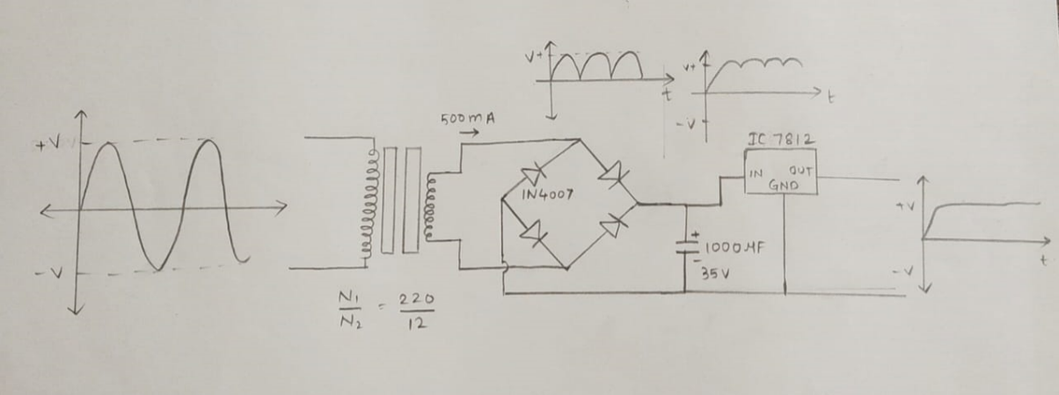

The power supply circuit that uses a 12V transformer and a 7812-voltage regulator IC to provide a stable 12V DC output. The circuit works by first stepping down the AC voltage from the transformer to a lower AC voltage, which is then rectified and filtered to produce a stable DC voltage. The voltage regulator IC then regulates this DC voltage to the desired output voltage.

The 12V transformer used in the circuit is a step-down transformer that reduces the input AC voltage to a lower voltage suitable for use in the circuit. The 12V AC output from the transformer is then fed into a bridge rectifier circuit, which consists of four diodes that are arranged in a bridge configuration. The rectifier circuit converts the AC voltage into a pulsating DC voltage, which contains both positive and negative voltage swings. The pulsating DC voltage is then filtered using a capacitor connected across the output of the rectifier circuit. The capacitor smoothens out the voltage fluctuations and produces a more stable DC voltage. The filtered DC voltage is then fed into the input of the 7812-voltage regulator IC. The 7812 IC is a three-terminal voltage regulator that regulates the input voltage to a stable 12V DC output.

The regulator IC contains a voltage reference, an error amplifier, and a power transistor, which work together to regulate the output voltage. The voltage reference sets the desired output voltage, while the error amplifier compares the actual output voltage to the reference voltage and adjusts the power transistor accordingly to maintain a constant output voltage. In summary, the power supply circuit using a 12V transformer and a 7812-voltage regulator. The circuit provides a stable and reliable 12V DC output that can be used to power a variety of electronic devices.

IC 555 timer

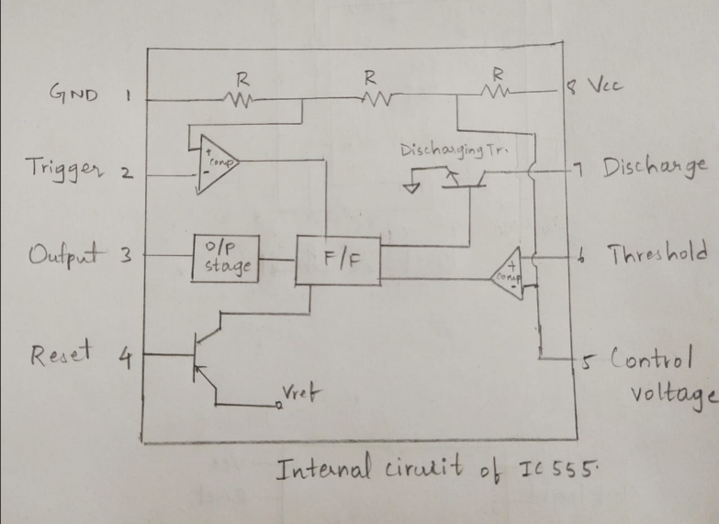

Internal circuit

The 555 timer IC is a monolithic timing circuit that produces accurate and highly stable time delays or oscillation. When compared to the applications of an op-amp in the same areas, the 555 IC is also equally reliable and is cheap in cost. The timer IC is setup to work in either of the two modes – one-shot or monostable or as a freerunning or astable multivibrator. The NE 555 can be used for temperature ranges between – 55°C to 125°. The NE555 is a highly stable controller capable of producing accurate pulses. With a monostable operation, the time delay is controlled by one external resistor and one external capacitor. With an astable operation, the frequency and duty cycle are accurately controlled by two external resistors and one capacitor.

Explanation of each pin of the IC

Pin 1: Grounded Terminal: All the voltages are measured with respect to the Ground terminal.

Pin 2: Trigger Terminal: The trigger pin is used to feed the trigger input when the 555 IC is set up as a monostable multivibrator. This pin is an inverting input of a comparator. The output of the timer depends on the amplitude of the external trigger pulse applied to this pin. When the trigger goes beyond Vcc/3(In the negative direction) the output of the lower comparator goes high setting the output of timer high.

Pin 3: Output of the timer is available at this pin. There are two ways in which a load can be connected to the output terminal. One way is to connect between output pin (pin 3) and ground pin (pin 1) or between pin 3 and supply pin (pin 8). The load connected between output and ground supply pin is called the normally on load and that connected between output and ground pin is called the normally off load.

Pin 4: Whenever the timer is to be reset or disabled, a negative pulse is applied to pin 4. The output is reset irrespective of the input condition. When this pin is not to be used for reset purpose, it should be connected to + VCC to avoid any possibility of triggering.

Pin 5: The external voltage applied to this pin can also be used to modulate the output waveform. Thus, the amount of voltage applied in this terminal will decide when the comparator is to be switched, and thus changes the pulse width of the output. When this pin is not used, it should be bypassed to ground through a 0.01 micro Farad to avoid any noise problem.

Pin 6: This is the non-inverting input terminal of comparator 1, which compares the voltage applied to the terminal with a reference voltage of 2/3 VCC. When the voltage applied in this terminal is greater than 2/3Vcc, the upper comparator switches to +Vsat and the output goes to 0.

Pin 7: This pin is connected internally to the collector of transistor and mostly a capacitor is connected between this terminal and ground. It is called discharge terminal because when transistor saturates, capacitor discharges through the transistor. When the transistor is cut-off, the capacitor charges at a rate determined by the external resistor and capacitor.

Pin 8: Supply Terminal: A supply voltage of + 5 V to + 18 V is applied to this terminal with respect to ground (pin 1).

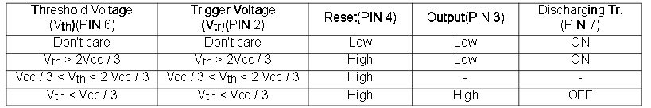

Basic Operation table

Monostable Operation**:**

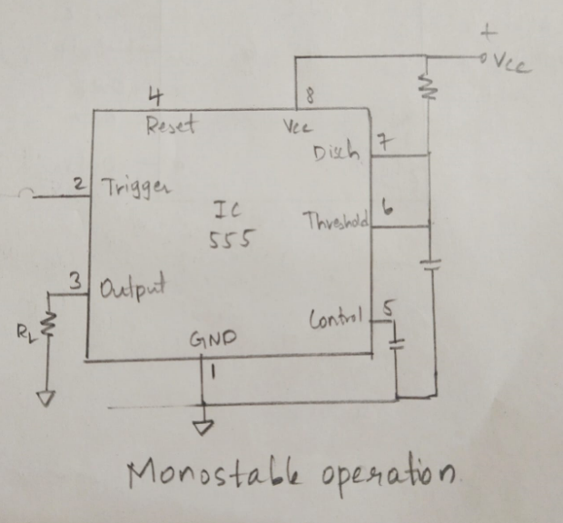

Monostable circuit

Monostable Multivibrator as its name indicates it has one stable state and it switches to unstable state for a predetermined time period T when it is triggered. The time period T is determined by the values of resistor and capacitor in the circuit. When a negative trigger less than Vcc/3 is applied on the Trigger input of 555, output goes high and capacitor starts charging through resistor R. When the capacitor voltage becomes greater than 2/3 Vcc, output goes low and capacitor discharges through internal transistor.

Astable Operation**:**

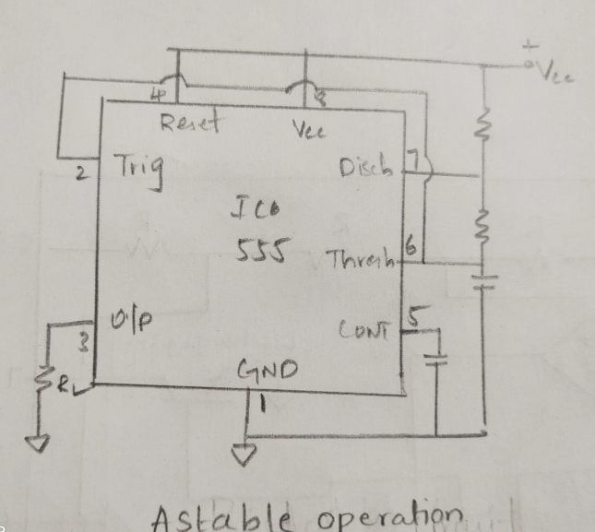

Astable circuit

Astable multivibrator has no stable states. In the astable operation, the trigger terminal and the threshold terminal are connected so that a self-trigger is formed. When the timer output is high, its internal discharging Transistor turns off and the voltage across capacitor increases. When it reaches 2Vcc/3, the first comparator output becomes high, resetting the F/F and causing the timer output to become low. This in turn turns on the discharging Transistor and the capacitor discharges through the discharging channel formed by Resistor and the discharging Transistor. When the voltage falls below Vcc/3, the second comparator output on the trigger terminal becomes high and the timer output becomes high again then capacitor starts charging again repeating the similar process.

Bistable Operation:

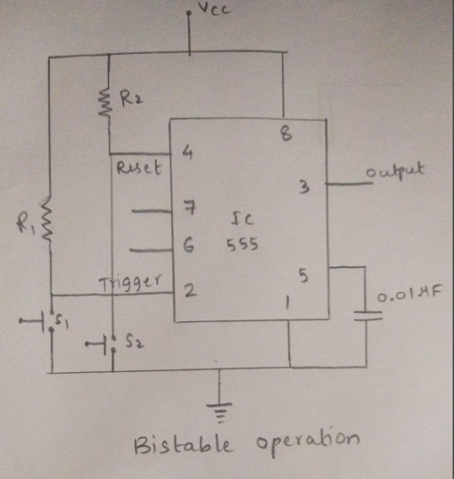

Bistable circuit

There are two stable states in a bistable multivibrator. The external trigger and reset inputs regulate the creation of high and low outputs rather than the charging and discharge of the capacitor in the RC unit.

Two resistors, R1 and R2, are used to link the trigger and reset pins to the Vcc so that they are permanently high. To briefly make these pins low, switches are connected between them and ground. The flip-flop's internal set input will be the switch at the trigger input. The internal flip-flop will be reset by the switch at the reset input.

Bypassing the trigger terminal when the switch S1 is depressed, the voltage from VCC instead shorts to ground via the resistorR1. As a result, the trigger pulse will briefly become low and the timer's output at pin 3 will turn high. Because there is no input from the threshold pin, the output of the internal first comparator does not go high, hence the output remains high.

Bypassing the reset terminal when the switch S2 is depressed, the voltage from VCC instead shorts to ground via the resistor R2. This pin is internally wired to the flip-flop's reset terminal. The flip-flop receives the reset signal and is reset when this signal briefly drops low. Hence, the output will become low and stays there until the trigger is applied.

IC CD4026

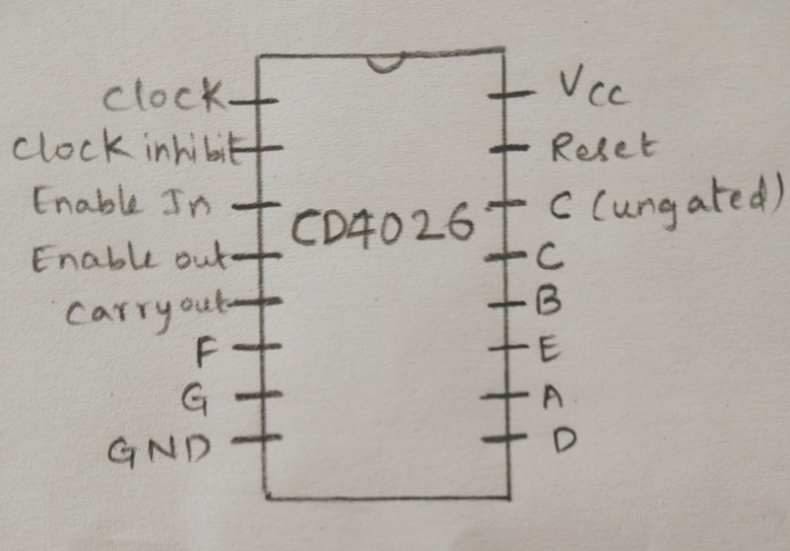

pin diagram

A Johnson counter IC, or CD4026, is frequently used in digital displays. It has a decoder that turns the Johnson code into a 7 segment decoded output and a five stage Johnson decade counter. It will simply translate the input into a numeric display that can be viewed on a 7-segment display or using LEDs. The CD4026B IC is designed to drive common cathode or common anode 7-segment displays, depending on the specific variant of the IC. It can directly drive a 7-segment display without the need for external current-limiting resistors. The decoded outputs are connected to the corresponding segments of the display, and the desired digit is displayed by activating the appropriate output pins.

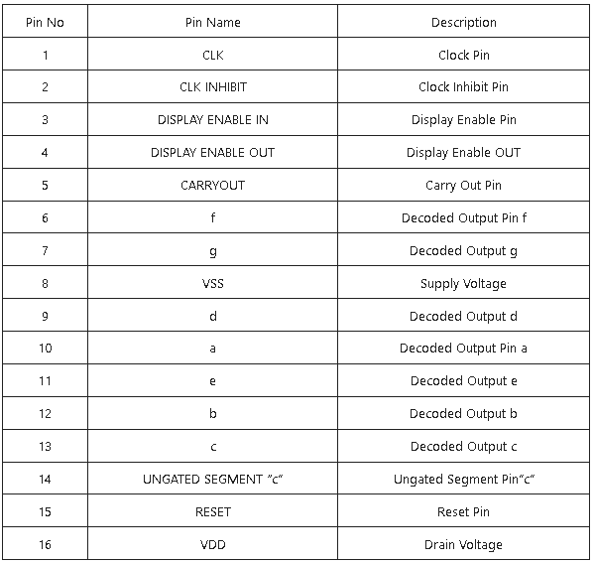

IC CD4011

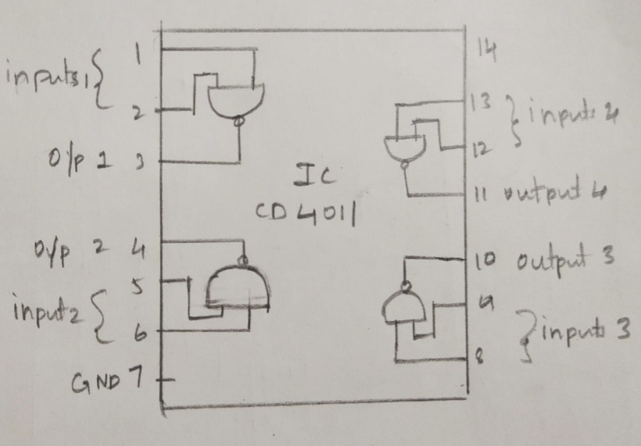

Pin diagram

The CD4011 is the complementary metal oxide semiconductor (CMOS) chip that is most frequently utilised. On a single chip, the integrated circuit (IC) includes 14 pins and four distinct NAND gates (N1, N2, N3, N3). Each NAND gate has a single output and two inputs. To operate, the cd4011 integrated circuit needs between 5V and 16V. Each output can deliver an output current of about 10 mA at 12V, although this range can be reduced when the power supply voltage drops. The positive battery terminal was connected to pin 14 while the negative battery terminal was connected to pin 7.The IC's output pins are 3,4,10, and 11, whereas its input pins are 1,2,5,6,9,8,12, and 13.

**Circuit diagram**

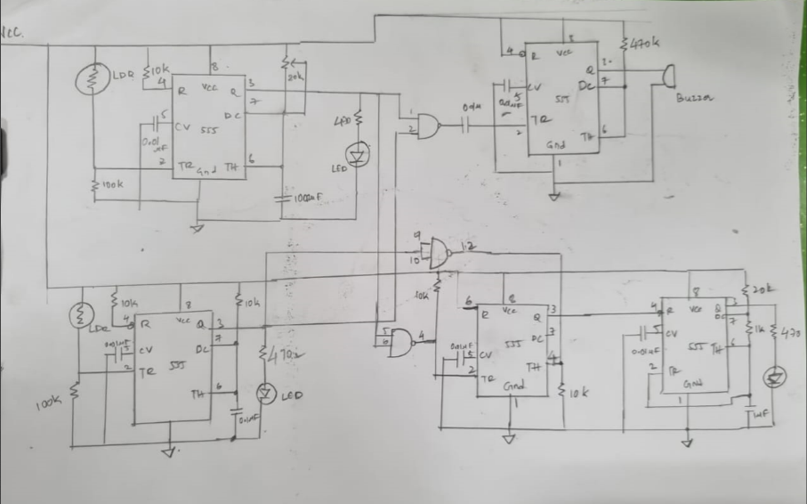

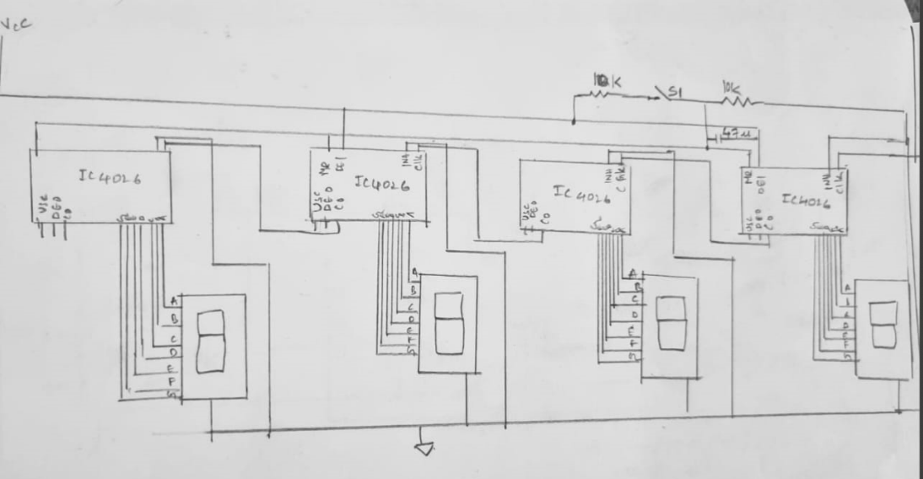

**Working**

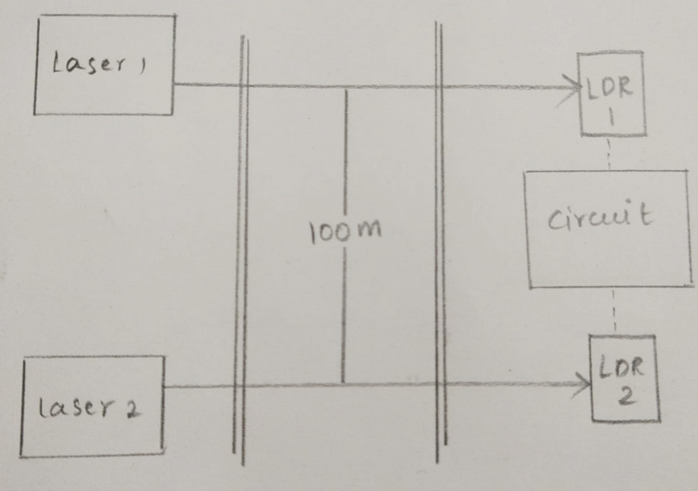

The time period of timer IC1 count-start monostable multivibrator is adjusted using resistors R and capacitor C. For 70kmph limit the time period is set for 5 seconds Normally, laser always strikes LDR and thus the LDR offers a low resistance and pin 2 of IC1 is high. Whenever light falling on the LDR is interrupted by any vehicle, the LDR resistance goes high and hence pin 2 of IC1 goes low to trigger the monostable. As a result, output pin 3 goes high for the preset period (5 seconds) and LED1 turns on to indicate it. Similarly, For IC2 the monostable is triggered when the vehicle intersects the laser beam incident on LDR2 to generate a small pulse for stopping the count and for use in the speed detection. LED2 glows for the duration for which pin 3 of IC2 is high.

The outputs of IC1 and IC2 are inputs of NAND gate. When the outputs of IC1 and IC2 go high simultaneously (Indicating the high speed of the vehicle), output Nand gate goes low to trigger monostable timer IC3. The output of IC3 is used for controlling piezo buzzer PZ1, which alerts the operator of speedlimit violation.

The output of IC1 triggers the bistable IC4 through Nand gate and which enables the IC5 astable multivibartor to act as a clock to the counters. The count-stop pulse output of IC2 is connected to pin 6 of IC4 via diode, it resets clock generator IC5

IC5 is configured as an astable multivibrator whose time period is set to 0.01 seconds( hence the resolution that can be seen on seven segment display is 0.01 seconds. The output of IC5 is fed to clock pin 1 of decade counter/7-segment decoder IC6 CD4026 .The counter advances by one count at the positive clock signal transition and the carry-out (Cout) signal from CD4026 provides one clock after every ten clock inputs to clock the succeeding decade counter. A multidecade counting chain is achieved by connecting pin 5 of each CD4026 to pin 1 of the next CD4026. A high reset signal clears the decade counter to its zero count. Pressing switch S2 provides a reset signal to pin 15 of all CD4026 ICs and also IC1 and IC4.

The seven decoded outputs ‘a’ through ‘g’ of CD4026s illuminate the proper segment of the 7-segment displays used for representing the decimal digits ‘0’ through ‘9’.

**Calculations**

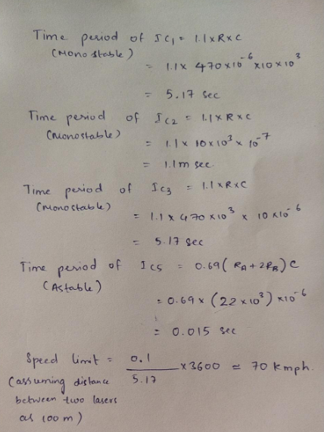

**Simulation Output**

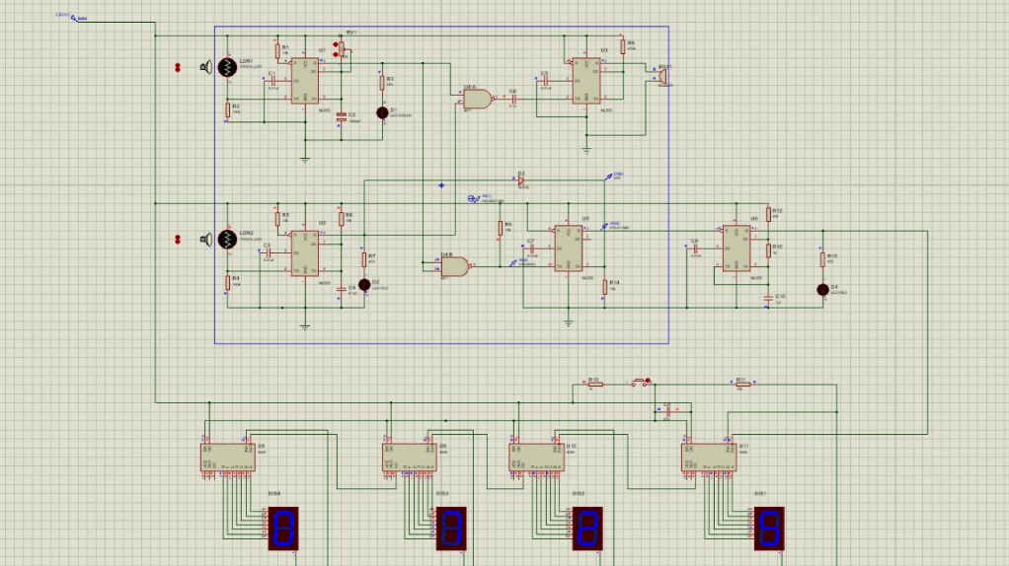

**Observations**

Time period of IC1 = 5.4 seconds

Time period of IC2 = 0.001 seconds

Time period of IC3 = 5.15 seconds

Speed limit = Distance/time = (0.1*3600)/5.4 kmph = 66.66kmph

**Applications**

* Road Safety: By enforcing speed limits and detecting over-speeding vehicles, road safety can be improved, reducing the chances of accidents and enhancing overall traffic management.
* Traffic Management: Monitoring the speed of vehicles helps in better traffic management, enabling authorities to identify congestion-prone areas and implement appropriate measures to regulate traffic flow.
* Law Enforcement: Over-speed detection systems provide valuable evidence for law enforcement agencies, aiding in the identification and prosecution of traffic violators.
* Intelligent Transportation Systems: Over-speed detection is a component of intelligent transportation systems (ITS), which aim to integrate advanced technologies for efficient and safe transportation management.

**Conclusion**

Implemented the “Over-speed detection” circuit. From point of view of safety on the Mega Highway we feel that if mega highway is supported with such faithful system then will not only help to maintain the traffic rules but also reduces accidents. As system is compact & user friendly so can be handled efficiently

**References**

[**https://circuitdigest.com/electronic-circuits/ac-to-dc-converter-circuit-diagram**](https://circuitdigest.com/electronic-circuits/ac-to-dc-converter-circuit-diagram)

[**https://freakengineer.com/7812-voltage-regulator/**](https://freakengineer.com/7812-voltage-regulator/)

[**https://www.electronicshub.org/understanding-555-timer/**](https://www.electronicshub.org/understanding-555-timer/)

[**https://www.circuits-diy.com/simple-seven-segment-counter-circuit-using-cd4026/**](https://www.circuits-diy.com/simple-seven-segment-counter-circuit-using-cd4026/)