**Project Title: Personal Blog on IBM Cloud Static Web Apps**

**Problem Statement:**

Create a personal travel blog hosted on IBM Cloud Static Web Apps. Share your travel adventures, tips and captivating photos with the world. Use IBM Cloud Static Web Apps to easily update your blog and document your journeys. Inspire others to explore the beauty of the world and forge unforgettable memories!

**Problem Definition:**

The objective of this project is to establish a personal travel blog hosted on the IBM Cloud Static Web Apps platform. The primary goal is to create an enticing platform that effectively shares travel adventures, provides valuable travel tips, and showcases captivating photos. The ultimate aim is to inspire and motivate readers to embark on their own journeys, explore the beauty of the world, and create unforgettable memories.

**Project Objective:**

The primary goal of our travel blog is to inspire and empower people to explore the world, discover new cultures, and create unforgettable memories through travel. Our target audience includes travel enthusiasts, adventure seekers, and anyone who shares a passion for exploring new places and experiences.

**Design Thinking:**

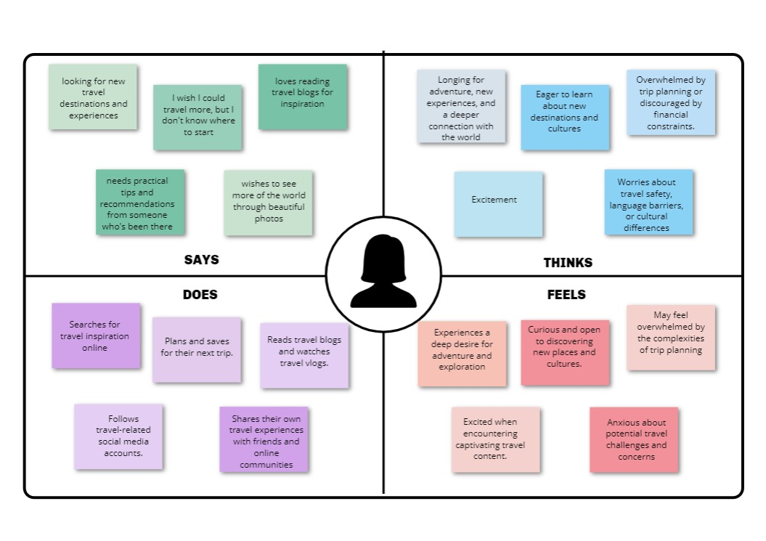

**1.Content Planning:**

Creating a well-structured blog is essential for providing an excellent user experience and ensuring that the content is easily accessible and organized.

**1. Home Page:**

A brief welcome message introducing ourself and the blog's purpose. It also has a Highlight a selection of the most recent or popular posts. There will also Search Bar Allow users to search for specific destinations, topics, or keywords. A Navigation Menu will be present to maintain a clear and user-friendly menu with links to various sections of the blog.

**2. Travel Stories:**

This section will be dedicated to sharing the personal travel narratives and experiences. Each travel story will have its dedicated page or post. Organize stories by destinations or themes, making it easy for readers to find content. Also Include captivating images to complement each story.

**3. Travel Tips and Guides:**

This section provides practical advice and tips for travellers, such as packing guides, budgeting tips, and travel planning. Creating destination-specific guides with itineraries, must-see attractions, and local insights. Organizing tips by categories, such as "Travel Essentials," "Travel Planning," and "Travel Safety."

**4. Photo Journals:**

Showcasing stunning travel photography in a visually appealing gallery format. Each photo journal focuses on a specific destination, experience, or theme. Captions are provided that tell the story behind each image. Responsive image gallery can be used to ensure optimal viewing on various devices.

**5. Interactive Map:**

Create an interactive map using Google Maps or a similar tool to visualize the places that have been visited. Pinpointing the locations mentioned in the travel stories and link to the respective posts. Including a legend or key for different types of destinations or experiences.

**7. Connect:**

Including links to the social media profiles for readers to follow the journeys in real-time.

**8. Resources and Recommendations:**

Creating a section where it recommends travel-related products, books, apps, and services. Offer honest reviews and insights into the resources you recommend.

**9. Comments:**

Enabling comments on the blog posts to encourage reader interaction and actively respond to comments and engage in discussions.

**2.Content Creation:**

Planning to put subsection "Travel Stories," with subcategories like "Solo Adventures," "Family Travel," and "Experiences" for more organized content, also there is a plan to include gallary and also share the locations of various destinations. It also includes the Travel tips to help other travellers. Explore the possibility of creating video content, virtual tours, or 360-degree photos to enhance the storytelling experience.

**3.Website Design:**

Developing a user friendly and simple layout that is easier to navigate and also made responsive to support different devices. Using visually pleasing design that aligns with the theme of the website. HTML and CSS will be used to create the layout of the website and its appearance and JavaScript will be used to make the site interactive.

**4.IBM Cloud Setup:**

Setting up an account on IBM Cloud and creating a Static Web App to host the travel blog involves several steps.

**1. Create an IBM Cloud Account:**

Visit the IBM Cloud website. Click on the "Sign Up" or "Create an IBM Cloud account" button. Follow the registration process, providing the required information.

**2. Log into Your IBM Cloud Account:**

After creating your account, log in to IBM Cloud with your credentials.

**3. Create a Static Web App:**

In the IBM Cloud dashboard, navigate to the "Create Resource" option. You can often find this on the homepage or in the resources section. Use "Static Web App" or "Cloud Foundry" in the catalogue of available services. Click on the "Static Web App" service or the "Cloud Foundry" service to create a new instance.

**4. Configure Your Static Web App:**

Specify a unique name for your app. Choose the region where you want to deploy your app (select the region closest to your target audience for better performance).Configure the route or domain where your app will be accessible Set up any additional settings as needed. You can often leave most settings at their default values for a simple static website.

**5. Upload Your Blog Files:**

Once the app is created, a dashboard or control panel will be visible for the app. Upload the blog's HTML, CSS, JavaScript, and image files to the app's server.

**5.Content Management:**

**1. WordPress (CMS):**

WordPress is one of the most widely used content management systems globally, known for its user-friendliness and extensive plugin ecosystem. It's an excellent choice if you want a dynamic blog with frequent updates and a wide range of themes and plugins to enhance functionality. Choose WordPress if you want a user-friendly, feature-rich CMS, plan to frequently update your blog with dynamic content, and don't mind managing plugins and regular updates.

**2. Jekyll (Static Site Generator):**

Jekyll is a static site generator known for its simplicity and speed. It's an excellent choice for a blog that focuses on content and doesn't require dynamic features like user logins or real-time commenting. Choose Jekyll if you prefer simplicity, fast-loading pages, and are comfortable with Markdown and basic coding. It's excellent for content-focused blogs that don't require complex features.