**PHASE 2 : INNOVATION**

Travel blog is where people can share their thoughts, experiences, and tips about travel.

**HOME PAGE:**

Creating a personal travel blog home page is an exciting way to showcase the adventures and invite readers to explore your travel experiences. The home gives an overview of the entire blog and helps in navigating in among the pages of the blog.

* **Header Section:**
  + The name of the blog is displayed right on the top of the page.
  + A navigation menu is added to link with various sections of the blog such as Home, Travel Stories, Tips and Guides, Journals, Contact.
  + The header section will be displayed in all the pages and is kept fixed for easier navigation
* **About Me Section:**
  + This section of the home page describes a brief information about myself and the passion of the travel.
  + It also includes the recent places of the travel and also gives an overview of what can be expected for the blog.
* **Featured Destinations/ Latest Blog Posts:**
  + This part highlights the favorite travel destination along with a small description .
  + It also contains links to some of the latest blog posts with a description to make the user view them.
* **Reviews:**
  + The reviews for various readers are showcased here
* **Social Media Icons:**
  + Different social media icons are linked to the blog to follow in various platforms.

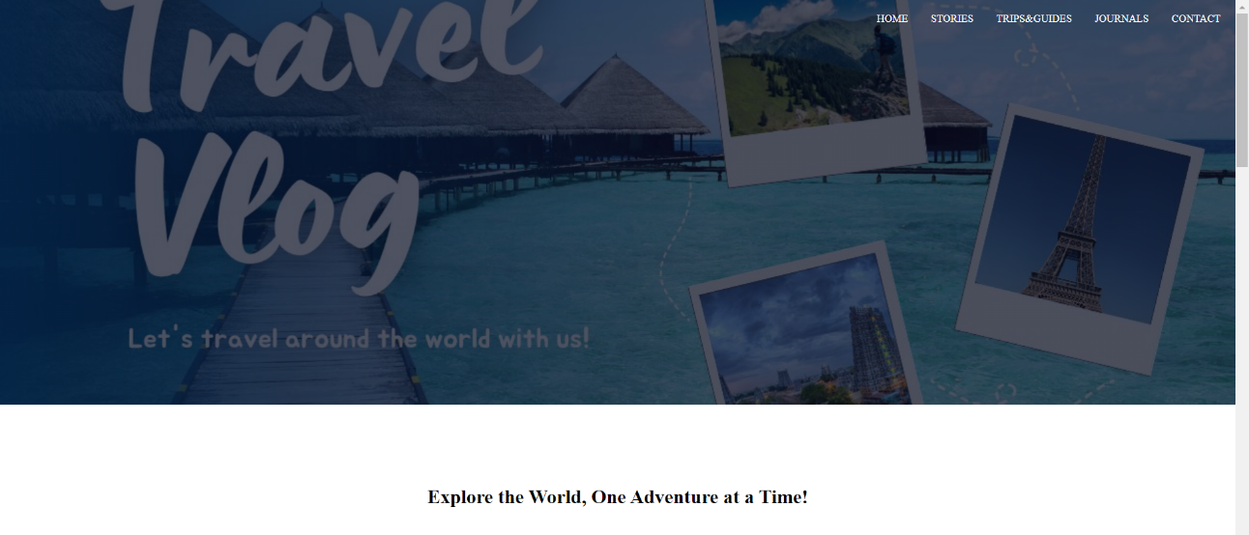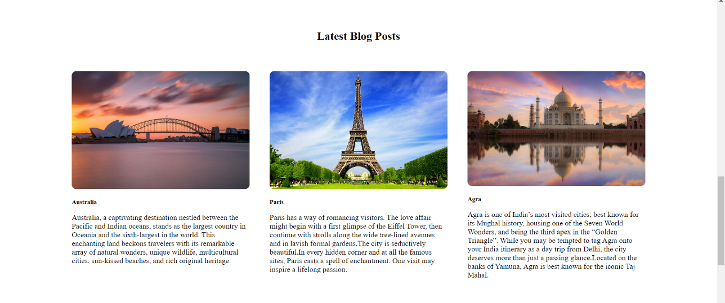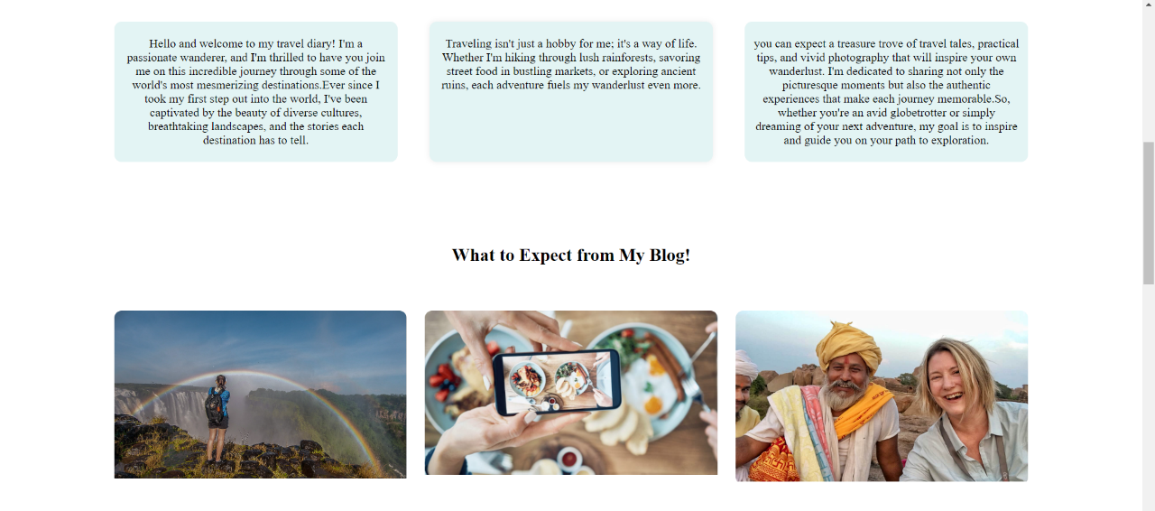

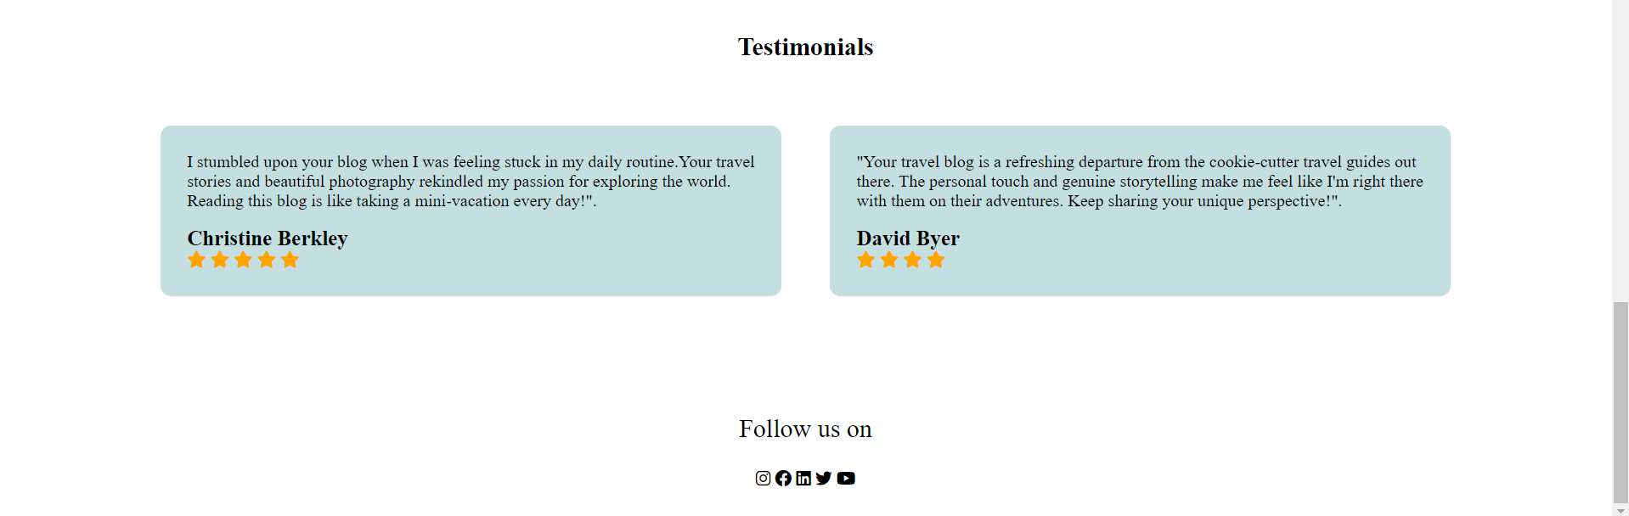

**TRAVEL STORIES:**

* **Navigation Instructions:**
  + The instructions provide straightforward instructions regarding how to navigate the page and access the various travel stories.
  + It demonstrates how the map's interactive feature works, including how to access stories by clicking on markers.
* **Photo Grid:**
  + The layout of interesting travel photographs, each of which links to a separate travel story. Users are taken to the complete story whenever they click on a photo.
* **Select Your Trip Stories:**
  + Select a few of the most captivating and unforgettable travel experiences to highlight on this page. The variety of sites and activities are highlighted.
* **Storytelling:**
  + The colorful and detailed phrases for your travel adventures are created. Write in a way that allows readers to visualize the locations and happenings.
  + Share experiences, emotions, and thoughts from your travels.
  + Use storytelling tactics such as suspense, comedy, and humor for the experience of travelers.
  + Photos and Multimedia:
  + The story is enhanced with high-quality images and multimedia content. Photo galleries, videos, or audio recordings are embedded to complement the narrative.
  + Caption your media to provide context and share interesting details.

**DESTINATION PAGE:**

The "Destination" page on the travel blog is a place that provides comprehensive information about specific travel destinations that have been explored. This page serves as a valuable resource for the readers who are interested in learning more about a particular place.

This page provides information about various destinations across the globe that have been visited. A comprehensive overview is given in this page and in depth information about the place will be displayed in the separate page for each destination.

**For each destinations,**

Starting with an engaging introduction to the destination, the page provides a brief

overview of what makes this place special and why readers should be interested in it.

* **Geographical Information:**

Basic geographical details such as the country region and climate of the destinations are included.

* **Travel Highlights:**

This part highlights the key attractions and landmarks in the destination. It includes must-visit places, iconic sights, and unique experiences that the location offers.

* **Local Culture and History:**

Insights about the local culture, traditions, and history of the destination is shared here . Discuss any cultural festivals, historical events, or significant cultural practices.

* **Cuisine and Dining:**

This section describes the local cuisine, popular dishes, and dining experiences in that place. It also recommends restaurants or street food stalls where readers can taste authentic local flavors.

* **Activities and Adventures:**

It lists and describes various activities and adventures available in the destination.

* **Accommodation Options:**

This section provides information on different types of accommodation available, such as hotels, hostels, guesthouses, and vacation rentals. It also mentions about any unique or boutique accommodations.

* **Transportation:**

This part offers advice on how to get to the destination, whether by air, train, bus, or other modes of transportation. It Includes tips on local transportation within the area.

* **Best Time to Visit:**

It provides insights into the ideal times to visit, taking into account weather conditions, seasonal events, and crowd levels.

* **Photographs and Visuals:**

Enhance the page with a gallery of high-quality photos showcasing the beauty of the destination. Visuals help readers get a sense of the place.

* **Interactive Maps:**

It includes interactive maps that highlight key points of interest, recommended restaurants, and accommodations. Readers can use these maps for planning.

* **Links to Related Blog Posts:**

Links to your blog posts that specifically cover the destination. This allows readers to explore your detailed travel stories about the place.

**TIPS AND GUIDES:**

* **Tips:**

It provides their unique knowledge and insights to help you get the most out of your activities. From insider tips to tried-and-true techniques, we've got you covered.

* **Comprehensive Guides:**
  + Explore into our well-researched guides on a variety of topics. You'll find everything you need here, whether it's step-by-step tutorials, in-depth explanations, or how-to articles.
  + We believe in the effectiveness of actionable counsel. Our practical advice is intended to be immediately useful, assisting you in overcoming obstacles and achieving your objectives.
* **Inspiration and Ideas:**

Do you need some ideas? Explore our innovative ideas and thought-provoking articles that will ignite your interest and feed your imagination.

**JOURNAL PAGE:**

* **Intimate Reflections:**

Join us as we share our ideas, emotions, and experiences on a more intimate level. Our diary writings reveal our inner world, from life lessons to ordinary observations.

* **Professional Insights:**

Gain access to our professional skills and insights. We share industry trends, research, and suggestions to help you succeed in your own pursuits.

* **Travel Diaries:**

Follow our adventures as we visit new places, cultures, and landscapes. Find hidden treasures and travel advice for your next vacation.

**CONTACT:**

* **Contact Form:**

Please complete our simple contact form below. Please include your name, email address, subject, and message, and we will respond as soon as possible.

* **Email:**

You can also contact us by email at [your email address]. We make every effort to react to all emails as soon as possible, so please do not hesitate to contact us.

* **Social media:**

Provides icons to connect with various social media pages to stay updated.

**FLASK:**

* Flask is used to generate dynamic content for web sites. It communicates with databases, APIs, and other data sources to retrieve and present information to consumers.
* Flask is used to construct and execute online forms, which let users to submit data and interact with the application.
* Flask is used to create bespoke dashboards for corporations and organizations to monitor and analyze data.
* Flask can be combined with technologies such as WebSocket to create real-time web applications such as chat applications and live data dashboards.
* Flask is used to develop custom content management systems (CMS) for websites.

**IBM CLOUD:**

Database is used to maintain required data and is stored in the cloud where the website will be finally deployed.

IBM Cloud is utilized to host and serve a personal travel blog, powered by Flask framework. The blog's code repository is linked to IBM Cloud Static Web Apps, which automates deployment, scaling, and SSL certificate management. Custom domain configuration ensures accessibility through a unique URL. The service offers continuous integration, analytics, and cost management tools. This cloud platform streamlines web hosting, allowing the blogger to focus on content creation, audience engagement, and an exceptional user experience while benefiting from IBM's infrastructure and security features.