**To Supply Leftover Food To Poor**

### 1. Project Overview

### The "To Supply Leftover Food to the Poor" project is focused on addressing food wastage by redistributing surplus food to underprivileged individuals in various locations. Using Salesforce, the platform connects food donors—such as restaurants and individuals—with volunteers who pick up and deliver the food to those in need.

### The project leverages Salesforce automation tools, including Flow and Process Builder, to streamline the donation and distribution process. Custom objects manage entities like food donations, volunteers, and distribution locations. Automated workflows notify volunteers about available food pickups and track successful deliveries. Real-time reporting and dashboards offer visibility into donation trends and help optimize distribution.

### This initiative addresses two key challenges:

### Reducing food waste by channeling surplus food from donors to recipients.

### Fighting hunger through efficient and timely food distribution.

### By combining Salesforce technology with a community-driven approach, the project creates a scalable solution to reduce food wastage and hunger.

**2. Objectives**

**Business Goals:**

**Reduce Food Wastage:** Facilitate the collection and redistribution of at least 80% of surplus food from participating donors to underprivileged communities.

**Increase Volunteer Engagement:** Achieve a 50% increase in the number of volunteers actively participating in food distribution through the platform.

**Improve Distribution Efficiency:** Reduce the time between food donation and delivery by 30% through optimized volunteer assignments and automated notifications.

**Expand Donor Network:** Grow the number of regular food donors (e.g., restaurants, caterers) by 25% within the first six months of launch.

**Specific Outcomes:**

**Centralized Donation Platform:** A fully functional Salesforce system where food donors can log donations, and volunteers can track and accept tasks.

**Automated Workflow:** Automation of key processes like notifying volunteers of available donations and assigning them based on location.

**Real-Time Reporting:** Dashboards and reports that track donation volumes, volunteer participation, and distribution success rates.

**Increased Food Redistribution:** Deliver at least 500 meals per month to people in need using the automated platform.

**User-Friendly Interface:** A Lightning-based interface that allows easy access for donors, volunteers, and administrators to manage and monitor operations.

**3. Salesforce Key Features and Concepts Utilized**

**Salesforce Flows**: Used to automate key processes like food donation submissions, volunteer assignments, and notifications. Flows ensure that donations are automatically logged, volunteers are assigned based on proximity, and notifications are sent to both donors and volunteers.

**Lightning App Builder**: Designed user-friendly pages for donors, volunteers, and administrators, providing a streamlined interface for logging donations, managing tasks, and tracking distribution progress.

**Triggers**: Implemented custom Apex triggers to automate business logic, such as sending alerts when donations are received and ensuring volunteers are notified promptly when food is ready for pickup.

**Public Groups**: Created public groups to manage permissions and assign roles, enabling smooth coordination between donors, volunteers, and administrators. This also ensures secure data access and visibility based on user roles.

**Users**: Managed different types of users, such as donors, volunteers, and admins, each with customized access and permissions to perform specific tasks within the system.

**Report Types and Reports**: Custom report types were created to track donation volumes, volunteer participation, and food distribution. These reports provide actionable insights to optimize operations and measure success.

**Dashboards**: Built dashboards to visually represent key metrics, such as the number of meals distributed, donor activity, and volunteer engagement. Dashboards allow administrators to quickly assess performance and make informed decisions.

**4. Detailed Steps to Solution Design**

**Objects:**

1. **Venue Object**: Created to manage the locations where leftover food will be collected or stored before distribution.
2. **Drop-Off Point Object**: Represents the locations where food will be dropped off for recipients.
3. **Task Object**: Used to assign specific tasks to volunteers, such as food collection or delivery.
4. **Volunteer Object**: Tracks information about the volunteers participating in food collection and distribution.
5. **Execution Details Object**: Holds detailed information about the execution of food delivery tasks, including time, location, and completion status.

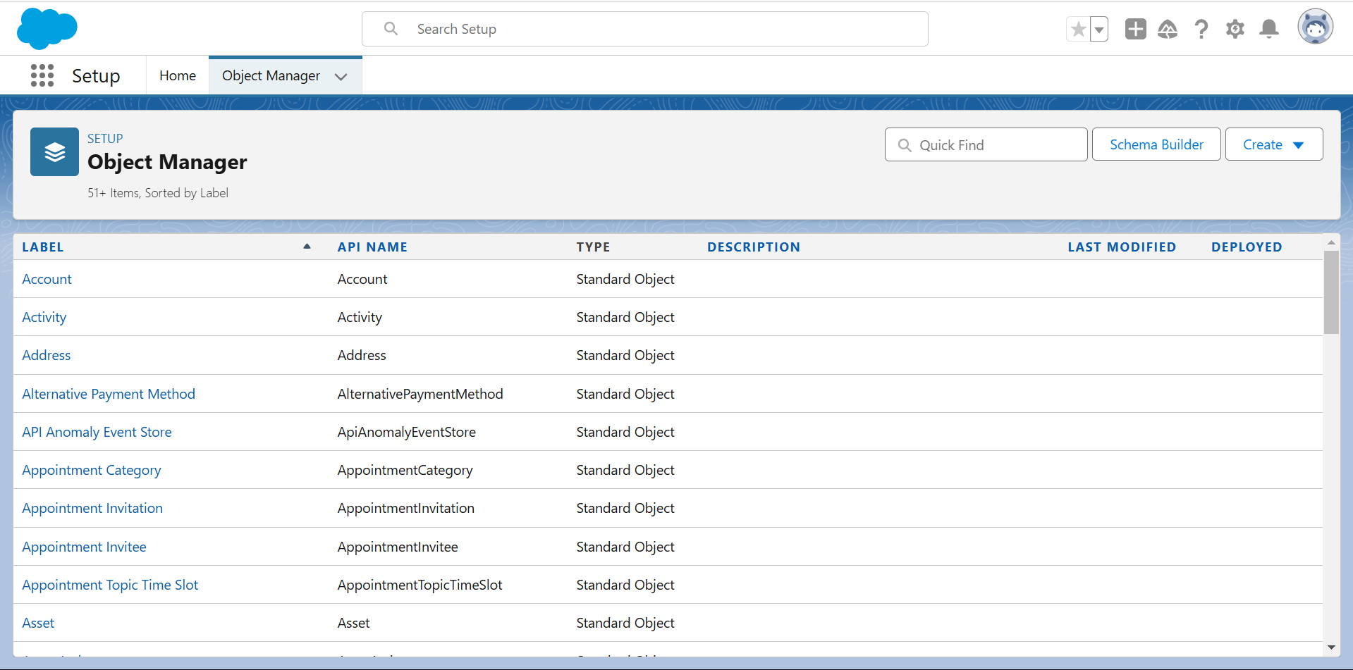

**Tabs:**

**Creating Custom Tabs**: Custom tabs were created to give users easy access to the objects, such as Venue, Drop-Off Point, Tasks, Volunteers, and Execution Details.

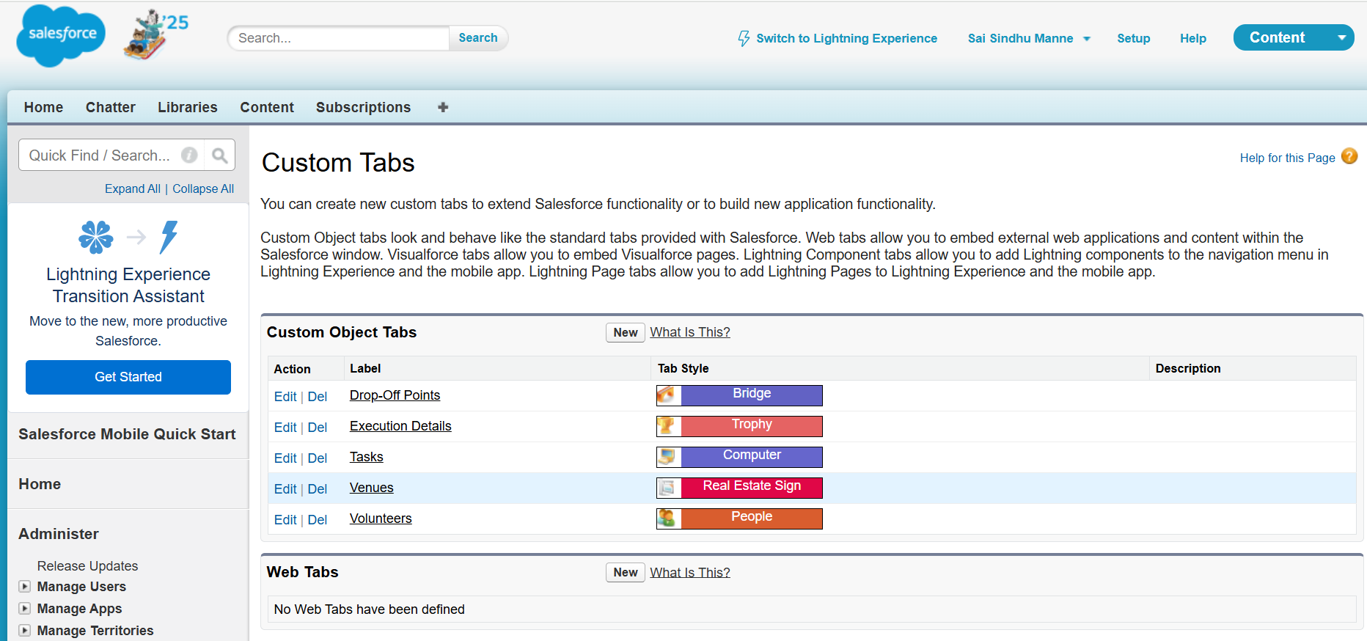

**Remaining Tabs**: Additional tabs were created to display other relevant information and streamline the navigation for users.

**The Lightning App:**

**Create a Lightning App**: A custom Lightning app was developed to provide a streamlined interface for all users, including donors, volunteers, and admins, making the process of logging and tracking food distribution seamless.

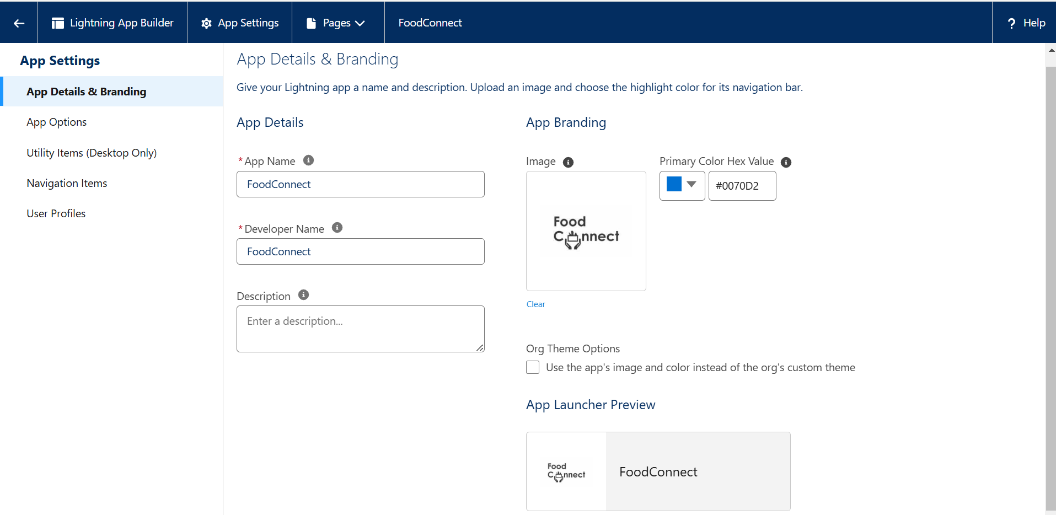

**Food Connect Logo:**



**Fields:**

**Creation of Relationships**: Defined relationships between the Venue, Drop-Off Point, Task, and Volunteer objects to establish logical connections in the system.

**Fields in Objects**:

* 1. **Venue Object**: Created fields such as Venue Name, Location, Capacity, and Contact Details.
  2. **Drop-Off Point Object**: Created fields like Drop-Off Point Name, Address, and Contact Person.
  3. **Task Object**: Created fields for Task Name, Task Description, Assigned Volunteer, and Due Date.
  4. **Volunteer Object**: Created fields for Volunteer Name, Contact Information, Availability, and Assigned Tasks.
  5. **Execution Details Object**: Created fields to track Completion Time, Delivery Status, and Feedback.

**Flows:**

**Create Flow for Venue Object**: Developed a flow to automatically create a record in the Venue object when a donor logs a new location.

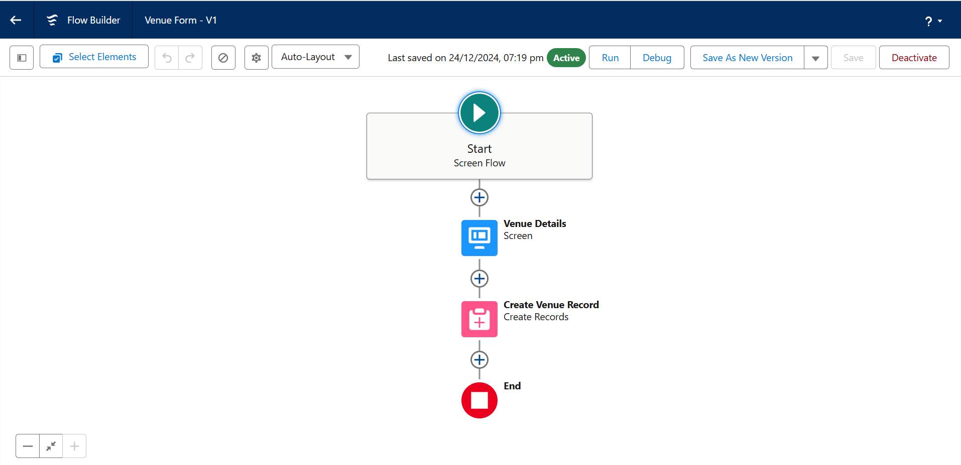

**Triggers:**

**Create a Trigger**: A trigger was implemented to automatically notify volunteers when a new task is created for food collection or delivery.

* 1. **Trigger Code**: Apex code was written to ensure real-time notifications and task updates for volunteers.

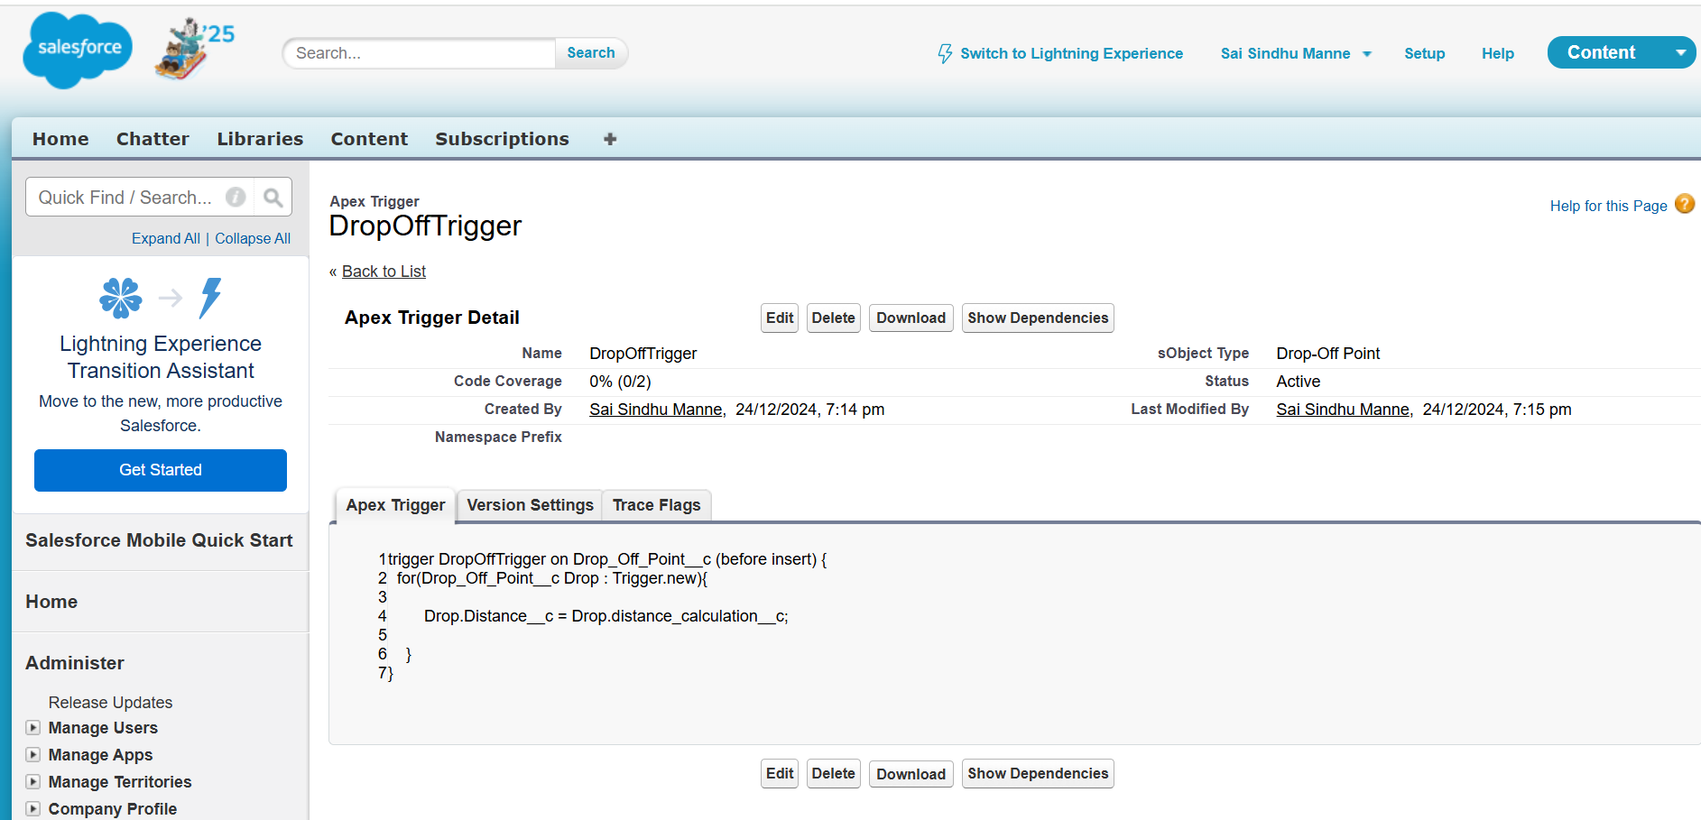

**Profiles:**

**Creation of Users**: Different user profiles were created for donors, volunteers, and admins to control access and permissions.

* 1. **User1, User2, User3**: Custom profiles were set up for different roles with specific access rights.

**Public Groups:**

**Creation of Public Group 1 and 2**: Public groups were created to manage user permissions and ensure proper collaboration between volunteers and admins.

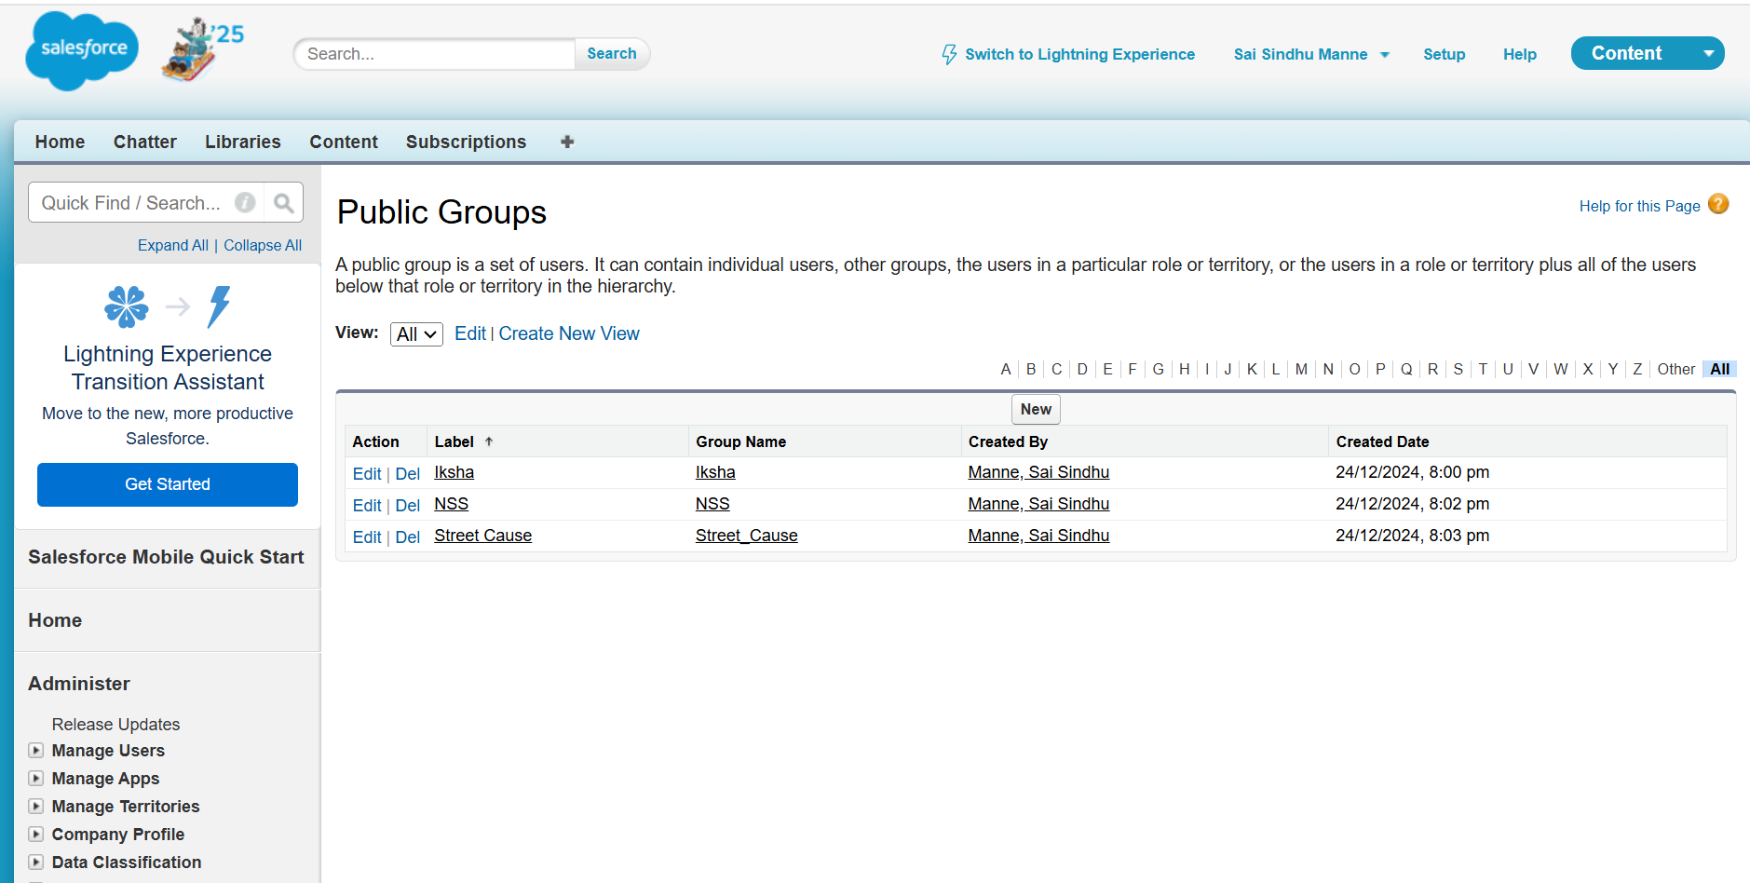

**Report Types:**

**Creation of Report Types**: Custom report types were developed to track various aspects of the project, such as Venue and Drop-Off Points, and Volunteers with Tasks and Execution Details.

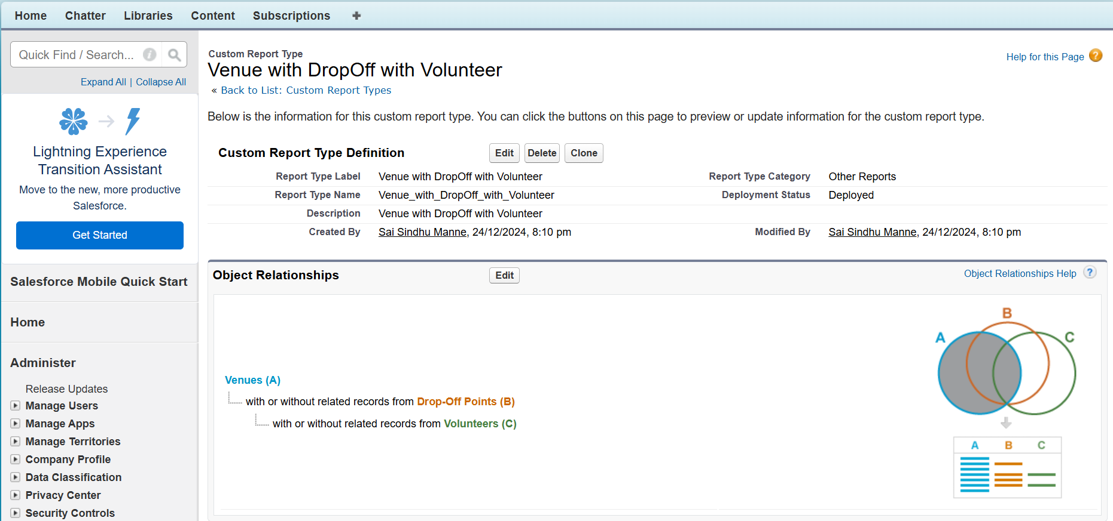

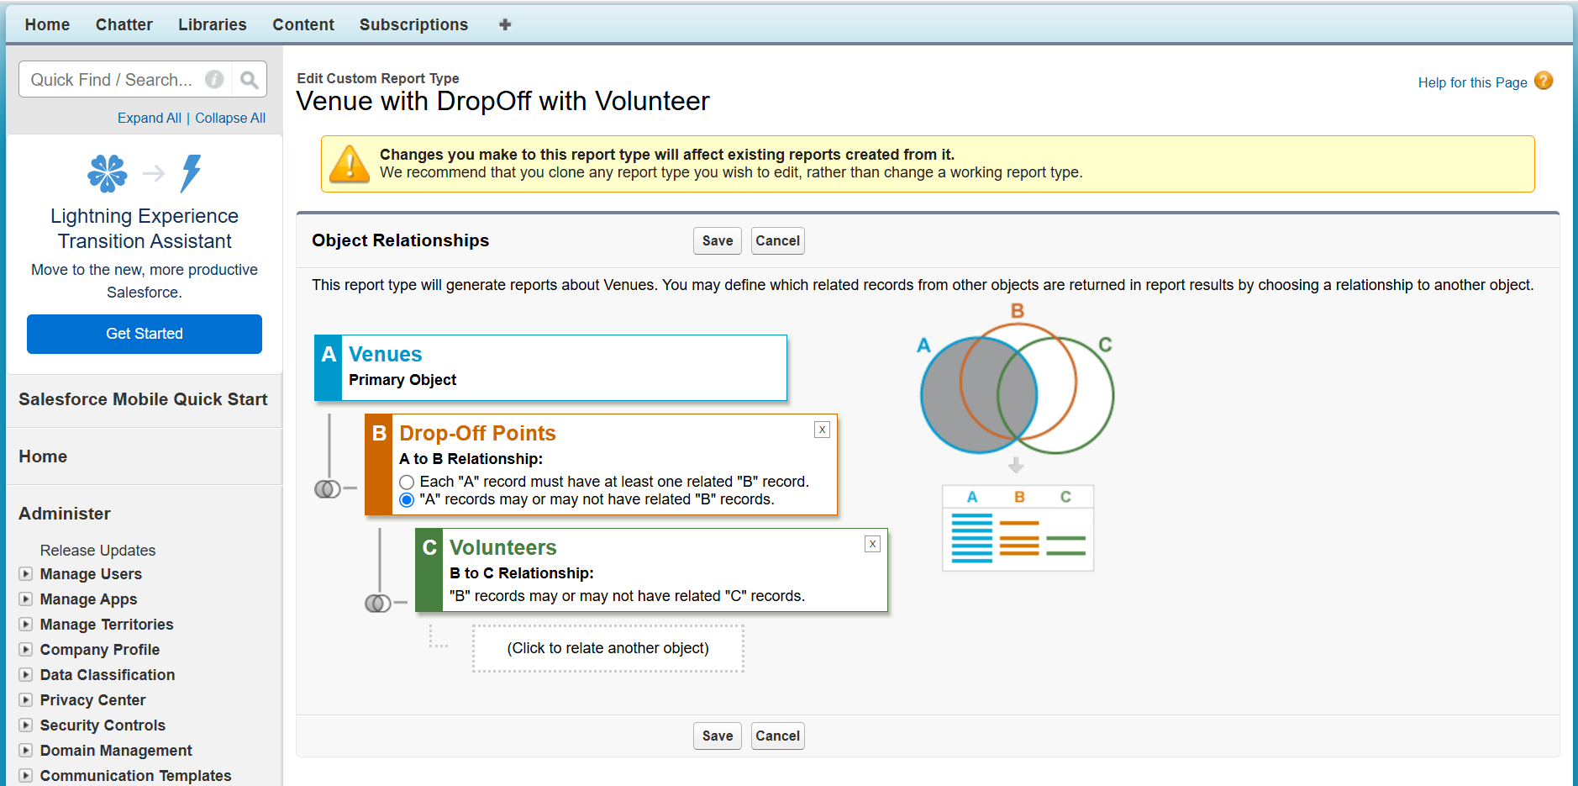

**Reports:**

1. **Creation of Venue and Drop-Off Report**: A report was created to monitor the relationship between venues and their corresponding drop-off points.
2. **Creation of Volunteer and Execution Report**: Another report was designed to track volunteer activity, tasks completed, and execution details.

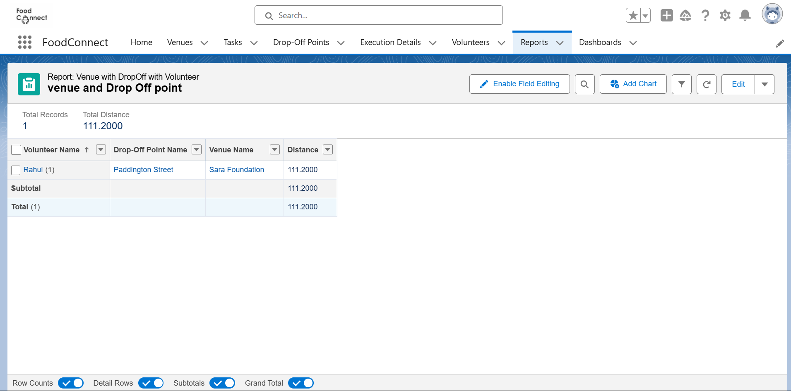

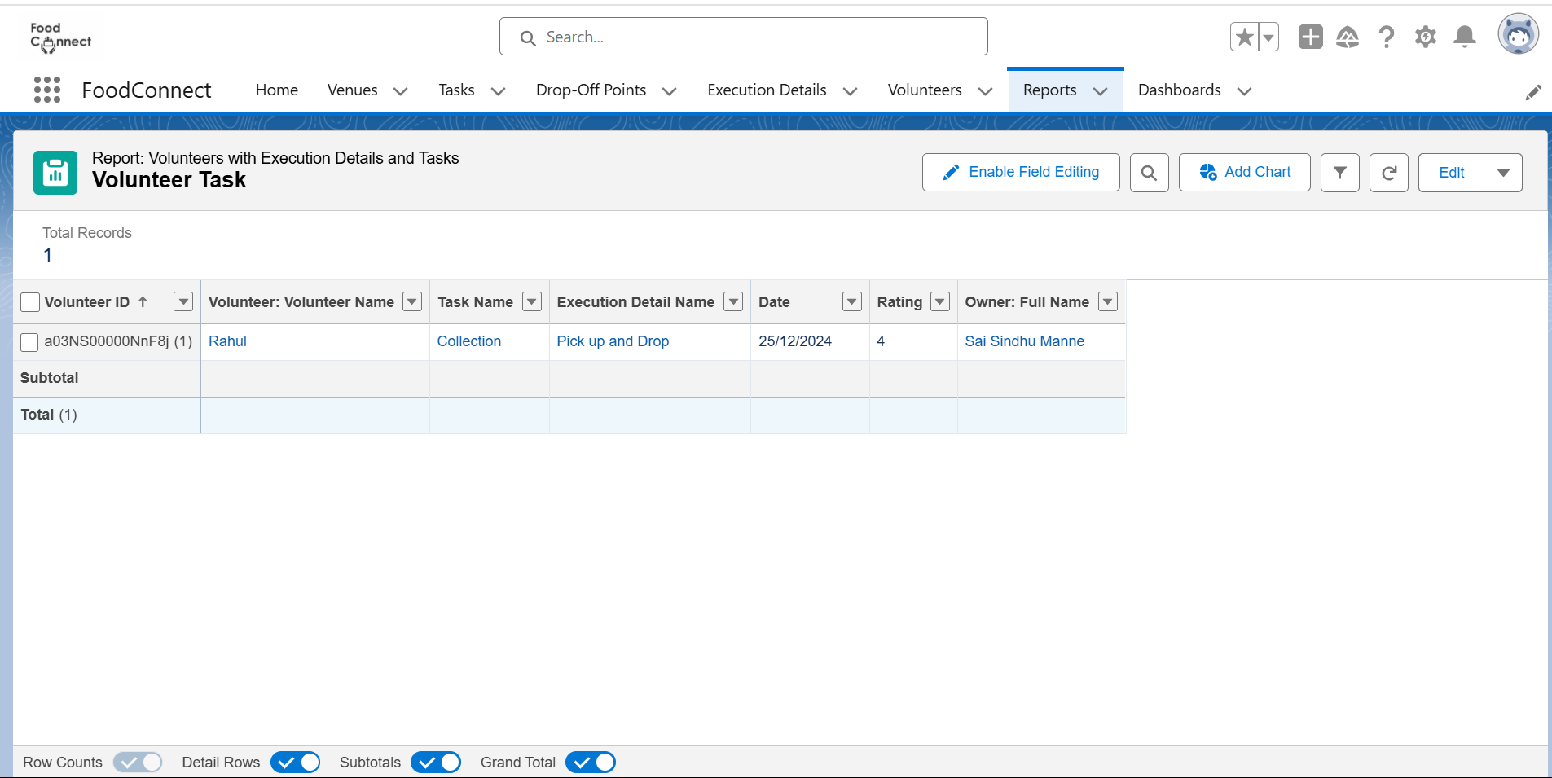

**Dashboards:**

* **Adding Venue and Drop-Off Report**: The Venue and Drop-Off Point report was added to the dashboard for real-time monitoring.

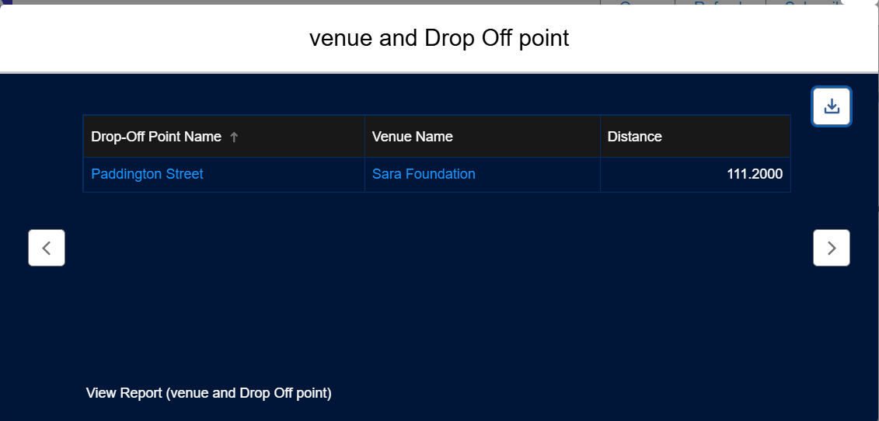

* **Adding Volunteer Task Report**: The Volunteer Task report was added to the dashboard to visualize task completion and volunteer engagement.

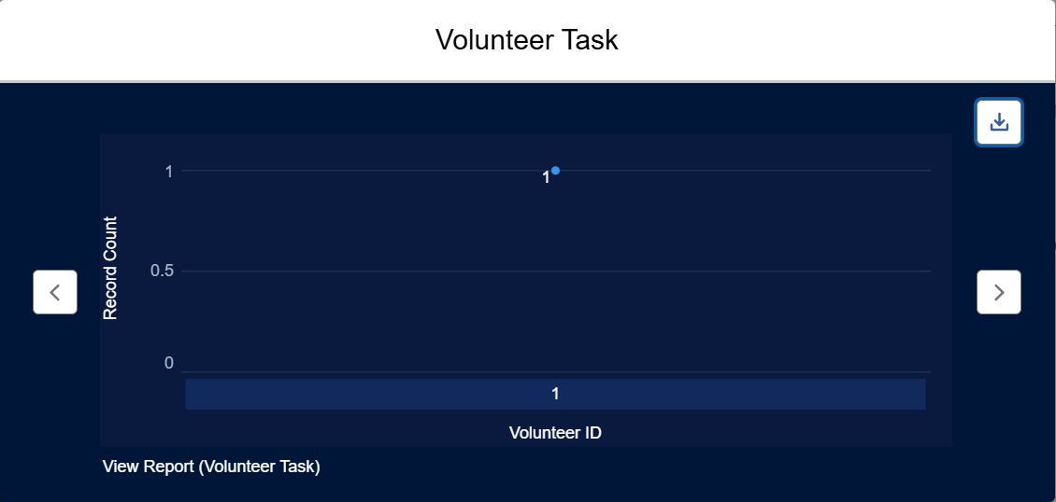

* **Adding a Picture (Optional)**: An optional picture was added to the dashboard for a personalized touch.

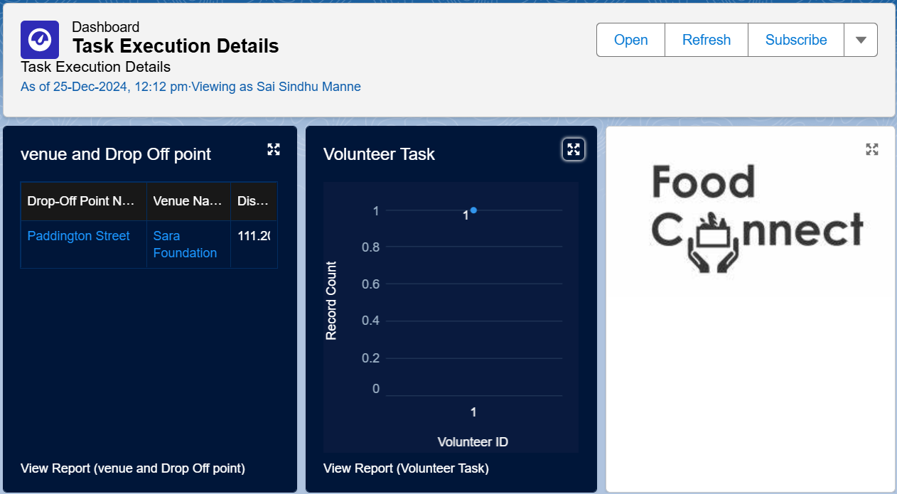

**Sharing Rules:**

**Creation of Sharing Rules**: Sharing rules were implemented to ensure secure data access and sharing based on user roles and public groups.

**Home Page:**

**Creation of Home Page**: A custom home page was designed for users to easily access key reports, dashboards, and objects related to the project.

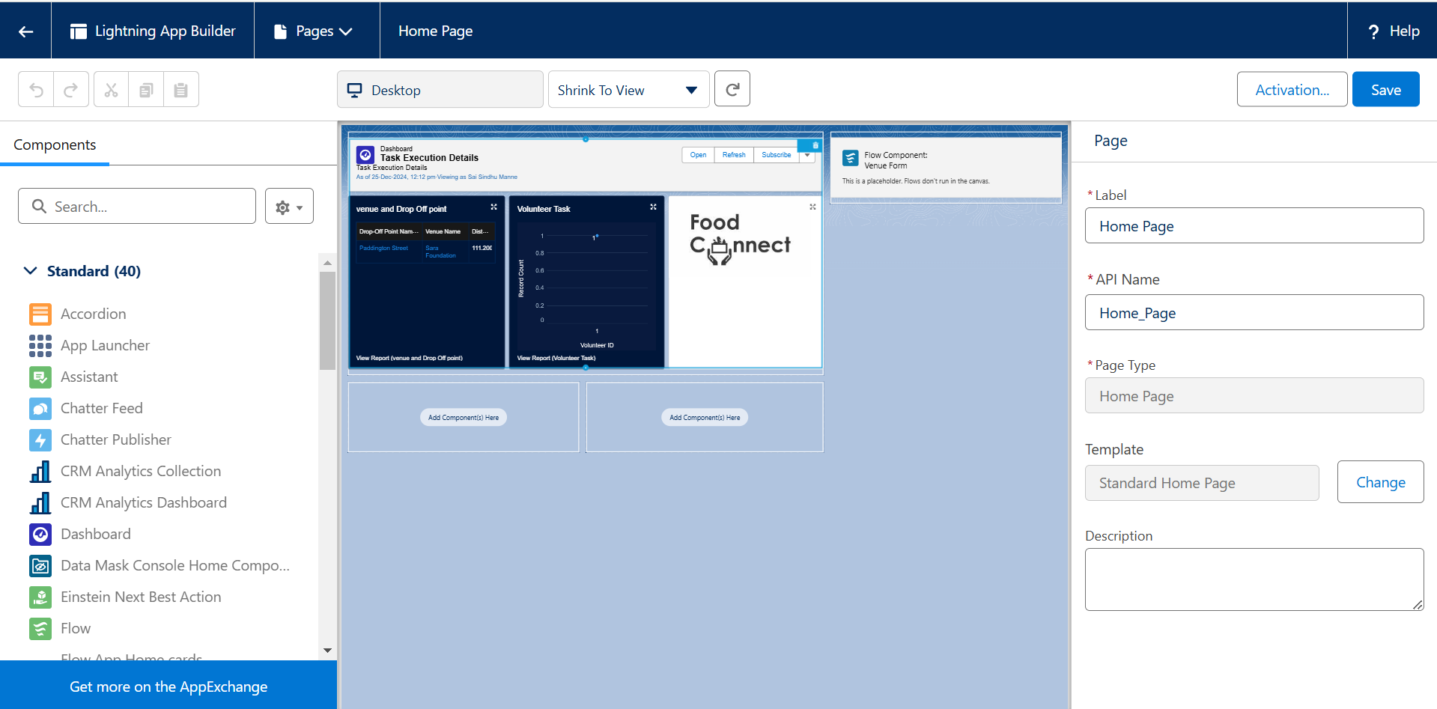

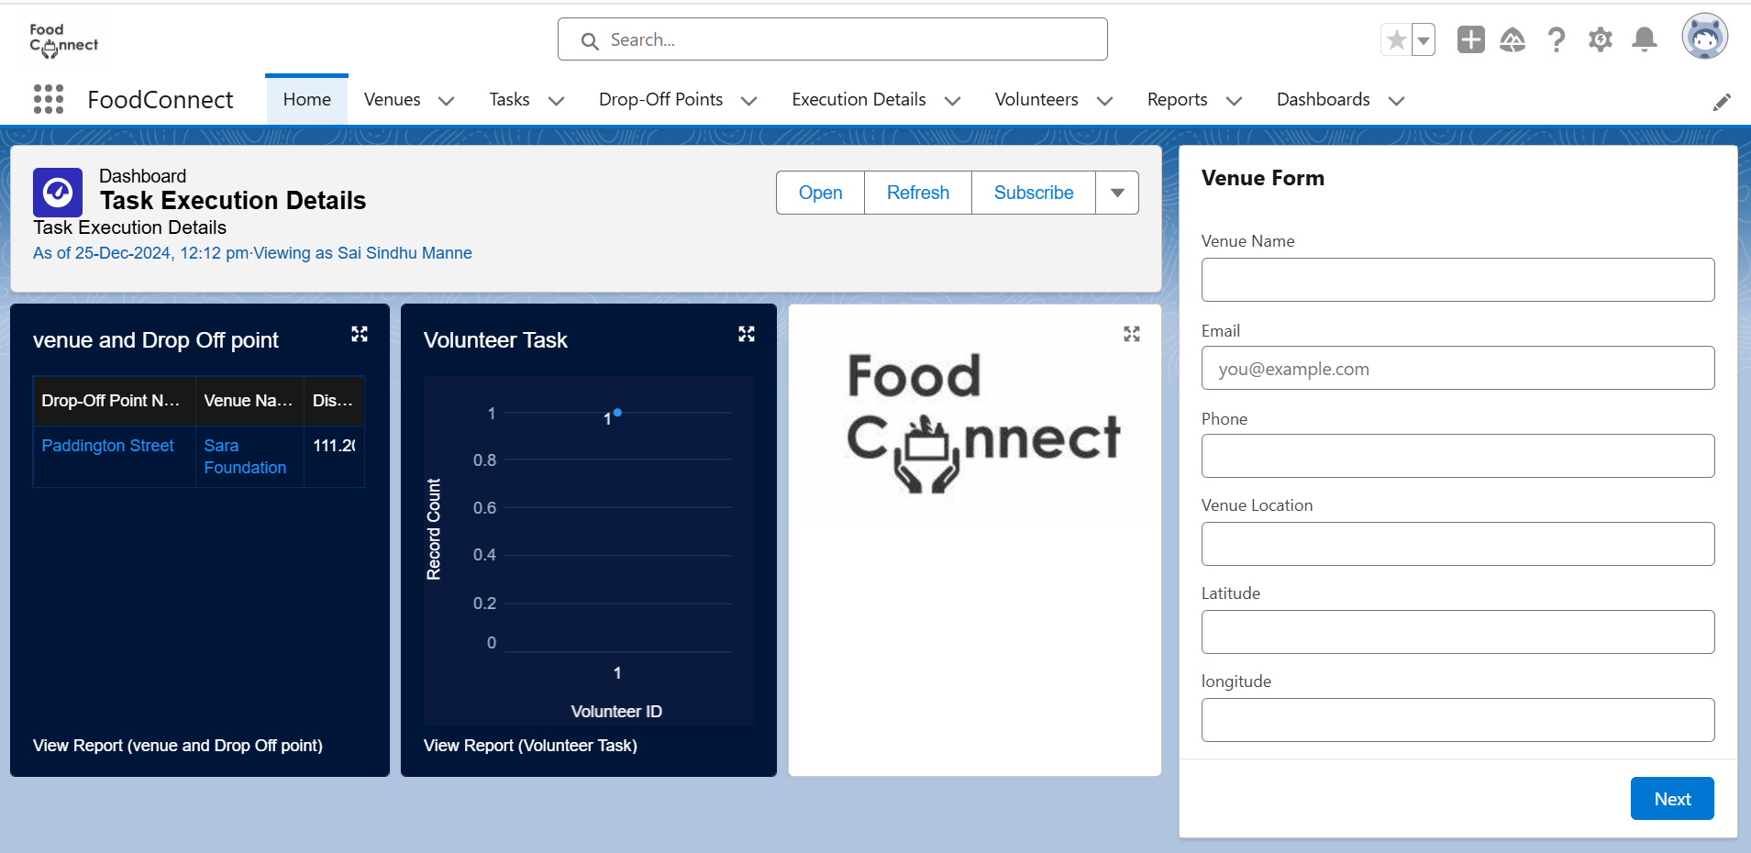

**Venue Form:**

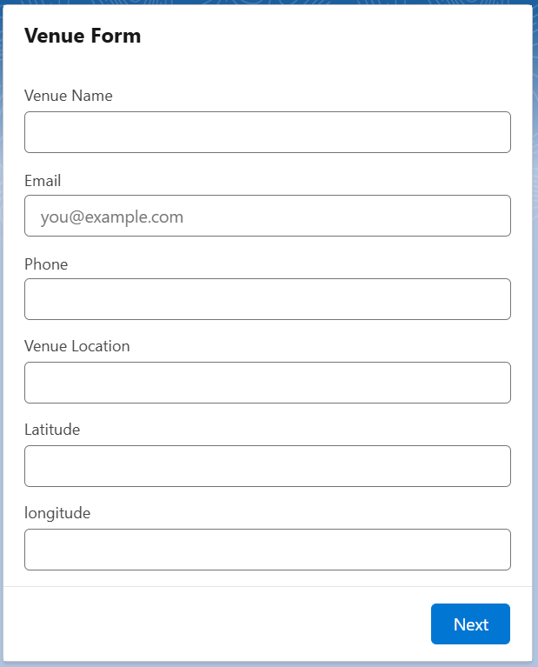

**5. Testing and Validation**

Testing and validation ensure the functionality and reliability of the **Drop-Off Point** feature. Unit testing will be conducted on the **Drop-Off Trigger** to verify record creation, mandatory field validation, and error handling. Additionally, user interface testing will assess the display of **Drop-Off Point** records, form functionality, and user interactions. This comprehensive approach will confirm that the application meets user requirements and operates smoothly before deployment.

**6. Key Scenarios Addressed by Salesforce in the Implementation Project**

The implementation project addresses several key scenarios to ensure efficient management and operation of the volunteer and drop-off logistics system. These scenarios include:

1. **Creation and Management of Venue and Drop-Off Points:**
   1. Users can create, update, and manage records for venues and drop-off points, ensuring accurate tracking of locations for food distribution.
2. **Task Assignment and Volunteer Management:**
   1. Tasks can be created and assigned to volunteers, allowing for effective coordination and management of activities related to food distribution efforts.
3. **Automated Workflow and Record Creation:**
   1. Flows have been established to automate the creation of records in various objects, streamlining processes and reducing manual effort.
4. **User Roles and Access Management:**
   1. Different user profiles have been created to manage permissions and access levels for users and volunteers, ensuring data security and appropriate information sharing.
5. **Reporting and Analytics:**
   1. Custom reports provide insights into the operations of venues, drop-off points, and volunteer activities, facilitating data-driven decision-making and operational improvements.
6. **Dashboard Integration for Real-Time Monitoring:**
   1. Key reports are displayed on dashboards, allowing stakeholders to monitor the status of venues, volunteer tasks, and overall project performance in real-time.
7. **Collaboration Through Public Groups:**
   1. Public groups facilitate collaboration among volunteers, enabling effective communication and coordination of food distribution efforts.
8. **Data Integrity and Relationship Management:**
   1. The creation of relationships between different objects ensures data integrity and enables comprehensive reporting across related entities.
9. **Custom Tabs for Enhanced Navigation:**
   1. Custom tabs have been developed for quick access to critical functionalities and records, improving user experience and workflow efficiency.
10. **Home Page Customization:**
    1. A tailored home page provides users with a centralized overview of important metrics and access to frequently used features, enhancing overall usability.

These scenarios highlight how the project leverages Salesforce capabilities to address various use cases, ultimately supporting the mission of efficiently supplying leftover food to those in need.

**7. Conclusion**

The implementation of the Salesforce project for managing food distribution through venues and drop-off points has been a significant success. This project has effectively streamlined operations by developing essential custom objects, automating workflows, and ensuring secure user access.

With the creation of comprehensive reports and dashboards, stakeholders can easily monitor activities and make informed decisions based on real-time data. The user-friendly interface enhances collaboration among volunteers and improves overall efficiency in the food distribution process.

Ultimately, this project not only demonstrates the power of Salesforce in addressing community needs but also lays a strong foundation for ongoing efforts to supply leftover food to those in need. Through these achievements, the initiative is better positioned to make a meaningful impact in the community.