Heart Disease Risk Prediction
End-to-End MLOps Pipeline: Data, Modelling, Tracking, CI/CD, Containerization, Kubernetes & Monitoring
AIMLCZG523 — MLOps, Assignment 1
Author: Sowjanya
Dataset: Heart Disease UCI Dataset (Cleveland subset)
Repository: https://github.com/SaiSowjanyaVadapalli/heart-disease-mlops

1. Problem Statement
Build a machine learning classifier that predicts the risk of heart disease from patient clinical data, and deploy it as a cloud-ready, monitored API. This report documents the full pipeline: data acquisition, exploratory data analysis, feature engineering, model development, experiment tracking, automated testing, CI/CD, containerization, Kubernetes deployment, and monitoring.

2. Setup / Install Instructions
From a clean checkout:
git clone <your-repo-url>
cd heart-disease-mlops
python -m venv .venv
source .venv/bin/activate (Windows: .venv\Scripts\activate)
pip install -r requirements.txt

python scripts/download_data.py # acquire + clean the dataset
python notebooks/01_eda.py # EDA figures + summary
python src/train.py # train, track with MLflow, save best model
pytest tests/ -v --cov=src # run the test suite
Full details, including Docker and Kubernetes commands, are in the project README.md.

3. Data Acquisition
scripts/download_data.py downloads processed.cleveland.data directly from the UCI Machine Learning Repository (archive.ics.uci.edu/static/public/45/heart+disease.zip) — the canonical source named in the assignment brief — rather than a pre-cleaned third-party mirror. The raw file has no header and uses '?' for missing values, so the script:
- Assigns the 14 standard clinical column names (age, sex, cp, trestbps, chol, fbs, restecg, thalach, exang, oldpeak, slope, ca, thal, num).
- Converts '?' to NaN.
- Binarizes the multi-class target 'num' (0 = no disease, 1-4 = increasing severity) into a binary 'target' column (0 = no disease, 1 = disease present), as required by the assignment.
If UCI is unreachable (e.g. a restricted CI runner), the script falls back to a mirrored copy of the same Cleveland data so the pipeline never silently breaks on a network hiccup.
Resulting dataset: 303 patients, 14 columns (13 features + target). Missing values are limited to 'ca' (4 rows) and 'thal' (2 rows) — under 2% of the data — and are handled inside the modelling pipeline (Section 5), not by dropping rows, to preserve every observation.

4. Exploratory Data Analysis
Generated by notebooks/01_eda.py into reports/figures/.

4.1 Class Balance
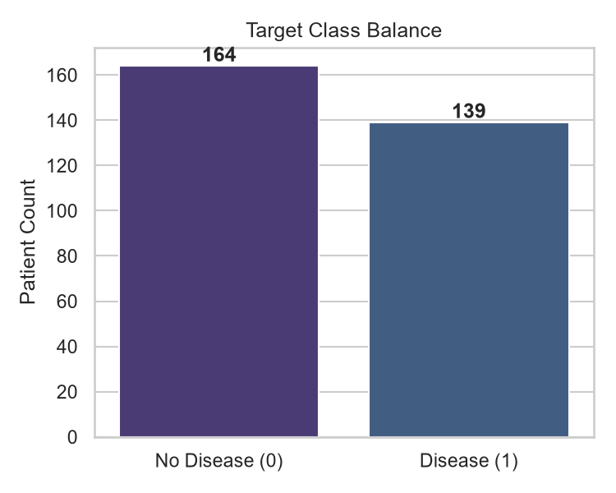
Figure 1: Target class distribution (45.9% disease-positive, 54.1% disease-negative).
The target is reasonably balanced, so accuracy is a meaningful metric here and no resampling (SMOTE, class weighting) was necessary.

4.2 Feature Distributions
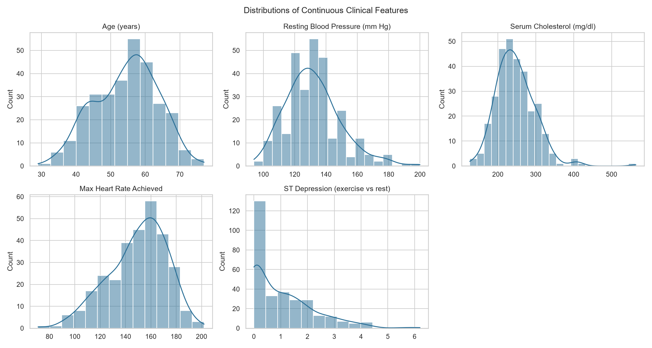
Figure 2: Distributions of continuous clinical features.
chol (cholesterol) and oldpeak (ST depression) are right-skewed with a handful of high outliers; age, trestbps, and thalach are closer to normally distributed. This informed the choice of StandardScaler over a method sensitive to extreme skew, plus median (not mean) imputation for missing numeric values, which is more robust to the outliers visible in chol.

4.3 Correlations
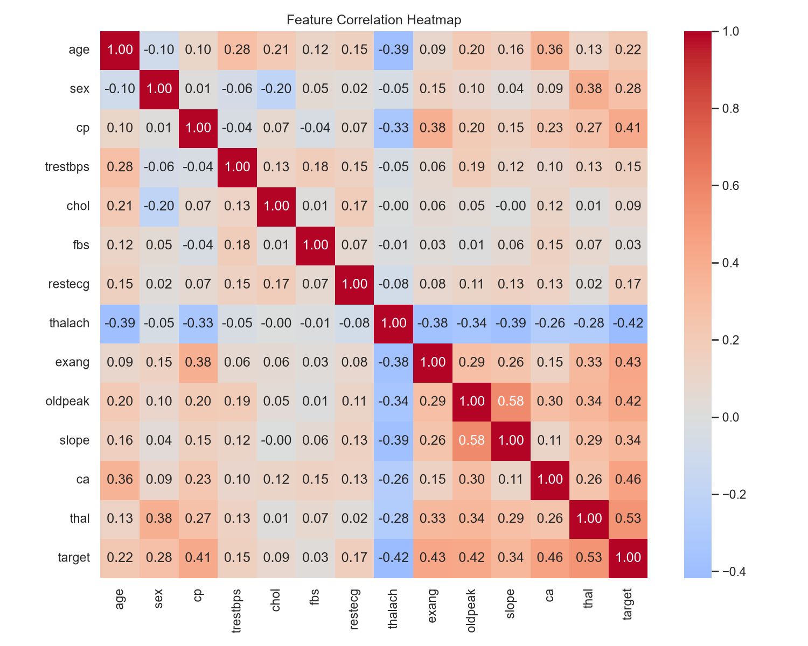
Figure 3: Feature correlation heatmap.
The features most correlated with the target are thal (0.53), ca (0.46), exang (0.43), oldpeak (0.43), and thalach (0.42) — all clinically plausible indicators. No feature pair showed problematic multicollinearity (all |corr| < 0.8 between predictors), so no features were dropped at this stage.

4.4 Target vs. Key Clinical Features
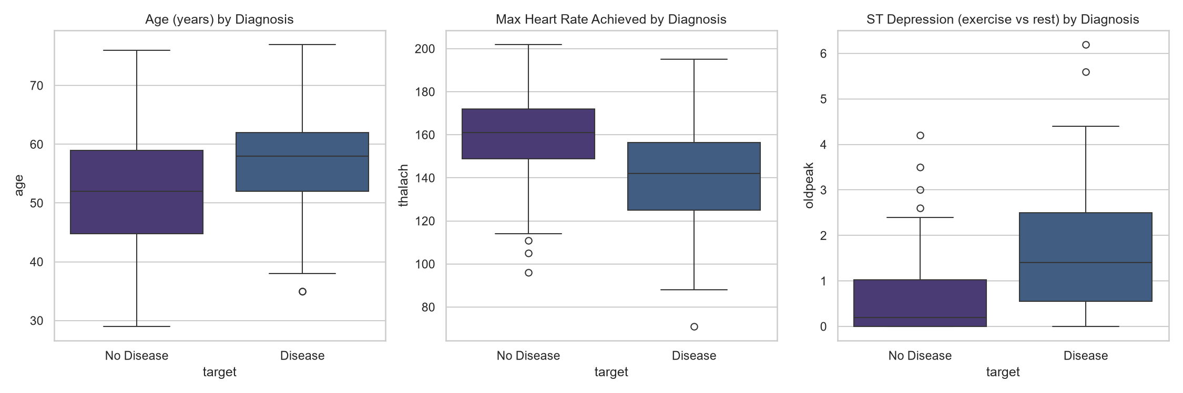
Figure 4: Age, max heart rate, and ST depression by diagnosis.
Patients with disease tend to be older, have a lower max heart rate (thalach), and show greater ST depression (oldpeak) under exercise — consistent with known clinical presentation.

4.5 Chest Pain Type vs. Diagnosis
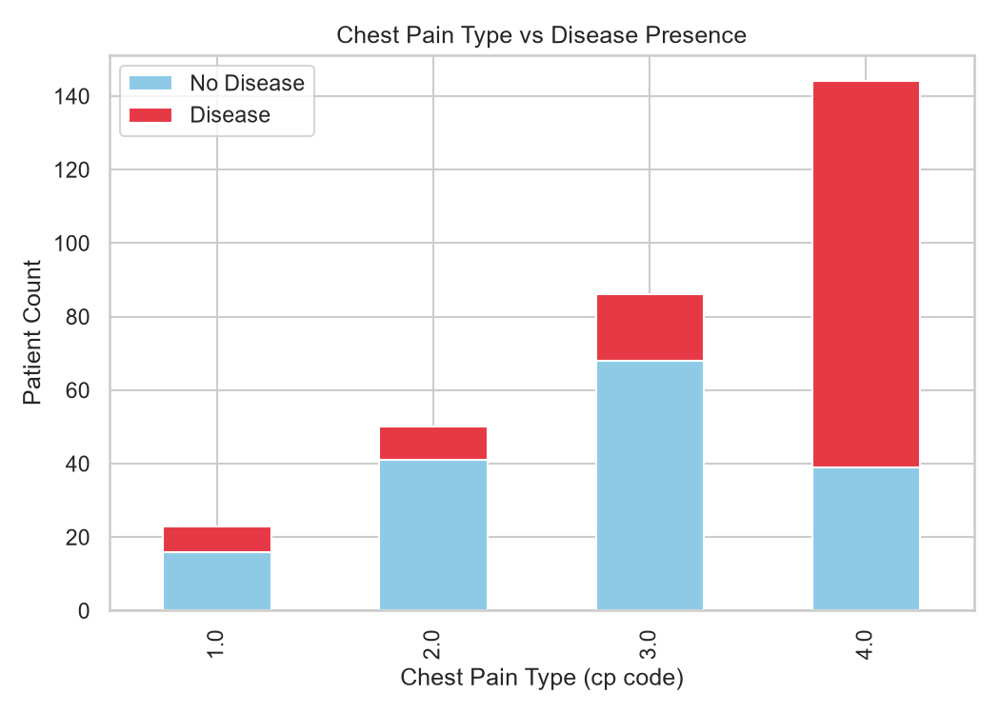
Figure 5: Chest pain type vs. disease presence.
Asymptomatic chest pain (cp = 4) is strongly associated with disease presence, while typical anginal pain (cp = 1) is more common among disease-negative patients — a counter-intuitive but well-documented clinical finding that justified keeping cp as a categorical (one-hot-encoded) rather than ordinal feature.

5. Feature Engineering & Model Development

5.1 Feature Engineering (src/data_processing.py)
Features are split into two groups and handled by a single ColumnTransformer (fit only on the training split, to avoid data leakage):
Group | Features | Treatment
Numeric | age, trestbps, chol, thalach, oldpeak | Median imputation → StandardScaler
Categorical | sex, cp, fbs, restecg, exang, slope, ca, thal | Mode imputation → OneHotEncoder(handle_unknown="ignore")

Wrapping this in a ColumnTransformer nested inside a Pipeline alongside the estimator means the exact fitted transformer (medians, scale factors, one-hot categories learned from training data only) is serialized together with the model — the API never needs to reconstruct feature engineering by hand, which is what makes this reproducible end-to-end.

5.2 Model Selection (src/train.py)
Two classifiers were trained and compared, as required:
- Logistic Regression — a strong, interpretable linear baseline; tuned over C in {0.01, 0.1, 1.0, 10.0}.
- Random Forest — a non-linear ensemble that can capture feature interactions; tuned over n_estimators in {100, 200, 400}, max_depth in {None, 4, 8}, min_samples_leaf in {1, 2, 4}.
Both were tuned with GridSearchCV using 5-fold stratified cross-validation (preserving class balance in every fold), optimizing for ROC-AUC since it is threshold-independent and appropriate for a moderately balanced binary clinical classification task.

5.3 Results (Held-Out 20% Test Split)
Model | CV ROC-AUC | Test Accuracy | Test Precision | Test Recall | Test F1 | Test ROC-AUC
Logistic Regression | 0.902 | 0.885 | 0.839 | 0.929 | 0.881 | 0.966 (best)
Random Forest | 0.902 | 0.852 | 0.806 | 0.893 | 0.847 | 0.948

Logistic Regression was selected as the production model: it matched Random Forest on cross-validated ROC-AUC but generalized better to the test split (higher test ROC-AUC, accuracy, and recall), and is simpler and faster to serve. Recall was prioritized as a secondary consideration over raw accuracy, since in a clinical screening context a missed positive (false negative) is costlier than a false alarm; Logistic Regression's 92.9% recall reflects that.
Full metrics (including best hyperparameters per model) are saved to reports/metrics.json by every training run.

6. Experiment Tracking (MLflow)
Every training run is tracked with MLflow against a local SQLite store (mlflow.db — the plain filesystem backend is deprecated in MLflow 3.x). Per run, we log:
- Parameters: the winning hyperparameters from GridSearchCV.
- Metrics: cross-validated ROC-AUC, and test accuracy / precision / recall / F1 / ROC-AUC.
- Artifacts: confusion matrix plot, ROC curve plot, and the fitted sklearn pipeline itself (via mlflow.sklearn.log_model).
To browse: mlflow ui --backend-store-uri sqlite:///mlflow.db, then open http://127.0.0.1:5000.

6.1 Example logged artifacts — Logistic Regression run
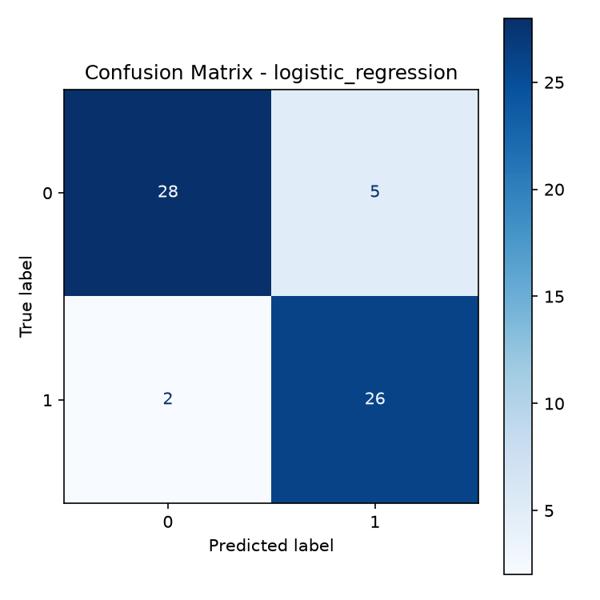
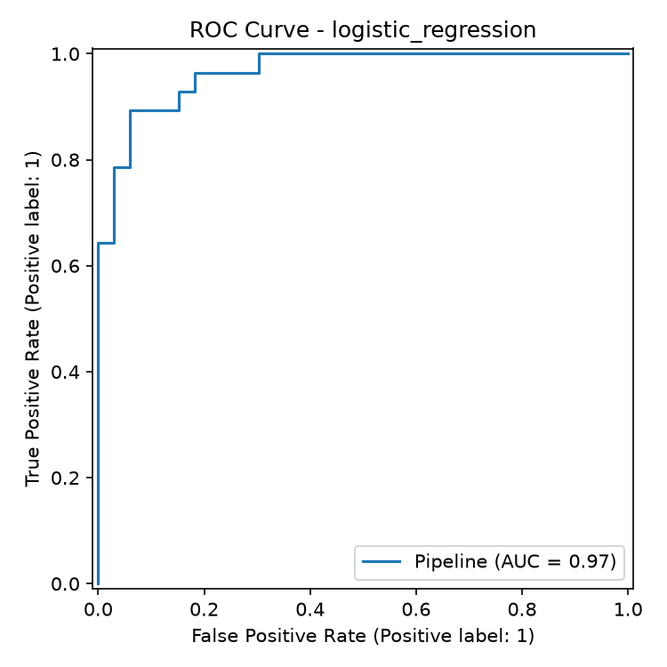
Figure 6: Confusion matrix and ROC curve logged as MLflow artifacts for the selected model.
[Insert screenshot of the MLflow UI here — showing the heart-disease-risk-classification experiment with both runs, their metrics columns, and one run's artifact view]

7. Model Packaging & Reproducibility
The winning pipeline (preprocessing + estimator, as one object) is persisted with joblib to models/model.pkl. Because preprocessing lives inside the same Pipeline object that was fit and evaluated, loading this single file and calling .predict() on a raw feature dict reproduces training-time behavior exactly — there is no separate "preprocessing script" that could drift out of sync with the model. requirements.txt pins every dependency to the exact version used during development, and scripts/download_data.py makes data acquisition itself scriptable and reproducible from a clean checkout.

8. Automated Testing & CI/CD

8.1 Unit Tests (pytest, 14 tests total)
- tests/test_data_processing.py — cleaning (duplicate removal, column selection), and the preprocessing pipeline (no NaNs survive imputation, numeric features are standardized, unseen categories at inference time don't crash the one-hot encoder). Uses synthetic in-memory data so this stage never depends on network access.
- tests/test_model.py — pipeline wiring, training, predicted probabilities sum to 1, and save/load round-tripping produces identical predictions. Uses sklearn.datasets.make_classification for the same reason.
- tests/test_api.py — FastAPI integration tests (/health, /predict happy path, /predict with an out-of-range or missing field returns HTTP 422, /metrics is exposed). Runs against the actually-trained model.
[Insert screenshot of `pytest tests/ -v` here, all 14 tests passing]

8.2 CI/CD Pipeline (.github/workflows/ci.yml)
Four sequential jobs, each gated on the previous one passing:
- lint — flake8 and black --check; fails the build on any style/syntax error.
- unit-tests — the offline pytest suite with coverage, uploaded as a workflow artifact.
- train — downloads the dataset, runs EDA, trains + logs to MLflow, runs the API integration tests against the freshly trained model, and uploads models/model.pkl plus reports/ as artifacts.
- docker-build-test — downloads the trained-model artifact, builds the Docker image, runs the container, polls /health with retries, and calls /predict with a sample payload — proving the model serves correctly from inside an isolated container. Container logs are dumped on any failure for debuggability.
[Insert screenshot of a green GitHub Actions run here, showing all four jobs]

9. Model Containerization
Dockerfile builds a slim python:3.11-slim image that installs requirements.txt, copies src/, api/, and the trained models/ directory, runs as a non-root user, and serves the FastAPI app with uvicorn on port 8000. A HEALTHCHECK hits /health every 30s.
python src/train.py
docker build -t heart-disease-api:local .
docker run -p 8000:8000 heart-disease-api:local
curl -X POST http://localhost:8000/predict -H "Content-Type: application/json" -d @sample_request.json
Verified response:
{"prediction": 0, "label": "no_disease", "confidence": 0.8146, "model_name": "LogisticRegression"}
[Insert screenshot of `docker build` + `docker run` + the curl response here]

10. Production Deployment (Kubernetes)
Manifests in k8s/:
- deployment.yaml: 2 replicas, readiness and liveness probes on /health, CPU/memory requests and limits, so Kubernetes can restart unhealthy pods and schedule resources sensibly.
- service.yaml: a LoadBalancer Service, which Docker Desktop's built-in Kubernetes exposes directly on localhost, and which Minikube can expose via `minikube tunnel` or `minikube service --url`.
Step-by-step instructions for both Docker Desktop Kubernetes and Minikube are in k8s/README.md.
[Insert screenshots here: `kubectl get pods`, `kubectl get svc`, and a successful curl/Postman call against the cluster-exposed endpoint]

11. Monitoring & Logging
- Structured request logging: a FastAPI middleware logs every request (method, path, status code, latency) as a JSON line to both stdout (so docker logs / kubectl logs capture it) and logs/api.log; /predict calls additionally log the prediction and confidence.
- Prometheus metrics: prometheus-fastapi-instrumentator exposes GET /metrics with request counts, latency histograms, and in-progress request gauges.
- Dashboarding: docker-compose.yml runs the API alongside Prometheus (monitoring/prometheus.yml scrapes /metrics every 10s) and Grafana, so request-rate and latency panels can be built against the live API.
[Insert screenshot of the Grafana dashboard / Prometheus targets page here]

12. Architecture Diagram
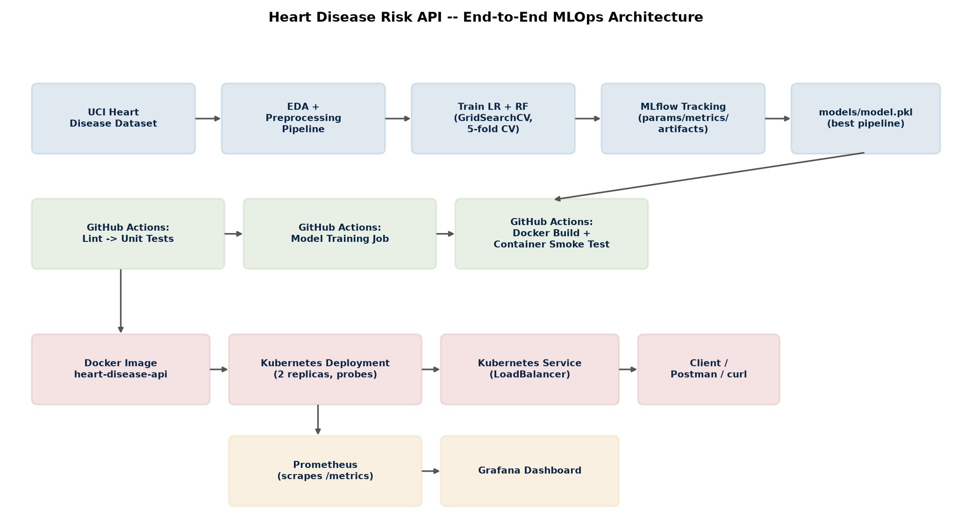
Figure 7: End-to-end MLOps architecture.
Data flows left-to-right/top-to-bottom: the UCI dataset feeds EDA and the preprocessing pipeline, which feeds model training (tracked in MLflow), which produces models/model.pkl. GitHub Actions orchestrates linting, testing, training, and a Docker build/smoke test, producing the image that Kubernetes deploys behind a load-balanced Service. Prometheus scrapes the running pods' /metrics endpoint and feeds a Grafana dashboard.

13. Summary & Key Decisions
Decision | Rationale
UCI official source over pre-cleaned mirrors | Matches the assignment's named source exactly; demonstrates raw-data handling rather than inheriting it from a mirror.
ColumnTransformer inside the saved Pipeline | Eliminates train/serve skew — the API loads one artifact that does imputation, scaling, encoding, and prediction identically to training.
Logistic Regression over Random Forest | Comparable CV score, better test-set generalization and recall, simpler to serve and explain.
SQLite MLflow backend | The plain filesystem backend is in maintenance mode as of MLflow 3.x.
Offline synthetic-data unit tests | Keeps the lint -> unit test CI stage fast and independent of network access or a pre-trained model.
FastAPI over Flask | Built-in request/response validation (Pydantic), automatic OpenAPI docs at /docs, and native async support.
LoadBalancer Service type | Works out-of-the-box with Docker Desktop's Kubernetes and with minikube tunnel, without needing an Ingress controller.

14. Repository Link
https://github.com/SaiSowjanyaVadapalli/heart-disease-mlops

