Question 1 :

main.tf file

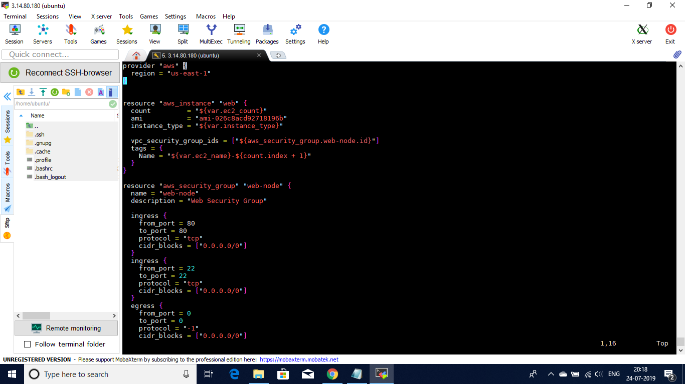

vars.tf file

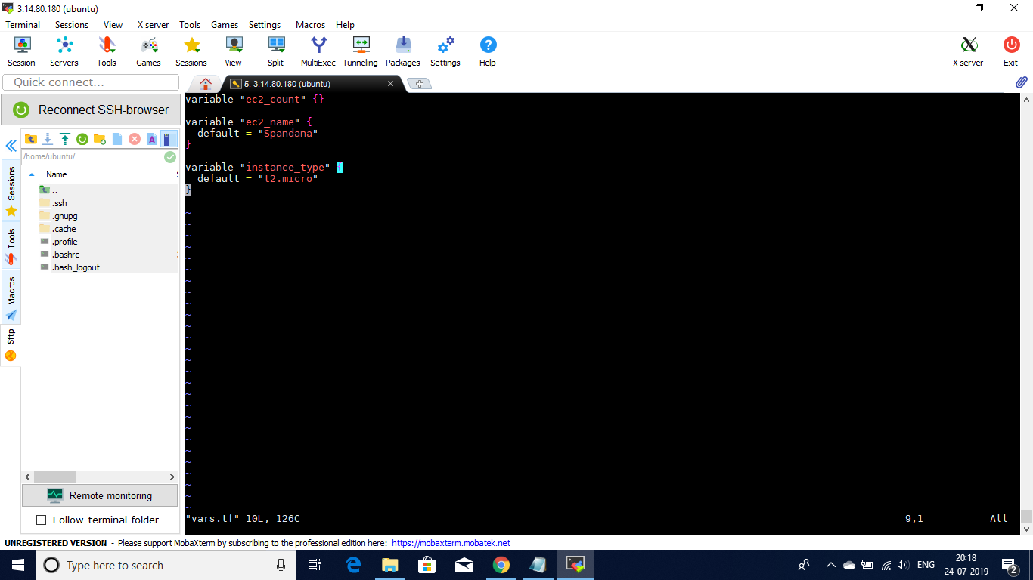

Default value is not given to ec2_count. We would be asked for the input to that parameter. (Given 2 as input for ec2_count). Accordingly instances would be created as shown below.

Observations :

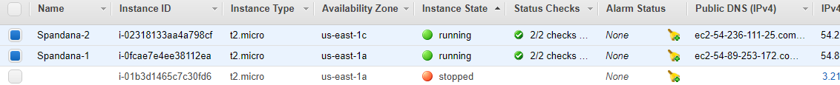

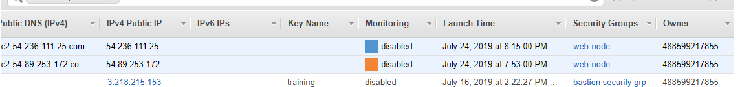

SSH and HTTP permissions to the instances set on terraform reflected

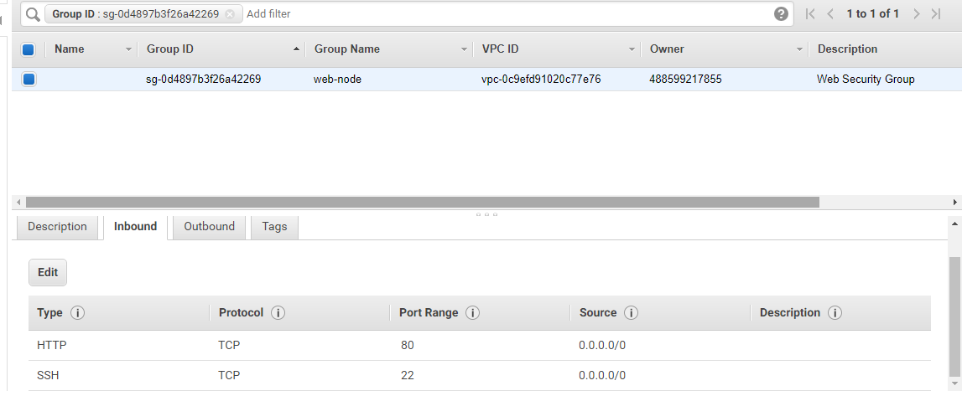

Question 2 :

Created three instances of same configuration.

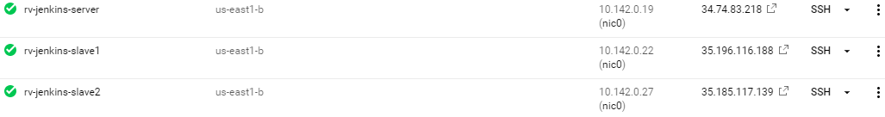

Out of those one is master and the others are slave nodes. Master should have java 8 version for opening jenkins server on 8080 port

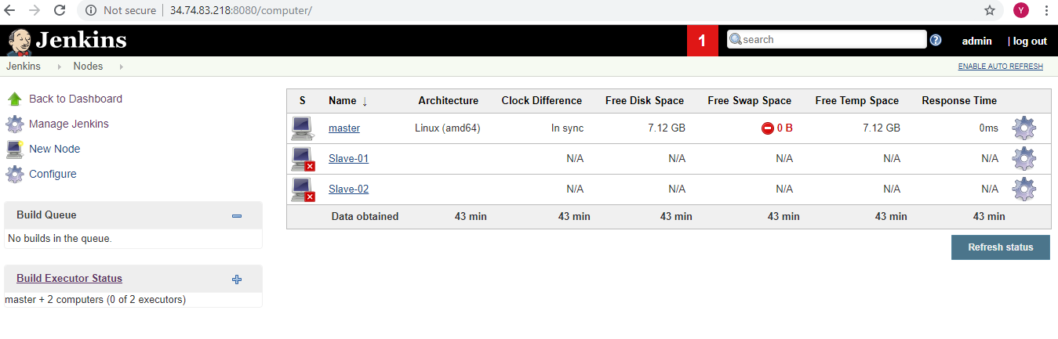

Necessary plugins are installed viz git plugin, cloud storage plugin.

TestBuildJob is created to fetch a file from git repo

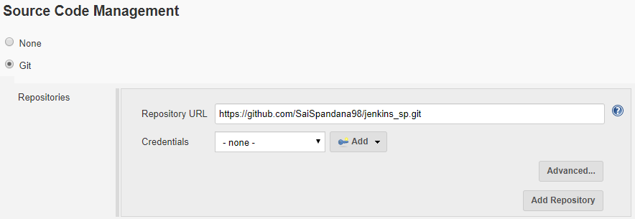

TestDeployJob is created to upload files to cloud storage

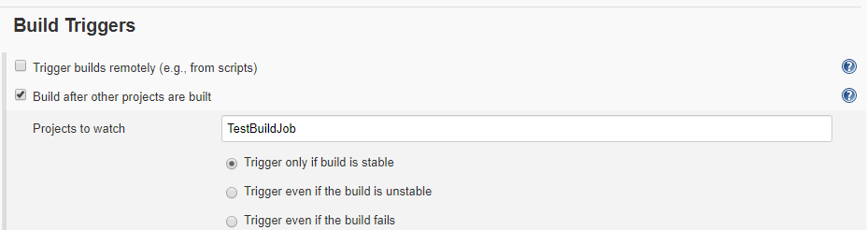

In the build field, selected the option of copying artifacts from another project. The files in the workspace of the TestBuildJob project would be copied to the current project workspace.

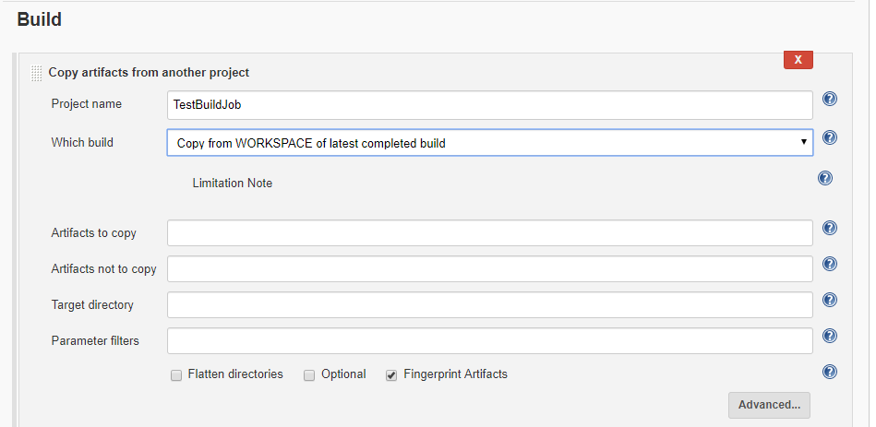

In the post-build action field, selected google cloud storage plugin and classic upload operation is added to it. Given file pattern and storage location. Before that Google Cloud Storage JSON API scope has to be added to our GCP service account.

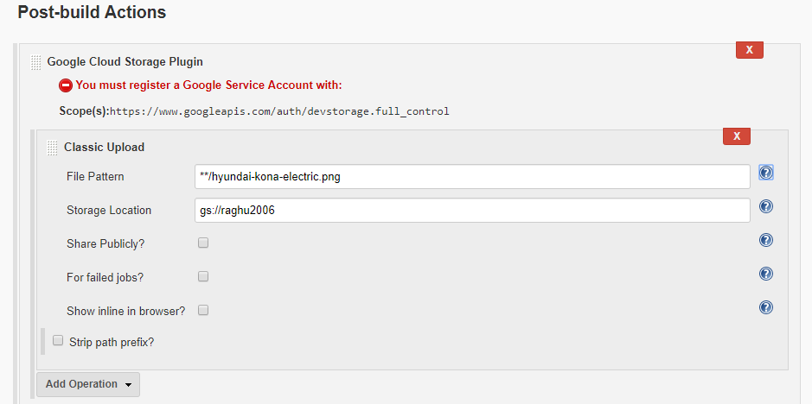

When TestBuildJob is build successfully, TestDeployJob would be triggered and git file would be uploaded to cloud bucket.