Question 1 :

Step 1 : Install google cloud SDK on local computer,

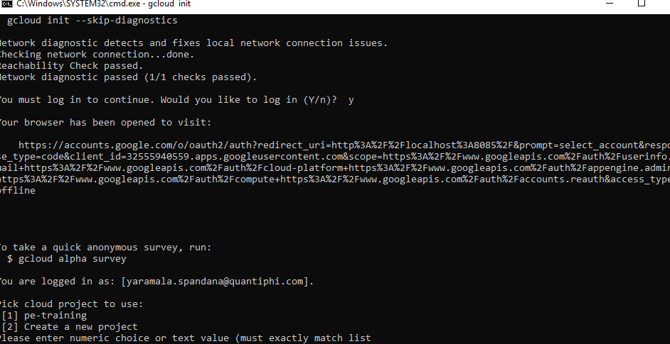

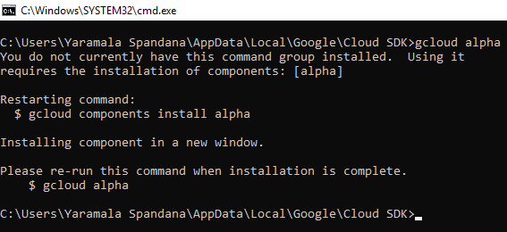

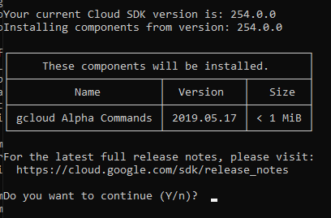

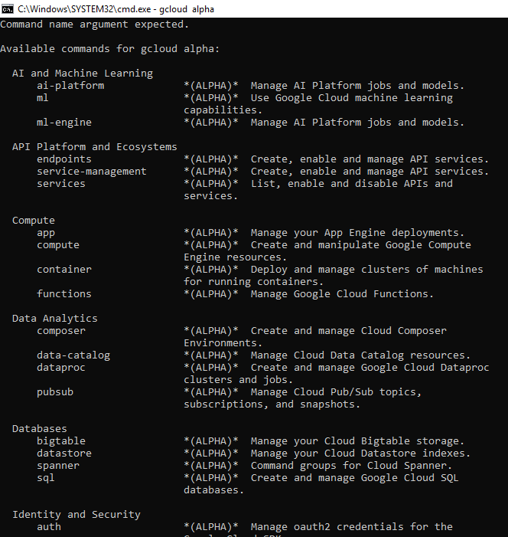

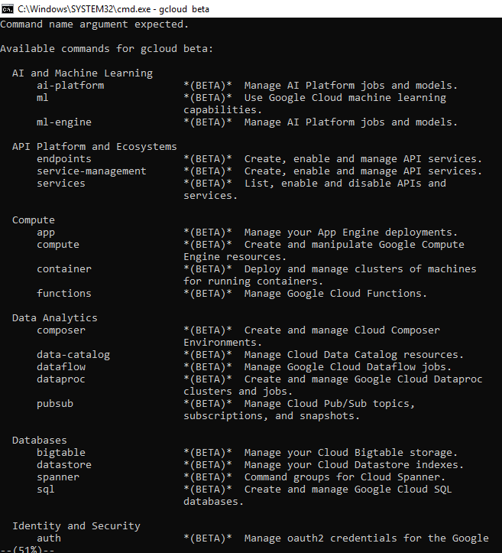

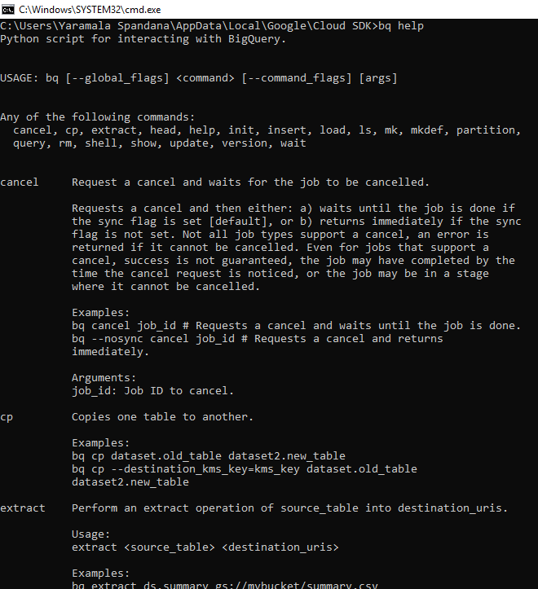

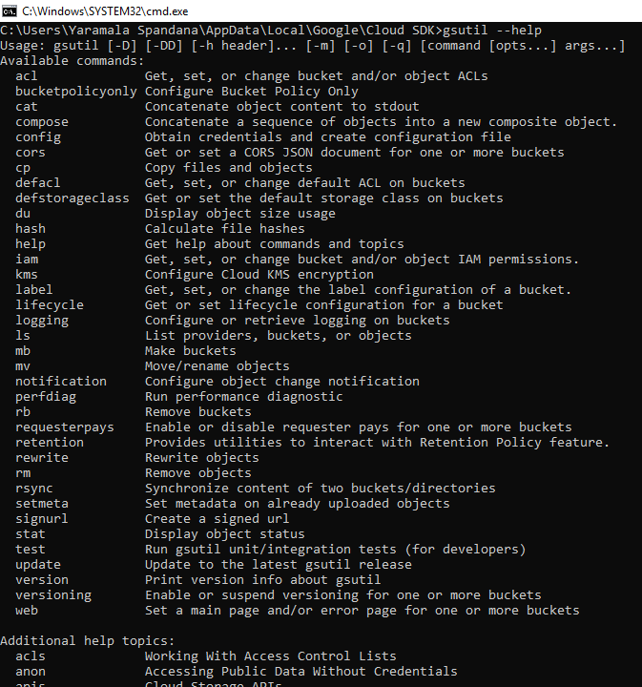

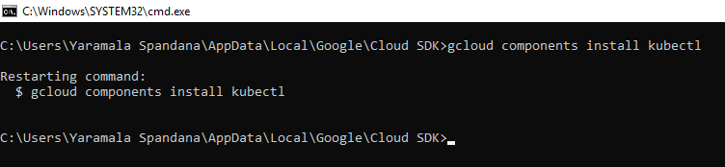

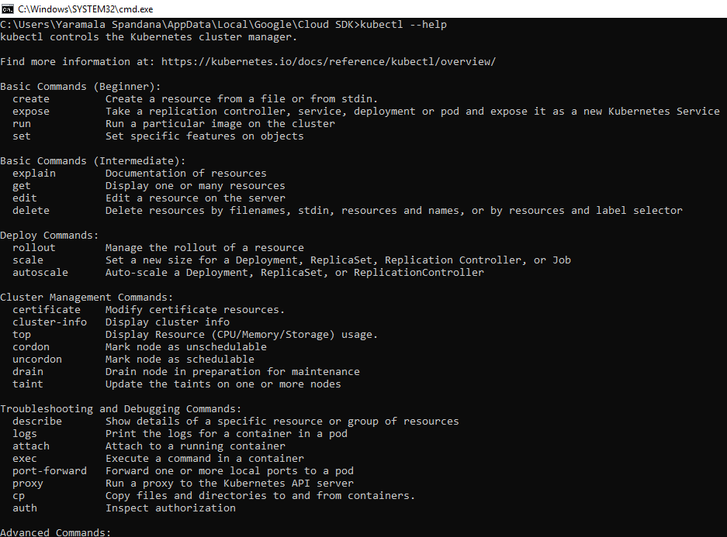

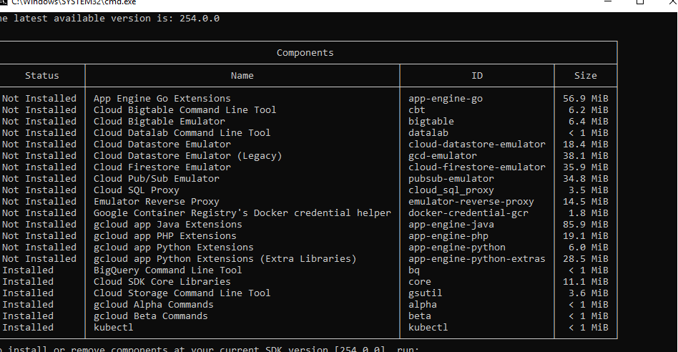

Question 2:

Step 1 : Opened google cloud sdk and typed ‘gcloud init’ command

Step 2 : Create a new configuration and put a name for it

Step 3 : Asked for log into an account, login through a new account

Step 4 : Asked to create a new project for this account

Step 5 : Again ‘gcloud init’ command is entered

Step 6 : Step 2 to Step 4 is repeated

Step 7 : entered ‘gcloud auth login’ command to switch into another account

Question 3 :

gcloud services list --available

gcloud services list --enabled

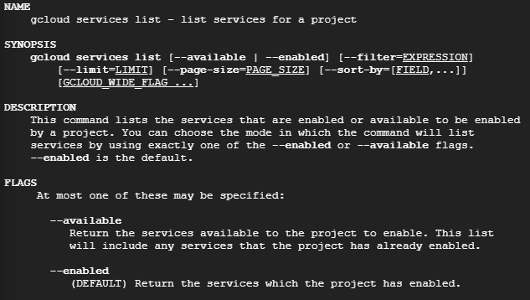

Question 4 :

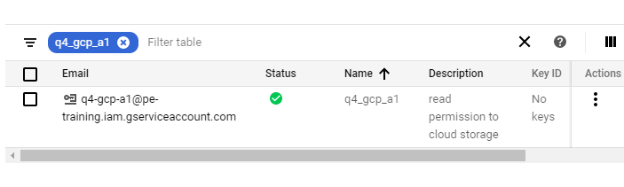

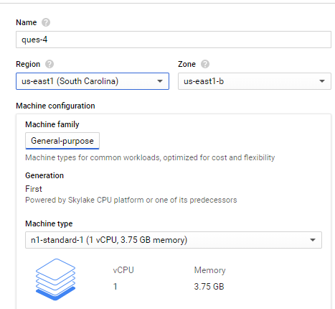

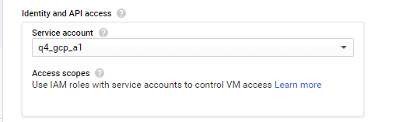

Question 5 :

1. Copy

gsutil cp gs://raghu2006/README-cloudshell.txt Desktop/README-cloudshell.txt

2. Move

gsutil mv gs://raghu2006/README-cloudshell.txt gs://raghu2006/newfolder/README-cloudshell.txt

3. Download

gsutil cp gs://raghu2006/newfolder/README-cloudshell.txt Desktop/README-cloudshell.txt

4. Upload

gsutil cp Desktop/Q9.json gs://raghu2006/Q9.json

5. Delete

gsutil rm gs://raghu2006/README-cloudshell.txt

Question 6 :

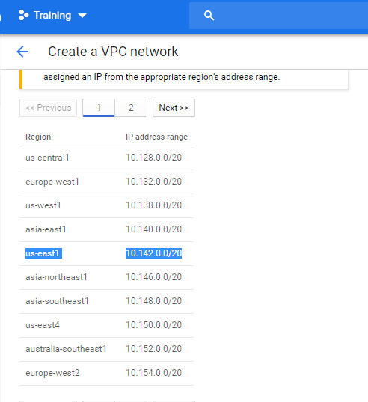

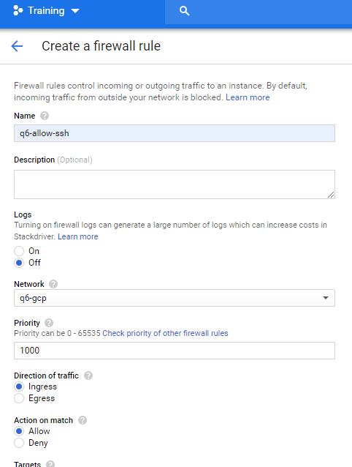

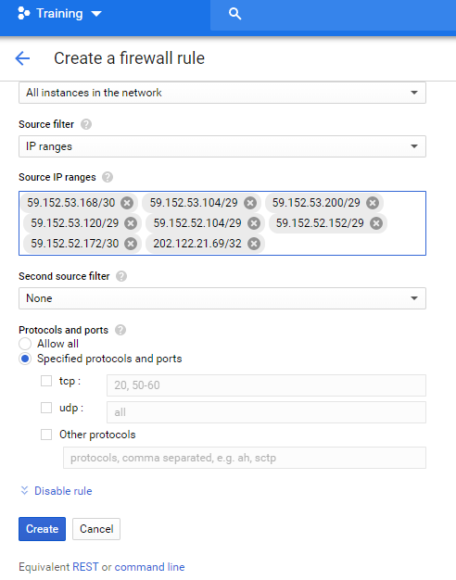

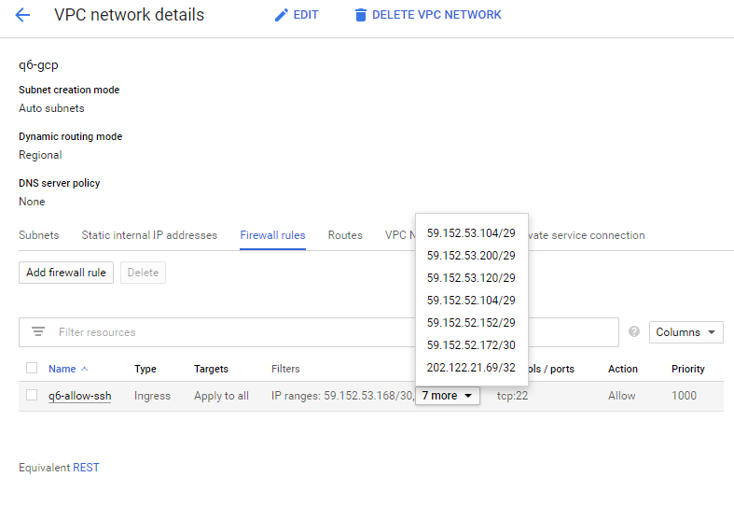

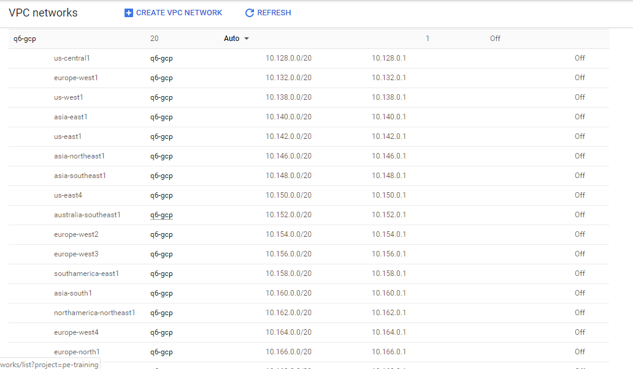

Question 7 :

Step 1 : created a dataset in BigQuery

Step 2 : Went to stackdriver logging and created export

Step 3 : filter to be submitted is-- resource.type="gce_firewall_rule"

Step 4 : Create a sink with a sink name, sink service is ‘BigQuery’ and sink destination is BigQuery dataset

Step 5 : logs would be exported to the selected destination dataset’s table

Question 8 :

Step 1 : Initially an instance template is created

Step 2 : Start-up script for the template is as follows

#! /bin/bash

sudo su

apt-get update

apt-get install -y apache2 stress

echo "<h1>This webpage in running on instance : $HOSTNAME</h1>" > /var/www/html/index.html

Step 3 : Created instance group with the help of instance template

Step 4 : Next run the stress command to spawn 2 workers spinning on sqrt() with a timeout of 60 sec

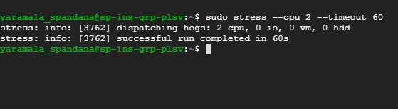

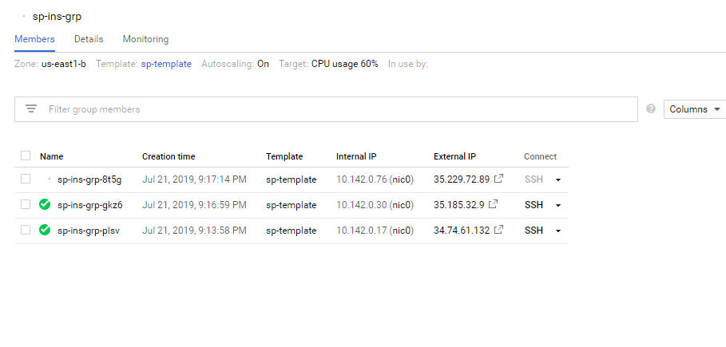

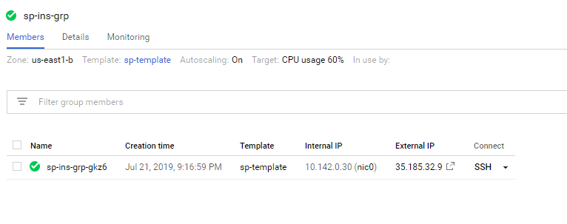

Question 9 :

Step 1 : created a bucket and uploaded json file as object into it

Step 2 : created a topic in pub/sub with push delivery type in subscription

Step 3 : created a cloud function with pub/sub trigger added to it and our topic is selected

Step 4 : created a dataset in BigQuery

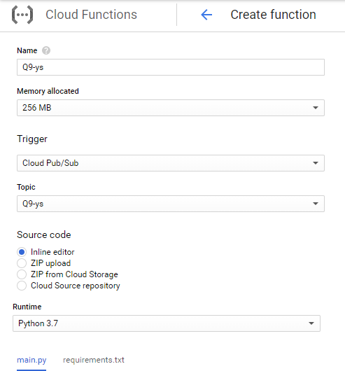

Step 5 : The code is written such that when we publish a message containing bucket name and object name into pub/sub, cloud function is triggered and the contents of json file are stored in BigQuery dataset

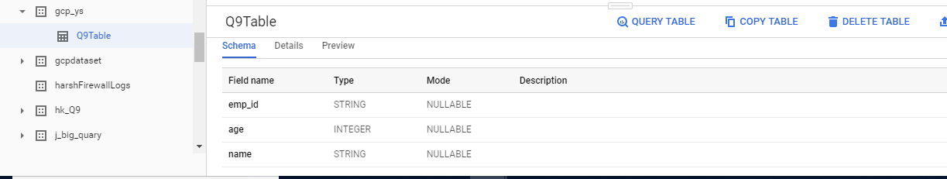

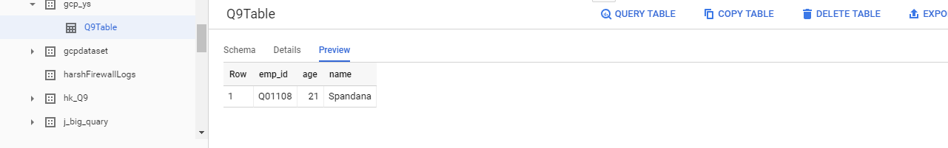

Question 10 :

Step 1 : Created an instance and installed apache in it

Step 2 : Went to Stackdriver monitoring, from resources select instances.

Step 3 : Selected my instance, created uptime-health check and also created policy to it

Step 4 : email is opted as Notification channel

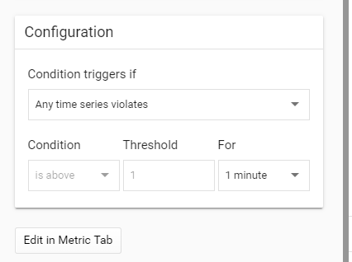

Step 5 : When the instance is stopped, alert notification is sent to our mail