Question 1 :

Step 1 : Initially two instances were launched, one having external ip address and the other with no external ip address.

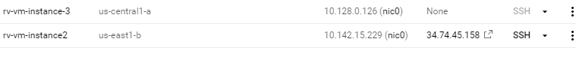

Step 2 : Network details of the instances are as follows

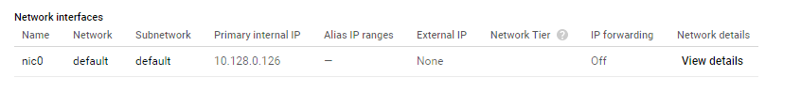

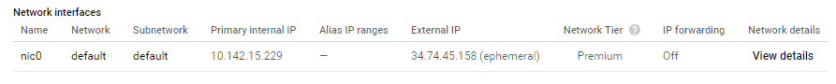

Step 3 : Created cloud nat

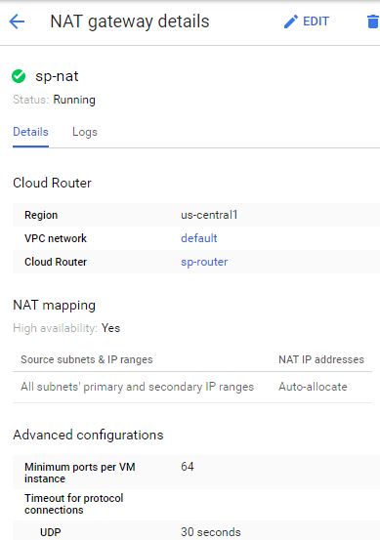

Step 4 : Opened the instance having ssh access and connected to the private instance

ssh rv-vm-instance-3

Step 5 : For testing the internet connection, typed the following command

ping 8.8.8.8

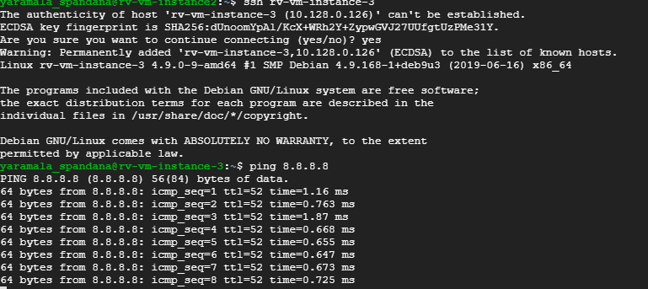

Question 2 :

Step 1 : Created a new project

Step 2 : Created a workspace for that project

Step 3 : Added AWS account to monitor

Step 4 : arn of existing iam role having ReadOnlyAccess policy name is specified while adding aws in GCP project(as we didn’t have access to create an iam role)

Step 5 : When connected to aws account, monitoring created aws connector project

Step 6 : Service account is created for the connector project with ‘monitoring metric writer’ and ‘logs writer’ roles attached to it

Step 7 : Private key in the form of ‘json’ is downloaded onto the local machine

Step 8 : EC2 instance is launched and SSH connection of the instance is established through mobaxterm

Step 9 : The downloaded json file is uploaded into our ec2 instance

Step 10 : The following commands are run on our instance

Step 11 : Installed stackdriver monitoring and logging agents on ec2 instance by running following commands

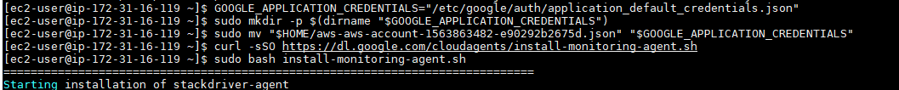

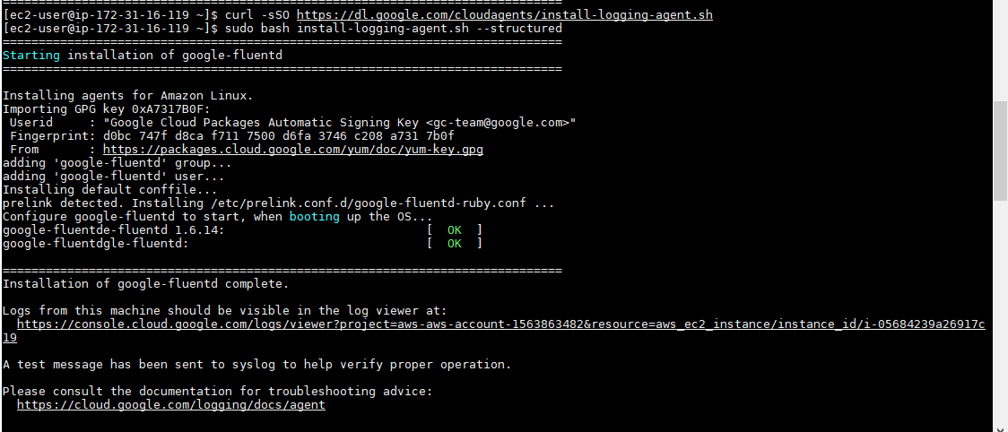

Step 12 : Created an uptime check with resource type ‘URL’ and hostname ‘18.221.178.147’ (ec2 instance)

Step 13 : Then created an alerting policy to the uptime check

Step 14 : View logs for the google project and amazon ec2 instances at a single place

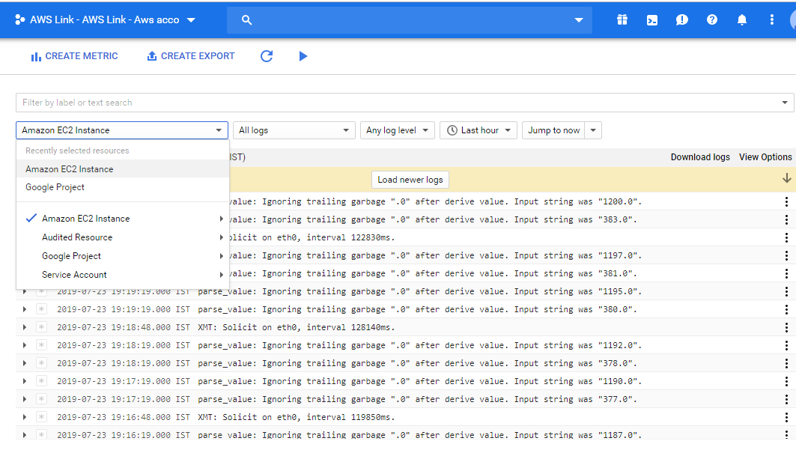

Question 3 :

Step 1 : An instance is created with a start-up script

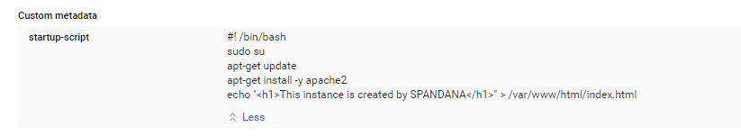

Step 2 : Through external ip address accessed the apache web-server

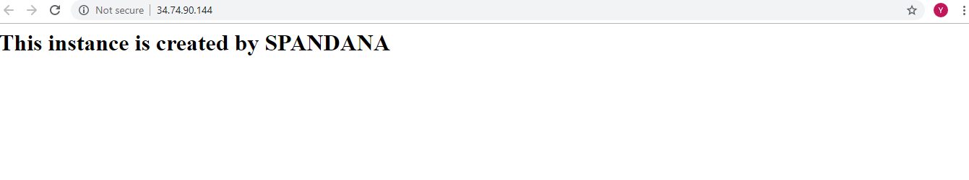

Step 3 : Without accessing through SSH, we were able to install and put content into apache server through a start-up script

Step 4 : The commands on cli to stop and restart instances are

gcloud compute instances stop rv-vm-instance-2

gcloud compute instances start rv-vm-instance-2

Step 5 : The external ip address of the instance was changed and when the apache web-server is accessed through the previous ip address web page was not available.

Step 6 : The log file of the instance is observed

Step 7 : access log file of apache server is

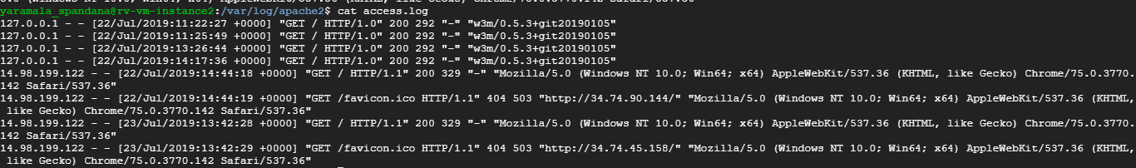

Question 4 :

Step 1 : Created a bucket named ‘raghu2006’

Step 2 : Created a cloud function and added ‘storage’ trigger to it

Step 3 : code is as follows

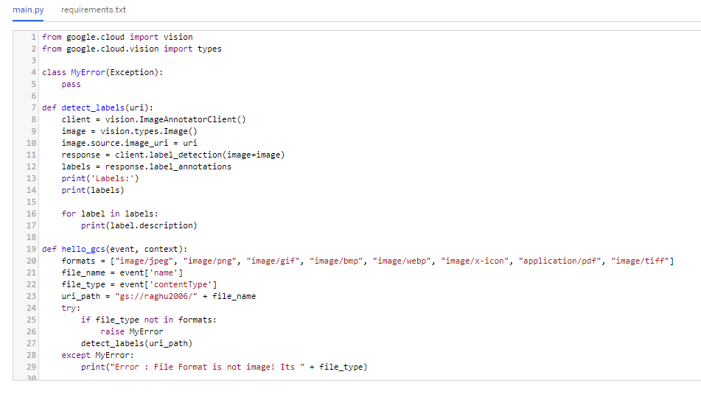

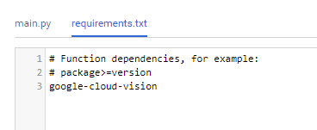

Step 4 : When an image is uploaded into the bucket, function is executed and the result is observed in the logs

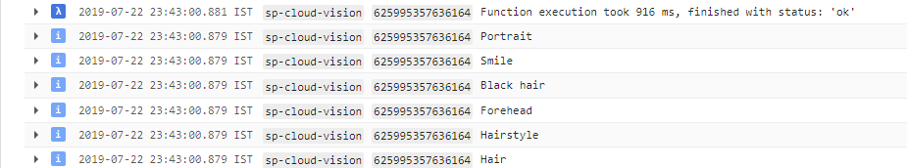

Step 5 : When a file other than image format is uploaded, error message would be seen

