k means clustering

Sai Sree Pulimamidi

2022-11-06

library(readr)  
Pharmaceuticals <- read_csv("C:/users/91773/Desktop/Pharmaceuticals.csv")

## Rows: 21 Columns: 14  
## ── Column specification ────────────────────────────────────────────────────────  
## Delimiter: ","  
## chr (5): Symbol, Name, Median_Recommendation, Location, Exchange  
## dbl (9): Market_Cap, Beta, PE_Ratio, ROE, ROA, Asset_Turnover, Leverage, Rev...  
##   
## ℹ Use `spec()` to retrieve the full column specification for this data.  
## ℹ Specify the column types or set `show_col_types = FALSE` to quiet this message.

View(Pharmaceuticals)

## installing libraries

library(ggplot2)  
library(factoextra)

## Welcome! Want to learn more? See two factoextra-related books at https://goo.gl/ve3WBa

library(flexclust)

## Loading required package: grid

## Loading required package: lattice

## Loading required package: modeltools

## Loading required package: stats4

library(cluster)  
library(tidyverse)

## ── Attaching packages  
## ───────────────────────────────────────  
## tidyverse 1.3.2 ──

## ✔ tibble 3.1.8 ✔ dplyr 1.0.10  
## ✔ tidyr 1.2.1 ✔ stringr 1.4.1   
## ✔ purrr 0.3.5 ✔ forcats 0.5.2   
## ── Conflicts ────────────────────────────────────────── tidyverse_conflicts() ──  
## ✖ dplyr::filter() masks stats::filter()  
## ✖ dplyr::lag() masks stats::lag()

summary(Pharmaceuticals)

## Symbol Name Market_Cap Beta   
## Length:21 Length:21 Min. : 0.41 Min. :0.1800   
## Class :character Class :character 1st Qu.: 6.30 1st Qu.:0.3500   
## Mode :character Mode :character Median : 48.19 Median :0.4600   
## Mean : 57.65 Mean :0.5257   
## 3rd Qu.: 73.84 3rd Qu.:0.6500   
## Max. :199.47 Max. :1.1100   
## PE_Ratio ROE ROA Asset_Turnover Leverage   
## Min. : 3.60 Min. : 3.9 Min. : 1.40 Min. :0.3 Min. :0.0000   
## 1st Qu.:18.90 1st Qu.:14.9 1st Qu.: 5.70 1st Qu.:0.6 1st Qu.:0.1600   
## Median :21.50 Median :22.6 Median :11.20 Median :0.6 Median :0.3400   
## Mean :25.46 Mean :25.8 Mean :10.51 Mean :0.7 Mean :0.5857   
## 3rd Qu.:27.90 3rd Qu.:31.0 3rd Qu.:15.00 3rd Qu.:0.9 3rd Qu.:0.6000   
## Max. :82.50 Max. :62.9 Max. :20.30 Max. :1.1 Max. :3.5100   
## Rev_Growth Net_Profit_Margin Median_Recommendation Location   
## Min. :-3.17 Min. : 2.6 Length:21 Length:21   
## 1st Qu.: 6.38 1st Qu.:11.2 Class :character Class :character   
## Median : 9.37 Median :16.1 Mode :character Mode :character   
## Mean :13.37 Mean :15.7   
## 3rd Qu.:21.87 3rd Qu.:21.1   
## Max. :34.21 Max. :25.5   
## Exchange   
## Length:21   
## Class :character   
## Mode :character   
##   
##   
##

#Task 1  
#Use only the numerical variables (1 to 9) to cluster the 21 firms.   
#Justify the various choices #made in conducting the cluster analysis,   
#such as weights for different variables, the specific   
#clustering the algorithm(s) used,number of clusters formed, and so on.   
R <- na.omit(Pharmaceuticals)  
R

## # A tibble: 21 × 14  
## Symbol Name Marke…¹ Beta PE_Ra…² ROE ROA Asset…³ Lever…⁴ Rev_G…⁵  
## <chr> <chr> <dbl> <dbl> <dbl> <dbl> <dbl> <dbl> <dbl> <dbl>  
## 1 ABT Abbott Labo… 68.4 0.32 24.7 26.4 11.8 0.7 0.42 7.54  
## 2 AGN Allergan, I… 7.58 0.41 82.5 12.9 5.5 0.9 0.6 9.16  
## 3 AHM Amersham plc 6.3 0.46 20.7 14.9 7.8 0.9 0.27 7.05  
## 4 AZN AstraZeneca… 67.6 0.52 21.5 27.4 15.4 0.9 0 15   
## 5 AVE Aventis 47.2 0.32 20.1 21.8 7.5 0.6 0.34 26.8   
## 6 BAY Bayer AG 16.9 1.11 27.9 3.9 1.4 0.6 0 -3.17  
## 7 BMY Bristol-Mye… 51.3 0.5 13.9 34.8 15.1 0.9 0.57 2.7   
## 8 CHTT Chattem, Inc 0.41 0.85 26 24.1 4.3 0.6 3.51 6.38  
## 9 ELN Elan Corpor… 0.78 1.08 3.6 15.1 5.1 0.3 1.07 34.2   
## 10 LLY Eli Lilly a… 73.8 0.18 27.9 31 13.5 0.6 0.53 6.21  
## # … with 11 more rows, 4 more variables: Net_Profit_Margin <dbl>,  
## # Median_Recommendation <chr>, Location <chr>, Exchange <chr>, and  
## # abbreviated variable names ¹​Market_Cap, ²​PE_Ratio, ³​Asset_Turnover,  
## # ⁴​Leverage, ⁵​Rev_Growth

row.names <- R[,1]  
Pharmaceuticals1 <- R[,3:11]  
head(Pharmaceuticals1)

## # A tibble: 6 × 9  
## Market_Cap Beta PE_Ratio ROE ROA Asset_Turnover Leverage Rev_Gr…¹ Net_P…²  
## <dbl> <dbl> <dbl> <dbl> <dbl> <dbl> <dbl> <dbl> <dbl>  
## 1 68.4 0.32 24.7 26.4 11.8 0.7 0.42 7.54 16.1  
## 2 7.58 0.41 82.5 12.9 5.5 0.9 0.6 9.16 5.5  
## 3 6.3 0.46 20.7 14.9 7.8 0.9 0.27 7.05 11.2  
## 4 67.6 0.52 21.5 27.4 15.4 0.9 0 15 18   
## 5 47.2 0.32 20.1 21.8 7.5 0.6 0.34 26.8 12.9  
## 6 16.9 1.11 27.9 3.9 1.4 0.6 0 -3.17 2.6  
## # … with abbreviated variable names ¹​Rev_Growth, ²​Net_Profit_Margin

Pharmaceuticals2 <- scale(Pharmaceuticals1)  
head(Pharmaceuticals2)

## Market_Cap Beta PE_Ratio ROE ROA Asset_Turnover  
## [1,] 0.1840960 -0.80125356 -0.04671323 0.04009035 0.2416121 0.0000000  
## [2,] -0.8544181 -0.45070513 3.49706911 -0.85483986 -0.9422871 0.9225312  
## [3,] -0.8762600 -0.25595600 -0.29195768 -0.72225761 -0.5100700 0.9225312  
## [4,] 0.1702742 -0.02225704 -0.24290879 0.10638147 0.9181259 0.9225312  
## [5,] -0.1790256 -0.80125356 -0.32874435 -0.26484883 -0.5664461 -0.4612656  
## [6,] -0.6953818 2.27578267 0.14948233 -1.45146000 -1.7127612 -0.4612656  
## Leverage Rev_Growth Net_Profit_Margin  
## [1,] -0.2120979 -0.5277675 0.06168225  
## [2,] 0.0182843 -0.3811391 -1.55366706  
## [3,] -0.4040831 -0.5721181 -0.68503583  
## [4,] -0.7496565 0.1474473 0.35122600  
## [5,] -0.3144900 1.2163867 -0.42597037  
## [6,] -0.7496565 -1.4971443 -1.99560225

fviz_nbclust(Pharmaceuticals2, kmeans, method = "wss") +  
 labs(subtitle = "Elbow Method")

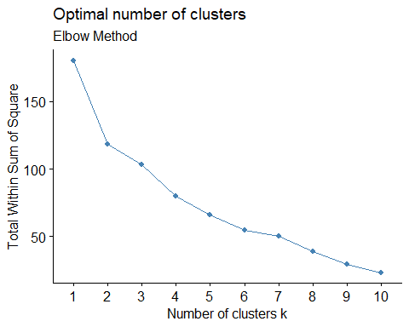

fviz_nbclust(Pharmaceuticals2, kmeans, method = "silhouette") + labs(subtitle = "Silhouette Method")

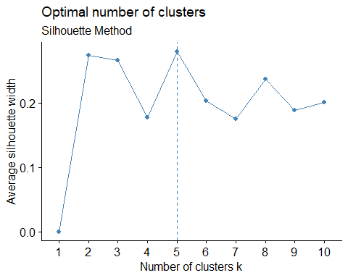

fviz_nbclust(Pharmaceuticals2, kmeans, method = "gap_stat") + labs(subtitle = "Gap Stat Method")

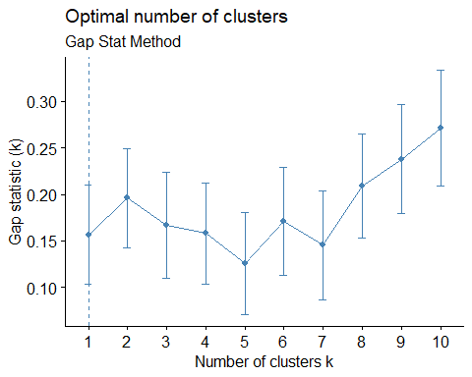

set.seed(64060)  
k5 <- kmeans(Pharmaceuticals2, centers = 5, nstart = 25)  
k5 $centers

## Market_Cap Beta PE_Ratio ROE ROA Asset_Turnover  
## 1 -0.87051511 1.3409869 -0.05284434 -0.6184015 -1.1928478 -0.4612656  
## 2 -0.43925134 -0.4701800 2.70002464 -0.8349525 -0.9234951 0.2306328  
## 3 -0.76022489 0.2796041 -0.47742380 -0.7438022 -0.8107428 -1.2684804  
## 4 -0.03142211 -0.4360989 -0.31724852 0.1950459 0.4083915 0.1729746  
## 5 1.69558112 -0.1780563 -0.19845823 1.2349879 1.3503431 1.1531640  
## Leverage Rev_Growth Net_Profit_Margin  
## 1 1.36644699 -0.6912914 -1.320000179  
## 2 -0.14170336 -0.1168459 -1.416514761  
## 3 0.06308085 1.5180158 -0.006893899  
## 4 -0.27449312 -0.7041516 0.556954446  
## 5 -0.46807818 0.4671788 0.591242521

fviz_cluster(k5, data = Pharmaceuticals2)

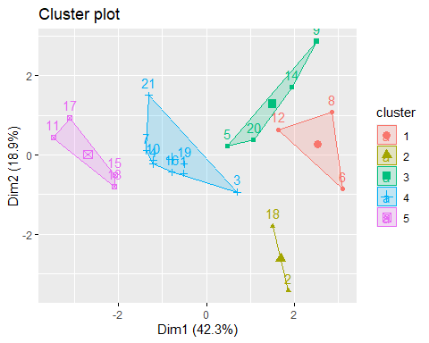

k5

## K-means clustering with 5 clusters of sizes 3, 2, 4, 8, 4  
##   
## Cluster means:  
## Market_Cap Beta PE_Ratio ROE ROA Asset_Turnover  
## 1 -0.87051511 1.3409869 -0.05284434 -0.6184015 -1.1928478 -0.4612656  
## 2 -0.43925134 -0.4701800 2.70002464 -0.8349525 -0.9234951 0.2306328  
## 3 -0.76022489 0.2796041 -0.47742380 -0.7438022 -0.8107428 -1.2684804  
## 4 -0.03142211 -0.4360989 -0.31724852 0.1950459 0.4083915 0.1729746  
## 5 1.69558112 -0.1780563 -0.19845823 1.2349879 1.3503431 1.1531640  
## Leverage Rev_Growth Net_Profit_Margin  
## 1 1.36644699 -0.6912914 -1.320000179  
## 2 -0.14170336 -0.1168459 -1.416514761  
## 3 0.06308085 1.5180158 -0.006893899  
## 4 -0.27449312 -0.7041516 0.556954446  
## 5 -0.46807818 0.4671788 0.591242521  
##   
## Clustering vector:  
## [1] 4 2 4 4 3 1 4 1 3 4 5 1 5 3 5 4 5 2 4 3 4  
##   
## Within cluster sum of squares by cluster:  
## [1] 15.595925 2.803505 12.791257 21.879320 9.284424  
## (between_SS / total_SS = 65.4 %)  
##   
## Available components:  
##   
## [1] "cluster" "centers" "totss" "withinss" "tot.withinss"  
## [6] "betweenss" "size" "iter" "ifault"

Fitting <- kmeans(Pharmaceuticals2,5)  
aggregate(Pharmaceuticals2,by = list(Fitting$cluster), FUN = mean)

## Group.1 Market_Cap Beta PE_Ratio ROE ROA  
## 1 1 1.69558112 -0.1780563 -0.1984582 1.2349879 1.3503431  
## 2 2 -0.66114002 -0.7233539 -0.3512251 -0.6736441 -0.5915022  
## 3 3 -0.96247577 1.1949250 -0.3639982 -0.5200697 -0.9610792  
## 4 4 -0.52462814 0.4451409 1.8498439 -1.0404550 -1.1865838  
## 5 5 0.08926902 -0.4618336 -0.3208615 0.3260892 0.5396003  
## Asset_Turnover Leverage Rev_Growth Net_Profit_Margin  
## 1 1.153164e+00 -0.4680782 0.4671788 0.5912425  
## 2 -1.537552e-01 -0.4040831 0.6917224 -0.4005718  
## 3 -1.153164e+00 1.4773718 0.7120120 -0.3688236  
## 4 1.480297e-16 -0.3443544 -0.5769454 -1.6095439  
## 5 6.589509e-02 -0.2559803 -0.7230135 0.7343816

Pharmaceuticals3 <- data.frame(Pharmaceuticals2,Fitting$cluster)  
Pharmaceuticals3

## Market_Cap Beta PE_Ratio ROE ROA Asset_Turnover  
## 1 0.1840960 -0.80125356 -0.04671323 0.04009035 0.2416121 0.0000000  
## 2 -0.8544181 -0.45070513 3.49706911 -0.85483986 -0.9422871 0.9225312  
## 3 -0.8762600 -0.25595600 -0.29195768 -0.72225761 -0.5100700 0.9225312  
## 4 0.1702742 -0.02225704 -0.24290879 0.10638147 0.9181259 0.9225312  
## 5 -0.1790256 -0.80125356 -0.32874435 -0.26484883 -0.5664461 -0.4612656  
## 6 -0.6953818 2.27578267 0.14948233 -1.45146000 -1.7127612 -0.4612656  
## 7 -0.1078688 -0.10015669 -0.70887325 0.59693581 0.8617498 0.9225312  
## 8 -0.9767669 1.26308721 0.03299122 -0.11237924 -1.1677918 -0.4612656  
## 9 -0.9704532 2.15893320 -1.34037772 -0.70899938 -1.0174553 -1.8450624  
## 10 0.2762415 -1.34655112 0.14948233 0.34502953 0.5610770 -0.4612656  
## 11 1.0999201 -0.68440408 -0.45749769 2.45971647 1.8389364 1.3837968  
## 12 -0.9393967 0.48409069 -0.34100657 -0.29136529 -0.6979905 -0.4612656  
## 13 1.9841758 -0.25595600 0.18013789 0.18593083 1.0872544 0.9225312  
## 14 -0.9632863 0.87358895 0.19240011 -0.96753478 -0.9610792 -1.8450624  
## 15 1.2782387 -0.25595600 -0.40231769 0.98142435 0.8429577 1.8450624  
## 16 0.6654710 -1.30760129 -0.23677768 -0.52338423 0.1288598 -0.9225312  
## 17 2.4199899 0.48409069 -0.11415545 1.31287998 1.6322239 0.4612656  
## 18 -0.0240846 -0.48965495 1.90298017 -0.81506519 -0.9047030 -0.4612656  
## 19 -0.4018812 -0.06120687 -0.40231769 -0.21181593 0.5234929 0.4612656  
## 20 -0.9281345 -1.11285216 -0.43297324 -1.03382590 -0.6979905 -0.9225312  
## 21 -0.1614497 0.40619104 -0.75792214 1.92938746 0.5422849 -0.4612656  
## Leverage Rev_Growth Net_Profit_Margin Fitting.cluster  
## 1 -0.21209793 -0.52776752 0.06168225 5  
## 2 0.01828430 -0.38113909 -1.55366706 4  
## 3 -0.40408312 -0.57211809 -0.68503583 2  
## 4 -0.74965647 0.14744734 0.35122600 5  
## 5 -0.31449003 1.21638667 -0.42597037 2  
## 6 -0.74965647 -1.49714434 -1.99560225 4  
## 7 -0.02011273 -0.96584257 0.74744375 5  
## 8 3.74279705 -0.63276071 -1.24888417 3  
## 9 0.61983791 1.88617085 -0.36501379 3  
## 10 -0.07130879 -0.64814764 1.17413980 5  
## 11 -0.31449003 0.76926048 0.82363947 1  
## 12 1.10620040 0.05603085 -0.71551412 3  
## 13 -0.62166634 -0.36213170 0.33598685 1  
## 14 0.44065173 1.53860717 0.85411776 3  
## 15 -0.39128411 0.36014907 -0.24310064 1  
## 16 -0.67286239 -1.45369888 1.02174835 5  
## 17 -0.54487226 1.10143723 1.44844440 1  
## 18 -0.30169102 0.14744734 -1.27936246 4  
## 19 -0.74965647 -0.43544591 0.29026942 5  
## 20 -0.49367621 1.43089863 -0.09070919 2  
## 21 0.68383297 -1.17763919 1.49416183 5

#Task 2  
  
#using cluster formation to interpret the clusters in relation to the numerical variables.  
  
aggregate(Pharmaceuticals2, by = list(Fitting$cluster), FUN = mean)

## Group.1 Market_Cap Beta PE_Ratio ROE ROA  
## 1 1 1.69558112 -0.1780563 -0.1984582 1.2349879 1.3503431  
## 2 2 -0.66114002 -0.7233539 -0.3512251 -0.6736441 -0.5915022  
## 3 3 -0.96247577 1.1949250 -0.3639982 -0.5200697 -0.9610792  
## 4 4 -0.52462814 0.4451409 1.8498439 -1.0404550 -1.1865838  
## 5 5 0.08926902 -0.4618336 -0.3208615 0.3260892 0.5396003  
## Asset_Turnover Leverage Rev_Growth Net_Profit_Margin  
## 1 1.153164e+00 -0.4680782 0.4671788 0.5912425  
## 2 -1.537552e-01 -0.4040831 0.6917224 -0.4005718  
## 3 -1.153164e+00 1.4773718 0.7120120 -0.3688236  
## 4 1.480297e-16 -0.3443544 -0.5769454 -1.6095439  
## 5 6.589509e-02 -0.2559803 -0.7230135 0.7343816

Pharmacy <- data.frame(Pharmaceuticals2,k5$cluster)  
Pharmacy

## Market_Cap Beta PE_Ratio ROE ROA Asset_Turnover  
## 1 0.1840960 -0.80125356 -0.04671323 0.04009035 0.2416121 0.0000000  
## 2 -0.8544181 -0.45070513 3.49706911 -0.85483986 -0.9422871 0.9225312  
## 3 -0.8762600 -0.25595600 -0.29195768 -0.72225761 -0.5100700 0.9225312  
## 4 0.1702742 -0.02225704 -0.24290879 0.10638147 0.9181259 0.9225312  
## 5 -0.1790256 -0.80125356 -0.32874435 -0.26484883 -0.5664461 -0.4612656  
## 6 -0.6953818 2.27578267 0.14948233 -1.45146000 -1.7127612 -0.4612656  
## 7 -0.1078688 -0.10015669 -0.70887325 0.59693581 0.8617498 0.9225312  
## 8 -0.9767669 1.26308721 0.03299122 -0.11237924 -1.1677918 -0.4612656  
## 9 -0.9704532 2.15893320 -1.34037772 -0.70899938 -1.0174553 -1.8450624  
## 10 0.2762415 -1.34655112 0.14948233 0.34502953 0.5610770 -0.4612656  
## 11 1.0999201 -0.68440408 -0.45749769 2.45971647 1.8389364 1.3837968  
## 12 -0.9393967 0.48409069 -0.34100657 -0.29136529 -0.6979905 -0.4612656  
## 13 1.9841758 -0.25595600 0.18013789 0.18593083 1.0872544 0.9225312  
## 14 -0.9632863 0.87358895 0.19240011 -0.96753478 -0.9610792 -1.8450624  
## 15 1.2782387 -0.25595600 -0.40231769 0.98142435 0.8429577 1.8450624  
## 16 0.6654710 -1.30760129 -0.23677768 -0.52338423 0.1288598 -0.9225312  
## 17 2.4199899 0.48409069 -0.11415545 1.31287998 1.6322239 0.4612656  
## 18 -0.0240846 -0.48965495 1.90298017 -0.81506519 -0.9047030 -0.4612656  
## 19 -0.4018812 -0.06120687 -0.40231769 -0.21181593 0.5234929 0.4612656  
## 20 -0.9281345 -1.11285216 -0.43297324 -1.03382590 -0.6979905 -0.9225312  
## 21 -0.1614497 0.40619104 -0.75792214 1.92938746 0.5422849 -0.4612656  
## Leverage Rev_Growth Net_Profit_Margin k5.cluster  
## 1 -0.21209793 -0.52776752 0.06168225 4  
## 2 0.01828430 -0.38113909 -1.55366706 2  
## 3 -0.40408312 -0.57211809 -0.68503583 4  
## 4 -0.74965647 0.14744734 0.35122600 4  
## 5 -0.31449003 1.21638667 -0.42597037 3  
## 6 -0.74965647 -1.49714434 -1.99560225 1  
## 7 -0.02011273 -0.96584257 0.74744375 4  
## 8 3.74279705 -0.63276071 -1.24888417 1  
## 9 0.61983791 1.88617085 -0.36501379 3  
## 10 -0.07130879 -0.64814764 1.17413980 4  
## 11 -0.31449003 0.76926048 0.82363947 5  
## 12 1.10620040 0.05603085 -0.71551412 1  
## 13 -0.62166634 -0.36213170 0.33598685 5  
## 14 0.44065173 1.53860717 0.85411776 3  
## 15 -0.39128411 0.36014907 -0.24310064 5  
## 16 -0.67286239 -1.45369888 1.02174835 4  
## 17 -0.54487226 1.10143723 1.44844440 5  
## 18 -0.30169102 0.14744734 -1.27936246 2  
## 19 -0.74965647 -0.43544591 0.29026942 4  
## 20 -0.49367621 1.43089863 -0.09070919 3  
## 21 0.68383297 -1.17763919 1.49416183 4

#CLuster 1:- JNJ, MRK, GSK, PFE  
#Cluster 1: Highest Market_Cap and lowest Beta/PE Ratio  
#Cluster 2:- AHM, WPI, AVE  
#Cluster 2: Highest Revenue Growth and lowest PE/Asset Turnover Ratio  
#Cluster 3:- CHTT, IVX, MRX, ELN  
#Cluster 3: Highest Beta/leverage/Asset Turnover Ratio and lowest   
#Net_Profit_Margin, PE ratio and Market#Cluster  
#Cluster 4:- AGN,BAY, PHA  
#Cluster 4: Highest PE ratio and lowest Leverage/Asset_Turnover  
#Cluster 5:- ABT, WYE, AZN, SGP, BMY, NVS, LLY  
#Cluster 5: Highest Net_Proft_Margin and lowest Leverage

#Task3  
#Is there a pattern in the clusters with respect to the numerical   
#variables (10 to 12)? (those \n #not used in forming the clusters)  
RD <- Pharmaceuticals[12:14] %>% mutate(Clusters=k5$cluster)  
ggplot(RD, mapping = aes(factor(Clusters), fill =Median_Recommendation))+geom_bar(position='dodge')+labs(x ='Clusters')

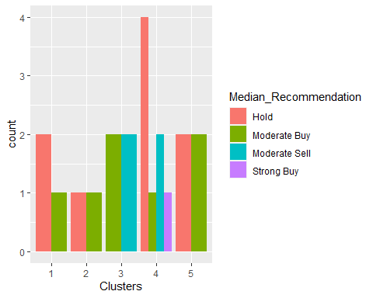

ggplot(RD, mapping = aes(factor(Clusters),fill = Location))+  
 geom_bar(position = 'dodge')+labs(x ='Clusters')

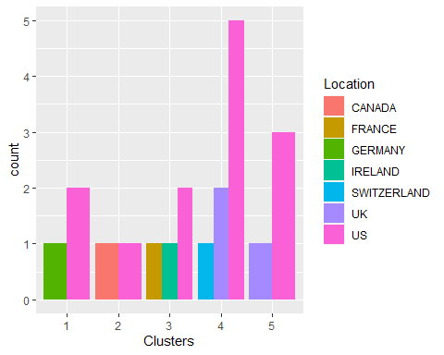

ggplot(RD, mapping = aes(factor(Clusters),fill = Exchange))+geom_bar(position = 'dodge')+  
 labs(x ='Clusters')

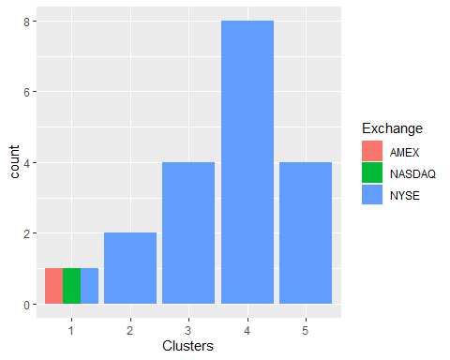

#The above graphs indicates that there is a slim pattern in the clusters.  
  
#In Cluster 1,the firms are evenly distributed among AMEX,NASDAQ, and NYSE despite the fact that cluster 1 has a different Hold and Moderate Buy median, a different count from the US and Germany, and a distinct nation count.  
  
#In Cluster 2,The medians for the cluster 2 are equally split between "Hold" and "Moderate Buy," and it is solely listed on the NYSE.  
  
#In Cluster 3,the Moderate Buy and Sell medians for the NYSE-listed are equal, and it has a separate count for France, Ireland, and the US.  
  
#In Cluster 4, the Hold median is the highest, followed by the Moderate Buy and Strong Buy medians, and the Hold median. They are listed on the NYSE and are from the US, the UK, and Switzerland.  
  
#The Cluster 5 is distributed throughout the US and the UK, it is listed on the NYSE, and it has the same hold and mild buy medians.

#TASK 4  
#Provide an appropriate name for each cluster using any or all of the variables in the dataset.  
  
#Cluster 1 :- Buy Cluster  
#Cluster 2 :- Sceptical Cluster  
#Cluster 3 :- Moderate Buy Cluster  
#Cluster 4 :- Hold Cluster  
#Cluster 5 :- High Hold Cluster