Tasks performed-

1.Trained CNN Model using different optimizers:

The optimizer which is used is Adam Optimizer to check the accuracy of the model for the given set of hyperparameters:

Following is the screenshot of the execution with hyperparameters mentioned in the code:

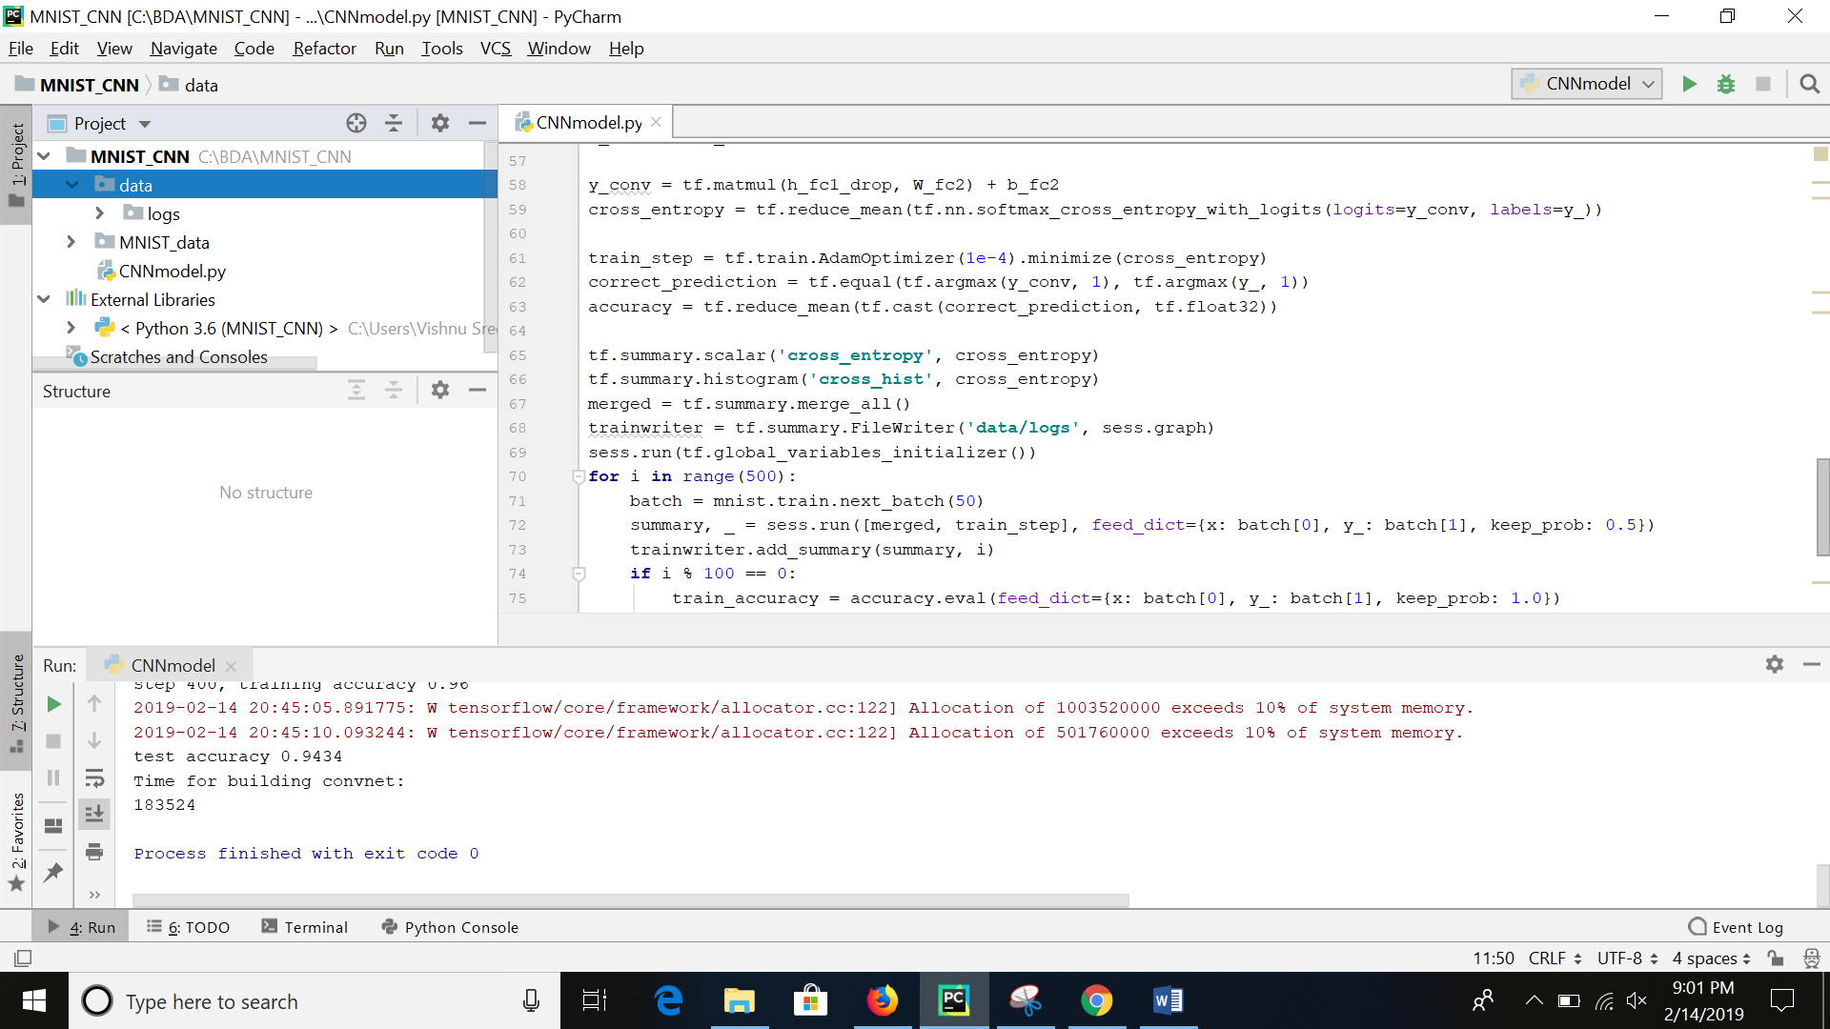

Accuracy shown in TensorBoard for adam optimizer-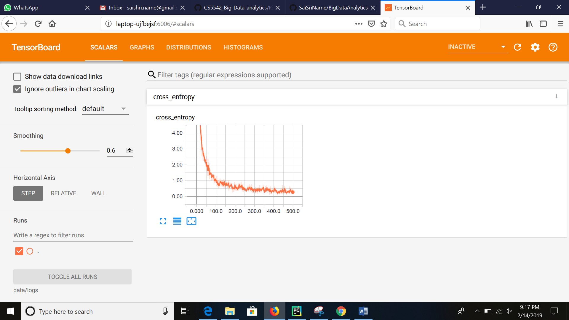

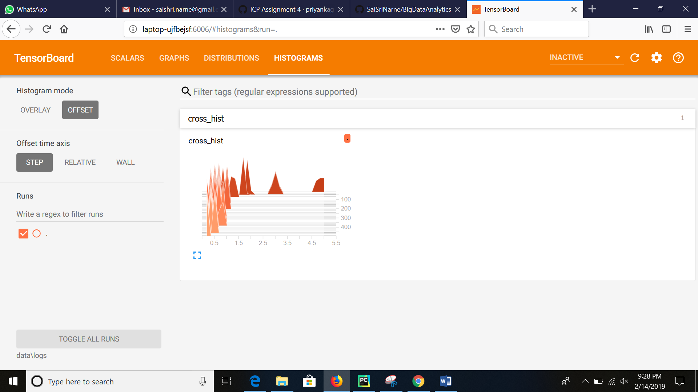

Now model is trained using **AdadeltaOptimizer** for the next run:

