-- PART A: Snowflake Setup
-- Create a database named RETAIL_DB.
CREATE OR REPLACE DATABASE RETAIL_DB;

-- Create a schema named RETAIL_DB.ORDERS_DEMO.
CREATE OR REPLACE SCHEMA RETAIL_DB.ORDERS_DEMO;

-- Create a warehouse named RETAIL_LOAD_WH.
CREATE OR REPLACE WAREHOUSE RETAIL_LOAD_WH
WITH
WAREHOUSE_SIZE = 'XSMALL'
AUTO_SUSPEND = 60
AUTO_RESUME = TRUE;

-- Create a role named RETAIL_DATA_ENGINEER_ROLE.
CREATE OR REPLACE ROLE RETAIL_DATA_ENGINEER_ROLE;
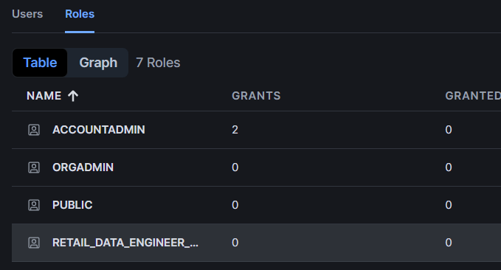

-- Create a user named RETAIL_ENGINEER_USER.
CREATE OR REPLACE USER RETAIL_ENGINEER_USER
PASSWORD='Retail_user'
DEFAULT_ROLE='RETAIL_DATA_ENGINEER_ROLE'
DEFAULT_WAREHOUSE='RETAIL_LOAD_WH'
MUST_CHANGE_PASSWORD=FALSE;
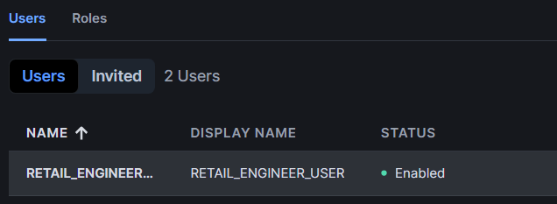

-- Grant required permissions to the role and user.
GRANT ROLE RETAIL_DATA_ENGINEER_ROLE TO USER RETAIL_ENGINEER_USER;
GRANT USAGE ON WAREHOUSE RETAIL_LOAD_WH TO ROLE RETAIL_DATA_ENGINEER_ROLE;
GRANT ALL PRIVILEGES ON DATABASE RETAIL_DB TO ROLE RETAIL_DATA_ENGINEER_ROLE;
GRANT ALL PRIVILEGES ON SCHEMA RETAIL_DB.ORDERS_DEMO TO ROLE RETAIL_DATA_ENGINEER_ROLE;

-- PART B: Azure Storage Setup
-- Create an Azure Storage Account.
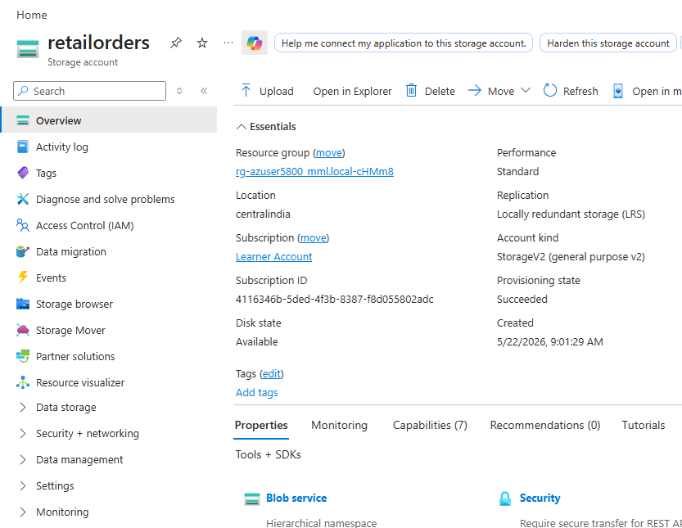
-- Create a container named retail-data.
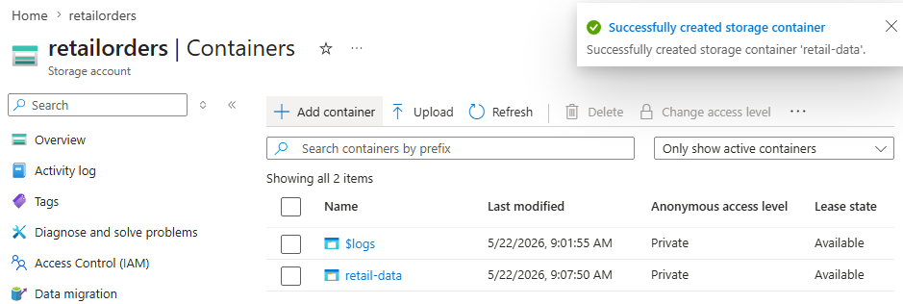
-- Inside the container, create this folder path:
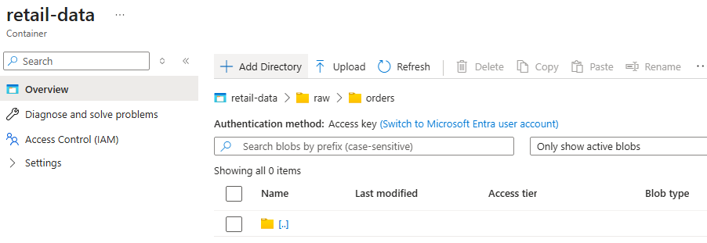
-- raw/orders/

-- Upload the initial CSV file:
-- retail_orders_initial.csv
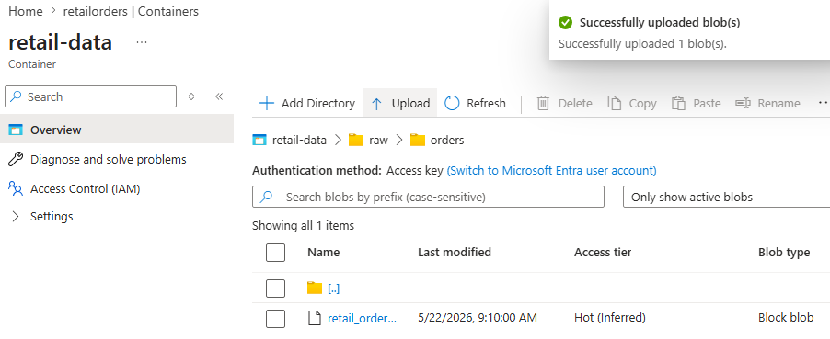

-- PART C: Snowflake External Stage
-- Create a file format for CSV.
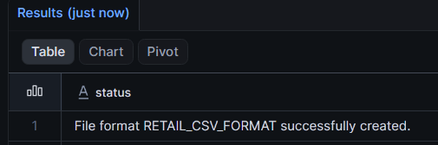
CREATE OR REPLACE FILE FORMAT RETAIL_CSV_FORMAT
TYPE = CSV
SKIP_HEADER = 1
FIELD_OPTIONALLY_ENCLOSED_BY = '"';

-- Create an Azure storage integration or external stage.
-- Create an external stage pointing to:
-- azure://<storage_account>.blob.core.windows.net/retail-data/raw/orders/
CREATE OR REPLACE STAGE RETAIL_AZURE_STAGE
URL='azure://retailorders.blob.core.windows.net/retail-data/raw/orders/'
CREDENTIALS=(
AZURE_SAS_TOKEN='?sv=2026-02-06&ss=bfqt&srt=sco&sp=rwdlacupiytfx&se=2026-05-21T19:05:41Z&st=2026-05-21T10:50:41Z&spr=https,http&sig=fUddKzLCjKfL2UiuTQcbJSgUe40rjpE5XSkiFP%2FPtMM%3D'
)
FILE_FORMAT = RETAIL_CSV_FORMAT;
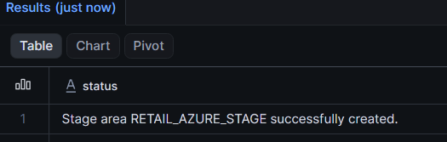

-- List files from the stage.
LIST @RETAIL_AZURE_STAGE;
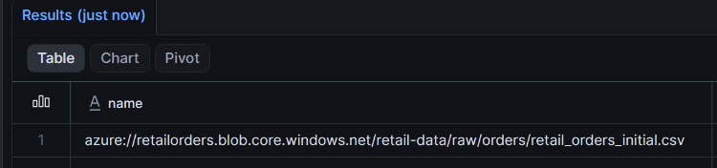

-- PART D: Initial Data Load
-- Create a raw landing table named ORDERS_RAW.
CREATE OR REPLACE TABLE ORDERS_RAW
(
ORDER_ID INT,
CUSTOMER_NAME STRING,
PRODUCT STRING,
QUANTITY INT,
PRICE FLOAT,
ORDER_DATE DATE
);

-- Create a final table named ORDERS_FINAL.
CREATE OR REPLACE TABLE ORDERS_FINAL
(
ORDER_ID INT,
CUSTOMER_NAME STRING,
PRODUCT STRING,
QUANTITY INT,
PRICE FLOAT,
ORDER_DATE DATE
);

COPY INTO ORDERS_RAW
FROM @RETAIL_AZURE_STAGE
FILES = ('retail_orders_initial.csv');
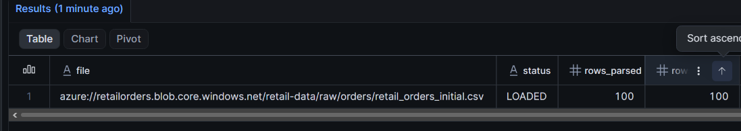
SELECT * FROM ORDERS_RAW;
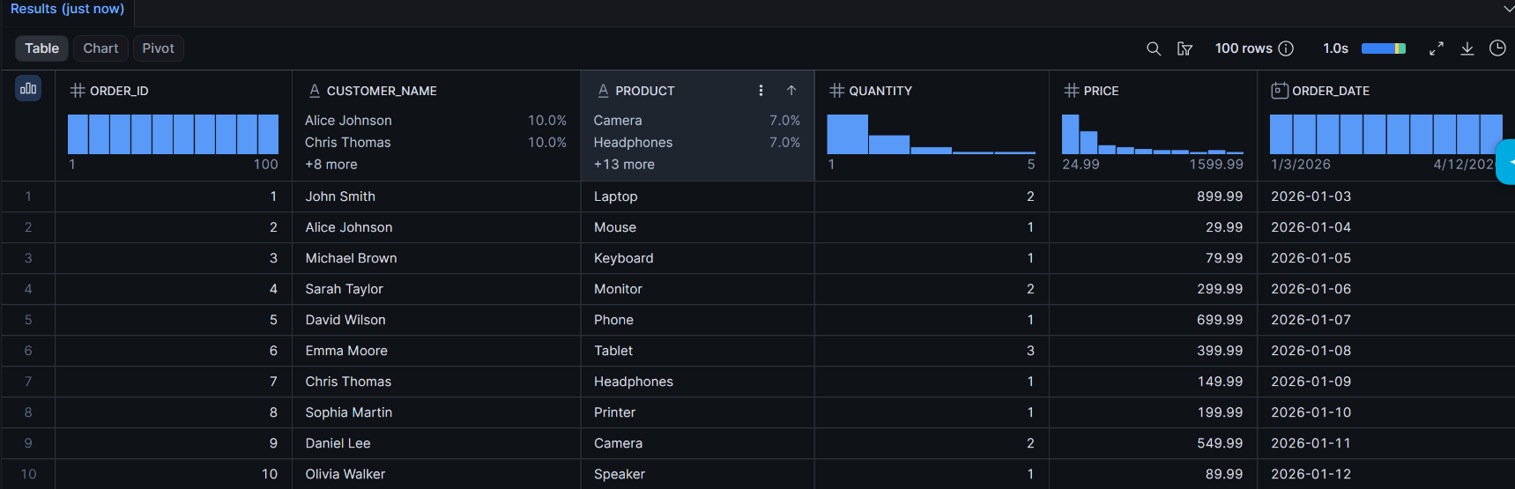

INSERT INTO ORDERS_FINAL
SELECT * FROM ORDERS_RAW;

SELECT * FROM ORDERS_FINAL;
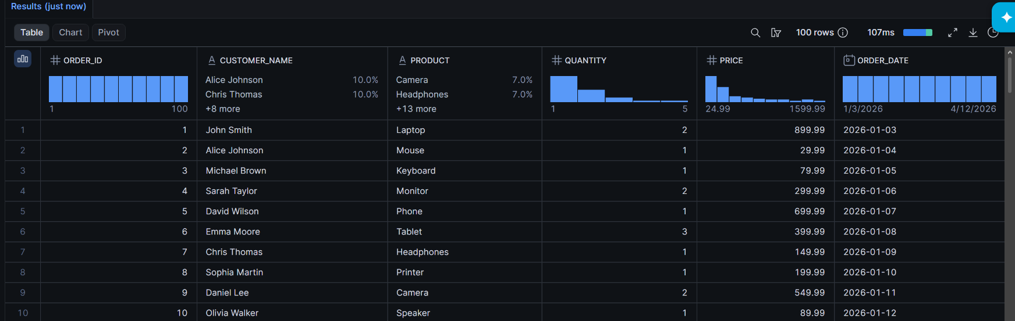

-- PART E: Incremental Loading
-- Create a Snowpipe object to load new files automatically into ORDERS_RAW.
CREATE OR REPLACE PIPE RETAIL_ORDERS_PIPE
AS
COPY INTO ORDERS_RAW
FROM @RETAIL_AZURE_STAGE
FILE_FORMAT = (FORMAT_NAME = RETAIL_CSV_FORMAT);
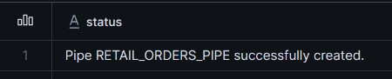
ALTER PIPE RETAIL_ORDERS_PIPE REFRESH;

-- Create a stream on ORDERS_RAW.
CREATE OR REPLACE STREAM ORDERS_STREAM
ON TABLE ORDERS_RAW;
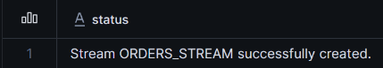
SELECT * FROM ORDERS_STREAM;

-- Create a task to merge new rows from the stream into ORDERS_FINAL.
CREATE OR REPLACE TASK ORDERS_MERGE_TASK
WAREHOUSE = RETAIL_LOAD_WH
WHEN SYSTEM$STREAM_HAS_DATA('RETAIL_DB.ORDERS_DEMO.ORDERS_STREAM')
AS

MERGE INTO ORDERS_FINAL T
USING
(
SELECT
ORDER_ID,
CUSTOMER_NAME,
PRODUCT,
QUANTITY,
PRICE,
ORDER_DATE
FROM ORDERS_STREAM
WHERE METADATA$ACTION='INSERT'
) S
ON T.ORDER_ID = S.ORDER_ID
WHEN MATCHED THEN
UPDATE SET
T.CUSTOMER_NAME = S.CUSTOMER_NAME,
T.PRODUCT = S.PRODUCT,
T.QUANTITY = S.QUANTITY,
T.PRICE = S.PRICE,
T.ORDER_DATE = S.ORDER_DATE

WHEN NOT MATCHED THEN
INSERT
(
ORDER_ID,
CUSTOMER_NAME,
PRODUCT,
QUANTITY,
PRICE,
ORDER_DATE
)
VALUES
(
S.ORDER_ID,
S.CUSTOMER_NAME,
S.PRODUCT,
S.QUANTITY,
S.PRICE,
S.ORDER_DATE
);
ALTER TASK ORDERS_MERGE_TASK RESUME;

-- Upload another CSV file into Azure Storage.
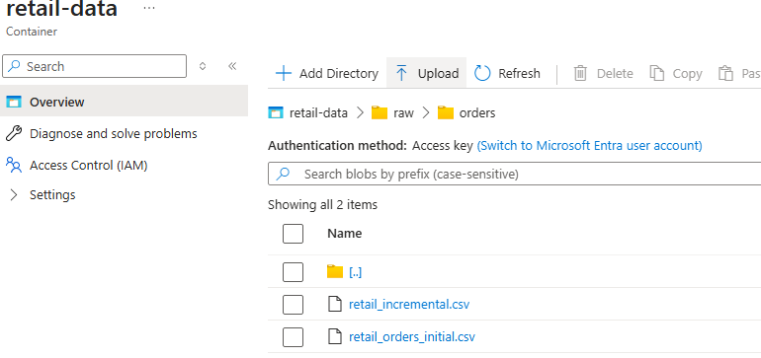
-- Verify that new rows are automatically loaded into Snowflake.
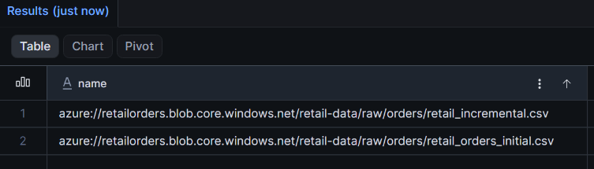

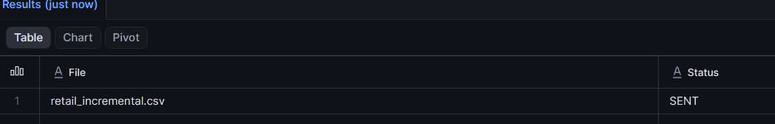

New rows added.
