Software Requirements Specification
Insurance Management System
A Full-Stack Insurance Lifecycle Platform

Document Title | Software Requirements Specification (SRS)
Project Name | Insurance Management System
Version | 1.0
Date | March 2026
Status | Final
Backend | ASP.NET Core 8 • C# • Entity Framework Core
Frontend | Angular 20 • TypeScript • Tailwind CSS
Database | SQL Server
Authentication | JWT Bearer Tokens • BCrypt Hashing • CAPTCHA
Architecture | Clean Architecture • RESTful API • Standalone Angular Components
User Roles | Admin • Agent • ClaimsOfficer • Customer

1. Introduction

1.1 Purpose of the Document
This Software Requirements Specification (SRS) document defines the complete functional and non-functional requirements for the Insurance Management System — a full-stack, web-based digital platform designed to automate and manage the end-to-end insurance policy lifecycle.
This document serves as the single authoritative reference for developers, QA engineers, system architects, and business stakeholders. It establishes a shared understanding of the system's capabilities, boundaries, business rules, and technical constraints before and throughout implementation. All design, development, and testing activities must align with the requirements documented herein.
The SRS addresses all eight core system modules: Authentication and Authorization, Insurance Plan Management, Policy Lifecycle Management, Premium Payment, Claims Processing, Policy Loan Facility, Notification Services, and Automated Background Services.

1.2 Scope of the Project
The Insurance Management System is a standalone web-based insurance portal that replaces manual, paper-driven workflows with a fully automated, role-based digital platform. The system supports the complete insurance journey from plan discovery and policy purchase to premium collection, loan management, and claim settlement for four distinct user roles operating within a single integrated platform.
The platform is built on a decoupled architecture: an Angular Single Page Application on the frontend communicates with an ASP.NET Core 8 REST API on the backend, backed by a SQL Server relational database. The system integrates with SMTP mail services for automated email notifications and generates QuestPDF invoices for every financial transaction.
That includes:
▸ Dynamic insurance plan creation with configurable benefit toggles (Death Benefit, Maturity Benefit, Bonus, Loan Facility, Coverage Increase, Whole Life coverage)
▸ 4-step policy purchase wizard with auto-save drafts, multi-member support, and nominee share percentage validation summing to 100%
▸ Agent-driven policy approval and rejection workflow with commission tracking on first premium payment
▸ Periodic premium collection with QuestPDF invoice generation, sequential invoice numbering, and NextDueDate tracking
▸ Multi-stage death claim processing: Customer files claim, Admin assigns to ClaimsOfficer, Officer reviews and settles or rejects
▸ Automated maturity claim processing with bonus calculation, terminal bonus, and outstanding loan deduction
▸ Policy-backed loan facility with surrender-value-based eligibility, interest-first repayment recorded in the Payments table
▸ Three automated daily background services: PremiumReminderService, LapsePolicyService, MaturityProcessingService
▸ Real-time in-app notification system using Angular signals with unread badge counter
▸ KYC document upload and secure management for policies and claims

1.3 Definitions, Acronyms and Abbreviations

Term / Acronym | Full Form / Meaning | Usage in System
JWT | JSON Web Token | Stateless auth token (2-hr expiry); carries userId, email, role claims in payload
EF Core | Entity Framework Core | ORM used for SQL Server data access in the .NET backend; Code-First migrations
DTO | Data Transfer Object | Lightweight object exchanged between API controller and application service layer
SRS | Software Requirements Specification | This document; defines all system requirements per IEEE Std 830-1998
REST | Representational State Transfer | API architectural style; all endpoints use JSON over HTTP/HTTPS
CAPTCHA | Completely Automated Public Turing Test | Bot protection on login endpoint; 6-char alphanumeric code
BCrypt | Blowfish Crypt | Password hashing algorithm used via BCrypt.Net-Next; plain-text never stored
SPA | Single Page Application | Angular frontend; navigates without full-page browser reloads
RBAC | Role-Based Access Control | All API endpoints protected by role claims extracted from JWT
KYC | Know Your Customer | Identity and income proof documents uploaded during policy submission
GST | Goods and Services Tax | 18% statutory tax applied as final multiplier in premium calculation
ACID | Atomicity Consistency Isolation Durability | Transaction guarantee for all financial operations in SQL Server
SMTP | Simple Mail Transfer Protocol | Email delivery protocol used by MailKit and MimeKit libraries

2. Overall Description

2.1 Product Perspective
The Insurance Management System operates as a standalone insurance management portal with a clear separation of concerns between the Angular-based Single Page Application frontend and the ASP.NET Core 8 REST API backend. The system is not a component of a larger insurance enterprise suite but is designed with integration-readiness for future third-party connections such as payment gateways and mobile applications.
The platform replaces traditionally manual, paper-intensive insurance workflows agent-based policy issuance, manual premium tracking, and in-person claim filing with a fully digital, automated, role-based workflow accessible from any modern web browser. The architecture follows Clean Architecture principles to ensure long-term maintainability and testability.
External System Interfaces
▸ SMTP Mail Server (MailKit / MimeKit) — automated emails on policy events, premium reminders, and claim updates
▸ SQL Server (LocalDB for development, Azure SQL for production) — persistent relational data storage
▸ Web Browser (Chrome 120+, Edge 120+, Firefox 120+) — end-user access point for all four roles
▸ File System / Blob Storage — KYC documents and QuestPDF invoices

2.2 Product Functions
The system provides the following high-level functional capabilities:

Module | Core Capability | Primary Actors
Authentication | CAPTCHA-protected login, BCrypt password hashing, JWT token issuance (1hr), password reset via time-limited GUID token | All Roles
Plan Management | Admin creates and edits insurance plans with configurable benefit toggles and actuarial risk factors for premium calculation | Admin, Customer
Policy Lifecycle | 4-step wizard: Config, Members, Nominees, Submit; draft auto-save at each step; agent approval workflow | Customer, Agent
Premium Payment | Premium collection with frequency tracking, NextDueDate advancement, QuestPDF invoice generation, agent commission on first payment | Customer, System
Claims Processing | Death claim filing with 5-point validation; Admin assigns to ClaimsOfficer; Officer settles with loan deduction or rejects | Customer, Admin, ClaimsOfficer
Maturity Processing | Daily auto-settlement of matured policies: coverage + bonus minus outstanding loan; policy status transitions | System
Loan Facility | Surrender-value-based loan eligibility; auto-approval by system; interest-first repayment via Payments table (no separate loan repayment table) | Customer, System
Notifications | Real-time in-app notifications using Angular signals; email via MailKit; five notification types covering all system events | All Roles, System
Background Services | Three daily IHostedService implementations: PremiumReminder, LapsePolicy, MaturityProcessing — all with graceful shutdown support | System

2.3 User Classes and Characteristics

2.3.1 Customer
The primary end-user of the system. Customers are individuals who purchase and manage their own insurance policies. They interact with the system to browse plans, purchase policies via the 4-step wizard, pay premiums, file death claims, apply for policy loans, and receive notifications. Customers are expected to have basic digital literacy and access to a modern web browser.
Customer Capabilities
▸ Browse and compare active insurance plans with benefit details and premium estimates
▸ Purchase a policy via 4-step wizard with draft auto-save and document upload on final submission
▸ Pay premiums, view payment history, and download QuestPDF invoices
▸ File death claims with death certificate documentation and nominee selection
▸ Apply for policy-backed loans and make interest-first repayments
▸ View maturity claim details — auto-processed by the system without customer action
▸ Receive real-time in-app and email notifications for all policy, payment, and claim events

2.3.2 Agent
Insurance agents are professional representatives responsible for validating and approving policy applications. Agents do not initiate policies but act as the approval gateway for customer-submitted applications. They earn commission on the first premium payment of policies they approve and are not involved in loan processing or claim management.
Agent Capabilities
▸ View all pending policy applications assigned to them in the approvals queue
▸ Review customer-submitted KYC documents (identity proof and income proof) and policy details
▸ Approve policies and triggers Active status
▸ Reject policies with documented rejection remarks — triggers Cancelled status
▸ Receive automatic commission when their approved policy receives its first premium payment

2.3.3 ClaimsOfficer
Claims Officers are specialist staff responsible for assessing and processing insurance claims. They are assigned claims by the Admin and have authority to settle or reject claims based on supporting evidence. Claims Officers can view loan status and outstanding balance alongside the pre-calculated payout breakdown to make informed settlement decisions.
ClaimsOfficer Capabilities
▸ View all claims assigned to them by the Admin through the claims queue
▸ Review full claim details: member information, death certificate, and policy documents
▸ View loan status and outstanding balance associated with the policy
▸ View pre-calculated payout breakdown (Current Coverage + Bonus minus Outstanding Loan) before deciding
▸ Settle a claim with a confirmed settlement amount — must be greater than zero
▸ Reject a claim with mandatory written remarks explaining the reason for rejection

2.3.4 Admin
Administrators have the broadest system access and are responsible for system configuration, plan management, oversight, and claim workflow management. Admins assign claims to ClaimsOfficers but do not process claims themselves. Admins have read-only visibility of loan records and full management control over insurance plans.
Admin Capabilities
▸ Create, edit, and deactivate insurance plans with full benefit toggle configuration
▸ View all policies, payments, and claims across the entire system
▸ Assign newly filed death claims to available ClaimsOfficers and also the agent assignment for the customers
▸ View all loan records across all customers in a read-only capacity
▸ Manage system-wide plan settings including commission rates and grace periods

2.4 Operating Environment

Component | Technology / Specification
Backend Runtime | ASP.NET Core 8, C#
Frontend Runtime | Angular 20 (Standalone Components), TypeScript, Tailwind CSS
Database | SQL Server
ORM | Entity Framework Core 8 - Code-First migrations for schema management
Authentication | JWT Bearer Authentication via Microsoft.AspNetCore.Authentication.JwtBearer
Password Security | BCrypt.Net-Next — BCrypt hashing; plain-text passwords never stored or logged
Email Service | MailKit + MimeKit — SMTP integration for all automated email notifications
PDF Generation | QuestPDF — invoice generation stored in wwwroot/invoices/ with sequential numbering
Browser Support | Google Chrome, Microsoft Edge, Mozilla Firefox
Dev Tools | Visual Studio 2022 / VS Code, Node.js 20+, .NET 8 SDK, SQL Server Management Studio

2.5 Design and Implementation Constraints
- Role-Based Access Control must be enforced on every API endpoint using JWT role claims — no endpoint is accessible without appropriate role authorization except Auth endpoints
- All financial transactions (payments, loan operations, claim settlements) must execute within ACID-compliant database transactions to ensure data integrity and prevent partial updates
- The system must follow Clean Architecture principles: Domain, Application, Infrastructure, and Presentation layers
- Frontend must use Angular standalone components, each component declares its own imports and is independently testable
- CoverageAmount stored at policy creation is never updated — current coverage is always computed on-the-fly using the compound growth formula when required for claims and loans
- All loan repayments are recorded as Payment records with PolicyLoanId populated
- Background services must use IServiceScopeFactory to create a new DI scope per execution to avoid singleton/scoped lifetime conflicts with DbContext
- All background services must accept and honour CancellationToken to enable graceful shutdown when the application stops without data corruption

2.6 Assumptions and Dependencies
- SQL Server is available and EF Core migrations are applied before the application starts for the first time
- SMTP server credentials are configured in appsettings.json; email delivery failures are logged but must not crash the application or fail a payment transaction
- Angular frontend and .NET backend are deployed on the same domain, or CORS is correctly configured to allow cross-origin requests from the Angular development origin
- Agent commission is automatically triggered on the first completed payment for each policy — no manual commission entry is required by any actor
- Plan configuration changes made by Admin apply to new policies only, except GracePeriodDays which is read live from the Plan and affects lapse detection for all existing policies
- Users are assumed to have JavaScript enabled in their browser and access to a stable internet connection

3. Functional Requirements

3.1 Authentication and Authorization
The Authentication module provides secure, CAPTCHA-protected access to the system for all user roles. Authorization is enforced at the API level using JWT role claims on every secured endpoint.

3.1.1 User Registration
New users register via POST /api/Auth/register providing name, email, password, phone, date of birth, and role. The system validates all fields, hashes the password using BCrypt, and persists the User record with IsActive = true.
Registration Rules
▸ Email must be unique across all users — duplicate email returns HTTP 409 Conflict
▸ Password is hashed using BCrypt.Net-Next before storage — plain-text password is never persisted or returned

3.1.2 User Login with CAPTCHA
Login is a two-phase process. The frontend first requests a CAPTCHA from GET /api/Auth/get-captcha (6-character random alphanumeric code), then submits it alongside credentials to POST /api/Auth/login. Both CAPTCHA validation and credential verification are performed server-side.

Step | Action | System Response
1 | GET /api/Auth/get-captcha | Returns 6-character alphanumeric CAPTCHA; stored server-side for validation
2 | POST /api/Auth/login with email + password + captchaCode | CAPTCHA validated first — mismatch returns HTTP 400 immediately
3 | Credential lookup | User retrieved from database by email — not found returns HTTP 401 Unauthorized
4 | Password verification | BCrypt.Verify() compares submitted password against stored BCrypt hash — failure returns HTTP 401
5 | JWT generation | On success: signed JWT token issued with 2-hour expiry containing userId, email, role
6 | Frontend routing | Angular decodes role claim from JWT; routes to role-specific dashboard

3.1.3 Password Reset
Users submit POST /api/Auth/forgot-password with their registered email. The system generates a GUID reset token stored in Users.ResetToken with a 1-hour expiry in Users.ResetTokenExpiry. The user submits the token and new password to POST /api/Auth/reset-password. After successful reset, both token fields are set to NULL.
Password Reset Security Rules
▸ Reset token is a GUID — unique, unpredictable, time-limited to 1 hour from generation
▸ After successful reset: ResetToken and ResetTokenExpiry are nulled — token is strictly single-use
▸ Expired or previously used tokens return HTTP 400 Bad Request with an appropriate error message

3.2 Insurance Plan Management
Admins create and manage insurance plan templates that define all rules, rates, and benefit configurations governing policies created from them. Customers browse active plans to select a policy.

3.2.1 Plan Configuration
Each plan is configured with core fields and benefit toggles. Benefit toggles conditionally make additional fields required:
Core Plan Fields
▸ PlanName, PlanType (Term, Endowment, ULIP, Child, Pension, WholeLife)
▸ BaseRate — actuarial base premium rate per 1,000 of coverage amount
▸ MinAge, MaxAge — member eligibility age bounds
▸ MinCoverageAmount, MaxCoverageAmount — policy coverage bounds
▸ MinTermYears, MaxTermYears — policy duration bounds (not applicable for Whole Life)
▸ GracePeriodDays — days after NextDueDate before the policy lapses; read live by LapsePolicyService
▸ MaxPolicyMembersAllowed, MinNominees, MaxNominees
▸ CommissionRate — percentage paid to agent on first premium payment
▸ HasDeathBenefit — enables death claim filing for this plan
▸ HasMaturityBenefit — enables automatic maturity settlement; if false, policy goes to Expired status
▸ HasBonus + BonusRate + TerminalBonusRate — annual bonus accumulation added to claim and maturity payouts
▸ HasLoanFacility + LoanEligibleAfterYears + LoanInterestRate + MaxLoanPercentage — loan configuration
▸ CoverageIncreasing + CoverageIncreaseRate — coverage compounds annually using compound growth formula
▸ CoverageUntilAge — if set to 100, plan is Whole Life; policy EndDate = member DOB + 100 years

3.2.2 Premium Calculation Formula
The premium is computed on the frontend for immediate customer feedback and confirmed on the backend before policy creation. GST at 18% is always applied as the final multiplier.
Annual Premium Formula
Premium = (CoverageAmount / 1000) x BaseRate x AgeFactor x SmokerFactor x GenderFactor x TermFactor x 1.18

Risk Factor | Values / Bands | Multiplier Logic
AgeFactor | 18-25 / 26-35 / 36-45 / 46-55 / 56+ | 1.0 / 1.1 / 1.3 / 1.6 / 2.0 — older age carries higher actuarial risk
SmokerFactor | Non-Smoker / Smoker | 1.0 / 1.5 — 50% lifestyle loading applied for declared smokers
GenderFactor | Female / Male / Other | 0.95 / 1.0 / 1.0 — actuarial female longevity benefit
TermFactor | 10yr or less / 11-20yr / 21-30yr / 31yr+ | 0.9 / 1.0 / 1.1 / 1.2 — longer term increases exposure
GST | Always 18% | Final statutory tax multiplier on all insurance premiums; non-negotiable

Frequency Adjustment
▸ Annual premium divided by 12 for Monthly, 4 for Quarterly, 2 for Semi-Annual, 1 for Annual frequency
▸ Result rounded to 2 decimal places — this becomes TotalPremiumAmount stored at policy creation
▸ TotalPremiumAmount is frozen at creation time — plan rate changes do not affect existing policies

3.3 Policy Lifecycle Management
The policy lifecycle spans from initial draft creation through active coverage to final closure. The 4-step wizard guides customers through the complete application process with automatic draft saving at each step.

3.3.1 Policy Status Lifecycle
Status | Description | How Triggered
Draft | Wizard in progress; data saved but policy not submitted | Customer starts 4-step wizard
Pending | Submitted; awaiting agent review and approval decision | Customer completes Step 4 and submits
Active | Approved; premium payments and coverage running | Agent approves the policy application
Lapsed | Missed premium payment beyond grace period | LapsePolicyService (daily background service)
Matured | Policy reached end date with maturity benefit enabled | MaturityProcessingService (daily background service)
Expired | Policy reached end date without maturity benefit | MaturityProcessingService (daily background service)
Cancelled | Rejected by agent or cancelled by admin | Agent rejects or Admin cancels the policy
Closed | Death claim settled; coverage permanently ended | ClaimsOfficer settles a death claim

3.3.2 4-Step Policy Purchase Wizard
Step | Screen | Key Inputs and Validations
Step 1 | Policy Configuration | CoverageAmount within plan min/max bounds; TermYears (not required for Whole Life plans); PremiumFrequency; StartDate must be today or a future date
Step 2 | Member Details | Add 1 to MaxPolicyMembersAllowed members; each requires Name, DOB (must be past date; age within plan min/max), Gender, IsSmoker, HasPreExistingDiseases, Occupation
Step 3 | Nominee Details | Add MinNominees to MaxNominees nominees; Name, Relationship to Policyholder, Contact Number; total SharePercentage across all nominees must equal exactly 100%
Step 4 | Review and Submit | Complete summary of all entered data; upload KYC documents (Identity Proof + Income Proof) as multipart/form-data; submission creates PolicyAssignment with Status = Pending

NOTE: Draft Auto-Save: All text data is automatically saved via PUT /api/Policies/draft/{id} at each wizard step. File uploads occur only on final submission at Step 4. Customers can close the browser mid-wizard and resume from the saved draft on next login.

3.3.3 Coverage Increase Calculation
For plans with CoverageIncreasing = true, coverage is not stored statically. It is computed on-the-fly whenever needed for claims, loan calculations, or payout breakdowns. The base CoverageAmount in the database is never updated after policy creation.
Current Coverage Formula
CurrentCoverage = BaseCoverage x (1 + CoverageIncreaseRate / 100) ^ YearsActive [capped at Plan.MaxCoverageAmount]

3.4 Premium Payment
The payment module handles premium collection, invoice generation, and NextDueDate tracking. Payments determine policy health status, trigger agent commissions, and establish loan eligibility based on total premiums paid.

3.4.1 Payment Business Rules
▸ Policy must be in Active status — payments on Pending, Lapsed, Cancelled, or Closed policies are rejected
▸ First payment is accepted immediately after policy activation — no 30-day waiting restriction for first installment
▸ Subsequent payments are blocked if the current date is more than 30 days before NextDueDate
▸ On each successful payment: NextDueDate advances by 1 month (Monthly), 3 months (Quarterly), 6 months (Semi-Annual), or 12 months (Annual)
▸ Agent commission is triggered on the first payment: CommissionStatus is set to Paid and agent receives a commission notification

3.4.2 Loan Repayment via Payments Table
All loan repayments are recorded as Payment records with the PolicyLoanId foreign key populated. This dual-purpose design allows unified payment history across premium and loan repayment transactions.
Field | Explanation
PolicyLoanId | Foreign key to PolicyLoans.Id — identifies the loan being repaid
PrincipalPaid | Amount applied to reduce the principal outstanding balance
InterestPaid | Interest deducted first from the repayment amount
BalanceAfter | Remaining outstanding loan balance after this repayment is applied

3.5 Claims Processing
The claims module handles the complete lifecycle of insurance claim events — from customer filing through Admin assignment to ClaimsOfficer settlement or rejection. Two claim types are supported: Death Claims (filed manually by the customer or nominee) and Maturity Claims (auto-generated daily by the system).

3.5.1 Death Claim Filing
▸ 1. Policy must be in Active status — claims on non-Active policies are immediately rejected
▸ 2. Insured member must have been covered for a minimum of 24 months from the policy start date
▸ 3. Death certificate number must be unique across all claims — duplicates are rejected to prevent fraud
▸ 4. No existing UnderReview or active claim for the same member — only one active claim per member at a time
▸ 5. At least one nominee must exist on the policy — claim is rejected if no nominee is registered

3.5.2 Claim Amount Calculations
Death Claim Amount: ClaimAmount = CurrentCoverage(policy, member) + TotalBonus
Bonus Calculation: TotalBonus = (SumAssured x BonusRate / 100) x YearsActive
Terminal Bonus: TerminalBonus = TotalBonus x (TerminalBonusRate / 100) [only at maturity]
Maturity Settlement Payout: MaturitySettlement = CurrentCoverage + TotalBonus + TerminalBonus - OutstandingLoanBalance

3.5.3 Claim Processing Workflow
Stage | Actor | Action and System Response
1 — File | Customer | Files death claim with death certificate and nominee selection; System runs 5-point validation; creates claim with Status = UnderReview; Admin notified
2 — Assign | Admin | Reviews new claim notification; assigns claim to an available ClaimsOfficer; ClaimsOfficer receives assignment notification
3 — Review | ClaimsOfficer | Opens assigned claim; views member info, loan status, outstanding balance, and full payout breakdown before making a decision
4a — Settle | ClaimsOfficer | Enters settlement amount (must be > 0); System deducts outstanding loan; Claim status = Settled; Policy status = Closed; Customer and Officer notified
4b — Reject | ClaimsOfficer | Enters mandatory rejection remarks; Claim status = Rejected; Policy remains unchanged; Customer and Officer notified with reason
Auto — Maturity | System | Daily MaturityProcessingService auto-creates Settled maturity claim; ClaimsOfficer not involved; Policy = Matured; Customer notified directly

3.6 Policy Loan Facility
The loan facility allows customers to borrow against the surrender value of their active eligible policies without surrendering coverage. Loans are auto-approved by the system — no manual officer approval is required. Only one active loan is permitted per policy at any time.

3.6.1 Loan Eligibility Criteria
▸ Policy must be in Active status — inactive, lapsed, or closed policies are not eligible
▸ Plan.HasLoanFacility must be true — not all plan types support the loan facility
▸ Policy age must be greater than or equal to Plan.LoanEligibleAfterYears (e.g. 3 years for Endowment, 5 years for Child plans)
▸ No existing Active loan on the same policy — only one loan is permitted at a time; new application rejected if active loan exists
Surrender Value and Maximum Loan Amount
SurrenderValue = TotalPremiumsPaid x 30% | MaxLoanAmount = SurrenderValue x (Plan.MaxLoanPercentage / 100)

3.6.2 Repayment Logic
▸ Each repayment: interest accrued is deducted first; remaining portion of repayment reduces the principal (OutstandingBalance)
▸ Every repayment creates a Payment record with PolicyLoanId set, PrincipalPaid, InterestPaid, and BalanceAfter populated
▸ When OutstandingBalance reaches zero: Loan.Status = Closed; customer receives 'Loan Fully Repaid' notification
▸ At policy maturity: if loan still active, OutstandingBalance is deducted from maturity settlement; Loan.Status = Adjusted

3.7 Role-Based Dashboards
Role | Dashboard Contents | Key Metrics and Actions
Customer | My Policies, My Payments, My Claims, My Loans, Notifications bell | NextDueDate alerts, loan balance, claim status tracker, premium history, invoice downloads
Agent | Pending Policy Approvals queue, My Approved Policies, Commission Tracker | Pending approval count, total commissions earned, approve/reject actions with remarks
ClaimsOfficer | Assigned Claims Queue, Claim Details with Payout Breakdown panel | Claims by status, outstanding count, settle or reject actions with loan deduction visibility
Admin | All Policies, All Claims, All Loans (read-only), Plan Management | System-wide counts, recent activity feed, assign claims to officers, create and deactivate plans

3.8 Notification System
All significant system events generate in-app notifications stored in the Notifications table. Where configured, email notifications are also sent via MailKit. The Angular frontend uses signals to maintain a real-time unread badge count without polling or page refresh.
▸ unreadCount = signal<number>(0) maintained in shared NotificationService — reactive, no polling
▸ Bell badge displays numeric count; shows '9+' when unread count exceeds 9
▸ Badge updates immediately without page reload when new notifications are received
▸ Marking notifications as read decrements the signal count in real time

Notification Type | Trigger Event | Recipients
PolicyStatusUpdate | Policy transitions between any lifecycle status | Customer; also Agent on approval/rejection events
ClaimStatusUpdate | Claim created, assigned, settled, or rejected | Customer, Admin (on filing), ClaimsOfficer (on assignment and settlement)
PaymentConfirmation | Every successful premium payment or loan repayment | Customer; Agent on first payment (commission)
PremiumReminder | 7 days before NextDueDate (PremiumReminderService) | Customer via in-app notification and email
General | Loan approval, commission credit, system messages | Role-specific recipient based on event context

3.9 Automated Background Services
Three background services run as IHostedService implementations registered via AddHostedService<T>() in Program.cs. Each service uses a 24-hour Task.Delay loop. IServiceScopeFactory creates a fresh DI scope per execution to safely resolve scoped services from within singleton-lifetime hosted services. CancellationToken enables graceful shutdown.
Service | Trigger | Business Logic
PremiumReminderService | Daily | Queries Active policies WHERE NextDueDate is between today and today plus 7 days. Creates in-app notification and sends email via MailKit to the policy customer.
LapsePolicyService | Daily | Queries Active policies WHERE (NextDueDate + GracePeriodDays) is in the past. Sets policy Status = Lapsed. GracePeriodDays read live from Plan. Sends lapse notification to customer.
MaturityProcessingService | Daily | Queries Active policies WHERE EndDate is in the past. HasMaturityBenefit=true: auto-creates Settled maturity claim with full payout calc; policy = Matured. HasMaturityBenefit=false: policy = Expired. Customer notified in both paths.

4. Software Interface Requirements

The system communicates exclusively through RESTful APIs using JSON as the payload format. All endpoints except the Auth module require a valid JWT Bearer token in the Authorization header. Role-based access is enforced via [Authorize(Roles)] attributes on every controller action.

4.1 Authentication APIs
Endpoint | Method | Description | Role Access
/api/Auth/get-captcha | GET | Generate and return 6-character CAPTCHA code for login protection | Anonymous
/api/Auth/register | POST | Register new user with BCrypt password hashing and role assignment | Anonymous
/api/Auth/login | POST | Validate credentials and CAPTCHA; return signed JWT token (2-hr expiry) | Anonymous
/api/Auth/forgot-password | POST | Generate GUID reset token with 1-hour expiry; return token in response | Anonymous
/api/Auth/reset-password | POST | Validate reset token; set new BCrypt-hashed password; null token fields | Anonymous

4.2 Plan Management APIs
Endpoint | Method | Description | Role Access
/api/Plans | GET | List all active insurance plans with benefit details and premium factors | All Roles
/api/Plans/{id} | GET | Get single plan with all benefit toggle fields for wizard configuration | All Roles
/api/Plans | POST | Create new insurance plan with full benefit toggle and rate configuration | Admin
/api/Plans/{id} | PUT | Update existing plan fields and benefit toggles; existing policies unaffected | Admin
/api/Plans/{id} | DELETE | Soft delete via IsActive=false; plan hidden from new customers immediately | Admin

4.3 Policy APIs
Endpoint | Method | Description | Role Access
/api/Policies | GET | Get policies; Admin and Agent see all; Customer sees only own policies | All Auth
/api/Policies/{id} | GET | Get full policy detail including members, nominees, and payment history | All Auth
/api/Policies/draft | POST | Create new policy draft (Step 1 auto-save); returns draftId for subsequent steps | Customer
/api/Policies/draft/{id} | PUT | Update draft text data at each wizard step; no files at this stage | Customer
/api/Policies/draft/{id}/submit | POST | Final submission with KYC documents as multipart/form-data; status = Pending | Customer
/api/Policies/{id}/approve | PUT | Agent approves policy; status = Active; NextDueDate set; customer notified | Agent
/api/Policies/{id}/reject | PUT | Agent rejects policy with remarks; status = Cancelled; customer notified | Agent

4.4 Payment APIs
Endpoint | Method | Description | Role Access
/api/Payments | GET | Get payment history for a policy including loan repayments (by PolicyLoanId) | Customer, Admin
/api/Payments/pay | POST | Submit premium payment; validates Active status and NextDueDate timing rules | Customer
/api/Payments/{id}/invoice | GET | Download QuestPDF invoice file for a specific payment transaction | Customer, Admin

4.5 Claims APIs
Endpoint | Method | Description | Role Access
/api/Claims | GET | Get claims; Admin and Officer see all; Customer sees own claims only | All Auth
/api/Claims/file | POST | File a death claim; runs 5-point validation before creating claim record | Customer
/api/Claims/{id}/assign | PUT | Admin assigns UnderReview claim to a specific ClaimsOfficer | Admin
/api/Claims/{id}/process | PUT | ClaimsOfficer settles (amount > 0) or rejects (remarks required) claim | ClaimsOfficer
/api/Claims/{id}/breakdown | GET | Get payout breakdown: Coverage + Bonus minus Loan for informed decision | ClaimsOfficer, Admin

4.6 Loan APIs
Endpoint | Method | Description | Role Access
/api/Loans/eligibility/{policyId} | GET | Check all 4 eligibility criteria; return MaxLoanAmount if eligible | Customer
/api/Loans/apply | POST | Submit loan application; system auto-approves; creates PolicyLoan record | Customer
/api/Loans/repay | POST | Submit loan repayment; interest-first logic; creates Payment record with PolicyLoanId | Customer
/api/Loans | GET | Get all loans; Admin sees all customers; Customer sees own loans only | Customer, Admin
/api/Loans/{id} | GET | Get single loan detail with repayment history (from Payments table) | Customer, Admin

4.7 Notification APIs
Endpoint | Method | Description | Role Access
/api/Notifications | GET | Get all notifications for the authenticated user ordered by CreatedAt desc | Customer
/api/Notifications/unread | GET | Get count of unread notifications for Angular signal badge initialisation | Customer
/api/Notifications/{id}/read | PUT | Mark a single notification as IsRead = true; decrements badge count | Customer
/api/Notifications/read-all | PUT | Mark all user notifications as read; resets badge count to zero | Customer

4.8 Dashboard APIs
Endpoint | Method | Description | Role Access
/api/Dashboard/customer | GET | Returns: active policies, upcoming dues, recent claims, loan balances | Customer
/api/Dashboard/agent | GET | Returns: pending approval count, approved policies list, total commissions | Agent
/api/Dashboard/claims-officer | GET | Returns: assigned claims by status, pending queue, recently processed | ClaimsOfficer
/api/Dashboard/admin | GET | Returns: system-wide counts, recent activity, plan statistics, revenue summary | Admin

5. System Architecture

5.1 Architectural Overview
The system is built on Clean Architecture principles with strict layer separation and controlled dependency direction. Each layer has a clearly defined responsibility, and the dependency rule is enforced: outer layers depend on inner layers; inner layers have no knowledge of outer layers. This ensures the Domain and Application layers remain independently testable and free from infrastructure concerns.

Layer | Technology | Responsibility
Presentation Layer | Angular 20 SPA, Standalone Components, Tailwind CSS | User interface, routing, reactive form validation, real-time notification badge via Angular signals, role-specific navigation
API Layer | ASP.NET Core 8 Controllers, JWT Middleware, CORS, GlobalExceptionHandler | HTTP request handling, model binding, authentication, role-based authorization, consistent JSON error responses
Service Layer | C# Application Services, AutoMapper, DTO mapping, business rule enforcement | All business logic: premium calculation, 5-point claim validation, loan eligibility, background service orchestration
Repository Layer | Entity Framework Core 8, IRepository pattern, LINQ queries | Database abstraction, Code-First migrations, ACID transaction management, query optimisation with AsNoTracking
Database Layer | SQL Server (LocalDB / Azure SQL) | Persistent relational storage for all 10 entities; referential integrity via foreign key constraints

5.2 Data Flow
The following describes the end-to-end request lifecycle for a typical operation:
- User interacts with Angular SPA and triggers an HTTP request to the REST API
- JWT Middleware validates the Bearer token in the Authorization header; extracts userId and role claims
- [Authorize(Roles)] attribute checks role authorization — returns HTTP 403 Forbidden if role is insufficient
- Controller receives the validated request DTO and delegates to the appropriate Application Service
- Service layer executes all business logic including validation, calculation, and rule enforcement
- Service calls the Repository via IRepository interface; Entity Framework Core translates to parameterised SQL
- SQL Server executes the query within an ACID transaction and returns the result set
- Service maps domain entity to response DTO using mapping
- Controller serialises the DTO to JSON and returns the HTTP response to Angular
- Angular service receives the response, updates component state, and re-renders the UI
- NotificationService creates a Notification record; Angular signal updates the unread badge count in real time

5.3 Frontend Architecture
▸ Standalone Components ,each component declares its own imports; independently testable
▸ AuthGuard checks JWT token expiry on route activation; redirects to login if token is invalid or expired
▸ RoleGuard validates the role claim from JWT before activating role-specific routes
▸ HTTP Interceptor automatically attaches Authorization: Bearer {token} to all outgoing API requests
▸ Reactive Forms with real-time validation: nominee share percentage total, DOB past-date check, start date future-date check
▸ Role-specific sidebar navigation renders only permitted menu items based on decoded JWT role claim

5.4 Background Services Design
Three background services are registered in Program.cs using AddHostedService<T>(). Each runs in an infinite loop with a 24-hour Task.Delay interval. The IServiceScopeFactory pattern resolves scoped services (DbContext, Application Services) safely from within the singleton-lifetime IHostedService.

6. Database Design

6.1 Entities
The database contains 10 core entities managed via Entity Framework Core Code-First migrations. The LoanRepayments table is intentionally absent — all loan repayments are stored as Payment records with the PolicyLoanId foreign key populated, keeping financial history unified.

Entity | Description | Key Fields
Users | Central identity store for all four system roles | Id, Name, Email, PasswordHash, Role, IsActive, ResetToken (nullable), ResetTokenExpiry (nullable), CreatedAt
Plans | Insurance plan templates configured by Admin with all benefit toggles | Id, PlanName, PlanType, BaseRate, all MinMax fields, GracePeriodDays, all benefit toggle boolean and rate fields, IsActive
PolicyAssignments | Live policy instance linking Customer to a Plan | Id, PolicyNumber, CustomerId FK, AgentId FK, PlanId FK, Status, TotalPremiumAmount, PremiumFrequency, NextDueDate, StartDate, EndDate, CommissionStatus
PolicyMembers | Insured individuals added to a policy in Step 2 of wizard | Id, PolicyAssignmentId FK, MemberName, DOB, Gender, IsSmoker, HasPreExistingDiseases, CoverageAmount, IsPrimaryInsured, Occupation
PolicyNominees | Beneficiaries registered on a policy in Step 3 of wizard | Id, PolicyAssignmentId FK, NomineeName, RelationshipToPolicyholder, ContactNumber, SharePercentage
Payments | All financial transactions: premium payments AND loan repayments | Id, PolicyAssignmentId FK, PolicyLoanId FK (nullable), Amount, PaymentMethod, Status, InvoiceNumber, PrincipalPaid, InterestPaid, BalanceAfter, PaymentDate
InsuranceClaims | Claim records for death and maturity claim events | Id, PolicyAssignmentId FK, PolicyMemberId FK, ClaimsOfficerId FK (nullable), ClaimType, ClaimAmount, SettlementAmount, Status, DeathCertificateNumber, Remarks
Documents | KYC and claim supporting documents uploaded by users | Id, PolicyAssignmentId FK (nullable), ClaimId FK (nullable), UploadedByUserId FK, FileName, FilePath, DocumentCategory, UploadedAt
Notifications | In-app notification records for all roles | Id, UserId FK, PolicyAssignmentId FK (nullable), ClaimId FK (nullable), PaymentId FK (nullable), Title, Message, Type, IsRead, CreatedAt
PolicyLoans | Loan records against policies; no separate repayments table | Id, PolicyAssignmentId FK, CustomerId FK, LoanAmount, InterestRate, OutstandingBalance, TotalInterestPaid, Status (Active/Closed/Adjusted), LoanDate, ClosedDate

6.2 Entity Relationships
Relationship | Cardinality | Notes
Users to PolicyAssignments (Customer) | 1 to Many | CustomerId FK on PolicyAssignments — a customer can have multiple policies
Users to PolicyAssignments (Agent) | 1 to Many | AgentId FK on PolicyAssignments — nullable; policy may not have an assigned agent
Users to InsuranceClaims (ClaimsOfficer) | 1 to Many | ClaimsOfficerId FK on InsuranceClaims — nullable; set when Admin assigns claim
Plans to PolicyAssignments | 1 to Many | PlanId FK on PolicyAssignments — many policies can be created from one plan
PolicyAssignments to PolicyMembers | 1 to Many | PolicyAssignmentId FK on PolicyMembers — at least 1, up to MaxPolicyMembersAllowed
PolicyAssignments to PolicyNominees | 1 to Many | PolicyAssignmentId FK on PolicyNominees — MinNominees to MaxNominees required
PolicyAssignments to Payments | 1 to Many | PolicyAssignmentId FK on Payments — always set for both premium and loan repayments
PolicyAssignments to InsuranceClaims | 1 to Many | PolicyAssignmentId FK on InsuranceClaims — one policy can have multiple claim records
PolicyAssignments to PolicyLoans | 1 to Many | PolicyAssignmentId FK on PolicyLoans — only one Active loan allowed at a time
PolicyMembers to InsuranceClaims | 1 to Many | PolicyMemberId FK on InsuranceClaims — claims are filed against specific members
PolicyLoans to Payments | 1 to Many | PolicyLoanId nullable FK on Payments — replaces LoanRepayments table entirely
InsuranceClaims to Documents | 1 to Many | ClaimId nullable FK on Documents — claim supporting evidence

7. Non-Functional Requirements

7.1 Security
▸ All passwords stored using BCrypt.Net-Next hashing — plain-text passwords are never persisted, returned in responses, or written to logs
▸ JWT tokens expire after 2 hours; password reset tokens expire after 1 hour and are strictly single-use (nulled after successful reset)
▸ CAPTCHA protection on the login endpoint prevents automated credential stuffing and brute-force attacks
▸ Role-Based Access Control enforced on every API endpoint via [Authorize(Roles)] — no secured endpoint is accessible without correct role claim
▸ HTTPS enforced in production deployment — all HTTP requests redirected to HTTPS
▸ CORS configured to allow only the Angular frontend origin in development; restricted to production domain in production
▸ Input validation on both client (Angular reactive forms) and server (model data annotations / FluentValidation) prevents injection and malformed data
▸ KYC documents stored in server-controlled directory — files not directly accessible via URL without authenticated download endpoint

7.2 Performance
▸ API response time target: under 500 milliseconds for all standard CRUD operations under normal load
▸ Premium calculation performed on the frontend for instant feedback; confirmed server-side to prevent manipulation
▸ EF Core read-only queries must use .AsNoTracking() to reduce object tracking overhead and improve query speed
▸ Angular Change Detection strategy: OnPush on performance-sensitive list components to minimise unnecessary re-renders
▸ Background services use Task.Delay (non-blocking async wait) rather than Thread.Sleep — prevents thread pool exhaustion
▸ QuestPDF invoice generation is asynchronous — payment confirmation response is not blocked by file I/O operations

7.3 Scalability
▸ Stateless JWT authentication enables horizontal scaling — no server-side session affinity or sticky sessions required
▸ Clean Architecture layer separation enables independent scaling of the API tier and database tier
▸ Background services are hosted within the API process in v1.0; high-volume deployments can extract them to Azure Functions or Worker Services without code changes
▸ SQL Server connection pooling managed transparently by EF Core — pool size configurable via connection string MaxPoolSize parameter
▸ Azure SQL compatibility ensures zero-friction migration from LocalDB development to cloud-hosted production database

7.4 Reliability
▸ All financial operations (payments, loan transactions, claim settlements) execute within ACID transactions — partial updates are automatically rolled back on any failure
▸ Background services accept and honour CancellationToken — application shutdown triggers clean loop exit without data corruption
▸ IServiceScopeFactory ensures each background service run uses a fresh DbContext instance — no stale tracked entities or connection leaks
▸ GlobalExceptionHandler middleware catches all unhandled exceptions and returns consistent JSON error responses with appropriate HTTP status codes
▸ Policy draft auto-save at every wizard step ensures no customer input data is lost due to browser crashes or network interruptions
▸ Background service execution failures are caught, logged, and suppressed — application continues running; next 24-hour cycle will retry

7.5 Maintainability
▸ Clean Architecture enforces strict dependency direction: Domain has no external dependencies; Application depends only on Domain; Infrastructure implements Domain interfaces
▸ Repository pattern abstracts all data access — switching the ORM or database engine requires changes only in the Infrastructure layer
▸ Angular standalone components eliminate NgModule boilerplate — each component is self-contained and independently unit-testable
▸ EF Core Code-First migrations provide versioned, source-controlled, reproducible schema evolution — no manual SQL scripts required
▸ All business rules (premium formula, loan eligibility, claim validation, bonus calculation) encapsulated in Application Services — not duplicated across controllers or frontend

7.6 Usability
▸ 4-step policy wizard with visible step progress indicator and draft auto-save — customers can pause and resume without losing any entered data
▸ Real-time inline form validation with clear error messages — nominee shares must total 100%, DOB must be a past date, start date must be today or future
▸ Role-specific sidebar navigation renders only the permitted menu items for each role — staff users never see irrelevant customer screens
▸ Notification bell badge updates in real time using Angular signals — no manual page refresh required to see new alerts
▸ Live premium calculator on the plan browse page updates the estimated premium as the customer adjusts coverage amount and term
▸ QuestPDF invoice immediately available for one-click download from payment history after payment confirmation
▸ Mobile-responsive layout using Tailwind CSS utility classes — designed desktop-first with responsive breakpoints for tablet and mobile

8. System Design Diagrams
8.1 ER Diagram

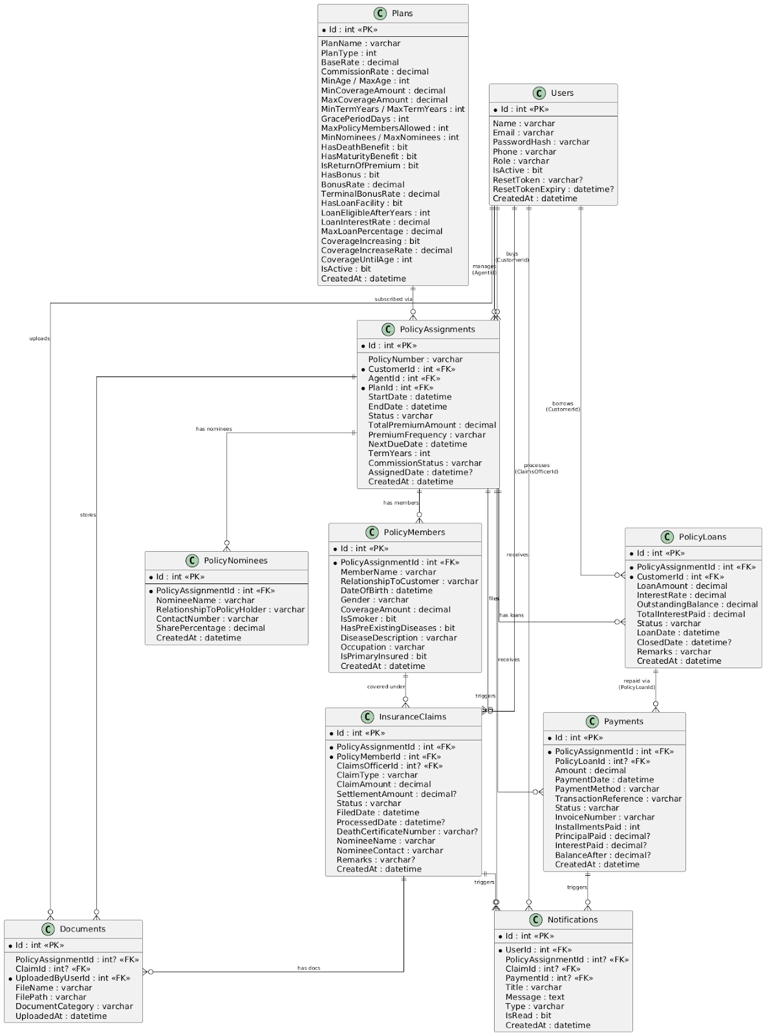

8.2 Use Case Diagram

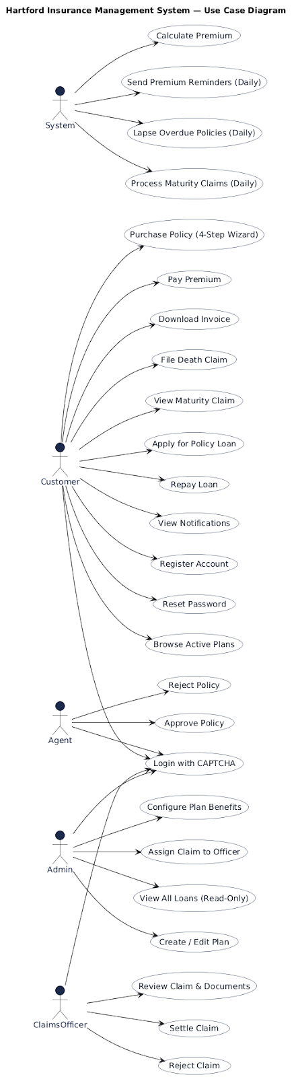
8.3 Activity Diagram(Insurance Policy Lifecycle)

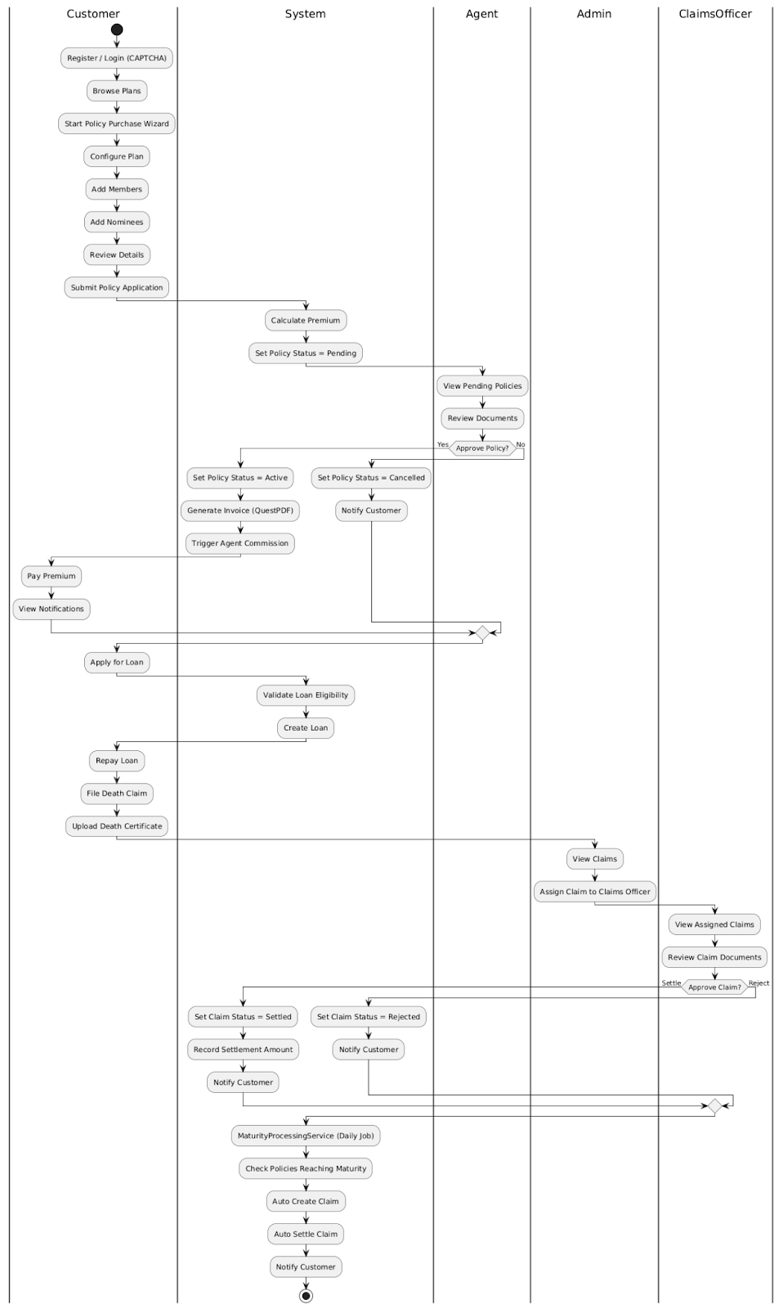

8.4 Sequence Diagram
8.4.1 Sequence Diagram for Policy Purchase & Approval
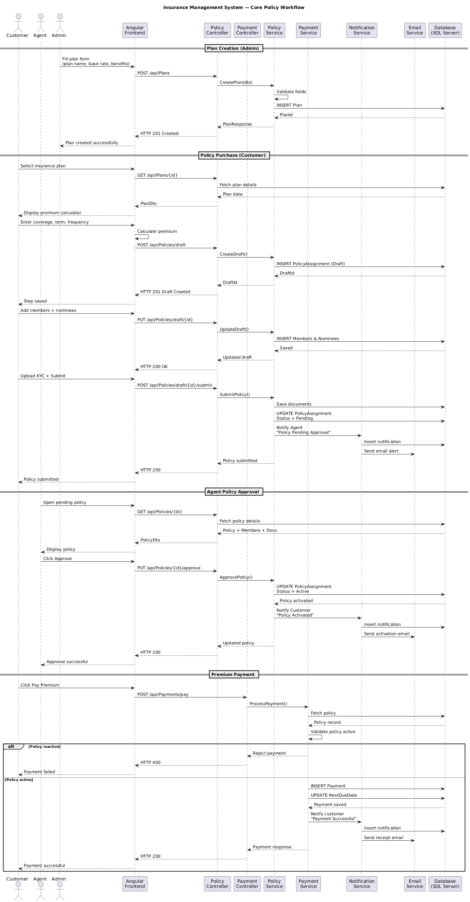

8.4.2 Sequence Diagram for Loans & Claims Processing
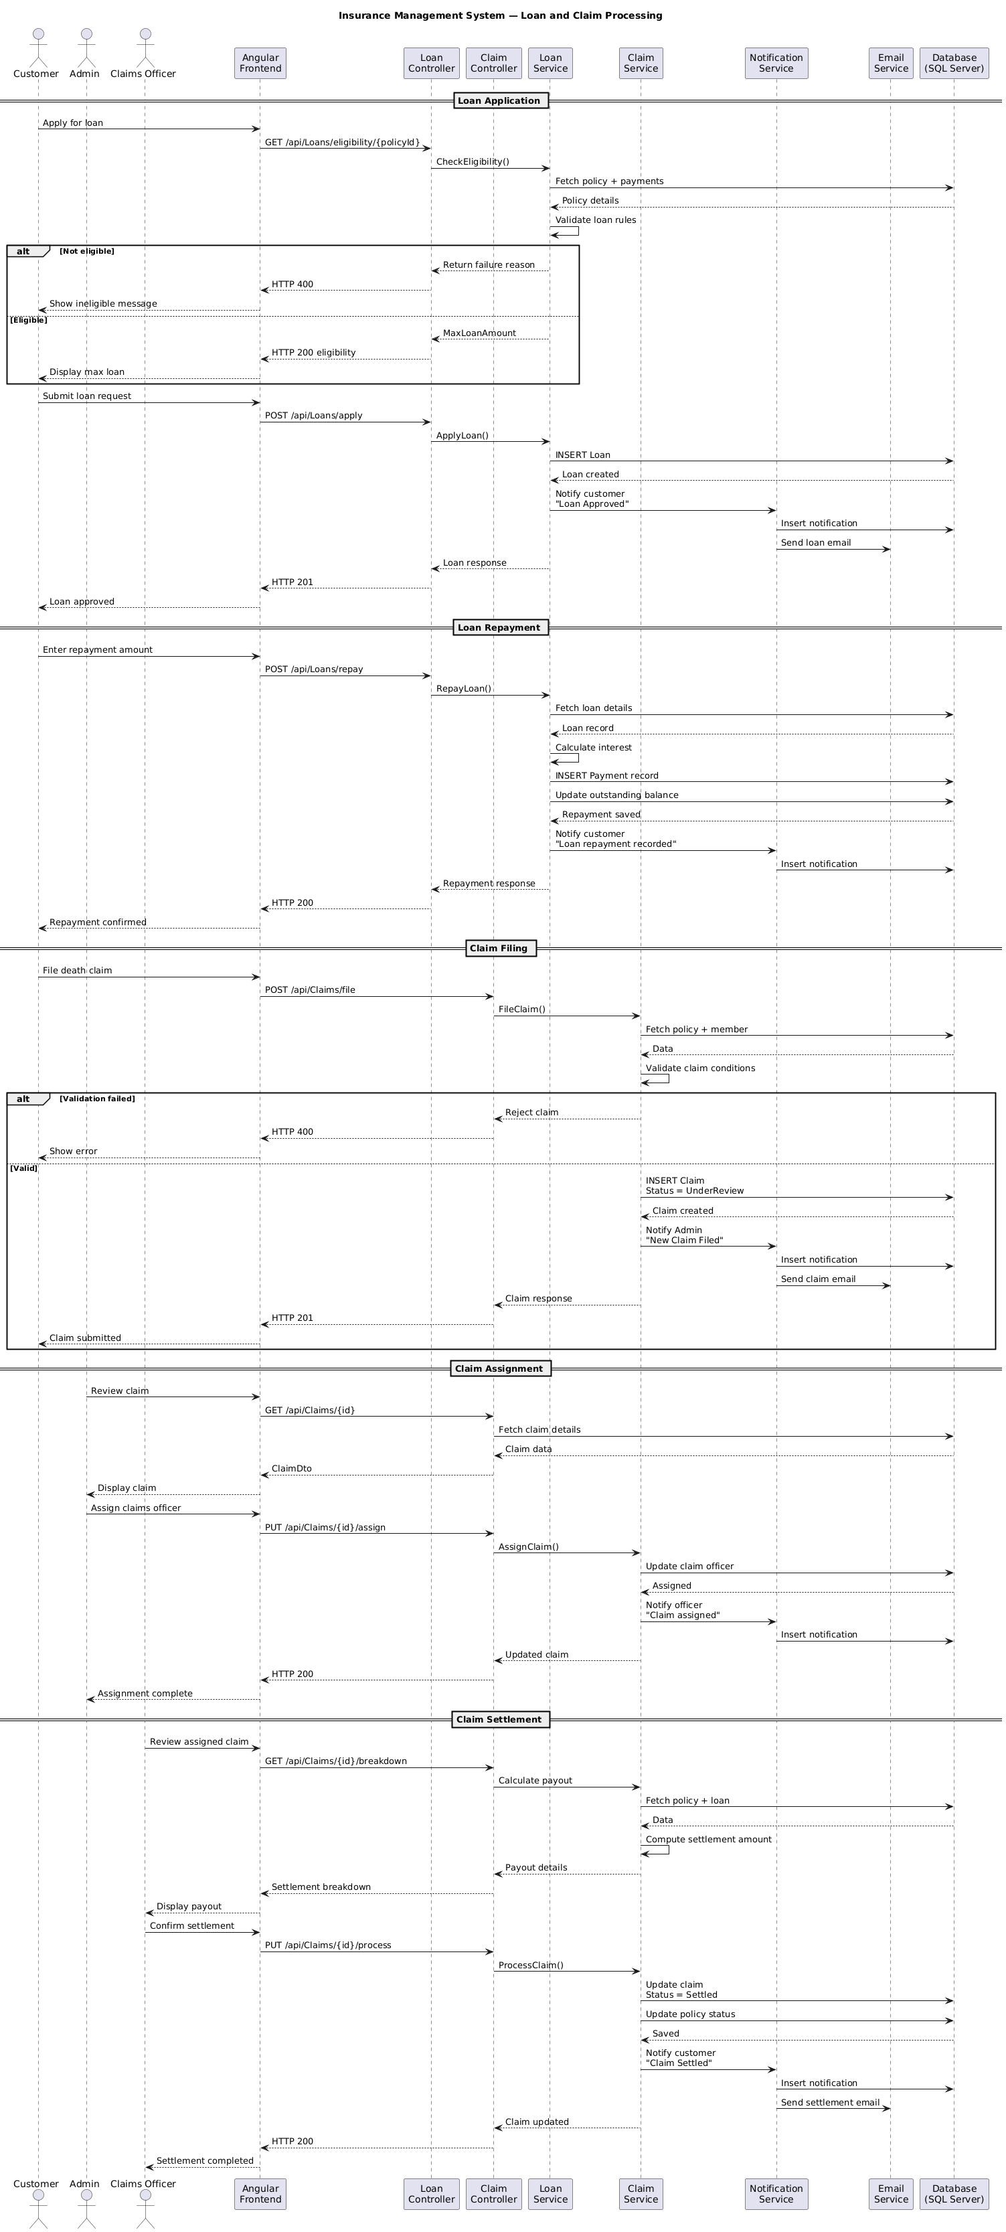

9. Use Case Examples

9.1 Use Case: User Login

Use Case ID | UC-01
Use Case Name | User Login with CAPTCHA Verification
Actors | All Roles — Customer, Agent, ClaimsOfficer, Admin
Pre-conditions | User has a registered account with a valid role. System is running and the login page is accessible. No existing valid JWT token is stored in the frontend.
Post-conditions | User holds a valid JWT token. Angular has routed the user to their role-specific dashboard. Unread notification badge count is initialised.
Trigger | User navigates to the /login route and submits their credentials via the login form.

Main Success Flow
- User opens the application in a web browser; Angular SPA loads the login page at /login
- Frontend automatically calls GET /api/Auth/get-captcha on page load — server generates a 6-character random alphanumeric code and returns it for display
- User enters their registered email address, password, and the CAPTCHA code shown on screen
- Angular reactive form validates that all fields are non-empty and the email field has valid format before enabling the submit button
- Frontend sends POST /api/Auth/login with payload: { email, password, captchaCode }
- Server's IAuthService validates the submitted captchaCode against the server-stored code — mismatch returns HTTP 400 with error 'Invalid CAPTCHA'
- IAuthService queries the Users table by email — no matching record returns HTTP 401 with error 'Invalid credentials'
- BCrypt.Verify() compares the submitted plain-text password against the stored BCrypt hash — mismatch returns HTTP 401
- On full validation success: JwtService generates a signed JWT token with 2-hour expiry containing claims: { userId, email, role, iat, exp }
- Server returns HTTP 200 with response body: { token, role, userId, userName }
- Angular AuthService receives the token, stores it in memory (not localStorage), and decodes the role claim from the JWT payload
- Angular Router redirects to the role-appropriate dashboard: /customer-dashboard, /agent-dashboard, /claims-dashboard, or /admin-dashboard
- NotificationService calls GET /api/Notifications/unread — populates the unreadCount signal — bell badge displays the correct unread count

Alternative and Exception Flows
▸ A1 — Wrong CAPTCHA: HTTP 400 returned; Angular shows inline error 'Invalid CAPTCHA'; CAPTCHA is refreshed automatically for retry
▸ A2 — Wrong credentials: HTTP 401 returned; Angular shows 'Invalid email or password'; no account enumeration information disclosed
▸ A3 — Expired JWT on subsequent request: HTTP Interceptor catches 401 response from any API call; clears token; redirects to /login
▸ A4 — Form validation failure: Angular disables submit button and shows field-level error messages before any API call is made
▸ A5 — Server unavailable: Angular HTTP error handler displays 'Service unavailable' message; user remains on login page

9.2 Use Case: File and Settle a Death Claim

Use Case ID | UC-02
Use Case Name | File Death Claim, Assign to Officer, and Settle with Loan Deduction
Actors | Customer, Admin, ClaimsOfficer, System
Pre-conditions | Policy is in Active status. Member has been covered for at least 24 months. Death certificate is available. At least one nominee exists on the policy.
Post-conditions | Claim status = Settled. Policy status = Closed. Outstanding loan deducted from settlement. Customer notified of net payout amount.
Trigger | Customer or nominee selects an active policy and initiates a death claim for a covered member.

Main Success Flow
- Customer navigates to their policy, selects the deceased member, enters the unique death certificate number, selects the nominee, and submits via POST /api/Claims/file
- System executes 5-point validation: Active policy, 24-month coverage, unique death certificate, no duplicate active claim, nominee exists
- All validations pass: System creates InsuranceClaim record with ClaimType = Death, Status = UnderReview; Admin receives 'New Death Claim Filed' notification
- Admin opens the new claim notification, reviews claim details, selects an available ClaimsOfficer from the assignment dropdown, and submits assignment via PUT /api/Claims/{id}/assign
- ClaimsOfficer receives 'Claim Assigned to You' notification; customer receives 'Claim Under Review' notification
- ClaimsOfficer opens the assigned claim from their queue; reviews: member information, policy duration, KYC documents, death certificate
- ClaimsOfficer calls GET /api/Claims/{id}/breakdown to view full payout: CurrentCoverage + TotalBonus = Gross Amount, minus OutstandingLoan = Net Settlement
- ClaimsOfficer confirms the pre-calculated settlement amount and submits decision via PUT /api/Claims/{id}/process with { decision: 'Settled', settlementAmount: X }
- System deducts OutstandingLoan from settlement amount; sets PolicyLoan.Status = Adjusted
- System sets InsuranceClaim.Status = Settled; PolicyAssignment.Status = Closed; records ProcessedDate and ClaimsOfficerId on the claim record
- Customer receives 'Claim Settled — Net Payout: Rs. X' notification; ClaimsOfficer receives 'Settlement Successfully Recorded' notification

10. Future Enhancements

The following enhancements are identified as out-of-scope for Version 1.0 but are proposed for future development phases based on business priority and technical feasibility:

Enhancement | Description
Mobile Application | Native iOS and Android applications for Customers and Agents using Flutter or React Native — enabling push notifications, biometric login, offline policy viewing, and mobile premium payments
Third-Party Payment Gateway | Integration with Razorpay or Stripe to replace mock payment processing with live card, UPI, net-banking, and wallet payment methods — with webhook-based confirmation
Policy Surrender Workflow | Allow customers to surrender their policy before tenure completion — system calculates the surrender value at the point of request and initiates a payout process with appropriate deductions
Lapsed Policy Reinstatement | Allow customers to reinstate a lapsed policy within a configurable reinstatement window by paying all overdue premiums plus a reinstatement fee defined on the plan
Reports and Analytics Export | Admin and Agent dashboards with date-range exportable reports in CSV and Excel formats — policy counts, premium collection totals, claims settlement ratios by plan type and region
Policy Audit Trail | Complete immutable audit log of all status changes, payment events, document uploads, and system actions per policy — viewable by Admin with timestamp, actor, and before/after state
Agent Commission Statements | Monthly auto-generated commission statement PDF for each agent — itemised by policy, first payment date, coverage amount, and commission rate; delivered by email and available in dashboard
Two-Factor Authentication | Optional TOTP-based 2FA for Admin and ClaimsOfficer roles — authenticator app integration (Google Authenticator, Authy) or SMS OTP as fallback for enhanced account security
Multi-Language Support | Angular i18n internationalisation for regional language support — UI text translation without code changes; date and currency formatting per locale

