**Git**

Git is a free, open distributed version control system tool which is designed to handle everything from small to very large projects with speed and efficiency. It was created by Linus Torvalds in 2005 to develop Linux kernel. Git has functionality, performance, security and flexibility that most teams and individual developers need. It severs as an important distributed version control tool in DevOps.

Version Control is the management of changes to documents, computer programs, large website and other collection of information.

There are two types of Version Control Systems:

1. Centralized Version Control System (CVCS)
2. Distributed Version Control System (DVCS)

**Centralized VCS**

Centralized VCS uses a central server to store all the files and enables team collaboration. It works on a single repository to which users can directly access a central server.

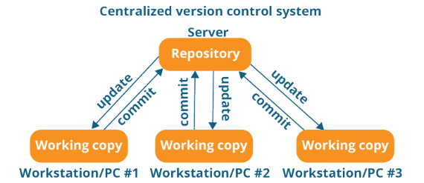

Every programmer can extract/update their work station with the date present in the repository or make changes to the data or **commit** in the repository. Every operation is performed directly on the repository.

**Drawbacks**

* It is not locally available, meaning you always need to connect to network to perform any action.
* Since it is centralized, in any case of the central server is crashed or corrupted all the data will be lost.