**Capstone project: The battle of neighbourhoods**

**Introduction:**

As it is the capstone project where we need to implement all the learnings of this course. starting with the name battle of neighbourhoods, which means choosing a best location for any business, like it may be a restaurant, a pharmacy store, etc choosing the best spot in order to make the business survive. Here we will try for establishment of the new restaurant where the community and cuisine. This creates a great opportunity for the entrepreneur that is place where Indian people are more they can introduce a India cuisine under the same food chain , if French cuisine where the French people are there, similar Chinese cuisine if there are more Chinese living in any particular place. I will be trying to design a project which will help the new entrepreneur to take wise decisions.

**Business Problem:**

The objective of the project is to find the suitable location for a restaurant chain and map them with the people located there and the cuisine , with the help of the data science algorithms we will be using all the python concepts , cluster and segment the people and choose a strategic area to open restaurant. See the areas with least restaurants

**EXTRACTING THE DATA:**

* We need data from the wiki page of the new York , so that we can map all the latitudes and longitudes required.
* To understand about the different cuisines and their communities we need to fond out the data used to map different country people with different cuisines.
* Using foursquare we will be taking all the data regarding the areas and their demographics.
* Similarly we will be taking the areas and the number of restaurants present each area.
* List of all the neighbourhoods.

**PROCESS:**

Step1 : extracting the data

Step2: Cleaning the data

Step3: Choosing a suitable machine learning algorithm and implementing

Step 4: create and test model

Step 5: Running the model

Step 6 : Analysis of the results

Step 7 : Recommendations

**METHODOLOGY:**

1. "https://cocl.us/new_york_dataset" is used to collect the data for the newyork city

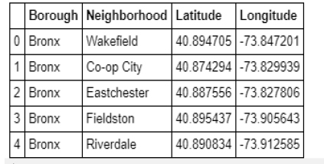

1. We have found all the neighbourhoods using the four square api

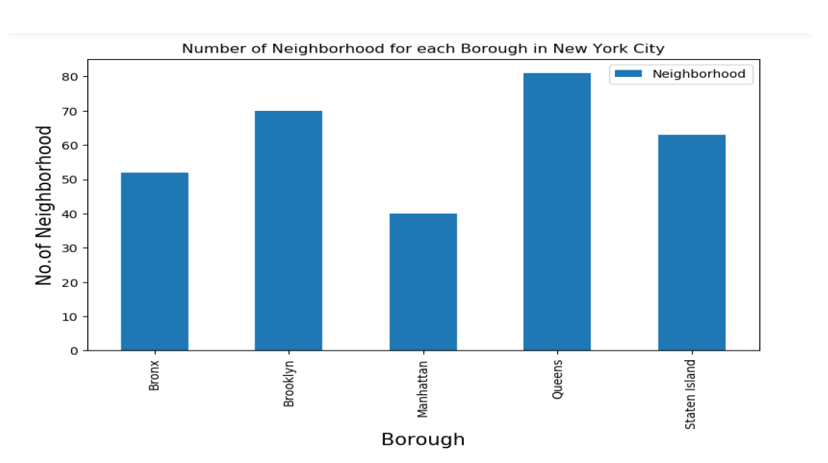

1. Then we filter out all the restaurants which are related to different cusines and countries for further analysis

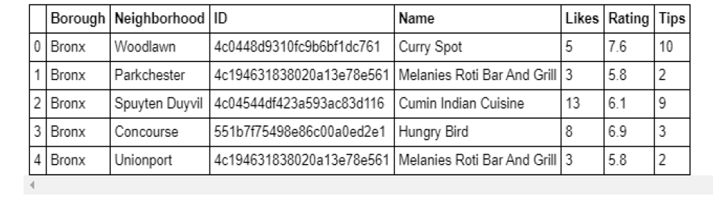

1. Next using Foursquare API, we will find the Ratings, Tips, and Number of Likes for all the Restaurants.
2. We will then sort Neighbourhoods and Borough the data keeping Ratings as the constraint
3. Next we will consider all the neighbourhoods with average rating greater or equal 9.0 to visualize on map.
4. Finally, we will visualize the Neighbourhoods and Borough based on average Rating using python’s Folium library.

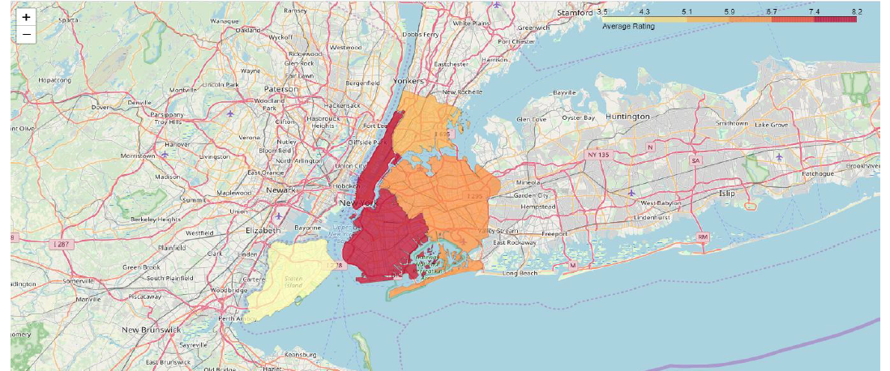

Conclusion:

There is always room for improvement and hence the above solution I have provided can also be improved for best results depending upon the data we have.