**Spring 2024:CS5720 Neural Networks & Deep Learning-**

**ICP-3 Assignment-3**

Name: Sai Sushma Sri Bireddy Student ID:700747557

GitHub Link: <https://github.com/SaiSushmaSriBireddy/Assignment_3>Video Link:

[https://drive.google.com/file/d/1TUBOE7pY7wKBEIWQdSwAj1hHPz8tU2X0/view? usp=sharing](https://drive.google.com/file/d/1TUBOE7pY7wKBEIWQdSwAj1hHPz8tU2X0/view?usp=sharing)

1. Create a class Employee and then do the following
   * Create a data member to count the number of Employees
   * Create a constructor to initialize name, family, salary, department i• Create a function to average salary
   * Create a Fulltime Employee class and it should inherit the properties of Employee class • Create the instances of Fulltime Employee class and Employee class and call their member functions.

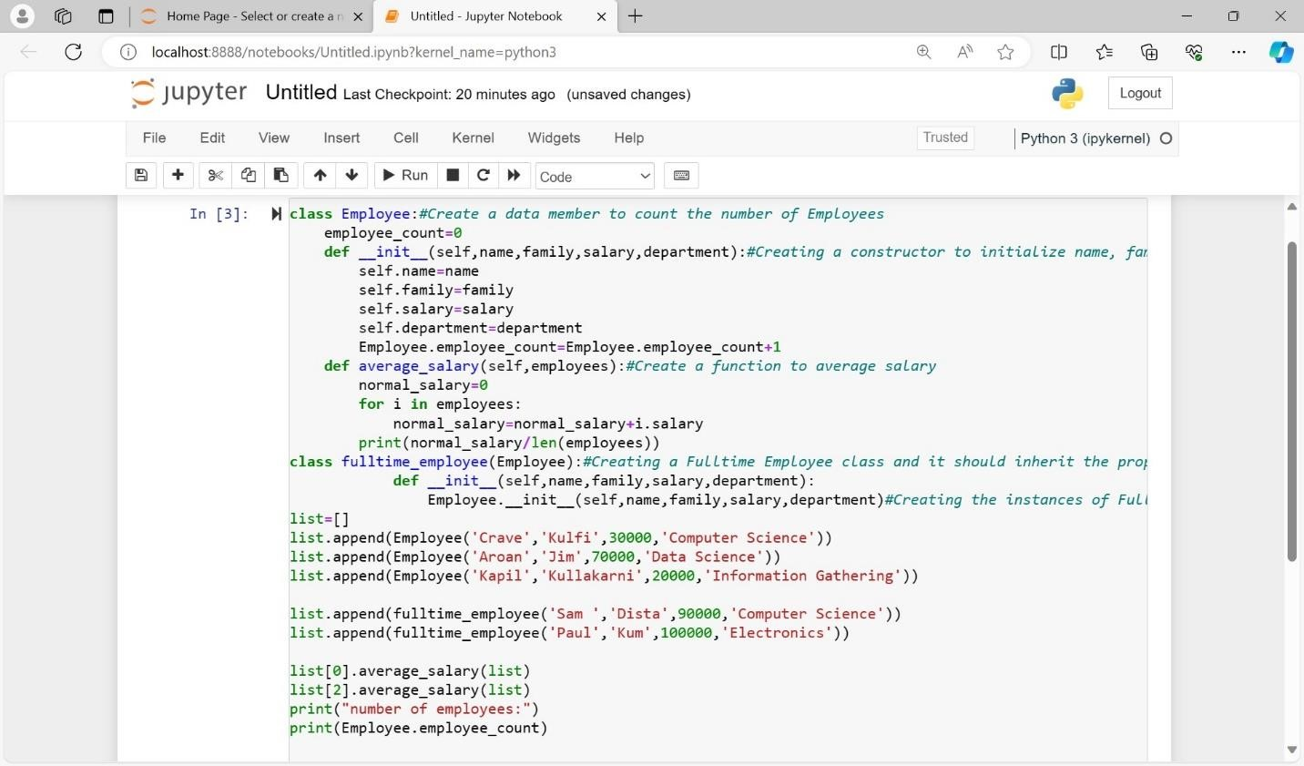

Output:

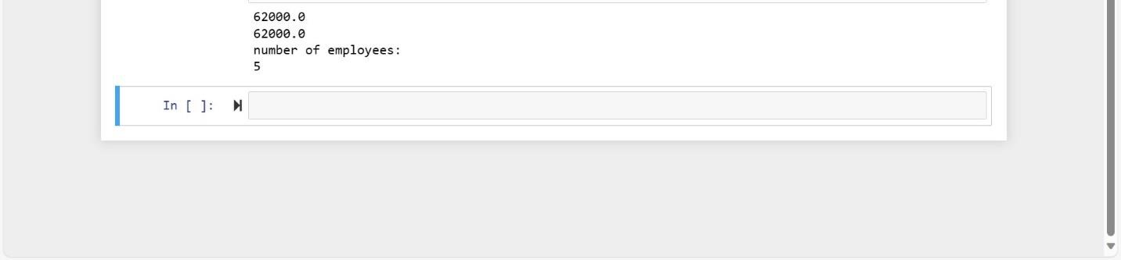

1. NumPy

Using NumPy create random vector of size 20 having only float in the range 1-20.

Then reshape the array to 4 by 5

Then replace the max in each row by 0 (axis=1)

(you can NOT implement it via for loop)

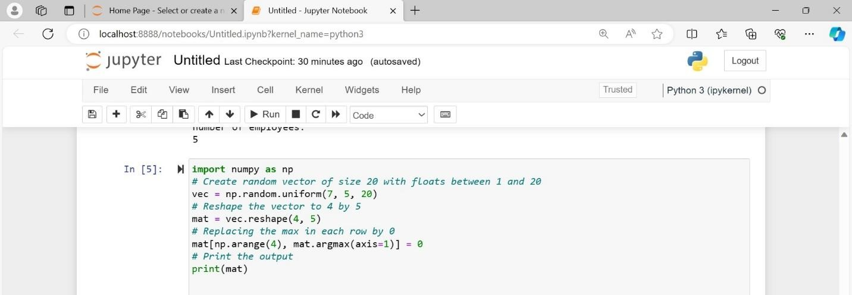

Output:

