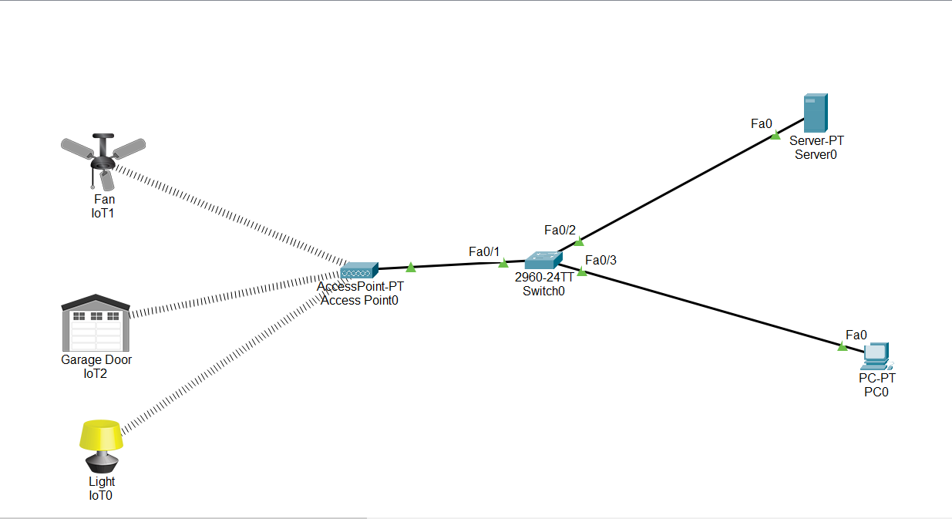

1. Go to Network Devices -----> Wireless Devices ---->select AccessPoint-PT-Device.

2. Choose a switch (2960-24TT).

3. Connect the two devices using port Fa0/1 on the switch.

4. Select Server and PC (PT type).

5. Connect the switch ports: Fa0/2 to the Server and Fa0/3 to the PC.

6. In the AccessPoint Device, navigate to port1 from the config.

7. Change the SSID name to: IOTEXPERIMENT.

8. Navigate End Devices-------->Home--select (FAN, GARAGEDOOR, LIGHT)

9In IOT FAN:

Navigate through Config tab -->Wireless0 tab--->change the SSID name to: IOTEXPERIMENT

10. Go to the Server and assign the IP address: 192.168.10.1.

11. In Server Navigate to the Services tab --------> DHCP option, then enable the ON button.

12. After enabling DHCP, all devices will automatically be assigned IP addresses.

13. On the PC, go to Desktop and click IoT Monitor.

14. Enter the Server IP address: 192.168.10.1, with the username "admin" and password "admin."

15. This will navigate to the new registration page.-----> click forgot password---> Enter a new username and password.

16. Go to IoT fan navigate toConfig option.

1. Change the IoT server to "Remote Server" and provide the Server address, username, and password.
2. Same process for Garage Door and Light.

19.On the PC, go to Desktop and click IoT Monitor.

Enter the Server IP address: 192.168.10.1, with the username "admin" and password "admin."

