# Research Project Database Documentation

This document outlines the schema, relationships, SQL code, insert queries, and ER diagram for the Research Project database. The goal is to manage data regarding research projects, their managing agencies, assigned employees, and collaborations effectively.

## 1. ER Diagram

Below is the ER Diagram showing the structure of the Research Project database:

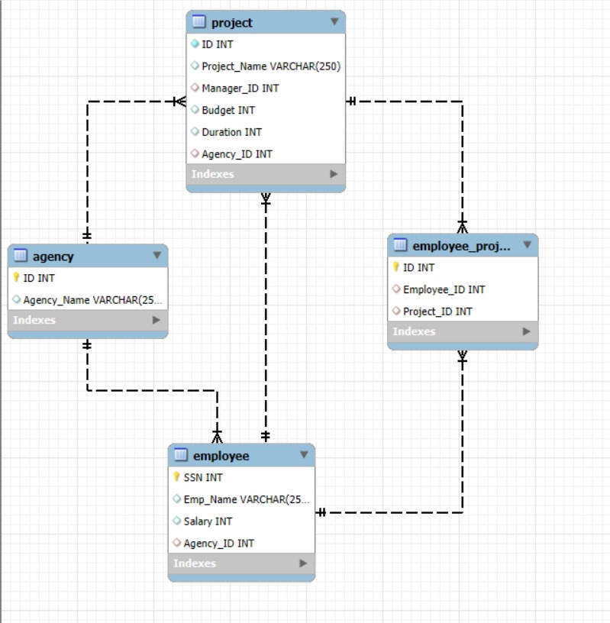

## 2. Table Structures and Relationships

- Agency: Stores funding agency details.  
- Employee: Stores employee details including the agency they belong to.  
- Project: Stores project details including manager, duration, and funding agency.  
- Employee_Project: Many-to-many relationship between employees and projects.

## 3. SQL Schema Code

CREATE DATABASE Research_Project;  
USE Research_Project;  
  
CREATE TABLE Agency(  
 id INTEGER NOT NULL PRIMARY KEY,  
 agency_name VARCHAR(250)  
);  
  
CREATE TABLE Employee(  
 SSN INTEGER NOT NULL PRIMARY KEY,  
 emp_name VARCHAR(250),  
 salary INTEGER,  
 agency_id INTEGER,  
 FOREIGN KEY(agency_id) REFERENCES Agency(id)  
);  
  
CREATE TABLE Project(  
 id INTEGER NOT NULL PRIMARY KEY,  
 project_name VARCHAR(250),  
 manager_id INTEGER,  
 budget INTEGER,  
 duration INTEGER,  
 agency_id INTEGER,  
 UNIQUE(id,agency_id),  
 FOREIGN KEY(manager_id) REFERENCES Employee(SSN),  
 FOREIGN KEY(agency_id) REFERENCES Agency(id)  
);  
  
CREATE TABLE Employee_Project(  
 id INTEGER NOT NULL PRIMARY KEY,  
 employee_id INTEGER,  
 project_id INTEGER,  
 FOREIGN KEY(employee_id) REFERENCES Employee(SSN),  
 FOREIGN KEY(project_id) REFERENCES Project(id)  
);

## 4. Insert Queries

### 4.1 Agency Table

INSERT INTO Agency (id, agency_name) VALUES (1, 'AI Research Foundation');  
INSERT INTO Agency (id, agency_name) VALUES (2, 'National Space Board');  
INSERT INTO Agency (id, agency_name) VALUES (3, 'Health and Life Sciences');  
INSERT INTO Agency (id, agency_name) VALUES (4, 'Cyber Security Council');  
INSERT INTO Agency (id, agency_name) VALUES (5, 'Green Earth Initiative');

### 4.2 Employee Table

INSERT INTO Employee (SSN, emp_name, salary, agency_id) VALUES (101, 'John Doe', 80000, 1);  
INSERT INTO Employee (SSN, emp_name, salary, agency_id) VALUES (102, 'Jane Smith', 85000, 2);  
INSERT INTO Employee (SSN, emp_name, salary, agency_id) VALUES (103, 'Alice Brown', 75000, 3);  
INSERT INTO Employee (SSN, emp_name, salary, agency_id) VALUES (104, 'Bob Lee', 90000, 4);  
INSERT INTO Employee (SSN, emp_name, salary, agency_id) VALUES (105, 'Eve Johnson', 88000, 5);

### 4.3 Project Table

INSERT INTO Project (id, project_name, manager_id, budget, duration, agency_id) VALUES (201, 'Smart Diagnosis System', 101, 600000, 3, 1);  
INSERT INTO Project (id, project_name, manager_id, budget, duration, agency_id) VALUES (202, 'Mars Exploration', 102, 1500000, 5, 2);  
INSERT INTO Project (id, project_name, manager_id, budget, duration, agency_id) VALUES (203, 'Pandemic Predictor AI', 103, 900000, 4, 3);  
INSERT INTO Project (id, project_name, manager_id, budget, duration, agency_id) VALUES (204, 'National Cyber Shield', 104, 1300000, 4, 4);  
INSERT INTO Project (id, project_name, manager_id, budget, duration, agency_id) VALUES (205, 'Zero Emission Cities', 105, 1100000, 5, 5);

### 4.4 Employee_Project Table

INSERT INTO Employee_Project (id, employee_id, project_id) VALUES (301, 101, 201);  
INSERT INTO Employee_Project (id, employee_id, project_id) VALUES (302, 102, 202);  
INSERT INTO Employee_Project (id, employee_id, project_id) VALUES (303, 103, 203);  
INSERT INTO Employee_Project (id, employee_id, project_id) VALUES (304, 104, 204);  
INSERT INTO Employee_Project (id, employee_id, project_id) VALUES (305, 105, 205);