**Interactive Quiz Application**

**Team#: 12**

**Team Members:**

|  |  |
| --- | --- |
| **26** | Makani,Sai Teja |
| **38** | Neelima-Putta,Divya-Sai-Lakshmi |
| **9** | Chinthakindhi,Nikhila |
| **62** | Arun |

**Introduction:**

Interactive Quiz application is a dynamic application which facilitates users to take quizzes online through web portal. Details of the tests taken with their results are accessible to the user at any time.

Users can take tests, retake tests and view written tests results in this application.

**Project Goal and Objectives:**

**Goal:**

Main idea of this project is to achieve online interactive quiz application where a user can select any exam among the topics listed and view results of the exams taken at any time.

**Objectives:**

* Objective is to create user friendly Interactive quiz application with register page, login page and home page.
* Home page would contain tabs for user profile and to take online quiz.
* User would receive an instant score as soon as he/she is done with the quiz.

**Features:**

* User can select topic for quiz from the various topics displayed in the home page. Questions for the topics are extracted dynamically from online repository API'S (yet to be completed).
* User can listen to questions in their quizzes while taking test. This is implemented through voice API (completed).
* Timer is displayed on the screen for user’s comfort (yet to be completed).
* Scribble pad is available for users for scratch work. It is saved for users future use to analyse wrong answers if any (yet to be completed).
* Application is built on ionic framework (yet to be completed).

**Significance:**

* **Instant grading:** This would save users time to await for results of the quizzes taken.
* **Self-assessment:** As results are provided immediately after the test, user can self-assess his/her performance and know their mistakes.
* **Knowledge gain:** Students in schools need not wait for their instructors to conduct quizzes anymore. They can take online quizzes and learn through their mistakes and improve themselves.

**Project Plan:**

**Burn down chart:**

GitHub’s burn down chart of the project is as follows:

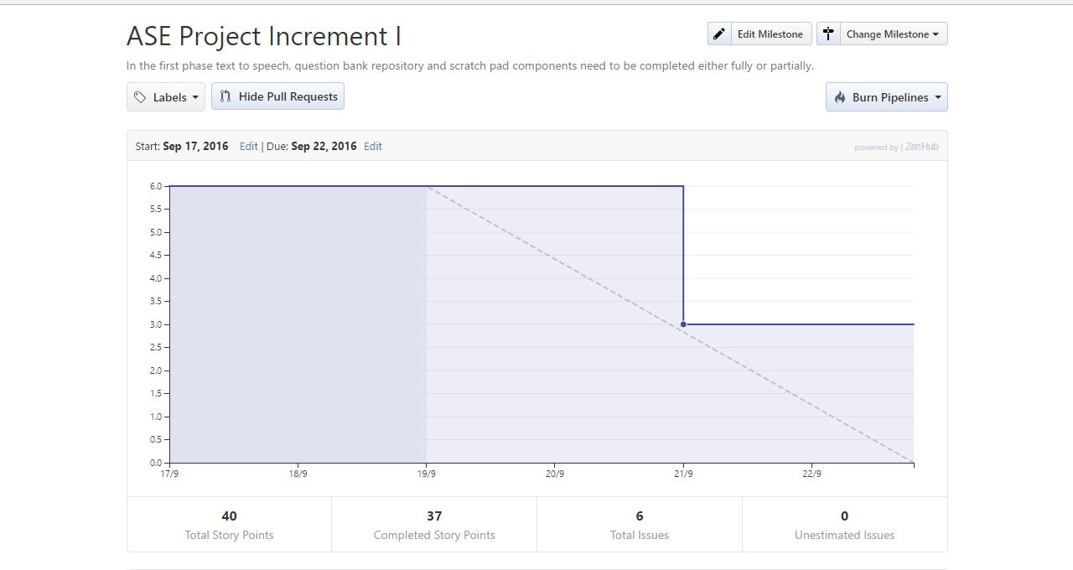

**Issues:**

GitHub’s issues for the project are as follows:

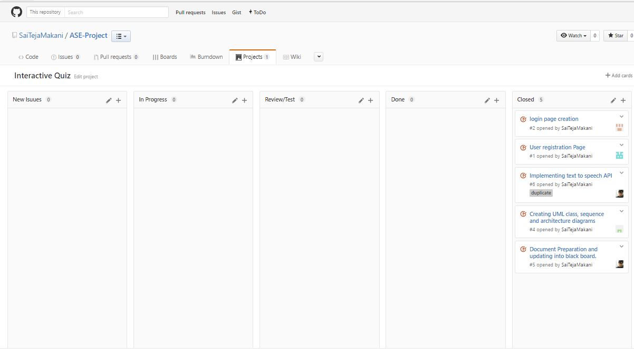

**Contributors graph:**

GitHub’s contributors graph for the project is as follows:

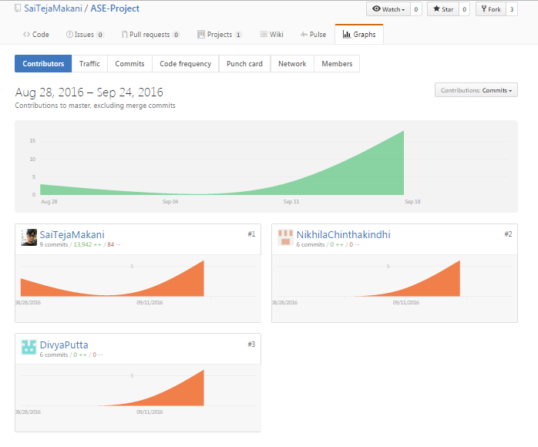

**First Increment Report:**

**Detailed Design of features:**

* **Wire Frames:**

Wire frame design for Start/Index page of the Interactive quiz application is as follows:

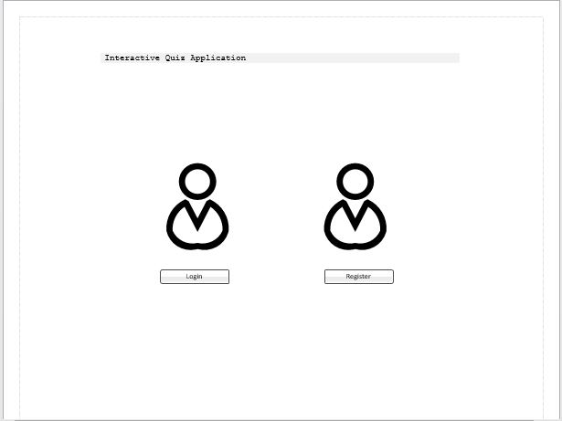

Wire frame design for register page of the Interactive quiz application is as follows:

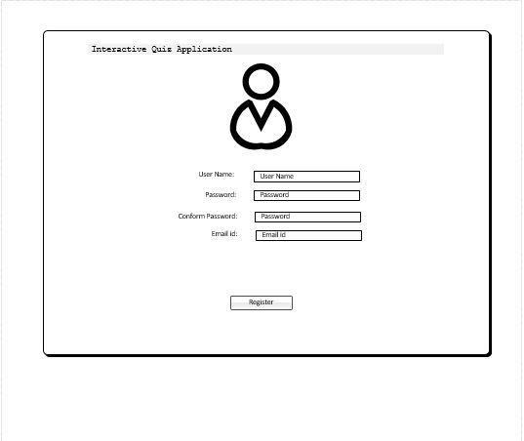

Wire frame design for login page of the Interactive quiz application is as follows:

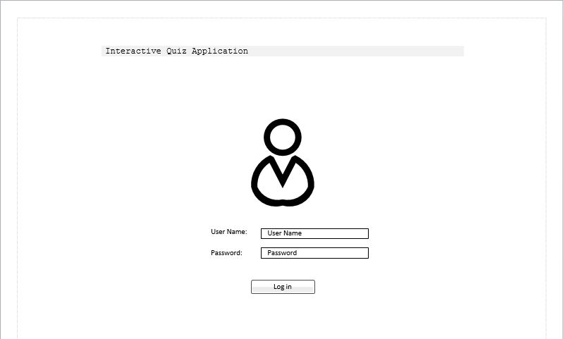

Wire frame design for home page of the Interactive quiz application is as follows:

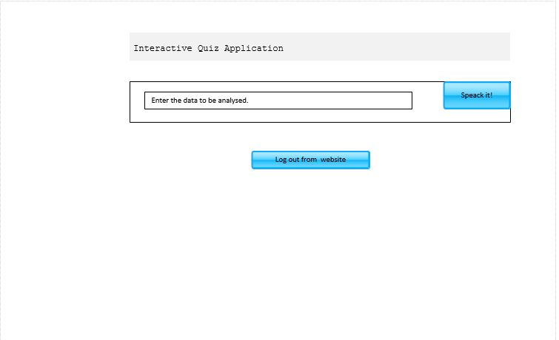

* **Architectural diagram:**

Architectural diagram for the project is as follows:

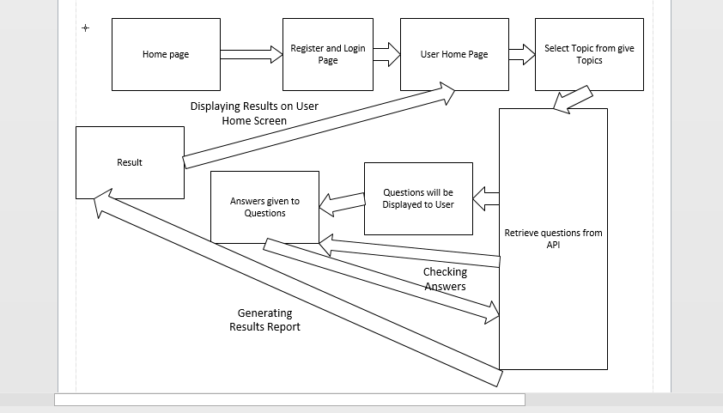

* **Sequence diagram:**

Sequence diagram for the project is as follows:

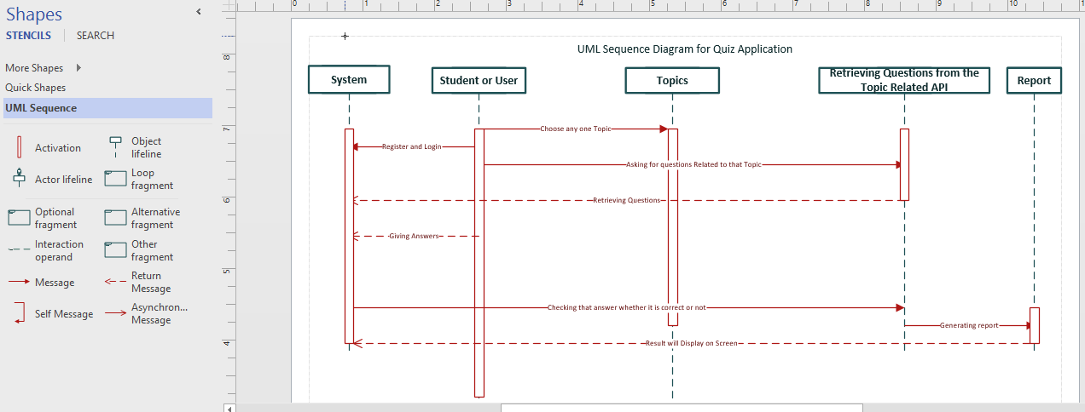

* **Class diagram:**

Class diagram for the project is as follows:

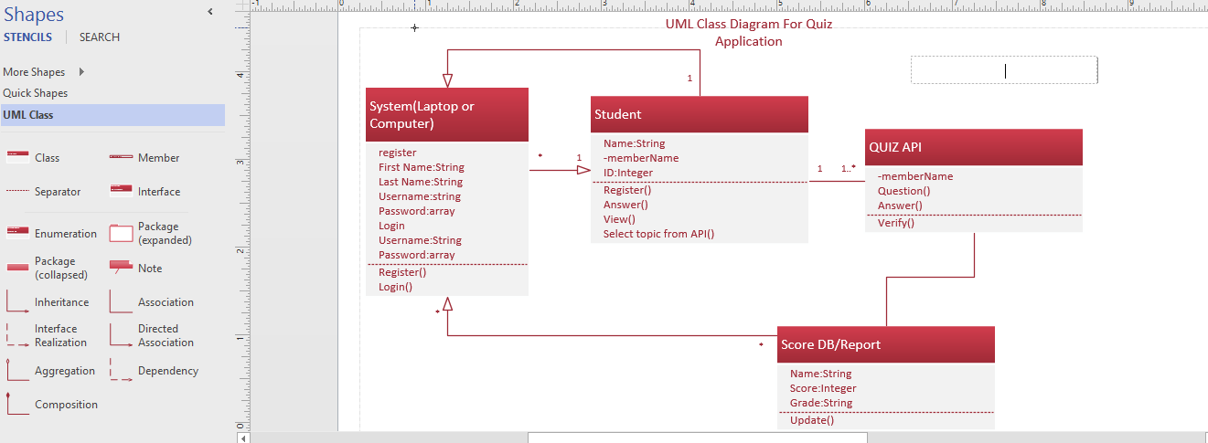

* **User story:**
* Students/users can take online quizzes through this Interactive quiz application.
* They can select any domain from the listed domains in the home page to take test.
* Users can listen to the questions on clicking speak button.
* Personal information can be edited in profile page.
* Test score is provided immediately after the quiz is completed.
* Users can assess their mistakes by the answers shown after the test.
* **Use case:**
* User must register himself/herself in the web portal.
* Upon successful registration user can login into the portal.
* After logging in user has option to select domain among the domains listed, to take test.
* Upon selecting domain, user can take tests and view scores after completing the tests.
* **Service description:**
* Interactive quiz application provides quizzes to the users.
* Users can take tests and view results after the test.
* As results are provided instantly users can assess their mistakes.
* Users can listen to questions in the quizzes.
* Scribbling pad is provided for scratch work.
* Timer is displayed on the screen.
* **Design:**

**Design of the project is detailed below:**

Start/index page of the Interactive quiz application is as follows:

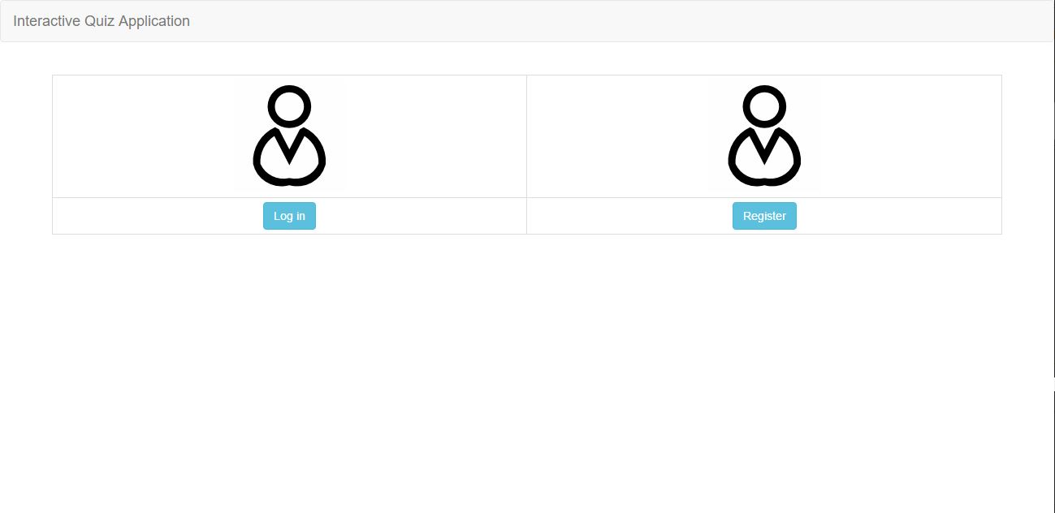

Register page of the application is as follows:

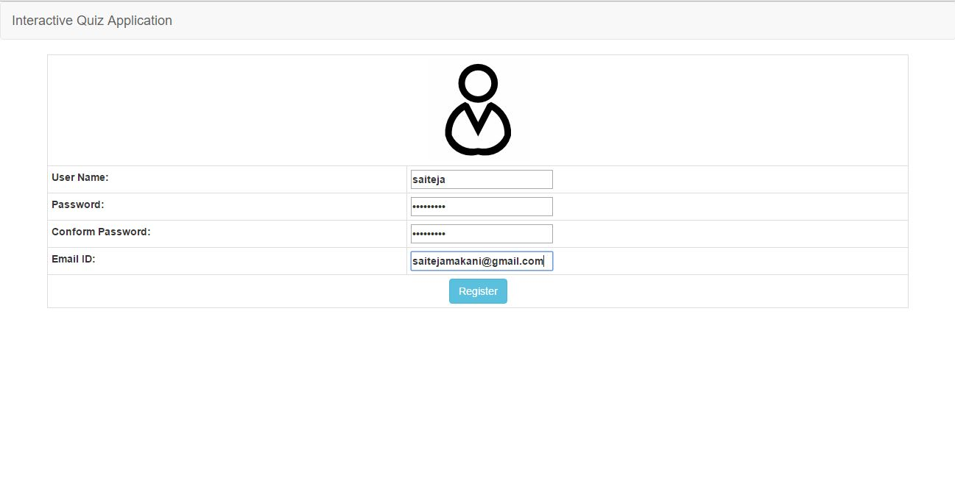

Error is shown for invalid email ID:

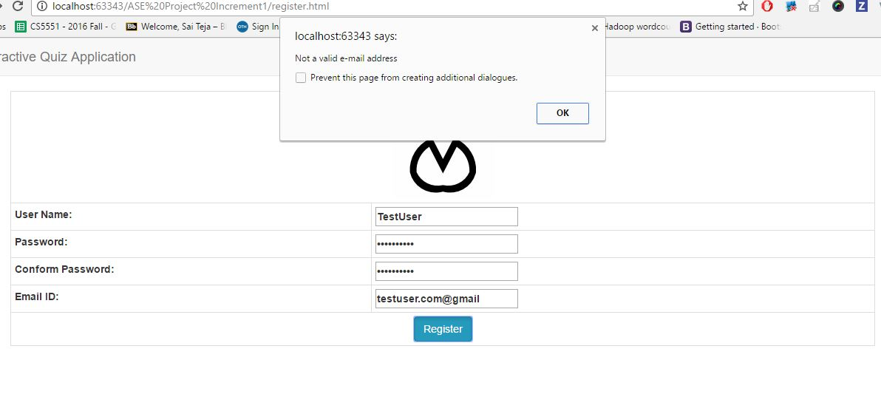

Error is shown if password length criteria is not met:

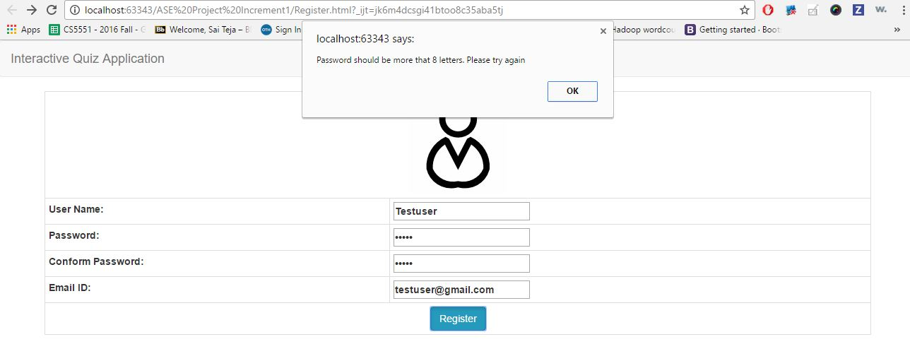

Error is shown if passwords doesn't match in register page of the application:

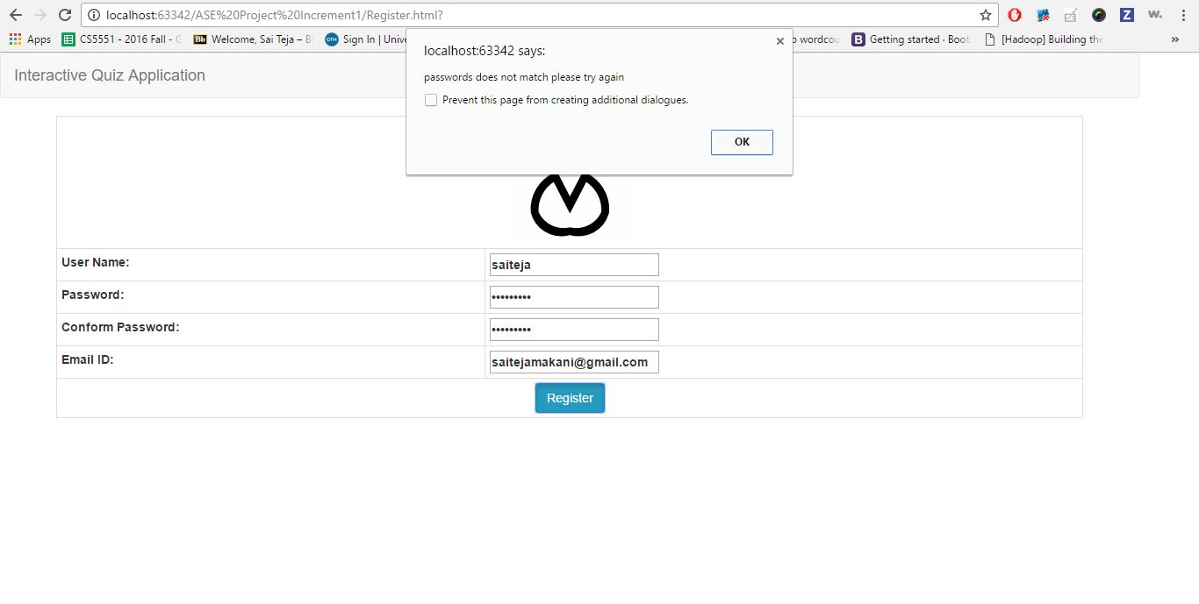

Registration success message is displayed upon successful registration of the user.

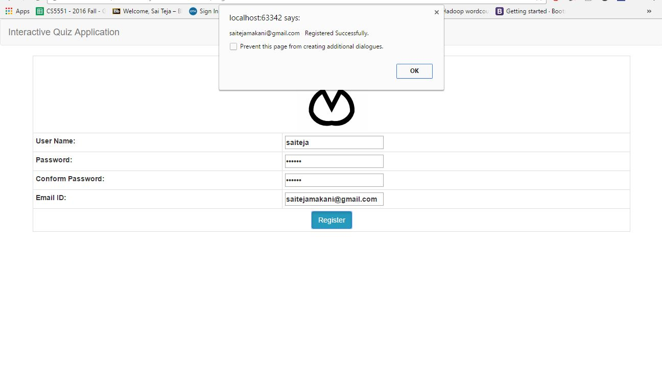

Login page is as follows:

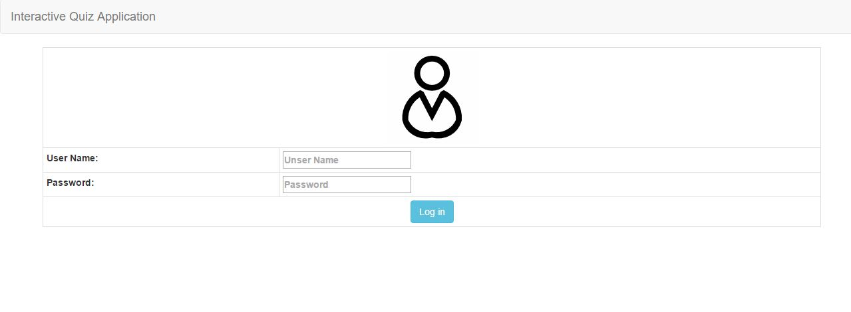

Error message upon providing invalid credentials:

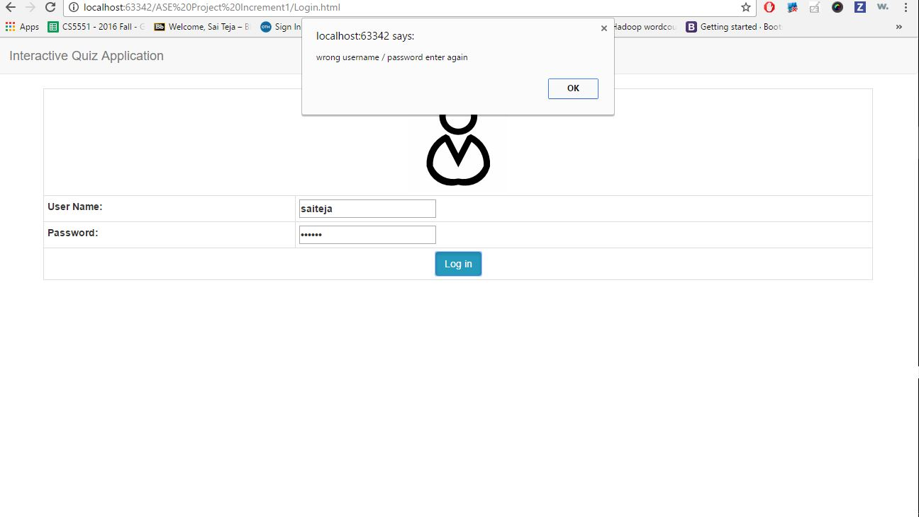

Home page on successful login:

The following is not the final home page. It is yet to be modified. This page has been created to implement voice API which reads out the quiz questions in the application.

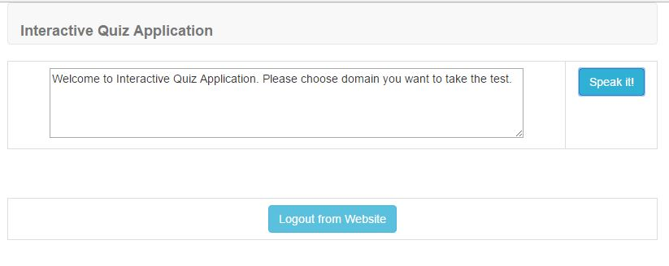

Output of the sample voice API is attached below:



**API used:**

<https://developer.mozilla.org/en-US/docs/Web/API/SpeechSynthesisUtterance>

**Implementation:**

Implementation code of the app has been uploaded into GitHub's source code folder.

<https://github.com/SaiTejaMakani/ASE-Project/tree/master/SourceCode>

**Testing:**

The following are the unit test cases and their results:

|  |  |  |  |  |  |
| --- | --- | --- | --- | --- | --- |
| **S.No** | **Test case** | **Description/Process** | **Expected result** | **Actual result** | **Pass/Fail** |
| 1 | Registration | User has to register in registration page | Registration has to be successful | Registration is successful | Pass |
| 2 | Registration | Invalid email ID | Error has to be shown stating invalid email ID | Error has been shown stating invalid email ID | Pass |
| 3 | Registration | Password criteria has to be met | Error has to be shown when password length criteria is not met | Error has been shown when password length criteria is not met | Pass |
| 4 | Log in | User has to login with valid credentials | Login has to be successful | Login successful | Pass |
| 5 | Log in | User has to login with invalid credentials | Error has to shown stating invalid credentials | Error has been shown stating invalid credentials | Pass |

**Deployment:**

Code has been moved to GitHub's source code folder. Wiki link of the first increment is as follows:

<https://github.com/SaiTejaMakani/ASE-Project/wiki/Interactive-Quiz-Application--(Increment-1)>

**Project Management:**

**Work completed:**

|  |  |  |  |  |
| --- | --- | --- | --- | --- |
| **S.No** | **Description** | **Responsibility** | **Time taken** | **Contributions** |
| 1 | Login Page Creation | Nikhila | 4 | 100% |
| 2 | User registration page | Divya | 4 | 100% |
| 3 | Implementing text to speech API | SaiTeja | 6 | 100% |
| 4 | Creating diagrams (Architectural, class, sequence, use cases) | Arun | 4 | 100% |
| 5 | Documentation | Nikhila, Divya, SaiTeja | 5 | 100% |

**Work to be done:**

All the work planned for first increment has been done.

**Bibliography:**

<https://developer.mozilla.org/en-US/docs/Web/API/SpeechSynthesisUtterance>

<http://www.w3schools.com/angular/>

<http://www.w3schools.com/bootstrap/default.asp>