***Interactive Quiz Application (Team 12)***

***Team Members:***

|  |  |
| --- | --- |
| **Class ID** | **Name** |
| **26** | Makani,Sai Teja |
| **38** | Neelima-Putta,Divya-Sai-Lakshmi |
| **9** | Chinthakindhi,Nikhila |
| **62** | Arun |

**Introduction:**

Interactive Quiz application is a dynamic application which facilitates users to take quizzes online through web portal. Details of the tests taken with their results are accessible to the user at any time.

Users can take tests, retake tests and view written tests results in this application.

**Objectives:**

* Objective is to create user friendly Interactive quiz application with register page, login page and home page using ionic framework.
* Home page would contain tabs for user profile and to take online quiz.
* User would receive an instant score as soon as he/she is done with the quiz.

**Features:**

* User can select topic for quiz from the various topics displayed in the home page.
* User can listen to questions in their quizzes while taking test.
* Timer is displayed on the screen for user’s comfort.
* Scribble pad is available for users for scratch work. It is saved for user’s future use to analyse wrong answers if any.
* Application is built on ionic framework.

**Detailed design of features:**

* **Wire Frames:**

Wire frame design for Start/Index page of the Interactive quiz application is as follows:

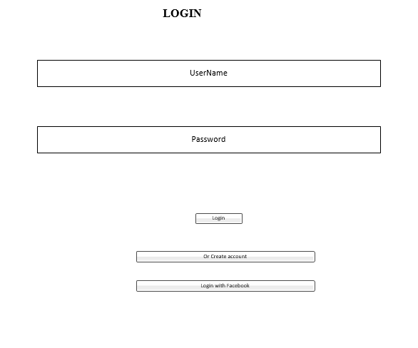

Wire frame design for sign up page of the Interactive quiz application is as follows:

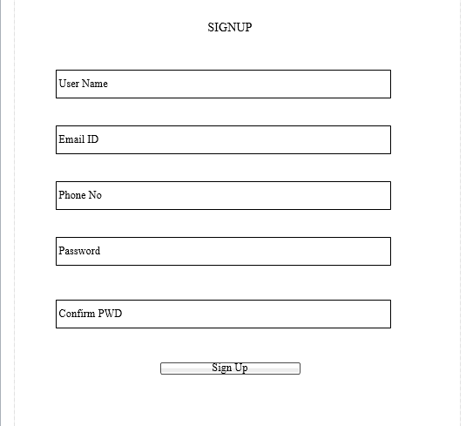

Wire frame design for profile page of the Interactive quiz application is as follows:

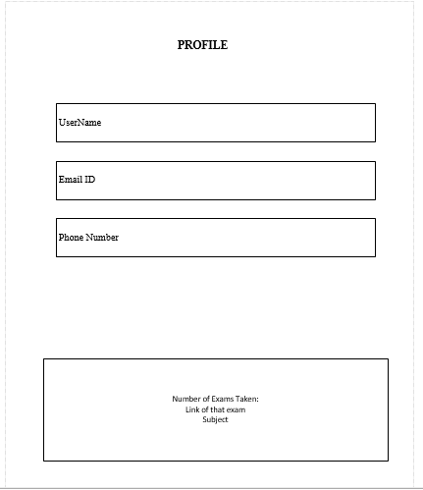

Wire frame design for quiz selection page of the Interactive quiz application is as follows:

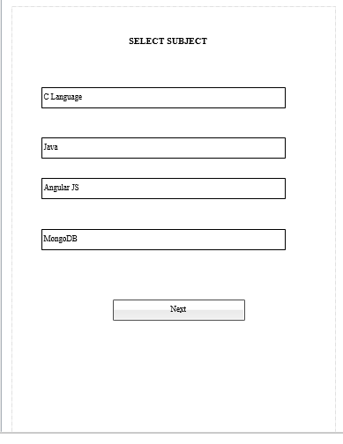

Wire frame design for quiz questions page of the Interactive quiz application is as follows:

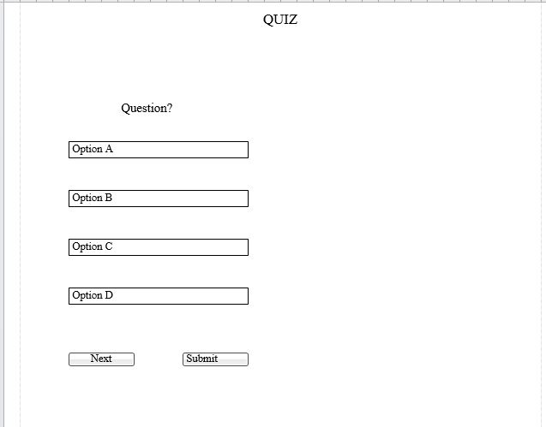

Wire frame design for tabs available in Interactive quiz application is as follows:

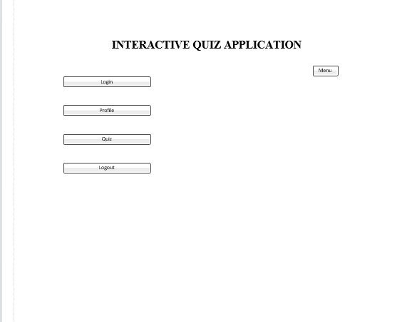

Wire frame design for quiz history page of the Interactive quiz application is as follows:

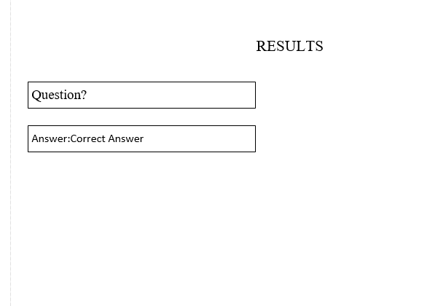

* **Architectural diagram:**

Architectural diagram for the project is as follows:

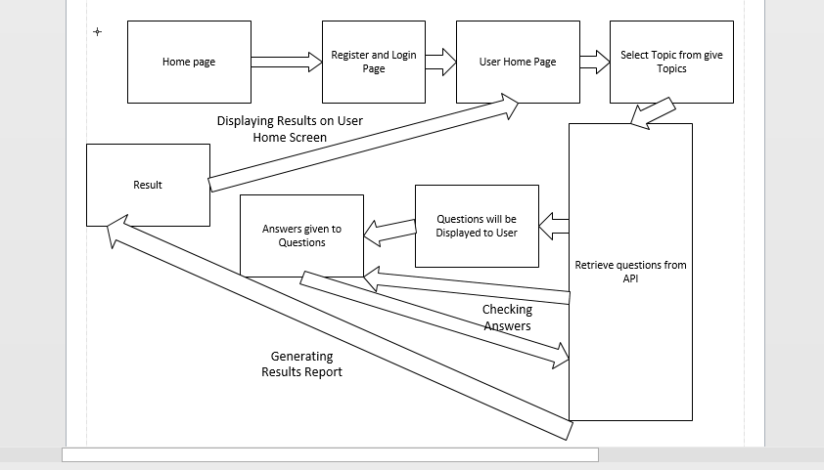

* **Sequence diagram:**

Sequence diagram for the project is as follows:

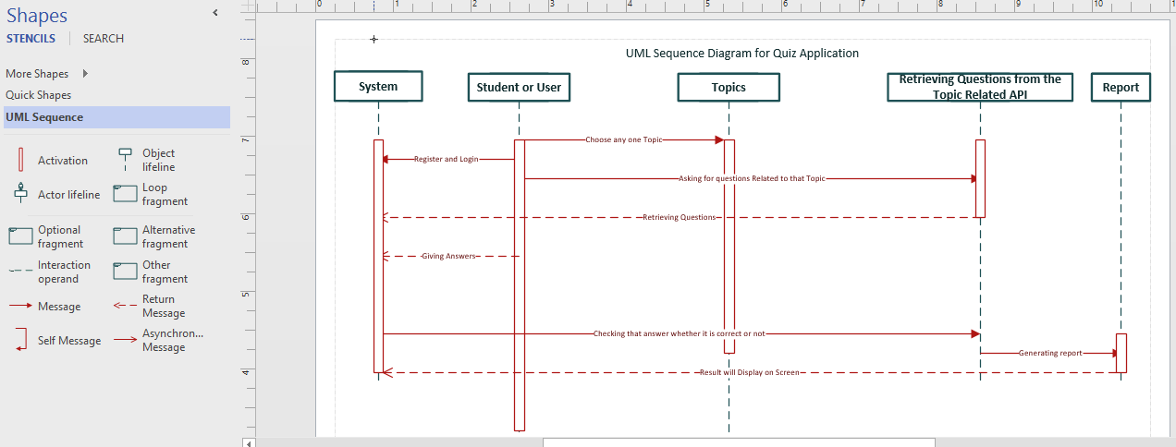

* **Class diagram:**

Class diagram for the project is as follows:

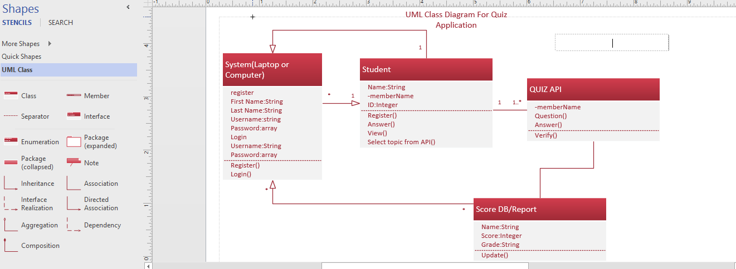

* **Activity diagram:**

Activity diagram for the project is as follows:

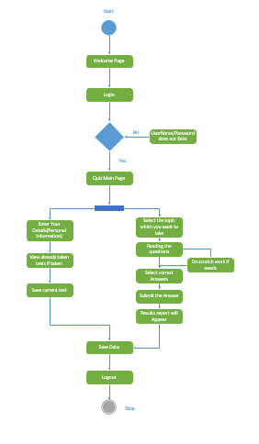

* **User story:**
* Students/users can take online quizzes through this Interactive quiz application.
* They can select any domain from the listed domains in the home page to take test.
* Users can listen to the questions on clicking speak button.
* Personal information can be edited in profile page.
* Test score is provided immediately after the quiz is completed.
* Users can assess their mistakes by the answers shown after the test.
* **Use case:**
* User must register himself/herself in the web portal.
* Upon successful registration user can login into the portal.
* After logging in user has option to select domain among the domains listed, to take test.
* Upon selecting domain, user can take tests and view scores after completing the tests.
* **Service description:**
* Interactive quiz application provides quizzes to the users.
* Users can take tests and view results after the test.
* As results are provided instantly users can assess their mistakes.
* Users can listen to questions in the quizzes.
* Scribbling pad is provided for scratch work.
* Timer is displayed on the screen.

**Testing:**

The following are the unit test cases and their results:

|  |  |  |  |  |  |
| --- | --- | --- | --- | --- | --- |
| **S.No** | **Test case** | **Description/Process** | **Expected result** | **Actual result** | **Pass/Fail** |
| 1 | Registration | User has to register in registration page | Registration has to be successful | Registration is successful | Pass |
| 2 | Registration | Invalid email ID | Error has to be shown stating invalid email ID | Error has been shown stating invalid email ID | Pass |
| 3 | Registration | Password criteria has to be met | Error has to be shown when password length criteria is not met | Error has been shown when password length criteria is not met | Pass |
| 4 | Log in | User has to login with valid credentials | Login has to be successful | Login successful | Pass |
| 5 | Log in | User has to login with invalid credentials | Error has to be shown stating invalid credentials | Error has been shown stating invalid credentials | Pass |
| 6 | Quiz selection | User can select any topic among the topicz listed for quiz | Quiz has to get started on the selected topic | Quiz has got started on the selected topic | Pass |
| 7 | Quiz history | Users quizzez history is stored | Quizzes written by user has to get saved | Quizzes written by user has got saved | Pass |
| 8 | Tabs | List of options available in the app like login page, logout, profile, quizzes are shown in the tab icon | Login page, logout, profile, quiz has to be shown in the tab icon | Login page, logout, profile, quizzes are shown in the tab icon and they are redirected to respective pages on selecting them | Pass |
| 9 | Facebook login | User can login with Facebook | User has to be logged in using Facebook login | User has successfully logged in using Facebook login | Pass |
| 10 | Profile | User is able to view his/her profile | User has to be able to view his/her profile | User is able to view his/her profile | Pass |

The following is the performance Yslow result:

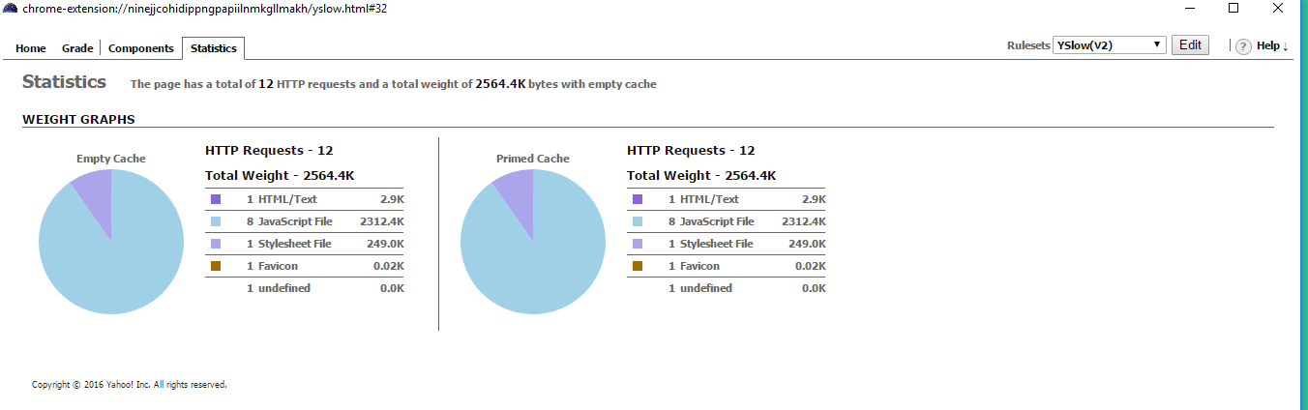

**Implementation:**

* **Mobile client implementation:** This app has been built on ionic framework and hence is compatible with both web and android mobiles.

**Deployment:**

Deployed code screenshots are attached below.

**Project Management:**

**Work completed:**

|  |  |  |  |  |
| --- | --- | --- | --- | --- |
| **S.No** | **Description** | **Responsibility** | **Time taken** | **Contributions** |
| 1 | Displaying quizzes/Reading data from Mongo DB,  Documentation | Nikhila | 10 | 100% |
| 2 | Facebook Login option,  Text-to-Speech Implementation | Divya | 10 | 100% |
| 3 | Creating quizzes Repository/Inserting data into Mongo DB,  Mongo DB connections in Ionic | SaiTeja | 10 | 100% |
| 4 | Completed Test Details,  Test Score on completion of Test | Arun |  |  |

**Work to be done:**

Mongo DB has to be implemented for the project to store user details and quizzes.

**Burn down chart:**

GitHub’s burn down chart of the project is as follows:

**Issues:**

GitHub’s issues for the project are as follows:

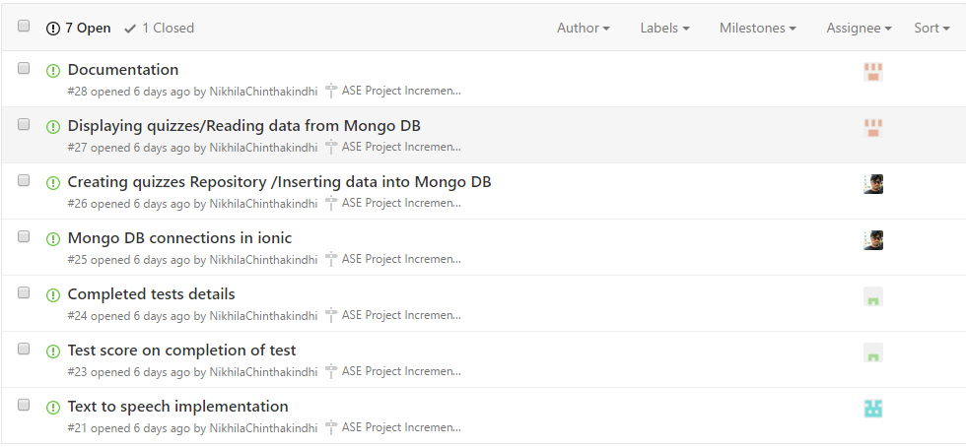



**Contributors graph:**

GitHub’s contributors graph for the project is as follows:

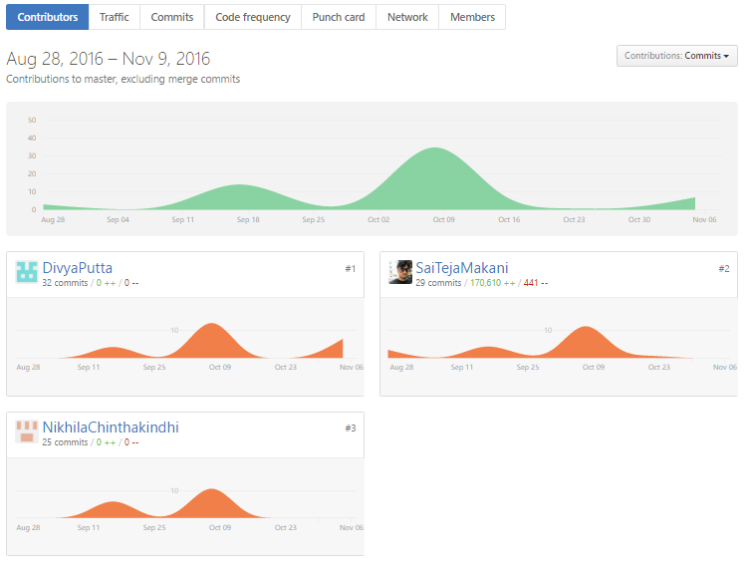

**Bibliography:**

<https://developer.mozilla.org/en-US/docs/Web/API/SpeechSynthesisUtterance>

<http://www.w3schools.com/angular/>

<http://www.w3schools.com/bootstrap/default.asp>