***Interactive Quiz Project Management (Team 12)***

***Team Members:***

|  |  |
| --- | --- |
| **Class ID** | **Name** |
| **26** | Makani,Sai Teja |
| **38** | Neelima-Putta,Divya-Sai-Lakshmi |
| **9** | Chinthakindhi,Nikhila |
| **62** | Arun |

**Project management through GitHub:**

Project management has been done through one of the most used agile websites GITHUB. This was used for pushing our code and to upload reports. Burndown chart was used for knowing the work remaining vs time. Milestones has been used for each increment to know tasks of each team member. Issues in each milestone informs the members their tasks to be accomplished.

The following is the project in GitHub:

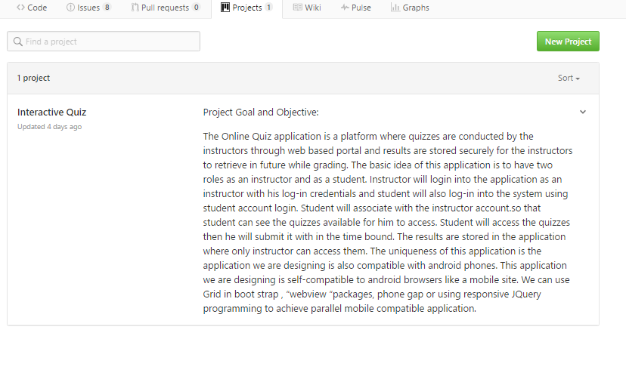

The project’s folders in GitHub is shown below:

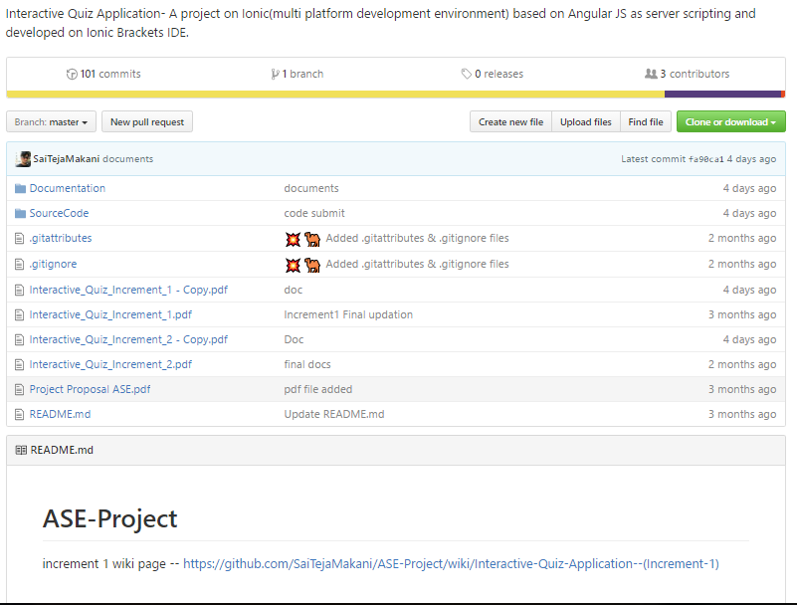

Source Code folder structure:

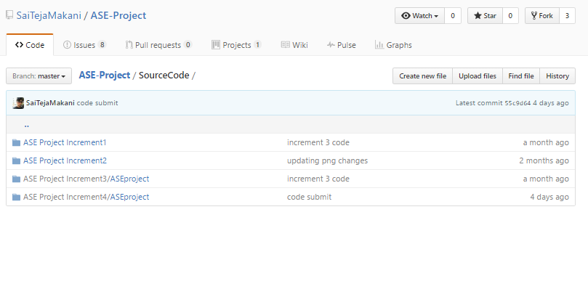

Documentation folder structure (Each folder has screenshots of the application):

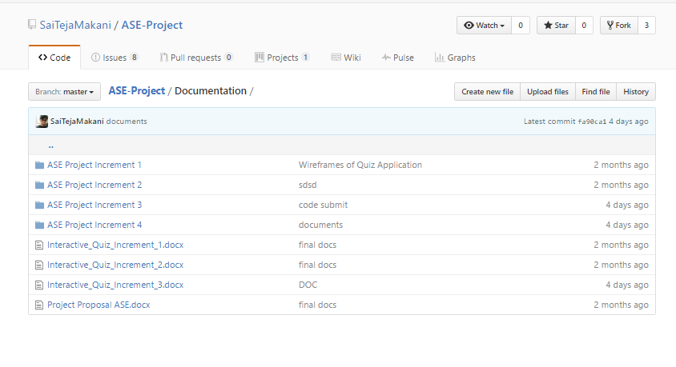

Milestones in GitHub is as follows:

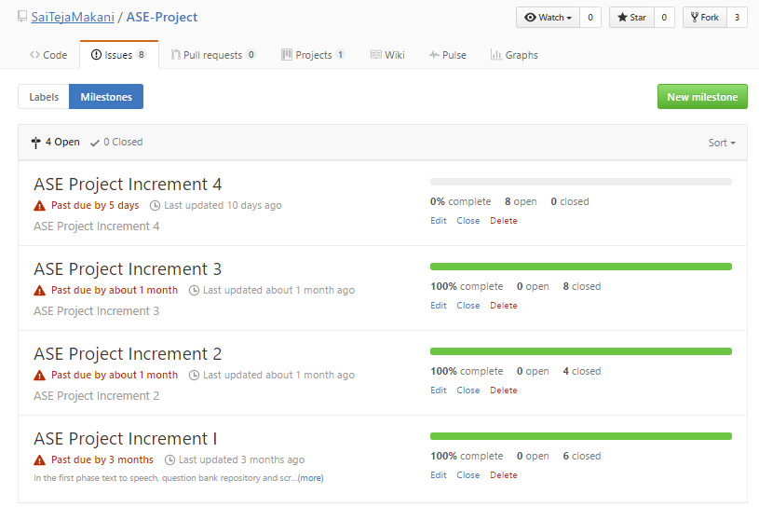

Issues/tasks in Increment 1:

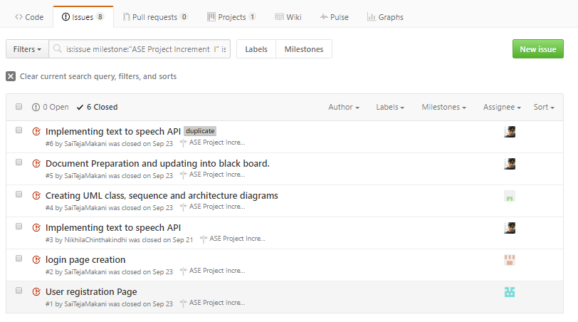

Issues/tasks in Increment 2:

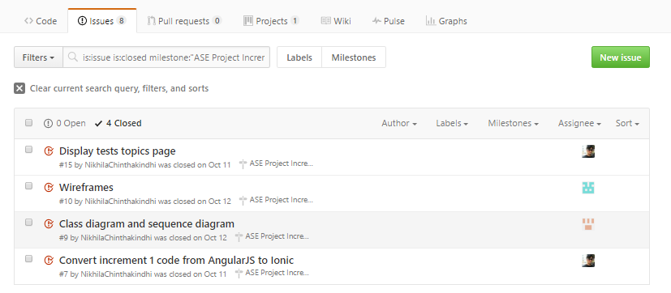

Issues/tasks in Increment 3:

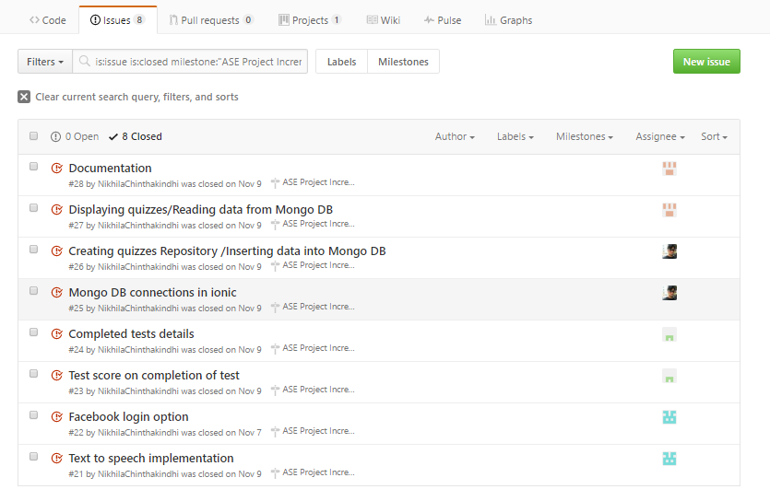

Issues/tasks in Increment 4:

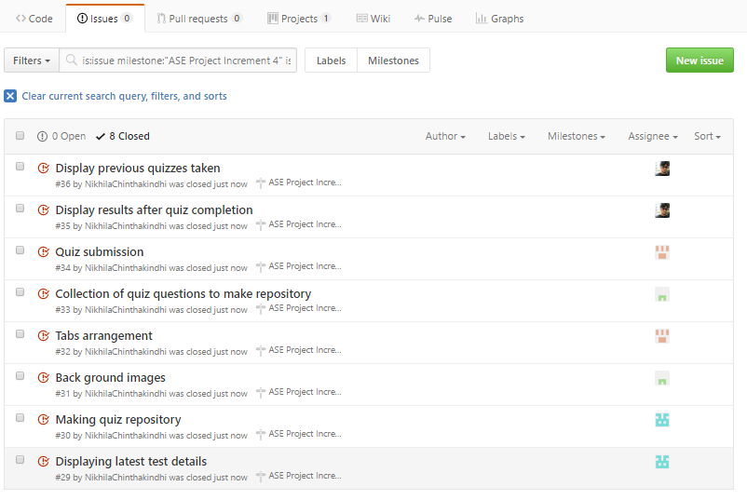

Contribution graph of the project:

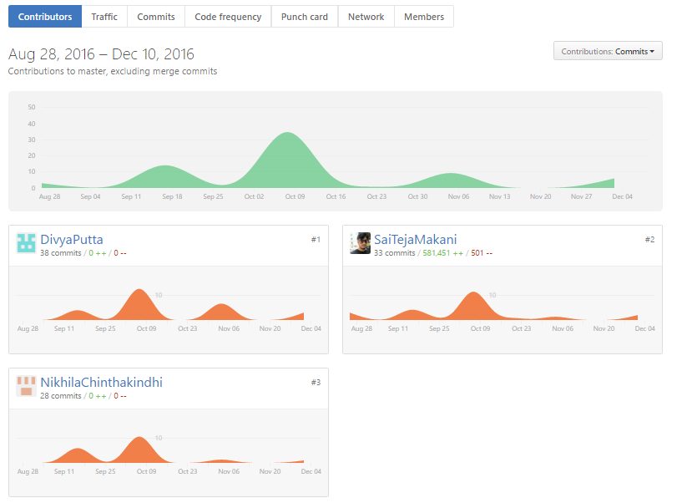

Burndown chart of Increment 1:

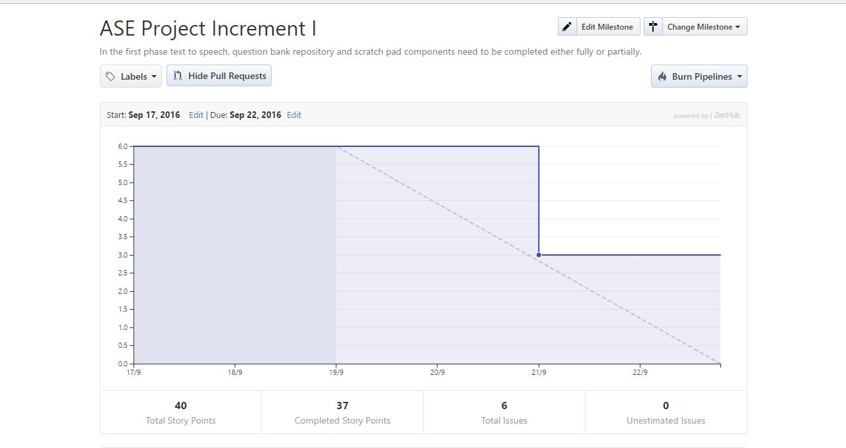

Burndown chart of Increment 2:

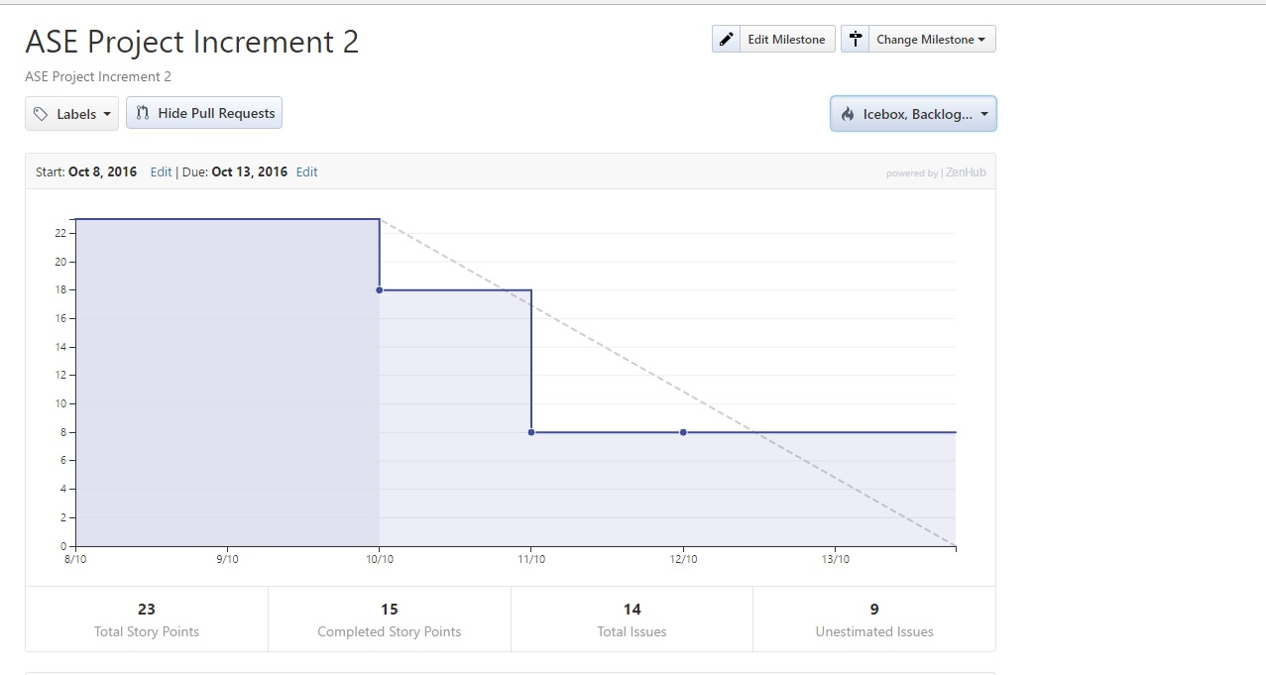

Burndown chart of Increment 3: