**ASSIGNMENT-01**

**Name: Veeramallu Veera Venkata Sai Teja**

**User ID: 27469**

**Batch: WiproNGA_Linux Device Driver_25VID0808**

**Task:**

**Draw your home network topology and explain it.**

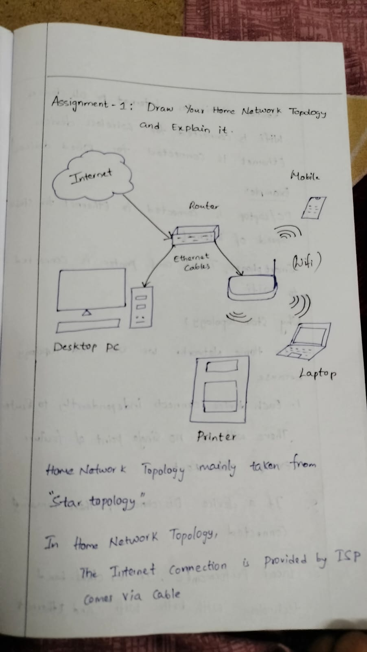

Hore Network Topology mainly taken from "Star topology ".

In Home Network Topology,

The Internet Connection is Provided by ISP(Internet Service Provider) Comes via Cables

Router distributes internet to all devices.

Wi-Fi is connected for wireless devices Ethernet is Connected for Wired devices

Example:

PC/Laptop is connected to Ethernet for Stable Speed of internet.

Smart phones, Tablets and printer is connected to Wi-Fi.

**Why Star Topology?**

In Home Network because we Use Star Topology,

1. Each device connects independently to Route There will be no single point of failure except the Route.

2. If a device Disconnects, Others remaining devices are Connected.

3. Good performance, It las dual-band technology with both Wi-Fi and Ethernet