Assembly effects of temporarily immunizing interventions across connected patches and their potential impact on strategy: a two-patch mathematical modelling study

Abstract
As malaria is getting close to elimination, there is more heterogeneity in its prevalence and incidence. This heterogeneity creates some places with high malaria incidence (hotspots) and some with low incidence (coldspots). Naturally, we would assume that targeting the malaria hotspots would bring about elimination.

We developed a connected two-patch model to look at how the connectedness influence the outcome of the immunizing intervention such as the mass drug administration (MDA).

Due to the temporary nature of MDA effect, it is always essential that we improve and maintain routine interventions such as early diagnosis and treatment (EDAT) and long-lasting insecticide-treated nets (LLIN) alongside the deployment of MDA.

We found that the focal MDA of malaria hotspots could bring about elimination only if we also do at least one round of MDA in the malaria coldspots.

Glossary

(Temporarily) Immunizing mass intervention: A public health intervention against an infectious disease, resulting in some form of immunizing effect against the disease in the recipient of the intervention. [A burst of effect for a specific duration after which the effect would drop]

Patch: Model’s representation of a certain geographical area. It can be a village, a city, a province, etc.

Connectedness: Two patches are connected when some number of people from one patch spend part of their time in the other patch and thus experiencing the disease spreading condition (effective contact rate) of the latter patch. For simplicity in our model, we have assumed the connectedness as the overlapping area between the two patches, for which the effective contact rate is the average of the two patches, as described in the following diagram. Subsequently, H proportion of people from each patch is assumed to spend have of their time in the other patch. When H is 0, there’s no connectedness between the two patches and when H is 1, the two patches essentially become one big patch with the average effective contact rate of the two.

Assembly effect: Advantageous or disadvantageous effect experienced by a particular patch owing to its degree of connectedness to another patch which is receiving an immunizing intervention at a higher or lower level (or not receiving at all).

MDA coverage: A composite term for the actual MDA intervention coverage and the adherence to the intervention by the participants.

Malaria hotspots:

Introduction
According to the latest Global Burden of Diseases (GBD 2017) study, the communicable diseases made up 44% and 31% of mortality in the countries with the low and low-middle socio-development index (SDI) (1). The hallmark of the communicable diseases is that they are preventable. The most preferred methods for this would be in terms of primary prevention where the aim is to prevent the onset of the disease ie. Stop people from contracting the disease. Immunization/vaccination has been an important strategy for primary prevention against the communicable disease.

Unfortunately, we couldn’t vaccinate every infectious disease. No vaccination is perfect. And overtime, the effect of immunization wanes. Some public health interventions could have a temporarily immunizing effects on these infectious diseases eg. vaccination against malaria, MDA provides protection from malaria similar to a form of immunity, flu vaccine, …. Albeit temporary, these immunizing interventions are important considerations because they could terminate the chain of transmission, provided there’s enough isolation. Unfortunately, in the modern world, no place is isolated. Even the island nations have connections to the outside world and stringent interventions may be required to prevent re-establishment of the disease.

Herd immunity: Assume homogeneity in a single population, which is not true. We extend this concept by experimenting with a two-patch model which could have a variable level of connectedness. This connectedness may be important for the success of the rollout of the aforementioned immunizing interventions on a large scale (eg. at a national and global scale).

Here, we constructed a hypothetical scenario in which there are two connected patches (isolated from the outside world) to look at the effect the connectedness have on deploying these temporarily immunizing interventions. We first looked at at a very simple general model and then at a specific, more complicated example where MDA is regarded as an immunizing intervention against malaria.

We have provided a specific example where the mass drug administration (MDA) is regarded as the immunizing intervention. Many malaria models assume that the population is homogeneous, which would be a correct assumption during the malaria control era. But as malaria incidence has come down globally, the presence of malaria becomes heterogeneous. Pockets of hotspots would have drastically different malaria incidence from those of the coldspots. Because of this heterogeneity, the consideration of human movement (connectedness) between them is increasing important. We will look at scenarios where these hotspots and coldspots are connected and how their connectedness could influence the way we deploy the immunizing interventions.
- (Cosner 2009, Prosper 2012)

Methods
All analyses were carried out in R programming language version 3.6.0 (2) using the following R software packages: deSolve (3), Rcpp (4), and lattice (5).

Model
We developed a two-patch model extended based on the structure of our previous model published elsewhere (6). The model included 8 compartments for each patch. There were two types of susceptible compartments: Susceptible with antimalarial drug (S_{D}), and those without drug (S). Likewise, there were two types of recovered compartments: R_{D} and R. Infected compartment was divided into three sub-compartments: I_{C} represented clinical cases, I_{A} represented the cases that were asymptomatic, but detectable through microscopy and RDT, and I_{U} represented the cases that were asymptomatic and undetectable through microscopy and RDT. There was a single treatment compartment (T) to accommodate those from infected compartment who got treated. Details of the model structure can be seen in the appendix [].

Force of infection terms (λ) in the two patches influence each other by having the weighted contribution of infected cases from the other patch experiencing the average effective contact rates in the two patches.
$$λ_{i}={\left(1-H\right) β}_{i}\left(\frac{I_{i}}{P_{i}}\right)+\frac{H}{2}\frac{\left(β_{1}+β_{2}\right) \left(I_{1}+I_{2}\right)}{\left(P_{1}+P_{2}\right)}$$

where P is the total population, $β$ is the effective biting rate adjusted by vector interventions, $I$ is the representation of Infected compartments in the corresponding patch. Different types of $I$ compartment has different infectiousness, but for simplicity, only one $I$ compartment for each patch is represented in the equation. $H$ is the level of connectedness between the two patches, with 0 representing no connectedness and 1 representing 100% connectedness.

Interventions
EDAT, MDA (including primaquine), LLIN and MSAT are included as interventions. MSAT for migrants may not be implemented in Karen state, but it could be the same effect when surrounding areas are also eliminated of malaria at the same time and there’s less and less importation. It is the imported cases that keep the transmission at equilibrium in the first place.
Three monthly MDA rounds are modeled as an MDA round that spanned over 3 months which is a time dependent term $m_{i}$ such that $m_{i}=-\frac{\ln\left(1-{κ_{m}}_{i}\right)}{d_{MDA}},$ when time is within the period between start and end of the three months of MDA, and $m_{i}=0$ otherwise. $d_{MDA}$is the duration of the MDA which is 3 months. ${κ_{m}}_{i}$ is the coverage of the MDA where a person receives at least one round of MDA. Other methods for modelling interventions remain the same as in the previous paper (6).

Set up of the scenarios
The parameters for the model were calibrated based on the data from (7). All parameters that were assumed can be found in Table x.

Outcome measurement in the model
Outcome presented here was whether elimination threshold (less than 1 case per 1000 per year) was achieved in one village or both of the villages at one-year after the completion of MDA. MDA success should be measured immediately after it’s done (before being complicated by other external effects such as importation). This may not be an ultimate outcome. It should also be noted that this measure has been estimated in the presence of other interventions.

Results

Results from the malaria MDA coverage example
While fixing the MDA coverage in the patch 1 at a particular value, we increased the connectedness from 0% to 100%, and the MDA coverage from 0% to 99% in the increment of 1% in patch 2 for each simulation. The permutation resulted in 10,100 simulations for each MDA coverage value in patch 1. The results of these were plotted as a surface plot with 101 by 100 grids. X-axis represents connectedness and Y-axis represents the MDA coverage in patch 2. We repeated this simulation exercise for the MDA coverage values in the patch 1 from 0% to 90%, with 10% increments. The complete results can be seen in the appendix []. We have selectively shown the results for 70%, 80% and 90% MDA coverage in patch 1 in the first row of Figure 1 below.

The remaining two rows represents the results of the same experiment as above but with one difference – the maximal human biting rate (HBR) is 25% lower in patch 2 in the second row, and the HBR is 25% higher in patch 2 in the last row.

At a particular incidence (API of … in the simulation), there exists a “baseline” or “minimal” threshold of MDA coverage above which pre-elimination (ie. <1 case/1000 population) would be achieved, if a patch is isolated /not connected to another one. This “baseline” threshold depends on the local incidence. As the connectivity increases, the MDA coverage threshold would increase above the “baseline” threshold if the connecting patch has a lower MDA coverage and vice versa. We will designate the effect varying degrees of connectedness has on the changing MDA threshold, an assembly effect.

HBR_max16
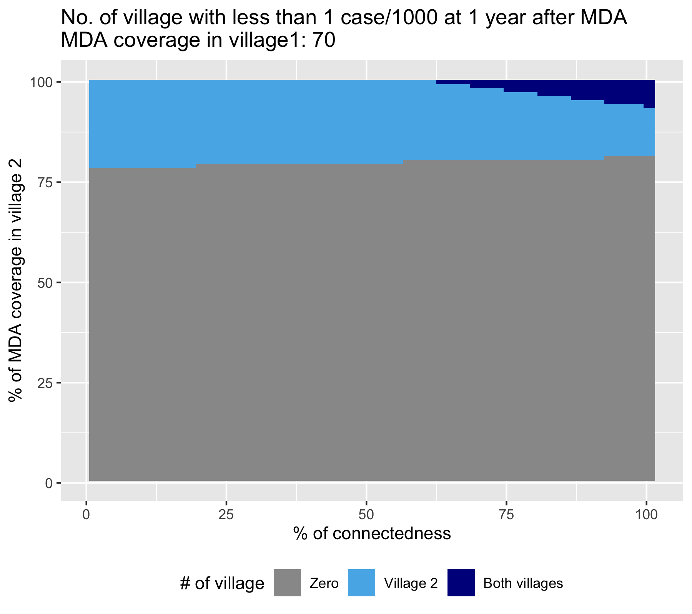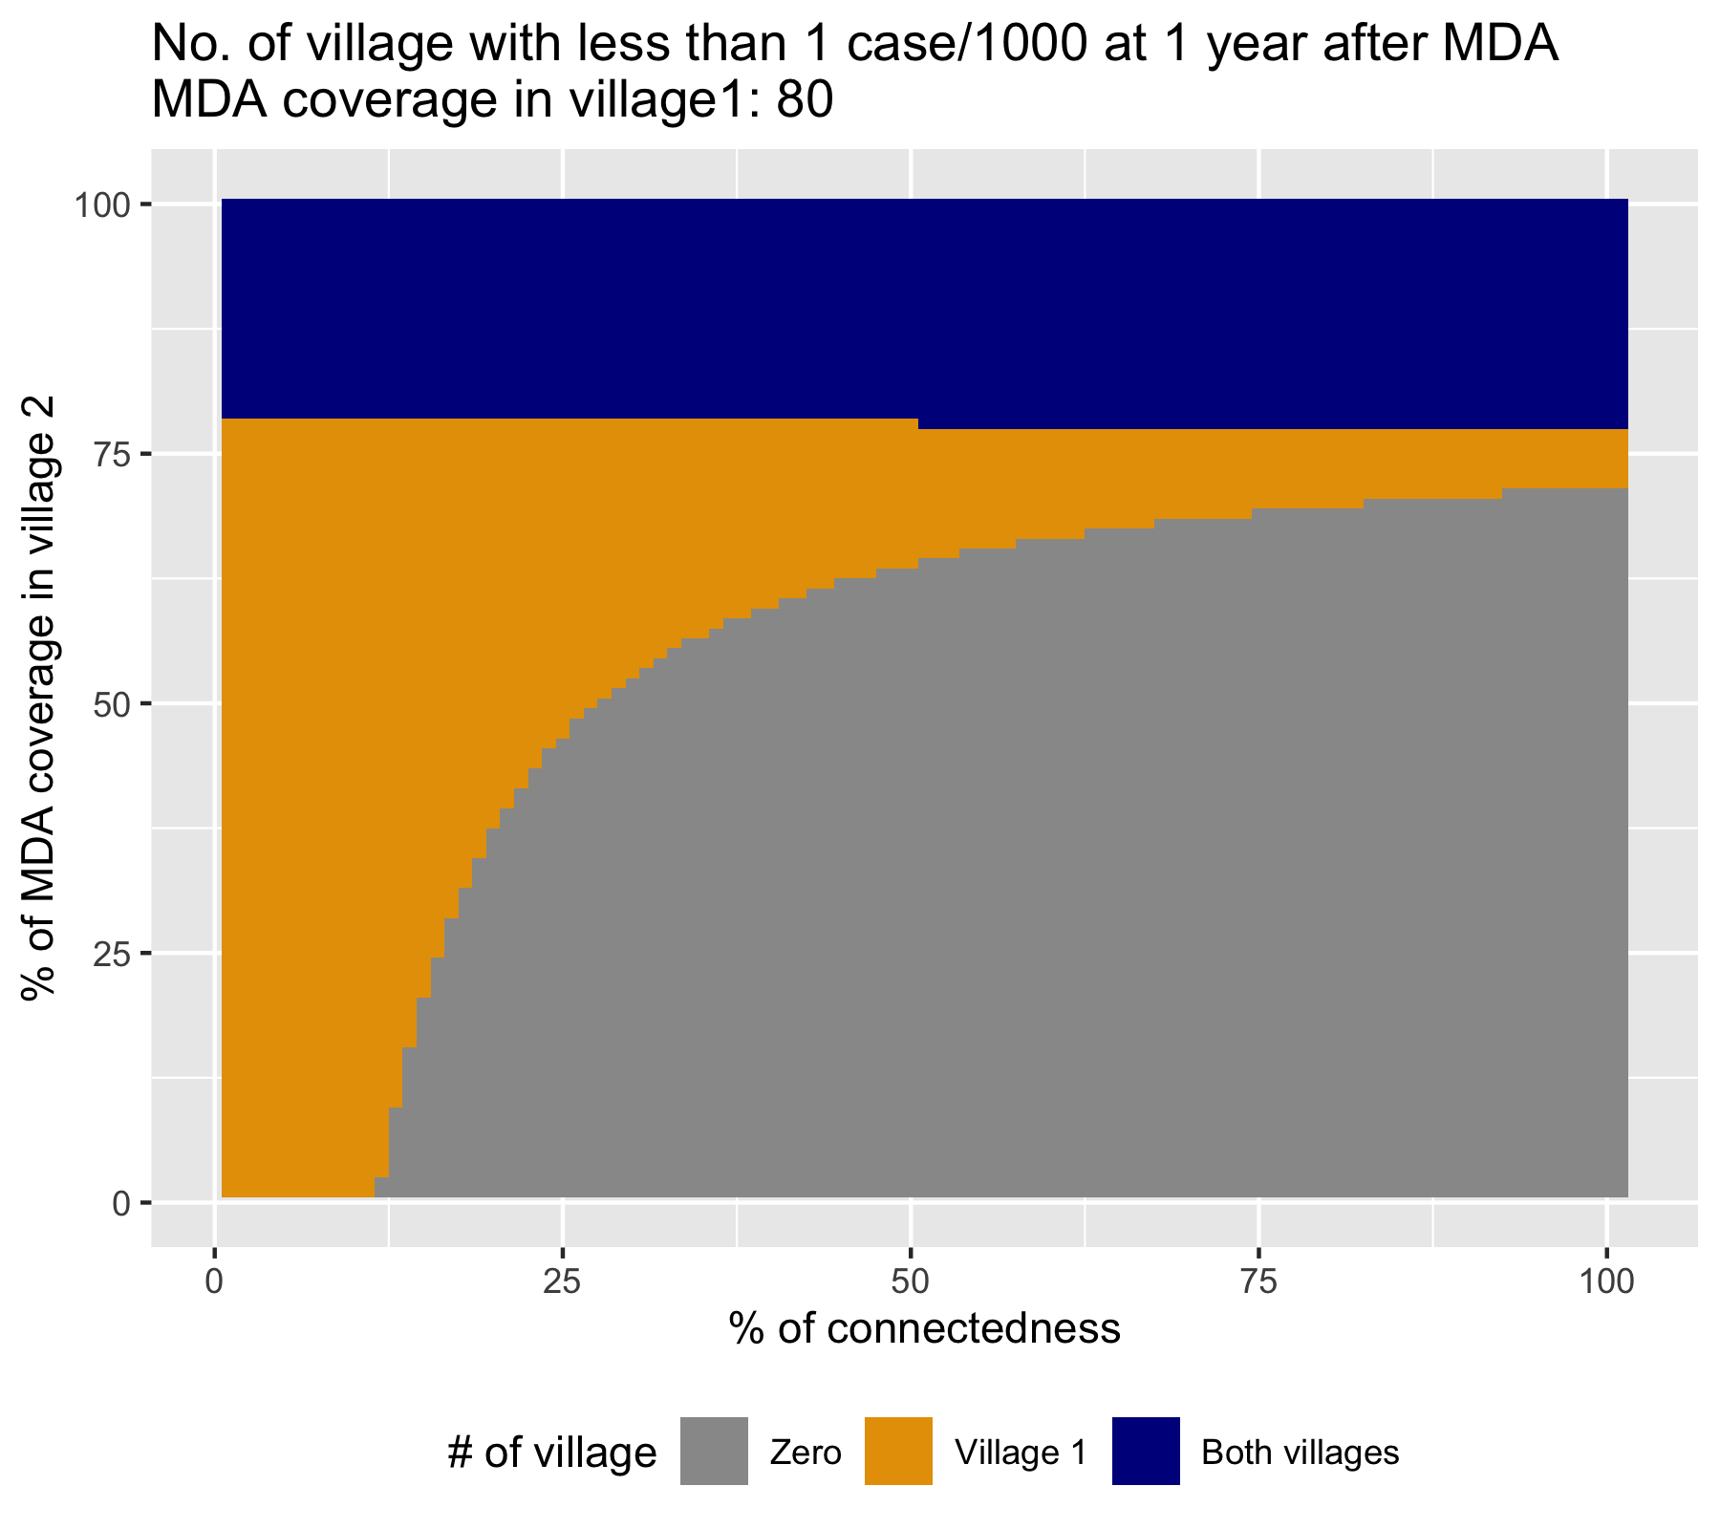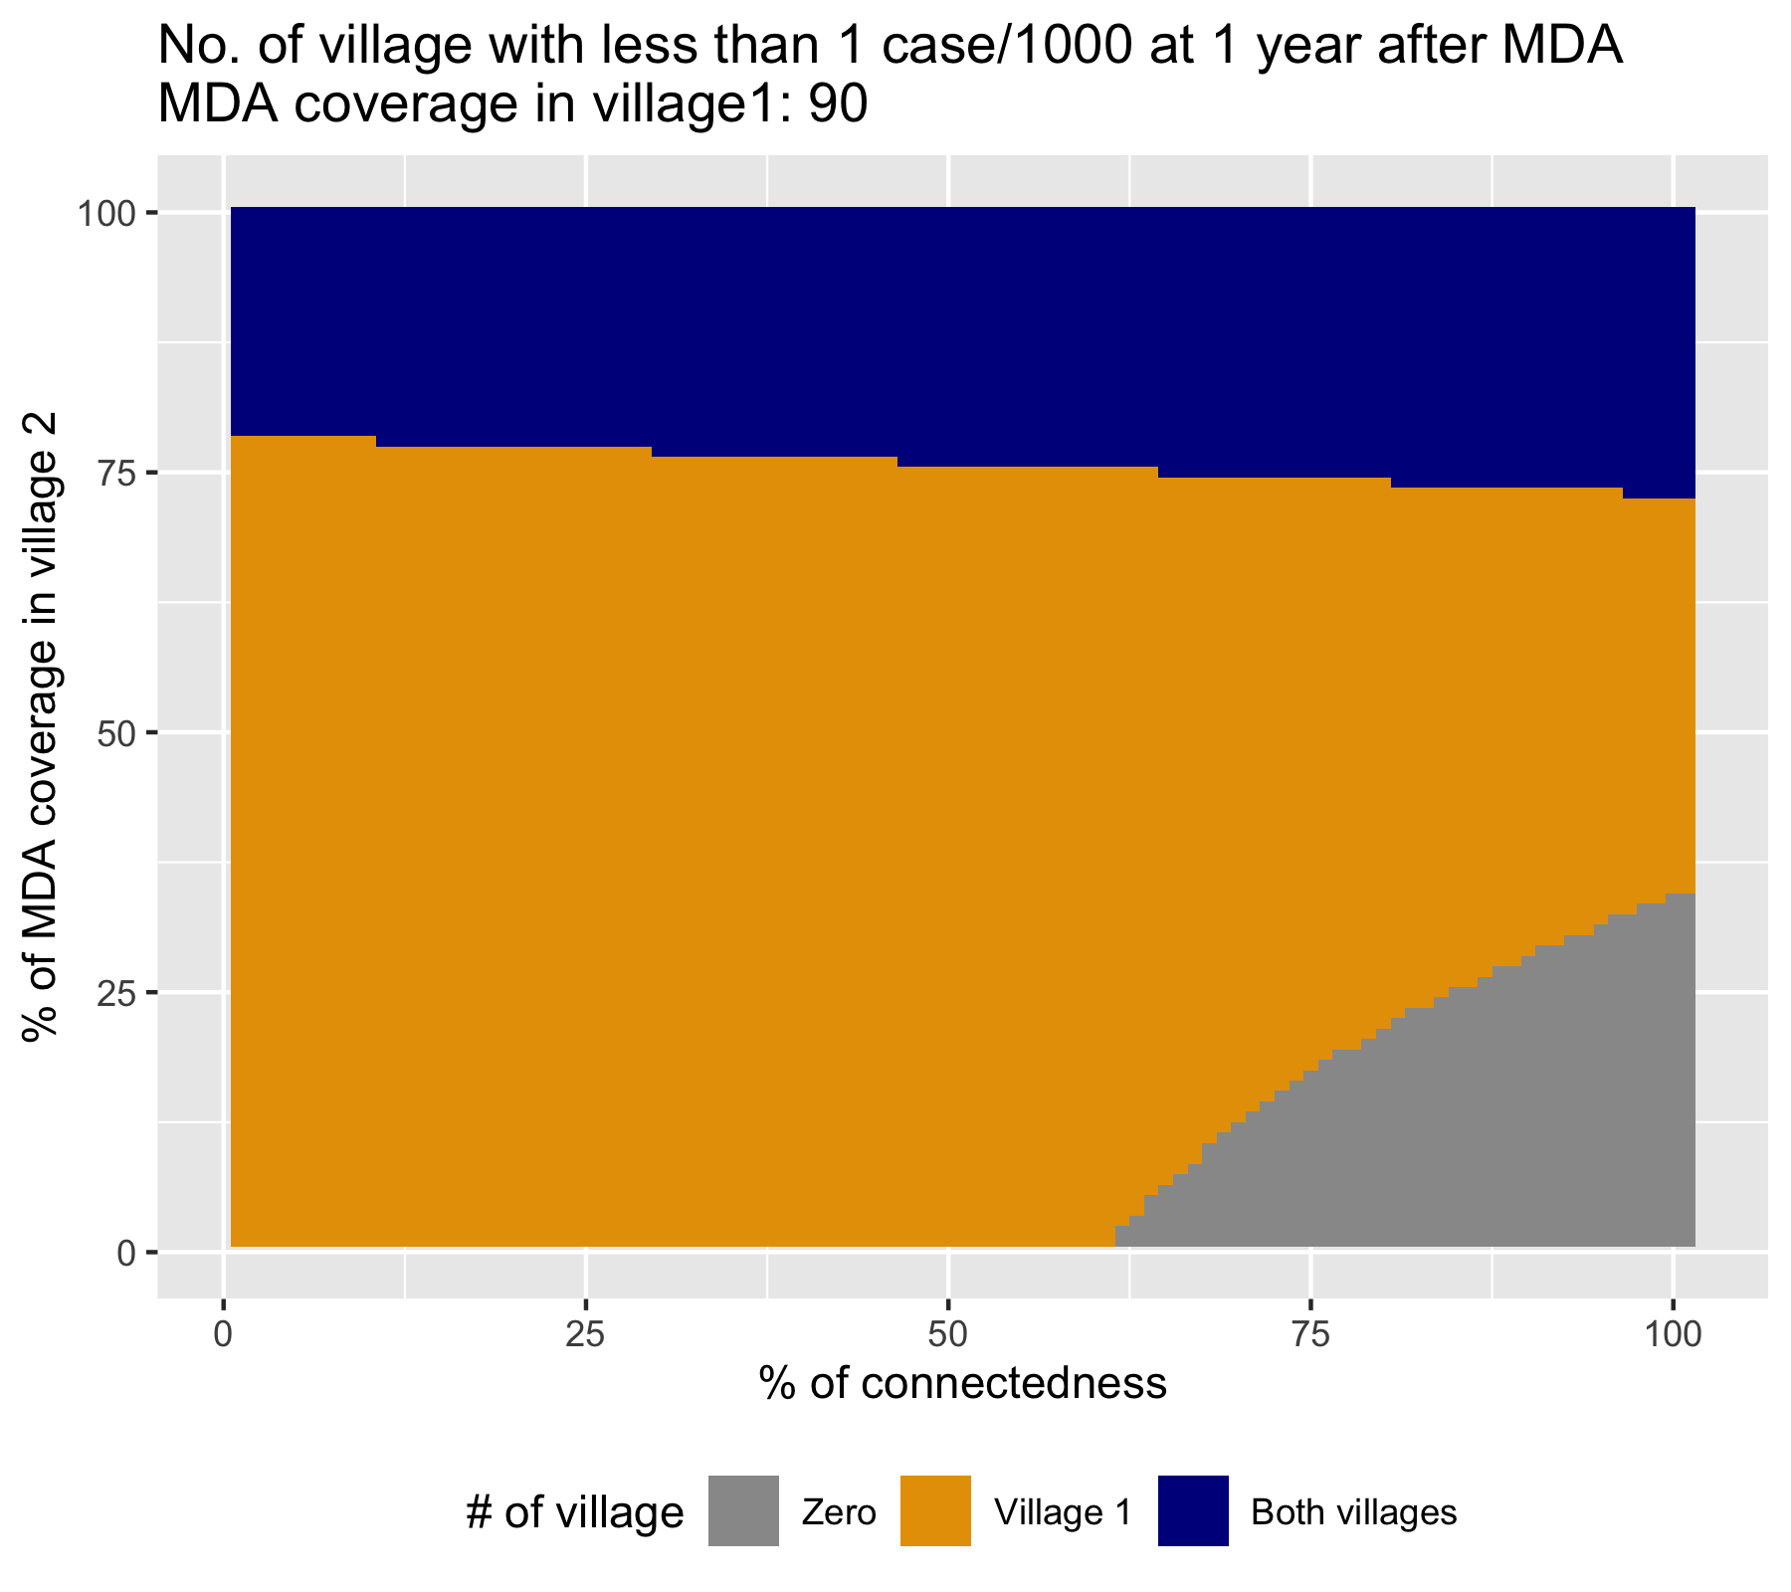
25% lower HBR in village 2
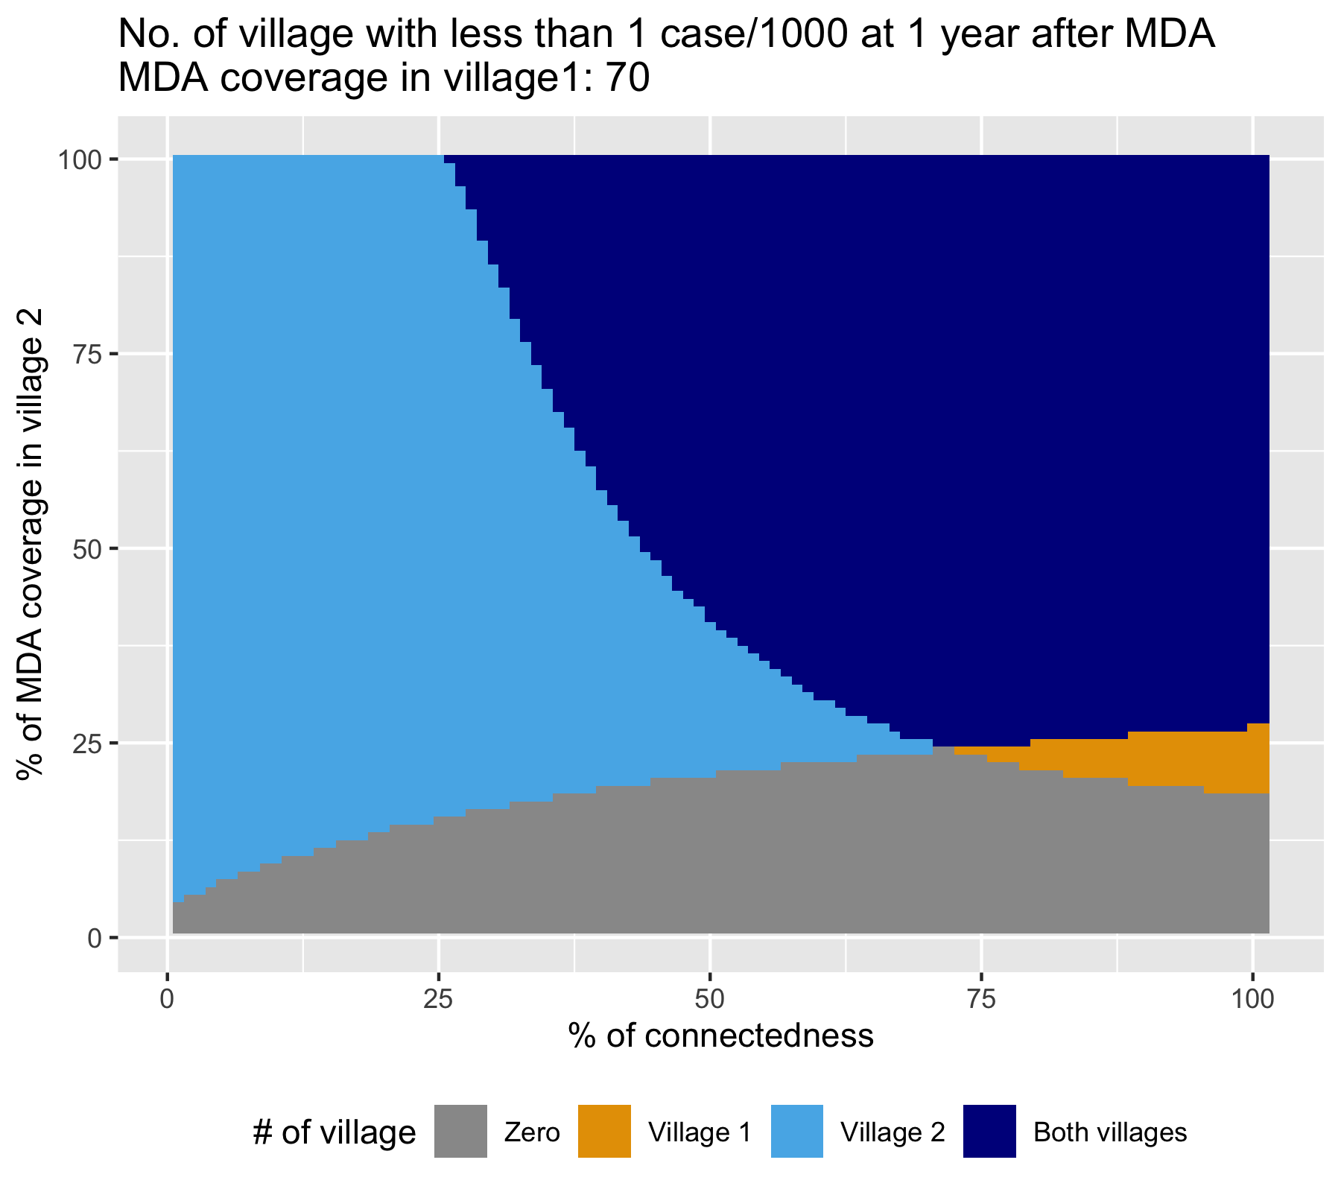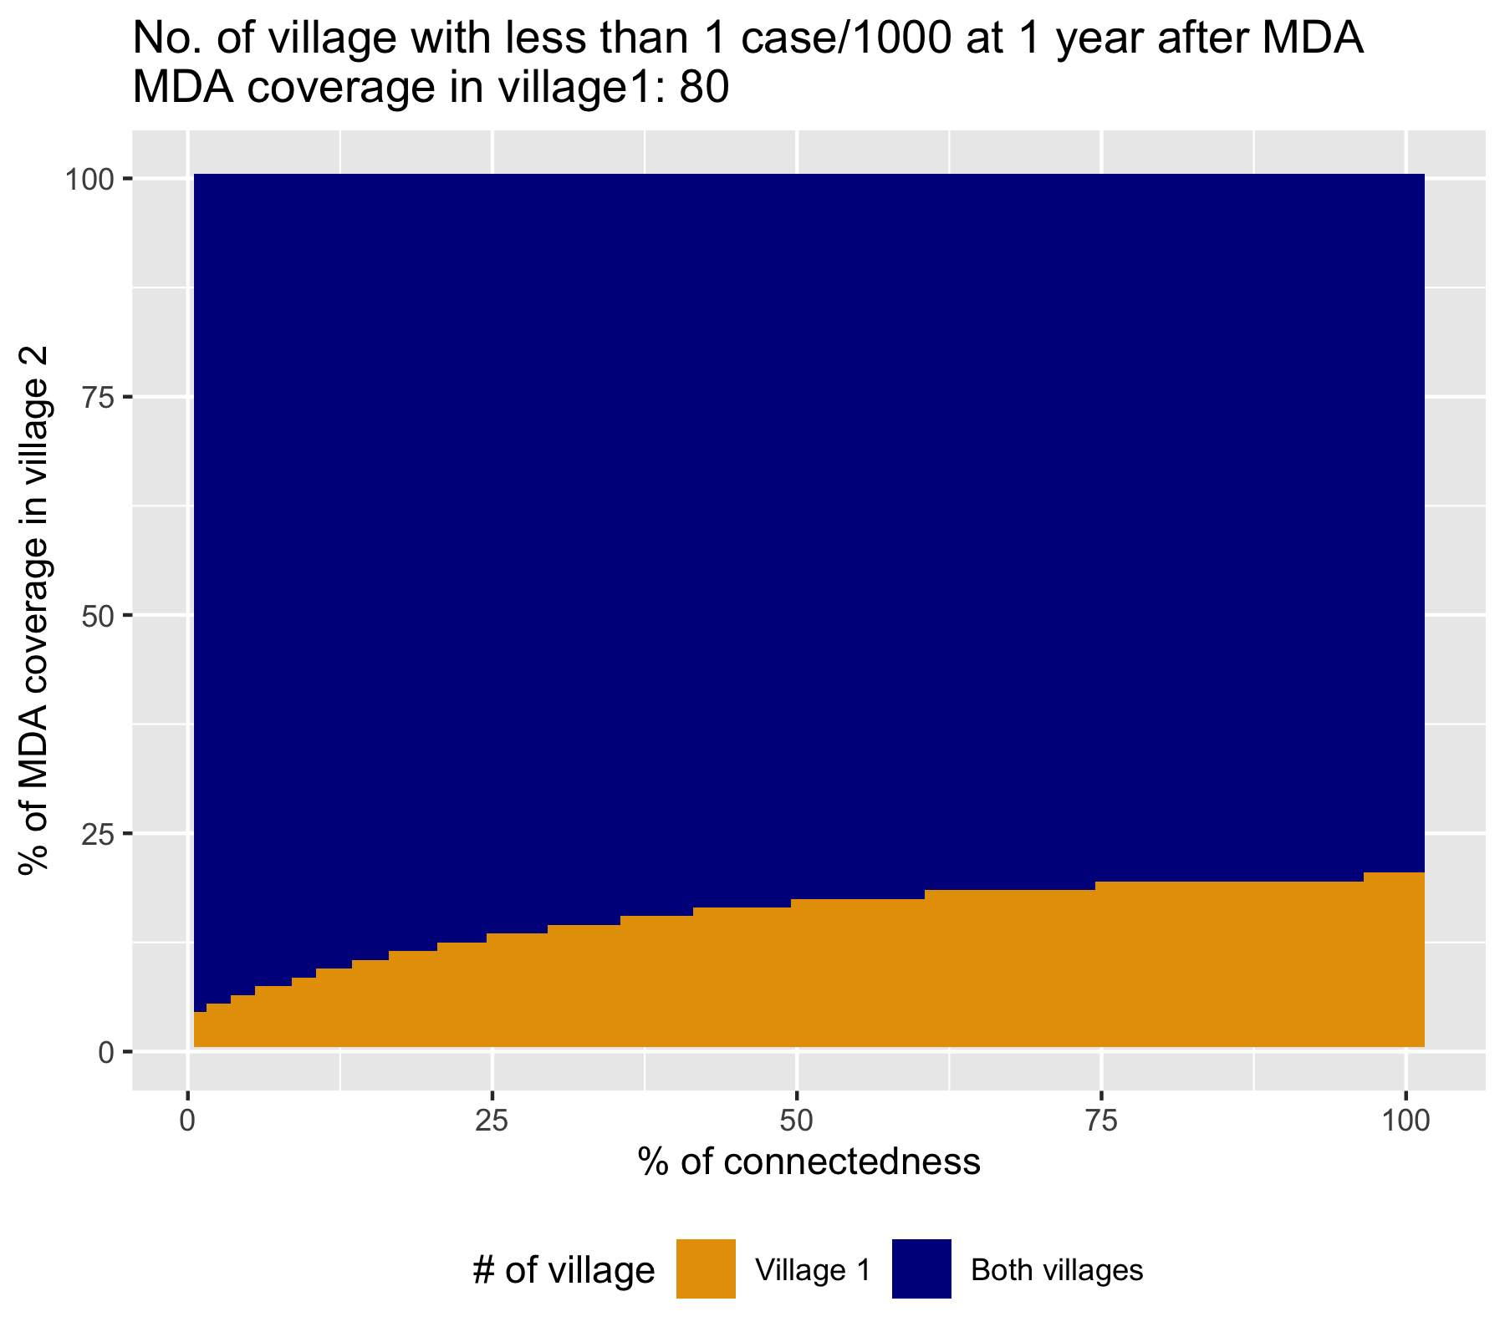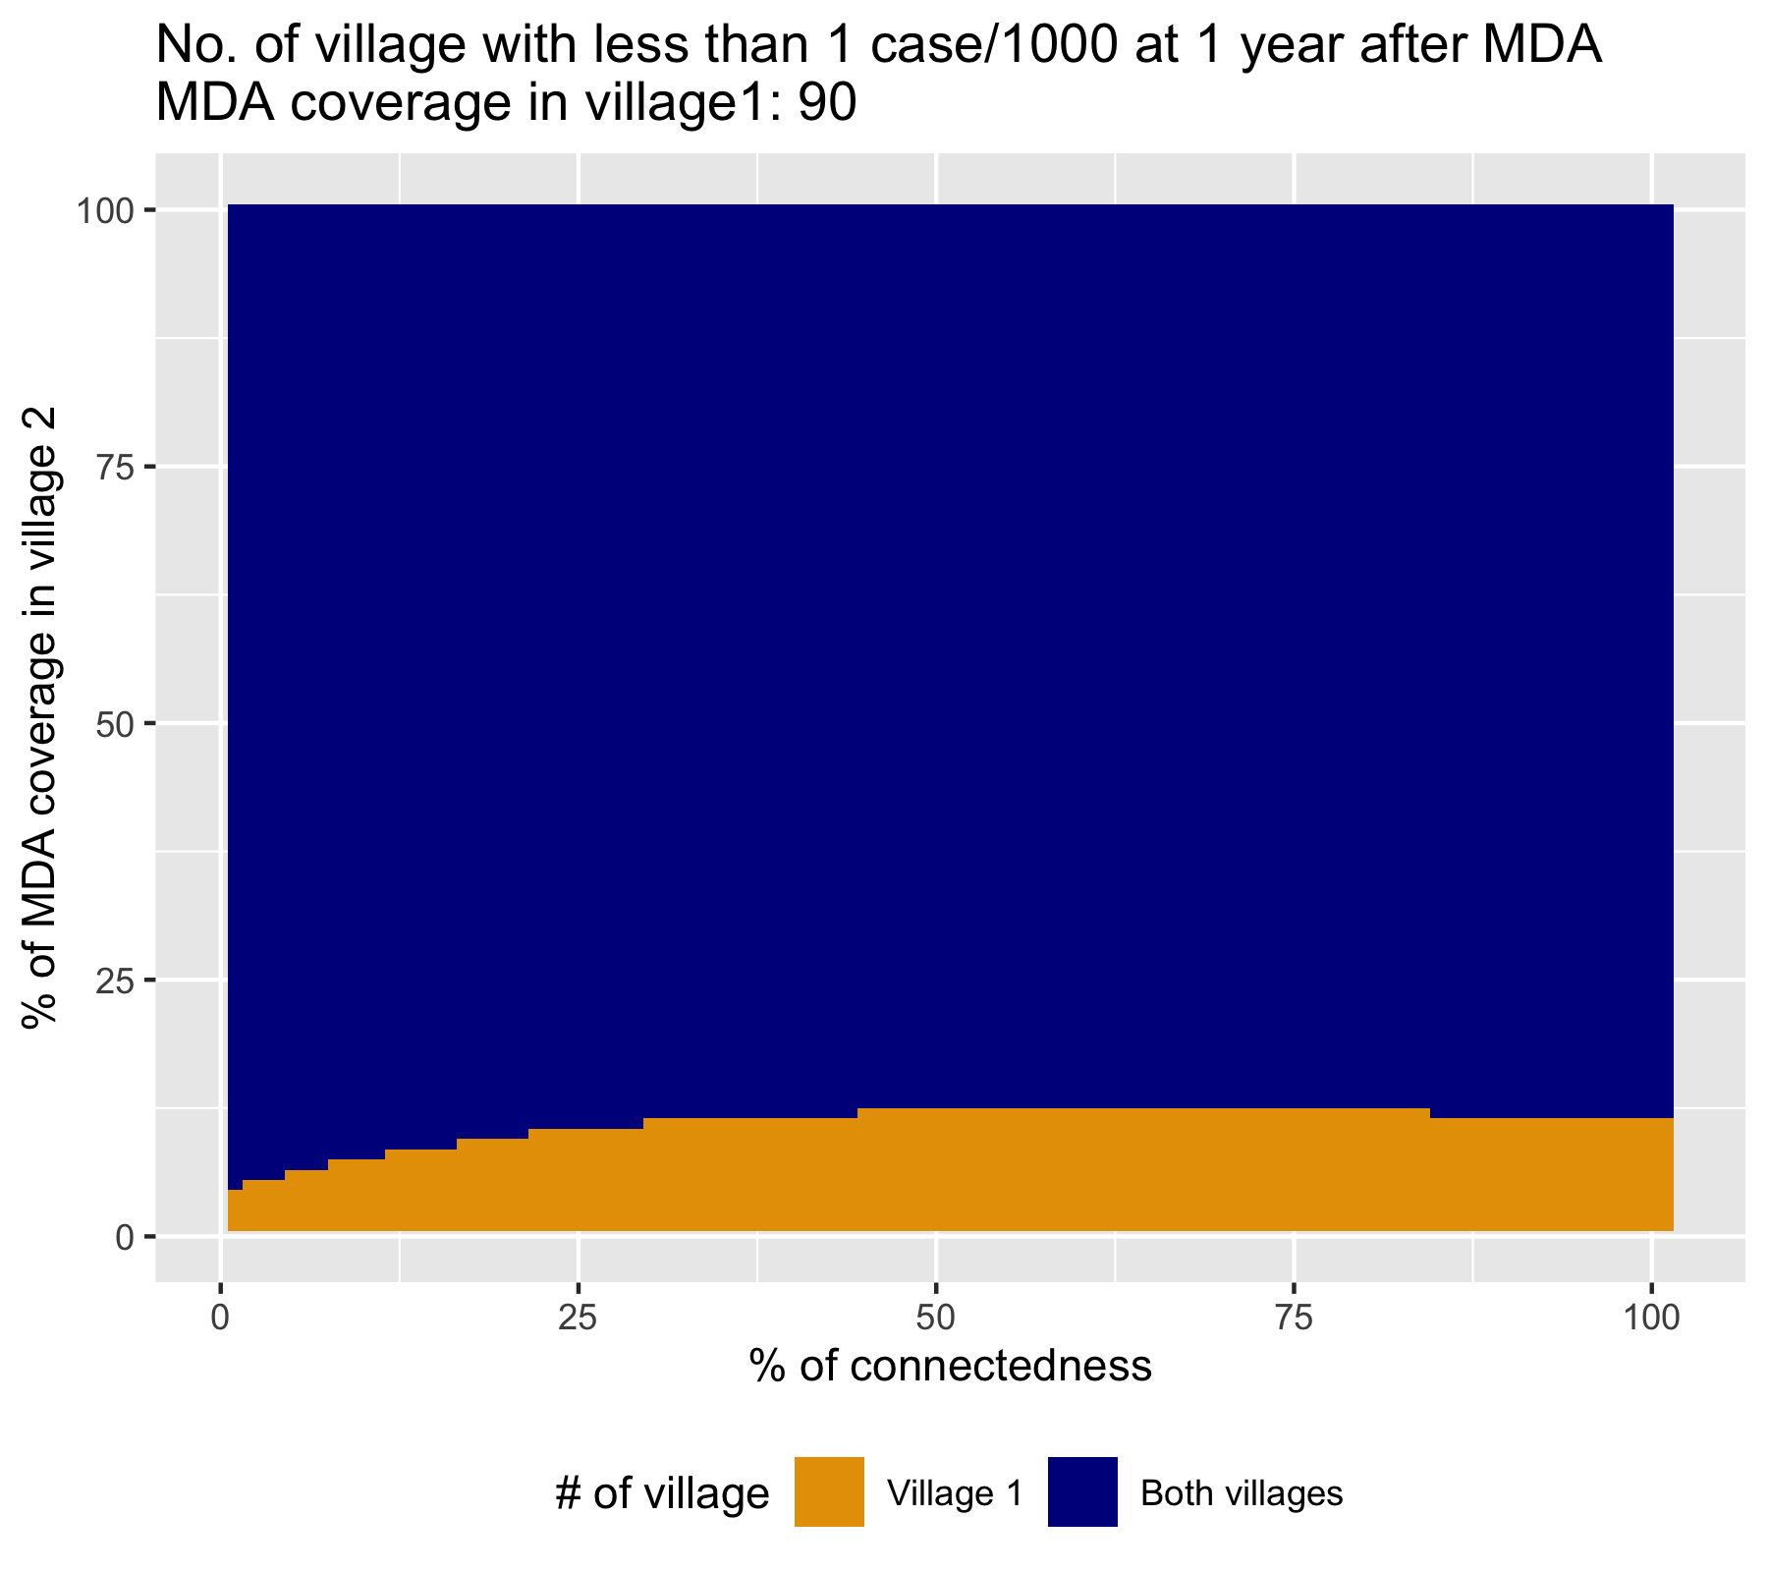
25% higher HBR in village 2
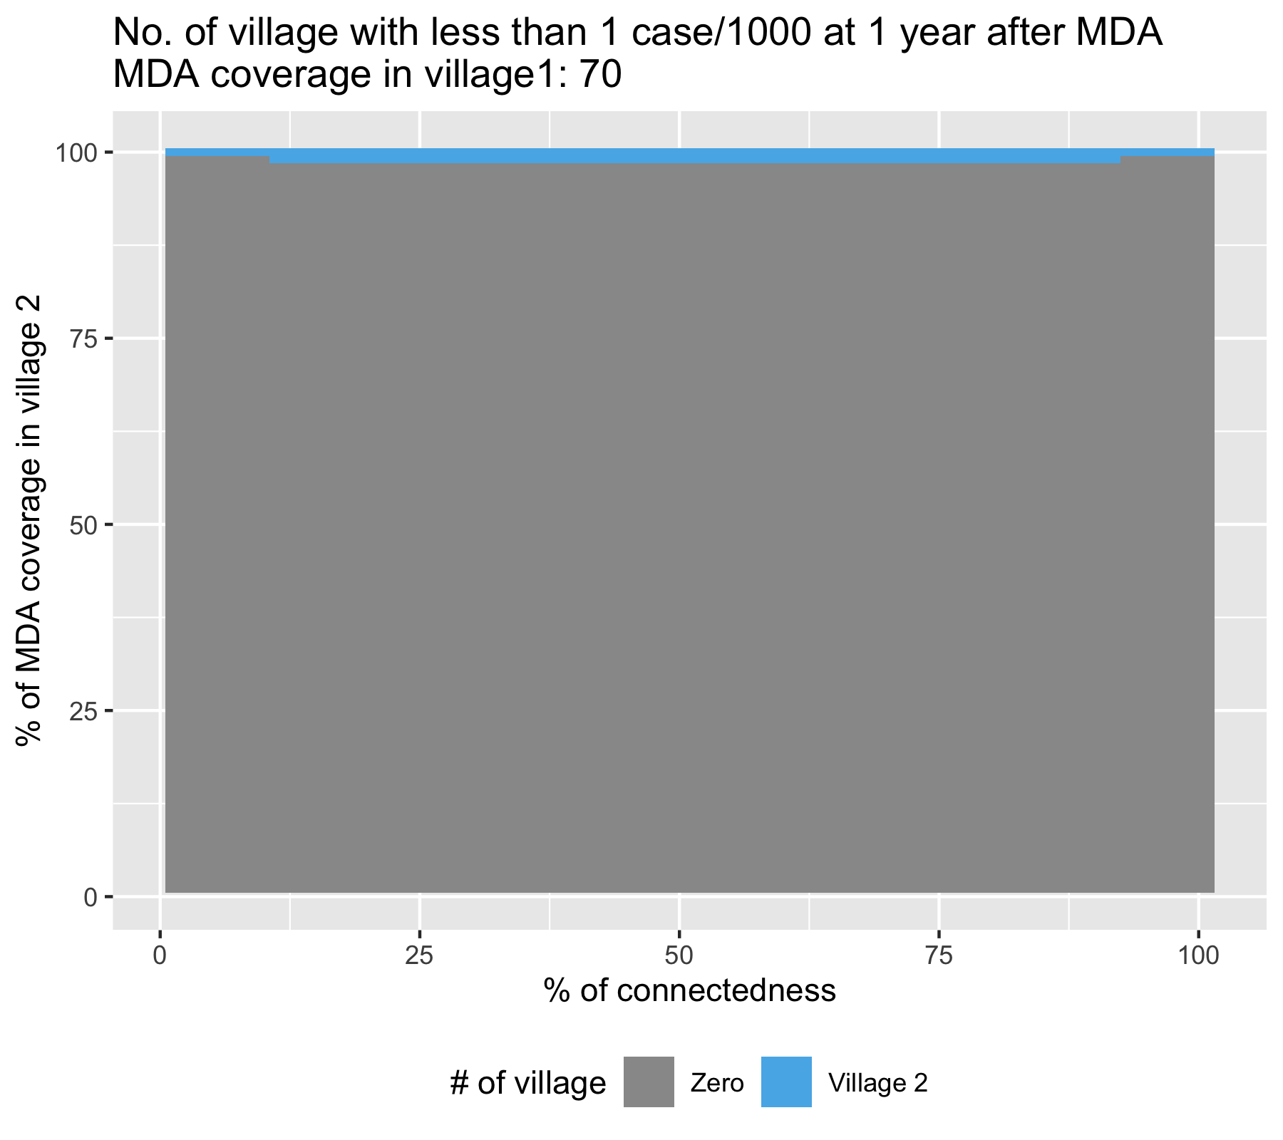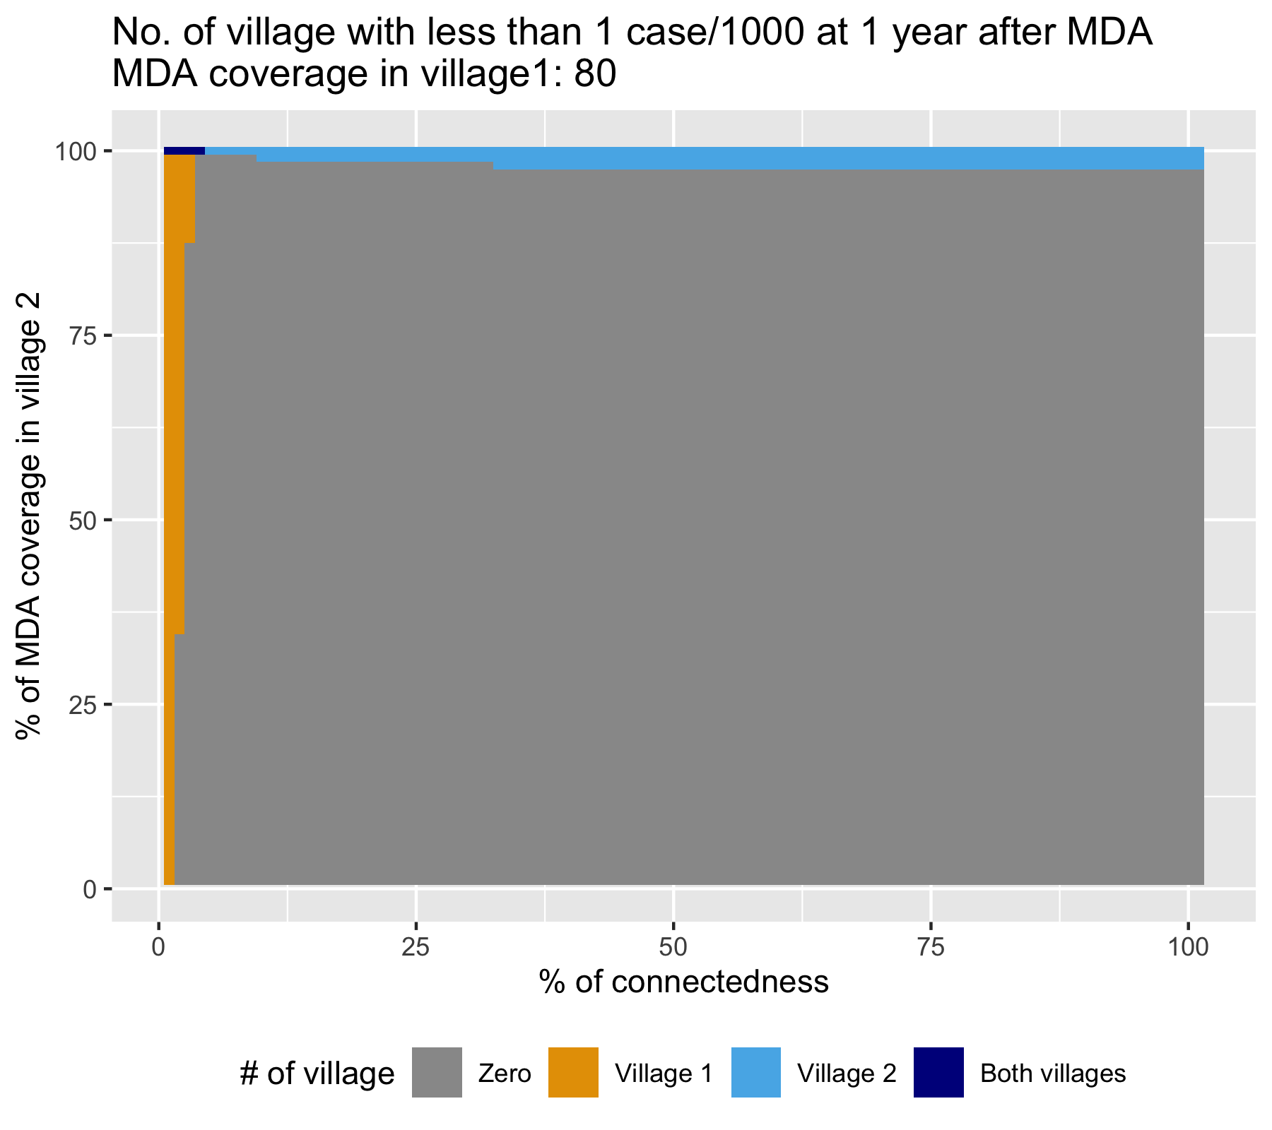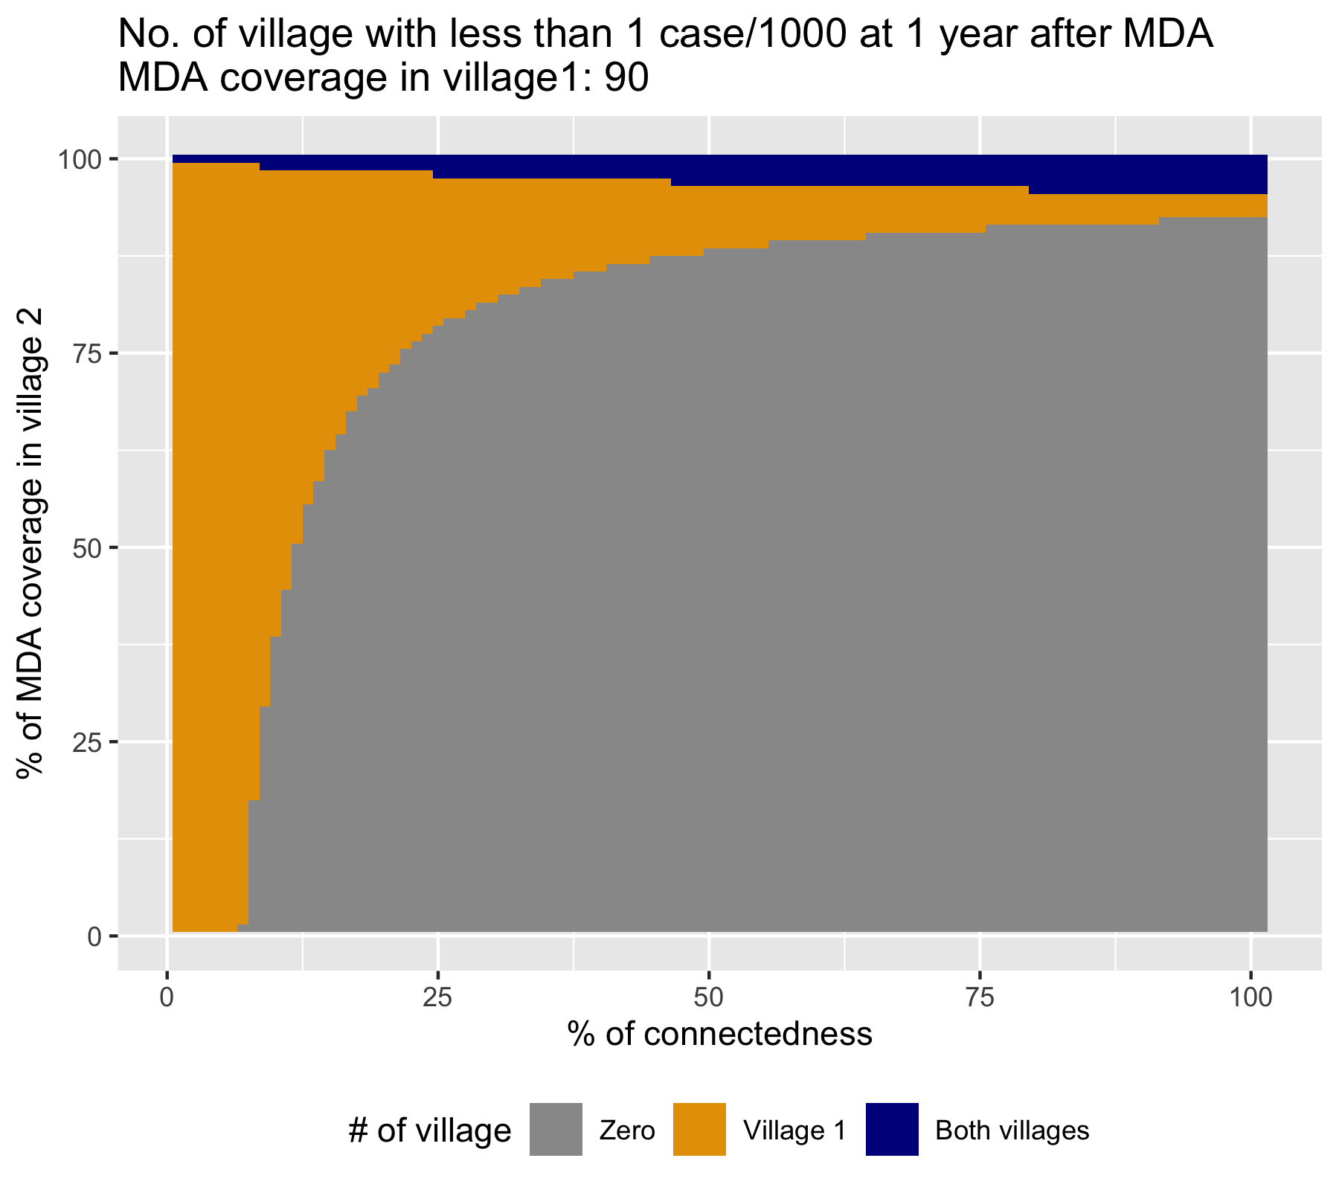
Figure 1: Achieving pre-elimination in the two connected villages by varying connectedness between the two villages (x-axis) and MDA coverage in the 2nd village (y-axis). Columns: 70, 80 and 90% MDA coverage in village 1. Rows: row 1 - same HBR in both villages, row 2 - HBR 25% lower in village 2, row 3 - HBR 25% higher in village 2)

Figure 2: Achieving pre-elimination in the two connected villages by varying connectedness between the two villages with same incidence (x-axis) and MDA coverage in the 2nd village (y-axis). MDA coverage in village 1 is fixed at 70%. [Row 1, Column 1 of Figure 1]
In all figures in row 1 of Figure 1, both villages have identical incidence that requires a baseline MDA threshold of 78% coverage.
Therefore, the village 2 is supposed to achieve pre-elimination with 78% MDA coverage on its own, but because of the increasing connectedness with village 1 which has a lower MDA coverage of only 70%, MDA threshold required for pre-elimination in village 2 increases. This is a negative assembly effect for village 2 (Figure 2, the grey area above the red line which denotes the baseline MDA threshold of 78%). However, this increasing connectedness is beneficial to the village 1. At 70% MDA coverage, village 1 will not achieve pre-elimination on its own. But because of the increasing connectedness with village 2 at 94% MDA coverage and above, pre-elimination is attainable in the village 1 (Figure 2, dark blue triangle at the upper right corner). This is a positive assembly effect for village 1.

Figure 3: Achieving pre-elimination in the two connected villages by varying connectedness between the two villages with same incidence (x-axis) and MDA coverage in the 2nd village (y-axis). MDA coverage in village 1 is fixed at 90%. [Row 1, Column 3 of Figure 1]
The tables are turned when the village 1 has higher MDA coverage (90% in this case) Figure 3. The village 2 now experiences the positive assembly effect – the dark blue triangle below the red line, and the village 1 experiences the negative assembly effect – the grey section at the lower right corner, with the increase in the connectedness. In this particular example, the positive assembly effect for village 2 starts at lower level of connectedness whereas the negative assembly effect for village 1 starts at higher level of connectedness (>62%). The negative assembly effect for village 1 is expressed for wider range of MDA coverage (0-34%) in village 2.

Implications:
Version 1- Being connected to a 2nd patch with similar incidence, but with higher coverage of intervention is beneficial to the 1st patch [positive assembly effect on the 1st patch]. But this benefit is at an expense of the 2nd patch [negative assembly effect on the 2nd patch]. A balance in coverage should be sought to achieve optimal impact of intervention on both of the connected patches of the same incidence.

Version 2- Despite a high coverage of intervention in a patch, if it is highly connected to another patch with similar incidence, but with lower intervention coverage, the intended effect will not be achieved [negative assembly effect on the former patch]. However all is not in vain, because the connectedness is beneficial to the latter patch with lower intervention coverage [positive assembly effect on the latter patch]. A balance in coverage should be sought to achieve optimal impact of intervention on both of the connected patches.

Figure 4: Targeting a hotspot with less than optimal coverage: MDA coverage in village 1 is fixed at 70%. Each pixel represents the pre-elimination in the two connected villages by varying connectedness between the two villages with 25% lower incidence in village 2 (x-axis) and MDA coverage in the 2nd village (y-axis). [Row 2, Column 1 of Figure 1]
When the two connected patches have different incidence (different HBR): village 2 has a lower HBR (of 12) than patch 1 (HBR of 16). If patch 2 is isolated, then it will have a low threshold of MDA coverage at 5%.
The MDA threshold in village 2 would increase with increasing connectedness between the two villages, given the village 1 has an MDA coverage slightly below its required threshold (eg. 70% in above Figure 4). This is the negative assembly effect for village 2 denoted by the grey and orange portion above the red line of baseline threshold for village 2.
Starting with the connectedness of 25%, having high MDA coverage in village 2 will exhibit a positive assembly effect towards the village 1, denoted by the dark blue and orange areas.

Implications: This could have a practical implications when we’re targeting malaria hotspots. The village 1 here could be regarded as a hotspot and let’s suppose it has high connectedness (>60%) to village 2 which is a coldspot. Even if we could not achieve an intended MDA coverage in the hotspot village (ie. 78% coverage) we could achieve pre-elimination in both villages by administering MDA to the village 2 with 30% coverage at most (the red diamond in the Figure 4).

Figure 5: Achieving pre-elimination in the two connected villages by varying connectedness between the two villages with 25% lower incidence in village 2 (x-axis) and MDA coverage in the 2nd village (y-axis). MDA coverage in village 1 is fixed at 80%. [Row 2, Column 2 of Figure 1]
There is only one assembly effect in Figure 5, and that is the negative assembly effect on the village 2. No assembly effect is observed for the village 1. This makes sense as the MDA coverage is high for the village with higher incidence and no benefit would be gained from being connected to the village with lower incidence. The negative assembly effect on village 1 could be possible if the incidence in village 2 is higher than it currently is.
Figure 6: Achieving pre-elimination in the two connected villages by varying connectedness between the two villages with 25% lower incidence in village 2 (x-axis) and MDA coverage in the 2nd village (y-axis). MDA coverage in village 1 is fixed at 90%. [Row 2, Column 3 of Figure 1]
In Figure 6, the increase in the MDA threshold for village 2 plateau between 40% & 80% of connectedness. This is where the balance/equilibrium is achieved between the incidences of the two villages. Further increase in the connectedness decreases the MDA threshold for village 2, hinting at the fact that the beneficial effect for village 2 from the MDA in village 1 comes only after certain level of connectedness.

hinting at the fact that the MDA in village 1 is starting to be beneficial for the village 2

Equilibrium happens first, then the effect of MDA comes next

Implications: Targeting hotspots with adequate MDA coverage (ie greater than 78%) will always achieve great result for the hotspot village. However, the connected coldspot village should not be left without any intervention. As we see in the figures above, because of its increasing connectivity to the hotspot village, the threshold for MDA coverage in the coldspot village (village 2) rises albeit the resulting threshold level is quite low. Providing at least 21% MDA coverage in village 2 will be able to bring both villages to pre-elimination level.
Practically, it is often difficult to achieve high (>80%) coverage for MDA, even after three rounds [cite ]. Therefore, most scenarios of targeting hotspots would be like Figure 4, where reinforcement of interventions in the connected coldspots would be beneficial [positive assembly effect for hotspots]. It may be possible to do three rounds of focal MDA in the hotspot village and one round of focal MDA in the coldspot village to achieve such coverage.

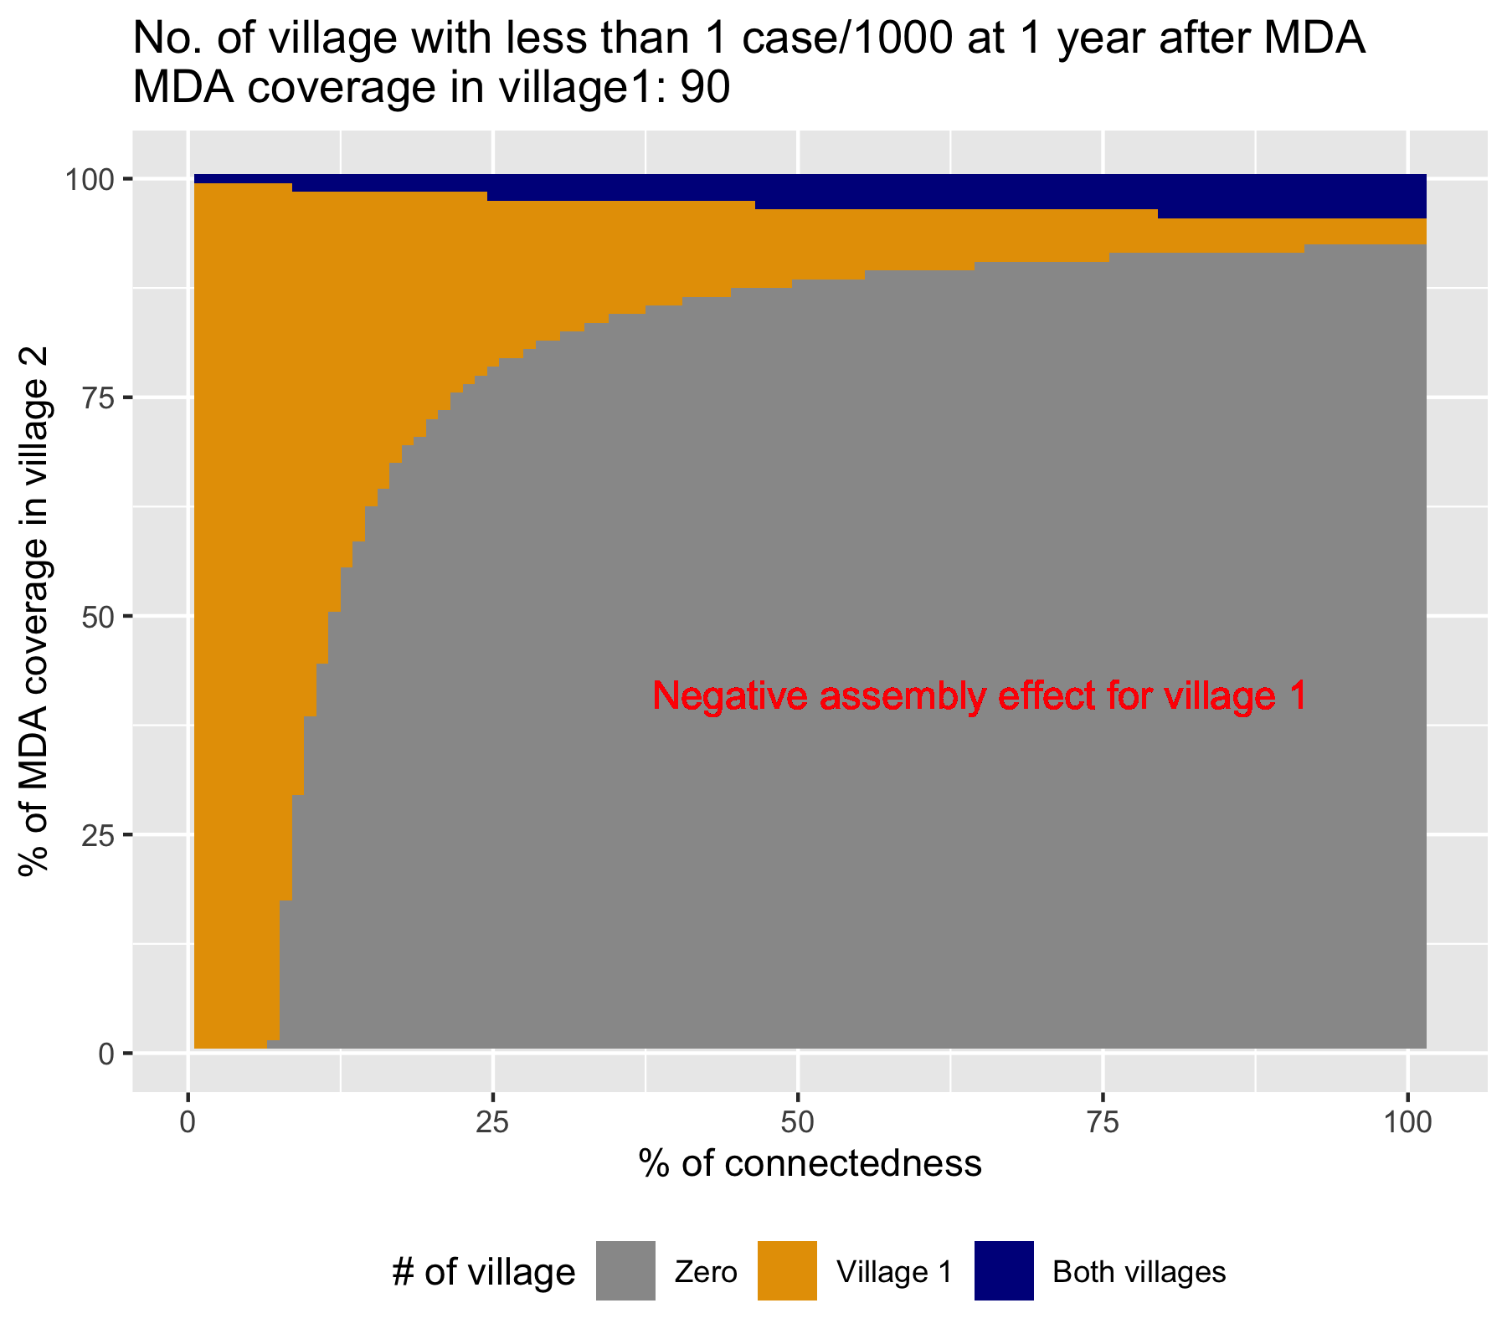
Figure 7: The cost of being connected to another hotspot in focal MDA. Achieving pre-elimination in the two connected villages by varying connectedness between the two villages with 25% higher incidence in village 2 (x-axis) and MDA coverage in the 2nd village (y-axis). MDA coverage in village 1 is fixed at 90%. [Row 3, Column 3 of Figure 1]
Here we look at the scenario where village 2 has 25% higher incidence and require very high coverage of MDA. This could be a result of either inadequacy in accompanying interventions such as EDAT and LLIN or rebound in incidence after the MDA due to re-importation of cases. If village 1, whose threshold for MDA is at 78%, is connected to village 2 with aforementioned scenario, there is a very high chance that the village 1 will no longer achieve elimination (Figure 7, big grey area of negative assembly effect for village 1).
It is extremely important to employ/improve other complementary interventions in addition to the MDA in the village 2 in this case.
We found that unless we are 100% sure in identifying the hotspots, we should not deploy focal MDA. This is because if the targeted hotspot is connected to another place with higher malaria incidence but not covered by MDA, there is a high chance that the focal MDA will not work. Even then, other measures such as early diagnosis and treatment (EDAT) and long-lasting insecticide-treated nets (LLIN) have to be improved and maintained, because MDA alone will not achieve a sustainable outcome.

Model result with scenario similar to TOT
For the specific scenario analysis for the particular village (TOT) which had different MDA coverage within the two parts of the village, the following MDA coverage and incidence parameters were used. The size of each patch is assumed to be equal to one another.
 | Patch 1 | Patch 2
MDA coverage | 81.56 | 63.95 (a horizontal line in graph)
Maximum human biting rate | 16 | 16

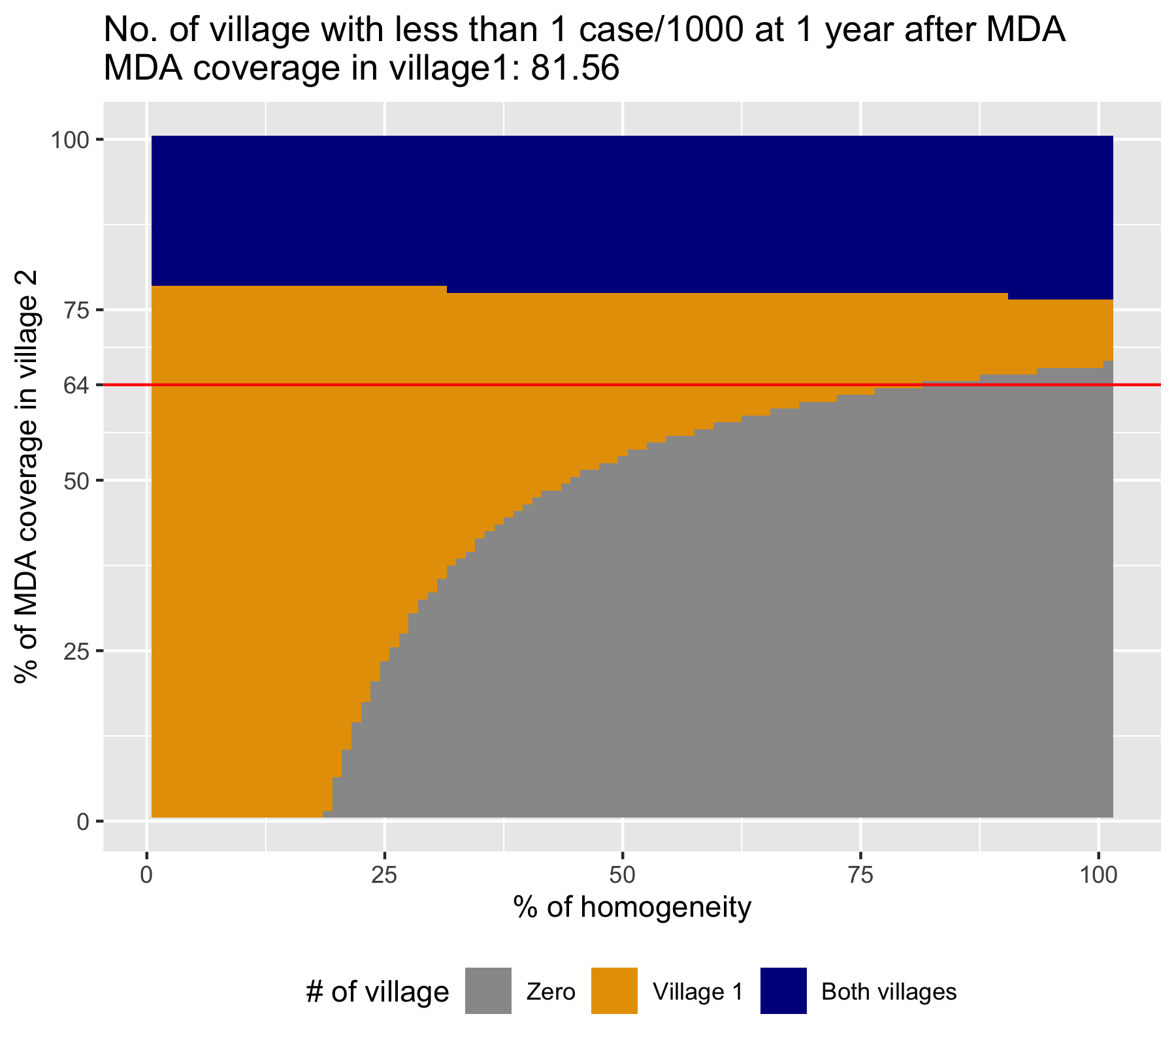
Fig. Scenario analysis: parameters calibrated with data from TOT

More General Model?

Discussion
A patch will experience a positive assembly effect when it is connected to another patch with higher intervention coverage and a negative assembly effect when it is connected to another patch with lesser intervention coverage.

Write about the scenario where you’re left with this model result and nothing else.
There are 10 villages with varying degree of malaria. How would you go about eliminating malaria in the most cost-effective way?
○ What would you measure? H?
○ What would you do? eg. which village should get MDA, etc
○ This could be a field guide for focal MDA strategy

- Improve and maintain the routine interventions
- Find out which ones are the hotspots?
- How much connected are the hotspots to other villages?
  - Connectivity matrix
  - Travel surveys [Bhu’s paper]
- Do 3 MDA rounds in hotspots, 1 round in coldspots which are connected to the hotspots

Conclusion

Policy recommendation
- Improve and maintain the routine interventions
- Connectivity matters, and depending on how connected the patch is to another patch with similar/higher/lower disease incidence the assembly effect will influence the outcome in that patch
- In focal MDA, hotspots should receive higher coverage of MDA whereas the coldspots should receive some coverage of MDA.

References

1. Global Burden of Disease Collaborative Network. Global Burden of Disease Study 2017 (GBD 2017) Results. [Internet]. Seattle, United States: Institute for Health Metrics and Evaluation (IHME); 2019 [cited 2019 Aug 15]. Available from: http://ghdx.healthdata.org/gbd-results-tool
2. R Core Team. R: A Language and Environment for Statistical Computing [Internet]. Vienna, Austria: R Foundation for Statistical Computing; 2019. Available from: https://www.R-project.org/
3. Soetaert K, Petzoldt T, Setzer RW. Solving Differential Equations in R: Package deSolve. Journal of Statistical Software. 2010;33(9):1–25.
4. Eddelbuettel D, Francois R. Rcpp: Seamless R and C++ Integration. Journal of Statistical Software. 2011;40(8):1–18.
5. Sarkar D. Lattice: Multivariate Data Visualization with R [Internet]. New York: Springer; 2008. Available from: http://lmdvr.r-forge.r-project.org
6. Tun STT, von Seidlein L, Pongvongsa T, Mayxay M, Saralamba S, Kyaw SS, et al. Towards malaria elimination in Savannakhet, Lao PDR: mathematical modelling driven strategy design. Malaria Journal. 2017 Nov 28;16(1):483.
7. Parker DM, Tun STT, White LJ, Kajeechiwa L, Thwin MM, Landier J, et al. Potential herd protection against Plasmodium falciparum infections conferred by mass antimalarial drug administrations. eLife. 2019 Apr 16;8:e41023.

