Things to test in the model are:

* Relationship between human biting rate and prevalence, incidence etc

**This is a bit complicated. Perhaps the following table is a good start? We only have HBR in high prevalence villages, and in many of those villages we would have opened an MP before the survey (so prevalence was probably decreasing because of the MP). I’ll try to dig up some incidence data for this too. For all METF surveys, the mean human biting rate of malaria vectors was 313 bites/person/month.**

|  |  |  |  |  |  |
| --- | --- | --- | --- | --- | --- |
| **HBR (bites per person per month)** | **Pop estimate** | **survey date** | **Pf prevalence** | **MP open date** | **Weeks MP opened before survey** |
| 17.4 | 346.5 | 13/07/2014 | 22.81 | 09/01/2014 | 26.42857 |
| 46.8 | 93.5 | 12/08/2014 | 23.91 | 09/01/2014 | 30.71429 |
| 218.4 | 187 | 06/03/2015 | 21.43 | 09/01/2014 | 60.14286 |
| 277.8 | 126.5 | 12/08/2014 | 25.00 | 12/01/2014 | 30.28571 |
| 17.4 | 66 | 14/08/2014 | 24.14 | 06/01/2015 | -20.7143 |
| 18.6 | 225.5 | 16/08/2014 | 25.53 | 06/01/2015 | -20.4286 |
| 49.2 | 110 | 16/08/2014 | 26.32 | 06/01/2015 | -20.4286 |
| 58.8 | 55 | 17/08/2014 | 25.00 | 06/01/2015 | -20.2857 |
| 2365.2 | 335.5 | 08/04/2015 | 12.20 | 06/01/2015 | 13.14286 |
| 948.6 | 165 | 07/04/2015 | 19.15 | 11/02/2015 | 7.857143 |
| 927 | 308 | 07/04/2015 | 35.19 | 06/01/2015 | 13 |
| 82.8 | 423.5 | 03/09/2014 | 24.00 | 12/01/2014 | 33.42857 |
| 243 | 330 | 23/06/2014 | 5.13 | 09/01/2014 | 23.57143 |
| 78 | 1067 | 19/08/2014 | 5.17 | 09/01/2014 | 31.71429 |
| 30.6 | 159.5 | 22/02/2015 | 6.67 | 12/01/2014 | 58 |
| 101.4 | 187 | 05/08/2014 | 14.63 | 09/01/2014 | 29.71429 |
| 309.2 | 247.5 | 09/07/2014 | 22.00 | 09/01/2014 | 25.85714 |

* Relationship between incidence and prevalence for different scenarios

**What if we use the figures that Ricardo made showing that cumulative incidence is predictive of prevalence?**

* Have we got the imported cases right?

* Have we got the bites outside the village right?

* How to model RCD. Can we test the impact and compare it to data from the field?

**Here are the data from our RCD paper. The table indicates the proportion of cases that would have been detected by screening radius (from only within the index house up to a 500 meter radius). Perhaps it would be good to try a few different outcomes (71% of cases using 100 meters radius, 33% using 50 meters radius, etc.)**

|  |  |  |  |  |  |  |
| --- | --- | --- | --- | --- | --- | --- |
| **search radius** | **min** | **Q1** | **median** | **mean** | **Q3** | **max** |
| **w/in house** | 0.00 | 0.00 | 0.14 | 0.21 | 0.27 | 1.00 |
| **50** | 0.00 | 0.27 | 0.33 | 0.39 | 0.45 | 1.00 |
| **100** | 0.00 | 0.45 | 0.71 | 0.64 | 0.90 | 1.00 |
| **150** | 0.50 | 0.86 | 1.00 | 0.91 | 1.00 | 1.00 |
| **200** | 0.86 | 1.00 | 1.00 | 0.98 | 1.00 | 1.00 |
| **250** | 1.00 | 1.00 | 1.00 | 1.00 | 1.00 | 1.00 |
| **300** | 1.00 | 1.00 | 1.00 | 1.00 | 1.00 | 1.00 |
| **350** | 1.00 | 1.00 | 1.00 | 1.00 | 1.00 | 1.00 |
| **400** | 1.00 | 1.00 | 1.00 | 1.00 | 1.00 | 1.00 |
| **450** | 1.00 | 1.00 | 1.00 | 1.00 | 1.00 | 1.00 |
| **500** | 1.00 | 1.00 | 1.00 | 1.00 | 1.00 | 1.00 |

**What if RCD only detects 20% of cases? Will it still influence ongoing transmission?**

* How about the impact of installing an MP?

**Right now we think that every 10 weeks of an MP being opened results in approximately a 15 to 24% decrease in Pf incidence.**

* How about the impact of MDA for different baseline scenarios?

Jordi’s figure:

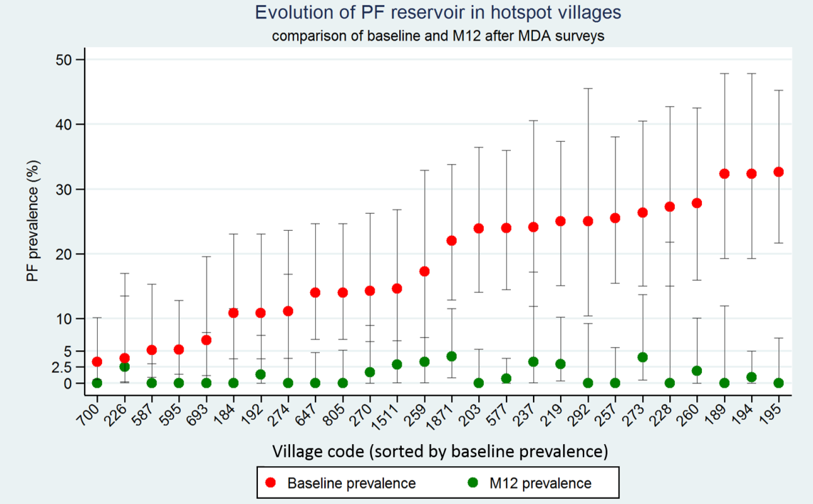

**What happens if mass drug administration only covers a portion of the village (for example, 50%). This is different than an RCD scenario where you hit only 50% of the cases. Also from Jordi’s figures (village numbers from both figures correspond):**

AlAnother of Jordi’s figures

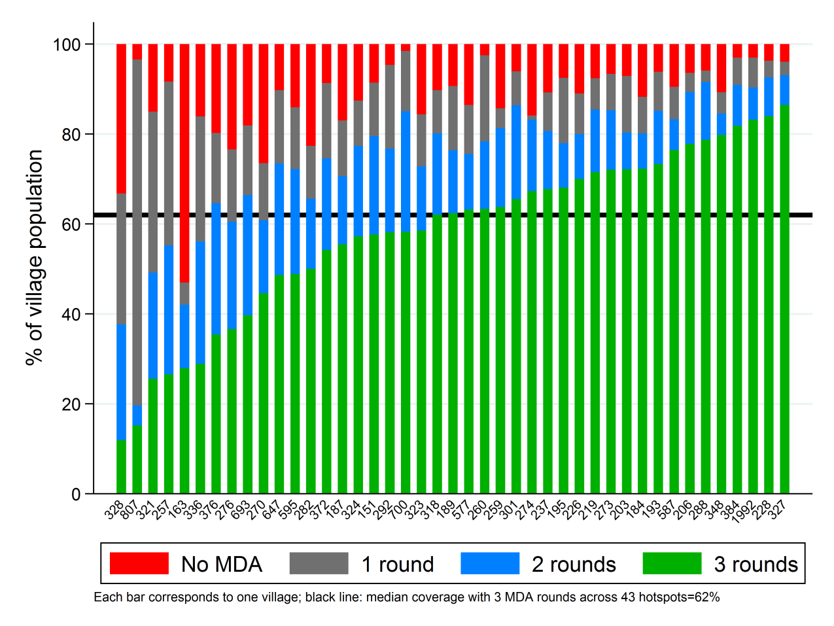

* The relative number of clinical, asymptomatic RDT positive and asymptomatic RDT negatives

**In the initial blood screenings we took whole blood to estimate prevalence using uPCR. We also checked for fevers and asked if participants had recently had a fever. The blood was also tested with RDTs. From this I see approximately 73% of the people who were uPCR positive for Pf were also RDT positive. Of those who were RDT positive, 14% had a fever during the survey or reported having recently had a fever. 10% of those who were uPCR positive either had a fever or a history of fever.**

* The relative infectiousness of each infection type per bite

**I’m working on a way to try to estimate this.**

* All the other parameters

* Anything else we can think of

**For migration:**

**Import 1 case, 10 cases, or 1000 cases under a scenario of:**

**•         Fully functional malaria post (MP) [infected person is diagnosed and treated within 24 hours]**

**•         Delayed diagnosis and treatment (say 3 days of waiting before being diagnosed and treated)**

**•         No MP**

**For interventions:**

**•         MPs are a must regardless of intervention. What happens when they fail? Are there ways to simulate MP closure in this type of model?**

**•**