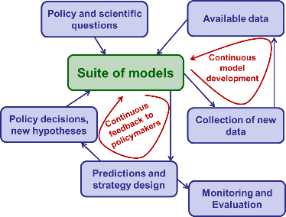MalMod User manual

Lisa White, Sai Thein Than Tun and Arjen Dondorp

# Description

This is a web-based mathematical modelling tool to support *Plasmodium falciparum* malaria elimination strategy design. This tool is intended for use by policymakers to support decision-making on malaria elimination strategy at the national and sub-national level.

The application is based on a simple mathematical model for malaria transmission and control which runs in the background. This model can be set up by the user to reflect local epidemiology and current malaria control activities in a district, province or township. The design features of a new strategy can then be adjusted until the desired outcome is predicted for that district. The model is not intended as an accurate representation of any specific setting, but rather to be used to support national and sub-national strategy design as part of a larger evidence base in the decision-making process of a National Malaria Control Program.

# Getting started

1. To get started, open the following website: <https://saitheinthantun.shinyapps.io/malmod/>. You will see the front page of the MalMod tool:

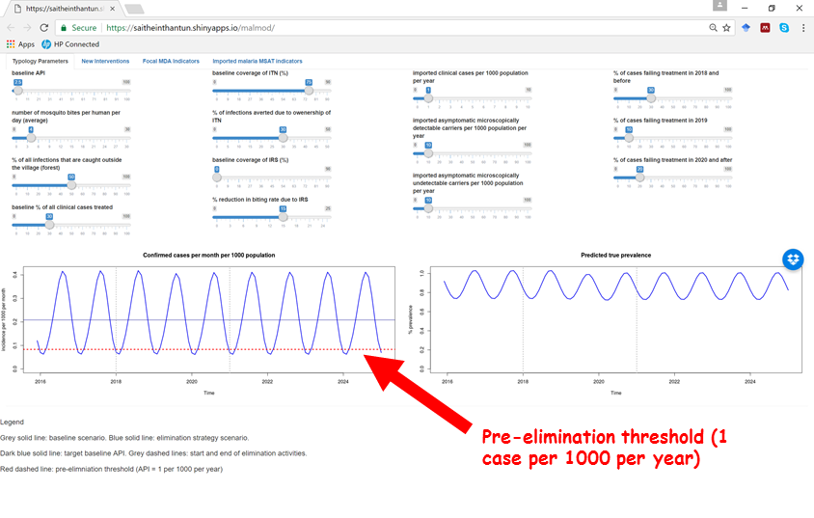

1. Adjust the zoom setting in your browser to zoom in or out:

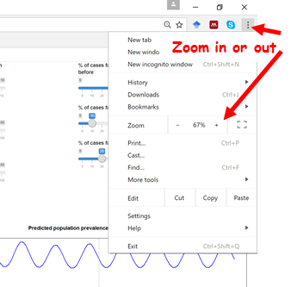

1. There are two graphs. **The left graph shows the model prediction for monthly incidence of confirmed clinical cases**. The number of confirmed cases will be less than the true clinical burden since the model assumes that not all clinical cases are detected and treated by the health system. The more cases that are detected by the health system, the more the confirmed cases will reflect the model’s prediction of the true clinical burden. **The right graph shows the model prediction for true prevalence.** This is defined as the percentage of the population that have a clinical infection, a microscopically detectable asymptomatic infection or a microscopically undetectable asymptomatic infection. It is intended to represent the entire transmission reservoir associated with each scenario.
2. The “Typology Parameters” tab allows the selection of the baseline scenario. Adjust the sliders until the baseline scenario desired is set. The dark blue line represents the average baseline API. After all the baseline values are selected, adjust the “no. of mosquito bites per human per day” parameter until the API line (dark blue, flat) passes through the centre of the model prediction for monthly incidence line (blue, wavy). Sliders can be adjusted using click and drag with a mouse, or by clicking on to the slider button and then using the keyboard arrow keys.

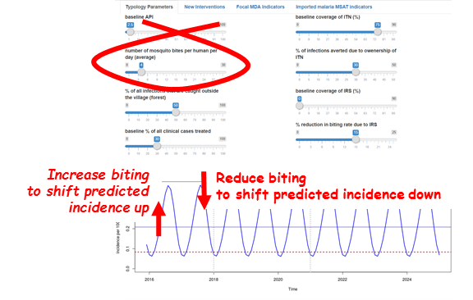

1. The parameter “number of mosquito bites per human per day (average)” on the “Typology Parameters” tab is not the entomological inoculation rate (EIR). It is simply the human biting rate (HBR) and is the sum of the infectious and non-infectious mosquito bites per 24-hour period on average throughout a typical year. The range given for number of mosquito bites per human per day (average)” is consistent with values measured for the GMS.
2. Note that in order to obtain API levels below 1 per 1000 per year, the imported cases must be reduced. This can be done by adjusting the three sliders in the third column in the “Typology Parameters” tab. Since every clinical case will most likely be accompanied by asymptomatic carriers (both detectable and undetectable by microscopy), then it is recommended to include roughly 10 times the number of clinical cases being imported to be imported as asymptomatic carriers of each category. For example, if the user choses 1 clinical cases per 1000 per year to be imported, they should also set 10 microscopically detectable and 10 microscopically undetectable carriers per 1000 per year.

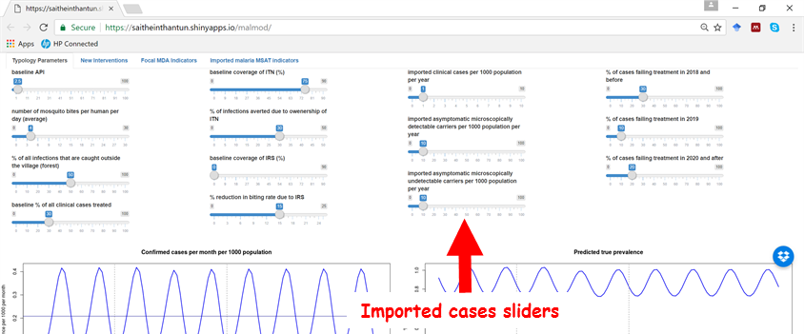

1. While the model is running, the graphs will look pale and then become bright again when the model has completed its run. If multiple changes are made in quick succession, the graphs will slowly flash pale and bright until all the changes have been run in sequence.

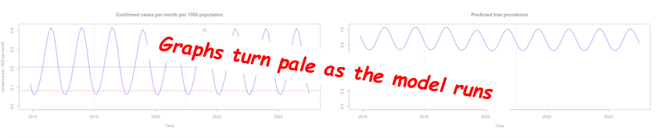

1. Now explore options for the elimination strategy design. These can be found in tabs labelled: “New Interventions”, “Focal MDA Indicators”, and “Imported malaria MSAT Indicators”. Various components of the strategy can be switched on and off using the check boxes. Any combination of interventions can be switched on at any single time. Eg. You can turn on only for MDA, or you can combine EDAT and ITN, etc. Also, their efficacy and coverage can be adjusted using the sliders. Once some new interventions are switched on, the baseline model prediction will be depicted as a grey solid line, with the selected strategy model prediction in blue.

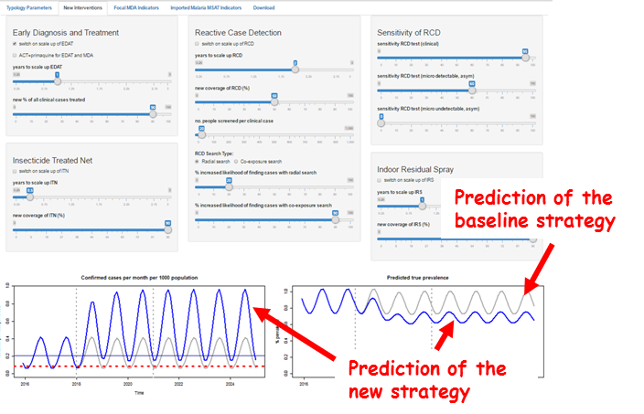

Note that some activities are predicted to increase the confirmed cases per 1000 population per month (left graph above). This is because increasing early detection and treatment (EDAT) will lead to increased numbers of clinical malaria cases being discovered and treated. Since only treated clinical cases are reported by the model (the modelled untreated clinical burden going unmeasured as it is in reality), then this figure can increase during an elimination strategy even though the prevalence declines (right graph above). The increase in confirmed cases per month is therefore an artefact since the true clinical burden will remain constant of reduce as a result of increased interventions, whereas detecting and treating more cases can lead to more confirmed cases.

## Saving and restoring your parameter values

Whenever you start the application, all the parameter values will be reset to their default values.

In order to store the values of your customized parameters and the corresponding graphs, please go to the rightmost tab “Download”. Click on the respective download buttons to save the parameter values and high resolution graphs.

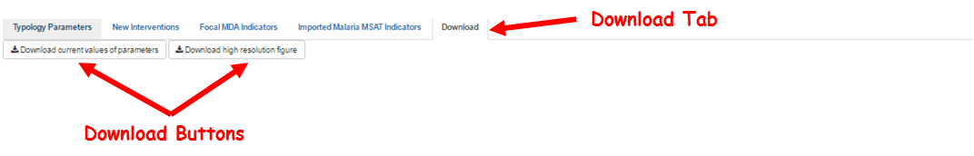

The downloaded csv files can be uploaded to get back your preferred parameter values. In order to do that, you can

1. Go to the “Upload & restore your previous parameters” tab
2. Click on “Browse” and
3. Choose/Upload your previously saved file.

Note: You must NOT have manually changed the content of the csv file or its format, in order for this feature to work.

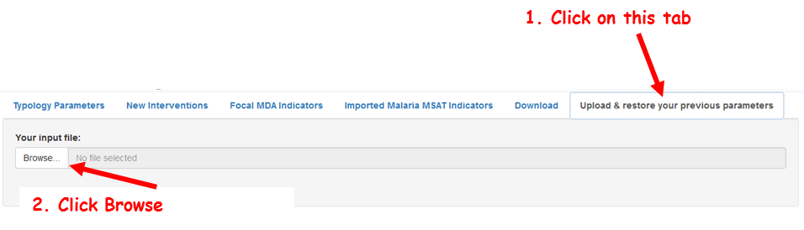

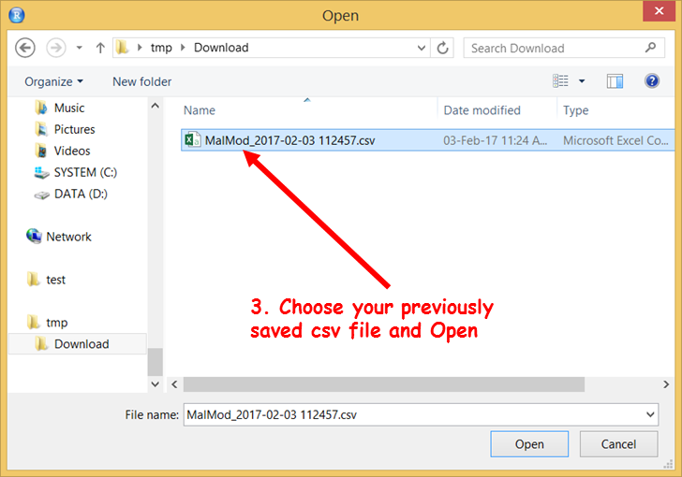

# Offline version for Windows

In order to access the model offline and get faster performance (depending on the computer), the model is also made available as a standalone version for Windows computers through this dropbox link: <https://www.dropbox.com/sh/arvp97i93x7tqs3/AAAzIohdKzz961GcYs7zQ62sa?dl=0>

It is more efficient to add the folder to your dropbox account and sync to your laptop instead of downloading directly.

Once your dropbox sync is completed or the folder has been downloaded, you will see the content of the folder in Windows explorer as follows:

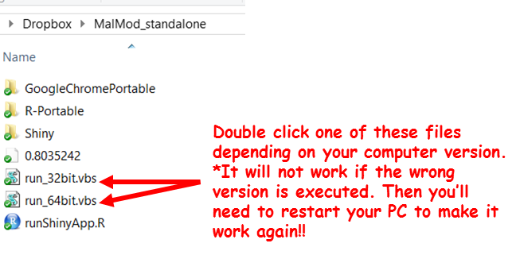

To identify which version to run, you’ll need to know what your PC’s system type is. You can find this out by:

1. Right click on your computer
2. Choose “Properties”

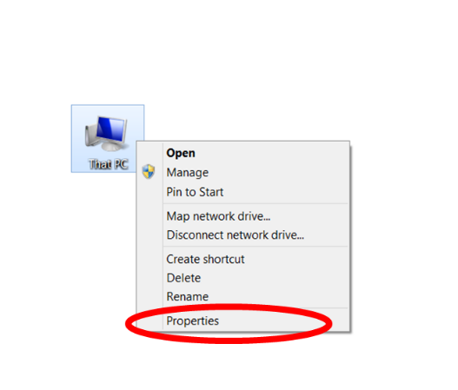

1. If the system type is 64-bit, double click on “run_64bit.vbs” file. If it’s 32-bit, please run the other one.

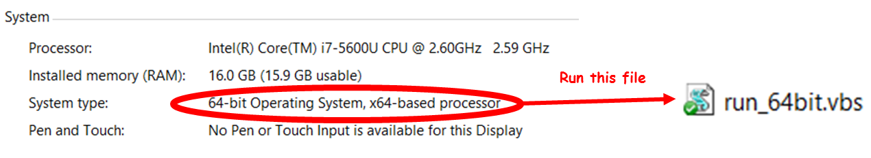

1. If you’ve mistakenly double-clicked on the item which is not suitable for your system type, you’ll not be able to run the application if you try again with the correct file. In that case, you’ll need to restart your computer and try again.

# Definitions

|  |  |
| --- | --- |
| **Parameter name** | **Definitions** |
| **Typology parameters** | **This group of parameters will determine the baseline malaria situation for a specific setting. If an intervention is not currently used (e.g. IRS), then put the coverage to 0.** |
| Baseline API | Annual Parasite Incidence per 1000 population for the area being modelled. It also determines the initial prevalence. |
| No. of mosquito bites per human per day (average) | Average number of mosquito bites per human per day, influencing the rate of infection. This value must be adjusted until the blue wavy blue line representing the predicted incidence is at the same level as the straight line representing the chosen baseline API. |
| % of all infections that are caught outside the village (forest) | Of all the infections reported, what percent of infections are caught while people are in the forest, plantations, etc. |
| baseline % of all clinical cases treated | Current percentage coverage of Early Diagnosis and Treatment of malaria. |
| baseline coverage of ITN (%) | Current percentage coverage of Insecticide Treated Nets, LLINs. |
| % of infections averted due to ownership of ITN | Percentage of infections averted due to the ownership and then usage of Insecticide Treated Nets. |
| baseline coverage of IRS (%) | Current percentage coverage of Indoor Residual Spraying. |
| % reduction in biting rate due to IRS | Percentage reduction in biting rates due to the use of IRS. |
| imported clinical cases per 1000 population per year | Symptomatic/Clinical malaria cases that are imported per 1000 population per year into the area. |
| imported asymptomatic microscopically detectable carriers per 1000 population per year | Asymptomatic malaria cases detectable by microscopy that are imported per 1000 population per year into the area. |
| imported asymptomatic microscopically undetectable carriers per 1000 population per year | Asymptomatic malaria cases undetectable by microscopy that are imported per 1000 population per year into the area. |
| % of cases failing treatment in 2018 and before | Percentage of malaria treatment failure in 2018 and before |
| % of cases failing treatment in 2019 | Percentage of malaria treatment failure in 2019 |
| % of cases failing treatment in 2020 and after | Percentage of malaria treatment failure in 2020 |
| **New interventions** | **On this tab, you can turn on/off new interventions. You can also change coverage, effect, etc. for each new intervention.** |
| switch on scale up of EDAT | Turn on/off Early Diagnosis and Treatment of malaria at a higher coverage as a new intervention using the parameters on this tab. |
| ACT+primaquine for EDAT and MDA | Turn on/off the use of primaquine in addition to ACT for both Early Diagnosis and Treatment and, if included, Mass Drug Administration. |
| years to scale up EDAT | Number of years it takes to achieve the new coverage of Early Diagnosis and Treatment of malaria. |
| new % of all clinical cases treated | New percentage coverage of Early Diagnosis and Treatment of malaria. |
| switch on scale up of ITN | Turn on/off Insecticide Treated Nets at a higher coverage as a new intervention using the parameters on this tab. |
| years to scale up ITN | Number of years it takes to achieve the new coverage of Insecticide Treated Nets. |
| new coverage of ITN (%) | New coverage of Insecticide Treated Nets, LLINs. |
| switch on scale up of RCD | Turn on/off Reactive Case Detection as a new intervention using the parameters on this tab. |
| years to scale up RCD | Number of years it takes to achieve the new coverage of Reactive Case Detection. |
| new coverage of RCD (%) | New coverage of Reactive Case Detection. |
| no. people screened per clinical case | Number of people screened for malaria for each clinical case detected. |
| RCD Search Type: | This option won’t work unless RCD has been switched on. Choose one of the options: Radial search -> search for new cases around the index case (this detects only within village transmission), Co-exposure search -> search for new cases through co-exposure search (this detects only outside village transmission) |
| % increased likelihood of finding cases with radial search | Percent increase in likelihood of finding malaria cases with radial search compared to a random sample from the population. |
| % increased likelihood of finding cases with co-exposure search | Percent increase in likelihood of finding malaria cases with co-exposure search compared to a random sample from the population. |
| sensitivity RCD test (clinical) | Sensitivity of the test used in Reactive Case Detection screening for detecting a clinical case |
| sensitivity RCD test (super-micro, asym) | Sensitivity of the test used in Reactive Case Detection screening for detecting an asymptomatic patent case |
| sensitivity RCD test (sub-micro, asym) | Sensitivity of the test used in Reactive Case Detection screening for detecting an asymptomatic non-patent case |
| switch on scale up of IRS | Turn on/off Indoor Residual Spraying as a new intervention using the parameters on this tab. |
| years to scale up IRS | Number of years it takes to achieve new coverage for Indoor Residual Spraying. |
| new coverage of IRS (%) | New coverage of Indoor Residual Spraying. |
| **Focal MDA Indicators** |  |
| switch on MDA | Turn on/off Mass Drug Administration. |
| effective population coverage of focal MDA in round 1 | The percentage of the total population of the area to receive MDA in the first round. For example, if 50% of the villages in an area receive MDA and the others do not, then the effective coverage is 50%. |
| effective population coverage of focal MDA in round 2 | The percentage of the total population of the area to receive MDA in the second round. For example, if 50% of the villages in an area receive MDA and the others do not, then the effective coverage is 50%. |
| effective population coverage of focal MDA in round 3 | The percentage of the total population of the area to receive MDA in the third round. For example, if 50% of the villages in an area receive MDA and the others do not, then the effective coverage is 50%. |
| timing of 1st round [2018+ no. of month, 1 means Jan'2018, 13 means Jan'2019] | Number of months after 01/01/2018 when the 1st round of MDA starts |
| timing of 2nd round [2018+ no. of month] | Number of months after 01/01/2018 when the 2nd round of MDA starts |
| timing of 3rd round [2018+ no. of month] | Number of months after 01/01/2018 when the 3rd round of MDA starts |
| months to complete each round | Number of months to complete each round of MDA in the entire area (that is to cover all the villages with their first round of MDA). |
| days prophylaxis provided by the ACT | Number of days protected from malaria because of the ACT treatment either from MDA or from treatment of a malaria case. |
| % population coverage of 1st MDA round | Population coverage within each village assigned to receive MDA within the area on the of 1st round of MDA. |
| % of 1st MDA round population to get 2nd | Percentage of the people who received the 1st MDA round to receive the 2nd MDA. |
| % of 2nd MDA round population to get 3rd | Percentage of the people who received the 2nd MDA round to receive the 3rd MDA. |
| **Imported malaria MSAT indicators** |  |
| switch on MSAT for imported cases | Turn on/off Mass Screening and Treatment of individuals on entry to the area. |
| years to scale up MSAT | Number of years it takes to achieve the coverage of MSAT for importations. |
| new coverage of MSAT (%) | Percentage of all individuals who are screened on entry to the area |
| sensitivity MSAT test (clinical) | Sensitivity of the test used in MSAT screening for detecting a clinical case |
| sensitivity MSAT test (super-micro, asym) | Sensitivity of the test used in MSAT screening for detecting an asymptomatic patent case |
| sensitivity MSAT test (sub-micro, asym) | Sensitivity of the test used in MSAT screening for detecting an asymptomatic non-patent case |