**Linear programming sensitivity analysis:**

**Reg no: 23913**

**QUESTION A)**

1. Formulate an LP that describes the production plans that the firm can use to maximize its profits

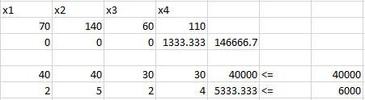

**ANS:** So, the maximum profit is $146666.7

__________________________________________________________________________________

2. What would happen if the price of unfinished chairs went up?

**ANS**: Now the price of unfinished chairs is $60 it can go until (60+50) $110. Although the production of unfinished chairs is 0. No change in profit.

__________________________________________________________________________________

3. What would happen if the price of unfinished tables went up?

**ANS**: Now the price of unfinished tables is $70 it can go until (70+76.6667) $146.6667. Although the production of unfinished tables is 0. So, No change in profit.

__________________________________________________________________________________

4. What if the price of finished chairs fell to $100?

**ANS**: If the price of finished chairs fell to $100. Since the allowable decrease of this is $105. So, there exist a new optimal solution

__________________________________________________________________________________

5. How would profit change if lumber supplies changed?

**ANS:** Every foot of wood cost $3.6667. So,

Allowable Increase – 45000

Allowable Decrease – 0

__________________________________________________________________________________

6. How much would you be willing to pay an additional carpenter?

**ANS:** Out of 6000 working hours, we are utilizing only 5333.333 hours. So,

Allowable Decrease – 666.666

__________________________________________________________________________________

7. Suppose that industrial regulations complicate the finishing process, so that it takes one extra hour per chair or table to turn an unfinished product into a finished one. How would this change your plans?

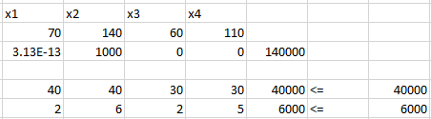

**ANS:** If we change the finishing process by 1 unit each. The new constraint will be

2x1+6x2+2x3+5x4 <=6000

So, the maximum profit will change to $140000. It is comparatively less. So, spending extra time for finishing process is reducing the total profit and **now we started producing 1000 finished tables from 0 tables and stopped producing 1333 finished chairs.**

__________________________________________________________________________________

8. The owner of the firm comes up with a design for a beautiful hand-crafted cabinet. Each cabinet requires 250 hours of labour (this is 6 weeks of full time work) and uses 50 board feet of lumber. Suppose that the company can sell a cabinet for $200, would it be worthwhile?

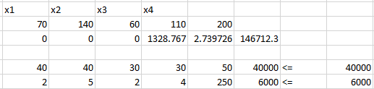

**ANS:** After adding the 200 additional profit and 50 foot woods and 250 hours. We got $146712.3 profit. We see there is an increase in profit.

So, it is recommended to make the hand-crafted cabinet.

__________________________________________________________________________________