Machine Learning Framework for Skill Gap Analysis and Personalized Learning Recommendation
K. Sai Vaishnavi  Department of Computer Science and Engineering,  Koneru Lakshmaiah Education Foundation,  Bowrampet, Hyderabad-500043, Telangana, India.  saivaishnavi@gmail.com | K. Bhargavi  Department of Computer Science and Engineering,  Koneru Lakshmaiah Education Foundation,  Bowrampet, Hyderabad-500043, Telangana, India.  bhargavikilaru595@gmail.com

Abstract—Rapid technological change has increased the demand for job-specific skills, yet many students and professionals struggle to identify the gap between their current skills and those required for a target career. This paper presents a machine learning framework for skill gap analysis and personalized learning recommendation. The framework extracts skills from a user’s profile, compares them with role requirements drawn from industry datasets, and recommends courses, certifications and learning resources in an optimized sequence. Instead of relying on keyword matching, it uses Natural Language Processing (NLP), sentence embeddings and semantic similarity to capture the contextual relationship between skills. The system comprises modules for profile analysis, job role selection, skill extraction, semantic skill matching, skill gap identification and personalized recommendation. The framework helps students, job seekers and working professionals make informed learning decisions, reduces the time needed to find suitable learning resources, and improves career readiness.
Index Terms—Skill gap analysis, machine learning, natural language processing, sentence embeddings, semantic similarity, recommendation system, personalized learning
I. INTRODUCTION
The job market is changing quickly as new technologies such as artificial intelligence, cloud computing and data science reshape the competencies employers expect. Students and early-career professionals often find it difficult to judge how well their present skills match the requirements of a desired job role. The result is unfocused learning, wasted effort and reduced employability.
Traditional career guidance and many online platforms depend on manual counselling or simple keyword matching between a résumé and a job description. Keyword matching treats skills as isolated strings and misses their meaning; for example, “machine learning” and “predictive modelling” may describe closely related abilities, yet a keyword matcher sees no connection. Moreover, such tools usually stop at pointing out what is missing and do not suggest how to acquire it.
This paper proposes a machine learning framework that addresses both problems. Using NLP and sentence embeddings, the framework compares a user’s skills with role requirements semantically, identifies the missing competencies for a selected job role, and recommends a personalized learning path to close those gaps. The main contributions are:
- a semantic skill-matching approach that goes beyond keyword overlap;
- a skill gap identification method that accounts for both skill presence and proficiency level;
- a ranked, personalized learning recommendation module covering courses, certifications and projects; and
- a modular architecture suited to students, job seekers and working professionals.
II. LITERATURE SURVEY
Early automated résumé and job-matching systems were based on term-frequency approaches such as TF-IDF, which weight words by their importance in a document collection [1]. These methods are fast and interpretable but cannot recognise synonyms or related concepts, which limits their usefulness for skill matching.
Distributed word representations such as Word2Vec [2] placed semantically similar words close together in a vector space and made it possible to compare skills by meaning. Transformer-based language models, notably BERT [3], produce context-aware representations that further improve language understanding. Sentence-BERT [4] adapts BERT with siamese networks to produce sentence-level embeddings that can be compared efficiently using cosine similarity, which makes it well suited to matching short skill phrases and job-description sentences. Such models are commonly accessed through open-source libraries [5].
Supervised learning methods such as Random Forest [6] and gradient-boosted trees such as XGBoost [7] are widely used to classify and score candidates from structured features, and are available in standard toolkits such as scikit-learn [8]. For suggesting learning content, recommender systems techniques, including content-based filtering and ranking, are well established [9]. Occupational databases such as O*NET [10] provide standardised descriptions of the skills and knowledge associated with job roles and serve as a reliable reference for role requirements.
Existing work therefore covers skill extraction, job matching and course recommendation separately. The framework proposed here combines semantic skill matching, explicit gap identification and ranked learning recommendation in a single pipeline.
III. PROPOSED METHODOLOGY
The overall architecture is shown in Fig. 1. Data from several sources is preprocessed and converted into skill features; a machine learning and semantic-matching stage then compares the user with the target role, identifies the skill gap, and generates a ranked learning recommendation that is presented through a progress dashboard.
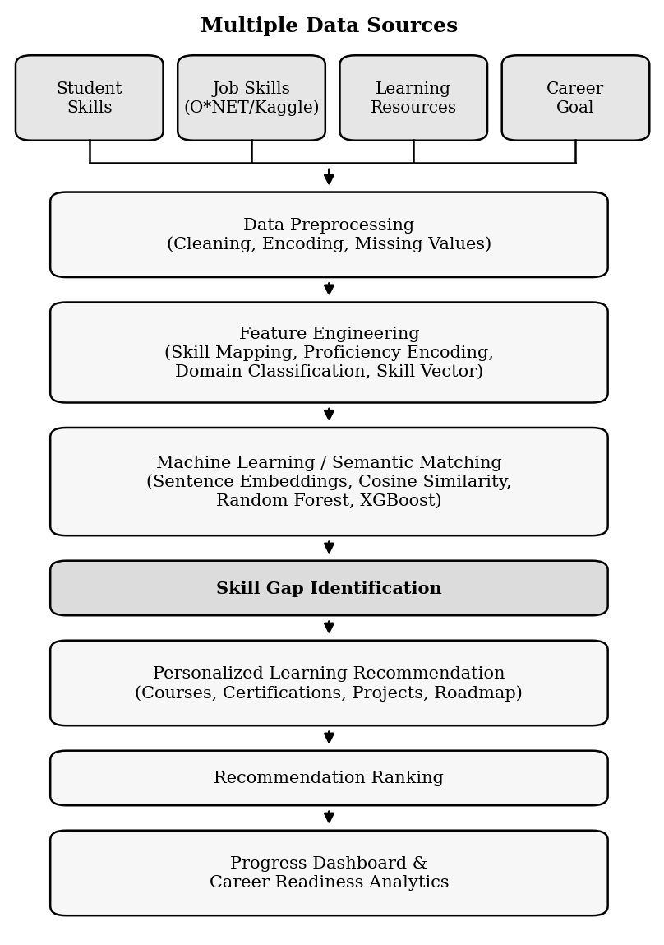
Fig. 1. Architecture of the proposed skill gap analysis framework.
A. Datasets
Four data sources are used, as summarised in Table I. The O*NET database [10] and a Kaggle job-skills dataset supply the skills required for each job role. A Coursera/Udemy course dataset provides the learning resources for missing skills, and a custom student dataset collected with Google Forms or Excel captures each student’s current skills, proficiency levels, interests and career goal.
TABLE I. DATASETS USED
Dataset | Purpose | Source
O*NET Skills Database | Skills required for different job roles | onetcenter.org/database.html
Kaggle Job Skills Dataset | Job descriptions and required technical skills | kaggle.com
Coursera/Udemy Course Dataset | Learning resources for missing skills | Kaggle or custom dataset
Custom Student Skills Dataset | Current skills, proficiency, interests, career goal | Google Forms / Excel

B. Data Preprocessing
Raw text from résumés, profiles and job descriptions is cleaned by removing noise, special characters and duplicates, and by normalising case and skill names (for example, mapping “ML” to “machine learning”). Categorical attributes such as domain and proficiency level are encoded numerically, and missing values are handled by imputation or removal, depending on the field.
C. Feature Engineering
Skills are extracted from the cleaned text and mapped to a common skill vocabulary. Proficiency is encoded on an ordinal scale (for example, beginner, intermediate, advanced), skills are grouped by domain, and each user and each job role is represented as a skill vector. These vectors are the inputs to the matching stage.
D. Semantic Skill Matching
Each skill phrase is converted into a dense vector using a pre-trained sentence-embedding model [4]. The semantic similarity between a required skill r and a user skill u is measured by cosine similarity:
sim(r, u) = (e_{r} · e_{u}) / (‖e_{r}‖ ‖e_{u}‖) (1)
where e_{r} and e_{u} are the embeddings of r and u. The best match for a required skill is the user skill with the highest similarity:
m(r) = max_{u ∈ U} sim(r, u) (2)
Because matching is based on meaning rather than exact words, related skills are recognised as partial or full matches. Supervised models such as Random Forest [6] and XGBoost [7] can additionally be trained on the matching features to improve the reliability of the match decision.
E. Skill Gap Identification
Let R be the set of skills required for the selected job role and U the set of the user’s skills. A required skill r is treated as a gap when its best match falls below a threshold τ, or when the user’s proficiency is lower than the level required for the role:
G = { r ∈ R : m(r) < τ or p_{u}(r) < p_{R}(r) } (3)
where p_{u}(r) and p_{R}(r) are the user’s proficiency and the role’s required proficiency for skill r. A career-readiness score is then computed as the fraction of required skills that are covered:
Readiness = 1 − |G| / |R| (4)
F. Personalized Learning Recommendation
For every skill in G, candidate courses, certifications, projects and practice platforms are retrieved from the learning-resource dataset by embedding similarity between the skill and the resource description. Candidates are then ranked by a weighted score:
score(c) = α·rel(c) + β·cov(c) + γ·fit(c) (5)
where rel(c) is the relevance of resource c to the missing skill, cov(c) is the number of gap skills it covers, fit(c) measures how well its difficulty suits the user’s current level, and α, β, γ are weights. Prerequisite skills are placed before advanced ones, which yields an optimized learning sequence or roadmap [9].
IV. SYSTEM MODULES
The framework is organised into six modules, summarised in Table II. The modular design allows each component, such as the embedding model or the ranking function, to be improved independently.
TABLE II. MODULES OF THE FRAMEWORK
Module | Function
Resume/Profile Analysis | Reads the user’s résumé or form-based profile and cleans the text
Job Role Selection | Lets the user choose a target role and loads its required skills
Skill Extraction | Identifies skills and maps them to a common vocabulary
Semantic Skill Matching | Compares user and role skills using embeddings and similarity
Skill Gap Identification | Lists missing or weak skills and computes readiness
Learning Recommendation | Ranks and sequences courses, certifications and projects

V. EVALUATION PLAN AND EXPECTED OUTCOMES
The framework will be evaluated on two aspects. The accuracy of skill matching and gap identification will be measured with precision, recall and F1-score against gaps labelled manually for a sample of student profiles, and compared with a keyword-matching baseline. The quality of the recommendations will be measured with precision@k and recall@k against resources judged relevant, together with user feedback on how useful the suggested learning path is.
The semantic approach is expected to identify related skills that keyword matching misses, and so to give a more accurate gap list and a more relevant learning path. In practice this should shorten the time users spend searching for learning resources and help them prepare for their target careers more efficiently.
VI. CONCLUSION AND FUTURE WORK
This paper presented a machine learning framework that analyses a user’s skills, identifies the gap to a selected job role using semantic similarity, and recommends a ranked, personalized learning path. By combining NLP, sentence embeddings and recommendation techniques, the framework offers an effective means of skill development for students, job seekers and working professionals.
Future work includes training and testing the models on the complete datasets, integrating live job-market data so that role requirements stay current, adding progress tracking and feedback to refine recommendations over time, and extending the system to a web-based application.
REFERENCES
[1] G. Salton and C. Buckley, “Term-weighting approaches in automatic text retrieval,” Information Processing & Management, vol. 24, no. 5, pp. 513–523, 1988.
[2] T. Mikolov, K. Chen, G. Corrado, and J. Dean, “Efficient estimation of word representations in vector space,” arXiv:1301.3781, 2013.
[3] J. Devlin, M.-W. Chang, K. Lee, and K. Toutanova, “BERT: Pre-training of deep bidirectional transformers for language understanding,” in Proc. NAACL-HLT, 2019, pp. 4171–4186.
[4] N. Reimers and I. Gurevych, “Sentence-BERT: Sentence embeddings using Siamese BERT-networks,” in Proc. EMNLP-IJCNLP, Hong Kong, 2019, pp. 3982–3992.
[5] T. Wolf et al., “Transformers: State-of-the-art natural language processing,” in Proc. EMNLP: System Demonstrations, 2020, pp. 38–45.
[6] L. Breiman, “Random forests,” Machine Learning, vol. 45, no. 1, pp. 5–32, 2001.
[7] T. Chen and C. Guestrin, “XGBoost: A scalable tree boosting system,” in Proc. 22nd ACM SIGKDD Int. Conf. Knowledge Discovery and Data Mining, 2016, pp. 785–794.
[8] F. Pedregosa et al., “Scikit-learn: Machine learning in Python,” J. Machine Learning Research, vol. 12, pp. 2825–2830, 2011.
[9] F. Ricci, L. Rokach, and B. Shapira, Eds., Recommender Systems Handbook, 2nd ed. New York, NY, USA: Springer, 2015.
[10] National Center for O*NET Development, “O*NET database.” [Online]. Available: https://www.onetcenter.org/database.html

