SafeKeep Support Agent
Software Functional Specification
Sai Varshini Thupakula

Contents
1. Introduction 3
2. Requirements catalog 4
3. Assumptions and design decisions 7
4. Architecture 9
5. Domain model 13
6. Investigation state machine 14
7. Event intake and deduplication 15
8. Agent loop and LLM contract 17
9. Tools, permissions and approval gate 20
10. Applications and scenarios 23
11. REST API 26
12. User interface 27
13. Error handling and reliability 28
14. Security 29
15. Out of scope and future work 29
16. Revision history 30

1. Introduction

1.1 Purpose
This document specifies the functional behavior, architecture, data model, interfaces and rules of the SafeKeep Support Agent. It translates the PRD “Event-Driven Application Support Agent” into a buildable and testable design. It is the input for the implementation (Problem 2) and the unit-test plan (Problem 3). Every requirement carries an ID, and every later artifact (code, tests, traceability matrix) refers back to those IDs.

1.2 Product context
The Agent is demonstrated against SafeKeep, a fictional enterprise VM backup and restore platform modeled on real-world experience with such products. Customers register datasources (for example, a VMware vCenter), define backup policies, and schedule backup and report jobs. The platform's main components are:
Table 1. SafeKeep platform components
Component | Role in the platform | Role for the Agent
Backup Server | Management VM: UI, datasources, policies, job scheduling, job sessions, reporting | Monitored application #1
Backup Storage Server | Stores backup data in disk pools; expires old backups; replicates to a DR site | Monitored application #2
Data Mover Proxy | Reads VM disk data through VMware's data-protection APIs and writes it to storage | Reached through Backup Server tools only
vCenter | VMware manager where customer VMs live (a datasource) | External dependency checked by tools

1.3 Scope
In scope is a working, demo-able vertical slice that covers every PRD requirement at demo fidelity:
- Event intake from two simulated applications, with validation, duplicate linking and recurrence detection.
- An LLM tool-calling agent (local model via Ollama) that gathers evidence, separates confirmed facts from suspected causes, and recommends next steps.
- An approval gate for corrective actions, verification of action outcomes, and a full audit trail.
- A web UI for investigations, follow-up questions, feedback, history, administration and health.
Section 15 lists what is explicitly out of scope.

1.4 Conventions
Table 2. Identifier conventions
Prefix | Meaning | Example
FR-xxx-nn | Functional requirement: what the system does | FR-ACT-03
NFR-xxx-nn | Non-functional requirement: how well it does it | NFR-SEC-02
UC-n | PRD use case (end-to-end scenario family) | UC-2
MET-nn | PRD success measure | MET-03
Dn | Design decision (Section 3) | D5
An | Assumption (Section 3) | A1
S-xx | Seeded demo scenario (Section 10) | S-1A

1.5 Glossary
Table 3. Glossary
Term | Definition
Application | A system that sends events to the Agent and exposes tools to it (here: Backup Server, Storage Server).
Event | A notification from an application that something needs attention (e.g. HIGH_MEMORY).
Investigation | The Agent's record of one issue: state, evidence, findings, actions, conversation. The equivalent of a ticket.
Correlation key | application + event type + resource. Two events with the same key describe the same issue.
Tool | A named, read-only diagnostic operation an application exposes (e.g. get_metrics).
Action | A named operation that changes application state (e.g. purge_stale_sessions). Requires approval.
Evidence | A recorded tool call and its result, identified as E1, E2, …
Finding | A statement produced by the Agent, labeled CONFIRMED, SUSPECTED or RULED_OUT, citing evidence.
Adapter | Application-specific code that implements an application's tools and actions.
State | Progress of the Agent's work on an investigation.
Resolution | Whether the underlying problem is fixed. Independent of state.

2. Requirements catalog
Each PRD statement is broken down into an atomic requirement with a unique ID. The Section column points to the part of this specification that defines how the requirement is met. Together with the test cases in the Unit-Test Plan, this forms the requirement-to-test traceability matrix.

2.1 Event intake (EVT)
Table 4. Event intake requirements
ID | Requirement | PRD | Section
FR-EVT-01 | Accept events only from configured applications and configured event types; reject others with a clear error. | 7.1 | 7
FR-EVT-02 | Identify application, event type, affected resource or operation, and details; validate required fields. | 6.1, 10 | 7.2
FR-EVT-03 | Acknowledge events promptly; run the investigation asynchronously. | NFR | 4.6
FR-EVT-04 | Link duplicate or repeated events about the same issue to the existing investigation. | 6.2, 7.1 | 7.3–7.5
FR-EVT-05 | Report event intake failures. | 7.1 | 7.6

2.2 Investigation lifecycle (INV)
Table 5. Investigation requirements
ID | Requirement | PRD | Section
FR-INV-01 | Create an investigation for each new, non-duplicate event. | 6.2 | 7
FR-INV-02 | Track states RECEIVED, INVESTIGATING, WAITING_FOR_INFO, COMPLETED, UNABLE_TO_COMPLETE; allow only valid transitions. | 7.1 | 6
FR-INV-03 | Show investigation progress while it runs. | 6.5 | 8, 12
FR-INV-04 | On failure, end in UNABLE_TO_COMPLETE with a stated reason and keep the user informed. | 7.1 | 13

2.3 Data gathering (DATA)
Table 6. Data gathering requirements
ID | Requirement | PRD | Section
FR-DATA-01 | Retrieve metrics, process/service details, logs, job information, settings and troubleshooting guidance through tools. | 7.2 | 10.3
FR-DATA-02 | Use only sources configured and permitted for the application. | 6.3 | 9.2
FR-DATA-03 | Store evidence references and tool results sufficient to explain each finding. | 7.2 | 5, 8.3
FR-DATA-04 | Request more information from the user when evidence is insufficient. | 6.4 | 8.7

2.4 AI analysis (AI)
Table 7. AI analysis requirements
ID | Requirement | PRD | Section
FR-AI-01 | Use an LLM to analyze the event and the evidence. | 7.2 | 8
FR-AI-02 | The LLM chooses tools only from those configured for that application. | 7.2 | 8.2, 9.2
FR-AI-03 | Distinguish confirmed measurements from suspected causes; never present a suspicion as fact. | 5.1, 7.2 | 8.5
FR-AI-04 | When evidence is incomplete, state what is missing and what to check next. | 7.2 | 8.4–8.5

2.5 Use cases (UC)
Table 8. Use cases
ID | Requirement | PRD | Section
UC-1 | High resource usage: check resource data, rank top consumers, correlate with logs, service status and recent changes; report leading consumers with time range, evidence and next checks. | 5.1 | 10.5
UC-2 | Failed job: retrieve job details, logs, settings and service status; summarize the error, explain the likely cause when supported, recommend troubleshooting steps. | 5.2 | 10.5
UC-3 | Dependency unavailable: check service status, error logs and affected operations; explain impacted functions; suggest next checks or escalation. | 5.3 | 10.5

2.6 User interaction (USR)
Table 9. User interaction requirements
ID | Requirement | PRD | Section
FR-USR-01 | Present event summary, findings, evidence, recommended actions and resolution status in clear language. | 7.3 | 12.4
FR-USR-02 | Let users view progress. | 7.3 | 12.4
FR-USR-03 | Let users provide context. | 7.3 | 8.7
FR-USR-04 | Let users ask follow-up questions. | 7.3 | 8.7
FR-USR-05 | Let users request more investigation. | 7.3 | 8.7
FR-USR-06 | Let users give feedback on whether findings were useful. | 7.3 | 12.4

2.7 Tools, permissions and actions (ACT)
Table 10. Tool and action requirements
ID | Requirement | PRD | Section
FR-ACT-01 | Administrators configure which tools and operations are available per application. | 7.4 | 10.2, 12.5
FR-ACT-02 | Validate every tool request and check permissions before execution. | 7.4 | 9.2
FR-ACT-03 | Require explicit approval before any action that changes application state. | 6.6, 7.4 | 9.4
FR-ACT-04 | Execute only the exact action approved, with the exact parameters. | 7.4 | 9.4
FR-ACT-05 | Verify and report the action result; never report a failed action as successful. | 7.4 | 9.5
FR-ACT-06 | If an action is unavailable or not permitted, give instructions instead. | 7.4 | 8.5
FR-ACT-07 | Record tool requests, results, approvals and action outcomes. | 6.7, 7.4 | 5, 14

2.8 Configuration and history (CFG)
Table 11. Configuration requirements
ID | Requirement | PRD | Section
FR-CFG-01 | Administrators configure application connections, event types, data access, tools, permissions and guidance. | 7.5 | 10.2
FR-CFG-02 | Authorized users retrieve past investigations with evidence and actions. | 7.5 | 12.3
FR-CFG-03 | Show Agent health, connection status and integration errors. | 7.5 | 12.6
FR-CFG-04 | Support new applications without redesigning the shared Agent. | 4, 7.5 | 10.7

2.9 Non-functional requirements (NFR)
Table 12. Non-functional requirements
ID | Requirement | Section
NFR-SEC-01 | Protect credentials and application data; secrets never logged, displayed or sent to the LLM. | 14
NFR-SEC-02 | Enforce user access and tool permissions on the server. | 9.3, 14
NFR-REL-01 | Handle application, tool and AI-service failures gracefully and show status. | 13
NFR-RESP-01 | Acknowledge events promptly; show progress during long investigations. | 4.6, 12.4
NFR-SCAL-01 | Run multiple investigations concurrently without mixing their data. | 4.6, 13.2
NFR-MAINT-01 | Keep application-specific integrations separate from shared Agent behavior. | 4.3, 10.7
NFR-USAB-01 | Clear findings, actionable errors, understandable approval requests. | 12

2.10 Success measures (MET)
Table 13. Success measures
ID | Measure | Section
MET-01 | Median time from event receipt to first recommended next step. | 12.6
MET-02 | Share of investigations with supporting evidence, and share with positive feedback. | 12.6
MET-03 | Success rate of approved actions; count of actions executed without approval (target: zero). | 12.6

3. Assumptions and design decisions
The PRD leaves several points open. Each was resolved explicitly; the decisions below are binding for implementation and testing.

3.1 Design decisions
Table 14. Design decisions
ID | Topic | Decision | Rationale
D1 | Duplicate events | Correlation key = application + event type + resource. Link to an open investigation with the same key; otherwise create a new one and mark it a recurrence of the most recent closed one. Ignore repeated eventIds (idempotency). Create-or-link is race-safe. | Deterministic and testable. LLM-based matching rejected: slow, non-repeatable.
D2 | Users and roles | Spring Security with three demo users: alice (APP_USER), sam (SUPPORT_ENGINEER), adam (ADMIN). Applications authenticate with per-application API keys. | Makes access enforcement real and demonstrable; separates human and machine identity.
D3 | Who approves | Each action declares requiredRole and risk in configuration (default SUPPORT_ENGINEER). | PRD: administrators control actions. Risk-proportionate control.
D4 | State vs resolution | Two independent fields: state (Agent's work) and resolution (UNRESOLVED, PARTIALLY_RESOLVED, RESOLVED, UNKNOWN). | An investigation can be complete while the problem persists.
D5 | Confirmed vs suspected | LLM must cite evidence IDs; code downgrades CONFIRMED findings without valid evidence to SUSPECTED. | Deterministic guardrail over AI output.
D6 | Waiting for info | The Agent may ask the user one question; state becomes WAITING_FOR_INFO until the user replies. | Implements PRD 6.4 with the user as information source.
D7 | Follow-ups | A question gets an answer without a state change. Added context or “investigate more” reopens the investigation. | Keeps COMPLETED meaningful.
D8 | Action verification | After execution the system re-checks with a configured read tool and sets resolution from the result. | FR-ACT-05: outcome is measured, not assumed.
D9 | Thresholds | Applications decide threshold breaches; configured thresholds are shown as context. | PRD section 10.
D10 | Guidance | Markdown runbooks per application, keyword search tool. | Sufficient for demo; vector search is future work.
D11 | LLM failure | Two retries with backoff, then UNABLE_TO_COMPLETE (“AI service unavailable”); evidence remains visible. | NFR-REL-01.
D12 | Loop cap | Maximum 8 tool calls per run; then a partial result listing missing evidence. | Prevents runaway loops and bounds latency.
D13 | Configuration | One YAML file per application loaded at startup; admin can toggle tools and actions at runtime. | Config-driven applications (FR-CFG-04).
D14 | LLM provider | Ollama only, behind an LlmClient interface; FakeLlmClient used for unit tests. | Local, free, offline; repeatable tests.
D15 | Model | qwen2.5:3b. qwen3:4b rejected: its reasoning mode could not be disabled (118 s per tool call). llama3.2:3b was fast (1.7 s) but stopped after one tool call and ignored evidence. qwen2.5:3b produced evidence-backed CONFIRMED findings and the correct proposal. | Measured on the target laptop (M1, 8 GB) with scenario S-1A.
D16 | Framework version | Spring Boot 4.1.2 instead of 3.x. | Spring Boot 3.5 reached open-source end of life in June 2026.
D17 | Agent guards for a small model | Code nudges the model when it stops before 4 tool calls (max 2 nudges), skips identical repeated calls, and sends it back once to use unused tools before asking the user a question. | Observed in test runs: early stopping, repeated calls, asking the user for data a tool could provide.
D18 | Two-phase answer | Tool phase first; then a separate final request in JSON mode, without tools, that re-lists every evidence item and asks for observations of abnormal values before findings. | The model ignored evidence it had already gathered when writing its conclusion.
D19 | Proposals only for present problems | Rule R-V8: a proposed action is kept only when the resolution is UNRESOLVED. | A re-investigation proposed a fix for a problem that was already gone.
D20 | API clients and CSRF | Browser sessions use form login with CSRF protection. API clients use HTTP Basic or the API key; requests carrying an Authorization header are exempt from CSRF. | CSRF attacks rely on cookies; a malicious page cannot add an Authorization header.
D21 | Context window | Kept at Ollama's default (4,096 tokens). Logs showed the largest request at 2,223 tokens and no truncation. | A suspected cause of weak reasoning was checked against evidence and rejected.

3.2 Assumptions
Table 15. Assumptions
ID | Assumption
A1 | Applications are simulated in-process behind the AppAdapter interface. Replacing an adapter with a real HTTP integration does not change the Agent core.
A2 | Events contain enough detail to identify the event type and affected resource (PRD section 10).
A3 | Single-node deployment. Concurrency control is in-process; distributed locking is out of scope.
A4 | Roles are global: every user can see all applications. Per-application access is future work.
A5 | Seed data contains raw observations only, never the root cause. The Agent must infer conclusions.
A6 | LLM output is non-deterministic. Correctness rules are enforced by code, and unit tests use a fake LLM.
A7 | Scenario timestamps are relative to the moment the event is sent, so demos look current.
A8 | All names (product, hosts, customers) are fictional. No real customer or vendor data is used.
A9 | Admin tool and action toggles are held in memory and reset on restart. Investigations, evidence, proposals and audit are stored in the H2 database file and survive restarts.
A10 | In the demo, events may carry an X-Demo-Scenario header that selects the seed data set. A real integration would not need it.

4. Architecture

4.1 System context
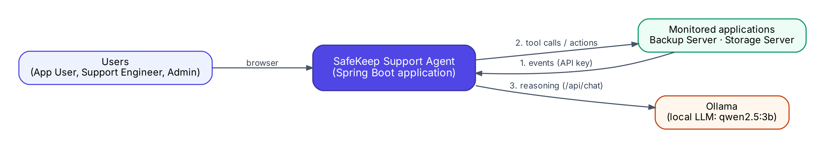
Figure 1. System context
The Agent is a single Spring Boot application. Users reach it through a browser. Monitored applications send events to it and expose tools to it; in this build they are simulated inside the same process. All reasoning is done by a local LLM served by Ollama.

4.2 Component architecture
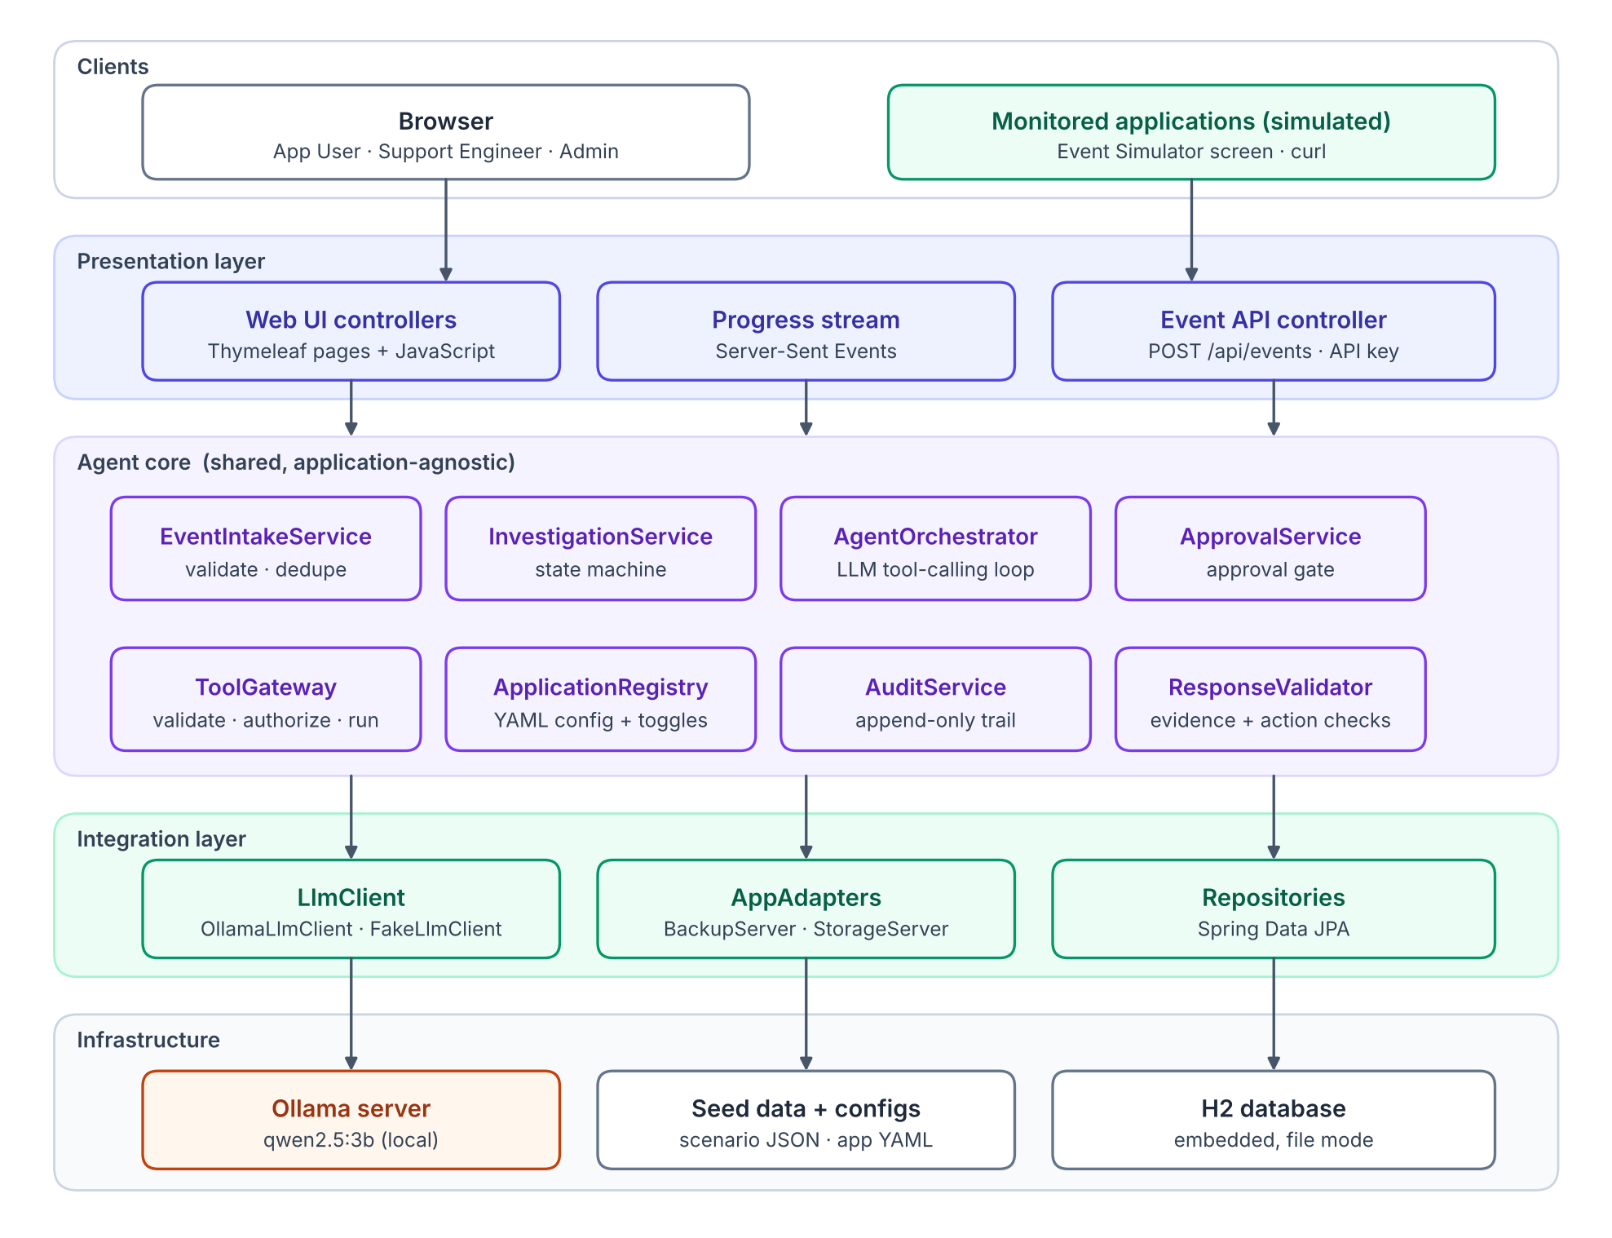
Figure 2. Layered component architecture
Table 16. Component responsibilities
Component | Responsibility | Requirements
Event API controller | Authenticates the application (API key), parses the event, returns 202/200/4xx. | FR-EVT-01, -02
EventIntakeService | Validation, idempotency, correlation, create-or-link, recurrence linking. | FR-EVT-01…05, FR-INV-01
InvestigationService | Owns the state machine and resolution status; publishes progress events. | FR-INV-02…04
AgentOrchestrator | Runs the LLM tool-calling loop; handles follow-ups and re-investigation. | FR-AI-01…04, FR-DATA-04
ToolGateway | Single entry point for every tool and action execution: existence, enablement, argument validation, timeout, recording. | FR-ACT-02, FR-DATA-02
ResponseValidator | Validates the LLM's final output: schema, evidence IDs, action rules, downgrades. | FR-AI-03, FR-ACT-06
ApprovalService | Approval gate: role check, single use, expiry, exact-parameter execution, verification. | FR-ACT-03…05
AuditService | Append-only record of every significant step. | FR-ACT-07
ApplicationRegistry | Loads application YAML; holds runtime enable/disable toggles. | FR-CFG-01, FR-ACT-01
LlmClient | Interface to the model. OllamaLlmClient (runtime), FakeLlmClient (tests). | D14
AsyncRunScheduler | Bounded worker pool; retries work rejected by a full queue. | FR-EVT-03
AppAdapters | Application-specific tool and action implementations backed by seed data. | NFR-MAINT-01
Progress stream | Server-Sent Events channel per investigation for live progress. | FR-INV-03

4.3 Design principles
Table 17. Design principles
# | Principle | Consequence
P1 | The LLM reasons; code enforces. | Permissions, approvals, state transitions, evidence checks and outcome reporting are deterministic code. The LLM only chooses tools and writes analysis.
P2 | Application specifics live at the edge. | Everything about Backup Server or Storage Server is in its YAML, adapter and seed data. The core never names a specific application.
P3 | Everything is recorded. | Each tool call becomes evidence; each decision becomes an audit entry. Findings are traceable to data.
P4 | Fail visibly, never silently. | Every failure ends in an explicit status with a reason shown to the user.
P5 | Least privilege for the model. | The LLM can call read-only tools only. Actions can only be proposed, and only a human can approve them.

4.4 Technology stack
Table 18. Technology stack
Concern | Choice | Reason
Language / runtime | Java 21 | Candidate's primary language; records and modern features.
Framework | Spring Boot 4.1.2 (Web MVC, Security, Data JPA) | Industry standard; one-command run (D16).
UI | Thymeleaf + small JavaScript file + one CSS file | Server-rendered, no Node toolchain; actions via fetch, live updates via Server-Sent Events.
Database | H2 (file mode) | Embedded, zero installation.
LLM | Ollama + qwen2.5:3b | Local, free, tool-calling support; fits 8 GB RAM (D15).
HTTP client | Spring RestClient | Calls Ollama /api/chat.
Configuration | YAML (Jackson) | Readable per-application config.
Testing | JUnit 5, Mockito, AssertJ | Standard Java unit-test stack.
Build | Maven | Standard; mvn spring-boot:run.

4.5 Package structure
com.safekeep.agent
├── api REST + SSE controllers, DTOs, error handler
├── web Thymeleaf page controllers
├── intake EventIntakeService, CorrelationKey, IdempotencyStore
├── investigation Investigation entity, state machine, InvestigationService
├── agent AgentOrchestrator, PromptBuilder, ResponseValidator
├── llm LlmClient, OllamaLlmClient, FakeLlmClient
├── tools ToolGateway, ToolDefinition, ArgumentValidator
├── approval ActionProposal, ApprovalService, ActionVerifier
├── apps ApplicationRegistry, AppAdapter
│ ├── backupserver BackupServerAdapter + scenario data
│ └── storageserver StorageServerAdapter + scenario data
├── audit AuditEntry, AuditService
├── security SecurityConfig, ApiKeyFilter, demo users
└── health HealthService, MetricsService

4.6 Concurrency model
- POST /api/events performs only validation and create-or-link, never an LLM or tool call, and returns in under 200 ms. The investigation runs on a bounded thread pool (4 workers, queue 50) after the transaction commits (FR-EVT-03).
- At most one worker processes a given investigation at a time (per-investigation lock). Different investigations run in parallel.
- If the pool and its queue are full, the investigation stays RECEIVED and is retried every 15 seconds; nothing is lost.
- The orchestrator keeps all run state in a per-run context object; no mutable state is shared between investigations (NFR-SCAL-01).
- Create-or-link is serialized per correlation key, so two identical events arriving together produce one investigation (D1).

5. Domain model
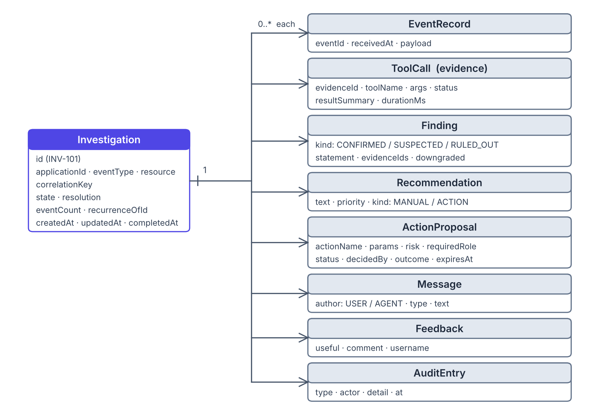
Figure 3. Domain model. Investigation is the aggregate root.

5.1 Investigation
Table 19. Investigation fields
Field | Type | Description
id | String | Human-readable ID, e.g. INV-101.
applicationId | String | e.g. backup-server.
eventType | String | e.g. HIGH_MEMORY.
resource | String | Affected resource or operation, e.g. backup-server-01, job Daily-Gold-VMware.
correlationKey | String | applicationId|eventType|resource (D1).
state | Enum | RECEIVED, INVESTIGATING, WAITING_FOR_INFO, COMPLETED, UNABLE_TO_COMPLETE.
resolution | Enum | UNRESOLVED, PARTIALLY_RESOLVED, RESOLVED, UNKNOWN (default UNKNOWN).
stateReason | String | Why the current state was entered (e.g. failure reason).
summary | String | Agent's one-paragraph summary.
eventCount | int | Number of linked events (≥ 1).
recurrenceOfId | String? | Most recent closed investigation with the same key.
toolCallsUsed | int | Counter against the loop cap (D12).
missingInformation | String | What the Agent could not determine, one item per line.
scenarioId | String? | Demo only: which seed data set the simulated adapter uses (A10).
createdAt / firstRecommendationAt / completedAt | Instant | Timestamps; firstRecommendationAt feeds MET-01.

5.2 Child entities
The child entities carry the fields shown in Figure 3. Three of them have rules worth stating:
- ToolCall: every tool request is recorded, including rejected ones (status DENIED or ERROR). Its evidenceId (E1, E2, …) is what findings cite.
- Finding: downgraded = true when the validator demoted a CONFIRMED finding to SUSPECTED (D5).
- ActionProposal: stores paramsHash and expiresAt so execution can prove it matches what was approved (Section 9.4).

6. Investigation state machine
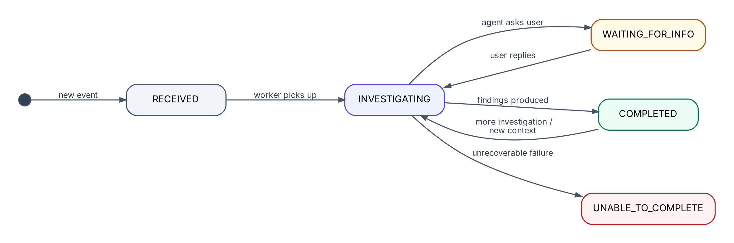
Figure 4. Investigation states and allowed transitions
Table 20. Transition table
From | To | Trigger | Side effects
(none) | RECEIVED | New, non-duplicate event accepted | Investigation created; run queued; audit INVESTIGATION_CREATED.
RECEIVED | INVESTIGATING | Worker starts the run | Progress event published.
INVESTIGATING | WAITING_FOR_INFO | Validated output contains questionForUser | Agent question shown to the user.
WAITING_FOR_INFO | INVESTIGATING | User replies | Reply added as context; run resumes.
INVESTIGATING | COMPLETED | Validated final output persisted | Findings, recommendations, optional action proposal saved.
INVESTIGATING | UNABLE_TO_COMPLETE | LLM unavailable after retries, invalid output after repair, or unexpected error | stateReason set; evidence kept.
COMPLETED | INVESTIGATING | User adds context or requests more investigation | Previous findings passed to the new run; pending proposals expire.
UNABLE_TO_COMPLETE | INVESTIGATING | User requests more investigation (retry) | New run with existing evidence.

Any transition not listed above is rejected with an IllegalStateTransitionException and audited. Plain follow-up questions never change the state (D7).

6.1 Resolution status rules
Table 21. Resolution status rules
Resolution | Set when
UNKNOWN | Default; also when the Agent cannot determine the cause.
UNRESOLVED | Analysis completed and the problem is still present, or an approved action FAILED verification.
PARTIALLY_RESOLVED | Action succeeded and the metric improved but is still beyond its threshold (e.g. S-1C).
RESOLVED | Action succeeded and verification shows the metric within threshold. Only the system sets this value, never the LLM.

7. Event intake and deduplication

7.1 Event schema
POST /api/events
X-Api-Key: <application key>
{
"eventId": "evt-9f12", // unique per occurrence
"application": "backup-server",
"eventType": "HIGH_MEMORY",
"resource": "backup-server-01",
"timestamp": "2026-11-07T10:00:00Z",
"details": { "memoryPercent": 93, "threshold": 85 }
}

7.2 Validation rules
Table 22. Event validation rules
# | Rule | Failure response
V-E1 | API key present and belongs to a configured application. | 401 Unauthorized
V-E2 | eventId, application, eventType, resource and timestamp present. | 400 Bad Request (missing fields listed)
V-E3 | Application is configured. | 422 UNKNOWN_APPLICATION
V-E4 | The API key belongs to the application named in the body. | 401 Unauthorized
V-E5 | Event type is configured for that application. | 422 UNKNOWN_EVENT_TYPE (hint lists valid types)
V-E6 | timestamp is ISO-8601 and not more than 24 h in the future. | 400 Bad Request

7.3 Intake decision flow
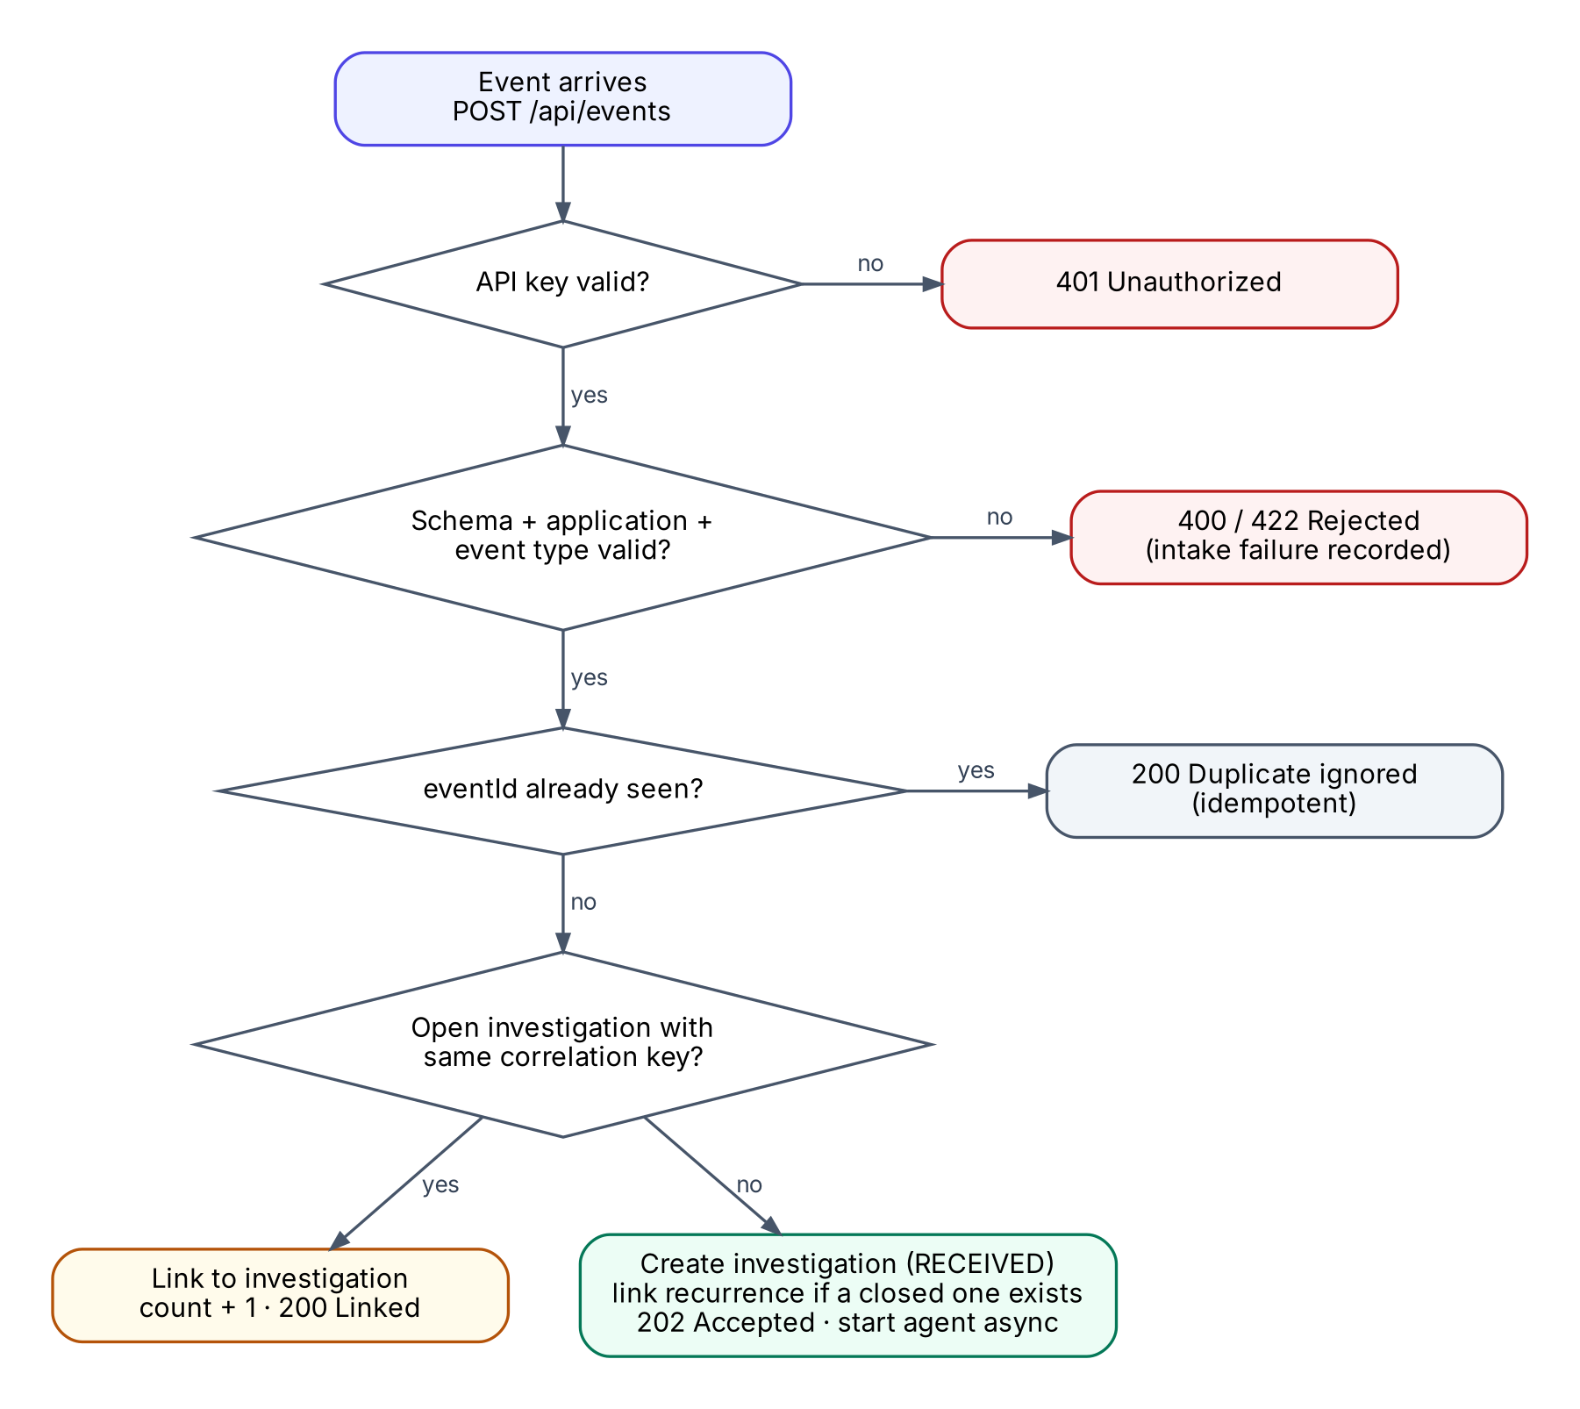
Figure 5. Event intake decision flow

7.4 Correlation and recurrence
Table 23. Correlation outcomes
Situation | Outcome | Response
Same eventId already received | Ignored; nothing changes | 200 {status: DUPLICATE_IGNORED, investigationId}
Open investigation (not COMPLETED / UNABLE_TO_COMPLETE) with same key | Event linked; eventCount + 1; event added to timeline | 200 {status: LINKED, investigationId}
No open investigation; a closed one exists with same key | New investigation; recurrenceOfId = most recent closed one | 202 {status: CREATED, investigationId}
No investigation with same key | New investigation | 202 {status: CREATED, investigationId}

7.5 Race safety
Create-or-link runs inside a lock striped by correlation key, in one database transaction. A second thread with the same key waits, then sees the investigation created by the first and links to it. Unit tests fire concurrent identical events and assert that exactly one investigation exists.

7.6 Intake failures
Rejected events (V-E1 to V-E6) are written to an intake-failure log with time, application (if known), reason and a payload excerpt with secrets removed. The Health screen lists the latest 50 (FR-EVT-05, FR-CFG-03).

8. Agent loop and LLM contract

8.1 Loop overview
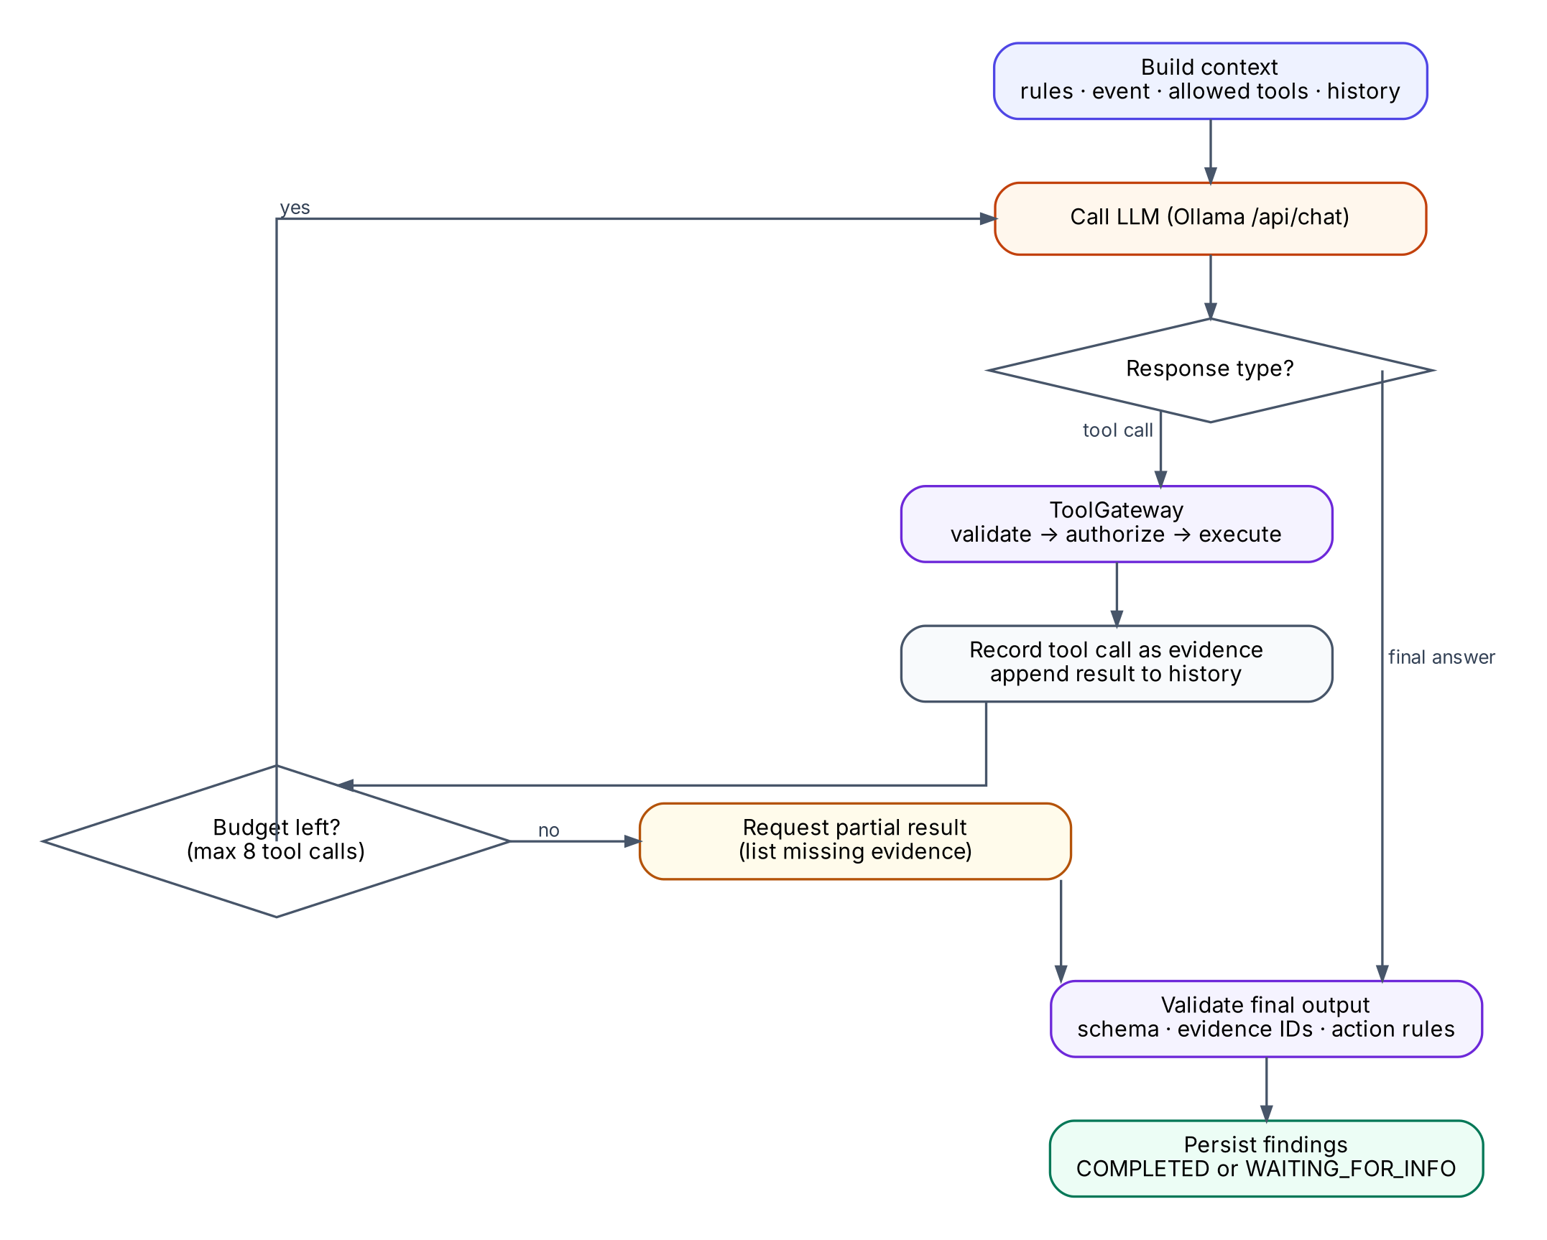
Figure 6. Agent tool-calling loop
A run has two phases (D18). In the tool phase, the orchestrator calls Ollama's /api/chat endpoint with the conversation so far and the tools allowed for the event type. Each tool_calls request goes through the ToolGateway and its result is appended as a tool message. In the answer phase, a separate request in JSON mode, without tools, re-lists every evidence item and asks for the final answer.
Guards in code compensate for a small model (D17):
Table 24. Agent guards
Guard | Behavior | Observed problem it fixes
Budget | At most 8 tool calls per run | Endless loops
Nudge | If the model stops before 4 tool calls, it is told which tools it has not used (at most 2 nudges) | Stopping after confirming the symptom
Duplicate call | An identical repeated call is not executed; the model is told to see the earlier evidence ID | Repeating the same call
Use tools before asking | If the model asks the user a question while unused tools and budget remain, it is sent back once to use them | Asking the user for data a tool could provide

8.2 Context sent to the model
Table 25. Model context
Part | Content
Role and rules | You are a support investigator for {application}. Use only the provided tools. Cite evidence IDs. Label each finding CONFIRMED (directly measured), SUSPECTED (inferred) or RULED_OUT. Never claim an action was executed. If information is missing, say what is missing or ask one question. Answer in the JSON schema provided.
Application profile | Name, description, configured thresholds, runbook titles.
Event | Event type, resource, details, event count, recurrence information.
Tools | Only read tools enabled for this application and event type (FR-AI-02). Typically 5–7.
Proposable actions | Names, descriptions and parameters of enabled actions. Listed as text, not as callable tools (P5).
Conversation | Prior tool results (with evidence IDs), user context and replies, prior findings when re-investigating.
Final instruction | All evidence re-listed, the JSON format, and decision rules: list abnormal observations first, CONFIRMED only for directly measured facts, propose an action only if it fixes a confirmed problem.

The exact prompt wording is iterated during implementation and recorded in the AI usage log. This section fixes what must be in the prompt, not the final wording.

8.3 Tool results as evidence
- Each executed or rejected tool call is stored as a ToolCall with the next evidence ID (E1, E2, …).
- The result is capped before it is sent to the model: at most 1,500 characters, with a truncation note. Logs are filtered to matching lines by the adapter.
- Rejected calls are returned to the model as structured errors (e.g. INVALID_ARGUMENT: hours must be 1–168) so it can correct itself.

8.4 Final output schema
{
"observations": [{"evidenceId": "E3", "fact": "1172 stale sessions, 8 running jobs"}],
"summary": "Backup Server memory has risen for 6 days ...",
"findings": [
{"kind": "CONFIRMED", "statement": "Heap usage is 93% (threshold 85%)", "evidenceIds": ["E1"]},
{"kind": "SUSPECTED", "statement": "Stale sessions are not released ...", "evidenceIds": ["E3","E4"]},
{"kind": "RULED_OUT", "statement": "No abnormal job volume", "evidenceIds": ["E3"]}
],
"missingInformation": ["Thread state of session-cleanup before the upgrade"],
"recommendations": [{"text": "Escalate thread dump to engineering", "priority": 2}],
"proposedAction": {"name": "purge_stale_sessions", "params": {}, "reason": "..."},
"questionForUser": null,
"resolution": "UNRESOLVED"
}

8.5 Output validation rules
The ResponseValidator applies these rules before anything is persisted. They are the deterministic guardrails over AI output (P1).
Table 26. Response validation rules
# | Rule | On violation | Req.
R-V1 | Output parses against the schema. | One repair retry with the parse error; then UNABLE_TO_COMPLETE. | NFR-REL-01
R-V2 | Every cited evidence ID exists in this investigation. | Unknown IDs removed. | FR-DATA-03
R-V3 | A CONFIRMED finding cites at least one valid evidence ID with status OK. | Downgraded to SUSPECTED; downgraded = true; shown in UI. | FR-AI-03
R-V4 | proposedAction exists, is enabled and belongs to this application. | Proposal dropped; a MANUAL recommendation with the action's instructions is added. | FR-ACT-06
R-V5 | At least one finding, or a non-empty missingInformation. | missingInformation set to “Cause could not be determined”; resolution UNKNOWN. | FR-AI-04
R-V6 | resolution is UNRESOLVED or UNKNOWN. | Any other value replaced by UNKNOWN (only the system sets RESOLVED). | D4, D8
R-V7 | questionForUser present. | State WAITING_FOR_INFO instead of COMPLETED. | FR-DATA-04
R-V8 | A proposal is kept only when resolution is UNRESOLVED. | Proposal dropped; a note explains why (D19). | FR-ACT-03

8.6 Limits and parameters
Table 27. Agent limits
Parameter | Value | Configurable
Model | qwen2.5:3b | Yes
Minimum tool calls before nudging | 4 (max 2 nudges) | Yes
Temperature | 0.1 | Yes
Max tool calls per run | 8 | Yes
LLM call timeout | 60 s | Yes
LLM retries | 2, exponential backoff (1 s, 3 s) | Yes
Tool execution timeout | 5 s | Yes
Max tool result sent to model | 1,500 characters | Yes

8.7 Follow-ups, context and re-investigation
Table 28. Follow-up handling
User input | Behavior | State change
Question (“Will this come back?”) | Single LLM call with the summary, findings and evidence; answer added to the conversation. No tools. | None
Reply to the Agent's question | Reply stored as context; run resumes. | WAITING_FOR_INFO → INVESTIGATING
Additional context (“we patched last night”) | Context stored; new run with prior findings. | COMPLETED → INVESTIGATING
“Investigate more” | New run with prior findings and remaining budget reset. | COMPLETED / UNABLE_TO_COMPLETE → INVESTIGATING

8.8 Untrusted content
Log lines, tool results and user messages are data, not instructions. Even if such content tries to steer the model, the model can only call read-only tools through the gateway, and any state change still needs a human approval with role checks. The worst outcome of manipulated content is a misleading text, which is mitigated by evidence citation and labeling.

9. Tools, permissions and approval gate

9.1 Tool and action definitions
Table 29. Definition fields
Field | Meaning
name | Unique within the application, e.g. get_job_sessions.
kind | READ (callable by the LLM) or ACTION (proposable only, needs approval).
description | Shown to the LLM; written for the model.
parameters | JSON schema: type, enum, min/max, default.
enabled | Runtime toggle controlled by ADMIN.
eventTypes | READ tools: event types for which the tool is offered.
risk / requiredRole | ACTION only: LOW / HIGH and the minimum role to approve (D3).
verify | ACTION only: read tool, optional fixed arguments, a condition for RESOLVED and an optional partial condition for PARTIALLY_RESOLVED (D8).
instructions | ACTION only: manual steps shown when the action is not available (FR-ACT-06).

9.2 ToolGateway pipeline
Every tool or action execution, from the agent loop or from an approval, passes through the same ordered checks.
Table 30. Gateway checks
Step | Check | Error code returned
G1 | Tool is defined for this investigation's application. | UNKNOWN_TOOL
G2 | Tool is enabled (admin toggle). | TOOL_DISABLED
G3 | From the agent loop, kind must be READ. ACTION is only reachable from ApprovalService. | ACTION_NOT_CALLABLE
G4 | Arguments validated against the schema. Safe coercion allowed ("7" → 7); out-of-range values rejected; missing optional values defaulted. | INVALID_ARGUMENT
G5 | Adapter executes with a 5 s timeout. | TIMEOUT / ADAPTER_ERROR
G6 | Request and outcome recorded as ToolCall + AuditEntry, including denials. | –

Motivation from the first model spike: llama3.2:3b called get_metrics with {"days": "0"}, a string with a meaningless value. G4 exists for exactly this.

9.3 Role permissions
Table 31. Role permission matrix
Capability | APP_USER | SUPPORT_ENGINEER | ADMIN
View investigations, evidence, history | ✓ | ✓ | ✓
Ask questions, add context, give feedback, request more investigation | ✓ | ✓ | ✓
Send simulated events (Event Simulator) | ✓ | ✓ | ✓
Approve or reject actions | if action requires APP_USER | if requiredRole ≤ SUPPORT_ENGINEER | all
View Health and Metrics |  | ✓ | ✓
Change application configuration and toggles |  |  | ✓

Roles are ordered APP_USER < SUPPORT_ENGINEER < ADMIN. Checks are enforced on the server in two layers: URL rules and method-level checks in services. Hidden buttons are a usability aid, not a control.

9.4 Approval gate
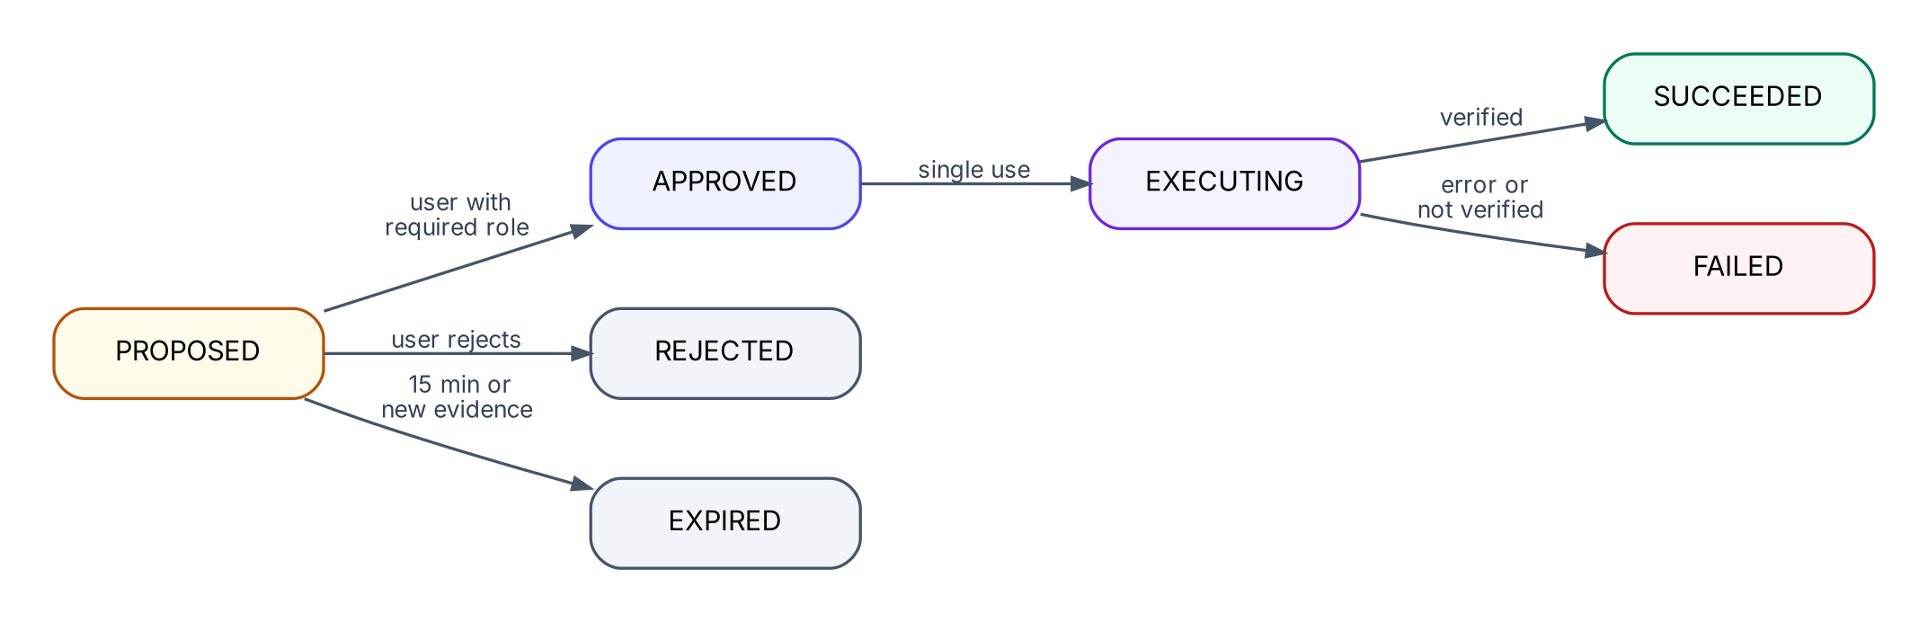
Figure 7. Action proposal lifecycle
Table 32. Approval rules
# | Rule | Req.
AR1 | The approval card shows the action, target, exact parameters, expected effect and risk. | NFR-USAB-01
AR2 | Approval is single-use: APPROVED moves immediately to EXECUTING and cannot be replayed. | FR-ACT-04
AR3 | A proposal expires after 15 minutes, or when new evidence or a new run makes it stale. | FR-ACT-03
AR4 | Users may reject a proposal with an optional reason. | FR-ACT-07
AR5 | Execution uses the stored parameters; a hash check guarantees they are unchanged. | FR-ACT-04
AR6 | Every decision and outcome is audited with user and time. | FR-ACT-07
AR7 | Users below requiredRole see “Requires {role} approval”; the server rejects their approve call with 403. | NFR-SEC-02

9.5 Execution and verification
- ApprovalService checks role, status PROPOSED, expiry and parameter hash.
- The action runs through the ToolGateway (G1, G2, G4–G6) with the stored parameters.
- The verify read tool runs and its conditions are evaluated, e.g. current < thresholds.memoryPercent. Condition true: RESOLVED. Otherwise partial condition true: PARTIALLY_RESOLVED. Otherwise FAILED.
- Outcome SUCCEEDED only if execution returned OK and verification passed; otherwise FAILED with the reason. A FAILED action is never shown as successful (FR-ACT-05).
- Resolution is updated according to Section 6.1 and the result is posted to the conversation.

10. Applications and scenarios

10.1 Applications
Table 33. Applications
Application ID | Description | Event types
backup-server | SafeKeep Backup Server: management, scheduling, job sessions, reporting, datasources | HIGH_MEMORY  HIGH_CPU  JOB_FAILED  REPORT_JOB_FAILED  DATASOURCE_UNHEALTHY  DEPENDENCY_UNAVAILABLE
storage-server | SafeKeep Backup Storage Server: disk pools, expiration, replication | HIGH_STORAGE_USAGE  REPLICATION_JOB_FAILED  UNEXPECTED_RESTART

Each application's API key is read from an environment variable named in its configuration (BACKUP_SERVER_API_KEY, STORAGE_SERVER_API_KEY).

10.2 Application configuration (example)
safekeep:
applications:
storage-server:
name: SafeKeep Backup Storage Server
thresholds: { poolUsagePercent: 90, memoryPercent: 85 }
event-types: [HIGH_STORAGE_USAGE, REPLICATION_JOB_FAILED, UNEXPECTED_RESTART]
tools:
- name: get_pool_status
description: Usage of the storage pool, capacity and daily growth.
event-types: [HIGH_STORAGE_USAGE, REPLICATION_JOB_FAILED]
- name: get_system_logs
event-types: ["*"]
parameters:
- { name: boot, type: string, allowed: [current, previous], default-value: current }
actions:
- name: run_expiration_cleanup
risk: HIGH
required-role: ADMIN
verify:
tool: get_pool_status
condition: "usagePercent < thresholds.poolUsagePercent"
partial-condition: "usagePercent < 98"
instructions: In Storage > Maintenance, start Expiration.
runbooks:
- runbooks/storage-server/storage-pool-full.md
API keys are bound separately from environment variables (safekeep.api-keys.storage-server: ${STORAGE_SERVER_API_KEY:}).

10.3 Tool catalog
Table 34. Read tools (each event type exposes a subset of 5–7)
Application | Tool | Returns | Main use
backup-server | get_metrics(metric: cpu|memory|login_rate|auth_sessions, hours) | Time series summary | UC-1
backup-server | get_top_processes(sortBy: cpu|memory, limit) | Ranked processes | UC-1
backup-server | get_job_sessions(status) | Session counts and samples | S-1A
backup-server | get_job_details(jobId) | Job, per-VM results, errors | UC-2
backup-server | get_logs(source, level, contains, limit) | Matching log lines | All
backup-server | get_recent_changes(days) | Upgrades, setting changes | UC-1, UC-2
backup-server | get_settings(section) | Configuration values | UC-2
backup-server | get_storage_targets() | Capacity of connected storage | S-2A, S-3B
backup-server | get_dependency_status(name) | Reachability, TLS, last success | UC-3
backup-server | get_affected_operations(dependency) | Operations depending on it | UC-3
both | search_runbook(query) | Matching runbook excerpts | All
storage-server | get_pool_status() | Usage %, growth trend | S-1C
storage-server | get_expiration_status() | Last run, pending expirations | S-1C
storage-server | get_replication_status(jobId) | Throughput, errors | S-2E
storage-server | get_system_logs(boot) | Kernel/system log lines | S-4A
storage-server | get_disk_health() | Per-disk I/O error counts | S-4A

Table 35. Actions
Application | Action | Risk | Required role | Verification
backup-server | purge_stale_sessions | LOW | SUPPORT_ENGINEER | stale sessions = 0, memory below threshold
backup-server | clear_expired_auth_sessions | LOW | SUPPORT_ENGINEER | auth sessions and CPU drop
backup-server | retry_failed_vms(jobId) | LOW | SUPPORT_ENGINEER | job status SUCCESS
backup-server | retry_report_job(jobId) | LOW | APP_USER | report status SUCCESS
storage-server | run_expiration_cleanup | HIGH | ADMIN | pool usage below threshold
storage-server | retry_replication(jobId) | LOW | SUPPORT_ENGINEER | replication status SUCCESS

10.4 Seed data rules
- Seed data holds raw observations only: numbers, log lines, records. It never contains a root-cause field (A5).
- Every scenario includes normal-looking noise (e.g. healthy storage in S-2B) so the Agent must rule causes out.
- Format: seed/<app>/baseline.json holds normal values; seed/<app>/<scenario>.json overrides them. Each tool maps selectors such as metric=memory (or *) to a result.
- Actions may declare effects that change later tool results, so outcomes are observable (e.g. memory 93% → 61%). _error / error entries simulate failures.
- Each scenario can be reset from the simulator, restoring its initial state.

10.5 Scenario catalog
Table 36. Scenario catalog (8 core, 3 extra)
ID | App / event | Root cause in data | Expected Agent outcome | Tier
S-1A | backup-server  HIGH_MEMORY | 1,172 stale job sessions; cleanup task stuck since an upgrade 6 days ago | Confirmed stale sessions; suspected stuck cleanup; propose purge → SUCCEEDED → RESOLVED | Core
S-1B | backup-server  HIGH_CPU | Login rate 1,200/min (baseline 15); 48,000 auth sessions: new session per job step | Suspected missing token reuse; clear sessions → SUCCEEDED; recurrence warning; escalate | Core
S-1C | storage-server  HIGH_STORAGE_USAGE | Pool 98%; expiration not run for 9 days | Propose cleanup (ADMIN) → SUCCEEDED → 92% → PARTIALLY_RESOLVED | Core
S-2A | backup-server  JOB_FAILED | 6 of 40 VMs failed with “insufficient space”; storage 98% | Retry approved → FAILED (still full) → UNRESOLVED; manual steps | Core
S-2B | backup-server  JOB_FAILED | API timeouts in job logs; CPU 96%; auth loop; storage healthy | Rules out storage; links cause to auth loop | Extra (designed, not seeded)
S-2C | backup-server  JOB_FAILED | Generic error, sparse logs, all metrics normal | Cause unknown; states missing info; asks user → WAITING_FOR_INFO | Core
S-2D | backup-server  REPORT_JOB_FAILED | Report query timeout: 365 days × 5,000 VMs | Suggest narrower range; retry (APP_USER can approve) | Extra
S-2E | storage-server  REPLICATION_JOB_FAILED | Replication throughput dropped to 5% of normal | Network suspected; retry; escalate to network team | Extra
S-3A | backup-server  DATASOURCE_UNHEALTHY | vCenter TLS certificate expired yesterday | Lists affected / unaffected operations; no action permitted; escalation steps | Core
S-3B | backup-server  DEPENDENCY_UNAVAILABLE | storage-01 unreachable since 02:14 | Backups to it queued, restores unavailable; links to S-4A | Core
S-4A | storage-server  UNEXPECTED_RESTART | Previous-boot log: kernel panic after repeated I/O errors on disk sdc | Hardware cause; no action; replace disk, run pool health check | Core

10.6 Adding a new application
- Create apps/<id>.yaml with event types, tools, actions, thresholds and runbooks.
- Implement AppAdapter for the application (tools and actions).
- Provide seed data or, for a real system, an HTTP-backed adapter.
No change is needed in intake, orchestrator, gateway, approval, UI or persistence (FR-CFG-04, NFR-MAINT-01). Unit tests register a third test-only application to prove this.

11. REST API
Table 37. REST endpoints
Method | Path | Auth | Purpose | Req.
POST | /api/events | API key | Submit an event | FR-EVT-01…05
GET | /api/investigations?state=&app=&from=&to= | Session or Basic | List / history | FR-CFG-02
GET | /api/investigations/{id} | Session or Basic | Full detail | FR-USR-01
GET | /api/investigations/{id}/stream | Session or Basic | Live progress (SSE) | FR-INV-03
POST | /api/investigations/{id}/messages | Session or Basic | Question, context or reply | FR-USR-03, -04
POST | /api/investigations/{id}/reinvestigate | Session or Basic | Request more investigation | FR-USR-05
POST | /api/investigations/{id}/proposals/{pid}/approve | Session or Basic + role | Approve action | FR-ACT-03
POST | /api/investigations/{id}/proposals/{pid}/reject | Session or Basic + role | Reject action | FR-ACT-07
POST | /api/investigations/{id}/feedback | Session or Basic | Useful / not useful | FR-USR-06
GET | /api/applications | ADMIN | Configuration view | FR-CFG-01
PATCH | /api/applications/{app}/tools/{name} | ADMIN | Enable / disable tool or action | FR-ACT-01
GET | /api/health | SUPPORT+ | Ollama, adapters, intake errors | FR-CFG-03
GET | /api/metrics | SUPPORT+ | MET-01…03 | MET
GET | /api/simulator/scenarios | Session or Basic | Scenario catalog | Demo
POST | /api/simulator/send | Session or Basic | Send a scenario event through the same intake path with the app key | Demo
POST | /api/simulator/reset | Session or Basic | Reset scenario state | Demo

All authenticated endpoints accept a browser session or HTTP Basic credentials (D20). Errors use one format, so the UI can show actionable messages (NFR-USAB-01):
{
"error": "UNKNOWN_EVENT_TYPE",
"message": "Event type DISK_FULL is not configured for storage-server",
"hint": "Configured: HIGH_STORAGE_USAGE, REPLICATION_JOB_FAILED, ..."
}

12. User interface

12.1 Design principles
- Calm, information-dense operations-tool look: neutral palette with one indigo accent, Inter typeface, cards with soft borders, light and dark themes.
- Color carries meaning only: state badges, and finding labels (CONFIRMED green, SUSPECTED amber, RULED_OUT gray).
- Progress is shown as a live vertical timeline of agent steps.
- Approval is a distinct card that states exactly what will change.

12.2 Screen map
Table 38. Screens
Screen | Roles | Purpose
Login | All | Sign in; quick-select buttons for the three demo users.
Event Simulator | All | Choose application and scenario; preview event JSON; send; reset scenario.
Investigations | All | List and history with filters (state, application, date).
Investigation detail | All | The working screen (12.4).
Applications | ADMIN | Per-application event types, tools and actions with toggles.
Health & Metrics | SUPPORT_ENGINEER, ADMIN | Agent health, connection status, intake errors, MET-01…03.

12.3 Investigations list
Columns: ID, application, event type, resource, state badge, resolution badge, event count (with “recurrence” marker), created, last updated. Rows update live. Filters make this screen the investigation history (FR-CFG-02).

12.4 Investigation detail
Table 39. Investigation detail areas
Area | Content | Req.
Header | Event summary, application, resource, state and resolution badges, linked events count, recurrence link. | FR-USR-01
Timeline | Live steps: received, each tool call (name, arguments, status), analysis, completion. | FR-INV-03
Findings | Grouped CONFIRMED / SUSPECTED / RULED_OUT; each cites evidence chips (E3). “Downgraded by validator” marker where applicable. | FR-AI-03
Evidence | Expandable tool results per evidence ID. | FR-DATA-03
Missing information | What could not be determined and what to check next. | FR-AI-04
Recommendations | Ordered next steps; MANUAL steps include instructions. | FR-ACT-06
Approval card | Action, target, parameters, expected effect, risk, required role, expiry countdown, Approve / Reject. | FR-ACT-03
Conversation | Agent questions, user questions and answers; input to ask, add context, or request more investigation. | FR-USR-03…05
Feedback | Useful / not useful with optional comment. | FR-USR-06
Audit | Collapsible chronological audit trail. | FR-ACT-07

12.5 Applications (admin)
For each application: connection status, event types, thresholds, read tools and actions with enable/disable toggles, risk and required role. Changes take effect immediately for new tool calls and are audited.

12.6 Health and metrics
Table 40. Health and metrics panels
Panel | Content
Agent health | Worker pool usage, queued runs, investigations by state.
LLM | Ollama reachable and model downloaded (UP / DEGRADED / DOWN).
Applications | Adapter status per application, last event received.
Intake errors | Latest 50 rejected events with reasons.
MET-01 | Median time from event to first recommendation.
MET-02 | % investigations with evidence-backed findings; % positive feedback.
MET-03 | Approved action success rate; actions executed without approval (always 0).

13. Error handling and reliability

13.1 Failure modes
Table 41. Failure handling
Failure | Behavior | User sees | Req.
Invalid / unauthorized event | Rejected; intake failure logged | Health: intake errors | FR-EVT-05
Tool argument invalid | Not executed; error returned to model to self-correct | Timeline step marked rejected | FR-ACT-02
Tool disabled by admin | Denied (TOOL_DISABLED); model continues with other tools | Timeline step marked denied | FR-DATA-02
Adapter error / timeout | Recorded; returned to model as error | Timeline step marked failed | NFR-REL-01
Ollama unreachable | 2 retries; then UNABLE_TO_COMPLETE | “AI service unavailable”; evidence kept; retry button | NFR-REL-01
Malformed model output | One repair retry; then UNABLE_TO_COMPLETE | Reason shown | NFR-REL-01
Tool budget exhausted | Partial result requested | Findings plus missing information | D12
Action execution or verification fails | Proposal FAILED; resolution UNRESOLVED | Failure and reason in conversation | FR-ACT-05
Application restart during a run | On startup, INVESTIGATING runs become UNABLE_TO_COMPLETE (“interrupted”); RECEIVED runs are resubmitted | Retry available | NFR-REL-01
Worker queue full | Investigation stays RECEIVED; retried every 15 s | Investigation appears as received | NFR-REL-01

13.2 Isolation between investigations
Isolation follows from the concurrency model in Section 4.6. A unit test runs two investigations concurrently with a fake LLM and asserts that their evidence and findings never mix (NFR-SCAL-01).

14. Security
Table 42. Security controls
Concern | Control | Req.
User authentication | Spring Security form login, BCrypt-hashed demo passwords. | NFR-SEC-02
Authorization | URL rules by role, plus checks inside services: the approval gate compares the user's role with the action's requiredRole. | NFR-SEC-02
Application authentication | Per-application API key from environment variables; constant-time comparison. | NFR-SEC-01
Secret handling | Keys never logged, rendered, stored in seed data, or sent to the LLM; log masking filter. | NFR-SEC-01
CSRF | Enabled for browser sessions (token sent by the UI). Exempt: the event API (API key) and requests with an Authorization header (D20). | NFR-SEC-02
Input validation | Explicit event field checks (V-E1 to V-E6); schema validation for tool arguments. | FR-ACT-02
Model privileges | Read-only tools only; actions need human approval (P5). | FR-ACT-03
Auditability | Append-only audit of tool calls, approvals, rejections, outcomes, config changes. | FR-ACT-07
Data locality | All processing local (Ollama); no data leaves the machine. | NFR-SEC-01

15. Out of scope and future work
Table 43. Out of scope
Item | Why out of scope | Future direction
Real application integrations | No access to real systems; simulated adapters prove the contract | HTTP adapters per product API
Enterprise SSO and user management | Three seeded users demonstrate enforcement (D2) | OIDC / SAML, roles from directory groups
Persistent admin toggles | In memory for the demo (A9) | Store in the database
Per-application access control | Roles are global (A4) | Role bindings per application
Cross-event-type correlation | Correlation key is per event type (D1) | Time-window clustering of related events
Semantic runbook search | Keyword search sufficient | Embeddings + vector store
Distributed scaling | Single node (A3) | Message queue + distributed locks
Notifications | Not required by PRD | Email / chat notifications
Secret vault | Environment variables sufficient for demo | HashiCorp Vault or cloud KMS

16. Revision history
Table 44. Revision history
Revision | Changes
1 | Initial specification, written before implementation.
2 | Updated after implementation and testing: Spring Boot 4.1.2 (D16); model qwen2.5:3b with the measured comparison (D15); agent guards (D17); two-phase answer with evidence re-list and observations (D18); rule R-V8 (D19); CSRF and HTTP Basic for API clients (D20); context-window check (D21); intake check order (Section 7.2); verification arguments and partial condition (Section 9); seed data format and demo scenario header (Section 10, A10); persistence and restart behavior (A9, Section 13); full-queue retry (Section 4.6); UI built with plain JavaScript instead of htmx.

