**ALTRER**

**PROBLEM:**

NOW-A-DAYS DISTRACTIONS LIKE SOCIAL MEDIA AND THEIR NOTIFICATIONS, USING MOBILE DURING WORKING HOURS FOR LONG TIME MAY EFFECT PRODUCTIVENESS OF AN INDIVIDUAL

**THEME:**

IT IS SAID THAT “IT IS MORE PRODUCTIVE WHEN WORKING FOR 1 HOUR WITH NO DISTRACTIONS, THAN WORKING FOR HOURS WITH DISTRACTIONS”

**STATS OF SURVEY:**

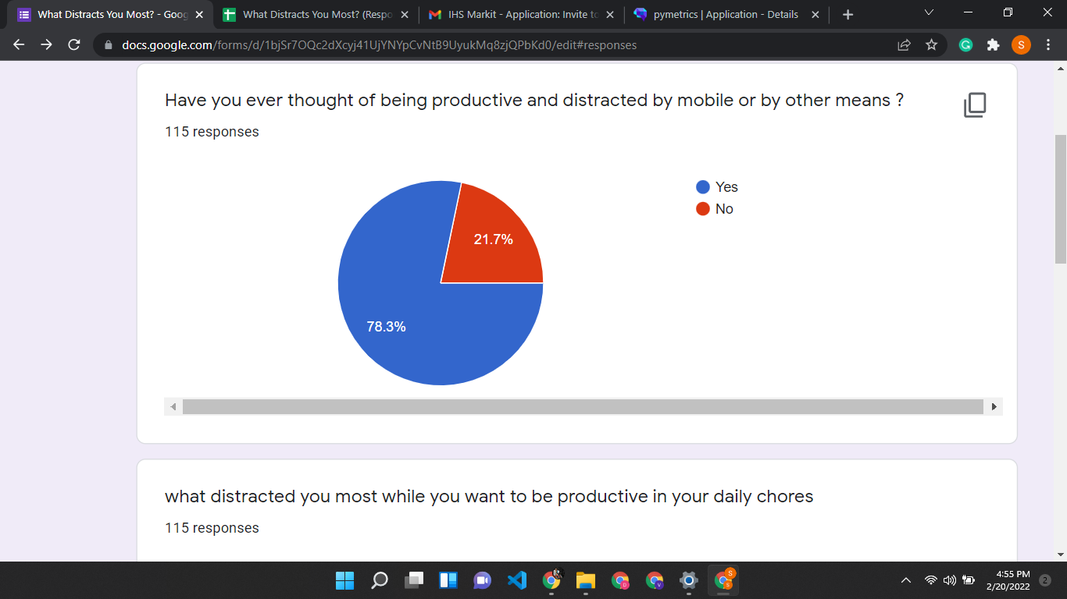

**OBSERVATION:**

MOST OF THE PEOPLE ARE WILLING TO WORK BUT GOT DISTRACTED BY OTHER MEANS

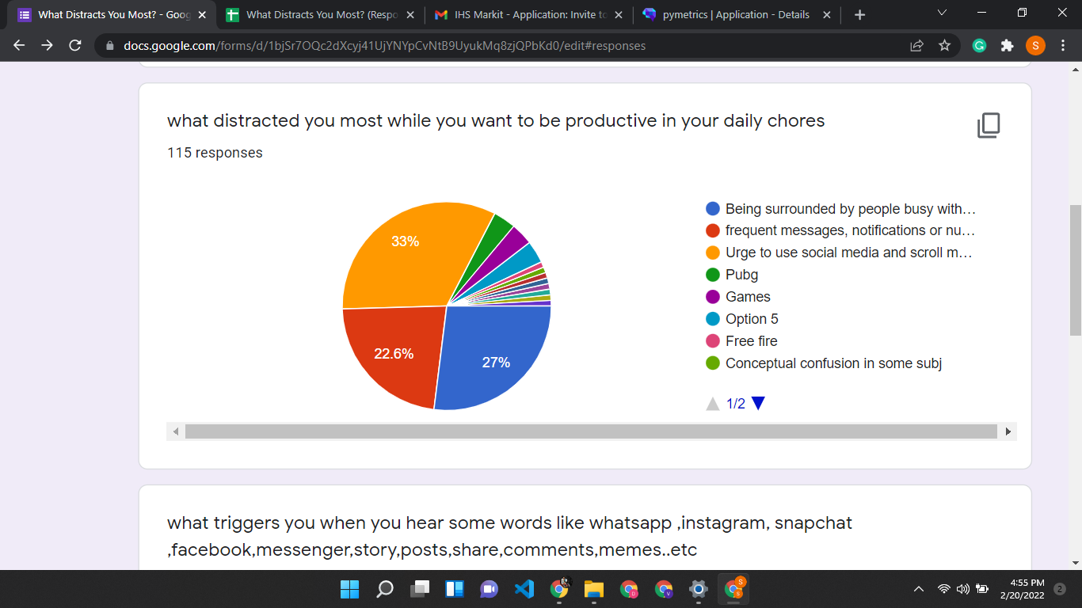

**OBSERVATION:**

MOST OF THE PEOPLE DISTRACTED BY MOBILE (A KNOWN FACT) DIRECTLY OR INDIRECTLY

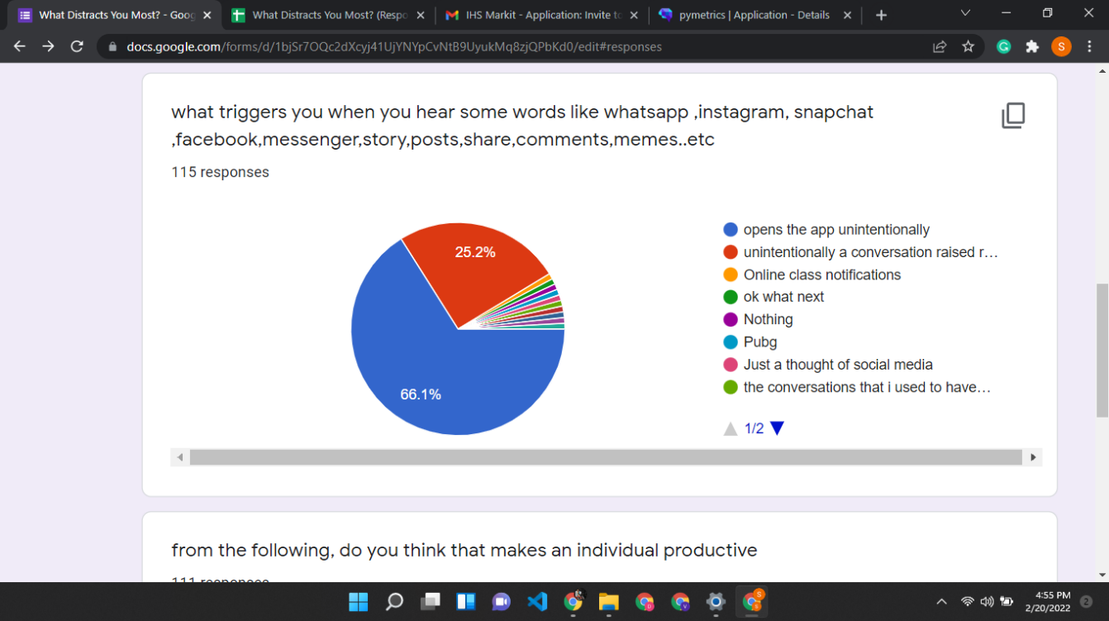

**OBSERVATION:**

MOST OF THE PEOPLE DEVELOPED REFLEXIVE BEHAVIOUR TOWARDS MOBILE

I.E WHENEVER THEY HEAR WORDS ABOUT SOCIALMEDIA THEY CHECKS THEIR MOBILE UNINTENTIONALLY

**INSPIRED FROM:**

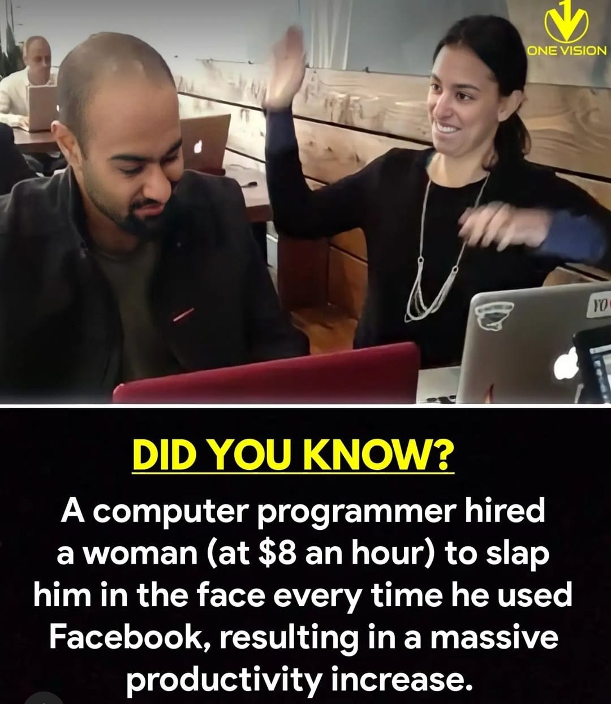

**SOLUTION**

**PROJECT ALTRER:**

ALTRER IS A LIVE FOCUS ASSIST.

ALTRER WARNS YOU WHEN YOU ARE USING MOBILE FOR MORE THAN TWO MINUTES

ALTRER RECORDS YOUR EMOTIONAL BEHAVIOUR THROUGH YOUR FACIAL EXPRESSIONS AND ANALYSIS YOUR EMOTIONAL HEALTH

**WITH ALTRER:**

ONE CAN WORK PRODUCTIVELY

ONE CAN OVERCOME DISTRACTIONS

ONE CAN IMPROVE EMOTIONAL HEALTH

ONE CAN INCREASE PRODUCTIVENESS