

**School of Computer Science and Engineering**

VIT Chennai

Vandalur - Kelambakkam Road, Chennai - 600 127

**J - CODES**

**Programme:** B.tech CSE

**Course Code:** CSE3002

**Course Name:** Internet and Web Programming

**Slot:** A2

**Faculty:** Dr.Premalatha.M

# Title: Dental Appointment Registration Website

Name: Sai Vignesh.N Reg.No: 20BCE1128

**FILE NAMES WITH EXPLANATION IN THE ORDER OF EXECUTION:**

1. **Index.php**

At first the file contains the PHP code for connecting the database, getting data from the form and inserting the data in the table.

Then the file contains the HTML code and has a title “Dentist Appointment Booking Portal”. We have also attached two links of external CSS and one external custom CSS link.

In the body part, the header starts, where we have showed the DentalCare logo and used the nav tag to show the navigation links to home, about, services, reviews and contact parts.

We have also given a button “make appointment” which when clicked will navigate to the appointment form.

The home section starts and we have given a background image in the css. A heading “let us brighten your smile” is given after which the text “A beautiful smile gives beautiful stories. Make your mouth look wonderful and clean.” is given. We have given the “make appointment” button here too which when clicked will navigate to the appointment form.

The about section starts. In the about section we have a heading “True Healthcare For Your Family”. Then we have some text “We aim at giving you the best dental services. Any problem regarding dentistry will be taken care of to ensure yourself having aclean and beautiful mouth.” Which describes our aim (tells about us). We have given the “make appointment” button here too which when clicked will navigate to the appointment form.

The services section starts where we tell about the services offered by us. We have a heading “Our Services” under which we will display the services provided each in a box. The box will have a small image for the service, the name of the service and a brief about the service.

Now the process section starts, where the work process will be briefed. We have a heading “Work Process” under which the processes are given each in a box. The box will have a background image, the name of the process and a brief about the process.

Then the reviews section starts. Here the reviews given by our clients is given. We have a title “Satisfied Clients” under which the reviews of the clients are given each in a box.

The box has the photo of the clients, their reviews, their rating, their name and a “Satisfied client” phrase.

Next comes the contact section. Here the appointment booking form is given. The form inputs the name of the patient, their email id, their phone number and the date and time on which they want to book their appointment.

The footer section is divided into four parts. The first contains details about phone number, the second contains details about the address, the third contains details about opening hours and the fourth contains details about email address. Here each part contains its image, its heading and its details.

1. **SCIPT .js INSIDE js FOLDER**

Here this script is written to navigation. Whenever a navigation item from the header is clicked, the page will automatically scroll down itself to that particular item. For example if we click on the “Services” link in the header, we will get scrolled down to the “services” part.

1. **STYLE.css INSIDE CSS FOLDER**

We declare the global css variables here

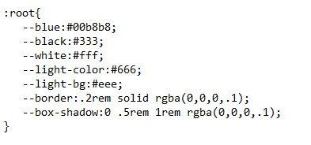

We have a basic style for all the elements

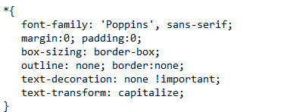

We have css for scrollbar

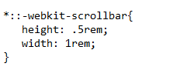

We have css for the track of the scrollbar

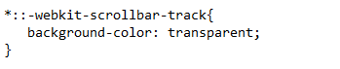

We have css for the draggable scrolling handle

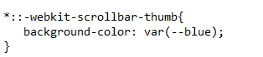

We have css for the entire html part

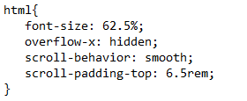

We have css for every section

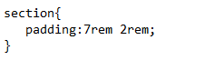

We have css for every heading

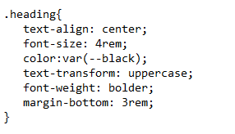

We have css for the make appointment button in the form

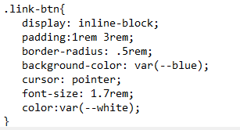

We have css for the same button on hover

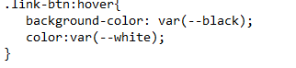

We have css for the header part

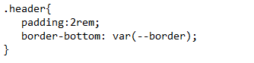

We have css for header active and header logo

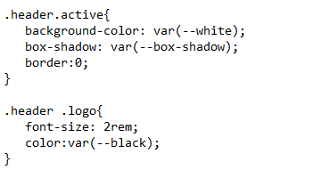

We have css for header logo span, header navigation links, navigation links on hover

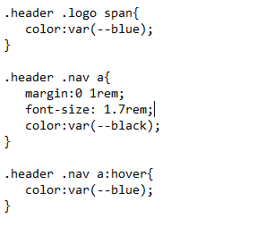

We have css for menu-btn

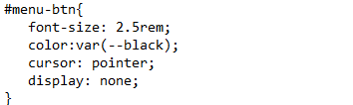

We have css for the overall home part, home content, heading in home and paragraph in home

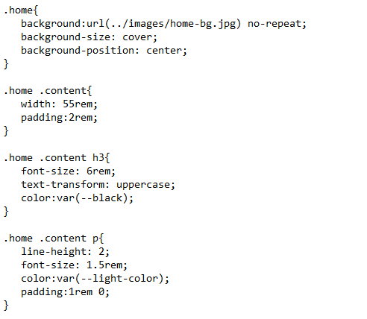

We have css for the about row, about content’s span about’s header and about’s paragraph

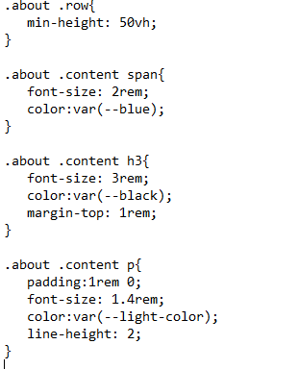

We have css for the services part, services box-container and inside the container, image in services part and heading in services part.

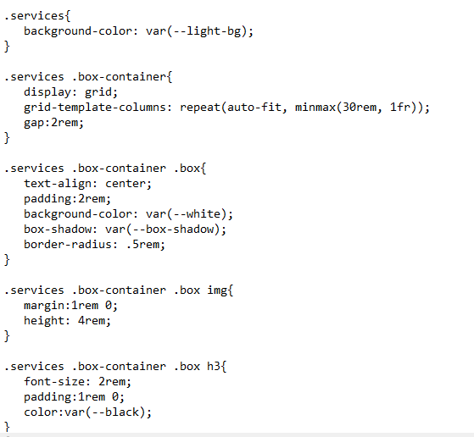

We have css for paragraph in services part

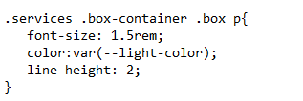

We have css for process box and inside the box, image in process, heading in process, paragraph in process.

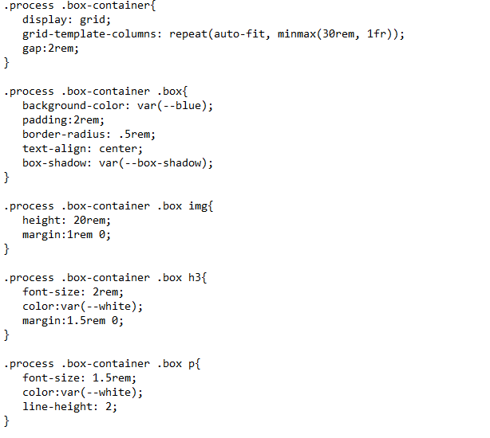

We have css for overall reviews part, reviews box, inside the box, image in the reviews and paragraph in the reviews

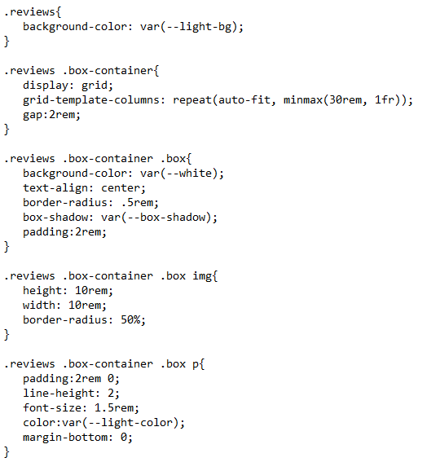

We have css for the heading3 in reviews

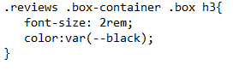

We have css for the whole conbtact form, for the message and for the input boxes.

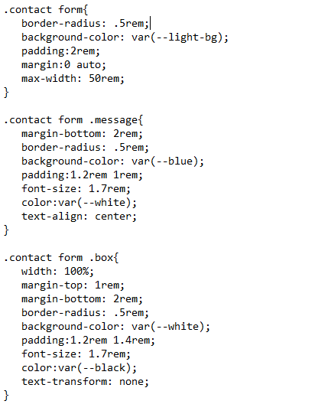

We have css for contact form’s span elements

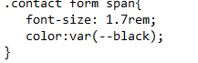

We have css for the entire footer, footer box, inside the box, the icons in the footer and the heading3 in footer

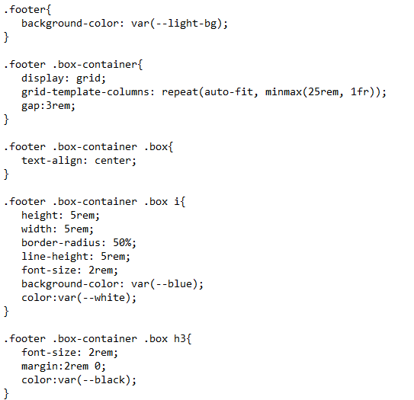

We have css for the paragraph in the footer, credit parts of the footer and span element in the credits part.

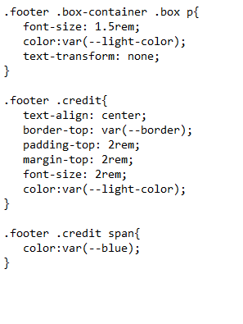

We have the css for media queries

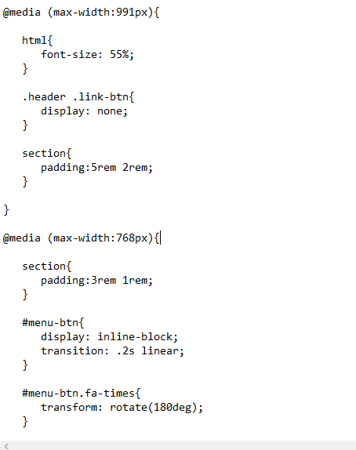

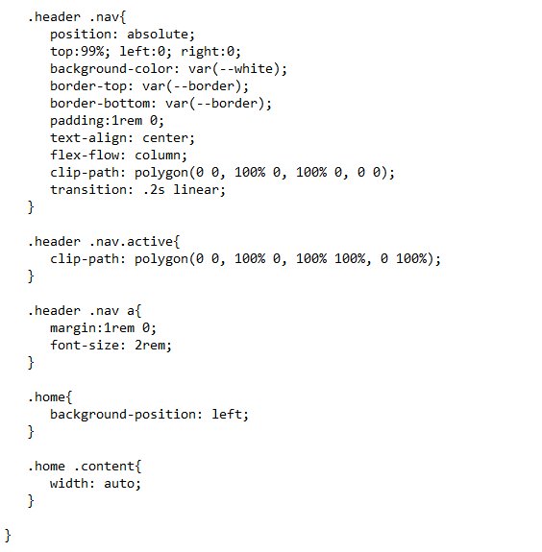

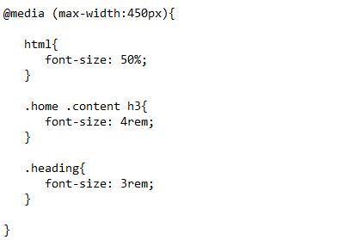

The images folder contain he images.