
Data Science Project Assignment
Student Habits and Academic Performance Analysis

Subject – Fundamentals of Data Science and Data Analytics
Professor – Dr. Rahat Izhar

Wai Yan Lynn – 67111411
Pyae Sone – 67111336
Min Hein Thu – 67111391

Table of Contents
Objective 3
Methodology Overview 3
Task 1 : Data Understanding 4
1.1 Number of rows and columns: 5
1.2 Data types of each column 6
1.2.1 Categorical Data Columns 6
1.2.2 Numerical Data Columns 6
1.3 Dataset Description 6
Task 2 : Data Cleaning 7
2.1 Checking for Missing Values 7
2.2 Ensuring Data is Ready 8
Task 3 : Correlation Analysis 9
3.1 Correlation Interpretation 10
3.2 Correlation Interpretation of the Data Set 11
Task 4 : Data Visualization 12
4.1 Scatter Plot Analysis: Study Hours vs. Final Exam Score 12
4.1.1 Objective 12
4.1.2 Analytical Interpretation 13
4.2 Boxplot Analysis: High Study vs. Low Study Groups 13
4.2.1 Objective 13
4.2.2 Visual Observations 14
4.2.3 Analytical Interpretation 14
4.2.4 Verdict 14
Task 5 : Statistical Analysis (T-Test Only) 15
5.1 Statistical Analysis (Independent Samples T-Test) 15
Task 6 : Final Conclusion 16
6.1 The Most Important Factor Affecting Performance 16
6.2 The Impact of Study Hours 17
6.3 The Effect of Social Media and Netflix 17
6.4 Summary of Statistical Validation 17
6.5 Final Takeaway 17

Objective
The primary objective of this project is to analyze how various daily lifestyle habits impact student academic performance. By examining a comprehensive dataset of 1,000 students, this report investigates how factors such as daily study hours, sleep duration, and digital entertainment consumption (including social media and Netflix) correlate with final exam scores. Through a step-by-step process of data cleaning, correlation analysis, visual exploration, and statistical testing, this study aims to identify the most significant drivers of academic success and provide data-backed insights into the habits of high-performing students.

Methodology Overview
This project employs a structured data science pipeline to derive insights from the dataset. The methodology includes:
Data Preparation: Inspecting and cleaning the raw data (handling missing values via imputation) to ensure accuracy for statistical testing.
Exploratory Data Analysis (EDA): Utilizing correlation matrices and data visualization techniques (scatter plots and box plots) to identify initial trends and relationships.
Statistical Validation: Applying an Independent Samples T-Test to rigorously verify the mathematical significance of any observed performance gaps.

Task 1 : Data Understanding
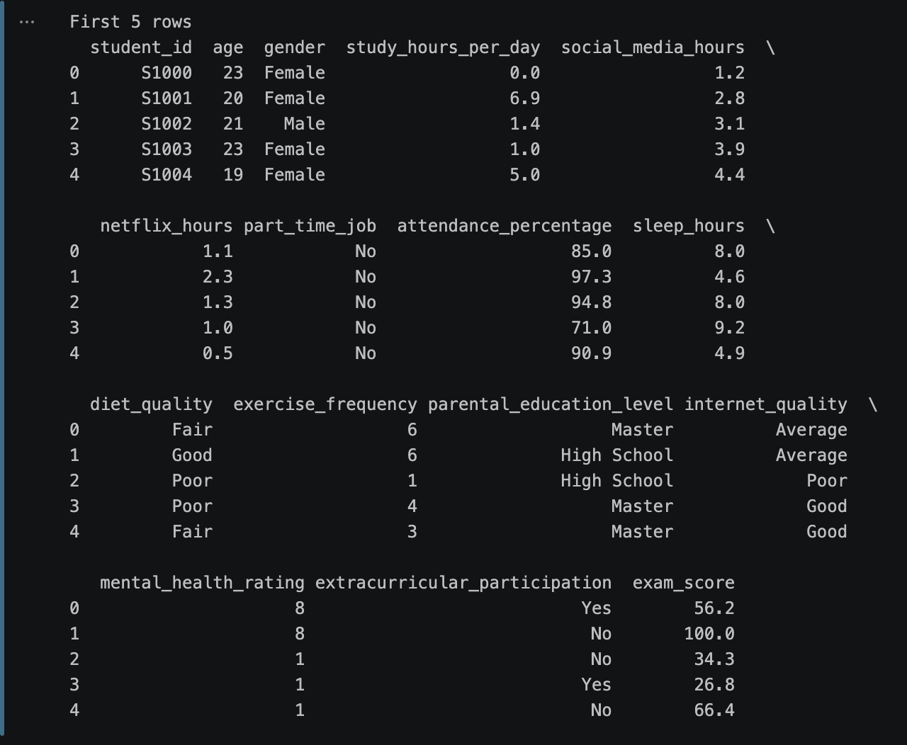
Figure 1Displaying the first five rows

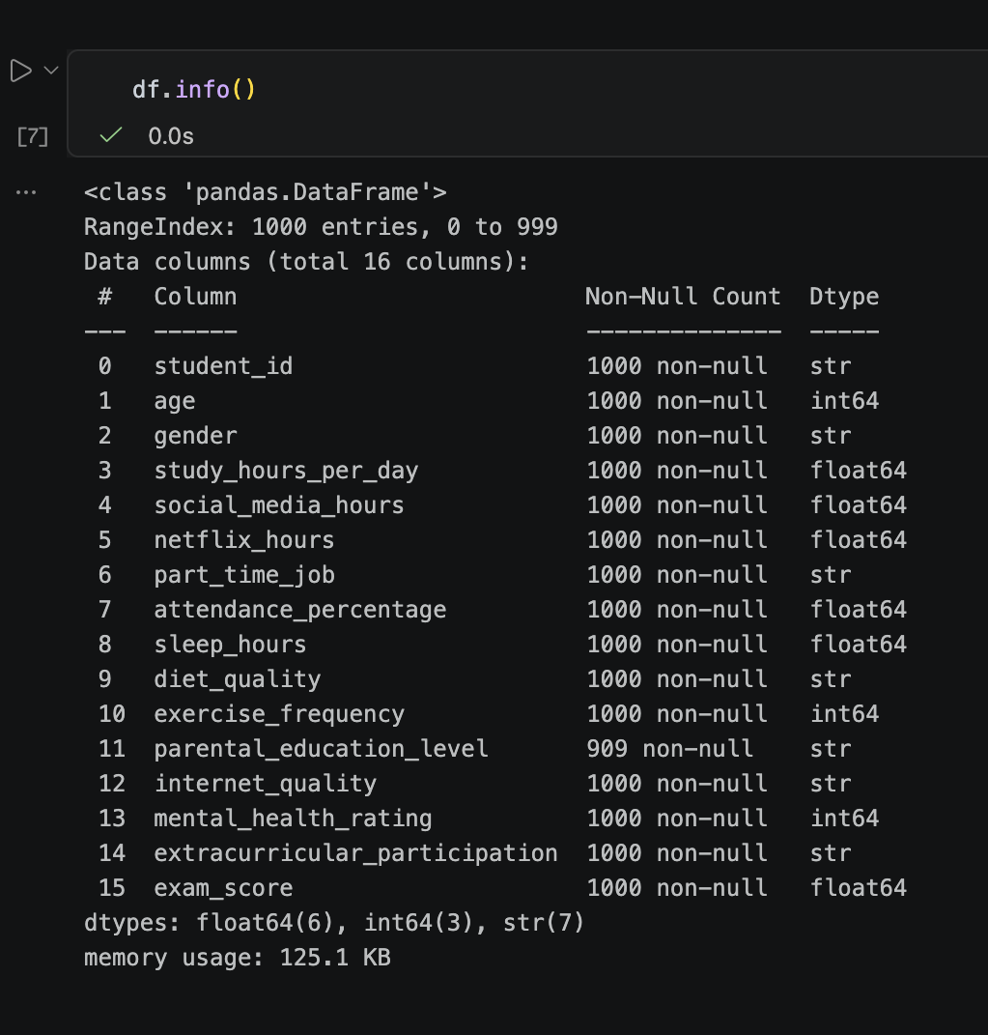
Figure 2 Data Information

1.1 Number of rows and columns:
The dataset contains 1,000 rows (individual student records) and 16 columns (variables tracked for each student).

1.2 Data types of each column
- Numeric (int64 and float64): age, study_hours_per_day, social_media_hours, netflix_hours, attendance_percentage, sleep_hours, exercise_frequency, exam_score.
- Categorical (object): student_id, gender, part_time_job, diet_quality, mental_health_rating, parental_education_level, internet_quality, extracurricular_participation.

1.2.1 Categorical Data Columns
No | Column Name | Data Type
1 | student_id | Nominal Categorical
2 | gender | Nominal Categorical
3 | part_time_job | Nominal Categorical
4 | extracurricular_participation | Nominal Categorical
5 | parental_education_level | Ordinal Categorical
6 | internet_quality | Ordinal Categorical
7 | mental_health_rating | Ordinal Categorical
8 | diet_quality | Ordinal Categorical

1.2.2 Numerical Data Columns
No | Column Name | Data Type
1 | age | Continuous Numerical
2 | study_hour_per_day | Continuous Numerical
3 | social_media_hours | Continuous Numerical
4 | netflix_hours | Continuous Numerical
5 | attendance_percentage | Continuous Numerical
6 | sleep_hours | Continuous Numerical
7 | exam_score | Continuous Numerical
8 | exercise_frequency | Discrete Numerical

1.3 Dataset Description
This dataset contains information on 1,000 students, tracking their daily lifestyle habits, such as study hours, social media usage, sleep, and exercise alongside their personal backgrounds to analyze how these factors impact their final academic performance (exam_score).

Task 2 : Data Cleaning
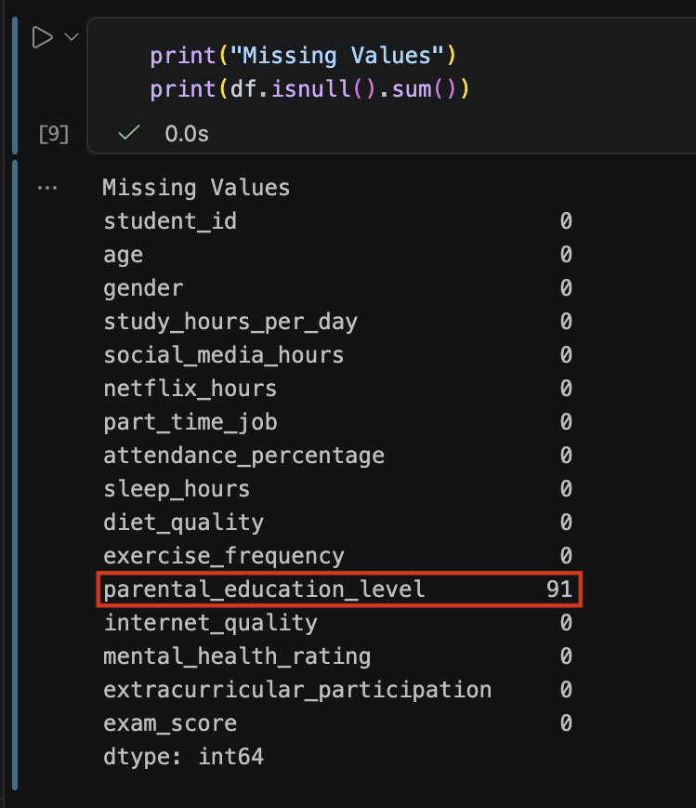
Figure 3 Missing Values (Before Cleaning)

2.1 Checking for Missing Values
Initial inspection revealed 91 missing values in the “parental_education_level” column. All other columns (including our primary focus areas like study hours, sleep, and exam scores) had 0 missing values.

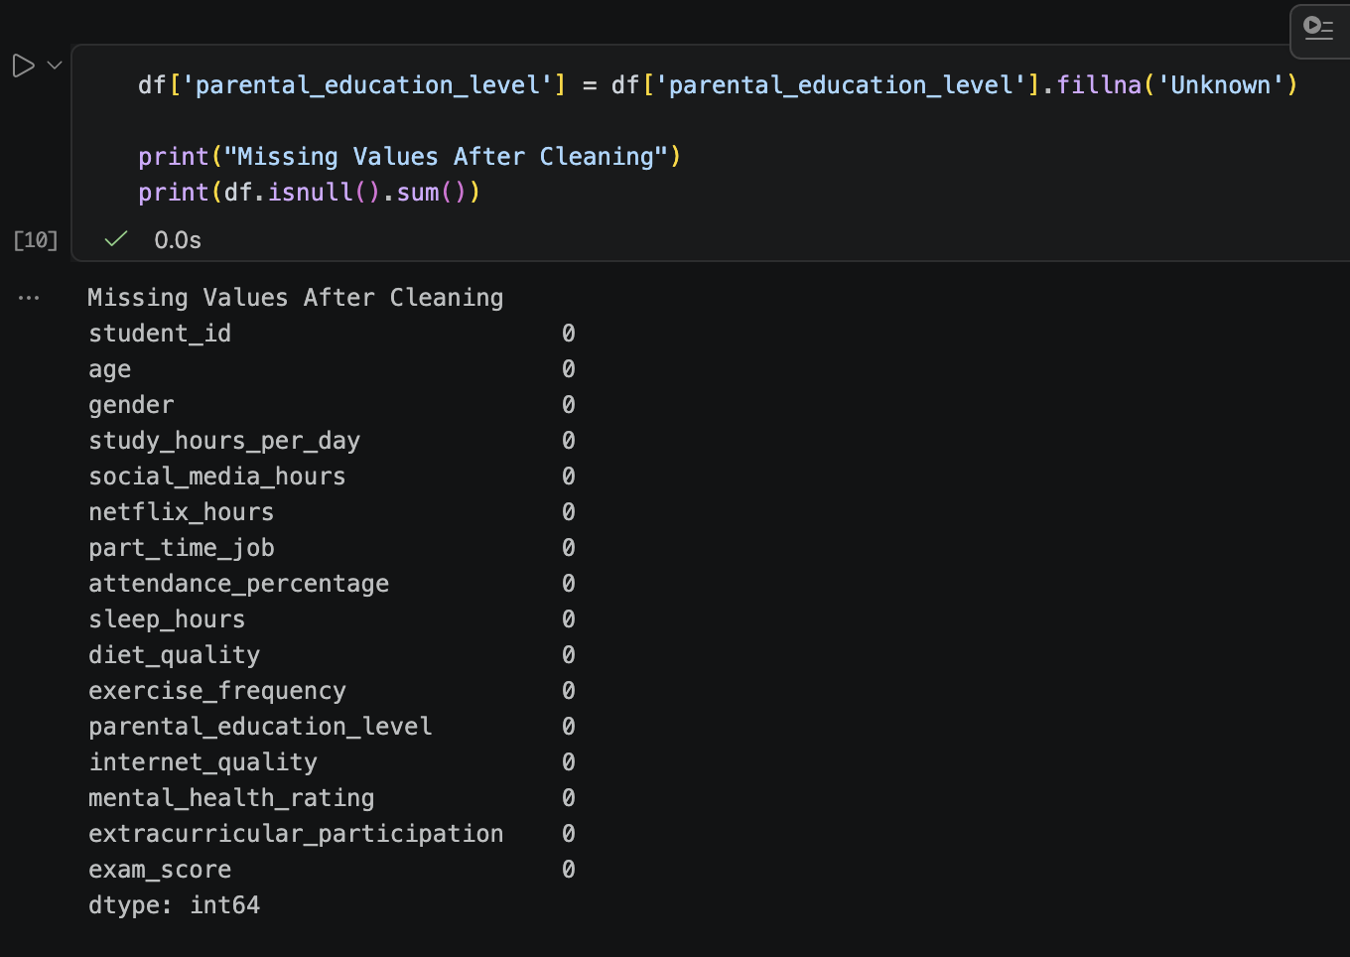
Figure 4 Missing Values (After Cleaning)

2.2 Ensuring Data is Ready
To ensure our data is ready for analysis without artificially skewing the results, we applied targeted imputation. For categorical data like “parental_education_level”, we filled missing values with “Unknown” to preserve the natural distribution of the survey responses.

Task 3 : Correlation Analysis
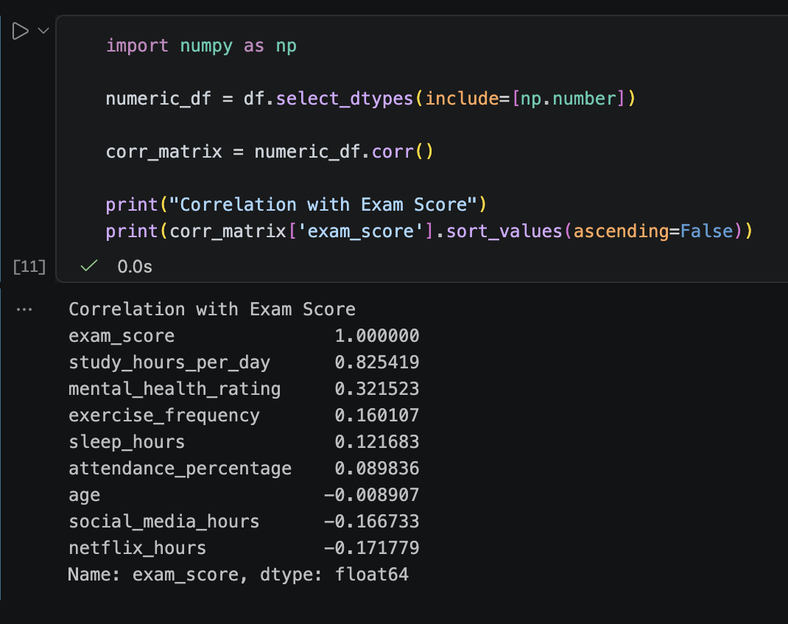
Figure 5 Correlation Matrix
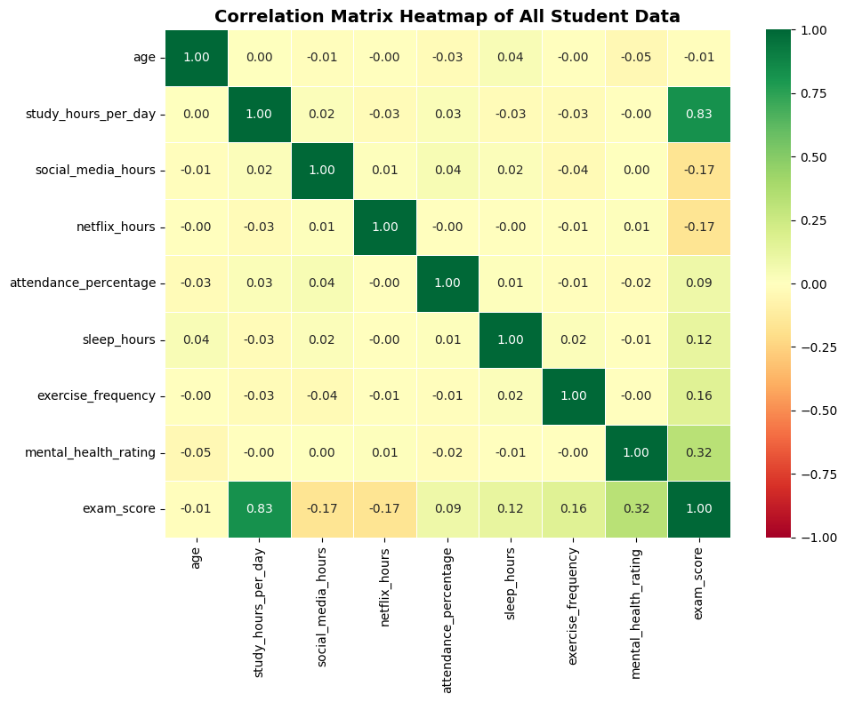
Figure 6 Correlation Heat Map

3.1 Correlation Interpretation
Correlation values always fall between -1.0 and 1.0.
- Closer to 1.0 means a strong positive relationship (as one goes up, the other goes up).
- Closer to -1.0 means a strong negative relationship (as one goes up, the other goes down).
- Closer to 0 means almost no relationship at all.

3.2 Correlation Interpretation of the Data Set
A correlation matrix was generated to understand the relationships between different lifestyle factors and the final exam score.
Q1: Which factor has the strongest relationship with exam score?
study_hours_per_day has the strongest positive relationship with the exam score, showing a high correlation coefficient of 0.825. This indicates that studying time is the primary driver of academic success in this dataset.
Q2: Which factors negatively affect performance?
Digital entertainment habits negatively impact performance. netflix_hours (correlation: -0.172) and social_media_hours (correlation: -0.167) have the strongest negative effects, suggesting that high consumption of screen time detracts from academic performance.

Task 4 : Data Visualization

4.1 Scatter Plot Analysis: Study Hours vs. Final Exam Score

4.1.1 Objective
To visually assess the continuous relationship between the amount of time a student dedicates to studying daily and their resulting exam performance.
Visual Observations: The scatter plot reveals a highly distinct, upward-sloping pattern. The data points cluster tightly together, forming a clear diagonal trajectory from the bottom-left to the top-right of the graph.
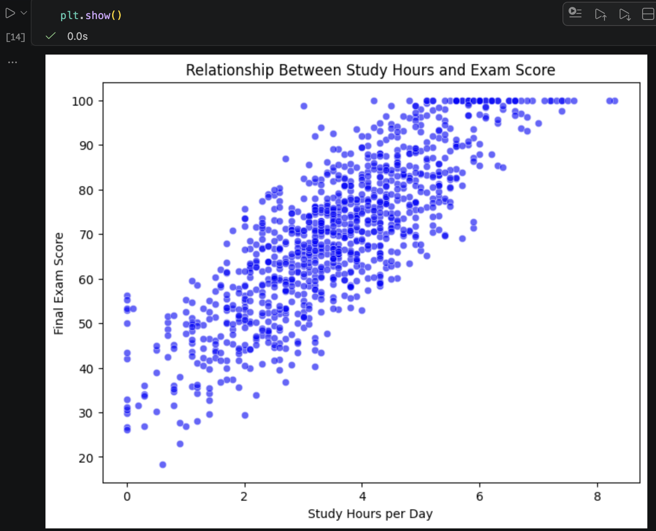 Figure 7 Scatter Plot

4.1.2 Analytical Interpretation
This upward trend visually confirms a strong positive linear correlation (r = 0.825). It demonstrates a consistent "return on investment" for students: every additional hour dedicated to studying yields a predictable increase in exam scores. The tightness of the clustering indicates that study time is a highly reliable predictor of success, with very few outliers (e.g., very few students who studied a lot but scored poorly, or studied very little but scored highly).

4.2 Boxplot Analysis: High Study vs. Low Study Groups

4.2.1 Objective
To compare the distribution, spread, and central tendency of exam scores between students who study above the median amount (High Study: 3.5+ hours) and those who study below it (Low Study: < 3.5 hours).
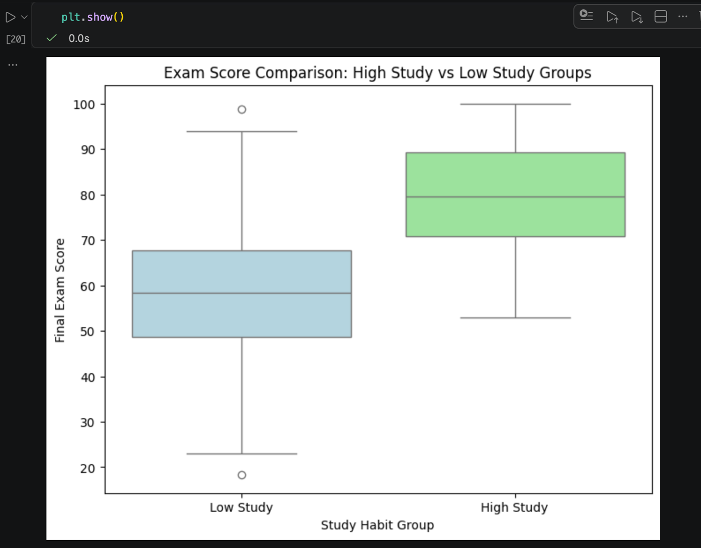
Figure 8 Box Plot

4.2.2 Visual Observations
The boxplot shows a stark separation between the two cohorts. The "High Study" box (which represents the middle 50% of students in that group) is elevated significantly higher on the y-axis compared to the "Low Study" box.

4.2.3 Analytical Interpretation
The Medians: The thick line inside the High Study box (the median score) is vastly superior to the median of the Low Study group, sitting around 80 points compared to the upper 50s.
The Distributions (IQR): Notice that the bottom edge of the High Study box is actually higher than the top edge of the Low Study box. This is a critical finding! It means that the bottom 25% of the High Study group still generally outperformed the top 25% of the Low Study group.

4.2.4 Verdict
This visual lack of overlap provides compelling evidence that crossing the threshold of 3.5 study hours per day fundamentally shifts a student's performance bracket upward.

Task 5 : Statistical Analysis (T-Test Only)
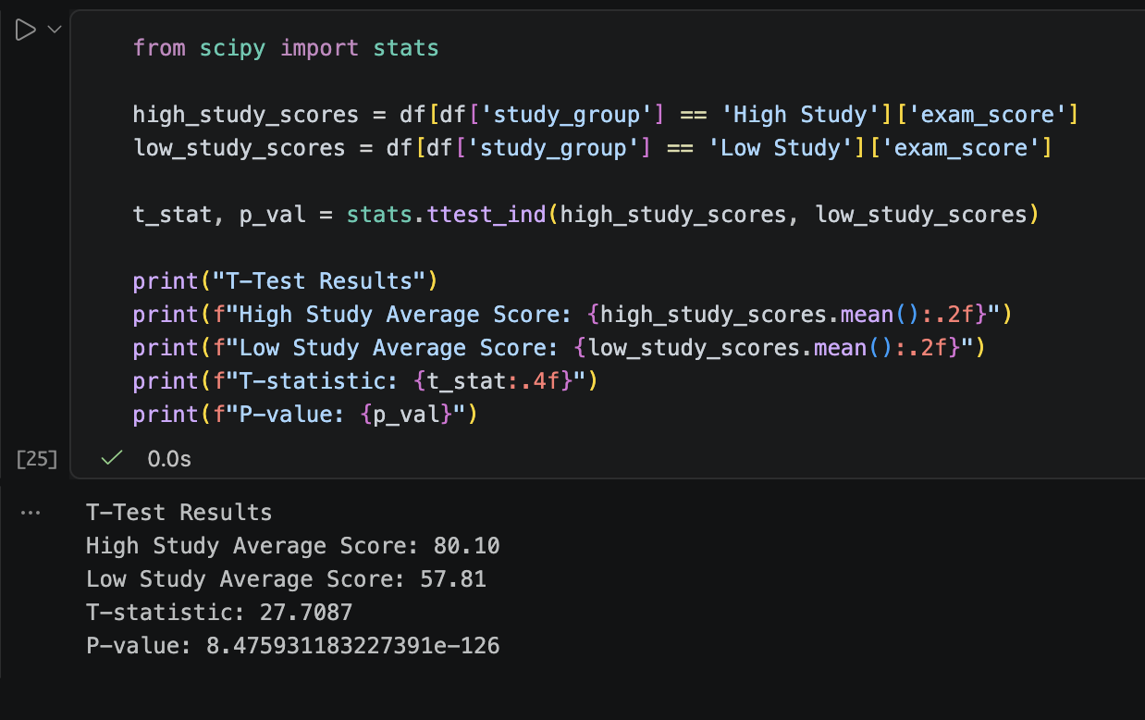
Figure 9 T-Test

5.1 Statistical Analysis (Independent Samples T-Test)
To move beyond visual observations and scientifically validate our findings, an independent samples T-test was conducted. This test compares the mean final exam scores of the "High Study" cohort (students studying ≥ 3.5 hours/day) against the "Low Study" cohort (< 3.5 hours/day).
Statistical Results:
High Study Group Average Score: 80.10
Low Study Group Average Score: 57.81
T-Statistic: 27.71
P-Value: 8.47e-126 (Effectively < 0.001)

Q1: What is a P-value?
In statistical hypothesis testing, the p-value represents the probability of observing our specific results assuming that the "null hypothesis" is true. In the context of this dataset, the null hypothesis would claim that study time has absolutely no effect on exam scores, and any difference between the two groups is strictly due to random chance.
Q2: Is the result significant?
The result is highly statistically significant. In data science, the standard threshold for significance (alpha) is 0.05. Our calculated p-value of 8.47e-126 is infinitesimally small and falls far below this threshold. Because the p-value is practically zero, we confidently reject the null hypothesis.
Q3: What does it mean in real life?
In practical terms, this proves that the 22.3-point difference in average exam scores between the two groups is not a statistical anomaly or a coincidence. It confirms a definitive, measurable, and highly reliable real-world advantage: crossing the threshold of 3.5 hours of daily study time fundamentally transforms a student's academic trajectory, providing a massive and predictable boost to their final academic performance.

Task 6 : Final Conclusion
Based on the comprehensive analysis of 1,000 student records, this project successfully identified the primary lifestyle factors that influence academic performance. The data reveals a clear hierarchy of habits that either drive success or detract from it.

6.1 The Most Important Factor Affecting Performance
Time investment in studying emerged as the undisputed primary determinant of academic success. Correlation analysis revealed a strong positive relationship (r = 0.825) between daily study hours and final exam scores, proving that academic achievement in this dataset is driven by consistent effort rather than demographic background or random chance.

6.2 The Impact of Study Hours
The division of students into specific study cohorts highlighted a stark performance gap. Students who dedicated above-average time to their academics (3.5 hours or more per day) achieved an average exam score of 80.10. In contrast, those studying less than 3.5 hours averaged only 57.81. This 22.3-point differential illustrates that crossing the median study threshold is critical for moving from a failing or average grade into the top percentiles.

6.3 The Effect of Social Media and Netflix
Conversely, digital entertainment consumption demonstrated a quantifiable negative impact on academic outcomes. Time spent on Netflix (r = -0.172) and social media (r = -0.167) showed the strongest negative correlations in the dataset. This suggests a "displacement effect," where excessive screen time actively cannibalizes the hours necessary for effective studying and restful sleep, directly resulting in lower exam scores.

6.4 Summary of Statistical Validation
Visual trends alone are insufficient for definitive conclusions, which is why an independent samples T-test was utilized to validate the findings. The resulting p-value of 8.47e-126 confirms, with near-absolute statistical certainty, that the performance advantage held by the High Study group is genuine.

6.5 Final Takeaway
Ultimately, this data science project proves that student performance is highly predictable based on daily habits. To maximize academic success, students must prioritize structured, daily study time while actively minimizing the negative impacts of digital distractions.

References
- Lecture slides by Dr. Rahat Izhar
- Gemini AI
Tools used
- VS Code
- Microsoft Word
- Pythong Libraries (pandas, numpy, matplotlib, seaborn, scipy)

