application development practices

project report

sai aditiyaa r b

contents:

1. Introduction [Page 2]
2. Why do we need this website ? [Page 2]
3. Code for the website [Page 3]
   1. HTML code [Page 3]
   2. Java Script code [Page 17]
   3. CSS code [Page 19]
4. Website Outlook [Page 45]
5. Conclusion [Page 47]

introduction :

This project aims to analyze the design and performance of a chair website, with the goal of understanding its strengths and weaknesses, identifying areas for improvement, and providing recommendations for optimizing its performance. The website in question features a wide range of chairs, including office chairs, dining chairs, lounge chairs, and accent chairs, among others. It provides a user-friendly interface that makes it easy for customers to navigate and search for chairs based on their needs, preferences, and budget.

The project will begin by analyzing the website's design and features, including its layout, user interface, and search functionality. This analysis will evaluate the website's ease of use, accessibility, and overall user experience. The product catalogue will also be examined, with a focus on the quality and variety of chairs available, as well as how they are presented and organized on the website.

why do we need this website ?

Convenience: A chair website provides a convenient way for consumers to shop for chairs from the comfort of their own homes. Instead of visiting physical furniture stores, consumers can browse a wide range of chairs online and make purchases with just a few clicks. This can save time and effort for busy individuals who may not have the time to visit a physical store.

Variety: A chair website typically offers a much wider variety of chairs than a physical store. This means that consumers can find chairs that suit their specific needs and preferences, whether they are looking for office chairs, dining chairs, accent chairs, or other types of chairs.

Price comparison: A chair website allows consumers to easily compare prices across different brands and models. This can help them find chairs that fit within their budget and ensure that they are getting the best value for their money.

Accessibility: A chair website can be accessed from anywhere in the world, making it an important resource for consumers who may not have access to physical furniture stores in their area. Additionally, a well-designed chair website can be optimized for accessibility, ensuring that consumers with disabilities can easily browse and make purchases.

Marketing and sales: For furniture retailers, a chair website can be a valuable marketing and sales tool. By promoting their website through online advertising and social media campaigns, retailers can reach a wider audience and potentially increase sales. Additionally, a chair website can be optimized for search engine rankings, making it easier for potential customers to find the website and potentially leading to increased traffic and sales.

code for chairly website :

html:

<!DOCTYPE html>

<html lang="en">

<head>

<meta charset="UTF-8">

<meta http-equiv="X-UA-Compatible" content="IE=edge">

<meta name="viewport" content="width=device-width, initial-scale=1.0">

<title>Chairly</title>

<!--=============== CSS ===============-->

<link rel="stylesheet" href="./assets/css/main.css">

<!--=============== SWIPER CSS ===============-->

<link rel="stylesheet" href="./assets/css/swiper-bundle.min.css">

<!--=============== ICONS ===============-->

<link href='https://unpkg.com/boxicons@2.1.2/css/boxicons.min.css' rel='stylesheet'>

<!--=============== GOOGLE FONT ===============-->

<link rel="preconnect" href="https://fonts.googleapis.com">

<link rel="preconnect" href="https://fonts.gstatic.com" crossorigin>

<link href="https://fonts.googleapis.com/css2?family=Inter:wght@300;400;500;700&display=swap" rel="stylesheet">

<!--=============== FAVICON ===============-->

<link rel="shortcut icon" href="./assets/images/favicon.png" type="image/x-icon">

</head>

<body>

<!--=============== HEADER ===============-->

<header class="header" id="header">

<nav class="nav container">

<a href="#home" class="nav-logo"><img src="./assets/images/logo.png" class="nav-logo-img">Chairly</a>

<div class="nav-menu" id="nav-menu">

<ul class="nav-list">

<li class="nav-item"><a href="#collection" class="nav-link">Collection</a></li>

<li class="nav-item"><a href="#company" class="nav-link">Company</a></li>

<li class="nav-item"><a href="#store" class="nav-link">Store</a></li>

<li class="nav-item"><a href="#contact" class="nav-link">Contact Us</a></li>

</ul>

<div class="nav-close" id="nav-close"><i class="bx bx-x"></i></div>

<div class="nav__dark">

<i class='bx bx-search-alt change-theme'></i>

<i class='bx bx-cart-add change-theme' ></i>

</div>

</div>

<div class="nav-toggle" id="nav-toggle"><i class='bx bx-align-right'></i></div>

</nav>

</header>

<!--=============== MAIN ===============-->

<main class="main">

<!--=============== HERO ===============-->

<section class="home section" id="home">

<div class="home-container container">

<h1 class="home-title">The best collection of <br> chairs is here</h1>

<div class="home-icons">

<p class="home-desc">

Find various types of quality chairs, and international standards. Only with this one website you

can see and buy quality chairs. Immediately order the best seat of your choice before the stock runs out!</p>

<a href="#collection"><i class='bx bx-down-arrow-alt change-theme home-theme'></i></a>

</div>

</div>

</section>

<!--=============== COLLECTION ===============-->

<section class="collection section" id="collection">

<div class="collection-container container">

<div class="collection-data">

<h1 class="collection-title">Why should <span class="span">you choose our product?</span></h1>

</div>

<ul class="collection-list grid">

<li>

<div class="collection-card">

<div class="card-icon">

<i class='bx bxs-badge-check change-theme collection-theme'></i>

</div>

<div>

<h3 class="collection-list-title">Best Quality</h3>

<p class="collection-list-desc">We always prioritize customer satisfaction over everything.</p>

</div>

</div>

</li>

<li>

<div class="collection-card">

<div class="card-icon">

<i class='bx bxs-plane-alt change-theme collection-theme'></i>

</div>

<div>

<h3 class="collection-list-title">International standard</h3>

<p class="collection-list-desc">We already have international standards, and we often import abroad.</p>

</div>

</div>

</li>

<li>

<div class="collection-card">

<div class="card-icon">

<i class='bx bxs-check-shield change-theme collection-theme'></i>

</div>

<div>

<h3 class="collection-list-title">Long warranty</h3>

<p class="collection-list-desc">All the products we provide have a long warranty of up to 2-3 years.</p>

</div>

</div>

</li>

</ul>

</div>

</section>

<!--=============== COMPANY ===============-->

<section class="company section" id="company">

<div class="filters container">

<button class="filter-options active">All</button>

<button class="filter-options">Armchair</button>

<button class="filter-options">Lounge Chair</button>

<button class="filter-options">Club Chair</button>

<button class="filter-options">Rocky Chair</button>

<button class="filter-options">Camping Chair</button>

<button class="filter-options">Folding Chair</button>

</div>

<div class="company-container container">

<ul class="has-scrollbar">

<!--1st-->

<li class="scrollbar-item">

<div class="company-card">

<figure class="card-banner img-holder" style="--width: 500; --height: 600;">

<img src="./assets/images/product-1.jpg" width="500" height="600" alt="Armless chair" class="img-cover">

<ul class="company-icon">

<li>

<button class="company-btn" title="add to cart">

<i class='bx bx-link-external'></i>

</button>

</li>

</ul>

</figure>

<div class="card-content">

<h3 class="card-title">Armless chair</h3>

<p class="card-text">500 stock availabe</p>

</div>

</div>

</li>

<!--2nd-->

<li class="scrollbar-item">

<div class="company-card">

<figure class="card-banner img-holder" style="--width: 500; --height: 600;">

<img src="./assets/images/product-2.jpg" width="500" height="600" alt="Wooden chair" class="img-cover">

<ul class="company-icon">

<li>

<button class="company-btn" title="add to cart">

<i class='bx bx-link-external'></i>

</button>

</li>

</ul>

</figure>

<div class="card-content">

<h3 class="card-title">Wooden chair</h3>

<p class="card-text">600 stock availabe</p>

</div>

</div>

</li>

<!--3rd-->

<li class="scrollbar-item">

<div class="company-card">

<figure class="card-banner img-holder" style="--width: 500; --height: 600;">

<img src="./assets/images/product-3.jpg" width="500" height="600" alt="Armchair" class="img-cover">

<ul class="company-icon">

<li>

<button class="company-btn" title="add to cart">

<i class='bx bx-link-external'></i>

</button>

</li>

</ul>

</figure>

<div class="card-content">

<h3 class="card-title">Armchair</h3>

<p class="card-text">400 stock availabe</p>

</div>

</div>

</li>

<!--4th-->

<li class="scrollbar-item">

<div class="company-card">

<figure class="card-banner img-holder" style="--width: 500; --height: 600;">

<img src="./assets/images/product-4.jpg" width="500" height="600" alt="Rocking chair" class="img-cover">

<ul class="company-icon">

<li>

<button class="company-btn" title="add to cart">

<i class='bx bx-link-external'></i>

</button>

</li>

</ul>

</figure>

<div class="card-content">

<h3 class="card-title">Rocking chair</h3>

<p class="card-text">100 stock availabe</p>

</div>

</div>

</li>

<!--5th-->

<li class="scrollbar-item">

<div class="company-card">

<figure class="card-banner img-holder" style="--width: 500; --height: 600;">

<img src="./assets/images/product-5.jpg" width="500" height="600" alt="Wooden chair" class="img-cover">

<ul class="company-icon">

<li>

<button class="company-btn" title="add to cart">

<i class='bx bx-link-external'></i>

</button>

</li>

</ul>

</figure>

<div class="card-content">

<h3 class="card-title">Wooden chair</h3>

<p class="card-text">200 stock availabe</p>

</div>

</div>

</li>

</ul>

<div class="hallmark">

<h3 class="hallmark-title">Accuracy and Quality is our Hallmark</h3>

<p class="hallmark-desc">Our products are often made with high-quality materials and are designed and manufactured with attention to detail. It may also come with a warranty or guarantee, providing our consumer with confidence in its durability and performance.</p>

</div>

</div>

</section>

<!--=============== STORE ===============-->

<section class="store" id="store">

<div class="title-wrapper section container">

<h1 class="store-title">New Products</span></h1>

<p class="store-desc">This beautifully crafted piece of furniture will add a touch of elegance and sophistication to any room.</p>

</div>

<ul class="store-list">

<!--1st-->

<li>

<div class="store-card has-bg-image has-after" style="background-image: url('./assets/images/product-8.jpg')">

<div class="store-content">

<div>

<p class="store-content-desc">Type</p>

<h3 class="store-content-title">Armless chair</h3>

</div>

<div>

<p class="store-content-desc">Availability</p>

<h3 class="store-content-title">51 stock</h3>

</div>

</div>

</div>

</li>

<!--2nd-->

<li>

<div class="store-card has-bg-image has-after" style="background-image: url('./assets/images/product-6.jpg')">

<div class="store-content">

<div>

<p class="store-content-desc">Type</p>

<h3 class="store-content-title">Armchair</h3>

</div>

<div>

<p class="store-content-desc">Availability</p>

<h3 class="store-content-title">75 stock</h3>

</div>

</div>

</div>

</li>

<!--3rd-->

<li>

<div class="store-card has-bg-image has-after" style="background-image: url('./assets/images/product-1.jpg')">

<div class="store-content">

<div>

<p class="store-content-desc">Type</p>

<h3 class="store-content-title">Armless chair</h3>

</div>

<div>

<p class="store-content-desc">Availability</p>

<h3 class="store-content-title">69 stock</h3>

</div>

</div>

</div>

</li>

<!--4th-->

<li>

<div class="store-card has-bg-image has-after" style="background-image: url('./assets/images/product-2.jpg')">

<div class="store-content">

<div>

<p class="store-content-desc">Type</p>

<h3 class="store-content-title">Wooden chair</h3>

</div>

<div>

<p class="store-content-desc">Availability</p>

<h3 class="store-content-title">37 stock</h3>

</div>

</div>

</div>

</li>

</ul>

</section>

<!--=============== CONTACT ===============-->

<section class="contact section container" id="contact">

<h2 class="section-title">What our happy <br> customers say</h2>

<p class="section-subtitle">Get to know what people say about our products.</p>

<div class="contact-container swiper">

<div class="swiper-wrapper">

<article class="contact-card swiper-slide">

<i class='bx bxs-quote-left contact-theme'></i>

<p class="contact-message">I recently purchased this product and have been extremely impressed with its quality and performance. It is well-made, reliable, and has exceeded my expectations in every way. The customer service provided by the company was also excellent, and I would highly recommend this product to others.</p>

<h3 class="contact-title">Ruthresh</h3>

<span class="contact-span">Customer</span>

</article>

<article class="contact-card swiper-slide">

<i class='bx bxs-quote-left contact-theme'></i>

<p class="contact-message">I recently purchased this product and have been extremely impressed with its quality and performance. It is well-made, reliable, and has exceeded my expectations in every way. The customer service provided by the company was also excellent, and I would highly recommend this product to others.</p>

<h3 class="contact-title">Mohammad Umar</h3>

<span class="contact-span">Customer</span>

</article>

<article class="contact-card swiper-slide">

<i class='bx bxs-quote-left contact-theme'></i>

<p class="contact-message">I recently purchased this product and have been very happy with it. The quality is excellent and it has exceeded my expectations in terms of durability and performance. The customer service provided by the company was also outstanding, and I would definitely recommend this product to others.</p>

<h3 class="contact-title">Jefino Jacob</h3>

<span class="contact-span">Customer</span>

</article>

<article class="contact-card swiper-slide">

<i class='bx bxs-quote-left contact-theme'></i>

<p class="contact-message">I recently purchased this product and was blown away by its quality and effectiveness. It is well-designed, reliable, and has exceeded my expectations in every way. The customer service provided by the company was also outstanding, and I would highly recommend this product to others.</p>

<h3 class="contact-title">Jessica</h3>

<span class="contact-span">Customer</span>

</article>

</div>

<div class="swiper-button-next"><i class='bx bx-right-arrow-alt'></i></div>

<div class="swiper-button-prev"><i class='bx bx-left-arrow-alt'></i></div>

</div>

</section>

</main>

<!--=============== FOOTER ===============-->

<footer class="footer section">

<div class="footer-container container grid">

<div class="footer-content grid">

<!-- footer 1st -->

<div class="footer-data">

<h3 class="footer-subtitle">Quick Links</h3>

<ul>

<li class="footer-item"><a href="index.html" class="footer-link">Home</a></li>

<li class="footer-item"><a href="#collection" class="footer-link">Collection</a></li>

<li class="footer-item"><a href="#company" class="footer-link">Company</a></li>

<li class="footer-item"><a href="#store" class="footer-link">Store</a></li>

</ul>

</div>

<!-- footer 2nd -->

<div class="footer-data">

<h3 class="footer-subtitle">Services</h3>

<ul>

<li class="footer-item"><a href="#" class="footer-link">Download</a></li>

<li class="footer-item"><a href="#" class="footer-link">Agents</a></li>

<li class="footer-item"><a href="#" class="footer-link">Careers</a></li>

<li class="footer-item"><a href="#" class="footer-link">Contact</a></li>

</ul>

</div>

<!-- footer 3rd -->

<div class="footer-data">

<h3 class="footer-subtitle">Social Media</h3>

<ul>

<li class="footer-item"><a href="#" class="footer-link">Facebook</a></li>

<li class="footer-item"><a href="#" class="footer-link">Instagram</a></li>

<li class="footer-item"><a href="#" class="footer-link">Twitter</a></li>

<li class="footer-item"><a href="#" class="footer-link">Whatsapp</a></li>

</ul>

</div>

<!-- footer 4th -->

<div class="footer-data">

<h3 class="footer-subtitle">Information</h3>

<ul>

<li class="footer-item"><a href="#" class="footer-link">Company</a></li>

<li class="footer-item"><a href="#" class="footer-link">Terms and Conditions</a></li>

<li class="footer-item"><a href="#" class="footer-link">Customer Support</a></li>

<li class="footer-item"><a href="#" class="footer-link">FAQ</a></li>

</ul>

</div>

</div>

<!-- footer rights -->

<div class="footer-rights">

<a href="index.html" class="footer-logo"><img src="./assets/images/logo.png" class="nav-logo-img">Chairly</a>

<div class="footer-terms">

<a href="https://github.com/mde3" target="_blank" class="footer-terms-link rights-link"> Copyright 2023 &#45; Sai Aditiyaa R</a>

</div>

</div>

</div>

</footer>

<!--=============== SWIPER JS ===============-->

<script src="./assets/js/swiper-bundle.min.js"></script>

<!--=============== MAIN JS ===============-->

<script src="./assets/js/main.js"></script>

</body>

</html>

java script:

/*=============== SHOW MENU ===============*/

const navMenu = document.getElementById('nav-menu');

const navToggle = document.getElementById('nav-toggle');

const navClose = document.getElementById('nav-close');

/*===== MENU SHOW =====*/

/* Validate if constant exists */

if(navToggle){

navToggle.addEventListener('click', () =>{

navMenu.classList.add('show-menu');

});

}

/*===== MENU HIDDEN =====*/

/* Validate if constant exists */

if(navClose){

navClose.addEventListener('click', () =>{

navMenu.classList.remove('show-menu');

});

}

/*=============== REMOVE MENU MOBILE ===============*/

const navLink = document.querySelectorAll('.nav-link');

function linkAction(){

const navMenu = document.getElementById('nav-menu');

// When we click on each nav__link, we remove the show-menu class

navMenu.classList.remove('show-menu');

}

navLink.forEach(n => n.addEventListener('click', linkAction));

/*=============== CHANGE BACKGROUND HEADER ===============*/

function scrollHeader(){

const header = document.getElementById('header');

// When the scroll is greater than 50 viewport height, add the scroll-header class to the header tag

if(this.scrollY >= 50)

header.classList.add('scroll-header');

else

header.classList.remove('scroll-header');

}

window.addEventListener('scroll', scrollHeader);

/*=============== CHANGE BACKGROUND HEADER ===============*/

let swiperTestimonals = new Swiper(".contact-container" , {

spaceBetween: 32,

grabCursor: true,

centeredSlides: true,

slidesPerView: 'auto',

loop: true,

navigation: {

nextEl: ".swiper-button-next",

prevEl: ".swiper-button-prev",

},

breakpoints: {

1024: {

spaceBetween: 72,

},

},

});

css code:

/*=============== VARIABLES ===============*/

:root{

--header-height: 3.5rem;

--grey-clr: hsl(0, 10%, 94%);

--grey-clr-alt: hsl(228, 3%, 33%);

--grey-clr-light: hsl(240, 2%, 81%);

--grey-clr-dark: hsl(0, 0%, 13%);

--black-clr: hsl(240,3%,7%);

--white-clr: hsl(0, 0%, 100%);

--footer-clr: hsl(0, 0%, 50%);

--product-clr: hsla(0, 0%, 20%, 1);

--linear-gradient: linear-gradient(to left, transparent, hwb(0 50% 50%), transparent);

--body-font: 'Inter', sans-serif;

--biggest-fs: 2.25rem;

--h1-fs: 1.5rem;

--h2-fs: 1.25rem;

--h3-fs: 1rem;

--normal-fs: .938rem;

--small-fs: .813rem;

--smaller-fs: .75rem;

--regular-fw: 300;

--medium-fw: 500;

--bold-fw: 700;

--z-tooltip: 10;

--z-fixed: 100;

}

/* LARGE SCREEN FONT */

@media screen and (min-width: 968px){

:root{

--biggest-fs: 4rem;

--h1-fs: 2.25rem;

--h2-fs: 1.5rem;

--h3-fs: 1.25rem;

--normal-fs: 1rem;

--small-fs: .875rem;

--smaller-fs: .813rem;

}

}

/*=============== BASE ===============*/

*,

box-sizing: border-box;

}

html{

scroll-behavior: smooth;

}

body{

font-family: var(--body-font);

font-size: var(--normal-fs);

background-color: var(--grey-clr);

color: var(--black-clr);

}

h1, h2, h3{

font-weight: var(--bold-fw);

}

ul{

list-style: none;

}

a{

text-decoration: none;

}

img{

max-width: 100%;

height: auto;

}

button,

input{

font-family: var(--body-font);

outline: none;

border: none;

}

/*=============== RESUABLE CSS ===============*/

.container{

max-width: 1024px;

margin-right: 1.5rem;

margin-left: 1.5rem;

}

.section{

padding: 4.5rem 0 2rem;

}

.section-title{

text-align: center;

font-size: var(--h1-fs);

margin-bottom: 1rem;

}

.section-subtitle{

display: block;

text-align: center;

font-size: var(--normal-fs);

color: var(--grey-clr-alt);

}

.main{

overflow: hidden;

}

.grid{

display: grid;

}

.button{

display: inline-block;

background-color: transparent;

color: var(--black-clr);

border: 1px solid var(--black-clr);

padding: 0.75rem 1.5rem;

border-radius: 5px;

font-weight: var(--regular-fw);

transition: 0.3s;

}

.button:active{

transform: scale(0.98);

}

/*=============== CUSTOM SROLL BAR ===============*/

::-webkit-scrollbar{

width: 0.8rem;

background: transparent;

}

::-webkit-scrollbar-thumb{

background: var(--black-clr);

}

/*=============== HEADER ===============*/

.header{

position: fixed;

top: 0;

left: 0;

width: 100%;

background: transparent;

z-index: var(--z-fixed);

}

.nav{

height: var(--header-height);

display: flex;

align-items: center;

justify-content: space-between;

}

.nav-logo,

.nav-toggle{

color: var(--grey-clr);

}

.nav-logo{

display: flex;

align-items: center;

column-gap: 0.25rem;

letter-spacing: 1.5px;

font-weight: var(--bold-fw);

}

.nav-logo-img{

width: 1.5rem;

}

.nav-toggle{

display: inline-flex;

font-size: 1.25rem;

cursor: pointer;

}

@media screen and (max-width: 768px){

.nav-menu{

position: fixed;

background-color: var(--black-clr);

top: 0;

right: -100%;

width: 70%;

height: 100%;

padding: 3rem;

box-shadow: -1px 0 4px hsla(38, 4%, 15%, 0.15);

transition: .3s;

}

}

.nav-item{

border-block-end: 1px solid var(--grey-clr);

padding-block: 12px;

}

.nav-list{

display: flex;

flex-direction: column;

row-gap: 2.5rem;

}

.nav-link{

color: var(--grey-clr);

font-weight: var(--medium-fw);

transition: 0.3s;

}

.nav-link:hover{

color: var(--white-clr);

}

.nav-close{

position: absolute;

top: 1rem;

right: 1.5rem;

font-size: 1.5rem;

color: var(--grey-clr);

cursor: pointer;

}

.show-menu{

right: 0;

}

.scroll-header{

background-color: var(--grey-clr);

box-shadow: 0 0 4px rgba(14, 55, 63, 0.15);

}

.scroll-header .nav-logo,

.scroll-header .nav-toggle{

color: var(--black-clr);

}

.nav__dark{

display: flex;

align-items: center;

column-gap: 1rem;

position: absolute;

left: 3rem;

bottom: 4rem;

}

.change-theme{

color: var(--white-clr);

}

.change-theme{

cursor: pointer;

font-size: 1.2rem;

background: transparent;

border: 1px solid var(--white-clr);

border-radius: 50%;

font-weight: var(--medium-fw);

padding: 10px;

}

/*=============== HOME ===============*/

.home{

height: 100vh;

background-image: linear-gradient(rgba(0, 0, 0, 0.6), rgba(0, 0, 0, 0.6)),

url(../images/home.jpg);

background-size: cover;

background-position: center;

background-repeat: no-repeat;

}

.home-container{

height: 80vh;

display: flex;

flex-direction: column;

justify-content: flex-end;

}

.home-title{

color: var(--white-clr);

font-size: var(--biggest-fs);

line-height: 1.2;

border-block-end: 2px solid var(--grey-clr);

padding-block: 12px;

margin-bottom: 0.75rem;

}

.home-desc{

color: var(--grey-clr);

font-weight: var(--regular-fw);

max-width: 50ch;

}

.home-icons{

display: flex;

align-items: center;

flex-direction: column;

gap: 1.5rem;

}

.home-theme{

font-size: 1.5rem;

padding: 12px;

}

/*=============== COLLECTION ===============*/

.collection-container{

display: flex;

flex-direction: column;

justify-content: center;

align-items: center;

margin-bottom: 4.5rem;

}

.collection-title{

text-align: center;

font-size: var(--h1-fs);

}

.collection-list{

margin-top: 2rem;

}

.collection-theme{

color: var(--black-clr);

font-size: 1.2rem;

background: transparent;

border: 1px solid var(--black-clr);

border-radius: 50%;

font-weight: var(--medium-fw);

padding: 10px;

}

.collection-card{

display: flex;

gap: 20px;

padding: 25px 16px;

border-block-end: 1px solid var(--black-clr);

}

.collection-list-title{

font-size: var(--h3-fs);

color: var(--black-clr);

line-height: 1.3;

margin-block-end: 5px;

}

.collection-list-desc{

color: var(--grey-clr-alt);

}

.span{

display: block;

}

/*=============== COMPANY ===============*/

.company{

background-color: var(--black-clr);

}

.filters{

left: 250px;

top: 60px;

width: calc(100% - -250px);

height: 60px;

padding: 0 0;

display: flex;

align-items: center;

overflow-x: auto;

overflow-y: hidden;

}

.filters::-webkit-scrollbar{

display: none;

}

.filter-options{

flex: 0 0 auto;

padding: 10px 20px;

font-size: var(--normal-fs);

color: var(--white-clr);

background: transparent;

border: 1px solid var(--grey-clr-dark);

border-radius: 50px;

margin-right: 15px;

cursor: pointer;

}

.filter-options.active{

color: var(--black-clr);

background-color: var(--white-clr);

}

.has-scrollbar{

display: flex;

gap: 10px;

overflow-x: auto;

scroll-snap-type: inline mandatory;

padding-block-end: 20px;

margin-block-end: -20px;

margin-inline: -15px;

padding-inline: 15px;

}

.has-scrollbar::-webkit-scrollbar{

height: 10px;

}

.has-scrollbar::-webkit-scrollbar-track{

background: transparent;

}

.has-scrollbar::-webkit-scrollbar-thumb{

background-color: transparent;

border-radius: 200px;

}

.has-scrollbar::-webkit-scrollbar-button{

width: 10px;

}

.has-scrollbar:is(:hover, :focus-within)::-webkit-scrollbar-thumb{

background-color: var(--grey-clr-dark);

}

.scrollbar-item{

min-width: 70%;

scroll-snap-align: center;

}

.company-container{

margin-top: 2rem;

}

.company-card .card-banner{

position: relative;

margin-block-end: 15px;

}

.img-holder{

aspect-ratio: var(--width) / var(--height);

background-color: hsl(0, 0%, 80%);

overflow: hidden;

}

.img-cover{

display: block;

width: 100%;

height: 100%;

object-fit: cover;

}

.company-icon{

position: absolute;

top: 50%;

left: 50%;

transform: translate(-50%, -50%);

display: flex;

opacity: 0;

transition: 0.5s ease;

}

.card-banner:is(:hover, :focus-within) .company-icon{

transform: translate(-50%, -50%);

opacity: 1;

}

.company-btn{

background-color: var(--grey-clr);

color: var(--black-clr);

font-size: 22px;

padding: 12px;

border-radius: 50%;

transition: 0.5s ease;

}

.card-banner{

text-align: center;

}

.card-content{

color: var(--white-clr);

}

.card-title{

font-size: var(--h3-fs);

line-height: 1.2;

margin-block: 8px 12px;

}

.card-text{

font-size: var(--small-fs);

color: var(--footer-clr);

-webkit-line-clamp: 3;

overflow: hidden;

padding-inline-end: 20px;

}

.hallmark{

text-align: center;

margin: 3.5rem 0;

}

.hallmark-title{

color: var(--white-clr);

font-size: var(--h1-fs);

margin-bottom: 1.5rem;

}

.hallmark-desc{

color: var(--footer-clr);

font-size: var(--normal-fs);

font-weight: var(--regular-fw);

}

/*=============== STORE ===============*/

.title-wrapper{

display: flex;

flex-direction: column;

text-align: center;

justify-content: space-between;

margin-block-end: 10px;

}

.store-title{

font-size: var(--h1-fs);

display: block;

line-height: 1.2;

margin-block-end: 20px;

}

.store-desc{

color: var(--grey-clr-alt);

max-width: 50ch;

margin-block-end: 20px;

}

.has-after{

position: relative;

z-index: 1;

}

.has-after::after{

content: "";

position: absolute;

}

.has-bg-image{

background-repeat: no-repeat;

background-position: center;

background-size: cover;

}

.store-card{

height: 430px;

padding: 20px;

padding-block-start: 50px;

}

.store-card::after{

top: 0;

left: 0;

width: 100%;

height: 100%;

background-color: var(--product-clr);

opacity: 0.5;

z-index: -1;

transition: 0.25s ease;;

}

.store-card:is(:hover, :focus-within)::after{

opacity: 0.7;

}

.store-content{

display: flex;

justify-content: space-between;

align-items: flex-end;

height: 100%;

}

.store-content-desc{

font-size: var(--small-fs);

color: var(--grey-clr);

}

.store-content-title{

font-size: var(--h3-fs);

color: var(--white-clr);

}

/*=============== CONTACT ===============*/

.contact-container{

padding-bottom: 5rem;

margin-bottom: 2.5rem;

}

.swiper-wrapper{

margin-top: 2.5rem;

}

.contact-theme{

color: var(--grey-clr);

cursor: pointer;

font-size: 1.2rem;

background: var(--black-clr);

border: 1px solid var(--white-clr);

border-radius: 50%;

padding: 10px;

margin-bottom: 1rem;

}

.contact-message{

border-block-end: 2px solid var(--grey-clr-light);

padding-block: 15px;

display: block;

}

.contact-title{

font-size: var(--h3-fs);

margin-top: .75rem;

}

.contact-span{

color: var(--grey-clr-alt);

margin-bottom: 20rem;

}

/* swiper */

.swiper-button-prev::after,

.swiper-button-next::after{

content: '';

}

.swiper-button-prev,

.swiper-button-next{

top: initial;

bottom: 0;

width: initial;

height: initial;

font-size: 1.4rem;

color: var(--black-clr);

border: 0.5px solid var(--black-clr);

border-radius: 50%;

padding: 1px;

transition: .3s;

}

.swiper-button-prev:hover,

.swiper-button-next:hover{

color: var(--white-clr);

background-color: black;

border: 0.5px solid var(--black-clr);

}

.swiper-button-prev{

left: calc(50% - 2rem);

}

.swiper-button-next{

right: calc(50% - 2rem);

}

/*=============== FOOTER ===============*/

.footer{

background-color: var(--black-clr);

color: var(--grey-clr);

}

.footer-container{

row-gap: 5rem;

}

.footer-content{

grid-template-columns: repeat(auto-fit, minmax(220px, 1fr));

row-gap: 2rem;

}

.footer-logo,

.footer-subtitle{

font-size: var(--h3-fs);

}

.footer-logo{

display: flex;

align-items: center;

column-gap: 0.25rem;

justify-content: center;

color: var(--grey-clr);

font-weight: var(--bold-fw);

letter-spacing: 1.5px;

}

.footer-subtitle{

color: var(--grey-clr);

margin-bottom: 1rem;

}

.footer-item{

margin-bottom: .75rem;

}

.footer-link{

color: var(--footer-clr);

transition: .3s;

}

.footer-link:hover{

font-weight: var(--medium-fw);

color: var(--grey-clr);

}

.footer-rights{

position: relative;

padding: 1rem 0;

padding-top: 1.5rem;

display: flex;

flex-direction: column;

row-gap: 1.5rem;

text-align: center;

font-weight: var(--medium-fw);

}

.footer-copy,

.footer-terms-link {

font-size: var(--small-fs);

color: var(--grey-clr);

}

.footer-terms{

display: flex;

column-gap: 1.5rem;

justify-content: center;

}

.rights-link{

color: var(--grey-clr);

font-weight: var(--bold-fw);

}

.footer-terms-link:hover{

color: var(--white-clr);

}

.footer-rights:before{

content: '';

position: absolute;

top: 0;

left: 0;

width: 100%;

height: 1px;

background: var(--linear-gradient);

}

/*=============== MEDIA QUERIES ===============*/

/* SMALLER DEVICES */

@media screen and (max-width: 320px){

.container{

margin-left: 1rem;

margin-right: 1rem;

}

.section{

padding: 3.5rem 0 1rem;

}

}

/* MEDIUM DEVICES */

@media screen and (min-width: 568px){

.scrollbar-item{

min-width: 40%;

}

}

/* LARGE DEVICES */

@media screen and (min-width: 768px){

.section{

padding: 6rem 0 2rem;

}

.nav{

height: calc(var(--header-height) + 1.5rem);

}

.nav-close,

.nav-toggle{

display: none;

}

.nav-menu{

display: flex;

align-items: center;

column-gap: 2.5rem;

}

.nav-list{

flex-direction: row;

column-gap: 2.5rem;

}

.nav-item{

border-block-end: 0;

padding-block: 0;

}

.nav__dark{

position: initial;

}

.scroll-header .nav-link{

color: var(--black-clr);

}

.scroll-header .change-theme{

color: var(--black-clr);

border: 1px solid var(--black-clr);

}

.home-container{

height: 70vh;

}

.home-desc{

color: var(--white-clr);

max-width: 70ch;

}

.home-icons{

flex-direction: row;

justify-content: space-between;

}

.collection-container{

flex-direction: row;

}

.collection-title{

text-align: initial;

font-size: var(--biggest-fs);

}

.collection-theme{

font-size: 1.5rem;

padding: 12px;

}

.title-wrapper{

flex-direction: row;

text-align: initial;

align-items: center;

}

.store-title{

font-size: var(--biggest-fs);

}

.store-desc{

margin-block-end: 0;

}

.store-list{

display: grid;

grid-template-columns: 1fr 1fr;

}

.footer-rights{

flex-direction: row;

justify-content: space-between;

}

}

@media screen and (min-width: 968px){

.hallmark-title{

font-size: var(--biggest-fs);

}

.section-title{

font-size: var(--biggest-fs);

}

.store-list{

grid-template-columns: repeat(2, 1fr);

}

.store-card{

height: 560px;

padding: 60px 40px;

}

}

/* LARGER DEVICES */

@media screen and (min-width: 1024px){

.container{

margin-left: auto;

margin-right: auto;

}

}

@media screen and (min-width: 1200px){

.container{

margin-left: auto;

margin-right: auto;

}

}

*::before,

*::after{

margin: 0;

padding: 0;

webpage outlook:

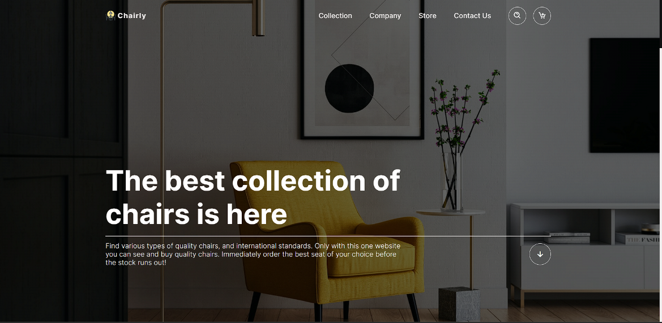

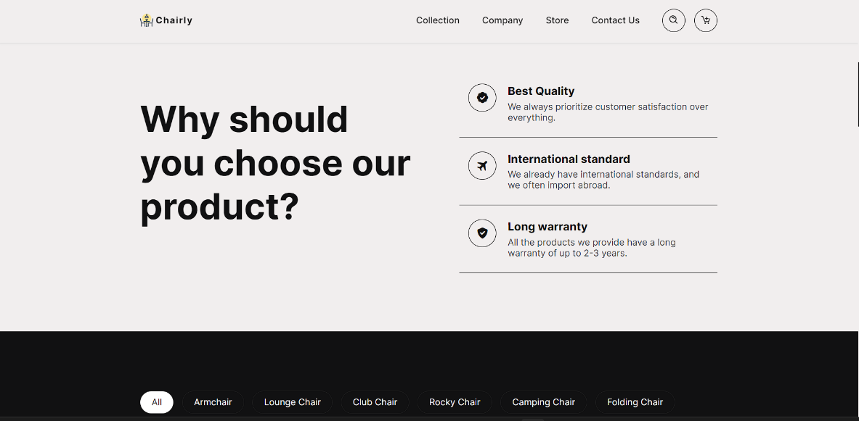

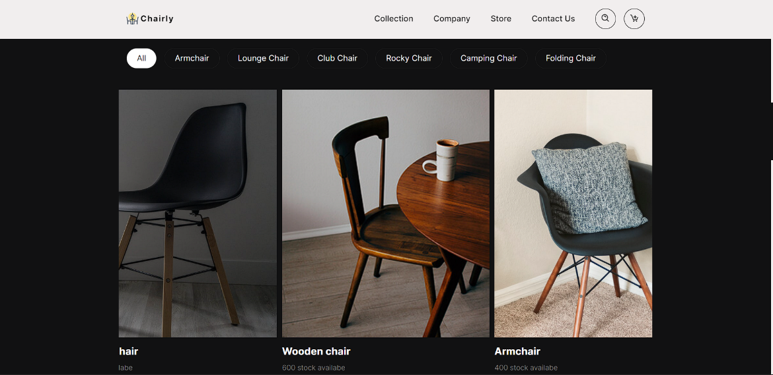

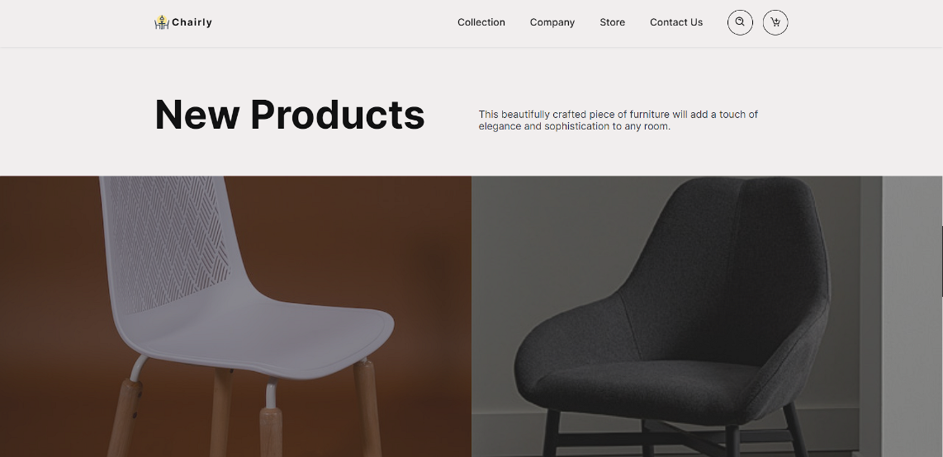

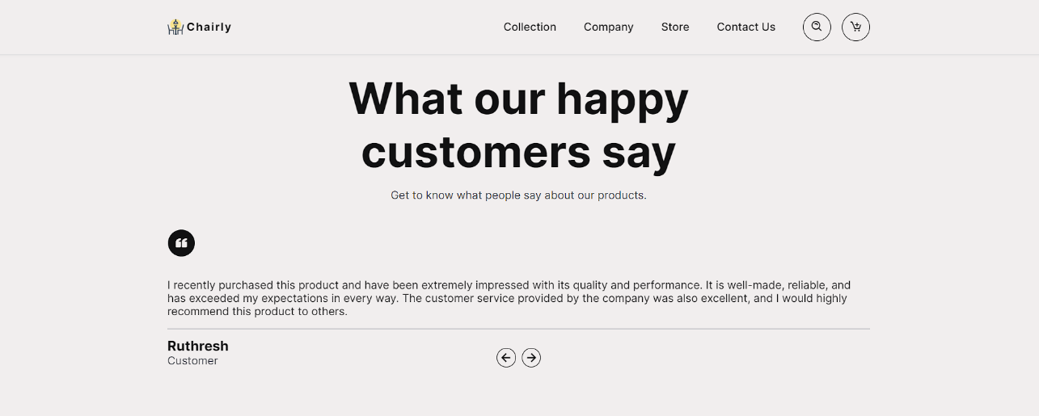

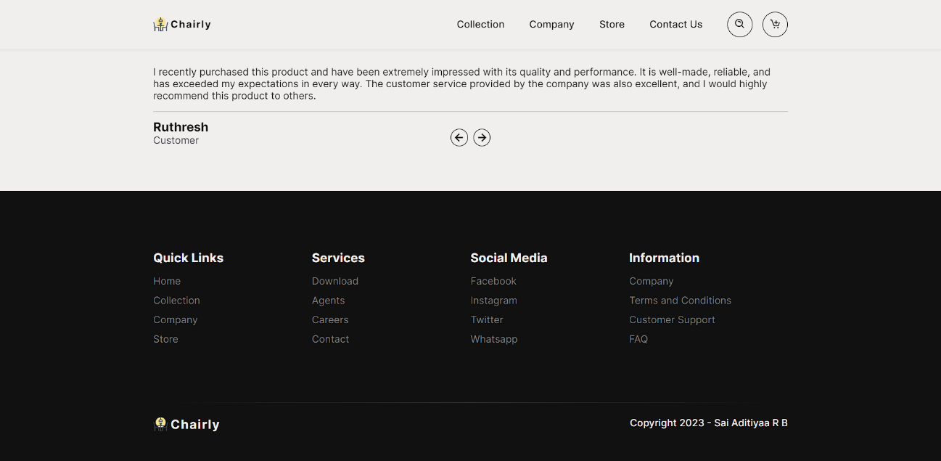

conclusion:

In conclusion, our project aimed to design and develop a chair website that would provide users with a seamless and engaging experience. Through extensive research, we identified key user needs and preferences, and developed a user-centered design that prioritizes functionality, usability, and aesthetics. Our website features a wide range of chairs, from ergonomic office chairs to stylish dining chairs, and allows users to easily filter and search for products based on their specific needs and preferences. Additionally, we integrated various features to enhance the user experience, including a virtual showroom, customer reviews, and an interactive design tool that allows users to customize their chairs.