Coordinate Points Comparision Tool Test Automation
Below are the guide lines to run project.
--> It is a Node.js Playwright Project.
Overview:
This project uses Playwright to automate the scenarios testing for Coordinate points comparision tool. Playwright provides reliable, fast, and scalable automation across all modern browsers.
Prerequisites:
Before begin, ensure that following are installed:
- Visual studio code installed.
- Node.js installed (v20.x or higher recommended)
- npm (Node Package Manager) installed.
Installation:
1. Clone the repository from Terminal
--git clone https://github.com/Saianuradha/CoordinatePointsTool.git
--cd **your repo name**
2. Install dependencies
--npm install
--npm playwright install
3.Running tests
--npm run test

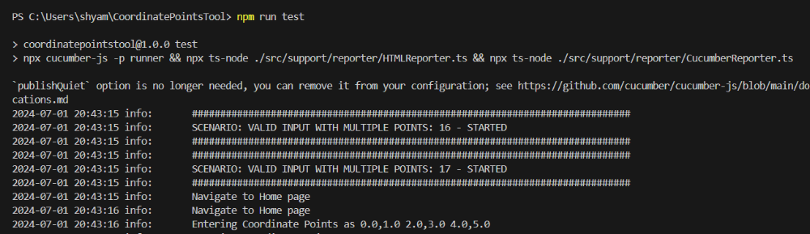

4. Running Report
--npm run report

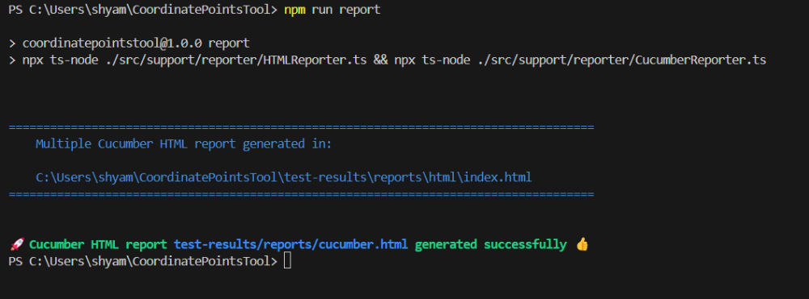

Navigate to reporter folder > right clik> select option reveal in file explorer > find the html/cucumber reports
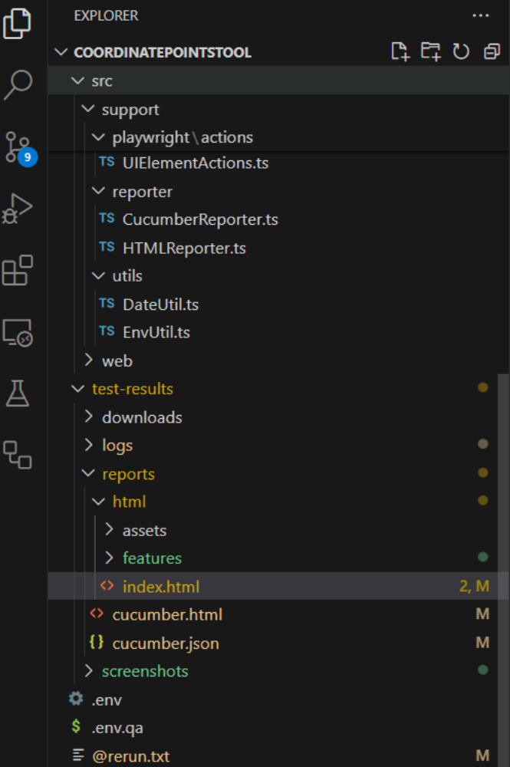
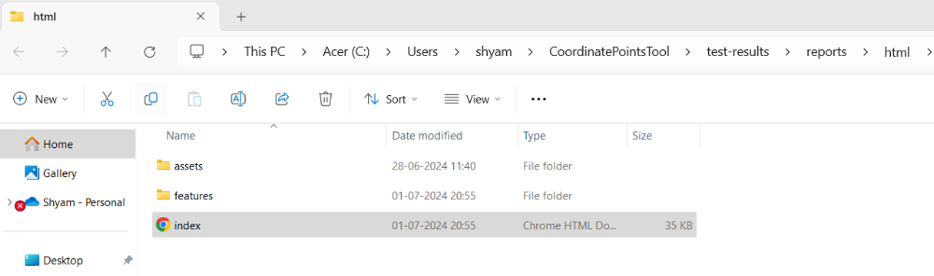

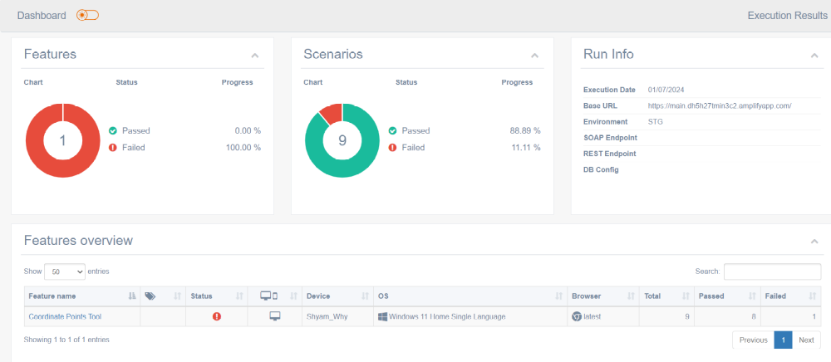

Running tests from CICD
Navigate to GitHub Actions> Automation Test Execution> Click on "Run WorkFlow" > Select "Run forkFlow button".
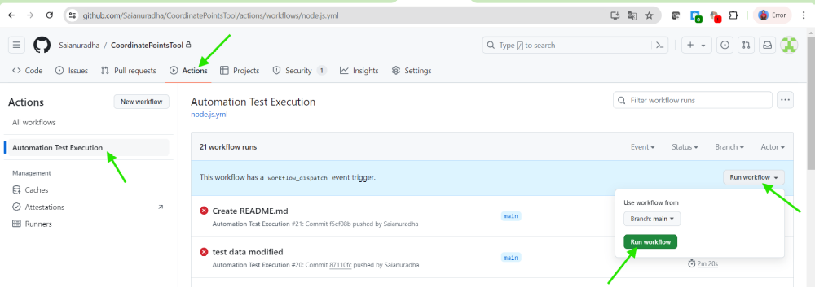
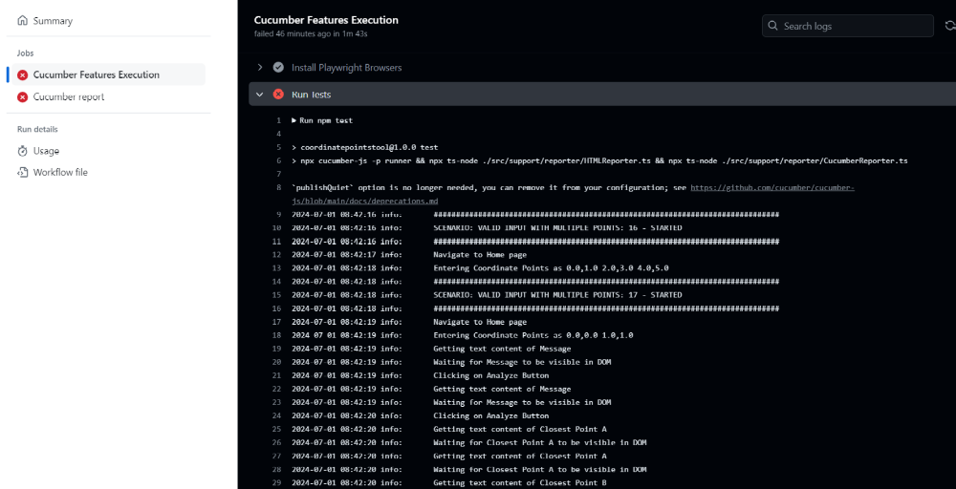

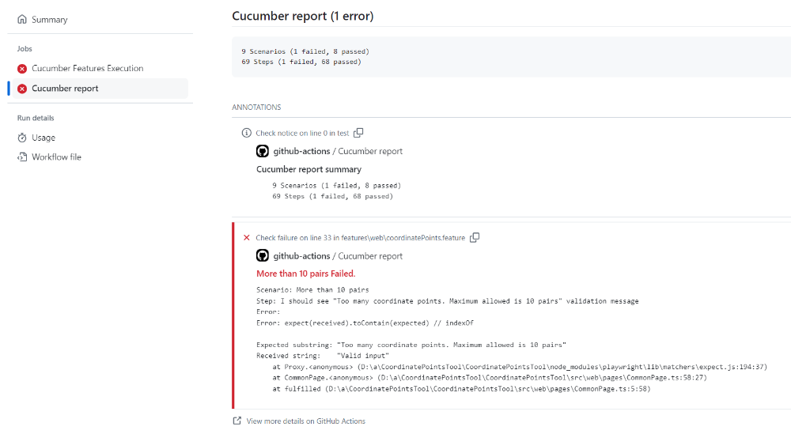

Can also be seen the online report from GitHub readme file by clicking on "ReportOnline" button.

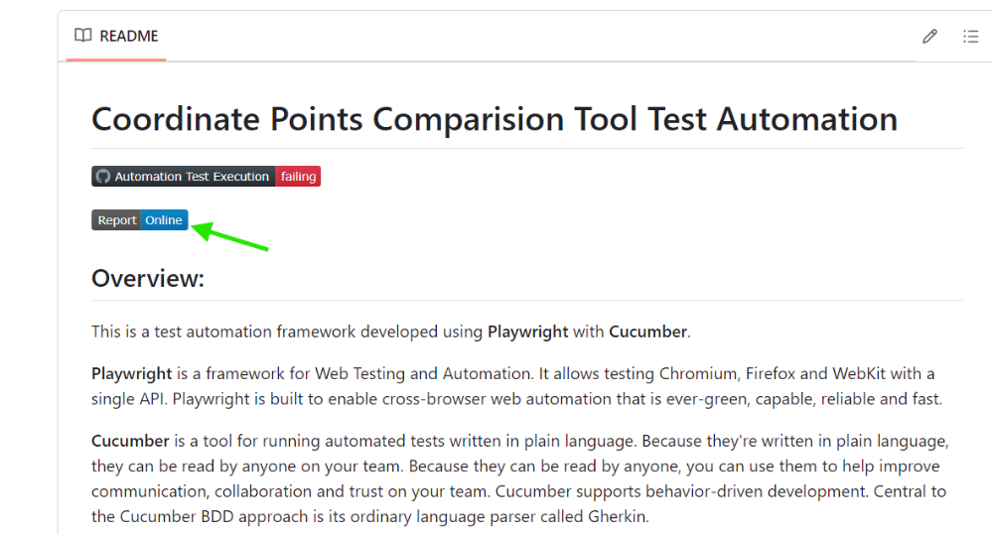
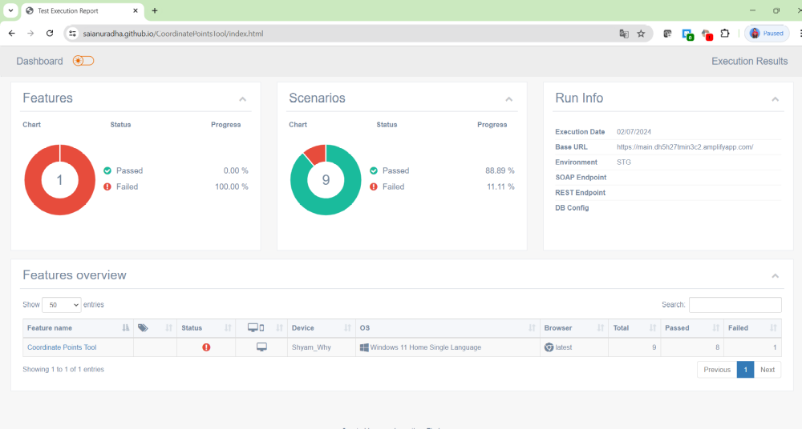
The current build has failed due to a scenario that is failing because of a bug. An email report has been sent to show the build results. Once this bug is fixed, the build will show as successful.

