Test Documentation for the Coordinate Points ComparisionTool
Test Objective: The Coordinate Points Comparison Tool allows the user to input a list of coordinate points and then calculates the distance between every pair of coordinate points, finding the closest pair, the furthest pair, and the average distance.
Url: https://main.dh5h27tmin3c2.amplifyapp.com/
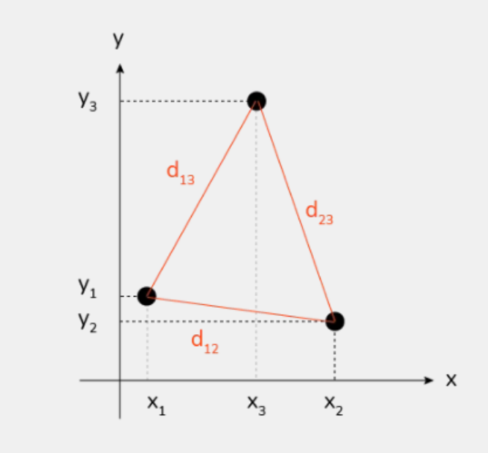

Distance between the coordinate points
d= SquareRootOf(x2−x1) 2+(y2−y1) 2
Input = 0.0,1.0 2.0,3.0 4.0,5.0
Closest pair: (0.0, 1.0) and (2.0, 3.0), Distance: 2.83
D1 = (2-0)^2 + (3-1)^2 = 4+4 = squareroot(8) = 2.83
Furthest pair: (0.0, 1.0) and (4.0, 5.0), Distance: 5.66
D2 = (4-0)^2+(5-1)^2 = 16+16 =squareroot(32) = 5.66
Distance between (2.0, 3.0) and (4.0, 5.0) d3 : 2.83
Average distance = d1+d2+d3/3 => 2.83+2.83+5.66/ 3 = 3.77

Manual QA
Test Plan
Test Scenarios:
1. Valid Input Processing
- Ensure the tool correctly processes valid input and calculate the the average distances.
2. Invalid Input Handling
- Verify the tool displays an error message for invalid input.
3. Edge Cases
- Test scenario with the maximum number of points.
- Test scenario with the minimum number of points (one pair).
- Test scenaro with negative coordinate points.
- Test scenario with more than maximum number of points.
Test Cases:
TC_01: Valid Input with Multiple Points
Summary: Verify that the tool correctly handles valid input with multiple coordinate points.
Input: 0.0,1.0 2.0,3.0 4.0,5.0
Expected Output:
Closest pair: (0.0, 1.0) and (2.0, 3.0), Distance: 2.83
Distance between (0.0, 1.0) and (4.0, 5.0): 5.66
Furthest pair: (0.0, 1.0) and (4.0, 5.0), Distance: 5.66
Average distance: 3.77
Result: Pass
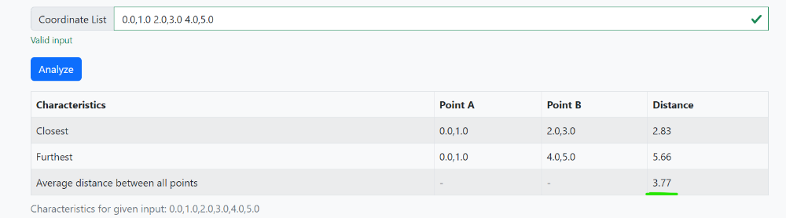

TC_02: Valid Input with Single Pair of Points
Summary: Verify that the tool handles input with a single pair of points.
Input : 0.0,0.0 1.0,1.0
Expected Output:
Closest pair: (0.0, 0.0) and (1.0, 1.0), Distance: 1.41
Furthest pair: (0.0, 0.0) and (1.0, 1.0), Distance: 1.41
Average distance: 1.41
Result: Pass
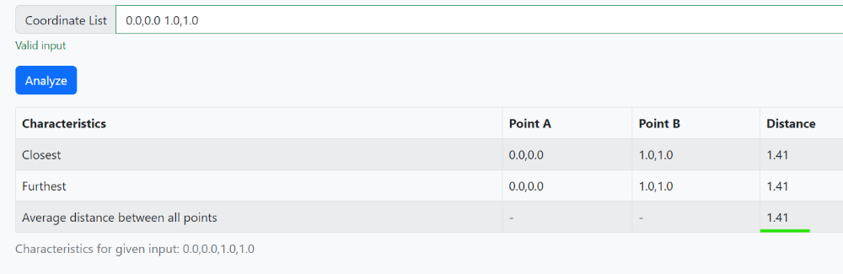
TC_03: Valid Input with duplicate points
Description: Verify that the tool handles input with duplicate points.
Input: 1.0,1.0 1.0,1.0 2.0,2.0
Expected Output:
Closest pair: (1.0, 1.0) and (1.0, 1.0), Distance: 0.00
Furthest pair: (1.0, 1.0) and (2.0, 2.0), Distance: `1.41`
Average distance: 0.94
Result: Pass
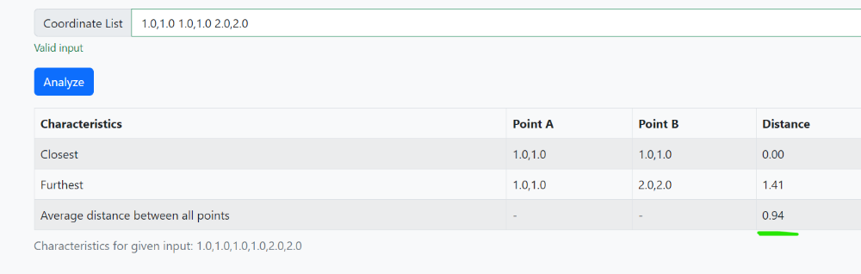

TC_04: Maximum Number of Points
Summary: Verify that the tool handles the maximum number of 10 pairs of coordinate points.
Input: 0.0,0.0 1.0,1.0 2.0,2.0 3.0,3.0 4.0,4.0 5.0,5.0 6.0,6.0 7.0,7.0 8.0,8.0 9.0,9.0
Expected Output: Correct pairs and distances for closest, furthest, and average. should be displyed without throwing any error.
Result: Pass

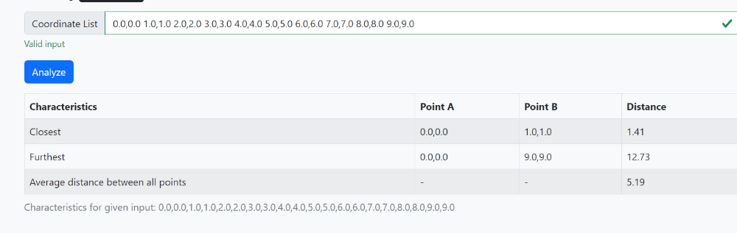
TC_05: Invalid Input Format
Summary: Verify that the tool displays an error message for invalid input formats.
Input: 0.0,0.0 1.0,1.0 invalid 2.0,2.0
Expected Output: Error Message " Please make sure the input follows the format required"
Result: Pass
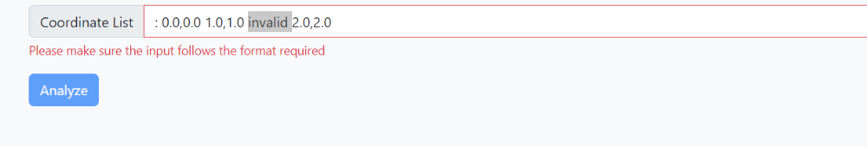
TC_06: More Than 10 Pairs
Description: Verify that the tool handles input with more than 10 pairs of coordinate points.
Input: 0.0,0.0 1.0,1.0 2.0,2.0 3.0,3.0 4.0,4.0 5.0,5.0 6.0,6.0 7.0,7.0 8.0,8.0 9.0,9.0 10.0,10.0
Expected Output: Error Message: "Too many coordinate points. Maximum allowed is 10 pairs." should be displayed
Result : Fail
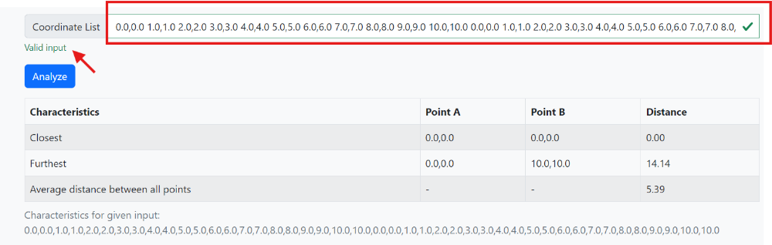
TC_07: Validation with Negative Coordinates
Summary: Verify that the tool handles negative coordinate points correctly.
Input: -1.0,-1.0 1.0,1.0 -2.0,-2.0 2.0,2.0
Expected Output:
Closest pair: (-1.0, -1.0) and (-2.0, -2.0), Distance: 1.41
Furthest pair: (-2.0, -2.0) and (2.0, 2.0), Distance: 5.66
Average distance: 3.32
Result: Pass
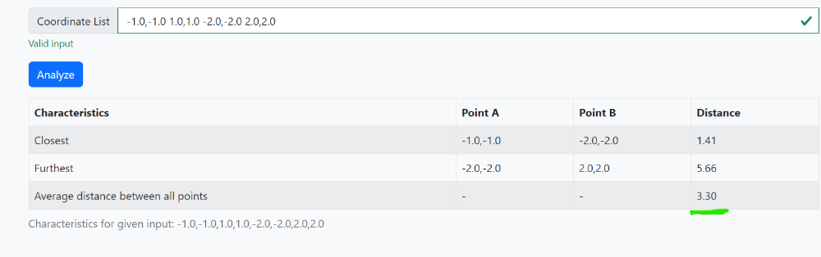
TC_08: Zero Distance
Summary: Verify that the tool handles input with points that are exactly the same (zero distance).
Input: 1.0,1.0 1.0,1.0 1.0,1.0
Expected Output:
Closest pair: (1.0, 1.0) and (1.0, 1.0), Distance: 0.00
Furthest pair: (1.0, 1.0) and (1.0, 1.0), Distance: 0.00
Average distance: 0.00
Result: Pass
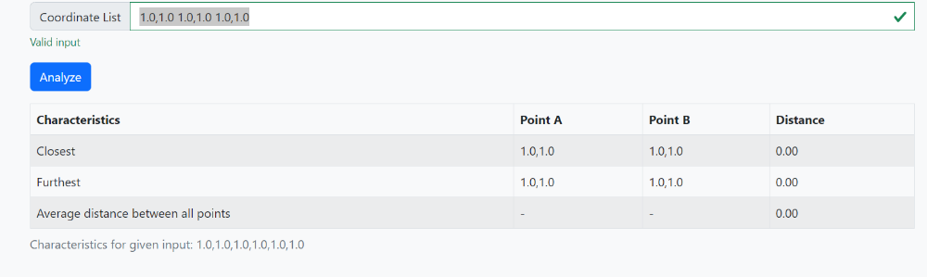
TC_09: Validation on Output values format
Summary: Validate the output format of coordinate points and distances to the specified decimal places.
Input: Enter 0.0,1.0 2.0,3.0 4.0,5.0.
Expected Output: Coordinate points formatted to 1 decimal place and distances to 2 decimal places.
Result : Pass
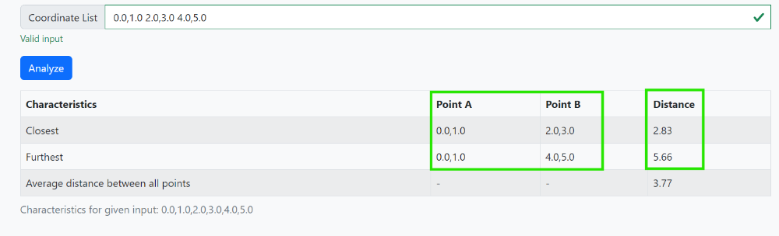
Test Execution Results:
Number of tests run : 9
Number of tests Passed : 8
Number of tests Failed : 1

Bug Reportting
Bug 1: Handling More Than 10 Pairs
Description: The tool does not correctly handled more than 10 pairs and does not display the error message.
Severity: Medium
Priority: Medium(P2)
Status: Open
Steps to Reproduce:
1. Run the tool.
2. Enter `0.0,0.0 1.0,1.0 2.0,2.0 3.0,3.0 4.0,4.0 5.0,5.0 6.0,6.0 7.0,7.0 8.0,8.0 9.0,9.0 10.0,10.0`.
Expected Result: Display error message "Too many coordinate points entered. Maximum allowed is 10 pairs."
Actual Result: The tool processed the input without any error message.

