AUTOMATED PRODUCT MANAGEMENT SYSTEM APPLICATION DEPLOYMENT
USING TERRAFORM IN AZURE
DOTNET <<>> MYSQL

- Project Over : The Automated Product Management System is a cloud-based application deployed on Azure using Terraform. It automates the provisioning of RG, VNet, Network Security Groups, VM, and MySQL Server. Built with .NET and integrated with MySQL, it enables efficient product management through CRUD operations. This project showcases scalable, reliable, and automated cloud deployment.

- Architecture Diagram :

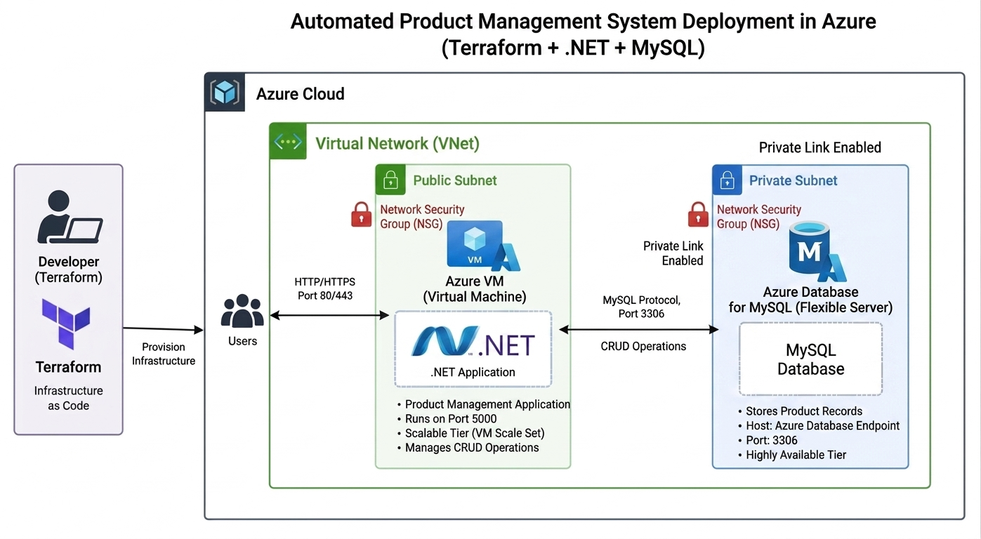

- Project Work Flow :
[Terraform] → [Azure Infrastructure: VNet + NSG + VM + MySQL ] → [.NET Application Deployment] → [MySQL Database Connection] → [CRUD Operations ( POST, GET, PUT, DELETE OPTIONS ) ] → [User Access]

+------------------------+----------------------+----------------------+-----------------+----------------+
| WEB BROWSER | REST | VM | SQL | MY SQL |
| HTTP | 5001 | DOTNET APP | 3306 | MYSQL |
| 80 | API | 5001 | | 3306 |
+------------------------+----------------------+----------------------+-----------------+-----------------+

- Project Files :
- Infrastructure files :

- Fixed files

- Values files :

- Note : provide your values like Client id, client secret, tenant id and subscription id in provider.tf file
- For .tfvars file your choice to change values

- Project Files :

- Index file :

- Terraform Commands :
- terraform init : For downloading supporting files and plugins for connecting
- terraform validate : Checking syntax errors
- terraform plan : Review what infrastructure is building
- terraform apply : Create Infrastructure, directory, files and complete configurations.

- Background Process :
- Infrastructure Provisioning
- Terraform initializes and authenticates with Azure.
- Azure resources are created automatically, including Resource Group, VNet, Subnet, NSG, VM, and MySQL database.
- Network connectivity is established between application and database tiers.

- Application Deployment
- The .NET application is deployed on the Azure Virtual Machine.
- Required runtime dependencies and configurations are installed.
- Application services are started and configured to run automatically.

- Database Configuration
- MySQL database instance is provisioned.
- Database schema and tables are created.
- Connection settings are configured within the application.

- Application Startup
- Users access the application through the VM Public IP or configured endpoint.
- The .NET application processes incoming requests.
- Business logic executes within the application layer.

- Data Processing
- User actions such as Create, Read, Update, and Delete (CRUD) operations are received.
- Application validates requests and interacts with MySQL.
- Database stores and retrieves product information.

- Security and Networking
- Network Security Groups control inbound and outbound traffic.
- Application communicates securely with the database.
- Access is restricted to authorized ports and services.

- End-to-End Workflow
- User → .NET Application → MySQL Database → Response Returned to User
- This process ensures automated infrastructure deployment, reliable application hosting, secure database communication, and efficient product management operations.

- Errors faced and solution :
- Declaring environmental variables issue :
- Problem : Due to syntax and based on software language
- Issue or wrong command
'ConnectionStrings__DefaultConnection=Server=${aws_db_instance.db.address};Database=${var.db_name};User=${var.db_user};Password=${var.db_password};SslMode=Required' | sudo tee /etc/productnet.env"

export 'ConnectionStrings__DefaultConnection=Server=${aws_db_instance.db.address};Database=${var.db_name};User=${var.db_user};Password=${var.db_password};SslMode=Required' | sudo tee /etc/productnet.env"

- Solution command use echo in command :
“echo 'ConnectionStrings__DefaultConnection=Server=${aws_db_instance.db.address};Database=${var.db_name};User=${var.db_user};Password=${var.db_password};SslMode=Required' | sudo tee /etc/productnet.env"

- .NET Runtime/SDK Not Installed
- Issue: The application failed to start because the required .NET SDK or Runtime was missing on the EC2 instance.

- Resolution: Installed the appropriate .NET SDK and ASP.NET Core Runtime packages.
- Before creating files : install this command
# Download Microsoft package repository
wget https://packages.microsoft.com/config/ubuntu/22.04/packages-microsoft-prod.deb

- After creating files and changed path to ~ and install this:
"dotnet add package Microsoft.EntityFrameworkCore --version 8.0.8",
"dotnet add package Pomelo.EntityFrameworkCore.MySql --version 8.0.2",
"dotnet add package Microsoft.EntityFrameworkCore.Design --version 8.0.8",

- Dotnet application running command in ~ directory :
- Problem : Running wrong command
- Product-Net.dll
- run product-Net.dll

- Solution : run this command
"printf '%s\n' '[Unit]' 'Description=Product Net App' 'After=network.target' '' '[Service]' 'WorkingDirectory=/home/ubuntu/Product-Net' 'ExecStart=/usr/bin/dotnet /home/ubuntu/Product-Net/publish/Product-Net.dll' 'Restart=always' 'RestartSec=10' 'User=ubuntu' 'EnvironmentFile=/etc/productnet.env' 'SyslogIdentifier=productnet' '' '[Install]' 'WantedBy=multi-user.target' | sudo tee /etc/systemd/system/productnet.service > /dev/null",

- Exchange parameters
- Before
From Database=${var.db_name}
To Database=${var.db_user}

- After Change
From User=${var.db_user}
To User=${var.db_name}

- Result : browse IP:5001 for application

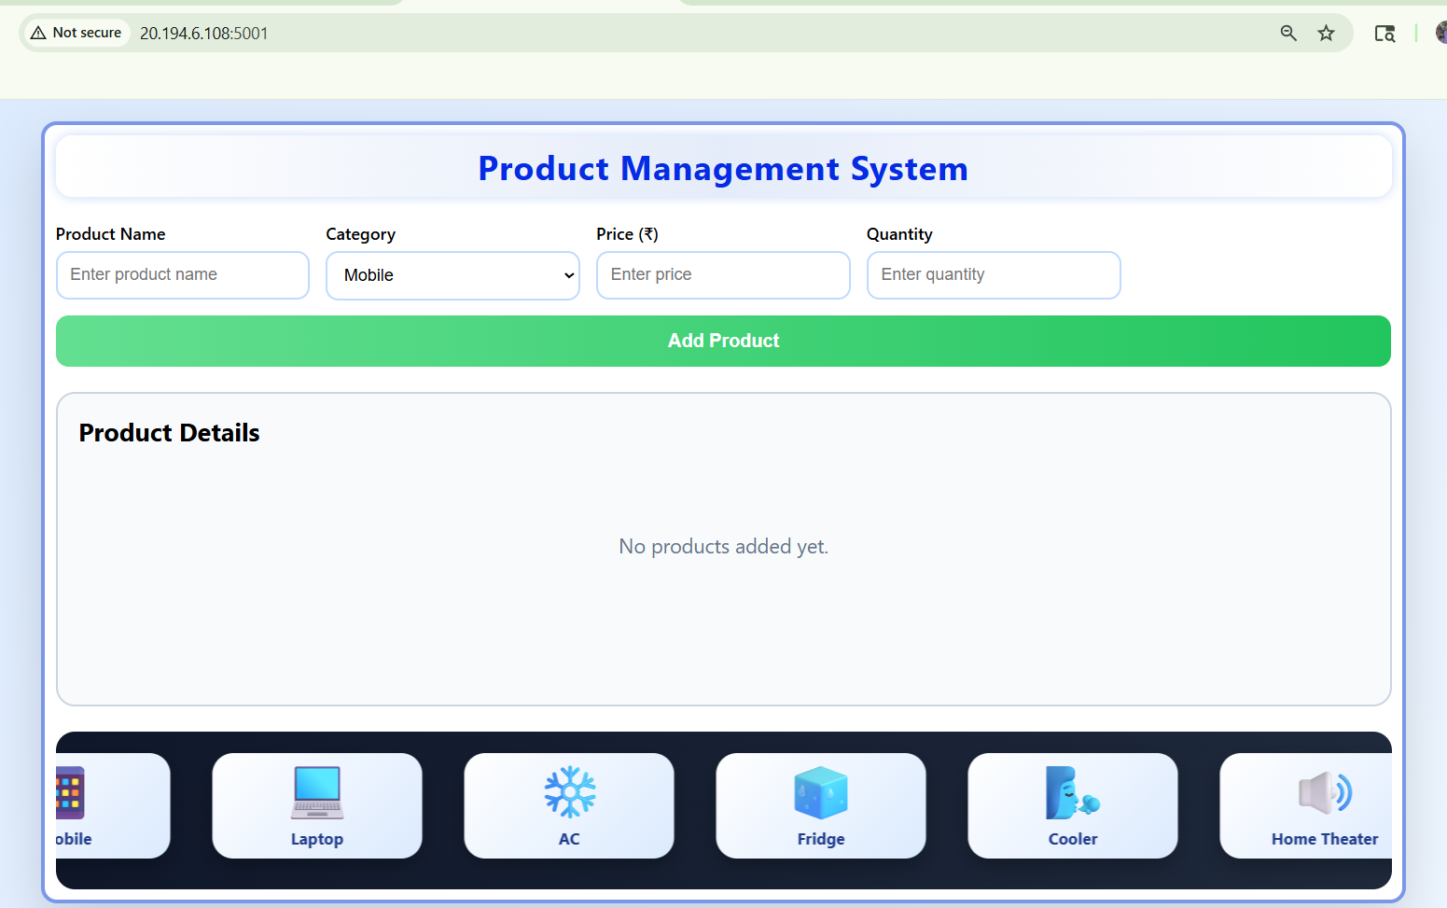

- After adding data

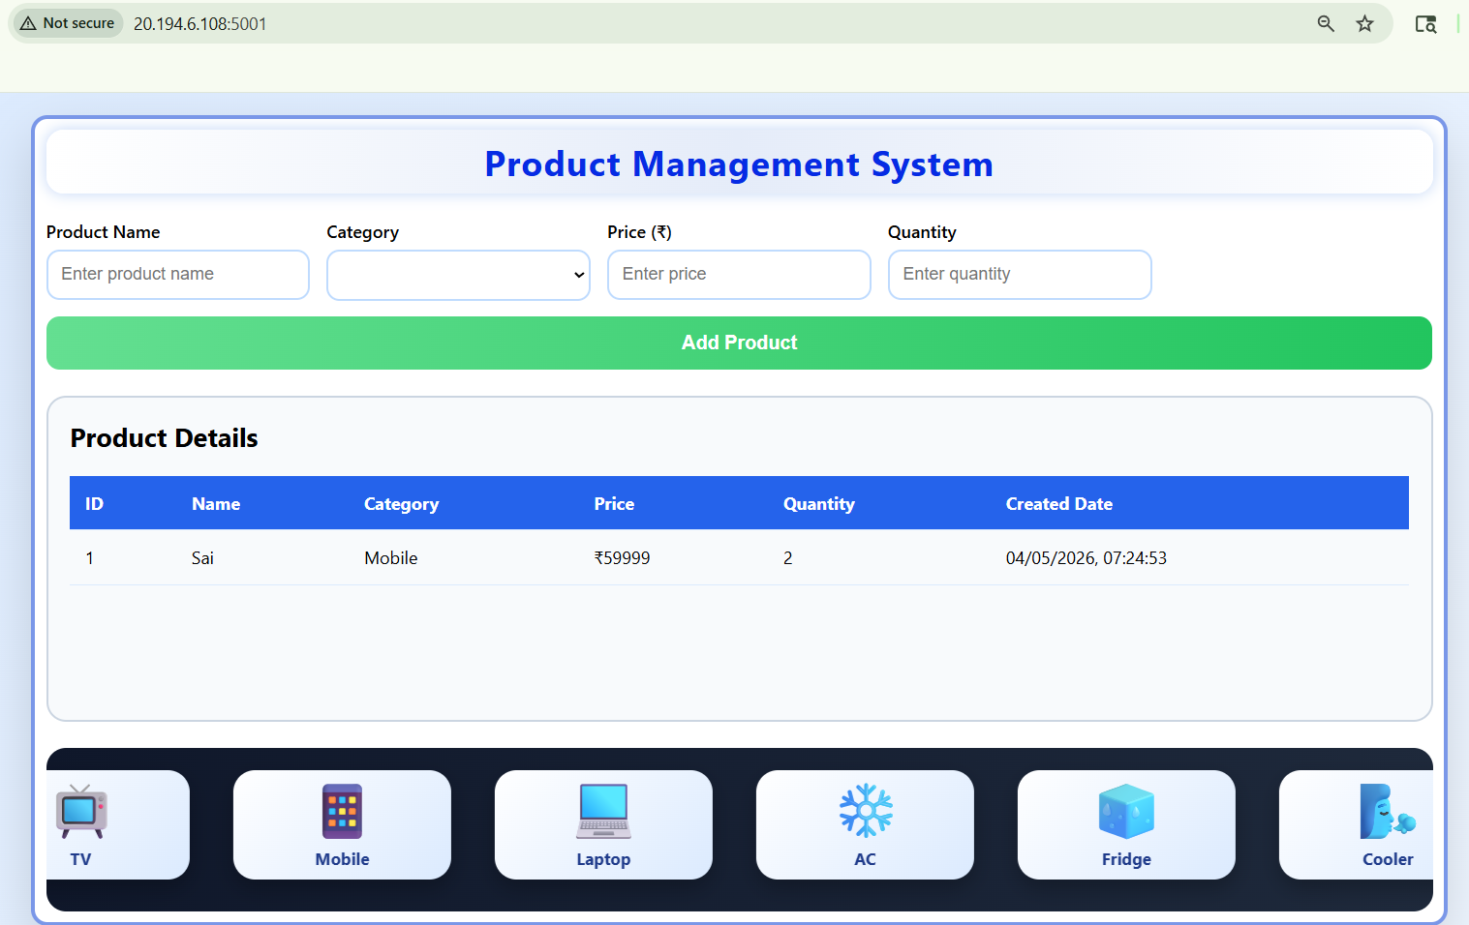

- Outcomes
- Successfully deployed a 2-tier Product Management Application on Azure using Terraform.
- Automated infrastructure provisioning, reducing manual deployment effort and configuration errors.
- Established secure communication between the .NET application and MySQL database.
- Achieved a scalable and repeatable cloud deployment architecture using Infrastructure as Code (IaC).

- Learnings
- Gained hands-on experience with Azure cloud resource deployment and management.
- Learned how to use Terraform for Infrastructure as Code and automated provisioning.
- Understood the implementation of a 2-tier architecture using .NET and MySQL.
- Developed knowledge of Azure networking components such as VNets, Subnets, NSGs, and VM

