AUTOMATED STUDENT APPLICATION DEPLOYMENT
USING TERRAFORM IN AZURE
PYTHON FLASK <<>> MYSQL

- Project Overview : This project is a cloud-based Student Management Application deployed on Azure using Terraform (IaC). It uses Python Flask for the backend and MySQL for data storage. The entire infrastructure is automatically provisioned, enabling fast, scalable, and repeatable deployments with minimal manual effort.

- Project Architecture Diagram :

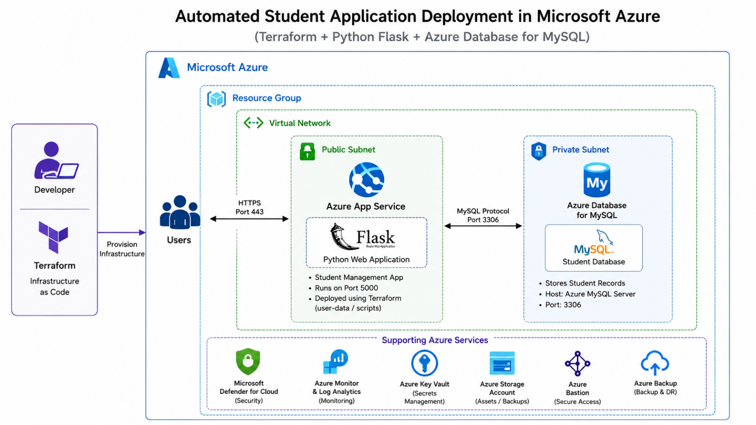

- Project Work Flow :

Developer
│
▼
Terraform Code (IaC)
│
▼
Azure Infrastructure Provisioning
(VNet → VM → Security Groups → MySQL Server )
│
▼
Flask Application Deployment on VM
│
▼
Flask Backend APIs (CRUD Operations)
│
▼
MySQL Database (Student Records Storage)
│
▼
User Browser / Frontend Access
(Student Management System)

- Technology Used :
- Azure Cloud : RG, Vnet, Subnets, NSG – Network Security Group, Virtual Machine, MySQL Server
- Python : Python, Flask, Unicorn, Mysqlclient
- Terraform : Provider block, Main block, Output block and variable Block

- Files Structure :
- Project : 1. Terraform and index files
  - 2. Python

- Terraform Files :

- Changes needed : in Provider block add your Client id, client secret, tenant id, subscription id Values need to be changed is output block if you want.

- Website customized Page :

- Python files :

  - Create config.py file
vi config.py
or
nano config.py

import os

class Config:
# Read environment variables correctly
DB_HOST = os.environ.get("DB_HOST")
DB_PORT = os.environ.get("DB_PORT", "3306")
DB_NAME = os.environ.get("DB_NAME")
DB_USER = os.environ.get("DB_USER")
DB_PASSWORD = os.environ.get("DB_PASSWORD")

# SQLAlchemy connection string
SQLALCHEMY_DATABASE_URI = f"mysql+pymysql://{DB_NAME}:{DB_PASSWORD}@{DB_HOST}:{DB_PORT}/{DB_USER}"
SQLALCHEMY_TRACK_MODIFICATIONS = False

SQLALCHEMY_ENGINE_OPTIONS = {
"connect_args": {
"ssl": {
"ca": "/etc/ssl/certs/ca-certificates.crt"
}
}
}

- For saving :
If vi editor is used : :wq or press esc ZZ
If nano editor is used : ctrl + o enter ctrl +x

  - Create app.py file
vi app.py
or
nano app.py

from flask import Flask, request, jsonify, render_template, redirect, url_for
from flask_sqlalchemy import SQLAlchemy
from config import Config

app = Flask(__name__)
app.config.from_object(Config)
db = SQLAlchemy(app)

# ─────────────────────────────
# MODEL
# ─────────────────────────────
class Student(db.Model):
__tablename__ = 'students'

id = db.Column(db.Integer, primary_key=True)
name = db.Column(db.String(100), nullable=False)
email = db.Column(db.String(120), unique=True, nullable=False)
course = db.Column(db.String(100), default='General')

def to_dict(self):
return {
"id": self.id,
"name": self.name,
"email": self.email,
"course": self.course
}

# ─────────────────────────────
# HOME (HTML PAGE - GET ALL)
# ─────────────────────────────
@app.route('/', methods=['GET'])
def home():
students = Student.query.all()
return render_template("index.html", students=students)

# ─────────────────────────────
# API: GET ALL STUDENTS
# ─────────────────────────────
@app.route('/students', methods=['GET'])
def api_get_all_students():
students = Student.query.all()
return jsonify([s.to_dict() for s in students])

# ─────────────────────────────
# API: GET STUDENT BY ID
# ─────────────────────────────
@app.route('/students/<int:id>', methods=['GET'])
def api_get_student_by_id(id):
student = Student.query.get_or_404(id)
return jsonify(student.to_dict())

# ─────────────────────────────
# HTML FORM: ADD STUDENT
# ─────────────────────────────
@app.route('/add', methods=['POST'])
def add_student_form():
name = request.form.get('name')
email = request.form.get('email')
course = request.form.get('course')

if not name or not email:
return "Name and Email required", 400

existing = Student.query.filter_by(email=email).first()
if existing:
return "Email already exists", 400

student = Student(name=name, email=email, course=course)
db.session.add(student)
db.session.commit()

return redirect(url_for('home'))

# ─────────────────────────────
# API: ADD STUDENT (JSON)
# ─────────────────────────────
@app.route('/students', methods=['POST'])
def api_add_student():
data = request.get_json()

if not data:
return jsonify({"error": "Invalid JSON"}), 400

name = data.get("name")
email = data.get("email")
course = data.get("course", "General")

if not name or not email:
return jsonify({"error": "name and email required"}), 400

try:
student = Student(name=name, email=email, course=course)
db.session.add(student)
db.session.commit()
return jsonify(student.to_dict()), 201

except Exception as e:
db.session.rollback()
return jsonify({"error": str(e)}), 400

# ─────────────────────────────
# API: DELETE STUDENT BY ID
# ─────────────────────────────
@app.route('/students/<int:id>', methods=['DELETE'])
def api_delete_student(id):
student = Student.query.get_or_404(id)

db.session.delete(student)
db.session.commit()

return jsonify({"message": "Deleted successfully"})

# ─────────────────────────────
# RUN APP
# ─────────────────────────────
if __name__ == '__main__':
with app.app_context():
db.create_all()

app.run(host='0.0.0.0', port=5000, debug=True)

- For saving :
If vi editor is used : :wq or press esc ZZ
If nano editor is used : ctrl + o enter ctrl +x

  - Create db_test.py
vi db_test.py
or
nano db-test.py

import os
from sqlalchemy import create_engine

DB_USER = os.getenv("DB_USER")
DB_PASSWORD = os.getenv("DB_PASSWORD")
DB_HOST = os.getenv("DB_HOST")
DB_PORT = os.getenv("DB_PORT", "3306")
DB_NAME = os.getenv("DB_NAME")

DATABASE_URL = (
f"mysql+pymysql://{DB_USER}:{DB_PASSWORD}"
f"@{DB_HOST}:{DB_PORT}/{DB_NAME}?ssl=true"
)

engine = create_engine(DATABASE_URL)

try:
conn = engine.connect()
print("✅ DB CONNECTED SUCCESSFULLY")
conn.close()

except Exception as e:
print("❌ DB CONNECTION FAILED")
print("Error Type:", type(e).__name__)
print("Error Details:", str(e))

- For saving :
If vi editor is used : :wq or press esc ZZ
If nano editor is used : ctrl + o enter ctrl +x

- Terraform commands to execute :
- Terraform initialize and connection :
terraform init

- Terraform check errors :
terraform validate

- Terraform preview plan
terraform plan

- Terraform execution manual :
terraform apply

- Terraform execution with permission :
terraform apply --auto-approve

- Output : now copy the pubic ip and paste in web
- PublicIP:5000

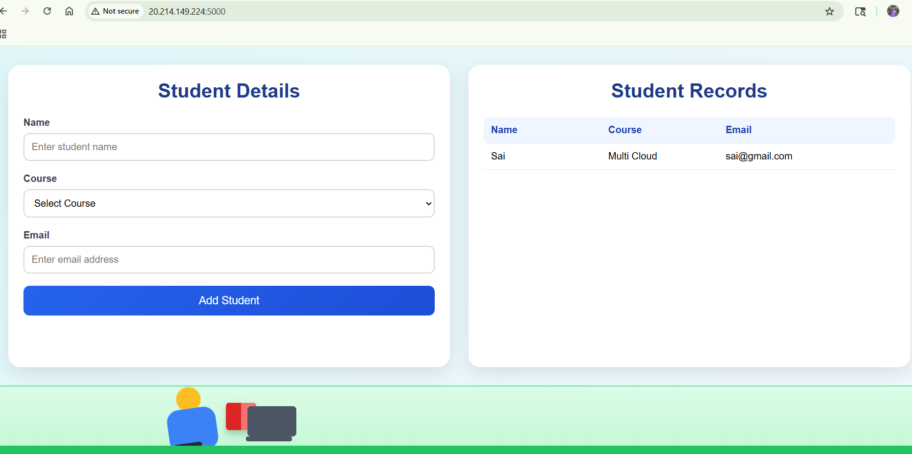

- Errors And Complications Faced And Solutions :
- Connection to database
- Problem : due to wrong connection database connection failed
SQLALCHEMY_DATABASE_URI = f"mysql+pymysql://{DB_USER}:{DB_PASSWORD}@{DB_HOST}:{DB_PORT}/{DB_NAME}"

- Solution : changed it to solve
SQLALCHEMY_DATABASE_URI = f"mysql+pymysql://{DB_NAME}:{DB_PASSWORD}@{DB_HOST}:{DB_PORT}/{DB_USER}"

- For exported variables and checking database connection :
- Problem : Checking database details exported or not
Problem env variable
"echo 'DB_HOST=${azurerm_mysql_flexible_server.mysql.fqdn}' > .env",
"echo 'DB_PORT=3306' >> .env",
"echo 'DB_NAME=${var.db_name}' >> .env",
"echo 'DB_USER=${var.db_user}' >> .env",
"echo 'DB_PASSWORD=${var.db_password}' >> .env",

- Solution : check connection success or not
cat db_test.py
import os
from sqlalchemy import create_engine

DB_USER = os.getenv("DB_USER")
DB_PASSWORD = os.getenv("DB_PASSWORD")
DB_HOST = os.getenv("DB_HOST")
DB_PORT = os.getenv("DB_PORT", "3306")
DB_NAME = os.getenv("DB_NAME")

DATABASE_URL = (
f"mysql+pymysql://{DB_USER}:{DB_PASSWORD}"
f"@{DB_HOST}:{DB_PORT}/{DB_NAME}?ssl=true"
)

engine = create_engine(DATABASE_URL)

try:
conn = engine.connect()
print("✅ DB CONNECTED SUCCESSFULLY")
conn.close()

except Exception as e:
print("❌ DB CONNECTION FAILED")
print("Error Type:", type(e).__name__)
print("Error Details:", str(e))

- Application running issue
- Problem : Running application in background
#"set -a && source .env && set +a && nohup /home/SaiAzadmin/student-python/venv/bin/python app.py > app.log 2>&1 &",

# "cd /home/SaiAzadmin/student-python && set -a && . ./.env && set +a && nohup venv/bin/python app.py > app.log 2>&1 &",

# "cd /home/SaiAzadmin/student-python && set -a && . ./.env && set +a && nohup venv/bin/python app.py > app.log 2>&1 &",

# "cd /home/SaiAzadmin/student-python && nohup env $(cat .env | xargs) venv/bin/python app.py > app.log 2>&1 &",

# "set -a && source /home/SaiAzadmin/student-python/.env && set +a && nohup /home/SaiAzadmin/student-python/venv/bin/python /home/SaiAzadmin/student-python/app.py > /home/SaiAzadmin/student-python/app.log 2>&1 &",

# "cd /home/SaiAzadmin/student-python && set -a && . ./.env && set +a && echo DB_HOST=$DB_HOST DB_NAME=$DB_NAME DB_USER=$DB_USER && nohup venv/bin/python app.py > app.log 2>&1 &",

# "cd /home/SaiAzadmin/student-python && touch app.log && echo \"===== APP START $(date) =====\" >> app.log && set -a && source .env && set +a && nohup venv/bin/python app.py >> app.log 2>&1 &",

# "cd /home/SaiAzadmin/student-python && set -a && source .env && set +a && nohup /home/SaiAzadmin/student-python/venv/bin/python /home/SaiAzadmin/student-python/app.py > /home/SaiAzadmin/student-python/app.log 2>&1 &",
# Debug

- Solution :
"cd /home/SaiAzadmin/student-python && touch app.log && echo \"===== APP START $(date) =====\" >> app.log && echo \"===== APP START $(date) =====\" >> app.log && DB_HOST=${azurerm_mysql_flexible_server.mysql.fqdn} DB_PORT=3306 DB_NAME=${var.db_name} DB_USER=${var.db_user} DB_PASSWORD=${var.db_password} nohup /home/SaiAzadmin/student-python/venv/bin/python3 /home/SaiAzadmin/student-python/app.py >> app.log 2>&1 &",

- Key Learnings :
- Built a full-stack application using Python and Flask, understanding REST APIs, routing, and backend logic.
- Gained hands-on experience with cloud deployment on Microsoft Azure, including networking (VNet, subnets) and service integration.
- Learned Infrastructure as Code using Terraform to provision and manage resources automatically.
- Implemented database integration with MySQL, handling CRUD operations and secure connections.
- Understood DevOps concepts like automation, deployment pipelines, and environment setup.

- Outcomes :
- Successfully deployed a Student Management System on cloud with real-world architecture.
- Achieved end-to-end automation from infrastructure provisioning to application deployment.
- Built a scalable and production-like setup with separation of public and private resources.
- Improved debugging and troubleshooting skills in cloud and application environments.
- Strengthened practical knowledge in cloud + DevOps + backend development integration.

